

Date: 11 November 2020

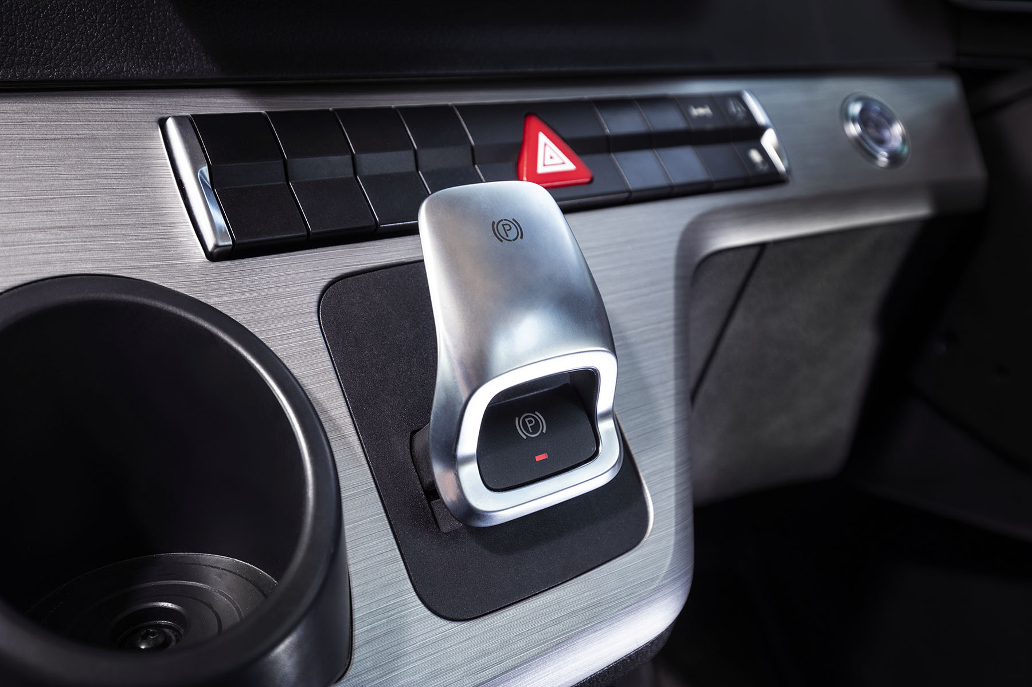

By popular demand: Mercedes-Benz Trucks’ Electronic Parking Brake is now applied automatically whenever the driver opens the door

With Mercedes-Benz Trucks, the best just keeps getting better

The announcement last month of a new emergency stop function designed to further increase the safety of its ground-breaking Active Drive Assist technology has underlined once again
Mercedes-Benz Trucks’ commitment to the constant improvement of its products.

Many of the innovations and developments made to its range by the company’s engineers are in direct response to feedback from UK customers.

Recent examples include an enhancement to the Electronic Parking Brake (EPB) fitted as standard on new Actros and Arocs models, which is now applied automatically whenever the driver opens their door and the vehicle is not moving.

Low-entry Econic models now leave the production line with standard-fit Active Brake Assist 5, a system first seen in the new-generation Actros launched last year. The latest version of Mercedes-Benz Trucks’ industry-leading emergency braking aid employs cameras for the first time, as well as radar.

Not only does this technology further increase safety for vulnerable road users and drivers of a vehicle that already leads the field in terms of Direct Vision, but it is also more accurate and reliable, while making the experience at the wheel more enjoyable and less stressful, particularly for those engaged in distribution and associated applications.

The electronic architecture required for operation of Active Brake Assist 5 means new Econics benefit from the Electronic Parking Brake too.

By contrast, while Sideguard Assist is already an established option for Econic customers, it also becomes available for right-hand drive Actros from June 2021 production. This news will delight safety-focused transport industry pundits in Britain, who have been urging the manufacturer to offer this system on other models in its range.

Sideguard Assist supports the driver when making left turns and changing lanes in busy environments where visibility may be restricted. Within the system limits, it is designed to reduce the possibility of accidents involving vulnerable road users. Two short-range radar sensors mounted on the passenger side of the vehicle monitor up to a lane’s width, and deliver optical and acoustic warnings which alert the driver to the presence of cyclists, pedestrians or other vehicles.

The first level 2 autonomous driving system to enter series production Active Drive Assist (ADA) encourages a more relaxed and fuel-efficient driving style, thereby increasing safety. It is currently available as an option on right-hand drive 4x2 and 6x2 tag axle tractor units and rigid models, but not yet on standard 6x2 mid-lift or mid-steer tractor units. The new emergency stop function is being introduced on most ADA-equipped Actros, also from June 2021.

Active Drive Assist manages the vehicle’s speed to keep it a safe distance from traffic ahead, and steers it to keep its position in the centre of the lane. The driver always retains overall control, though, and must keep hands on the steering wheel at all times – if the sensor in the steering column detects a lack of human interaction, it issues audible and optical alerts, and disengages after a minute.

Mercedes-Benz engineers developed the emergency stop function in recognition of the fact that rather than simply not paying sufficient attention, the driver may be incapacitated due to a health issue. If there has still been no response after 60 seconds of multiple warnings, the new feature will bring the truck smoothly and safely to a halt within its lane, while simultaneously operating the hazard lights to caution traffic behind.

Mercedes-Benz Trucks recognises that no two drivers are the same, which explains why it is constantly extending and refining the range of technical, comfort and styling options available to customers. As well as radical technology such as MirrorCam, the acclaimed replacement for conventional mirrors, the new-generation Actros range comes as standard with the high-tech Multimedia Cockpit, which features stylish and intuitively operated twin screens – one with ‘touch’ functionality – replacing many of the switches used previously.

The same was true of new-generation Arocs models. However, and again in response to requests from UK operators, particularly those working in the construction sector,
Mercedes-Benz has confirmed that with immediate effect Arocs variants can once again be specified with the Classic Cockpit, as a ‘lower specification’ alternative to the new Multimedia version. In addition, four-axle variants of the new Arocs can now be ordered with Active Brake Assist 5.

With construction and related applications still in mind, another new option underscores the lengths to which Mercedes-Benz Trucks will go, to ensure that customers can specify vehicles to meet their precise requirements. This allows them to choose an Actros with the same straight front axle, steel rather than plastic front bumper, and headlight arrangement as a flat-floored Arocs.

The result is a vehicle that offers up to 85mm (depending on tyre choice) of additional ground clearance, and therefore carries a reduced risk of underbody damaged caused by ‘bottoming out’ or getting stuck while manoeuvring on sites and other off-road locations. Although take-up is expected to be relatively modest in terms of overall numbers, this option is likely to prove attractive to operators who particularly want an Actros, perhaps for its on-road styling.

Those choosing an Actros with the new straight axle and steel bumper option can additionally select steps with rubber mounts which allow a certain degree of lateral movement. Already popular with Arocs customers, these rugged steps are specially designed for vehicles that work on construction sites and rough terrain, and offer reductions in repair costs.

Ross Paterson, Mercedes-Benz Trucks’ Head of Product & Marketing, declared: “The customer is ‘king’ at Mercedes-Benz Trucks, so our principal focus is always on those who acquire and operate our vehicles. We listen to what they tell us, and wherever possible we deliver what they need.

“Together, Mercedes-Benz Trucks and its sister brand FUSO offer the broadest product range of any manufacturer, and we are widely acknowledged as the market leader when it comes to technical innovation. We also recognise, though, that even the best trucks can always be improved on, whether through enhancements to their standard specification or extensions to the range of available options.

“From major safety developments such as the new emergency stop function for Active Drive Assist and the introduction of an Electronic Parking Brake for Econic, to relatively minor, incremental advances like the raised ride height option for Actros, the latest raft of developments and enhancements to our range illustrates perfectly how determined we are to ensure that our trucks continue to be the perfect partners for our customers.”

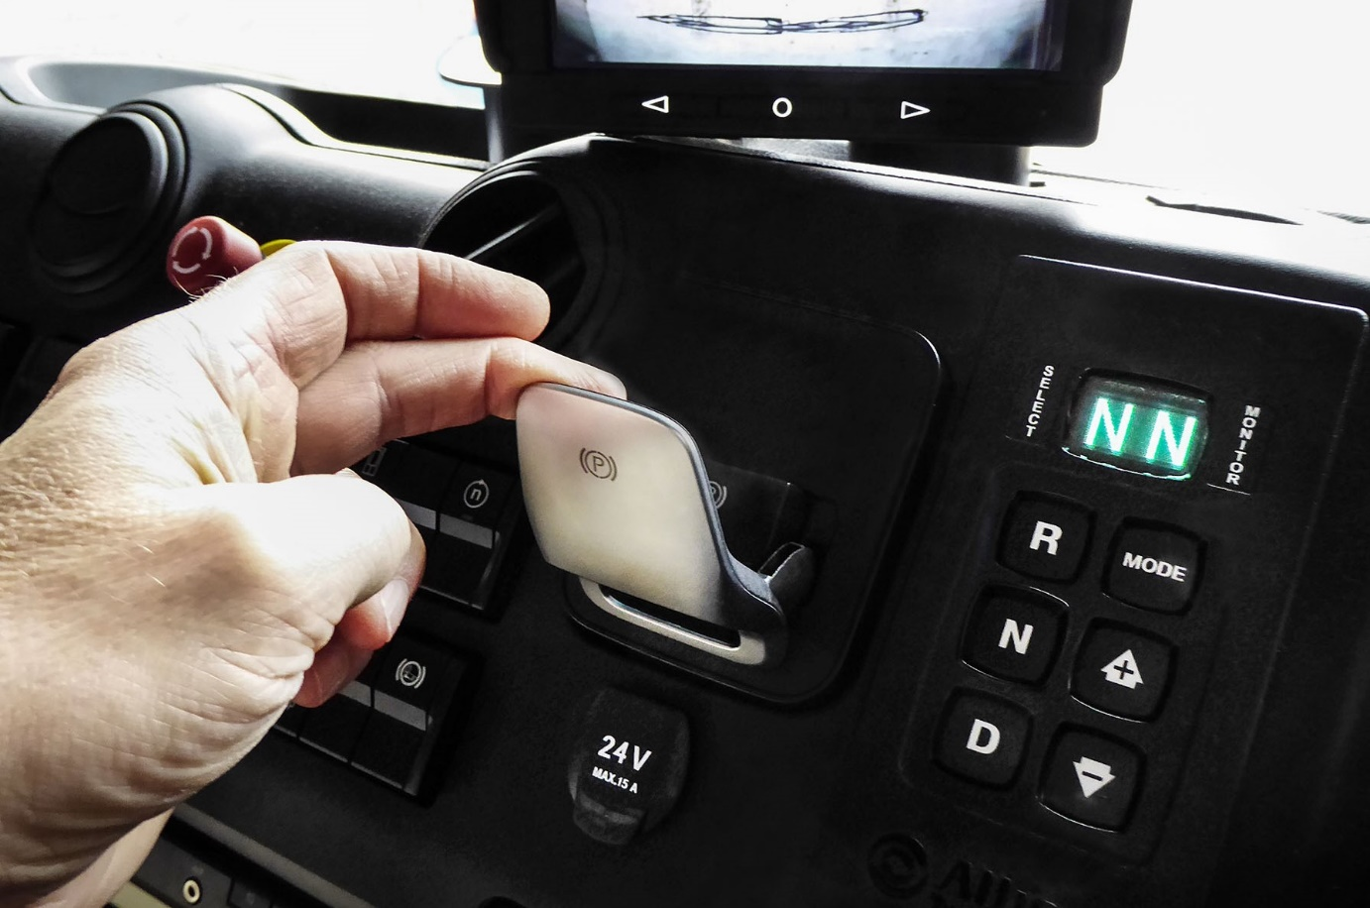

Econic upgrades: The Electronic Parking Brake is also standard equipment now in low-entry Econic models, together with the latest Active Brake Assist 5 emergency braking technology



Safety aid: From June 2021 production, right-hand drive Actros models will be available with Sideguard Assist technology, which is already an established option on Econic models

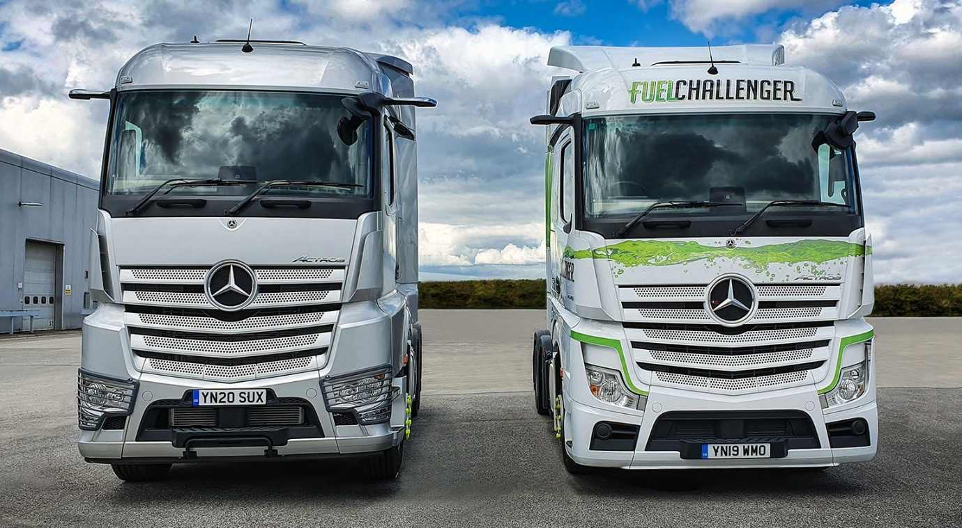

Reducing repair costs: Actros customers whose vehicles regularly venture off road can now specify a straight front axle that raises the vehicle’s ride height, left, and comes with a more durable, steel bumper

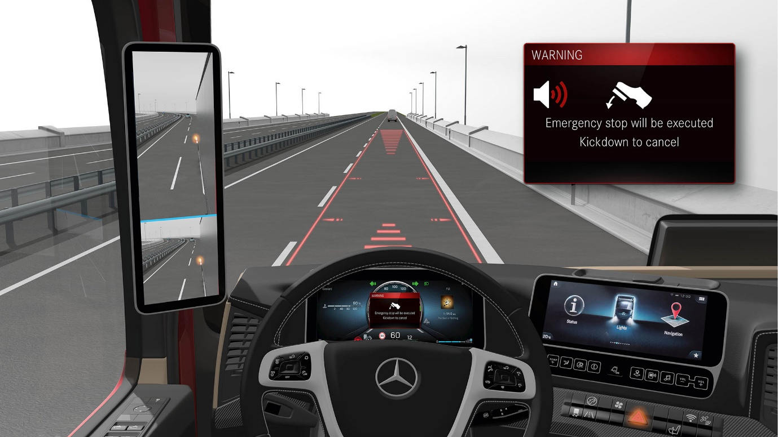

Added reassurance: The Level 2 autonomous Active Drive Assist system gets an emergency stop function next year, which will bring the truck safely to a halt in its lane in the event that the driver is incapacitated

ends

For more information, or to request higher-res image files, please contact:

Jamie Fretwell at Mercedes-Benz Trucks UK Ltd
07712 519230, jamie.fretwell@daimler.com

or

Steve Warren or John Ripley
Impact Communications, 01926 842126
Steve: 07770 470251, steve@impactcom.co.uk
John: 07771 484595, john@impactcom.co.uk

About Mercedes-Benz Trucks UK Ltd
Mercedes-Benz Trucks UK Ltd is the sales and marketing organisation responsible for all Daimler truck products in the UK, including FUSO Canter. In 2019, the company registered 6,963 new trucks. Mercedes-Benz accounted for 6,188 new trucks registered in 2019, making it the third-biggest truck brand in the UK. Meanwhile, FUSO registrations hit 775 – including 580 new trucks over 6.0-tonnes. The flagship new Mercedes-Benz Actros which won the 2020 International Truck of the Year award, features seven core innovations including MirrorCam, Multimedia Cockpit and Active Brake Assist 5. Our premium range of innovative trucks – Actros, Arocs, Atego, Econic and Unimog – draw upon more than 125 years of exceptionally high standards of quality, backed up by our promise of Trucks You Can Trust.
www.mbtrucks.co.uk

