

Date: 9 March 2021

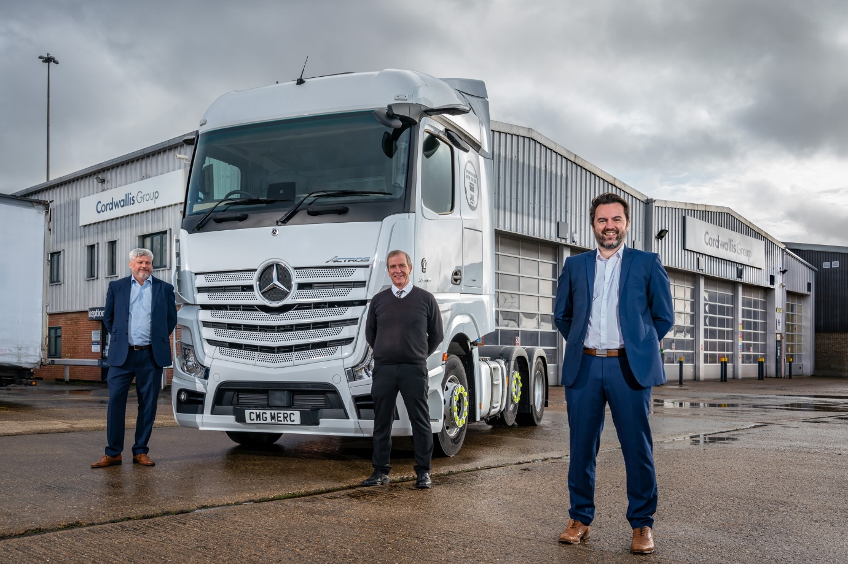

Moving forward with Mercedes-Benz Trucks: Cordwallis Managing Director Rob Zubovic is pictured, right, with Service Director Mark Haines, left, and Parts Director David Alston

Cordwallis celebrates its 50th anniversary by joining the Mercedes-Benz Trucks ‘family’

Thames Valley-based operators of Mercedes-Benz and FUSO trucks can look forward to the highest standards of aftersales back-up from the latest recruit to the manufacturer’s fast-growing network of Authorised Repairers.

Cordwallis can now undertake warranty work on Mercedes-Benz and FUSO truck models at its 2.3-acre site in Reading, which is comprehensively equipped and ideally located, a couple of minutes’ drive from Junction 11 of the M4. Its appointment means Cordwallis is also able to provide customers with access to Mercedes-Benz Trucks’ cost-effective range of repair and maintenance plans.

A family-owned business established in 1971, Cordwallis was already representing other truck and van brands from its Reading facility, and those at Heathrow, Maidenhead and Bicester. Coming in the year of its 50th anniversary, the alliance with Mercedes-Benz Trucks marks a new and exciting milestone in the company’s development.

Managing Director Rob Zubovic declared: “Our goal is to be the best commercial vehicle solutions provider in the Thames Valley, and that means providing peace of mind for our customers by delivering ‘one-stop shop’ services that enable us to restrict vehicle downtime to an absolute minimum.

“We recognise that every operator has different requirements. As a Mercedes-Benz Trucks Authorised Repairer we can now provide an extended range of focused aftersales solutions for new as well as established customers, whether they be single- or multi-marque fleets, or indeed an owner-driver with just one truck.”

Opened 10 years ago, the facility on Bennet Road, Reading, boasts an impressive frontage and offers an ample acre-and-a-half of space for drivers, including those piloting tractor and trailer combinations, to manoeuvre and park. In line with Mercedes-Benz Trucks standards, one 20 metre-long parking bay is picked out with blue hatching and UPTIME marking, and allocated specifically to vehicles bearing the three-pointed star requiring the most urgent turnarounds.

The workshop features five standard 22-metre bays, and another couple, each with pits – one of these serves as a dedicated Authorised Testing Facility, at which inspectors from the Driver and Vehicle Standards Agency (DVSA) conduct truck MOT tests; the other is equipped for brake testing, tachograph installation and calibration, and steam cleaning.

Cordwallis is currently open for business at Reading from 7am until 7pm on weekdays, and from 8am until noon on Saturdays. However, said Rob Zubovic: “Following our appointment by Mercedes-Benz Trucks we plan to extend our hours of operation at the earliest opportunity, to meet customer requirements.”

Operators of Mercedes-Benz Actros, Arocs, Atego and Econic truck models, and those running FUSO Canter light trucks, can be assured that their vehicles will be inspected and maintained by Cordwallis technicians who have undergone factory training and fit only manufacturer-approved GenuineParts.

“There is a great wealth of experience, loyalty and dedication in the team at Reading, and this underpins our commitments to customer centricity and continuous improvement in everything we do,” said Mr Zubovic. “Despite the pandemic all of our staff, so not only technicians but also parts colleagues and managers, have undergone Mercedes-Benz training and development through the digital environment, and this process will be ongoing as we move forward.”
He continued: “Our business is all about building long-term relationships, being open and transparent, and working with our partners to find better ways of enhancing the customer experience.

“In all of these respects our new association with Mercedes-Benz Trucks could not have got off to a better start. The support we’ve received from the manufacturer’s team has been nothing short of amazing, as even in these challenging times they have come up with solutions to guide and assist us through process of integration, training and implementation. We look forward to continuing the exciting journey on which we’ve now embarked.”
Mercedes-Benz Trucks Managing Director Wolfgang Theissen added: “We recognise that even the best trucks are only as good as the aftersales support behind them, which explains why we continue to focus so heavily on improving and extending our representation nationwide.

“As a well-established business with a proven track record and unwavering commitment to customer service, Cordwallis is a very welcome new addition to our expanding network of Authorised Repairers. We have every confidence in the ability of Rob and his team to provide operators of Mercedes-Benz and FUSO trucks in this busy part of the country with the industry-leading standards of back-up they are entitled to expect. Welcome on board!”

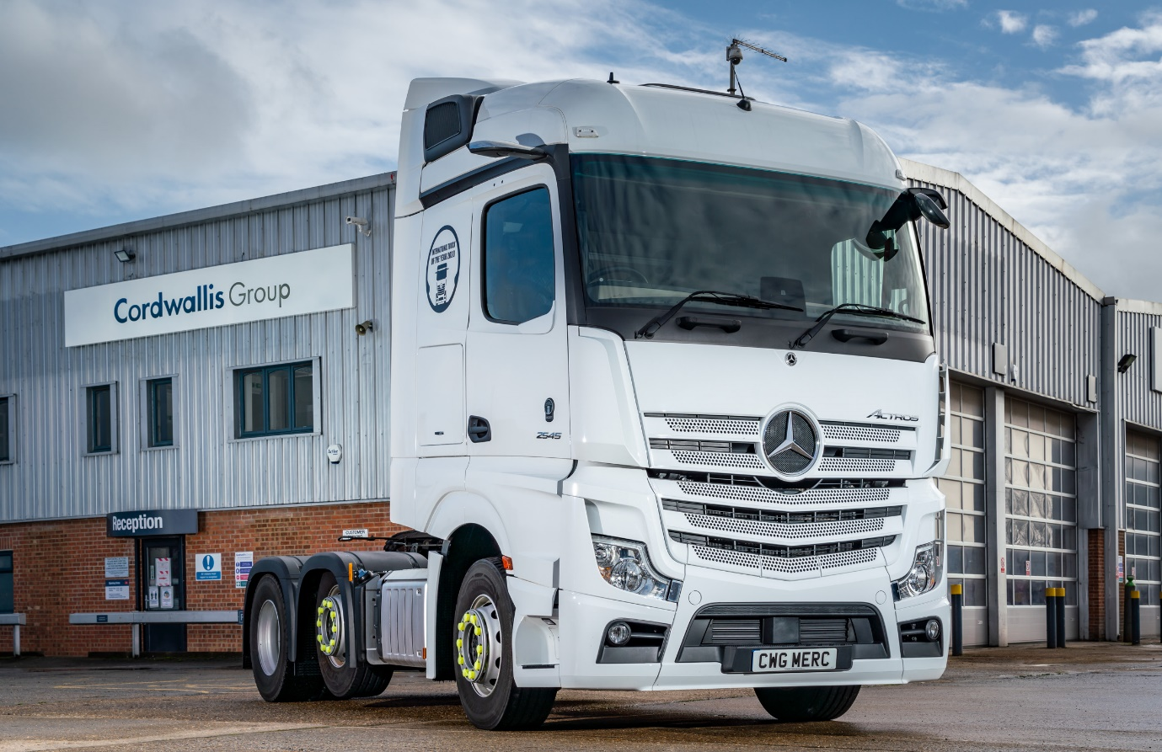

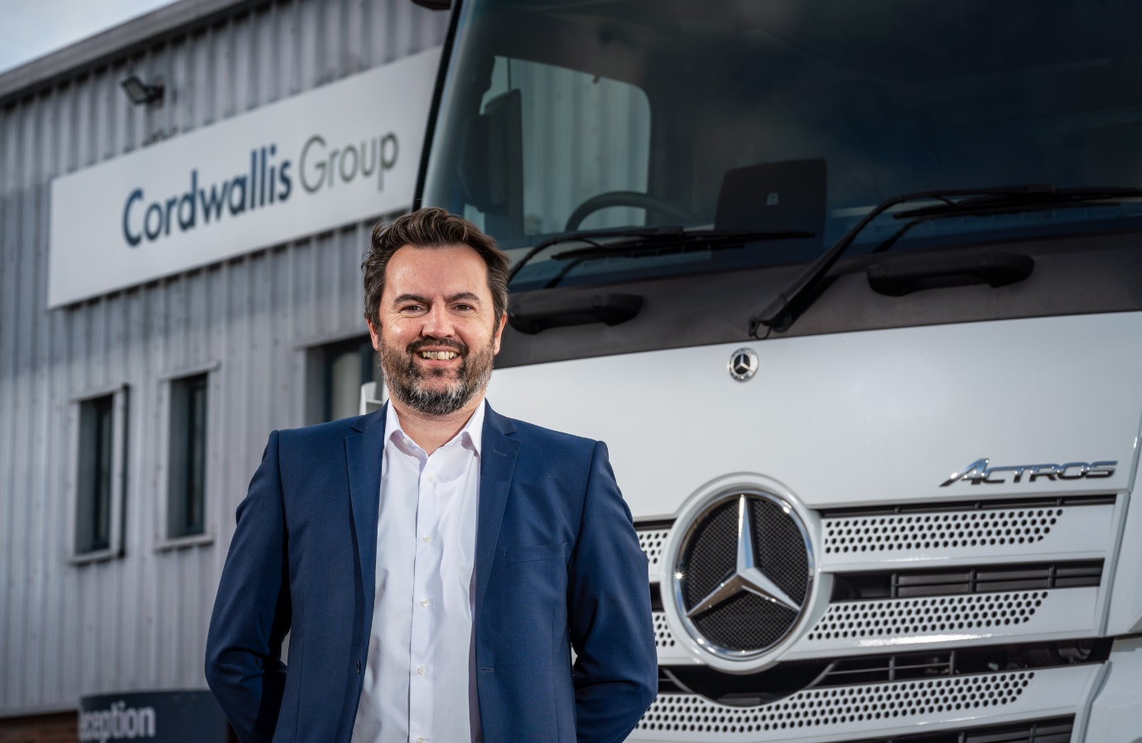

Front-runner: Cordwallis Managing Director Rob Zubovic leads a business that’s built on “customer centricity”

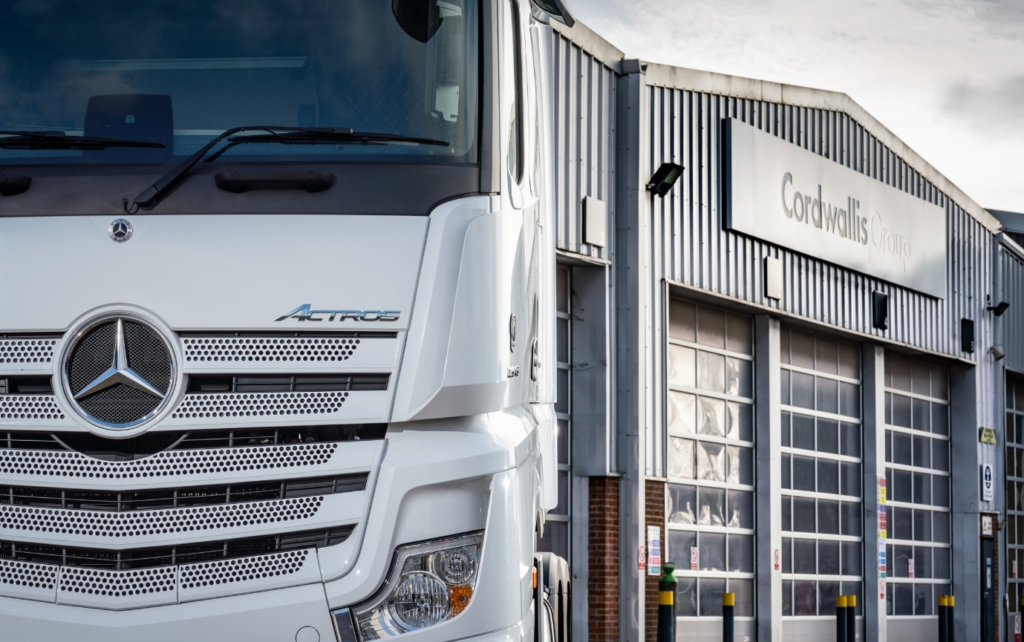

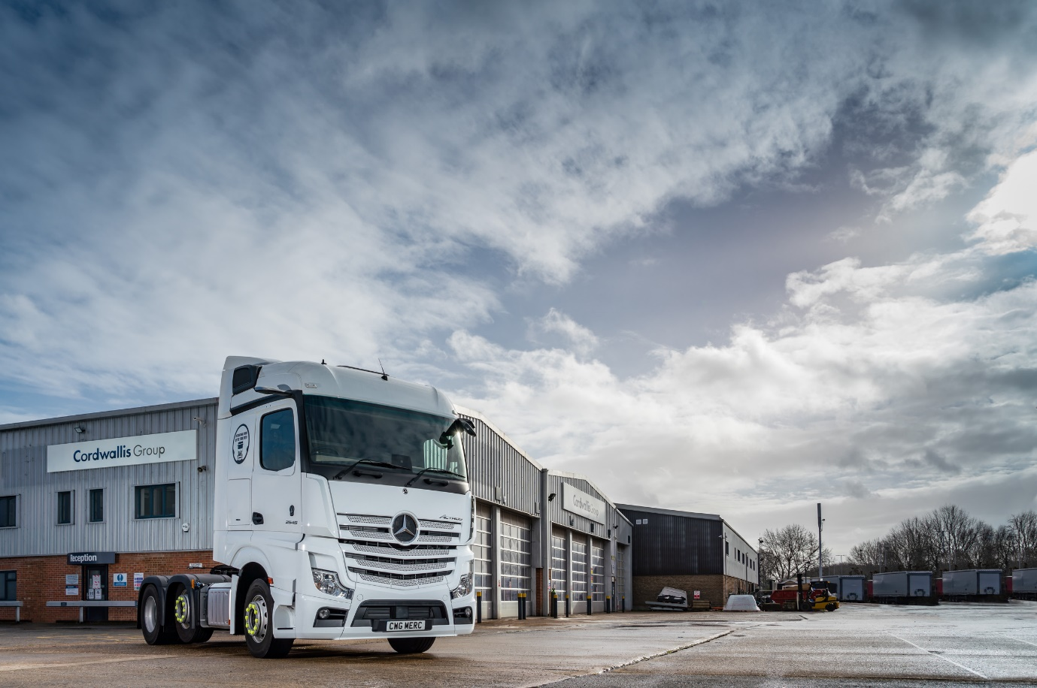

Room and a view: The Cordwallis site at Reading offers ample space for trucks to manoeuvre and park

For more information, or to request higher-res image files, please contact:

Jamie Fretwell at Mercedes-Benz Trucks UK Ltd
07712 519230, jamie.fretwell@daimler.com

or

Steve Warren or John Ripley
Impact Communications, 01926 842126
Steve: 07770 470251, steve@impactcom.co.uk
John: 07771 484595, john@impactcom.co.uk

About Mercedes-Benz Trucks UK Ltd
Mercedes-Benz Trucks UK Ltd is the sales and marketing organisation responsible for all Daimler truck products in the UK, including FUSO Canter. In 2019, the company registered 6,963 new trucks. Mercedes-Benz accounted for 6,188 new trucks registered in 2019, making it the third-biggest truck brand in the UK. Meanwhile, FUSO registrations hit 775 – including 580 new trucks over 6.0-tonnes. The flagship new Mercedes-Benz Actros which won the 2020 International Truck of the Year award, features seven core innovations including MirrorCam, Multimedia Cockpit and Active Brake Assist 5. Our premium range of innovative trucks – Actros, Arocs, Atego, Econic and Unimog – draw upon more than 125 years of exceptionally high standards of quality, backed up by our promise of Trucks You Can Trust.
www.mbtrucks.co.uk

