

Date: 12 February 2021

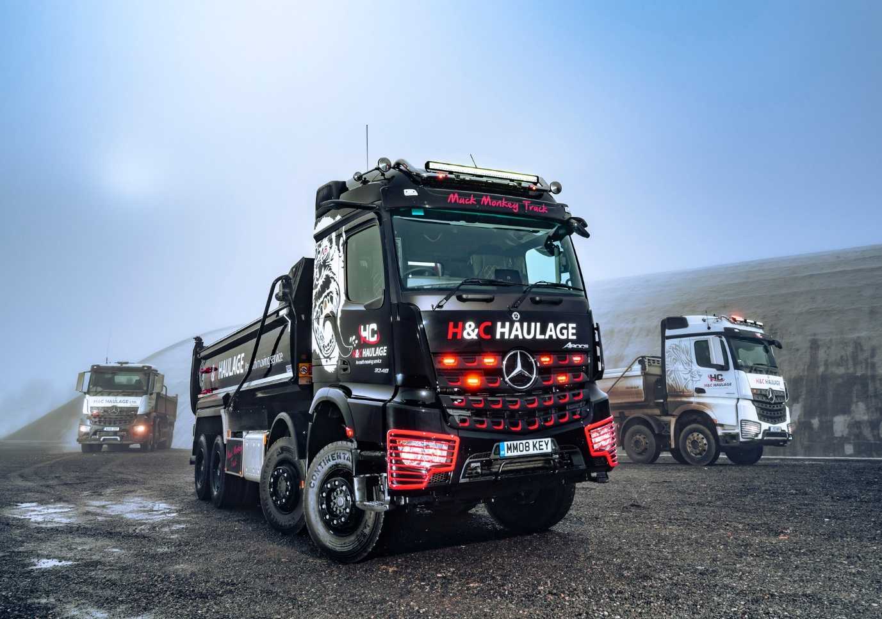

H&C Haulage goes bananas for its Mercedes-Benz ‘Muck Monkey’ and Rygor’s back-up

Family matters for Mercedes-Benz fan Jason Ward. He took the initials of daughters Holly and Carly when naming his business H&C Haulage, and in its 20th anniversary year he has just treated son-in-law Rhys to his dream truck.

A real head-turner, the 8x4 Arocs was supplied to the Swindon-based aggregates and muckaway specialist by local Dealer Rygor Commercials and is the subject of a
Mercedes-Benz Complete Service Contract.

It is now working alongside the company’s two other eight-wheelers, both of which are also tippers and from the same muscular model range. The established vehicles are in white, but the new Arocs wears an eye-catching black scheme – including wheel hubs and chassis, which were painted at the Mercedes-Benz factory – with red highlights in its distinctive grille.

Other enhancements to the truck’s appearance include a roof-mounted light bar and air horns, and red headlamp covers, while the sun visor bears the name that Jason and Rhys coined: Muck Monkey Truck. Picking up on this theme, Millard Signs & Graphics, of nearby Corsham, applied stylised artwork depicting an angry ape, behind both doors of the aerodynamic StreamSpace sleeper cab.

Mercedes-Benz Trucks’ ground-breaking MirrorCam system enhances safety – not only does Rhys benefit from greatly improved rear visibility, with reversing guides displayed on the screens inside the cab on the A-pillars, but the absence of conventional mirror housings also eliminates forward-facing blind spots.

The upgraded Multimedia Cockpit, interactive version of the manufacturer’s stylish and intuitive twin-screen dashboard incorporates a larger, 12in instrument panel and offers additional functionality. Leather upholstery, a fridge and a night heater also add to the truck’s driver appeal.

As a 3248 model, the Arocs is powered by a 12.8-litre ‘straight-six’ that produces 350 kW (476 hp) and drives through a smooth and efficient 12-speed Mercedes PowerShift automated manual transmission with Manoeuvring, Rocking and EcoRoll modes. Its steel Predator body is by Abba Commercials, of St Helens, and will carry a 19-tonne payload.

Driver Rhys Ford is married to Carly, who also works for the family concern. Rhys was quickly won over by the pioneering technology in his new Mercedes-Benz. “The dash is brilliant,” he declared. “It looks great, and very modern without all the usual knobs and switches.

“The screens are easy to navigate; I love the fact that one has ‘touch’ functionality, as it’s just like having a tablet at your fingertips. Plus, of course, the settings are digital, so you can be more precise with things like the cab temperature.”

On MirrorCam, he admitted: “I’d wondered before my new truck arrived why the manufacturer had decided to ‘fix’ something that wasn’t broken. It took only a very short time at the wheel, however, for me to really appreciate how much better the cameras are compared to traditional mirrors.

“You can see a lot more of what’s going on behind you and I like the wide-angle lens, which offers a different view. Also, of course, and there are no mirrors to hide a car at the entrance to a roundabout, for example.”

Rhys added: “I understand that some drivers may be resistant to change. But I’m 29, and for professionals of my generation this is definitely the way forward.”

H&C Haulage undertakes the bulk of its work for one of the largest independent earthmoving, recycling and quarrying companies in the south of England, and has remained busy throughout the pandemic. Their decision to invest in an additional truck reflects the optimistic outlook of Jason Ward and his wife and co-Director Janette.

“We’ve been running six- and eight-wheeled Mercedes-Benz trucks since we started out two decades ago,” Jason recalled. “It was only in 2016 that we switched to tippers, though; prior to that they were all concrete mixers.

“The Arocs is a great truck and we’re particularly pleased with the new one. I’m a bit ‘old school’ but I drove one of Rygor’s demonstrators with MirrorCam and really liked the system. The greatly improved visibility it offers must contribute to increased safety.

“The biggest single factor that keeps us loyal to Mercedes-Benz, though, is the service we receive from Rygor Commercials. We ordered the new truck from its Sales Executive Marcus Cahalin, who had it all worked out from start to finish. He kept us posted on progress every week while the truck was in build, and he also recommended the firm that applied the livery, whose work was ‘spot on’.

“As for aftersales support, we’ve never had a truck off the road for any length of time, which speaks volumes for the professionalism of the Service team at Rygor’s Swindon branch. They stand by their commitments and if ever we have an issue, they’re on it straight away, shifting things around as necessary to keep us up and running. You can’t put a price on customer-focused back-up like that.”

Marcus Cahalin commented: “We’ll do whatever it takes at Rygor to provide operators with trucks that meet their precise requirements. It’s not often, though, that we get the opportunity to deliver a vehicle as highly specified and personalised as H&C Haulage’s latest Arocs. Doing so was a real buzz, and I know my workshop colleagues now look forward to ensuring that it continues to perform at peak efficiency.”

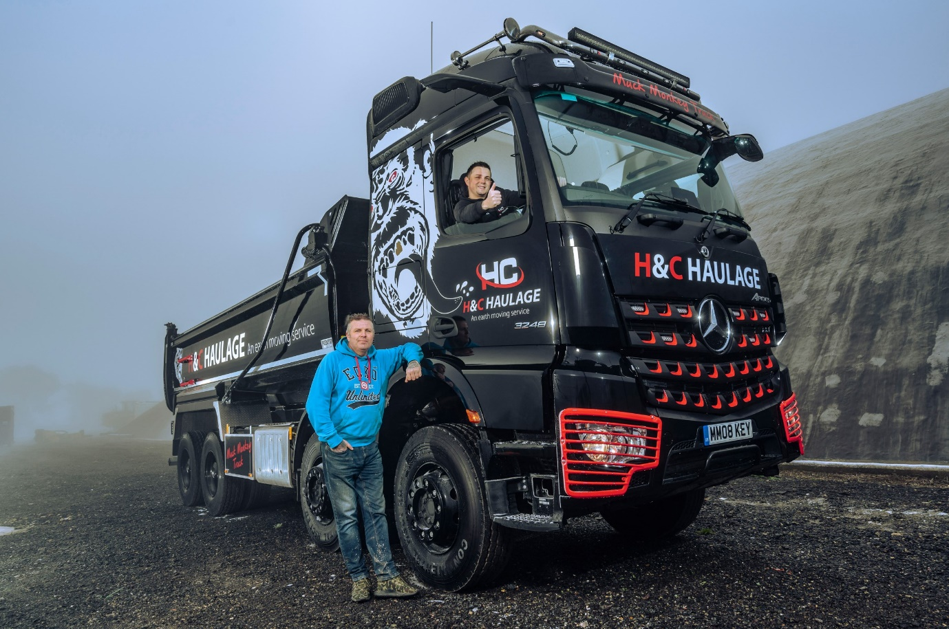

Black magic: Jason Ward and his son-in-law Rhys Ford, with their eye-catching Arocs

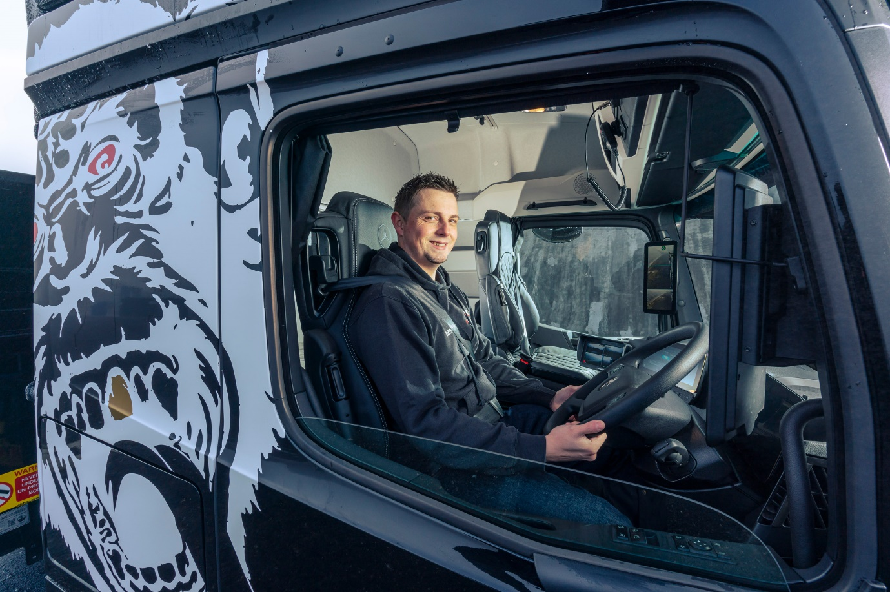

Wheel appeal: Rhys Ford loves his new truck’s Multimedia Cockpit, interactive

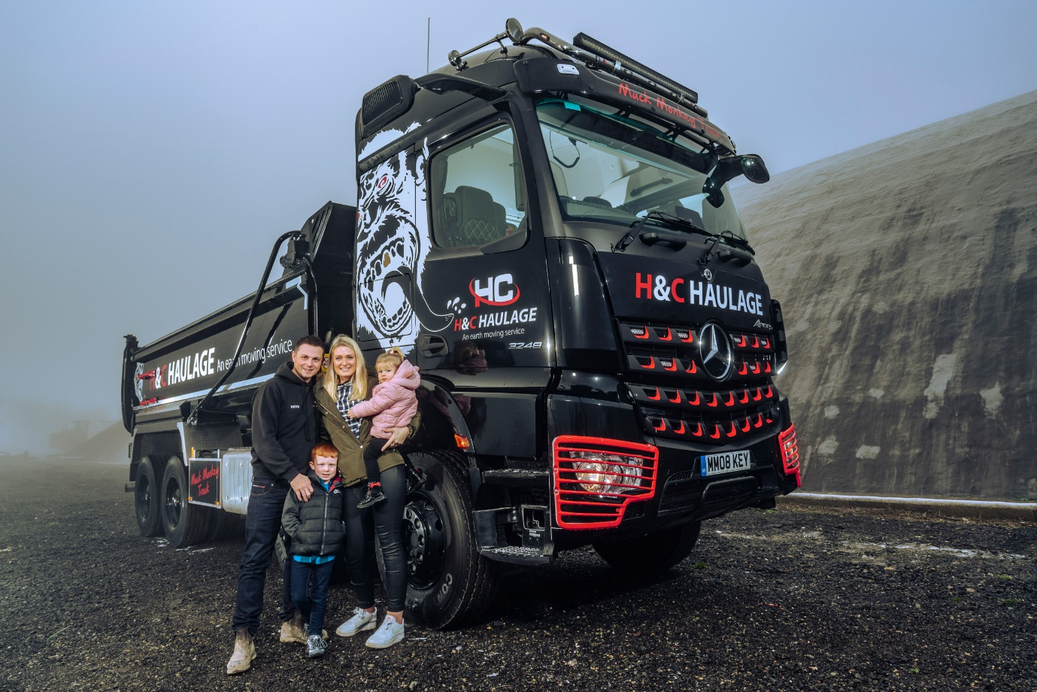

Keeping it in the family: Rhys and Carly Ford, with their children Lewis, aged five, and Evie, two

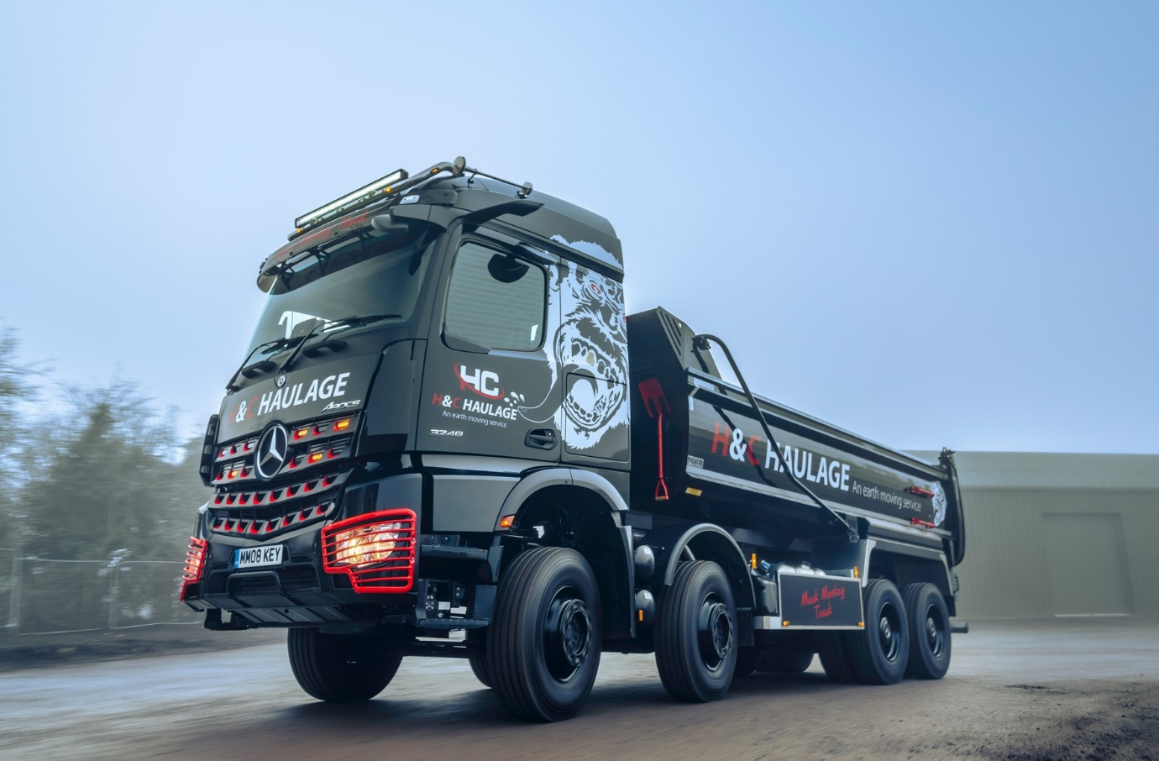

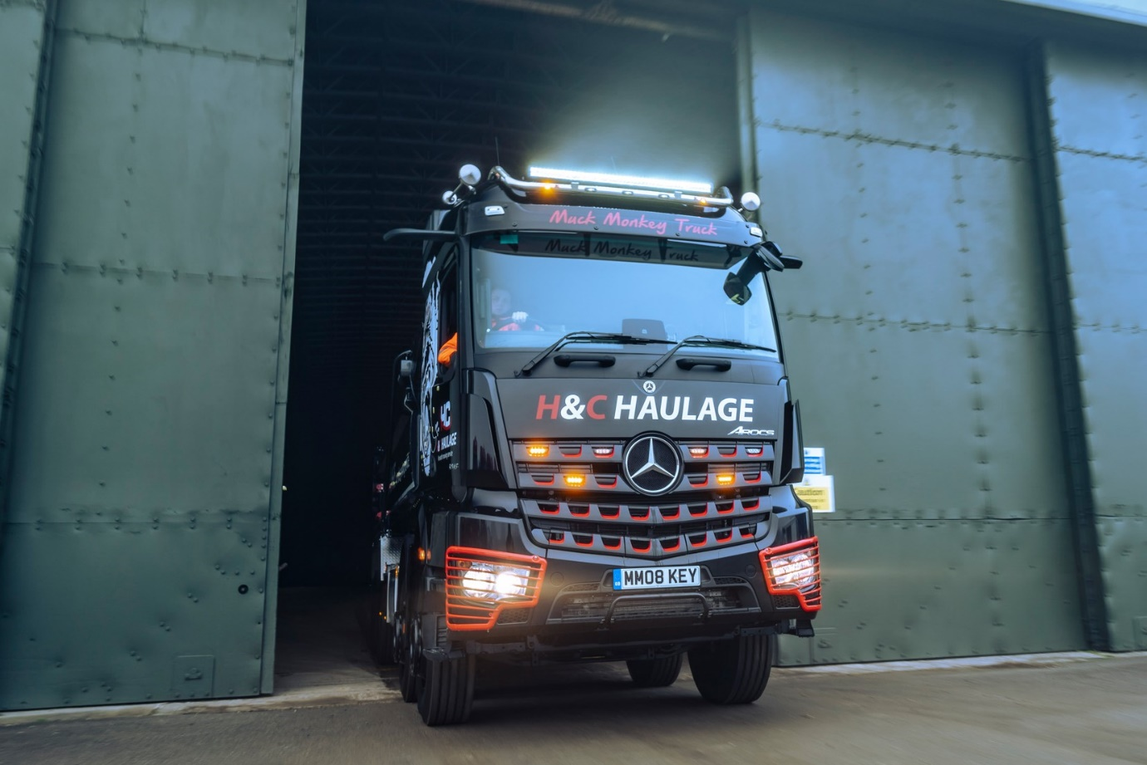

ends

For more information, or to request bigger/higher-res image files, please contact:
Steve Warren or John Ripley
Impact Communications, 01926 842126
Steve: 07770 470251, steve@impactcom.co.uk
John: 07771 484595, john@impactcom.co.uk

Notes to Editors: Rygor Commercials

Award-winning Mercedes-Benz Commercial Vehicle Dealer group, Rygor Commercials, has branches in Berkshire, Gloucestershire, Oxfordshire, Somerset, West London, Warwickshire, Wiltshire, and Worcestershire, offering extensive coverage for customers throughout the M5, M4 and M42 corridors.

The Rygor business has developed and gone from strength to strength in recent years, investing in extensive renovations of its sites across the country as well as a brand-new, dedicated Heathrow Truck Centre which opened in 2020. With six industry and network awards under its belt in the past 24 months, Rygor continues to be dedicated to providing exceptional customer service, which Sets Standards. The Dealer was delighted to be announced as winner in the ‘Franchised Dealer of the Year’ category at the 2019 Commercial Motor Awards and ‘Van Dealer of The Year 2021’ at the What Van? Awards, accolades which not only demonstrate the company’s focus on customer satisfaction, but also its commitment to the development, training, and wellbeing of its team members.

With a proven track record, Rygor is proud to be selling, maintaining and supporting the most prestigious name in commercial vehicles.

For more information, in the first instance please contact Kate Ruberry-Shoemack, Head of People and Communications at Rygor – kateruberry-shoemack@rygor.co.uk, or in her absence, Communications Assistant, Talitha Scott – talithascott@rygor.co.uk.

