

Date: 22 July 2021

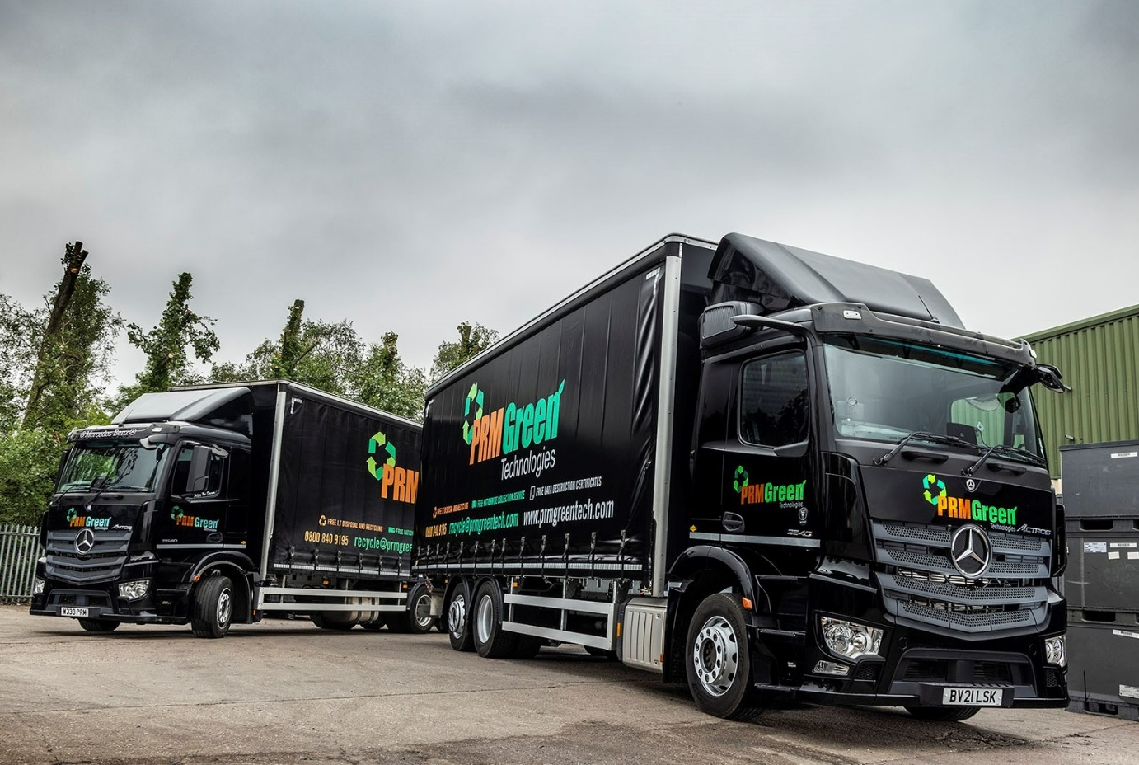

PRM Green Technologies gets the Mercedes-Benz low-down once again from Midlands Truck & Van

Mercedes-Benz Trucks’ ability to supply a 26-tonne chassis with the low frame height that allows customers to maximise load volumes meant that when it needed a second truck to stay ahead of growing customer demand, PRM Green Technologies had no hesitation in choosing another eye-catching Actros.

The company, which operates from headquarters in Cannock, Staffordshire, provides specialised IT equipment recycling and secure data destruction services for customers from across the commercial and public sectors.

Like its three-year-old predecessor, the new vehicle was supplied by Dealer Midlands Truck & Van. Once again, the operator chose a 2540 LnR model with ClassicSpace L-cab, 10.7-litre in-line six-cylinder engine producing 290 kW (394 hp), and single-tyred trailing axle.

And as before, the curtainside body is by Fred Smith & Sons, of West Bromwich, while the six-wheeler is finished in PRM Green Technologies’ striking livery, its black paintwork – which extends to the colour-coded bumper – having been applied at the Mercedes-Benz factory.

Unlike its established stablemate, however, the new truck is from the fifth-generation Actros range introduced to the UK market in the autumn of 2019. As a result, the most casual of observers would notice the absence of conventional mirrors. Instead, the truck is equipped with MirrorCam, the revolutionary camera-based system that offers much improved rear visibility while also eliminating the forward-facing blind spots caused by mirror housings.

PRM Green Technologies adheres to the WEEE Directive governing the disposal of ‘Waste Electrical & Electronic Equipment’ and takes pride in its industry-leading environmental practices, as well as the strict security procedures that protect data confidentiality.

The company relies on a fleet of vans and 7.5-tonne trucks to collect redundant IT equipment from customer premises and return it either to Cannock, or to one of its three outbases, in Alton, Hampshire, Carlisle and Taunton.

A third-party carrier was previously responsible for transporting consignments from those outbases to its headquarters for processing. However, the company acquired its first Actros when the financial case for taking this function in-house became compelling. Continued growth has now prompted the investment in a second truck.

The new Actros has an overall height of 4.2m but thanks to its low frame a loading aperture that is just under 2.75m high. As a result, it is able to carry no fewer than 60 of the Euro containers used by PRM Green Technologies. Stacked in three decks, each container is 800mm-high and has a volume capacity of more than 500 litres.

Tim Hawkins, who founded PRM Green Technologies with his co-Director Paul Mullett in 2009, recalled: “When we started out on this road three years ago we invited quotations from all of the major manufacturers.

“Midlands Truck & Van’s was the best response. It was able to offer the low-height chassis that gave us the headroom we needed, while the finance rates were also very attractive. We thought Mercedes-Benz would be the most expensive, but because the residual value on the vehicle was so high the opposite was true.”

PRM Green Technologies’ Actros drivers also have occasional nights away in their trucks, so the fact that the ClassicSpace L-cab comes with a fold-down bed is another advantage. “It means we don’t have to go for the full-size sleeper that would encroach on our all-important volume carrying capacity,” explained Mr Hawkins.

“The aftersales back-up from Midlands Truck & Van is very good too,” he continued. “The Dealer’s Wolverhampton workshop team look after us very well, and we’ve never had an issue when it comes to getting a truck in.”

The subject of a Mercedes-Benz Finance contract hire agreement, the new Actros has won a resounding ‘thumbs up’ from Alex Melbourne, who splits his time between driving and working in the office as PRM Green Technologies’ Fleet Manager.

“Our first Mercedes-Benz is still a very nice drive but this new model is something else altogether,” he enthused. “It feels more like a luxury S-Class car than a truck, and I really look forward to taking it out.

“I quickly got the hang of MirrorCam and once you’ve done so it’s fantastic. I can see pretty much everything as I’m approaching an island now, because there’s no mirror blocking my view.”

The truck’s radical Multimedia Cockpit replaces traditional switchgear with stylish and intuitive twin screens, and is also a hit. PRM Green Technologies chose the upgraded interactive version, which comes with a larger, 12in instrument panel and extra functionality, including satellite navigation.

“I love the technology on this vehicle, and the fact that you can personalise all of the settings,” added Alex Melbourne. “It helps to make the job a lot less stressful, which is exactly what a driver needs.”

prmgreentech.com

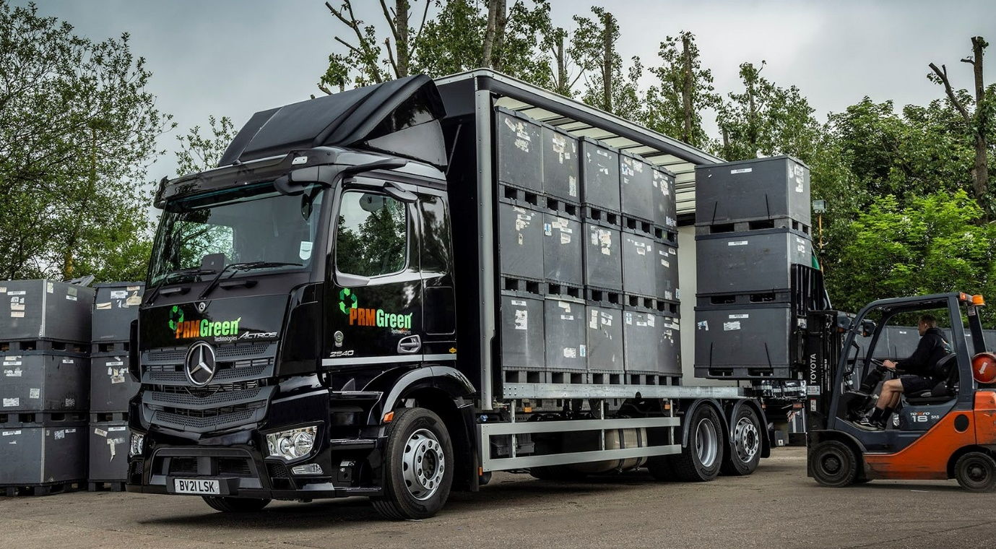

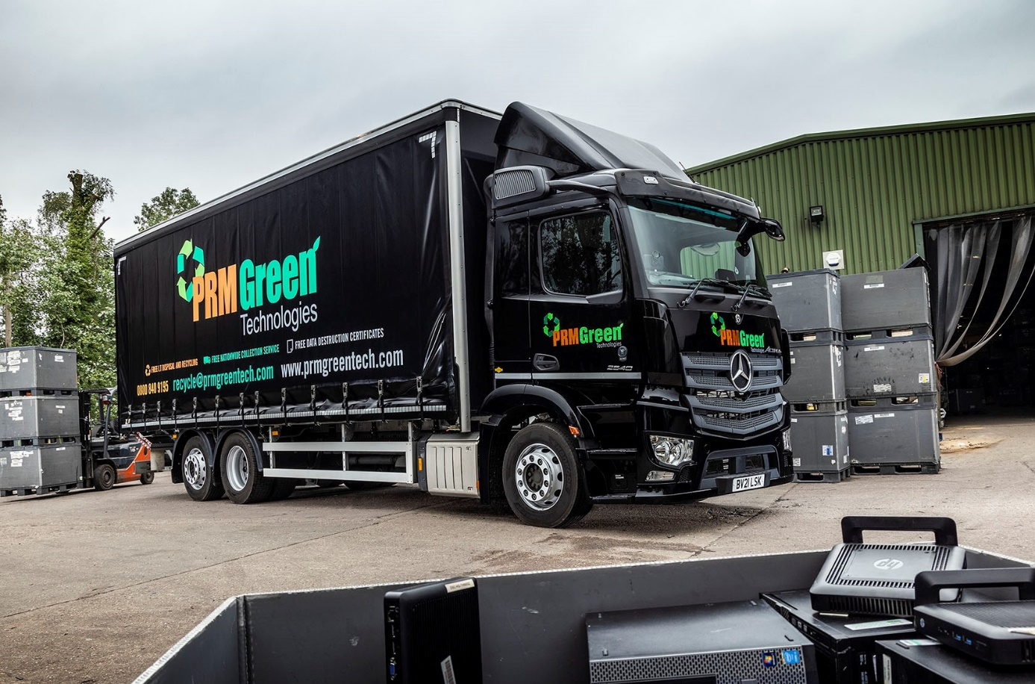

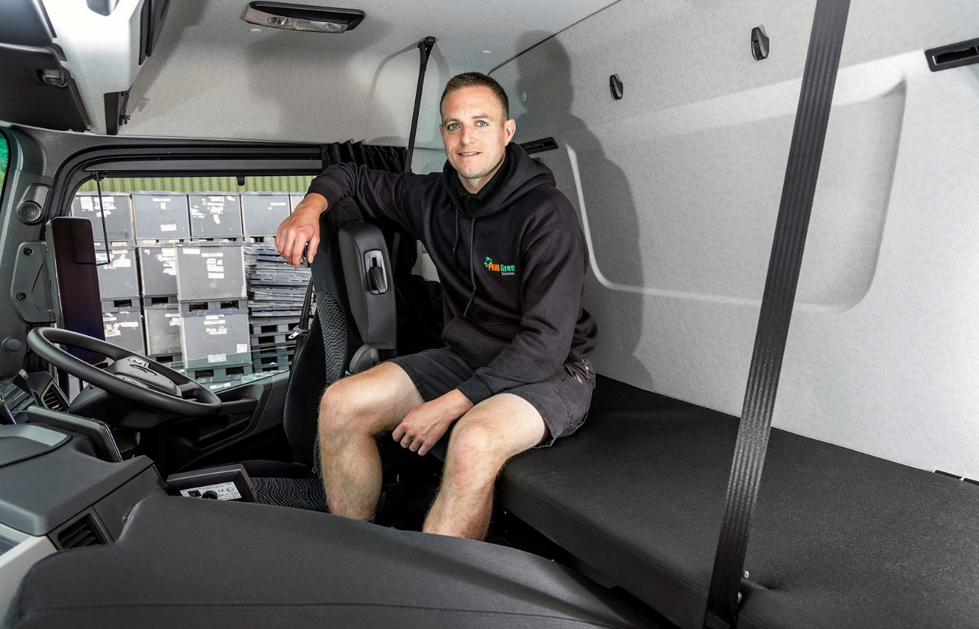

Big is not always best: PRM Green Technologies’ Alex Melbourne on the fold-down bed which is ideal for occasional nights out and does not impinge on his truck’s carrying capacity

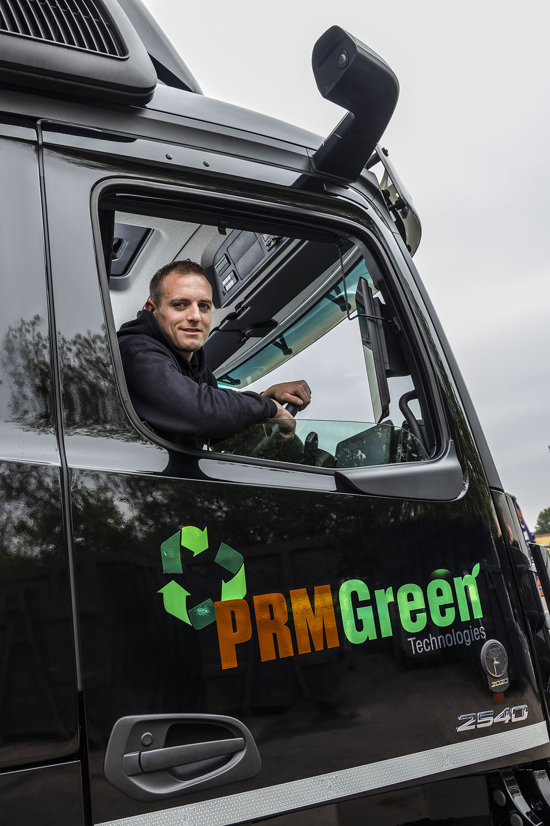

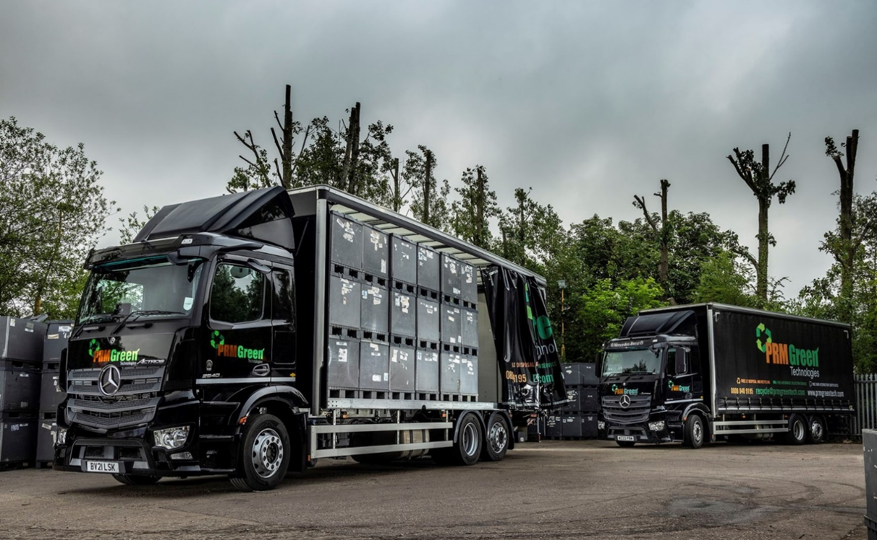

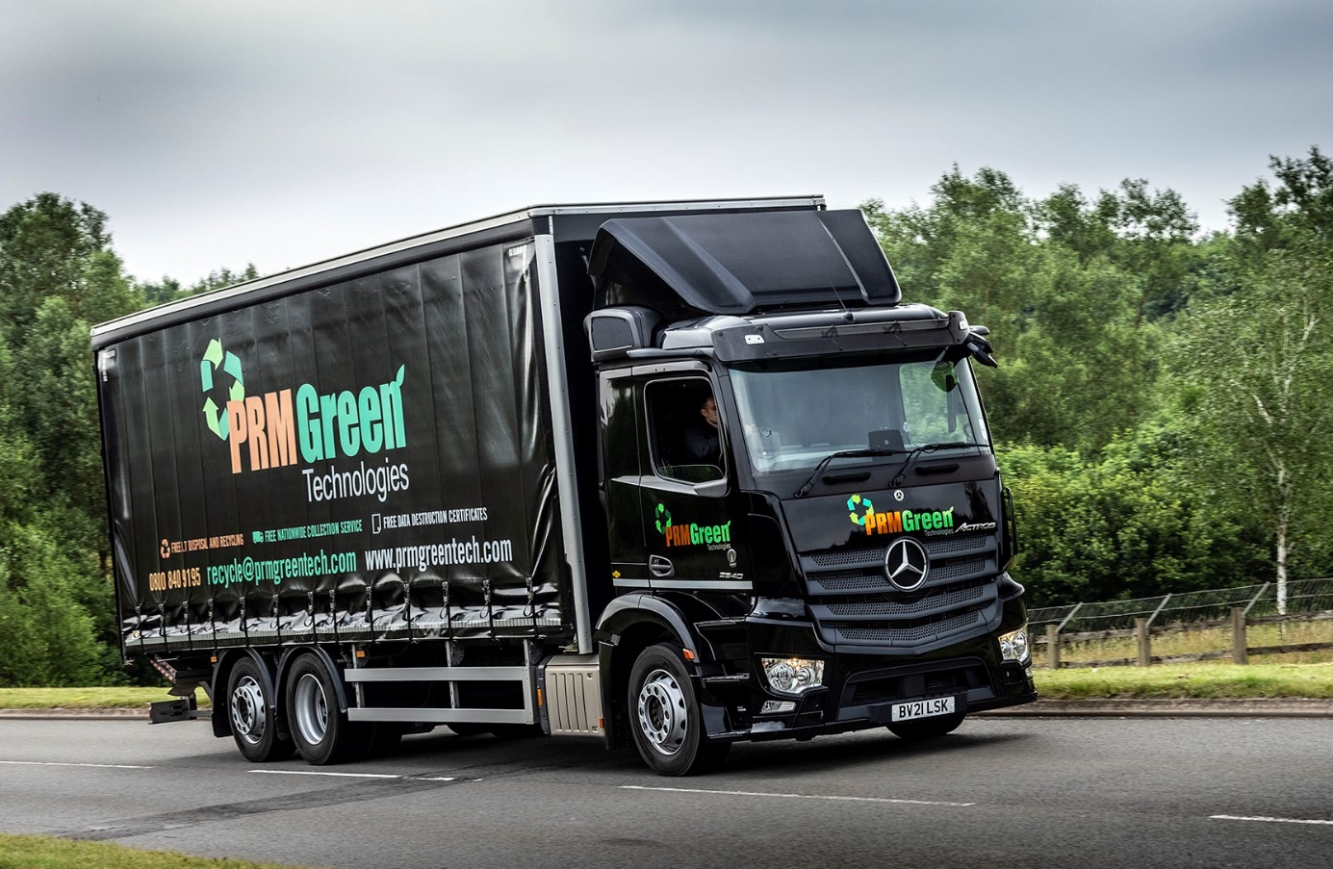

ends

For more information, or to request bigger/higher-res image files, please contact:
Steve Warren or John Ripley
Impact Communications, 01926 842126
Steve: 07770 470251, steve@impactcom.co.uk
John: 07771 484595, john@impactcom.co.uk



