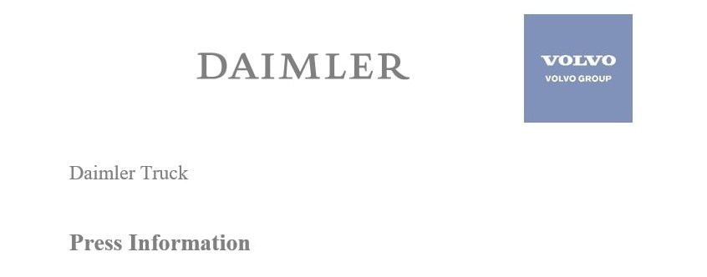

Date: 29 April 2021

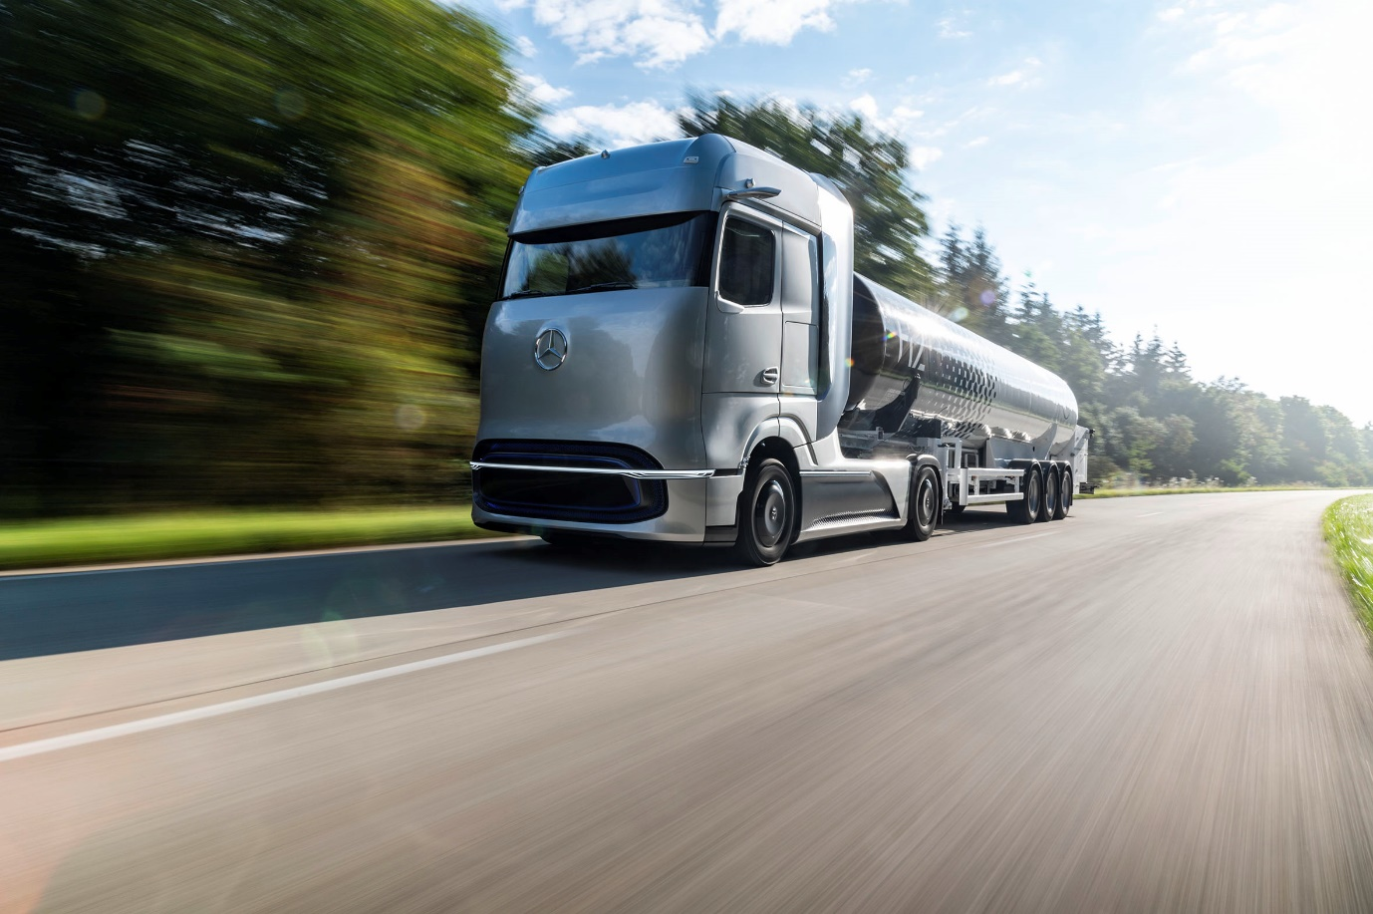

Glimpse of the future: The fuel-cell-powered Mercedes-Benz GenH2 Truck long-haul vehicle concept – series production is planned for the second half of the decade

Daimler Truck AG and Volvo Group fully committed to hydrogen-based fuel-cells – launch of new joint venture cellcentric

Stuttgart, Germany / Gothenburg, Sweden – Today, two leaders of the commercial vehicle industry – Daimler Truck AG and Volvo Group – officially outlined their pioneering roadmap for the new fuel-cell joint venture cellcentric, as part of an industry-first commitment to accelerate the use of hydrogen-based fuel cells for long-haul trucks and beyond. With the ambition of becoming a leading global manufacturer of fuel-cell systems, cellcentric will build one of Europe’s largest planned series production of fuel-cell systems, with operation planned to commence in 2025. To accelerate the rollout of hydrogen-based fuel-cells, the two cellcentric shareholders call for a harmonized EU hydrogen policy framework to support the technology in becoming a viable commercial solution.

These ambitions were revealed as part of an exclusive digital launch today, led by Martin Daum, CEO of Daimler Truck AG, and Martin Lundstedt, CEO of Volvo Group. Designed to help meet the 2050 targets of sustainable transport and a carbon-neutral Europe as part of the European Green Deal, cellcentric will develop, produce and commercialize fuel-cell systems for both long-haul trucking and other applications. The joint venture can draw on decades of expertise and development work from both Daimler Truck AG and Volvo Group.

According to Daimler Truck AG and Volvo Group, purely battery-electric and hydrogen-based fuel-cell trucks will complement each other depending on the individual customer use case. Battery power will be rather used for lower cargo weights and for shorter distances, while fuel-cell power will tend to be the preferred option for heavier loads and longer distances.

Martin Daum, Chairman of the Board of Management of Daimler Truck AG and Member of the Board of Management of Daimler AG, says: “Hydrogen-powered fuel-cell electric trucks will be key for enabling CO₂-neutral transportation in the future. In combination with pure battery-electric drives, it enables us to offer our customers the best genuinely locally CO₂-neutral vehicle options, depending on the application. Battery-electric trucks alone will not make this possible. Together with our partner Volvo Group, we are therefore fully committed to our fuel-cell joint venture cellcentric and we are both pushing forward the development of the technology as well as the series production preparations. Regarding the necessary hydrogen infrastructure, it is clear that green hydrogen is the only sensible way forward in the long term.”

Martin Lundstedt, CEO of Volvo Group, says: “Our united ambition is to meet the targets in the Paris agreement of becoming CO₂-neutral by 2050 at the latest. We are convinced that hydrogen fuel-cell technology plays an essential role in helping us reach that milestone. But we know there is so much more to achieve than just the electrification of machines and vehicles. There needs to be greater cooperation between public and private stakeholders to develop the necessary technology and infrastructure, which is why we are calling for united action from policymakers and governments around the world in helping us make hydrogen fuel-cell technology a success. Partnerships like cellcentric are vital to our commitment to decarbonizing road transport.”

The major truck manufacturers in Europe, also backed by Daimler Truck AG and Volvo Group, are therefore calling for the setup of around 300 high-performance hydrogen refuelling stations suitable for heavy-duty vehicles by 2025 and of around 1,000 hydrogen refuelling stations no later than 2030 in Europe. This joint initiative, using hydrogen as a carrier of green electricity to power electric trucks in long-haul operations, is one important part of decarbonizing road transport.

As CO₂-neutral trucks are currently significantly more expensive than conventional vehicles, a policy framework is needed to ensure demand and affordability. According to Daimler Truck AG and Volvo Group, this should include incentives for CO2-neutral technologies and a taxation system based on carbon and energy content. An emissions trading system could be an additional option.

Clear roadmap towards series production of fuel-cell systems and fuel-cell trucks

Currently, cellcentric is conceptualizing the plans for its large-scale series production. More details and a decision on the location will be revealed over the course of 2022. As a significant step towards series production, preparations for pre-series production are taking place at a new site in Esslingen near Stuttgart. In parallel, cellcentric is scaling up on-going prototype output.

Daimler Truck AG’s and Volvo Group’s goal is to start with customer tests of fuel-cell trucks in about three years and to be in series production of fuel-cell trucks during the second half of this decade. All vehicle-related activities are carried out independently from each other, as both companies remain competitors in all vehicle and product ranges, and particularly in fuel-cell integration solutions for all products.

Joint venture for fuel-cell systems

On 1 March 2021, Daimler Truck AG and Volvo Group formed cellcentric. To that end, Volvo Group acquired 50 percent of the partnership interests in the existing Daimler Truck Fuel Cell GmbH & Co. KG for approximately EUR 0.6 billion on a cash and debt-free basis. In November 2020, Daimler Truck AG and Volvo Group signed a binding agreement for the joint venture. A preliminary non-binding agreement had already been signed in April of the same year.

More than 300 highly specialized experts work for cellcentric in inter-disciplinary teams at locations in Nabern, Stuttgart (Germany) and Burnaby (Canada). Around 700 individual patents have been issued so far, underlining the leading role played by the company when it comes to technological development.

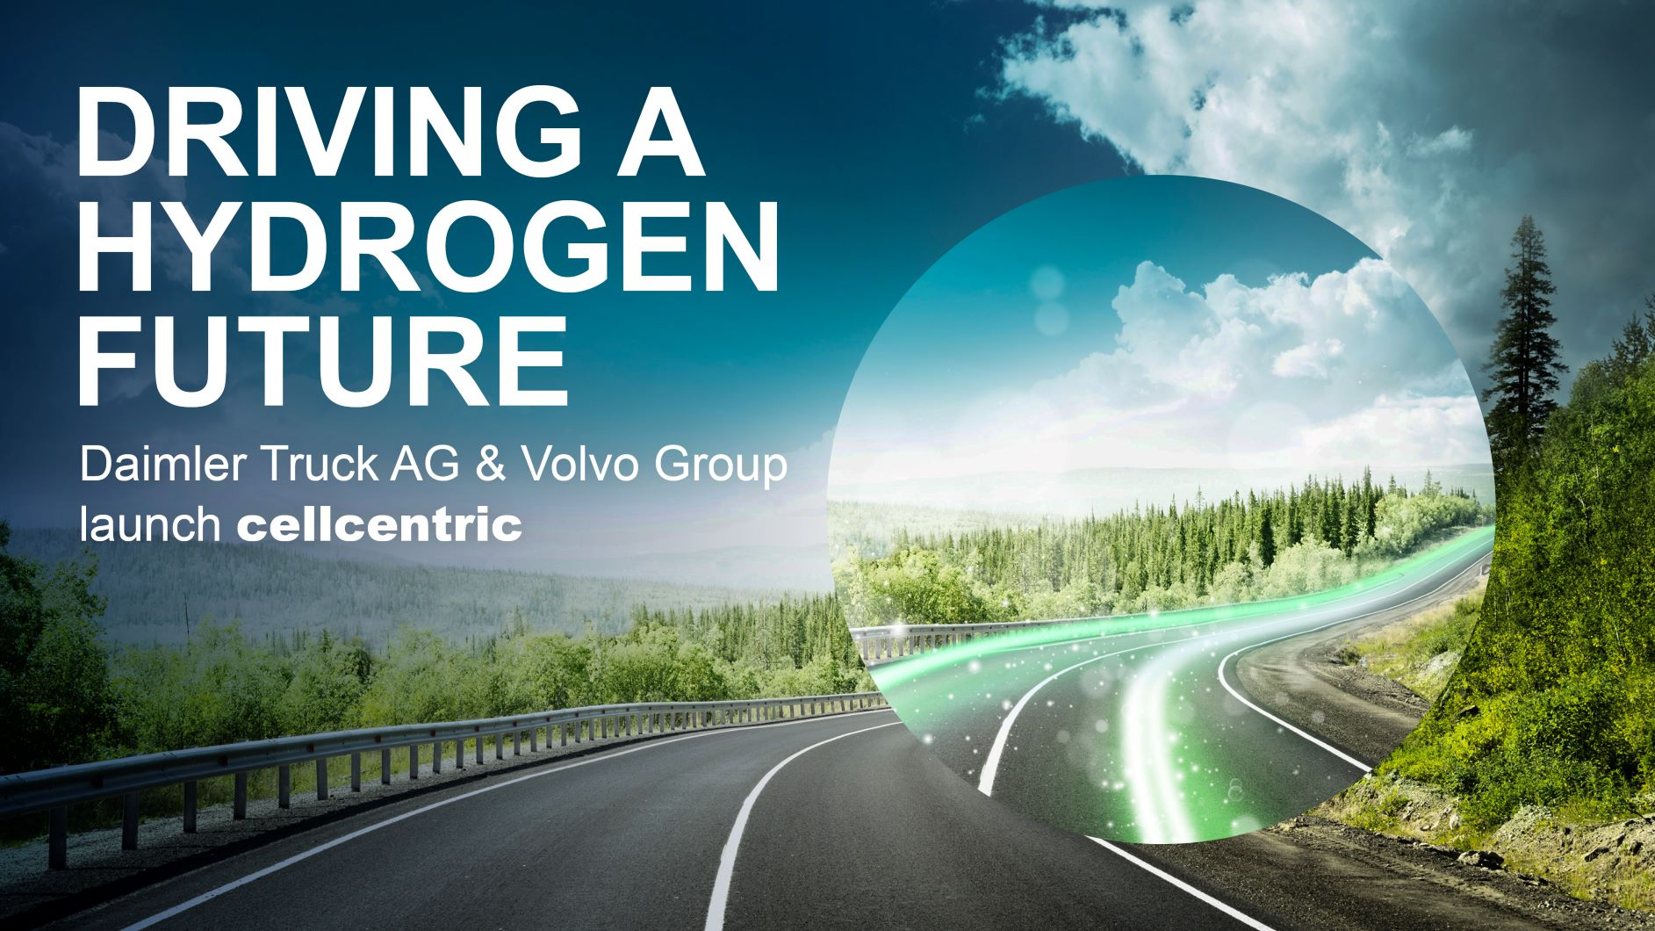



Ambitious for fuel-cell leadership: Martin Daum, of Daimler AG, left, and Volvo Group’s Martin Lundstedt

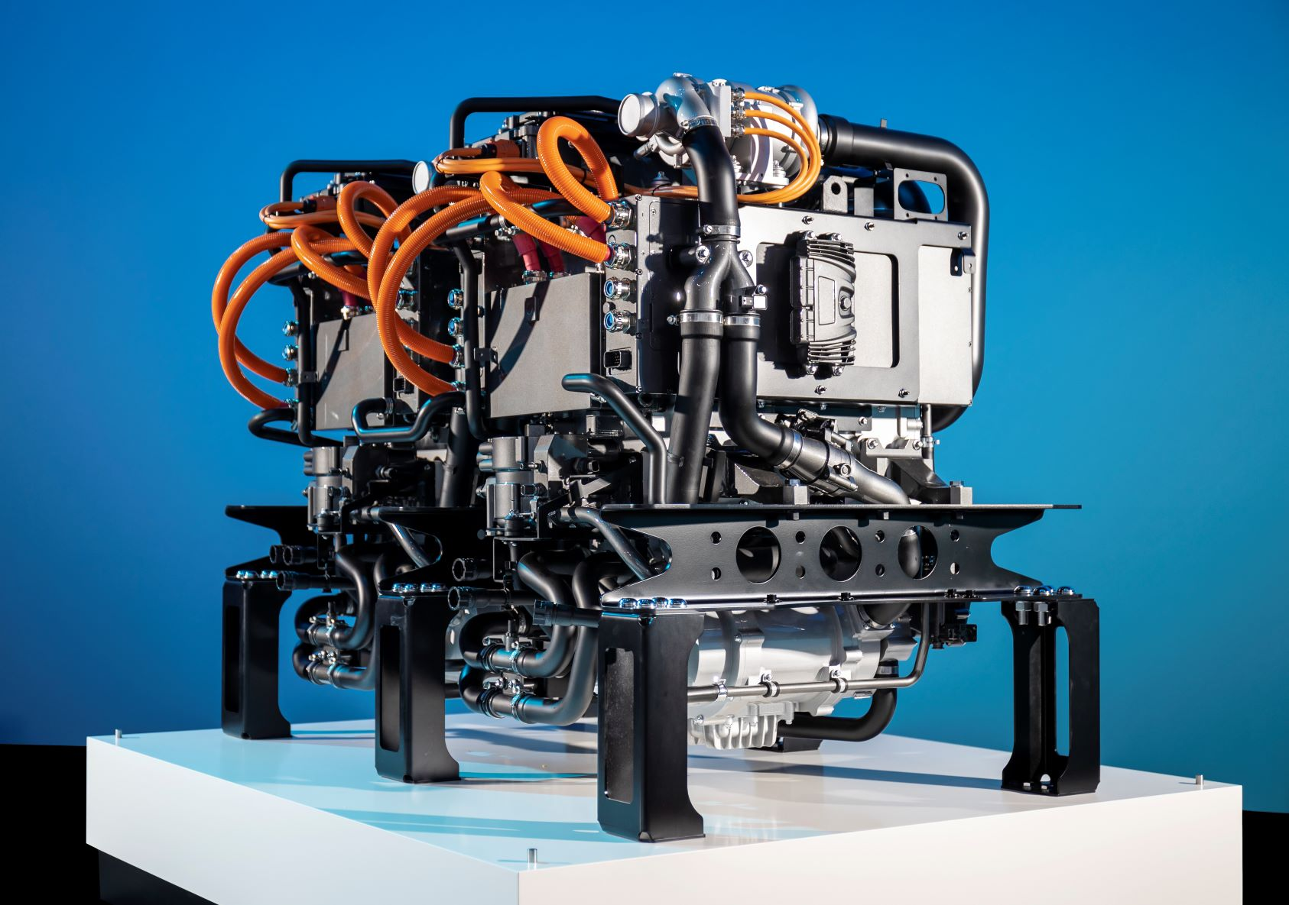

Harnessing hydrogen: The Mercedes-Benz GenH2 concept’s fuel-cell powerplant

Contact:
Peter Smodej, +49 176 30936446, peter.smodej@daimler.com
Florian Laudan, +49 176 30930878, florian.laudan@daimler.com
Claes Eliasson, Volvo Group, +46 76 553 72 29, claes.eliasson@volvo.com
Kim Jana Eisfeld, cellcentric, +49 176 30963783, kim.eisfeld@cellcentric.net
Further information from Daimler Truck is available at:
www.media.daimler.com and www.daimler-truck.com

Daimler Truck AG
The Daimler Truck AG is one of the world's largest commercial vehicle manufacturers, with more than 35 primary locations around the world and approximately 100,000 employees. The company brings together seven vehicle brands under one roof: Mercedes-Benz (light, medium and heavy trucks as well as city, intercity and touring coaches) and Setra (intercity, long-distance and premium coaches) are our traditional European brands; our U.S. brands Freightliner Trucks (trucks in weight classes 5 to 8 for a wide range of commercial vehicle applications), Western Star (heavy trucks for specialized and long-haul transports) and Thomas Built Buses (light to medium-duty buses); and our Asian brands Bharat Benz, based in Chennai, India (trucks in the weight classes 10 to 55 t and medium and heavy-duty buses) and FUSO with its headquarters in Japan (trucks and buses for Asia, the Middle East, Africa, Europe and Latin America). This allows the Daimler Truck AG to offer its customers around the globe a broad spectrum of commercial vehicles, ranging from minibuses to heavy-duty trucks for special-purpose transport applications – in short: products and solutions for everyone who keeps the world moving. Gottlieb Daimler and Carl Benz laid the foundation for the modern transport industry 125 years ago. Over the past decades, Daimler's truck and bus divisions have consistently set standards for the entire transportation industry – in terms of safety, fuel efficiency and driver and passenger comfort. It is now time for the next evolutionary step: emission-free, automated and connected driving. Daimler Trucks & Buses is working to bring these important technologies to high-volume series production, across brands, divisions and regions. In this way the company intends to take a major step closer to realizing its vision of CO2-neutral transport and accident-free driving whilst also contributing to the sustainability of global goods and passenger transport. In 2020, a total of 378.500 trucks and buses were delivered. In 2020 the revenue of the individual areas of business amounted to € 35 billion for the Daimler Truck AG. The adjusted EBIT was € 678 million for the Daimler Truck AG.

