

Date: 11 April 2024

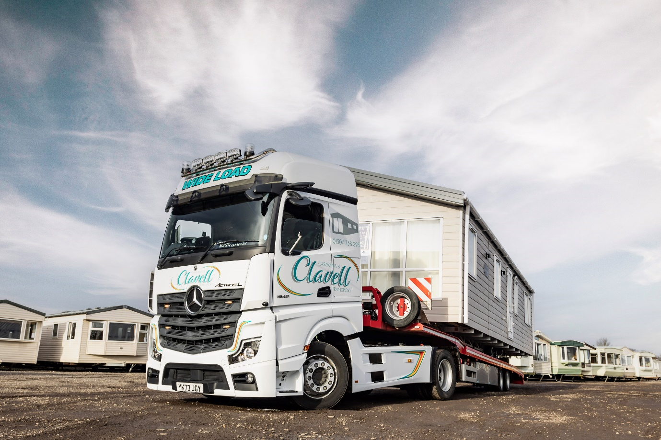

Mercedes-Benz Actros L brings proven performance with a touch of luxury to Clavell Caravans fleet

Clavell Caravans & Transport opted for proven Mercedes-Benz reliability and fuel economy when choosing its new fleet flagship – a premium Actros L tractor unit.

The new truck joins a second Actros in the Lincolnshire operator’s six-strong fleet. That vehicle, supplied in 2017, has proved to be highly efficient while racking up well over 500,000 trouble-free kilometres.

The older truck was a 4x2 1845 unit, with a 12.8-litre in-line six-cylinder engine that produces 330 kW (450 hp). The latest addition, though, is an 1848 variant with a 350 kW (476 hp) variant of the latest, third-generation OM 471 powerplant – which is engineered for even better driving dynamics and efficiency.

Both were supplied by Yorkshire and Lincolnshire Dealer Northside Truck & Van: the new truck with the benefits of a competitive funding package from Daimler Truck Financial Services, and a seven-year Service Contract.

“Ours is a specialised application and the nature of the work makes it difficult to compare one vehicle with another, but our older Actros has consistently been good on fuel,” said proprietor John Harneiss.

“Its long-term average is 8.9 mpg, which might not sound much but is very respectable in a role that can see it moving lodge buildings up to 15 ft wide along country roads, with frequent stopping and starting. It’s been reliable too, with no unscheduled downtime,”

“The new Actros L has a more powerful engine but if anything we expect it to be even more economical, as it won’t have to work so hard. The early signs are that it could be up to a full mile per gallon better, which is a very promising start.”

Clavell’s operation, based at Conishome, near Louth, is two-fold. The company buys and sells a range of static caravans, lodges and other prefabricated buildings; it also transports these, and other specialist loads including boats, plant and machinery, across the UK. Established by Mr Harneiss more than 20 years ago, the business is now run by a team including his son James, who started as a driver and now runs the traffic office.

The keys to the new truck, which is paired with a bespoke Martrans trailer by Hull-based Paneltex, have been handed to driver Jason Chapman, who is equally impressed with his new ride.

“The Actros L cab is certainly comfortable and clearly designed by someone who understands what life behind the wheel is like. It’s great to drive and very relaxing on a long journey,” he said.

The Actros L range sets new standards in the segments for long-distance haulage and heavy-duty distribution. In addition to a full complement of well-proven Mercedes-Benz technology, it comes with a host of new features that deliver further improvements in efficiency, safety and comfort.
Highlights include sophisticated aerodynamics, quieter cabs with improved heat insulation, and a lower, more comfortable seating position that also provides improved visibility.

The Actros L badge now applies to all four- and six-wheeled tractor units with single or double drive axles, and 18- and 26-tonne rigid chassis, that have flat-floored GigaSpace, BigSpace or Stream Space cabs in the wider (2.5m) of the two widths available.

The service from Northside Truck & Van comes in for high praise too. “They’ve made consistent improvements over the last few years and are now among the best suppliers we’ve dealt with,” said Mr Harneiss.

“Sales Consultant Nigel Hill looks after us very well, always staying in touch and keeping us fully informed – he understands our business and strongly recommended the 480 hp engine as the best option for us, which turned out to be excellent advice. He also worked out all the details of the well-priced funding package for us. Meanwhile we’ve built up a good relationship with the workshop team at Northside’s Immingham depot, which explains why we were happy to sign up for a long-term Service Contract on our new Actros L.”

www.clavellstaticcaravans.com

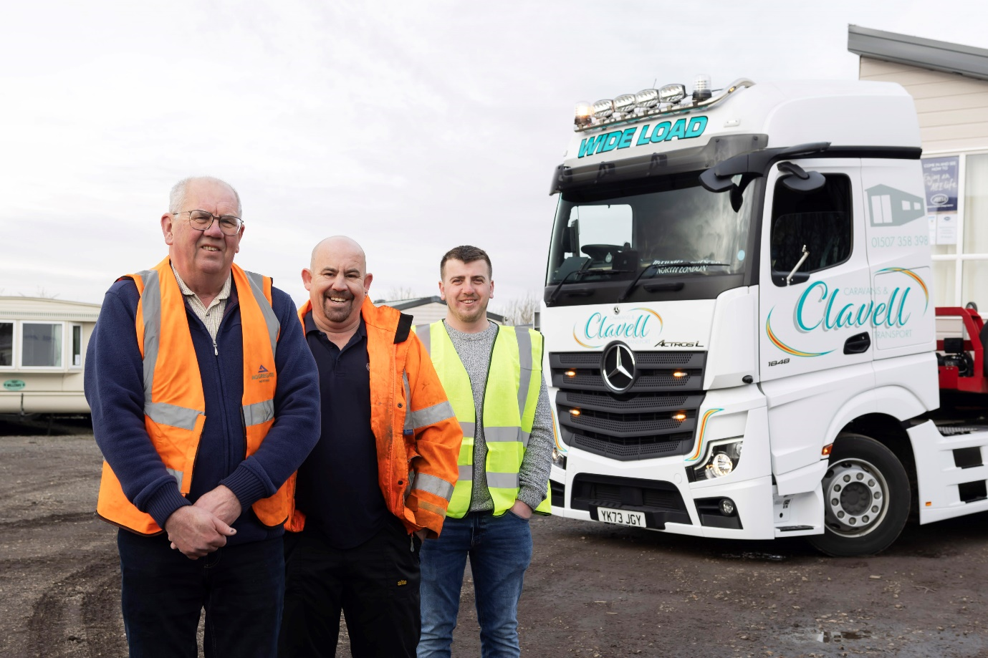

Home team: John Harneiss of Clavell Caravans, left, with driver Jason Chapman (centre) and John’s son James, the company’s Transport Planner

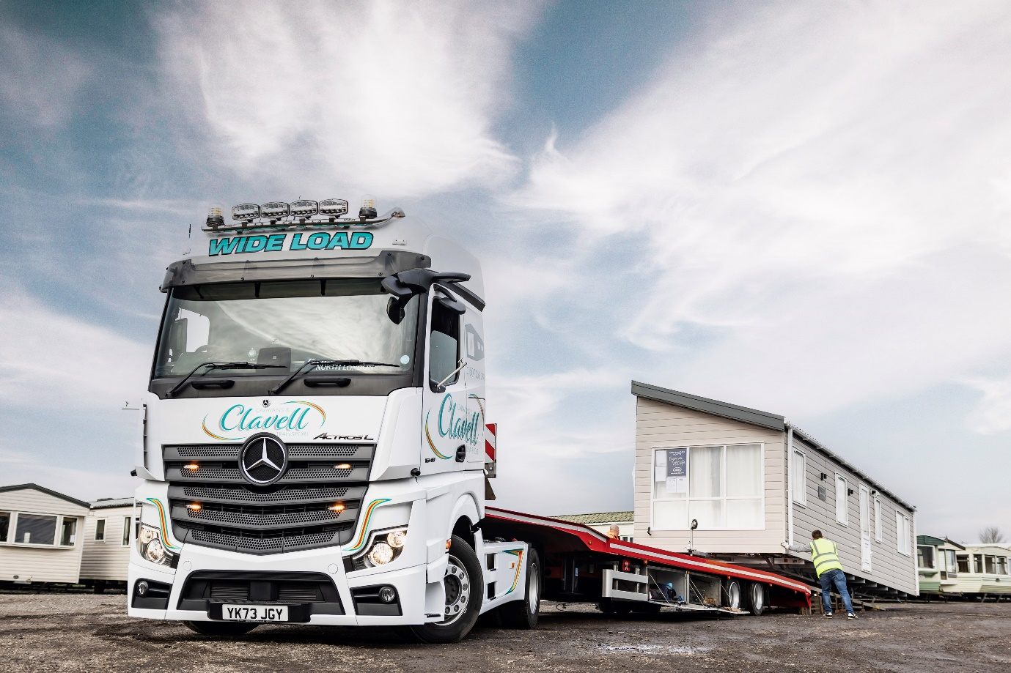

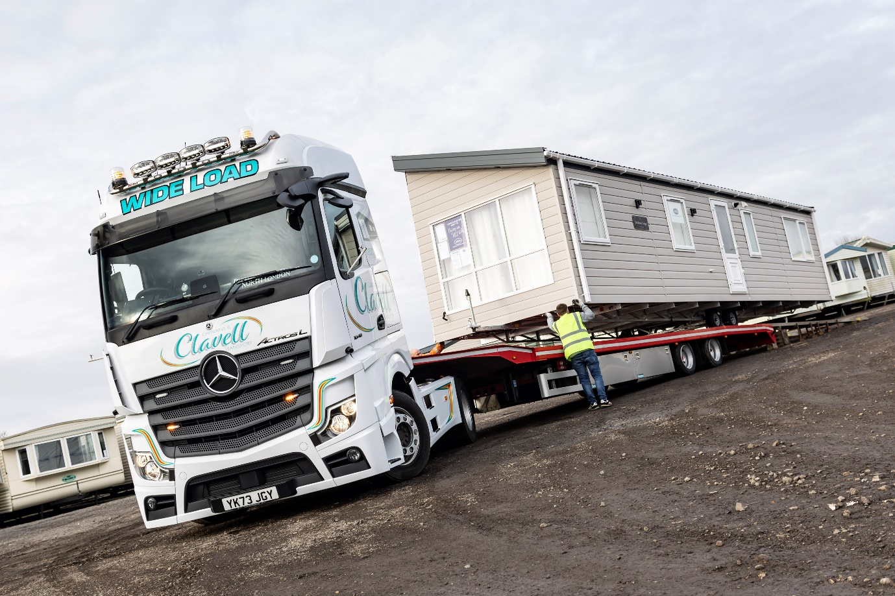

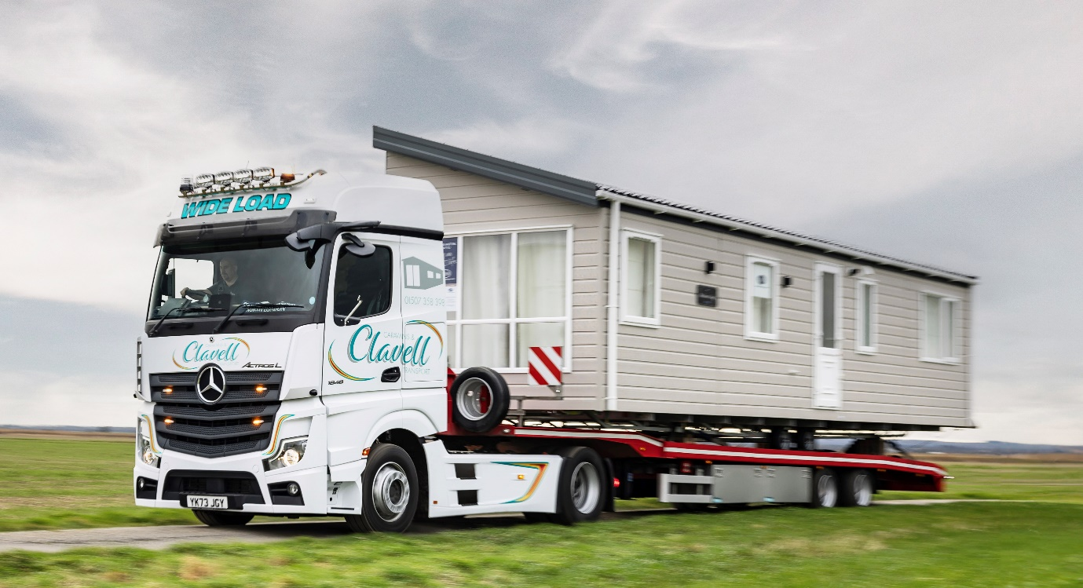

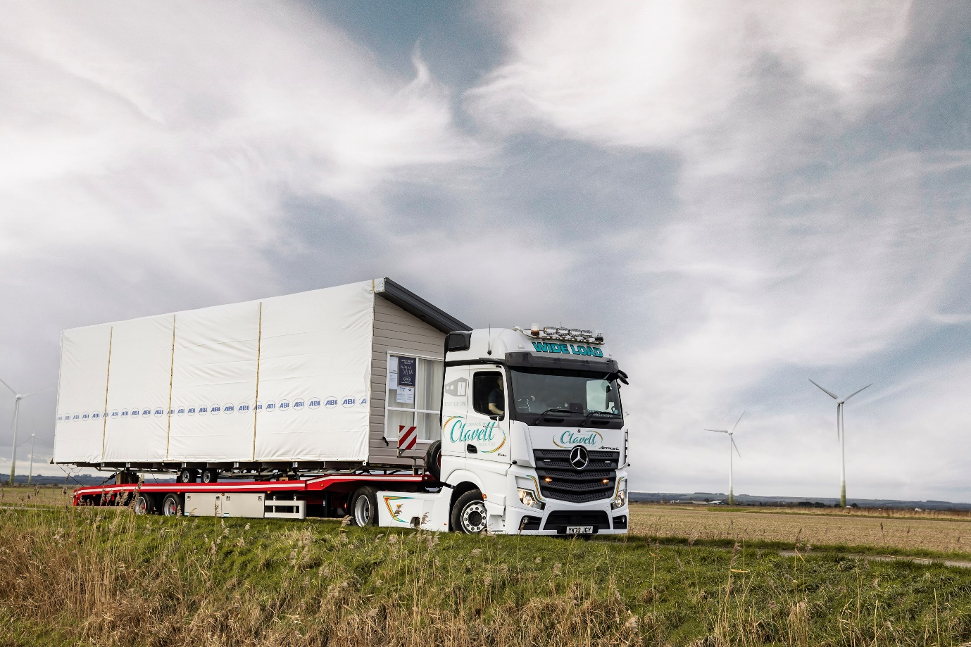

ends

For more information, or to request bigger/higher-res image files, please contact:
John Ripley: 07771 484595, john.ripley@loopagency.co.uk

