

Date: 9 March 2020

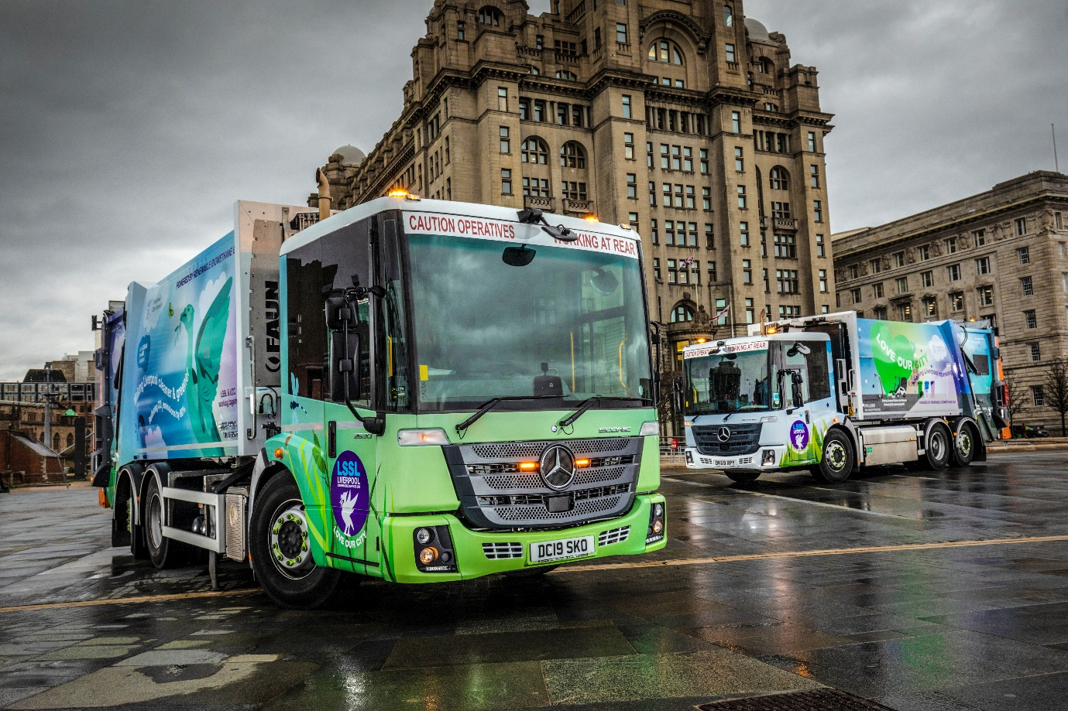

Liverpool steps on the gas with 20 cleaner, greener Mercedes-Benz Econic NGTs

The city of Liverpool has taken a radical step to reduce urban air pollution by commissioning a fleet of Mercedes-Benz Econic refuse collection trucks that run on renewable biogas.

Supplied by local Dealer Roanza Truck & Van, the 20 Econic NGT (Natural Gas Technology) 2630 L models will make a significant contribution towards the reduction of Liverpool City Council’s carbon footprint.

The new trucks are powered by in-line six-cylinder M936G engines which are designed to burn compressed natural gas (CNG). These 7.7-litre powerplants generate 222 kW (302 hp) and drive through six-speed Allison automatic transmissions.

Between them the vehicles will cover more than 150,000 miles per year, mostly in Liverpool city centre. They run on Biomethane gas which is 100% renewable and derived from waste feedstocks.

The council calculates they will produce 80% less carbon and 90% less nitrogen oxide compared to diesel-engined refuse trucks, while also cutting fuel costs by 35%.

Operator Liverpool Streetscene Services Ltd (LSSL), a Local Authority Trading Company, was established in 2016 when the city council brought cleansing and refuse operations back under its control.

LSSL’s Head of Service for Refuse and Recycling Harvey Mitchell said: “These gas-powered trucks are much cleaner, and also quieter, than traditional refuse collection vehicles, so we’re confident they’ll make a real difference to the local environment.

“At the same time, they benefit from the very high levels of reliability, safety and user-friendly design that our older diesel-engined Econics have been delivering for years.”

"The vehicles were selected through a competitive tender but once we’d made the choice, the team at Roanza Truck & Van worked very closely with us throughout the ordering and delivery process. Sales Director Neil Parkinson, Truck Sales Executive Richie Rainford and their colleagues put in a lot of hours to help us get the specification right.

“We know from experience that we can also trust them when it comes to back-up. Although we maintain our vehicles in-house, Roanza keep us supplied with competitively priced parts and their expert technical advice is only ever a phone call away if we need it."

The 6x2 trucks are fitted with Faun Zoeller Variopress compactor bodies, and offer 10.0-tonne payload capacities. Their rear steering axles enhance manoeuvrability, making it easier for drivers to get in and out of tight city-centre locations.

The Econic’s low-height cab has a single-step floor for ease of entry and exit. Its deep, panoramic windscreen, and a seating position which is much lower than in a conventional truck, give drivers excellent visibility of vulnerable road users such as pedestrians and cyclists.

Safety is one of the three pillars of Mercedes-Benz Trucks’ all-encompassing RoadEfficiency strategy. The standard-fit Active Brake Assist 4 emergency braking system is programmed to recognise other vehicles, as well as pedestrians. It is capable of bringing the truck to a complete stop.

Mayor of Liverpool Joe Anderson said: “Our investment in this new fleet of refuse vehicles is a great statement of intent in our goal to make Liverpool a cleaner and greener city. These safe and efficient vehicles give collection teams the right tools to ensure residents receive a reliable service.

“However, we still need residents to take action by reducing, reusing and recycling their waste, if we are to hit our target of recycling more than 55% of the waste we collect.’’

To drive home this message the Econics wear a vinyl-wrap livery which was designed in-house by the council’s marketing team, to promote the vehicles’ environmentally friendly credentials and carry messages about services.

The launch of the eco-friendly refuse fleet follows the recent announcement that Liverpool City Council is set to meet its climate change targets – three years ahead of schedule!
According to government statistics, the city has already achieved an impressive 18% reduction in carbon emissions since 2012 and is on course to hit 35% by the end of 2020.

The council is also greening the city. Having recently won funding to plant 750 new urban trees over the next two years, it is currently planting the first wave of 150 in the city centre with a sustainable drainage system to reduce surface flooding.

New cycles lanes are also being created and the council is currently working on a business case to DEFRA which looks at the option of introducing a Clean Air Zone that will charge the highest polluting vehicles.

www.liverpool.gov.uk

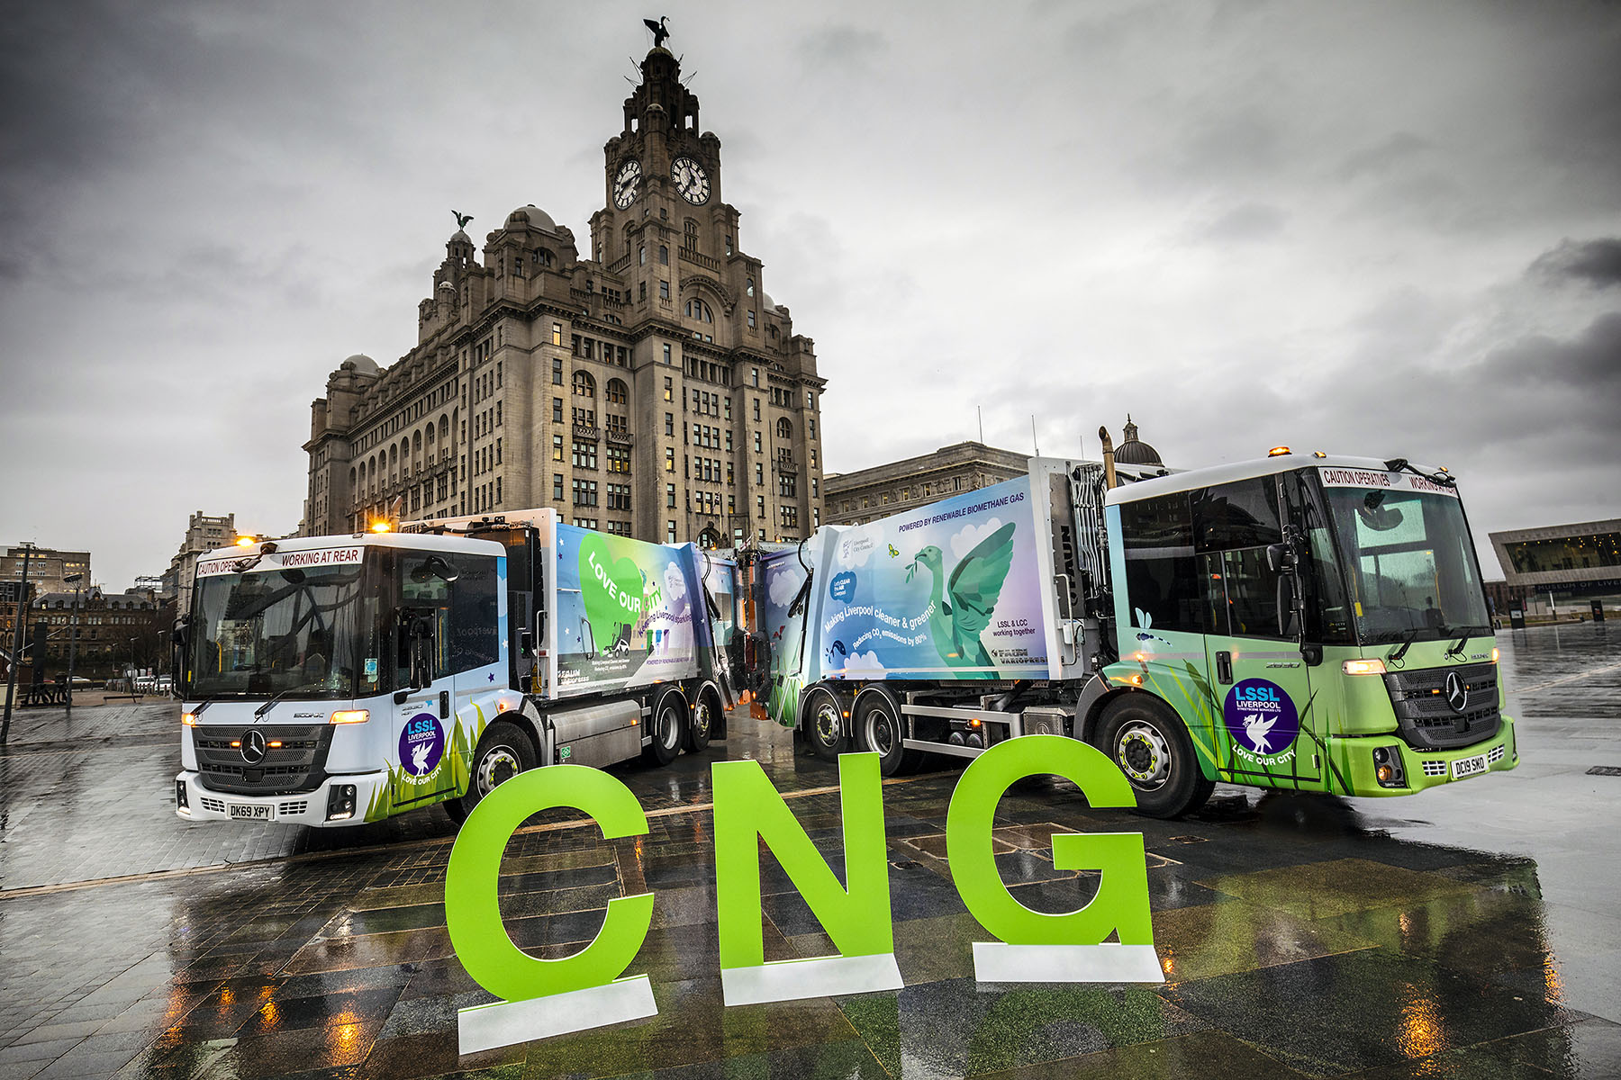
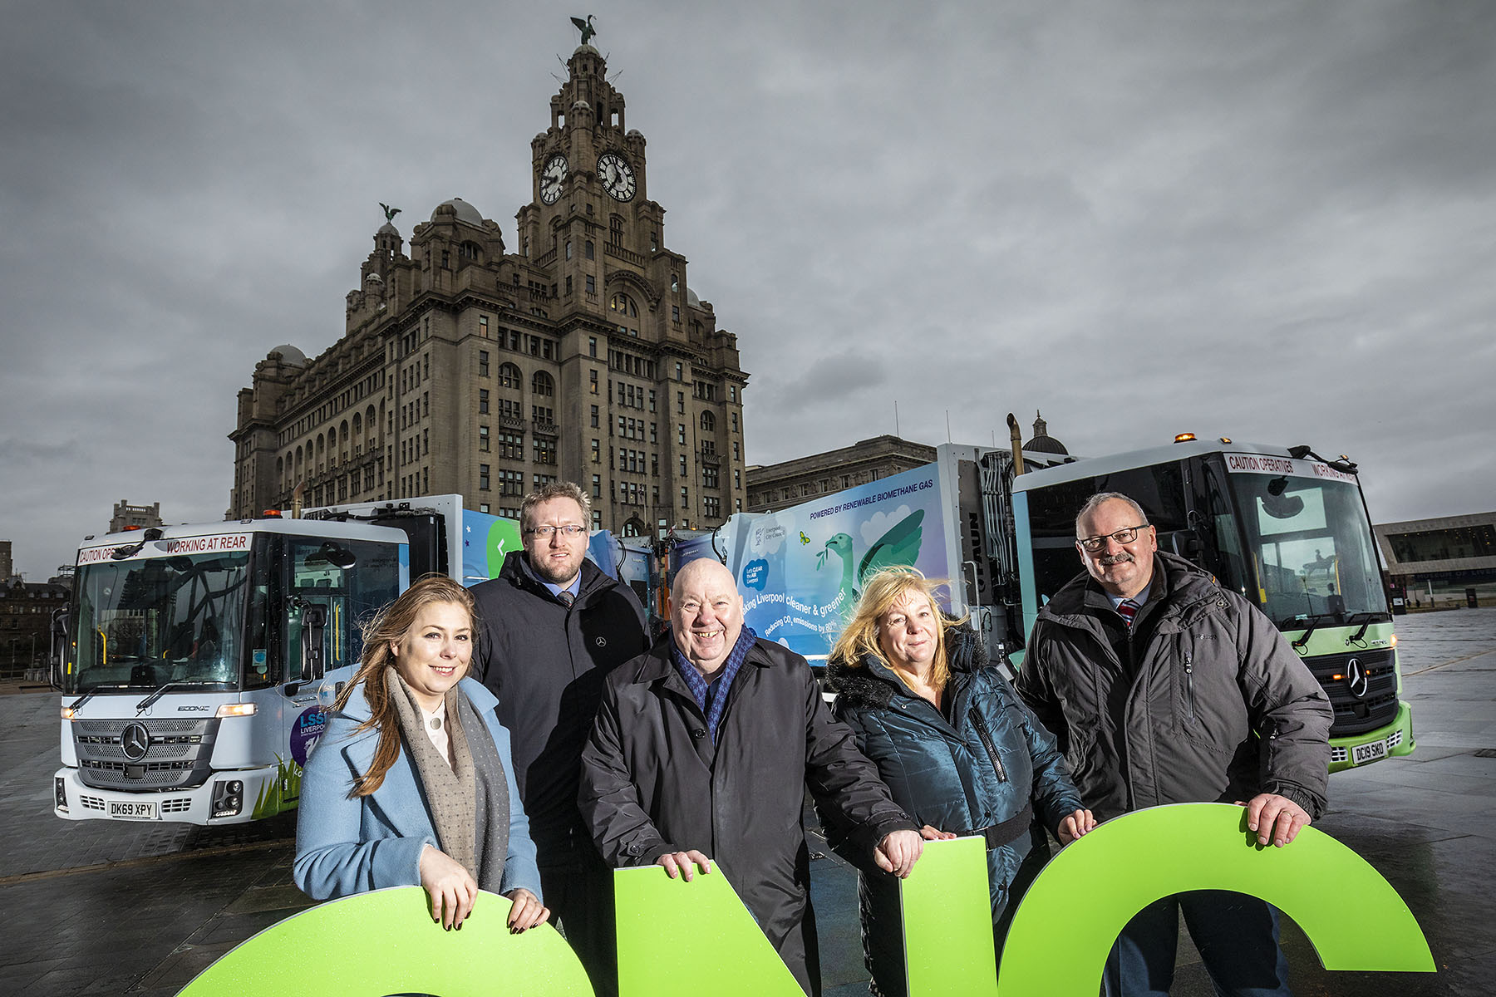

Green zone: Liverpool Mayor Joe Anderson, centre, is pictured in front of the iconic Royal Liver Building with Councillor Sharon Connor, Cabinet Member for Regeneration & Highways, left, and Councillor Wendy Simon, Deputy Mayor and Cabinet Member for Culture, Tourism and Events, and Sales Director Neil Parkinson and Truck Sales Executive Richie Rainford, right, both of Roanza Truck & Van

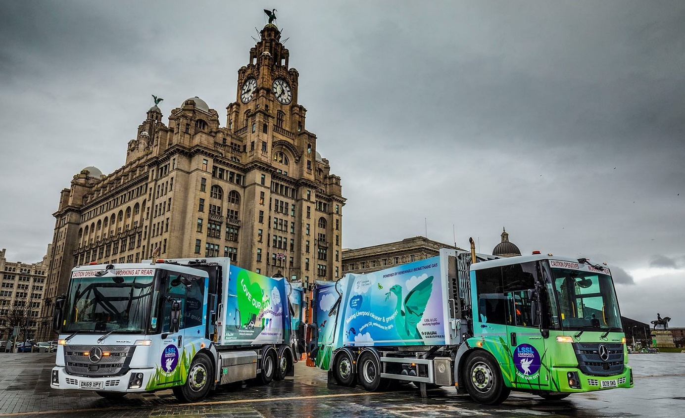

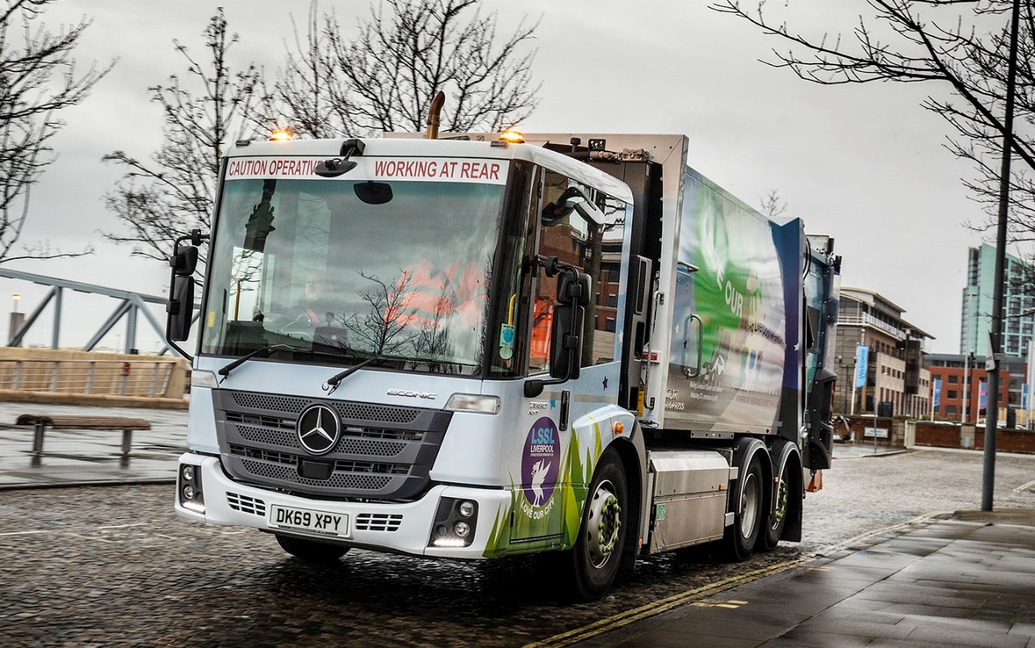

ends

For more information, or to request higher-res image files, please contact:

Jamie Fretwell at Mercedes-Benz Trucks UK
07712 519230, jamie.fretwell@daimler.com

or

Steve Warren or John Ripley
Impact Communications, 01926 842126
Steve: 07770 470251, steve@impactcom.co.uk
John: 07771 484595, john@impactcom.co.uk

About Mercedes-Benz Trucks UK Ltd
Mercedes-Benz Trucks UK Ltd is the sales and marketing organisation responsible for all Daimler truck products in the UK, including FUSO Canter.

In 2019, the company registered 6,963 new trucks. Mercedes-Benz accounted for 6,188 new trucks registered in 2019, making it the third-biggest truck brand in the UK. Meanwhile, FUSO registrations hit 775 – including 580 new trucks over 6.0-tonnes.

The flagship new Mercedes-Benz Actros which won the 2020 International Truck of the Year award, features seven core innovations including MirrorCam, Multimedia Cockpit and Active Brake Assist 5. Our premium range of innovative trucks – Actros, Arocs, Atego, Econic and Unimog – draw upon more than 125 years of exceptionally high standards of quality, backed up by our promise of Trucks You Can Trust.

www.mbtrucks.co.uk

