

Date: 18 January 2022

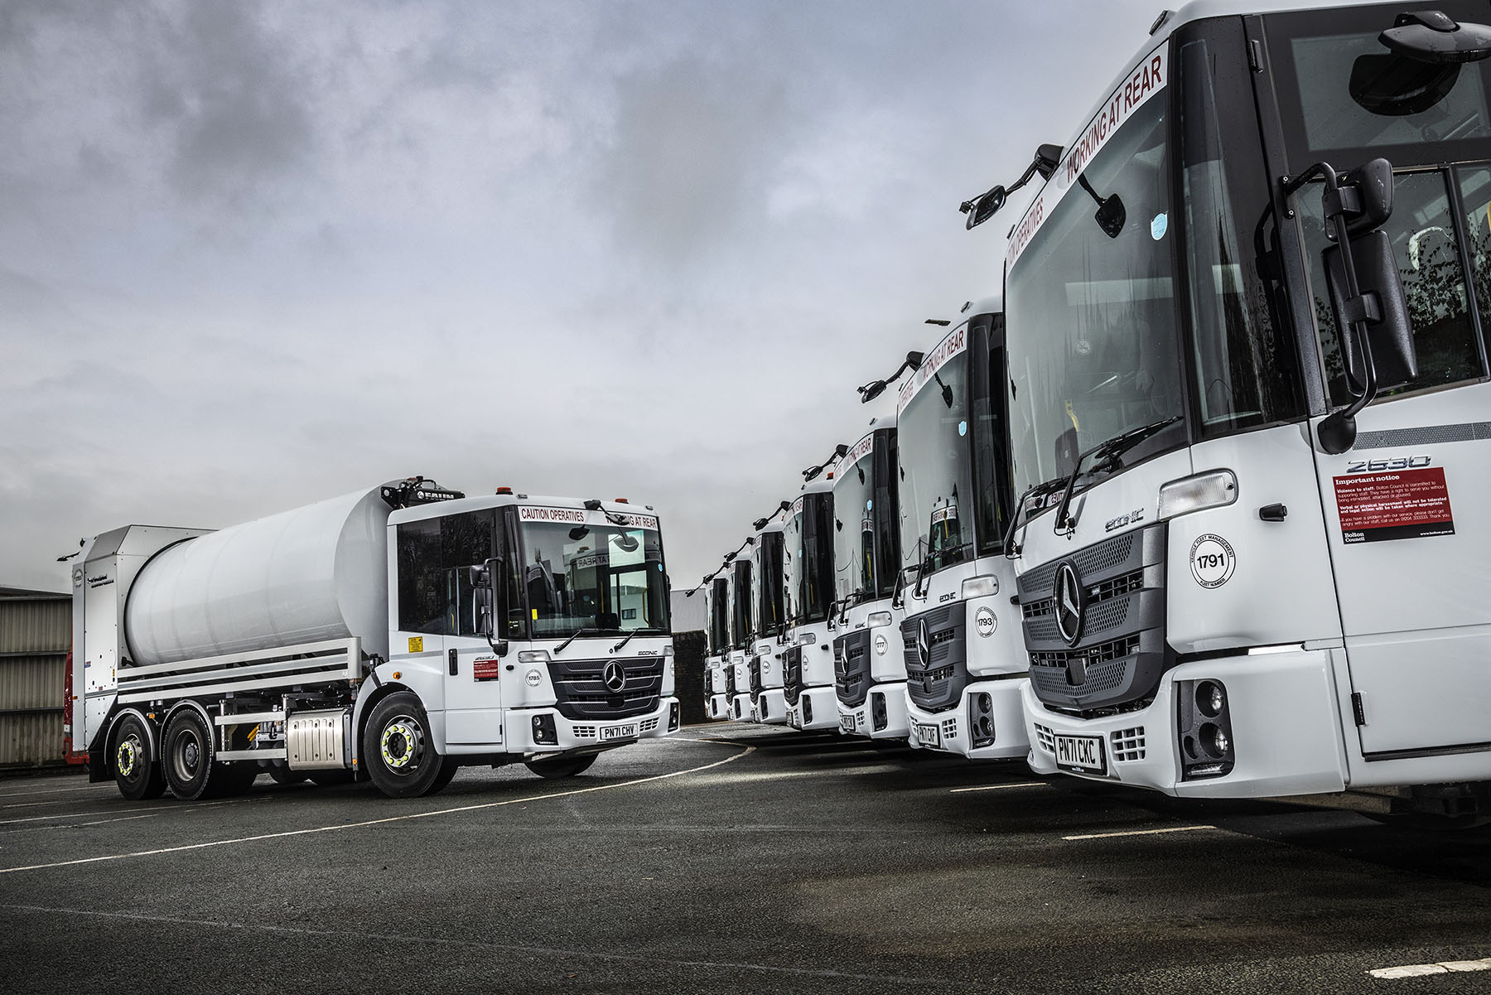

Bolton Council opts for a ‘body double’ with its 19 new Mercedes-Benz Econics

Bolton Council’s latest refuse collection vehicles are fitted with two types of FAUN Zoeller body but true to form all are based on well proven Mercedes-Benz Econic chassis.

Supplied by local Dealer Ciceley Commercials, the 19 six-wheelers represent a major step forward for the authority in terms of emissions reduction, operating efficiency and safety.

The new trucks are all 2630 L variants with 7.7-litre in-line six-cylinder engines that transmit their 220 kW (299 hp) outputs to the road via six-speed Allison automatic gearboxes purpose-designed for stop-start applications.

Rear-steer axles provide enhanced manoeuvrability by reducing turning circles – a significant advantage when working on residential streets. The vehicle’s comprehensive safety armoury includes the latest Active Brake Assist 5 emergency braking technology, with industry-leading pedestrian recognition capability, and Electronic Parking Brakes that are applied automatically when the engine is switched off.

Most of the low-entry Econics they have replaced were 2012 models, although four had been providing reliable, cost-effective service since 2009. The new, Euro VI-compliant trucks offer a 90% reduction in particulate and nitrogen oxide (NO_{x}) emissions compared to their Euro V predecessors, while also consuming less fuel and up to 40% less AdBlue.

Like Ciceley Commercials, primary contractor FAUN Zoeller is also a well-established supplier to Bolton Council. The bodybuilder and Dealer enjoy an excellent relationship, having worked together on other local authority tenders.

Eight of the new trucks are fitted with 22m³ versions of FAUN Zoeller’s Variopress body and work with split Delta high-level bin lifts. The Variopress system employs a conventional packer plate to compress the waste and was already being operated successfully by Bolton Council on the six Mercedes-Benz Econics it purchased in 2017.

The remaining 11 vehicles, however, have been specified with cylindrical Rotopress bodies, which represent a new departure for the authority. Built around a rotating drum, this radical design offers a number of benefits, including higher payloads, reduced rear overhangs, a tight seal resulting in less dust and odour during collection operations, and fewer moving parts, which translate into lower maintenance and repair costs.

Bolton Council’s 20 m³ capacity Rotopress units are also fitted with Delta lifts and offer 11.5-tonne maximum payload capacities, up by about a tonne on their Variopress stablemates. They have been assigned to food and green garden waste collections. Although this type of body is capable of compacting all types of waste and recyclables, it is particularly well suited to organic material as the rotating body ‘kick starts’ the composting process.

Bolton Council operates a fleet of 42 refuse collection vehicles which is dominated by the three-pointed star. The authority maintains these trucks in its own workshop, a stone’s throw from Ciceley Commercials’ branch on Weston Street. However, it relies on the Dealer for regular parts supplies and any warranty work – as with all new Econics supplied through the official Mercedes-Benz Trucks Dealer network, Bolton’s vehicles came with comprehensive cover extending to three years/160,000 km.

Jason Molyneux, Senior Team Leader in the Council’s Waste Department, confirmed: “Ciceley Commercials’ Truck Sales Executive Matt Riley provides a great service, while we also have a very good relationship with the Dealer’s aftersales team, who provide first-class back-up. If ever we have a technical issue we know we can just give them a call and they’ll sort it out for us quickly.

“In truth, though, and this explains why we have remained loyal to Mercedes-Benz, our Econics have given us very few problems. The drivelines are exceptionally reliable and the cabs are comfortable and well-liked by the drivers and crews who use them.

“FAUN Zoeller is also a trusted supplier, and experience has shown that its products offer the performance we need. By specifying the two different types of body, we’ve ensured that we have the flexibility to manage every kind of waste stream efficiently and cost-effectively.”

Purpose-designed for municipal applications, the Mercedes-Benz Econic has a deep, panoramic windscreen and this, coupled with a low seating position, provides drivers with unrivalled direct visibility. Its air-conditioned cab, meanwhile, is easily accessed via a single step, making life easier for operatives who get in and out numerous times during a shift.

The Econic also leads the field in terms of active safety. Active Brake Assist 5 combines camera and radar technology to detect vehicles ahead and stationary objects in its own lane, at speeds of up to 56 mph (90 km/h). Detection of a dangerous situation triggers a three-stage reaction: first, the system warns the driver with visual and audible alerts; then, if the driver fails to react, it applies partial (approximately 50%) braking; finally, if the driver has still not intervened, it initiates maximum braking to bring the truck to a halt, applying the Electronic Parking Brake and activating the hazard warning lights to alert drivers behind.

At speeds of up to 31 mph (50 km/h) Active Brake Assist 5 is capable of applying full braking when encountering pedestrians crossing its path, approaching from the front or walking ahead. Not only does this remarkable technology increase safety for vulnerable road users and vehicle crews, but it also helps to relieve stress for drivers.

Bolton Council’s Executive Cabinet Member for Environmental Services, Cllr Nadim Muslim, said: “Our waste collection teams have done a great job working through the challenges of the pandemic, during which there has been a significant increase in demand for our household waste and recycling service. These new vehicles will make a real improvement to that service.”

And Executive Cabinet Member for Regeneration & Development, Cllr Adele Warren, added: “This is a great step forward in our commitment to be a cleaner, greener, environmentally sustainable borough. These new vehicles will reduce carbon emissions and support our efforts to reduce pollution and deliver improved air quality in Bolton.”

www.bolton.gov.uk

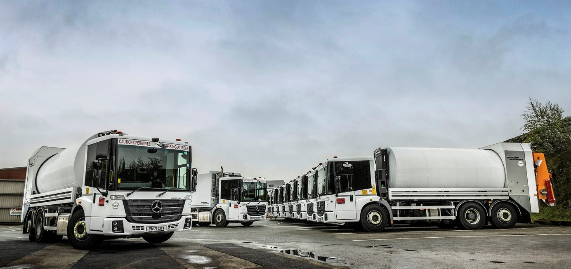

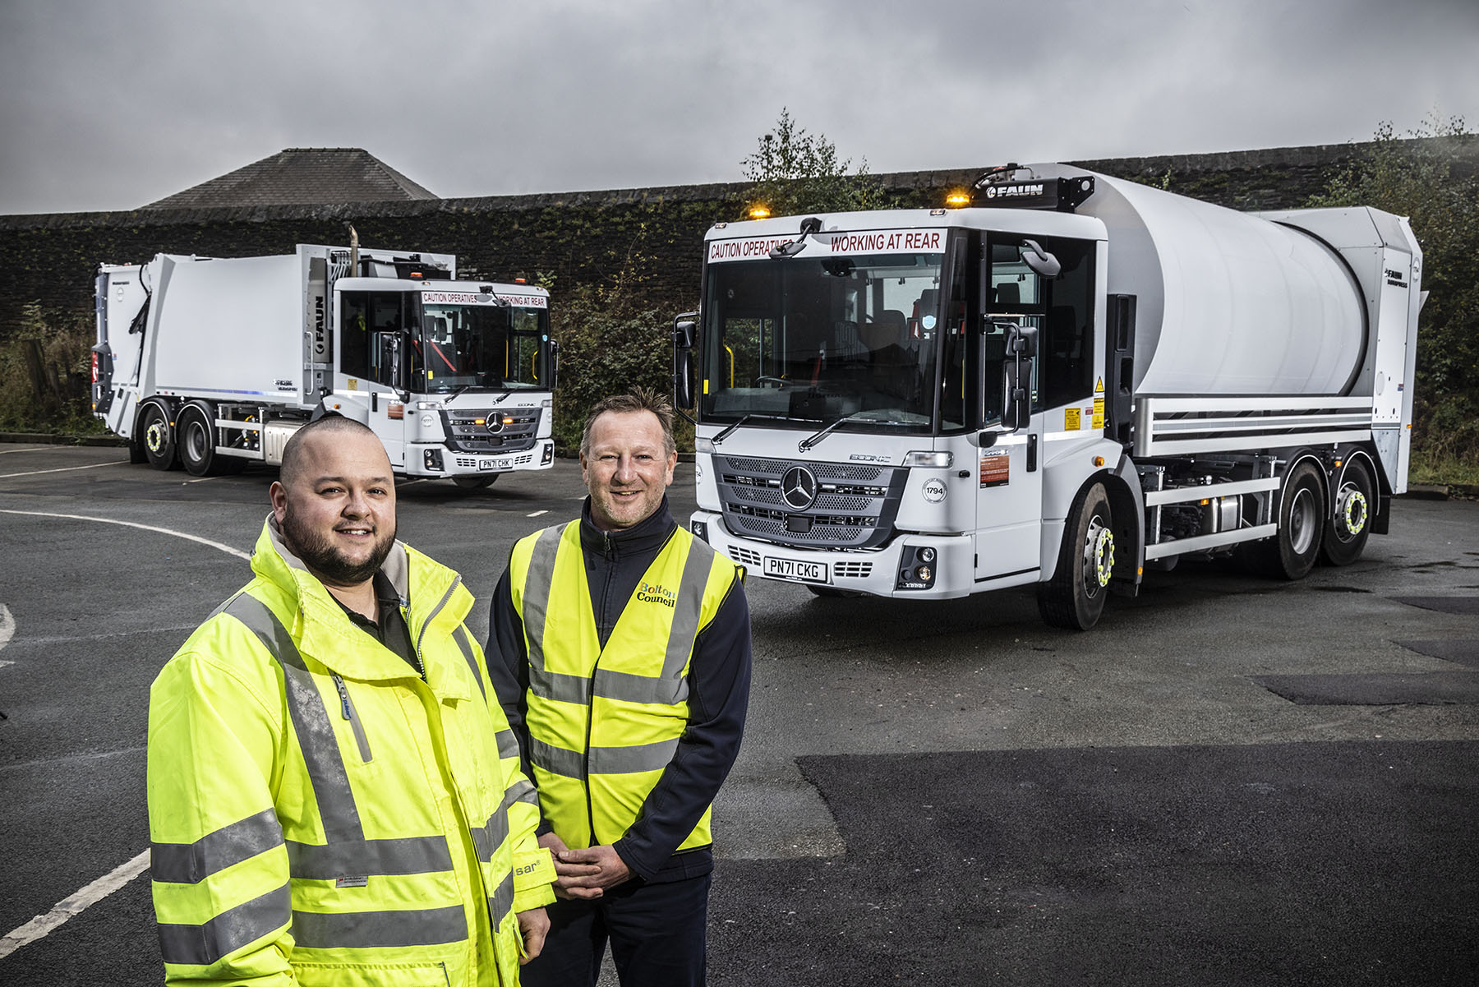

A winning team: Waste Manager – Environmental Services Tom Alberts, left, and Senior Team Leader Jason Molyneux are pictured with two of the new Mercedes-Benz Econics supplied by Ciceley Commercials and bodied by FAUN Zoeller

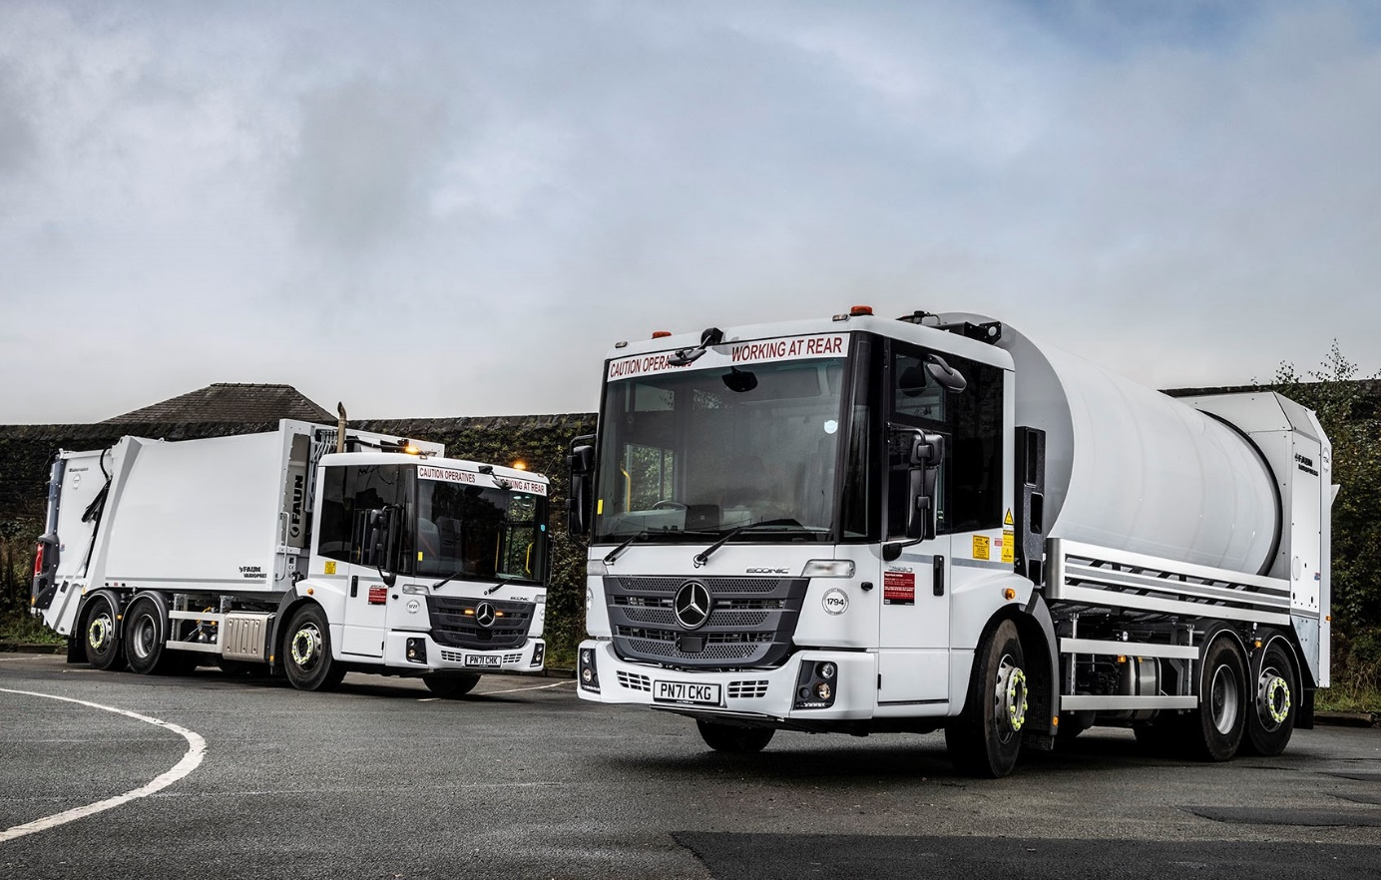

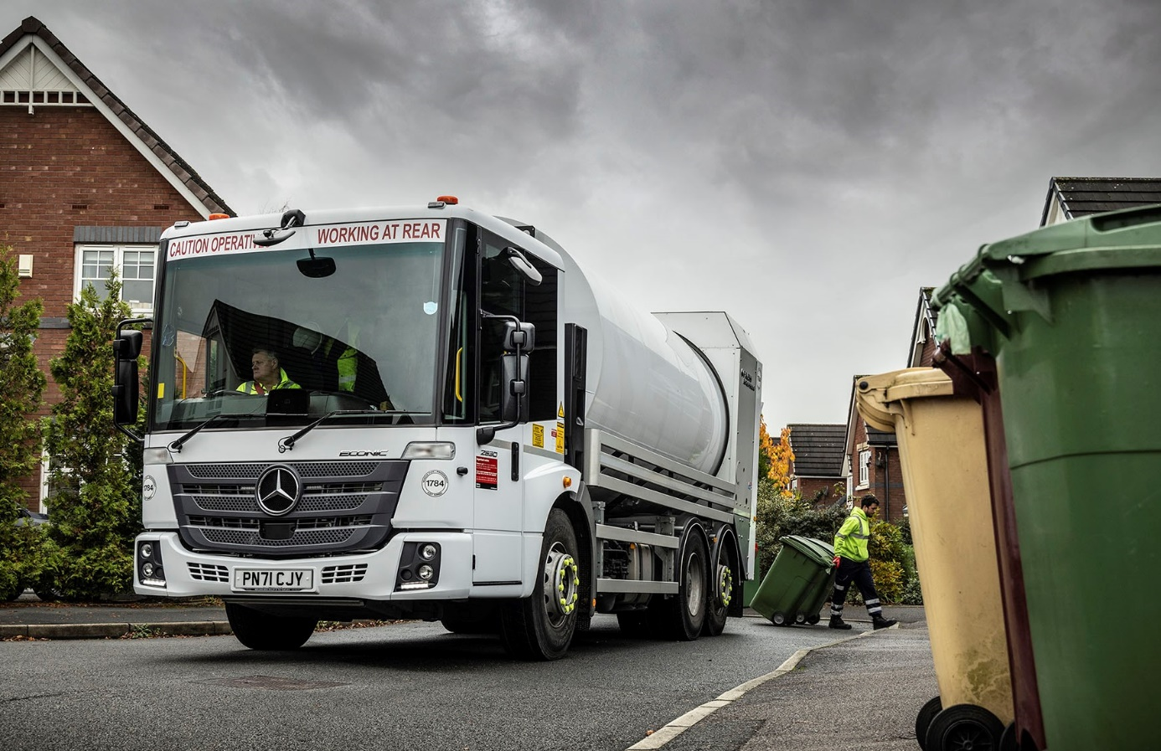

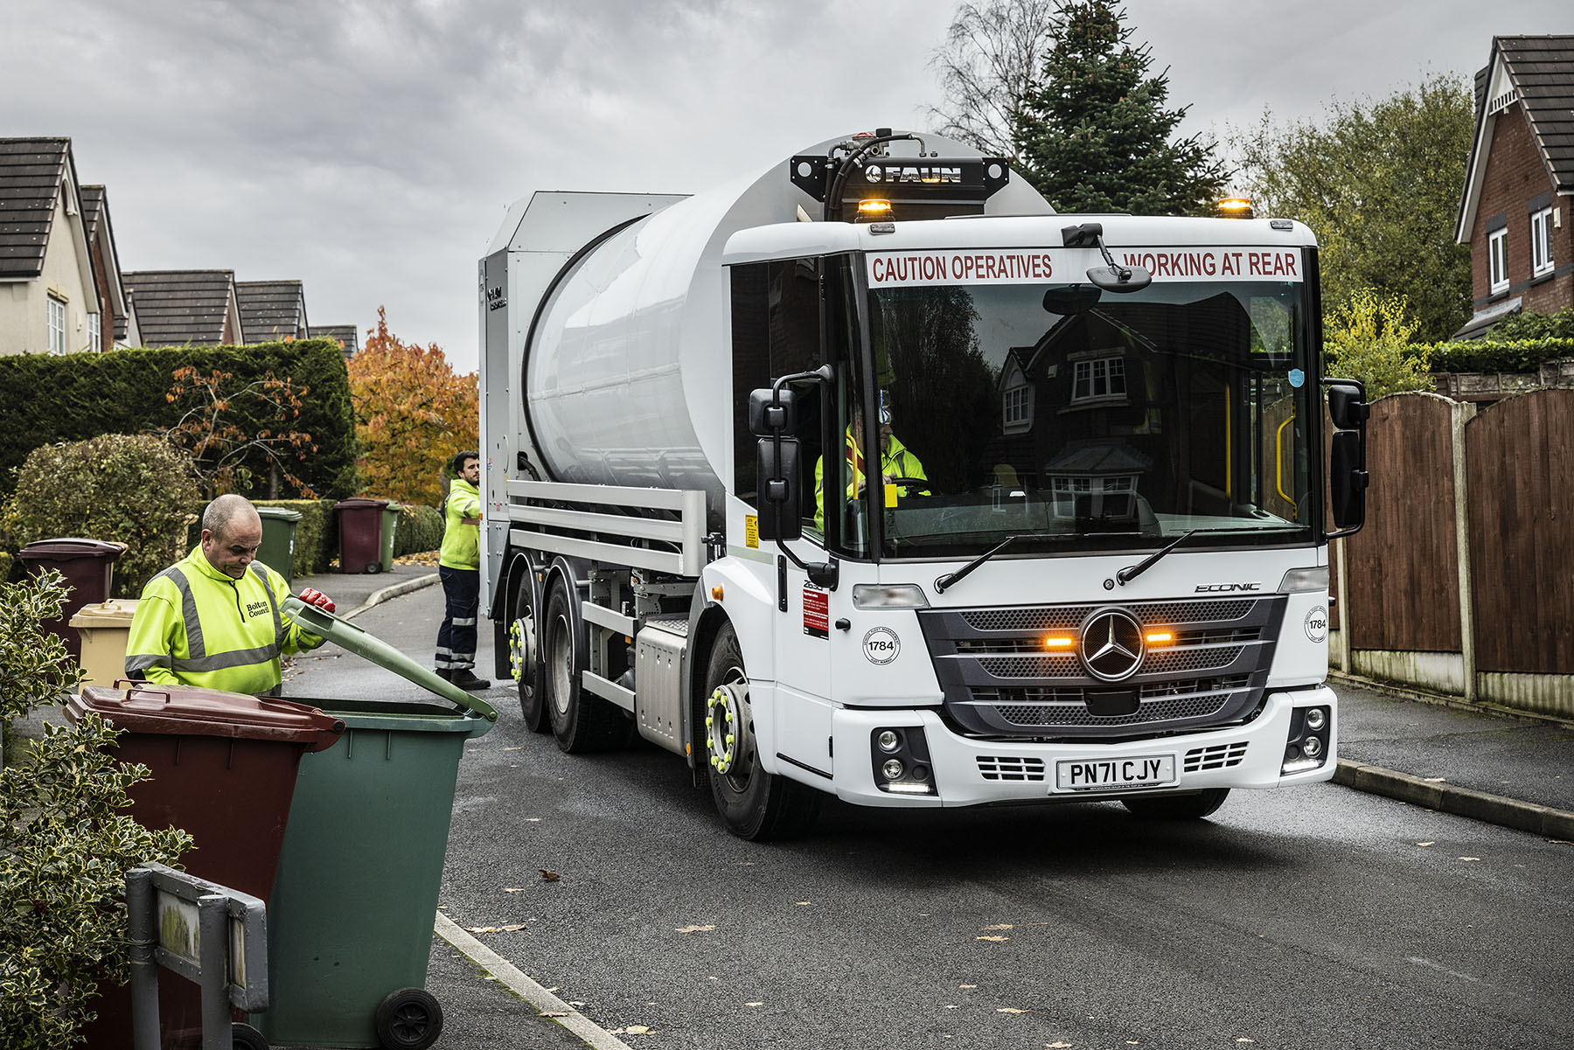

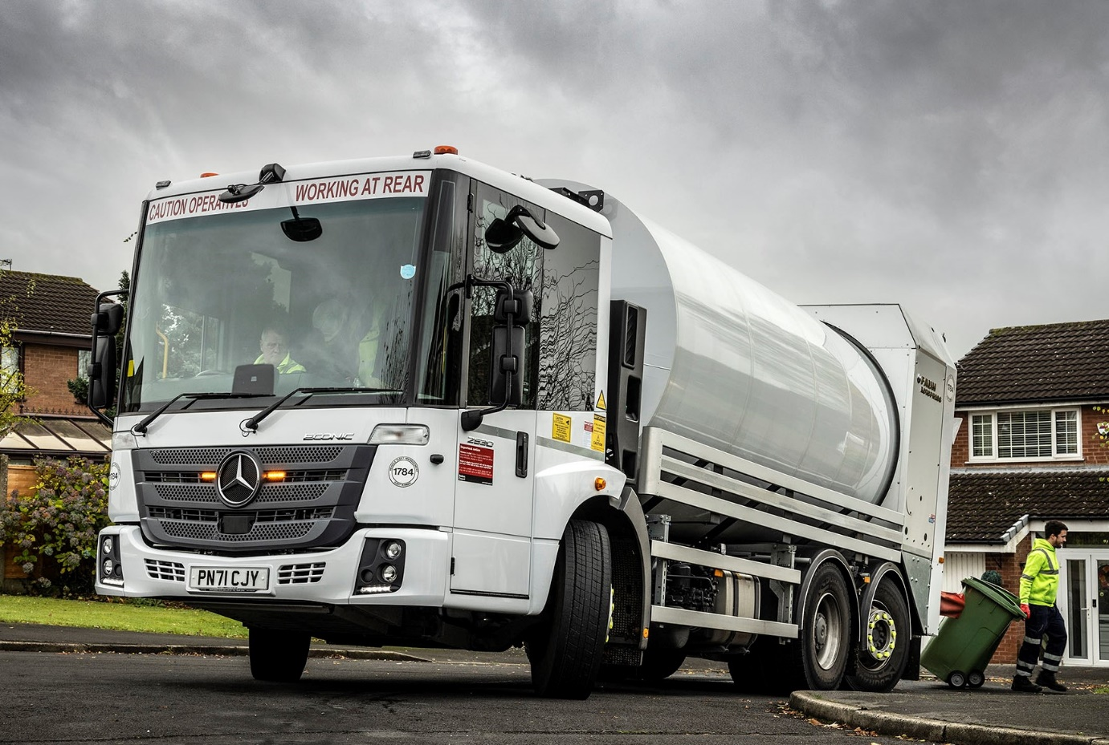

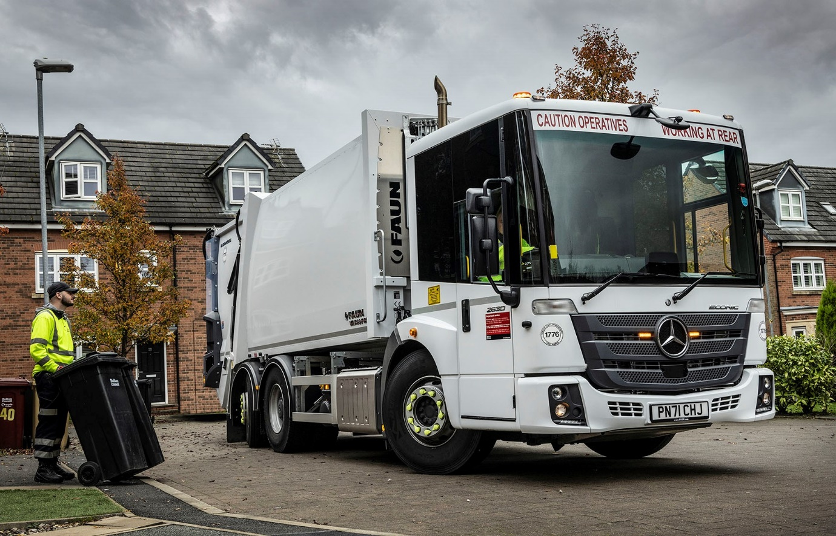

ends

For more information, or to request bigger/higher-res image files, please contact:
Steve Warren or John Ripley
Impact Communications
Steve: 07770 470251, steve@impactcom.co.uk
John: 07771 484595, john@impactcom.co.uk

