

Date: 28 October 2019

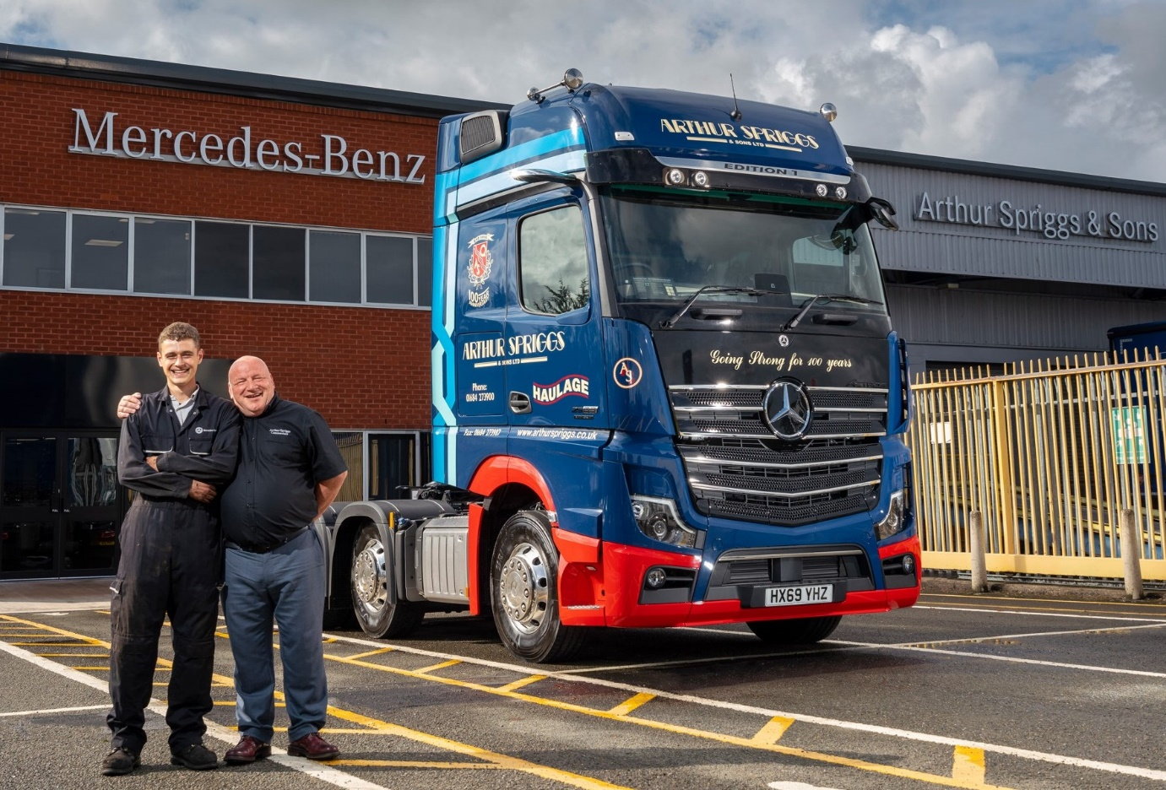

Family values: Chris Spriggs and son Harry are pictured with Arthur Spriggs & Sons’ flagship Mercedes-Benz Actros Edition 1, the first supplied to a UK customer

Arthur Spriggs & Sons’ stunning Mercedes-Benz Actros Edition 1 is ‘a driver’s dream’

The first of just 35 awesome Mercedes-Benz Actros Edition 1 tractor units to be delivered to a UK customer has taken to the road in the colours of family-owned haulier Arthur Spriggs & Sons.

The Edition 1 is a stunning showcase for the fifth-generation Actros range, and production has been restricted to just 400 examples worldwide. Arthur Spriggs’ truck wears a special livery that highlights the Tewkesbury-based operator’s recent 100th anniversary.

Supplied by Dealer Marshall Truck & Van, it has joined an all-Mercedes-Benz and FUSO fleet of 60 trucks of various sizes, as well as a number of vans which also wear three-pointed stars.

In addition to the many ground-breaking innovations – MirrorCam, Active Brake Assist 5, the Multimedia Cockpit, and enhanced Predictive Powertrain Control technology, for example – that come as standard in the new Actros, the limited edition model is loaded with extra equipment and stylish details geared to the driver.

Powered by a range-topping 15.6-litre straight-six engine which produces a potent 460 kW (625 hp), the Edition 1 is instantly recognisable. Visual highlights of the GigaSpace cab include a distinctive gloss black grille, darkened headlamp covers and rims, and an Edition 1-branded sun visor incorporating four extra LED main-beam headlamps.

Arthur Spriggs & Sons Managing Director Chris Spriggs confessed: “I’ve been in this business for 40 years and there’s not much that gets me excited these days. When I set eyes on this truck for the first time, though, my reaction was ‘Wow! Now that really is special’.”

It was a sentiment echoed by driver Andy Quinn, who has been rewarded for his 18 years’ loyal service to the operator with the keys to its new flagship. “I’m still pinching myself, what an amazing truck!” he declared. “I’ve come out of a 510 hp Actros GigaSpace which was a great drive and never let me down, but the Edition 1 is something else altogether.

“Everything about this truck is state-of-the-art. MirrorCam is a real step forward in terms of safety, not least because it eliminates a major ‘blind spot’, while my seat and bunk are unbelievably comfortable. I love the way it looks too. It’s obvious that the driver was the number one priority for Mercedes-Benz when it designed the Edition 1.”

Andy’s black leather-trimmed cab interior – including door handles with contrasting topstitching – features a polished and brushed aluminium dashboard badge that confirms it as ‘One of 400’ Edition 1s. He can choose from no fewer than eight colours of ambience ceiling lighting, while an unbroken night’s sleep is assured thanks to a bed that measures an industry-leading 900 mm wide – described by Andy as “a bunk-and-a-half” – and wraparound curtain for privacy.

All new Actros models are offered as standard with a Mercedes-Benz Safety Pack. This incorporates the latest-generation Active Brake Assist 5 emergency braking system, which offers improved pedestrian recognition capability compared to the previous version, together with Proximity Control Assist and a driver’s airbag. Increasing safety still further, Edition 1 models come with the optional Sight Package, which provides for ‘best possible’ lighting and visibility by adding a rain sensor, bi-xenon headlamps, fog lamps, LED daytime running lights, cornering lights and LED tail lights.

Also included on the truck’s exhaustive specification list are:
• Driving Package with electric roller sun visor, leather-trimmed steering wheel, and more;
• Comfort Package with shaving mirror and refrigerator, as well as ambience lighting;
• Media Package with sound system, notebook bracket, and extra sockets;
• Stowage Package including table, shelving, and drawer beneath the instrument panel;
• ExtraLine, with LED position lamps, LED indicators and welcome light.

This is not the first time that Arthur Spriggs & Sons has led the way for Mercedes-Benz. Marshall Truck & Van supplied its high-profile customer with a limited edition Actros1 tractor unit from the outgoing model range last spring, and the operator has just ordered another two.

Arthur Spriggs also commissioned a number of Euro VI Actros models as long ago as 2012. One of those vehicles, a 26-tonne curtainsider, was the UK’s very first Mercedes-Benz rigid to meet the emissions standard that remains in force to this day.

“That truck continues to be a brilliant workhorse,” confirmed Chris Spriggs. “Our Euro VI Actros have always been fantastically reliable, cost-effective vehicles to run, and if the Edition 1 serves us as well as those that have gone before I’ll be a very happy man indeed.”

As with the operator’s previous acquisitions, Marshall Truck & Van’s dedicated Handover Specialist Phil Whiting has spent time in the cab with Andy Quinn to help him achieve optimum levels of performance and economy from his new unit.

Arthur Spriggs & Sons provides a comprehensive portfolio of transport services and prides itself on its commitment to customer service. The company also has a thriving aftersales business. Awarded Authorised Repairer status in 2014 by Mercedes-Benz and FUSO Trucks, it is about to add another five van bays to an impressive workshop that already incorporates 14 full-length tractor-and-trailer bays, and two dedicated ATF lanes for truck MoTs.

Arthur Spriggs & Sons was established in Northamptonshire by Chris Spriggs’ grandfather shortly after he left the army in 1918 following the end of the First World War. The current Managing Director was 19 when he joined his parents Derek and Jean in the family business in 1979.

The company moved to its current home in 1993. Now representing the fourth generation of the Spriggs family are Chris’s sons Harry and Billy – 22-year-old Harry is a qualified technician with specialist tachograph training, while Billy, 17, has just begin a Technical Apprenticeship with Mercedes-Benz.

arthurspriggs.co.uk

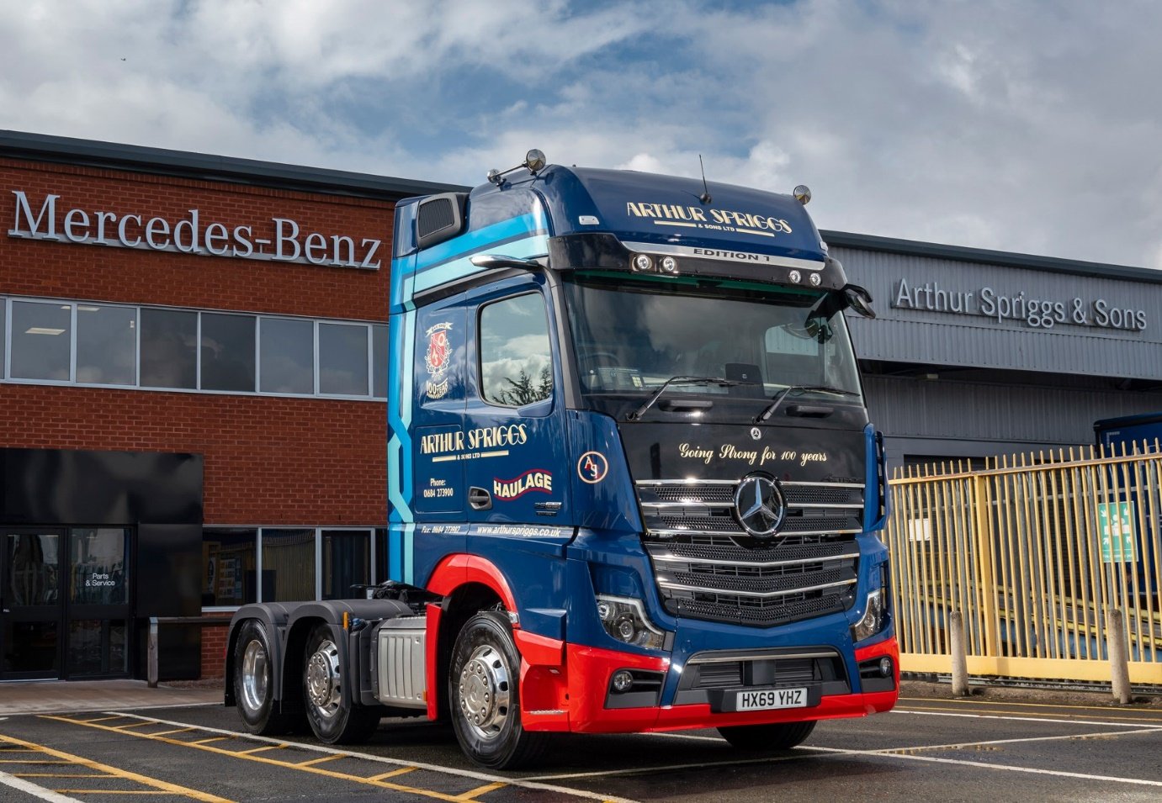

Technology meets tradition: Arthur Spriggs & Sons’ new Actros Edition 1 wears a livery that celebrates the operator’s 100th anniversary

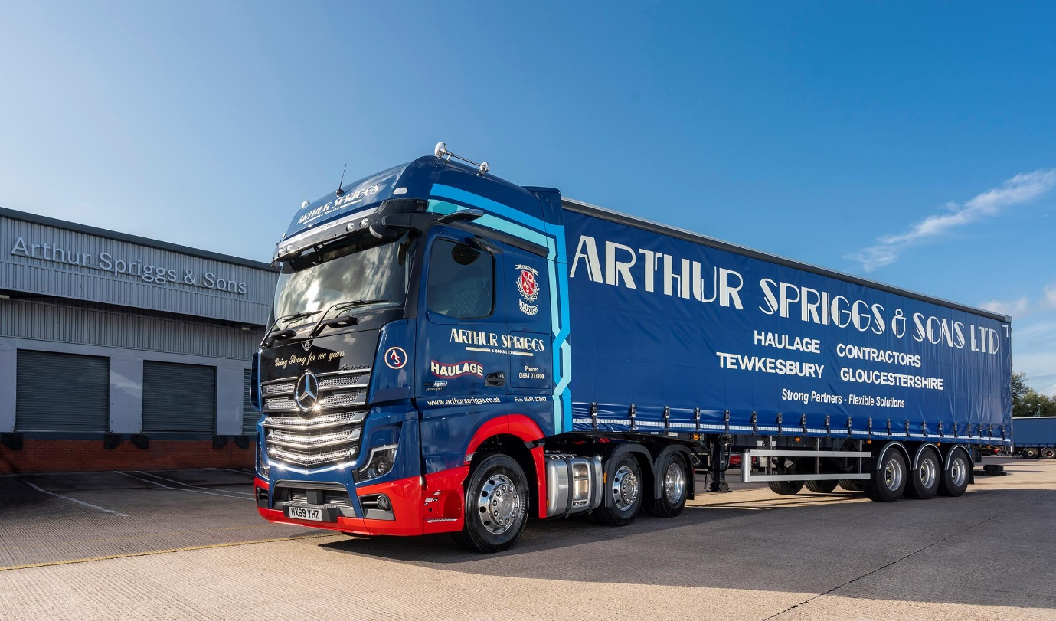

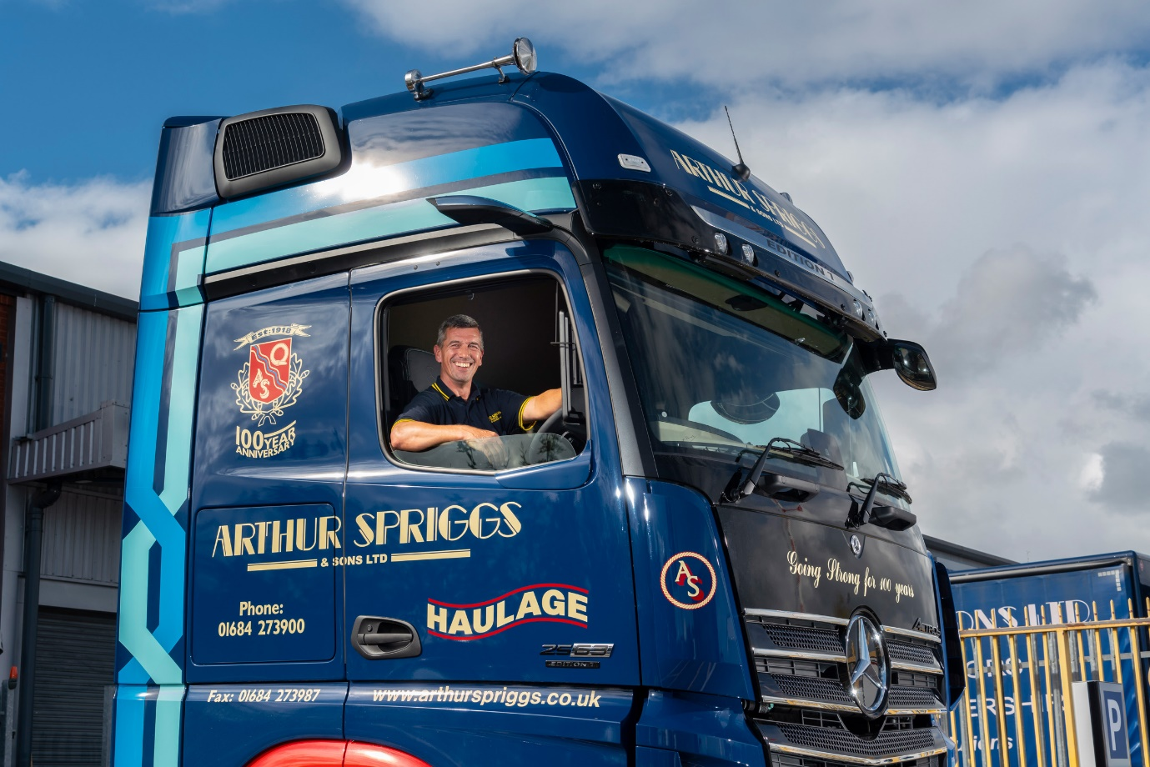

Miles more smiles: Long-serving driver Andy Quinn is riding high in his Mercedes-Benz Actros Edition 1

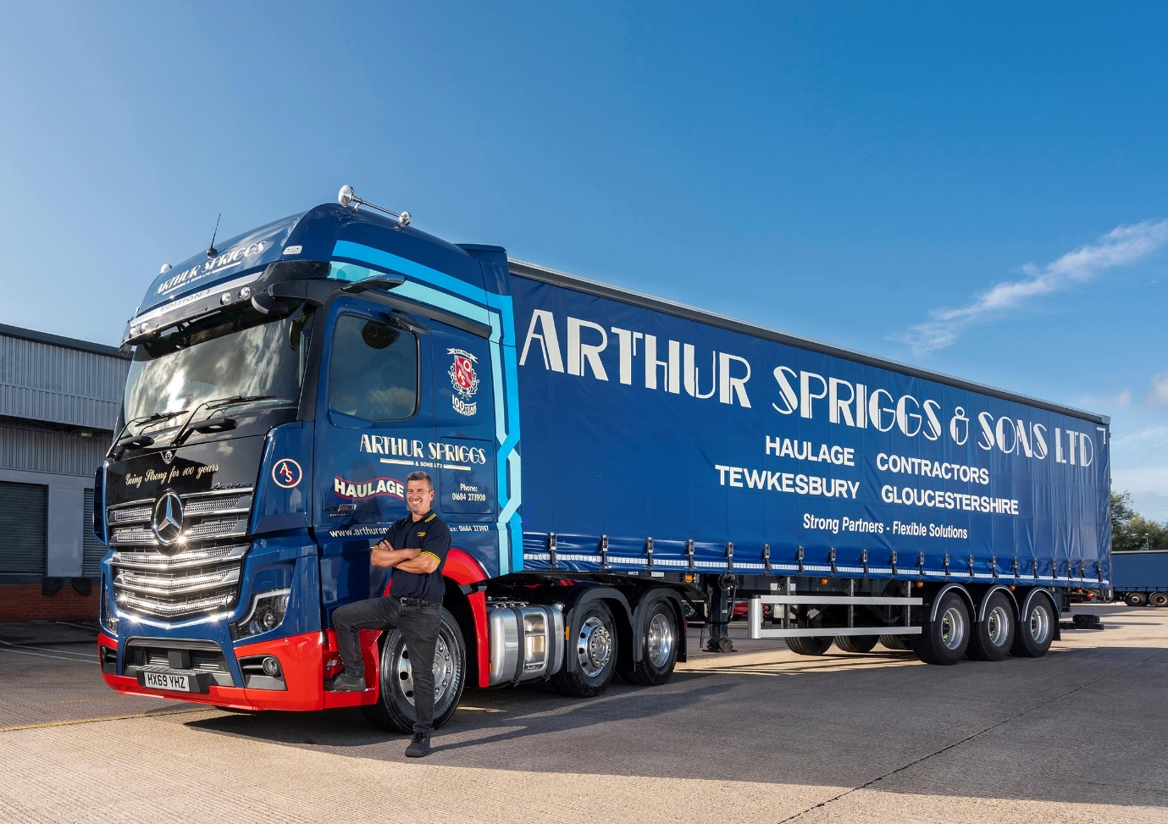

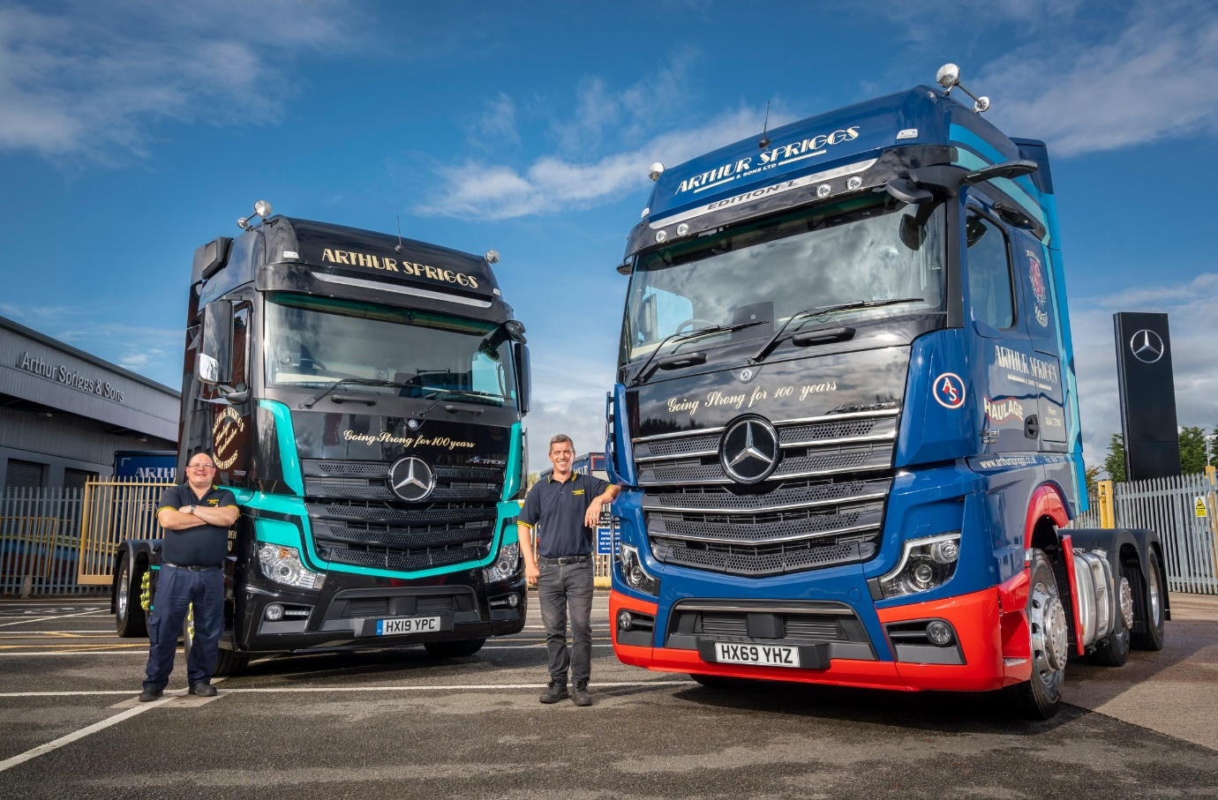

Limited editions: Actros Edition 1 driver Andy Quinn, right, is pictured with colleague Shaun Baker, proud pilot of Arthur Spriggs & Sons’ outgoing model generation Actros1

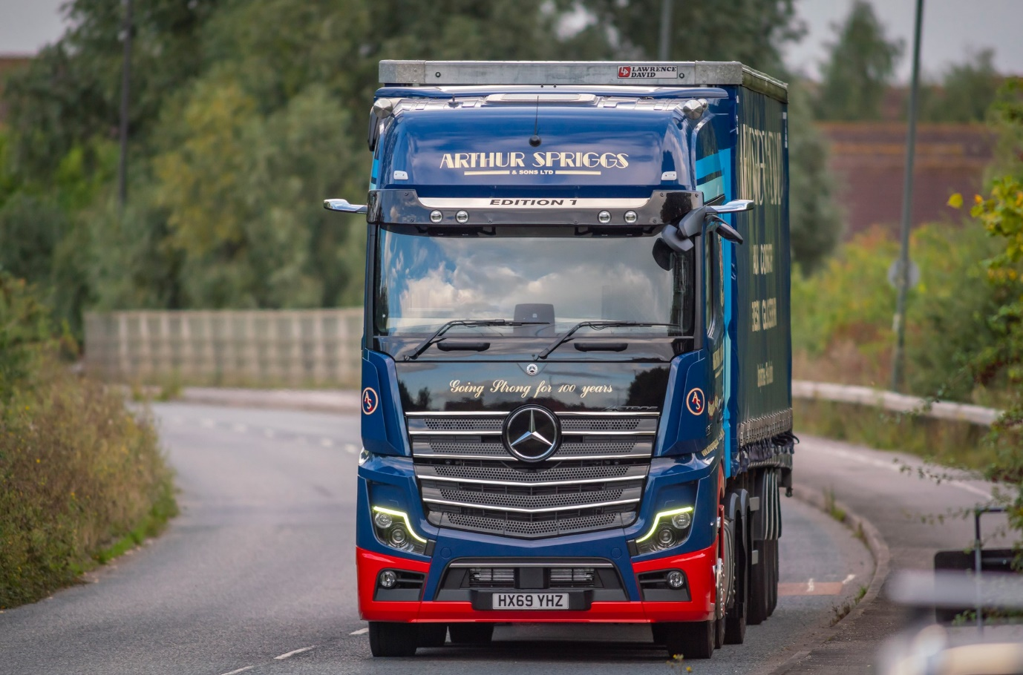

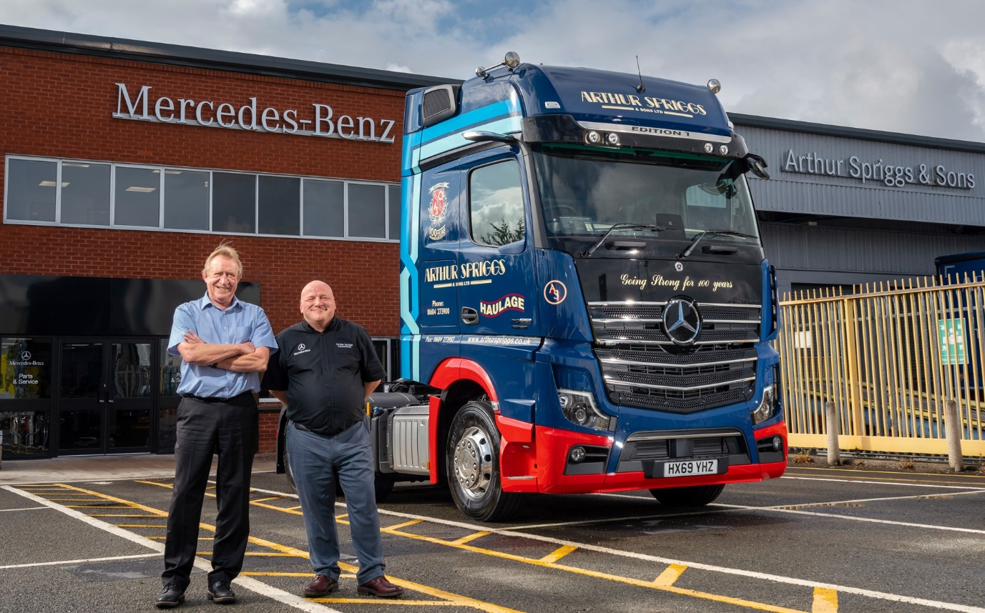

Bowing out in style: Delivery of Arthur Spriggs & Son’s Actros Edition 1 represented a fitting ‘swansong’ for Marshall Truck & Van Sales Executive Brian Phippen, pictured left with Chris Spriggs, who has now retired after 39 years in the truck business, the last 20 of them with Mercedes-Benz

ends

For hi-res image files, please visit:
media.mbtrucks.co.uk

For further information, please contact:

Jamie Fretwell, PR & Internal Communications
Mercedes-Benz Trucks
07712 519230, Jamie.Fretwell@daimler.com

or

Steve Warren or John Ripley
Impact Communications, 01926 842126
Steve: 07770 470251, steve@impactcom.co.uk
John: 07771 484595, john@impactcom.co.uk

About Mercedes-Benz Trucks UK Ltd

Mercedes-Benz Trucks UK Ltd is the sales and marketing organisation responsible for all Mercedes-Benz truck products in the UK, including FUSO Canter.

In 2018, the company registered 8,061 new trucks. After growth in 2017, Mercedes-Benz registrations levelled off to 7,223 trucks in 2018, ensuring it retained its title as the second-biggest truck brand in the UK. Meanwhile, FUSO made great strides to reach 838 registrations – including 675 new trucks over 6.0-tonnes.

For more than 125 years, Mercedes-Benz has stood for innovative vehicles that meet exceptionally high standards of quality. Our claim to perfection, sustainability and avant-garde design is now embodied in the next generation of trucks: Actros, Arocs, Atego, Econic and Unimog.

www.mbtrucks.co.uk

