

Date: 7 March 2019

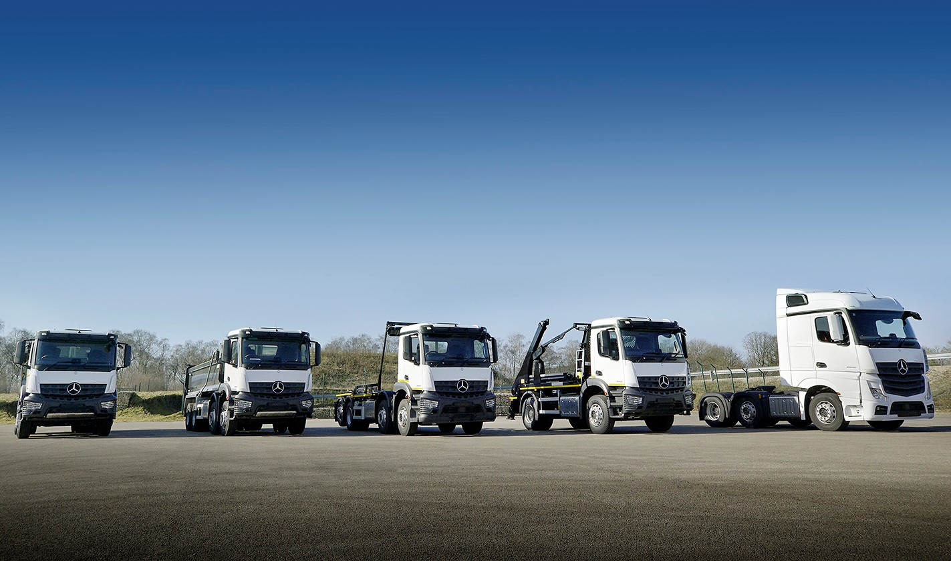

When work just won’t wait: Mercedes-Benz Trucks’ WorkReady programme offers time-pressed customers the opportunity to acquire pre-bodied new trucks

Right Truck. Right Spec. Right Now. Introducing WorkReady from Mercedes-Benz Trucks

Mercedes-Benz Trucks has launched an exciting new initiative aimed at time-pressed customers needing new vehicles – and fast!

The WorkReady programme provides operators with access to a range of rigid vehicles and tractor units, which are readily available off-the-shelf and at very short notice, in some cases within days.

It brings together a comprehensive array of pre-bodied new chassis and top-quality Approved Used vehicles, supported by Mercedes-Benz Trucks’ wide selection of demonstrators, which allow customers to ‘try before they buy’.

Mercedes-Benz Trucks UK Marketing Communications Manager Ben Grayson explained: “WorkReady is aimed at operators who, for any one of a multitude of reasons, may not have the time to acquire a vehicle in the conventional way.

“The process of ordering the base chassis from a Dealer and then, when it arrives in the UK, waiting for one or more third-party suppliers to build the body and, potentially, add ancillaries or undertake further modifications, can take months. For some, that’s just not an option. If they’re faced with an urgent business requirement, WorkReady can provide the answer.”

The growing portfolio of new WorkReady trucks currently available for purchase includes Actros StreamSpace and BigSpace tractor units, as well as stunning Actros1 models with range-topping GigaSpace cabs, 390 kW (530 hp) straight-six engines, and showcase specifications that elevate driver appeal to a new level.

Meanwhile, rigid vehicles are being pre-built and tailored for work in a variety of industry sectors. The latest line-up features muscular 8x4 Arocs construction trucks with Boweld and Thompson tipping bodies, Thompson tipper-grabs and Hyva hookloaders – for payload-conscious operators whose trucks do not venture off-road, the latter is also offered in 8x2 configuration.

Further down the weight spectrum come 18-tonne Arocs with Hyva skip-loading gear, and a broad cross-section of box-bodied vehicles, extending from 26-tonne Actros and Antos variants, through 18-tonne Antos, to 7.5- and even 3.5-tonne FUSO Canters – Mercedes-Benz Trucks and its Dealer Network also sell and support the ruggedly reliable Japanese light truck range in Great Britain.

Mercedes-Benz Trucks is committed to offering the widest possible choice of pre-bodied vehicles under the WorkReady banner. However, for some operators the right vehicle may not be available on a new chassis at the time they need it. For them, as, indeed, for those seeking to keep their acquisition costs as low as possible, a pre-owned Mercedes-Benz or FUSO truck represents the ‘next best’ option.

There is always an extensive selection of Mercedes-Benz Approved Used trucks in a huge variety of sizes and specifications available for sale or lease. Offering an unrivalled combination of quality and value, these vehicles are all under seven years old and have covered less than 700,000 km. Prior to sale they are subjected to thorough, multipoint inspections inside and out by certified technicians, and come with a minimum six months’ MoT, as well as six months’ mechanical breakdown insurance.

Whether new or used, the acquisition of a vehicle will always represent an important decision for an operator. That’s why Mercedes-Benz Trucks also offers a broad range of demonstrators, which prospective customers can put through their paces on a short-term loan basis. From long-distance and distribution models, including a low-entry Econic tractor unit, to purpose-built vehicles for the construction, municipal and waste sectors, the manufacturer has the majority of bases well and truly covered.

The pre-bodied new vehicles which Mercedes-Benz Trucks is now commissioning, complement bank stock offered by its Dealer partners. Franchisees also retail Approved Used trucks, and run their own demonstration fleets. As with all Mercedes-Benz and FUSO trucks, customers can take advantage of flexible, cost-effective funding support from Mercedes-Benz Finance to acquire their WorkReady vehicles. For peace of mind, they can also take out Mercedes-Benz Service Contracts, under which their trucks will be maintained by factory-trained technicians fitting only Mercedes-Benz GenuineParts.

Ben Grayson added: “Most customers will continue to order their chassis from the factory, then get them built or converted by a bodybuilder, and one or more other parties. However, given the time these processes take, some operators will be better served by a WorkReady vehicle.

“The significant investments we are making in this programme underline Mercedes-Benz Trucks’ commitment to supporting such customers by ensuring we are always in a position to provide them with the vehicles they need, when they need them.”

mbworkready.co.uk

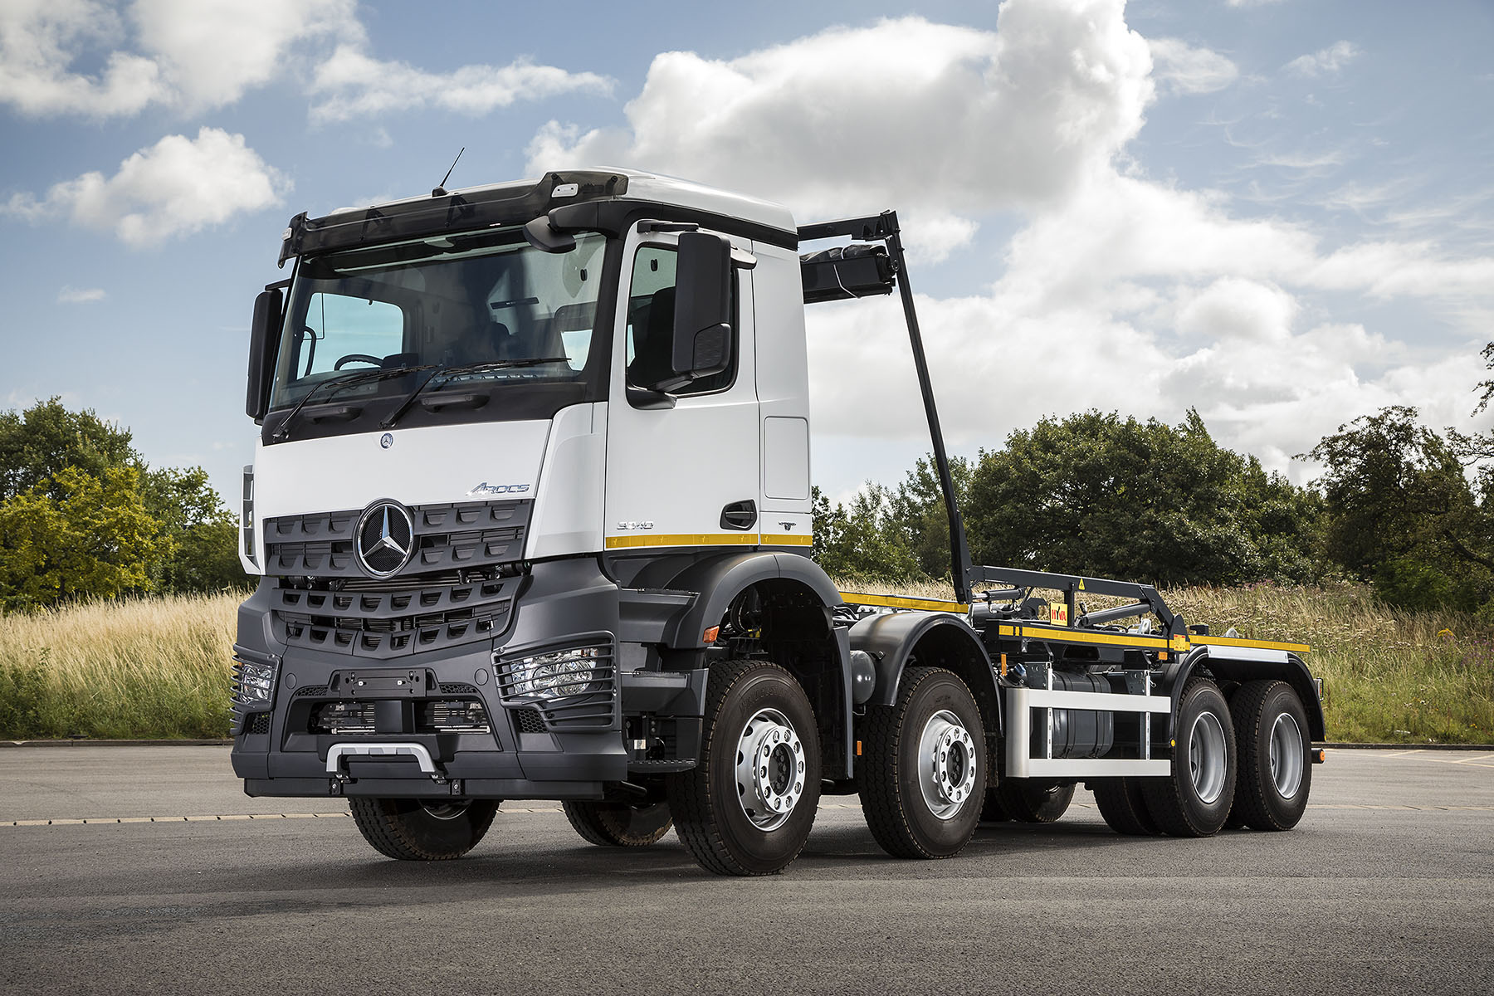
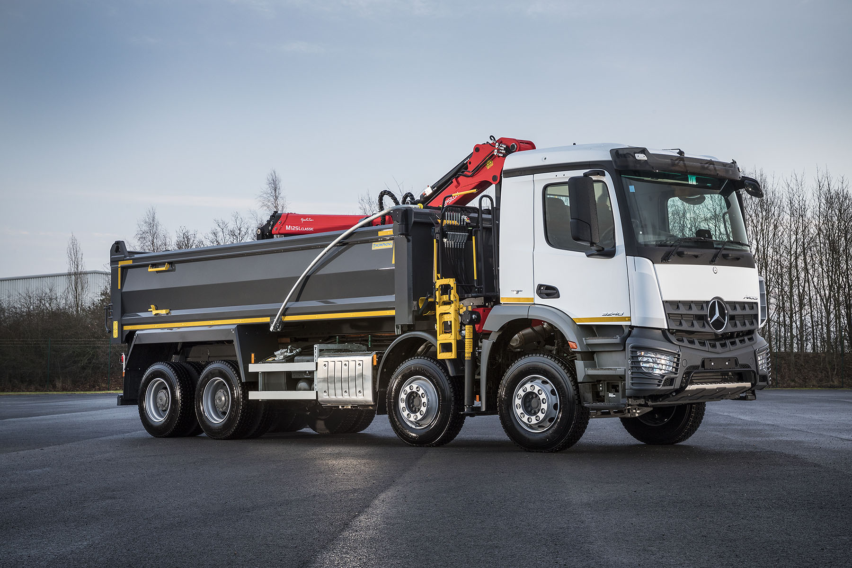

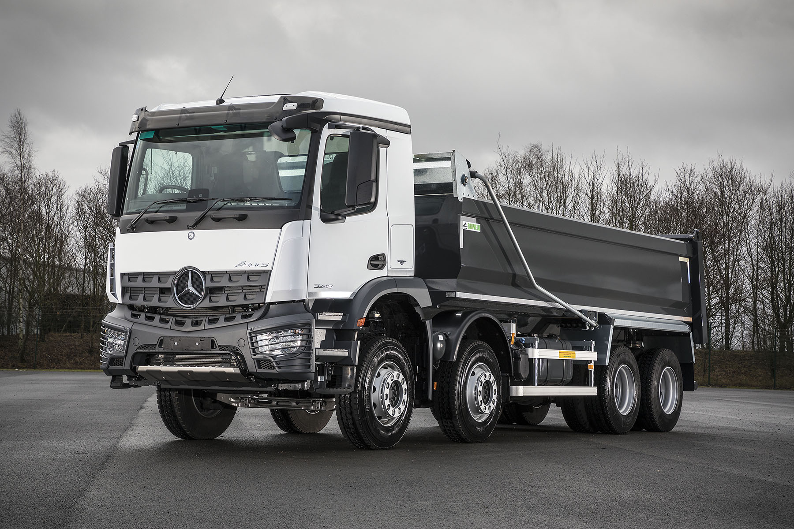

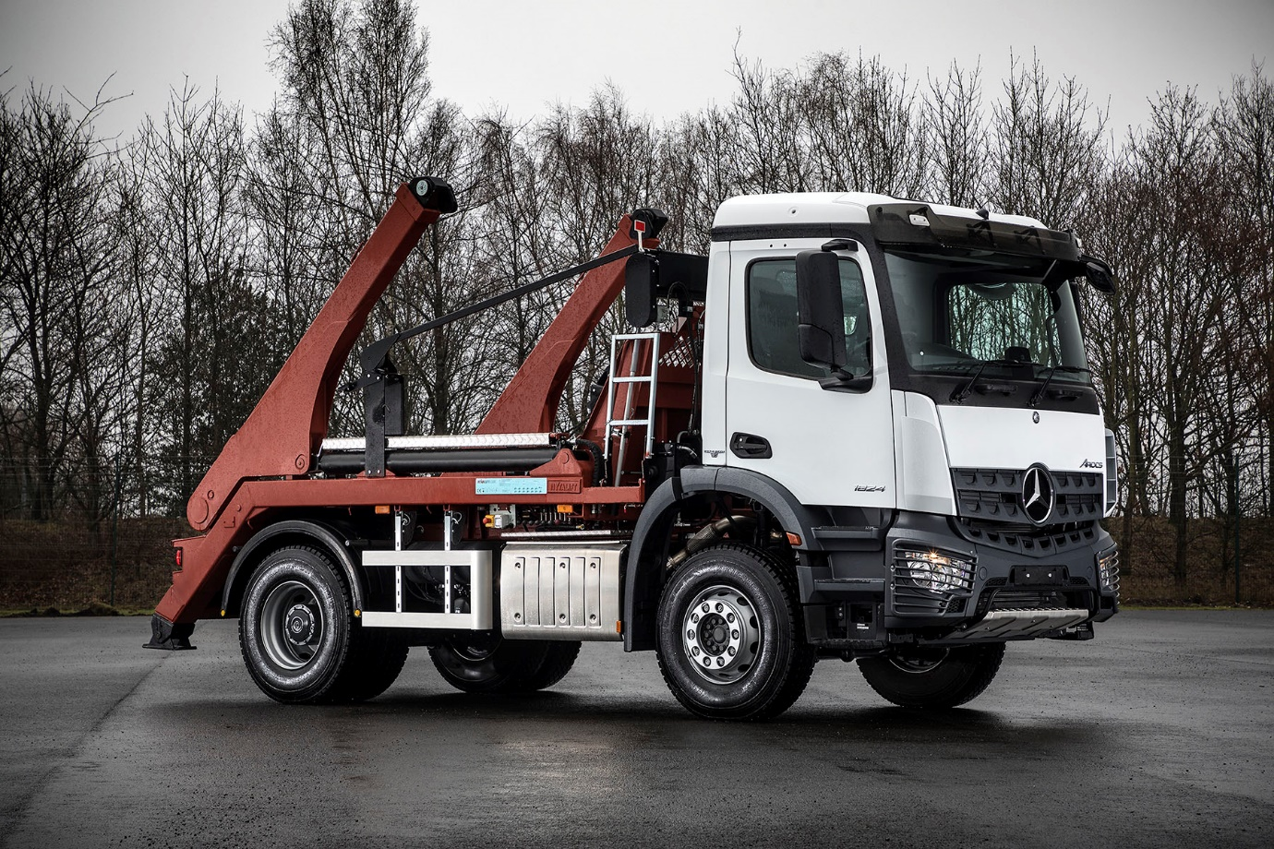

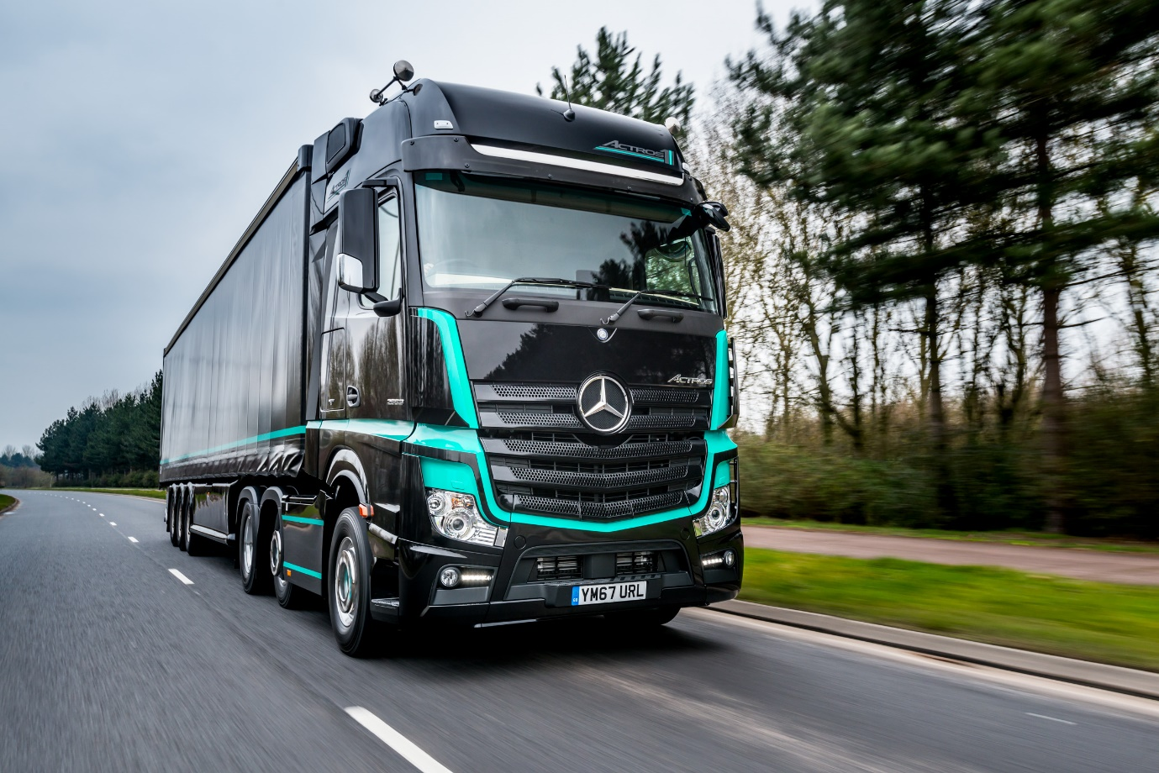

ends

For hi-res image files, please visit:
media.mbtrucks.co.uk

To arrange a Mercedes-Benz WorkReady Trucks test drive, or to request further information, please contact:
Jamie Fretwell, PR & Internal Communications
Mercedes-Benz Trucks
07712 519230, Jamie.Fretwell@daimler.com
or

Steve Warren or John Ripley
Impact Communications, 01926 842126
Steve: 07770 470251, steve@impactcom.co.uk
John: 07771 484595, john@impactcom.co.uk

About Mercedes-Benz Trucks UK Ltd

Mercedes-Benz Trucks UK Ltd is the sales and marketing organisation responsible for all Mercedes-Benz truck products in the UK, including FUSO Canter.

In 2018, the company registered 8,061 new trucks. After growth in 2017, Mercedes-Benz registrations levelled off to 7,223 trucks in 2018, ensuring it retained its title as the second-biggest truck brand in the UK. Meanwhile, FUSO made great strides to reach 838 registrations – including 675 new trucks over 6.0-tonnes.

For more than 125 years, Mercedes-Benz has stood for innovative vehicles that meet exceptionally high standards of quality. Our claim to perfection, sustainability and avant-garde design is now embodied in the next generation of trucks: Actros, Arocs, Atego, Econic and Unimog.

www.mbtrucks.co.uk

