

Date: 12 July 2024

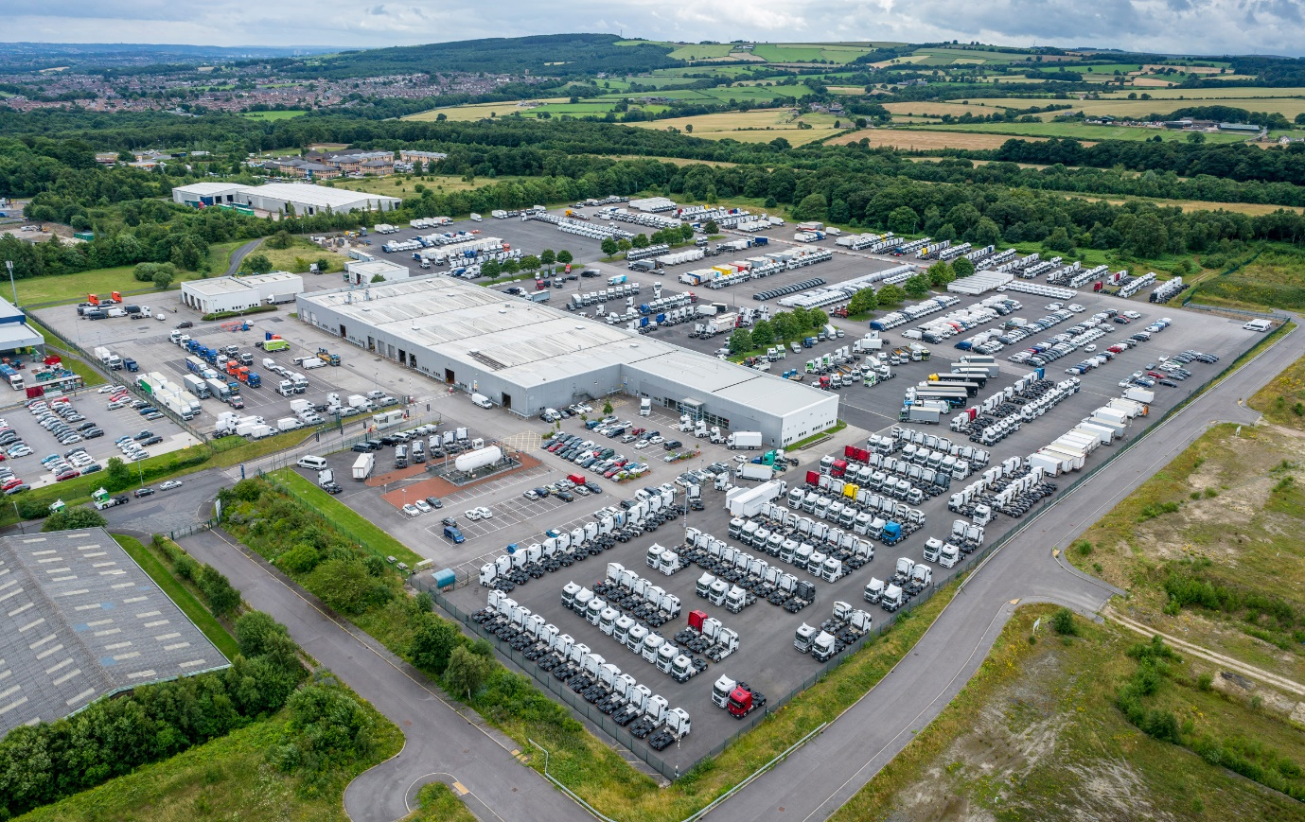
Daimler Truck UK sells Wentworth Park site
Daimler Truck UK has secured the future of its flagship Wentworth Park complex in South Yorkshire, by completing a sale of the land to new owner Culina Asset Management (CAM).

Under the terms of the agreement, CAM will occupy the 34-acre site, close to Junction 36 of the M1, and will continue the running of its extensive workshop.

Wentworth Park is the home of national programmes for re-marketing and sales of used Mercedes-Benz and FUSO Canter trucks, as well as the brand’s demonstrator fleet. Daimler Truck UK will continue to run these functions with a presence on-site, so services to customers will continue largely unchanged.

Heiko Selzam, Managing Director, Daimler Truck UK said: “We’re delighted to announce the completion of this sale, which will allow Wentworth Park and all the services we offer from this impressive site to continue to flourish.

“By collaborating with CAM we can maintain all of the important brand functions we carry out here, while passing responsibility for the workshop to a trusted partner with an impeccable track record.”

CAM will continue to provide workshop services as required to Daimler Truck UK but also use the facilities for its own purposes. The operator’s extensive fleet currently numbers some 5,000 tractor units, some of which are Mercedes-Benz vehicles, and 8,000 trailers.

Culina Asset Management Managing Director David Meir said: “This one-off opportunity to occupy and operate Wentworth Park is seen by CAM as key to the continued strategic development of our offering to both internal and external customers.”

ends

For more information, or to request higher-resolution images, please contact:

Dominic Dawes at Daimler Truck UK
07864 600148, dominic.dawes@daimlertruck.com

or

John Ripley: 07771 484595, john.ripley@loopagency.co.uk

