

Date: 8 February 2023

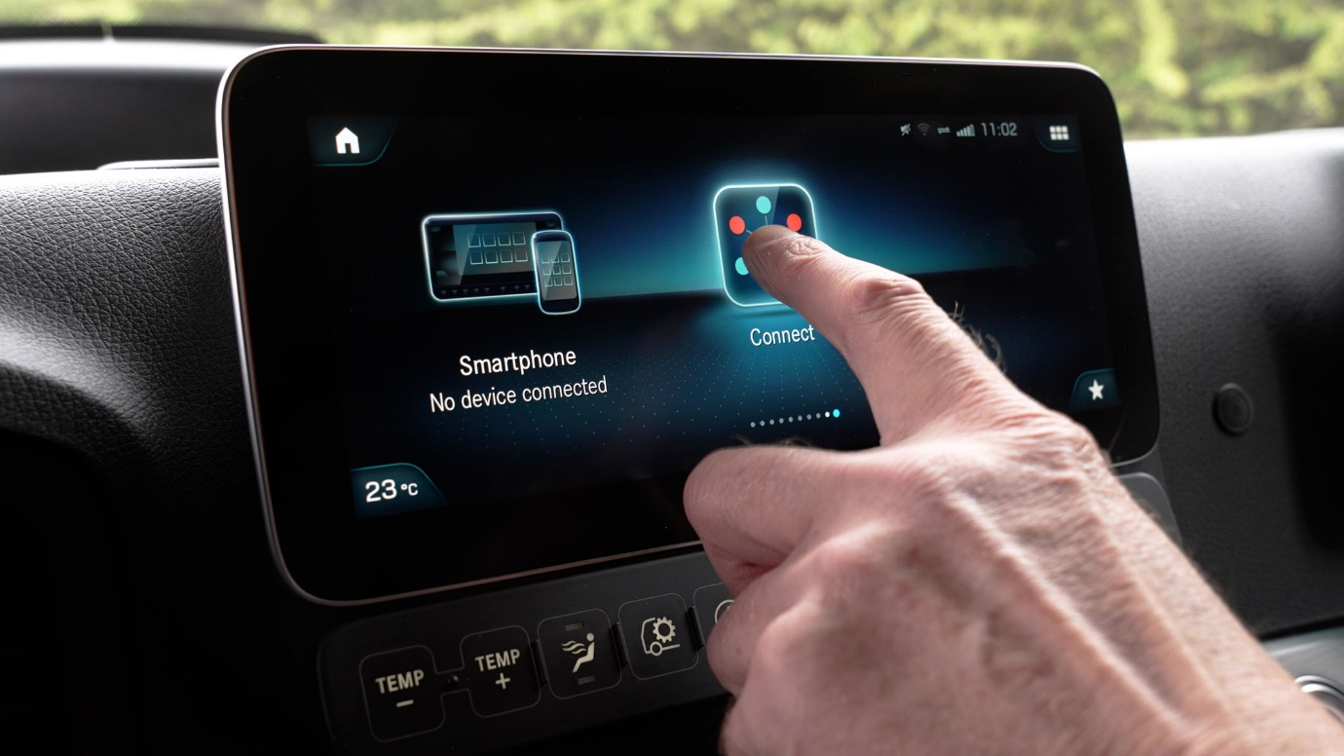

Fingertip control: Mercedes-Benz Actros drivers can now take advantage of Microlise SmartFlow’s market-leading functionality via their Multimedia Cockpit touchscreens

Mercedes-Benz Trucks teams up with Microlise to offer easy, low-cost SmartFlow app access

Operators of Mercedes-Benz Actros trucks with the manufacturer’s innovative Multimedia Cockpit can now download market-leading Microlise SmartFlow work management software directly into their cabs.

A tailored app version of this popular package is now included within the Mercedes-Benz Truck App Portal system, making the Actros the only truck available on the UK market capable of running it without extra hardware.

The move allows operators to make significant cost savings – a monthly subscription to the Microlise SmartFlow Driver WorkFlow App could be up to 85% cheaper than a traditional ‘wired’ installation, with all associated hardware.

Microlise SmartFlow is already the workflow management tool of choice for many of Britain’s leading fleets. It allows drivers to perform a range of tasks such as reviewing and accepting assignments, accessing site details and planned arrival or departure times, and alerting the traffic office to any problems.

In any other truck, a separate dedicated in-cab screen must be installed before Microlise SmartFlow can be used. Actros operators, though, can now use the Truck App Portal to download the new app incorporating many of the full package’s functions, straight to their vehicles.

The Truck App Portal integrates seamlessly with the vehicle’s Multi-Touch Display. Not only can drivers use this to access and operate the system, but the software also engages with the in-built satellite navigation system for optimum routing.

“As well as being more cost-effective, this development allows users to install the Microlise SmartFlow App a lot more quickly and easily than was previously possible,” explained Richard Skidmore, Head of Customer Service Delivery at Mercedes-Benz Trucks UK.

“By teaming up with Microlise to offer this innovative solution we have been able to demonstrate once again, the wide variety of benefits that our in-cab technology is capable of delivering.”

Steve Watson, Microlise Director of Product, said: “This new app allows Actros operators to get on the road with SmartFlow quickly and easily. It can then save drivers and their traffic office colleagues time and effort, as well as helping with compliance.

“Drivers are logged into the system automatically when they insert their tacho cards. Journeys are fed through directly to the cab and integrated with sat-nav screens. Administration becomes easier, with instant updating of deliveries, collections and consignment information. Communication is improved and delivery paperwork reduced, which helps everyone’s working day run more smoothly.”

The Mercedes-Benz Truck App Portal is an integral feature of the Multimedia Cockpit. It allows fleet managers to assign specific apps to their vehicles via the Multi-Touch Display.

Software engineers at Mercedes-Benz Trucks UK worked with their counterparts at Microlise to develop the Driver WorkFlow App and tune it for optimum performance and delivery through the Truck App Portal.

“This Microlise SmartFlow Driver WorkFlow App was developed here in the UK, specifically to suit the particular requirements of operators in this country,” continued Richard Skidmore. “It’s the first of what we hope will be a series of bespoke products created in-house for our domestic customers.

“Connectivity is a key part of our strategy to support customers, and the development of this exciting new addition to our portfolio of apps is a perfect example of the consultative way we work with fleets to help save them money and increase operating efficiency.”

To watch Microlise Smartflow on Truck App Portal in action, click the video link https://vimeo.com/786263416/18086075ce

For more information about Mercedes-Benz Truck App Portal and the apps available, please get in touch with MBTUK Connectivity Services at truckconnectivityuk@daimlertruck.com

To find out more about how Microlise SmartFlow App can support your needs, visit https://www.microlise.com/blog/product-insight-mercedes-benz-truck-portal/

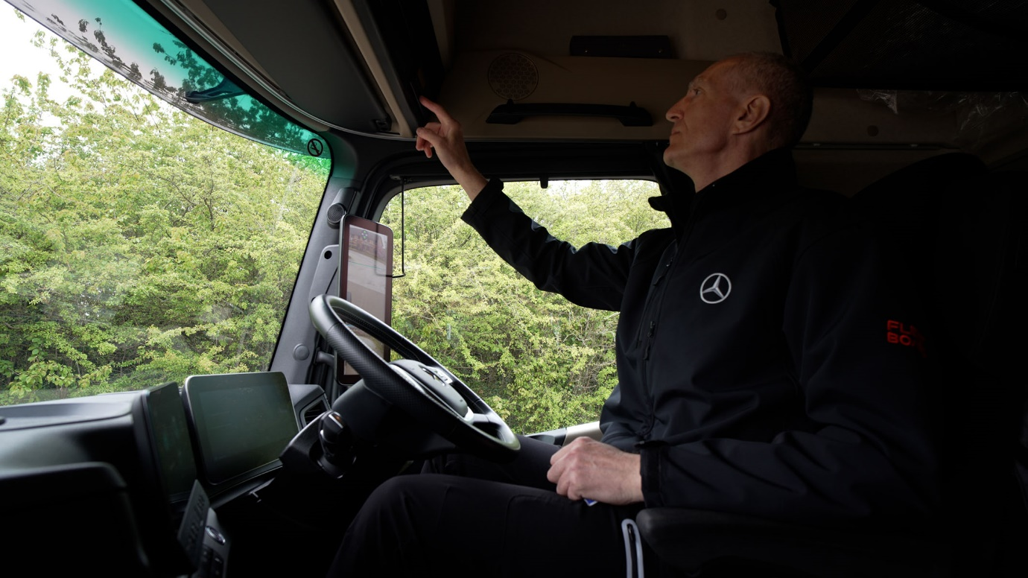

Logged and loaded: Drivers access the system automatically by inserting tacho cards

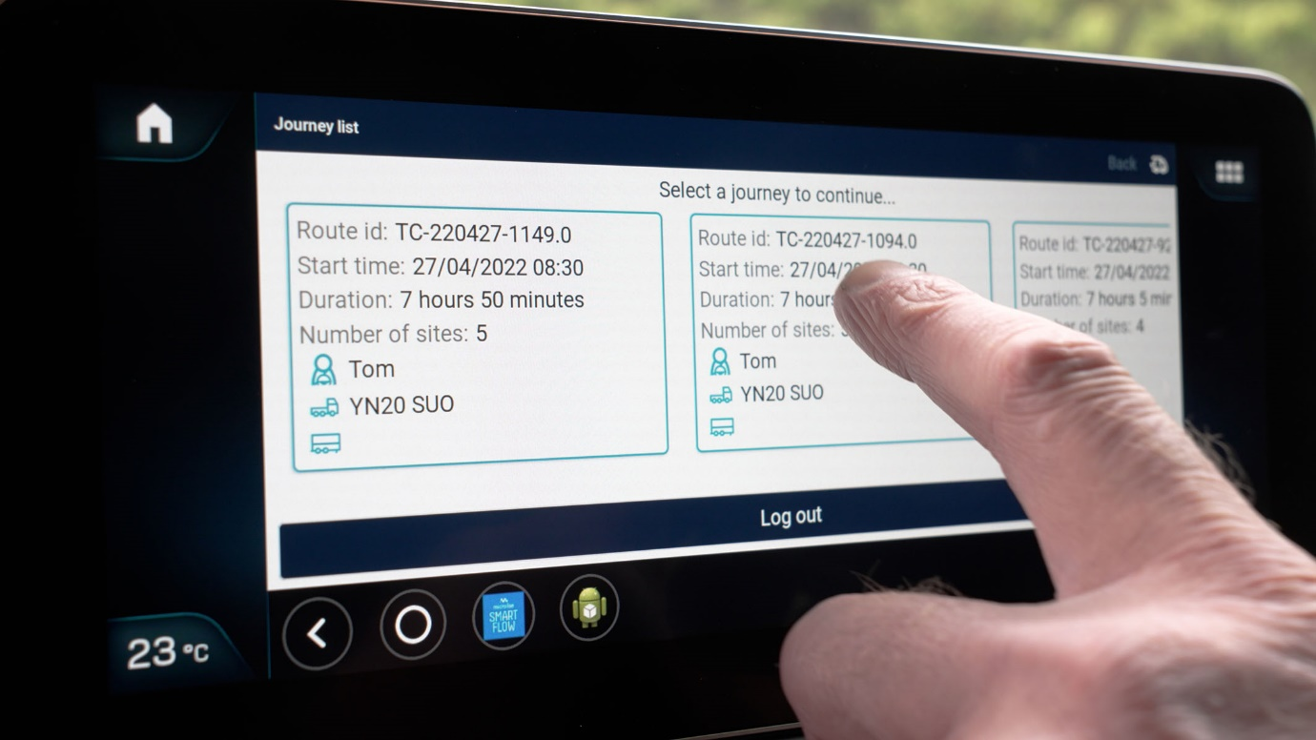

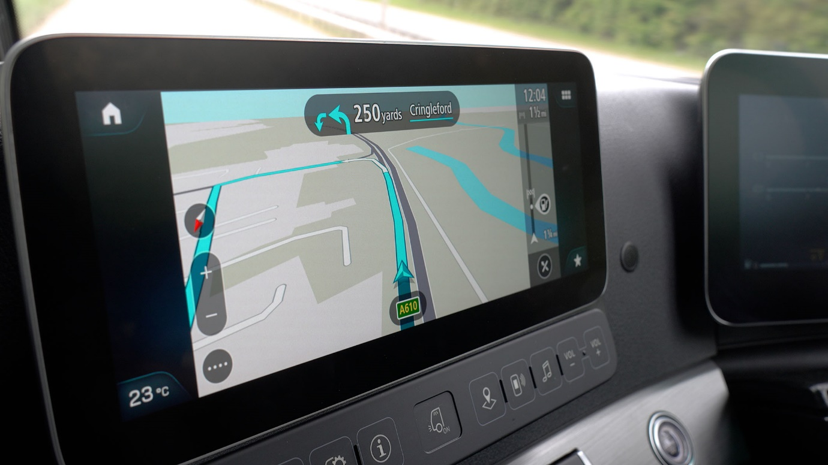

‘Routeing’ for you: The Microlise SmartFlow App integrates with existing satellite navigation

ends

For more information, or to request higher-res image files, please contact:

Jamie Fretwell at Mercedes-Benz Trucks UK Ltd
07712 519230, jamie.fretwell@daimlertruck.com

For more information regarding the Microlise SmartFlow App, please contact:

Leonardo Mifsud, Microlise
07768 711355, len.mifsud@microlise.com

