

Date: 18 December 2020

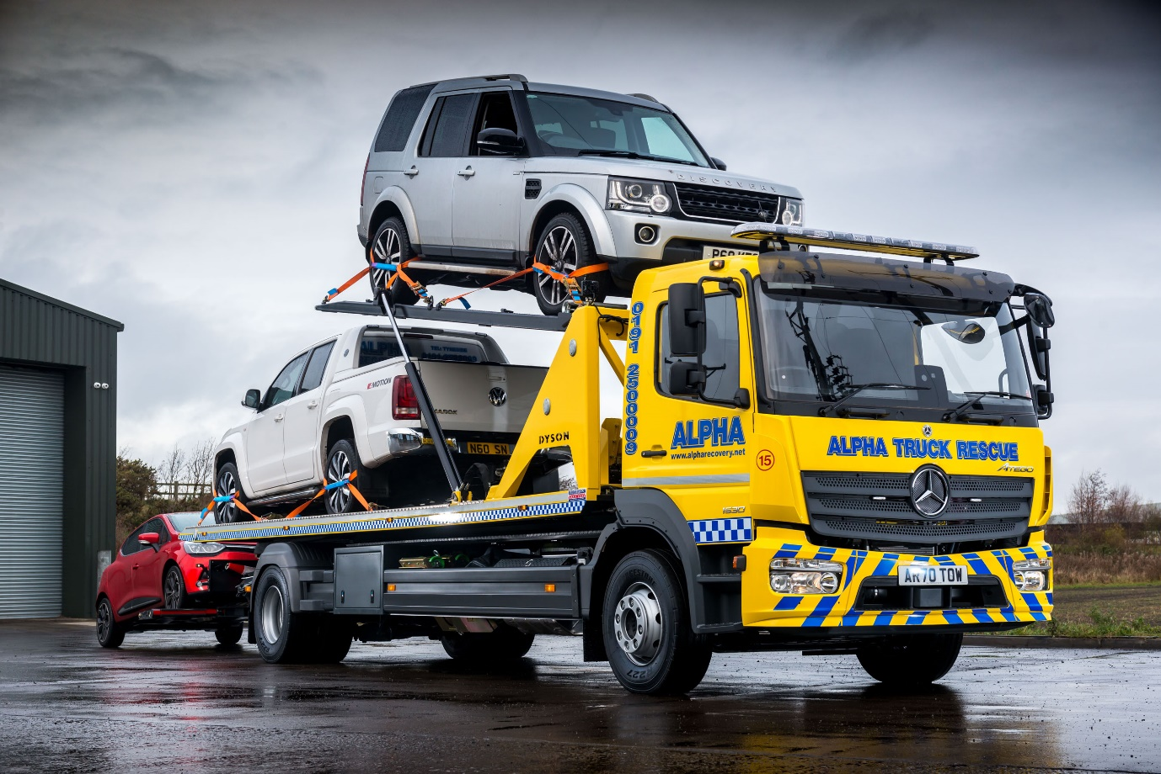

Rugged, reliable Mercedes-Benz Atego slides smoothly into action for Alpha Recovery

The long-standing relationship between Northumberland’s Alpha Recovery and Mercedes-Benz Dealer Bell Truck and Van has been given a lift by the delivery of a new breakdown truck from a model line renowned for its strength and durability.

The Atego 1530 is the latest addition to the Cramlington-based operator’s fleet. It has an uprated gross weight of 16 tonnes and a ClassicSpace cab with optional third seat, while the 7.7-litre ‘straight six’ engine produces 220 kW (300 hp).

The vehicle’s SLA Super-Low Approach vehicle transporter bodywork is by specialist manufacturer Roger Dyson, of Droitwich, Worcestershire. While one vehicle is carried on the sliding bed, a lifting section accommodates a second, and a third can be towed using a spectacle lift.

The Atego arrived with Alpha Recovery just as the latest lockdown came to an end, and the first snows of the winter swept across parts of northern England. “The truck landed at a particularly busy time for us, due to the bad weather and increased traffic volumes,” recalled Recovery Manager Simon Narey. “The fact that Bell Truck and Van delivered it on time and in perfect condition meant we could get it straight out and into the thick of the action.”

Alpha is a trusted contractor to regional police and ambulance services, as well as commercial fleets, insurance companies and national roadside assistance organisations.
Ideally specified to attend multi-vehicle accidents, the Atego offers a payload capacity of 6.0 tonnes which is easily sufficient to carry two large SUVs, while the spectacle lift means it can recover up to three vehicles from a location in a single trip.

Roger Dyson’s SLA transporter bed is designed to slide clear of the chassis and lie very close to the ground, giving an approach angle of less than five degrees – as a result, high-performance sports cars and others with very low clearance can be loaded without any risk of damage.

Alpha Recovery has operated Mercedes-Benz trucks of various size in the past, but more recently most of the vehicles have been Swedish-built. The company’s decision to award its latest order to Bell Truck and Van owes much to the dogged determination of Truck Sales Executive Alex Wordsworth.

“The Dealer has made great strides over the past couple of years, and Alex worked hard to convince us that we should give it another chance,” said Mr Narey. “His customer service, like that of everyone to whom we’ve spoken from the senior management team down, has been excellent.

“We maintain the fleet in our own large and very busy workshop, but Bell’s parts department has put systems in place to keep us well stocked with everything we need. We know, too, that should we require any technical advice its own workshop is only a phone call away,.”

Purpose-designed for light- and medium-duty distribution work, as well as construction applications, the Mercedes-Benz Atego range from 7.5-16 tones GVW offers outstanding dynamics, comfort and manoeuvrability. It also enjoys an unrivalled reputation for rugged reliability.

Having operated Atego-based recovery trucks previously, Alpha Recovery is already familiar with these attributes. “It’s a great piece of kit,” enthused Simon Narey, “well built and comfortable to drive, while also providing a solid platform for the recovery equipment.

“We can’t afford to run breakdown trucks that break down themselves, but we know from experience that we can always depend on an Atego. The new truck looks great in our high-visibility livery too.”

Established in 1987 with a single, crane-equipped 4x4, Alpha Recovery now runs a diverse fleet of 36 recovery vehicles, from 7.5 tonnes GVW upwards. The business remains family-run, while several members of its 20-plus workforce have accrued long service records.

Working 24 hours a day, 365 days a year, Alpha Recovery has satellite depots to the north and south of Newcastle, and covers an area that stretches from North Yorkshire to southern Scotland.

alpharecovery.net

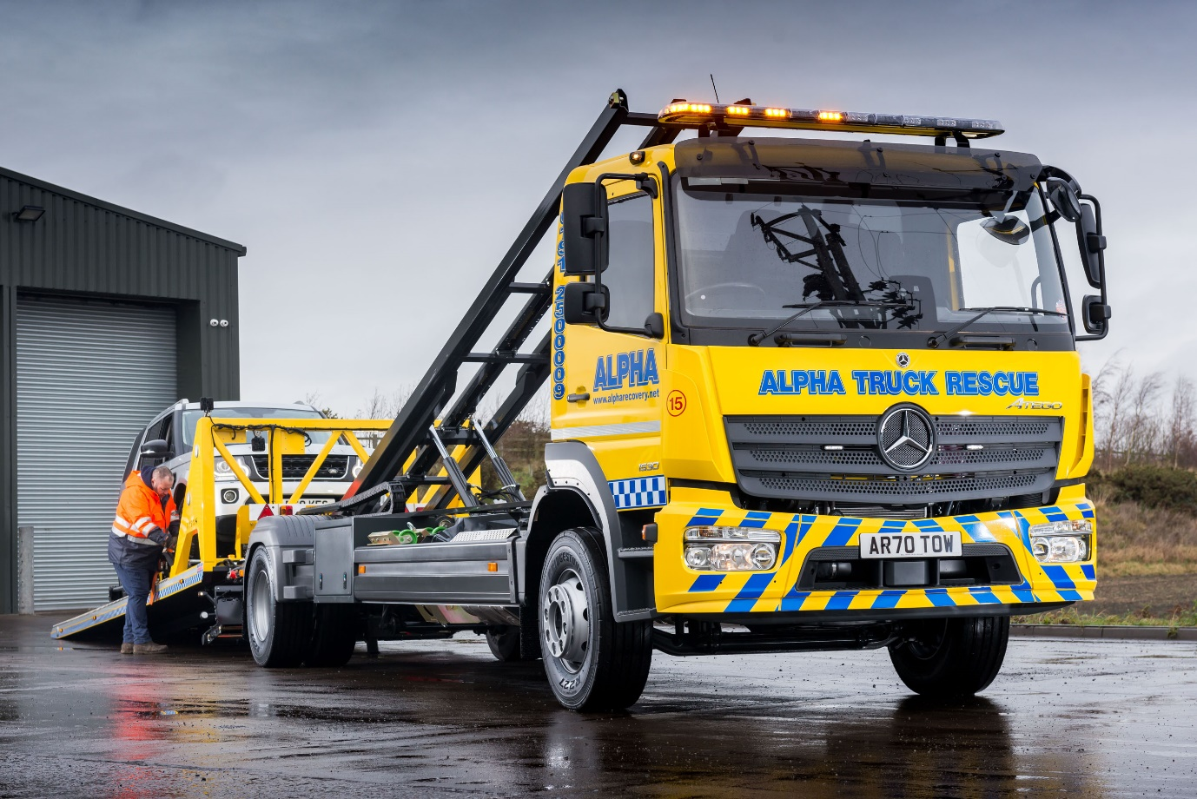

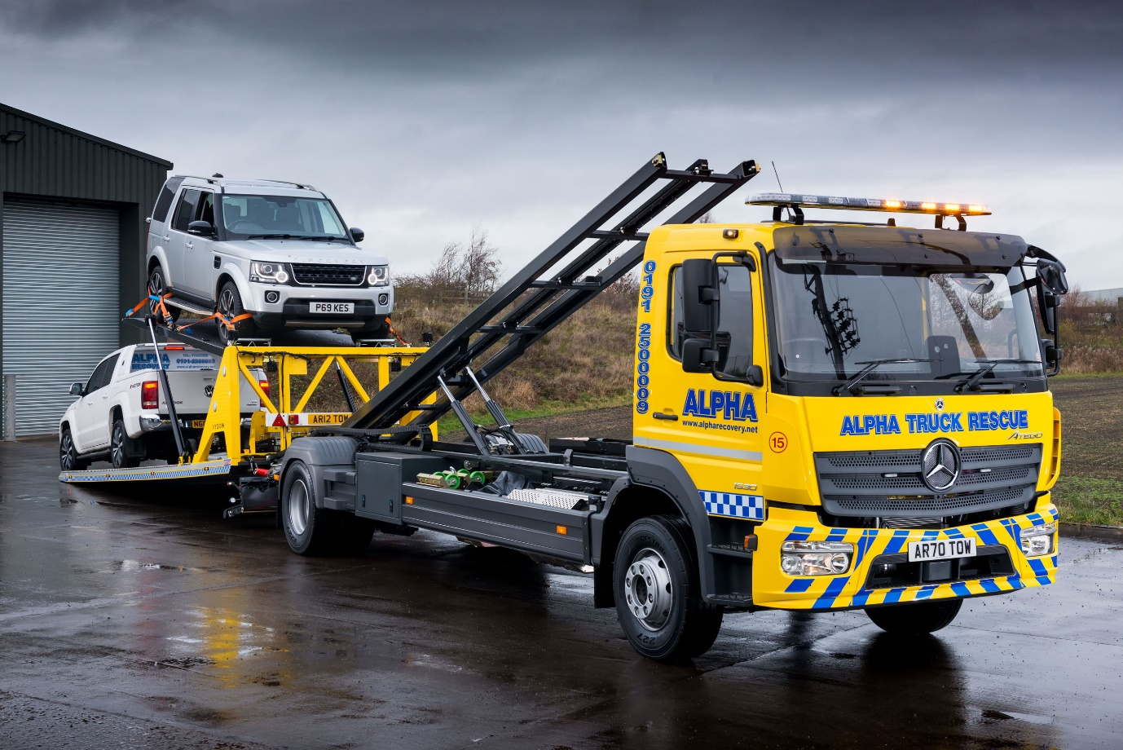

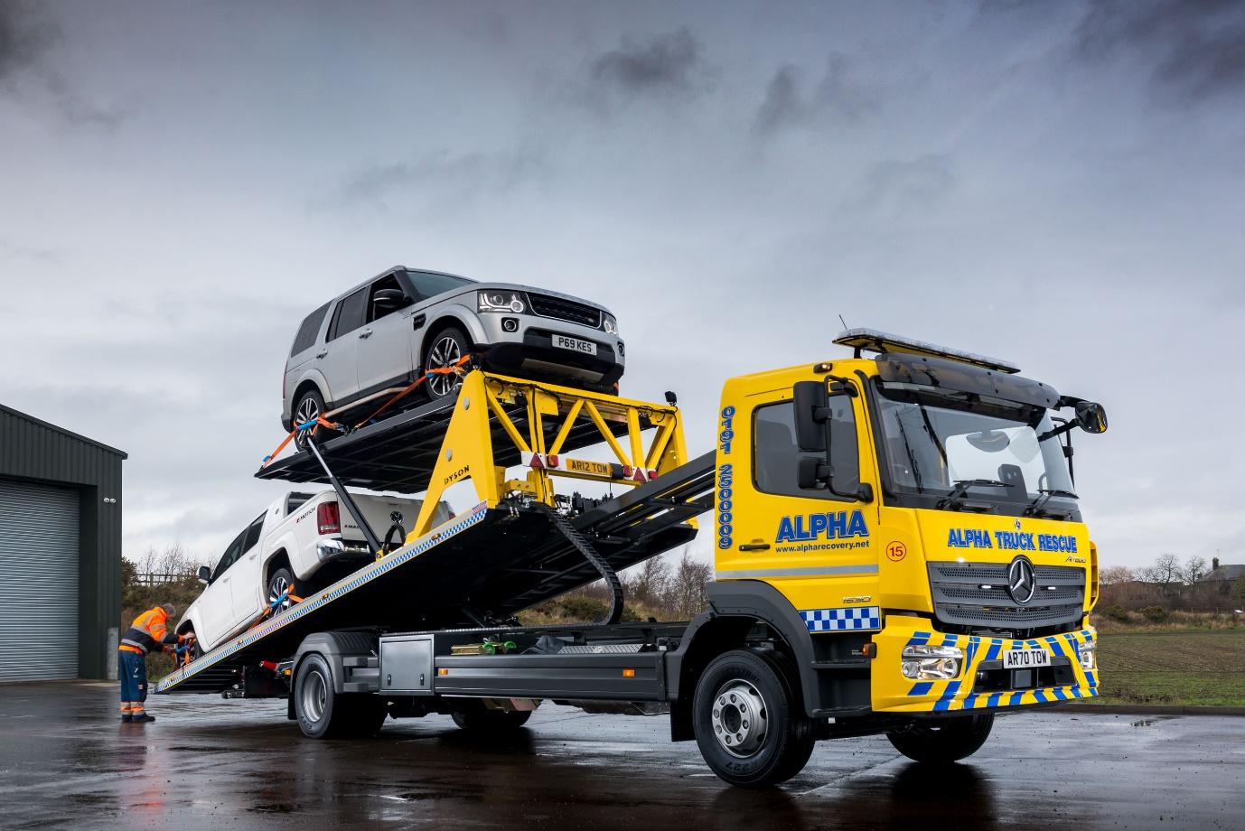

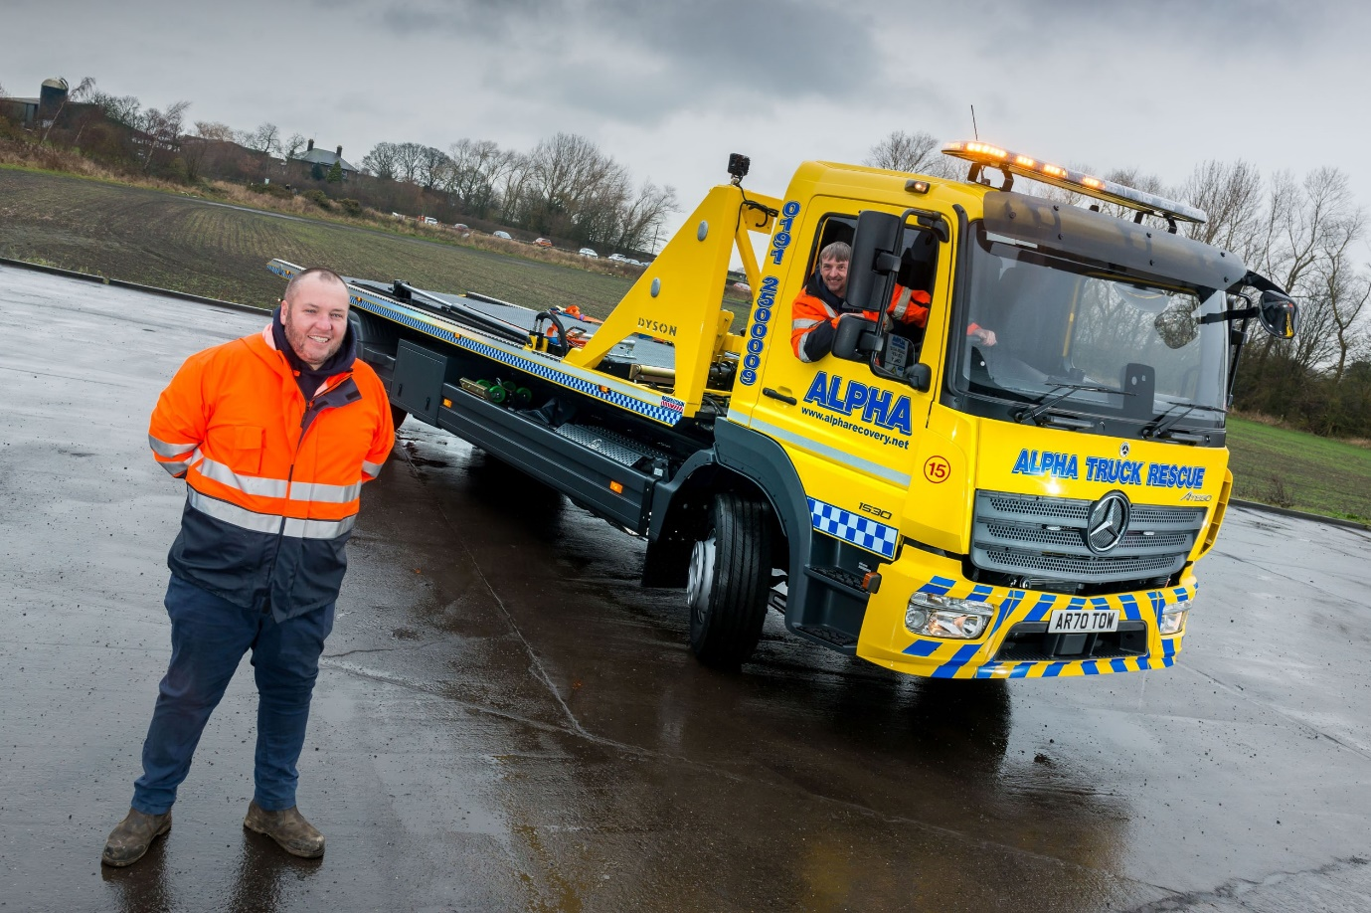

Convinced: The Mercedes-Benz Atego is a “great piece of kit” according to Alpha Recovery’s Simon Narey, left, who is pictured with driver Ian Pigg

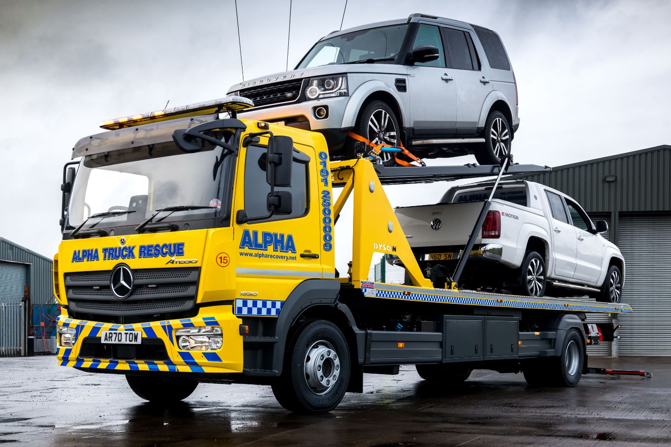

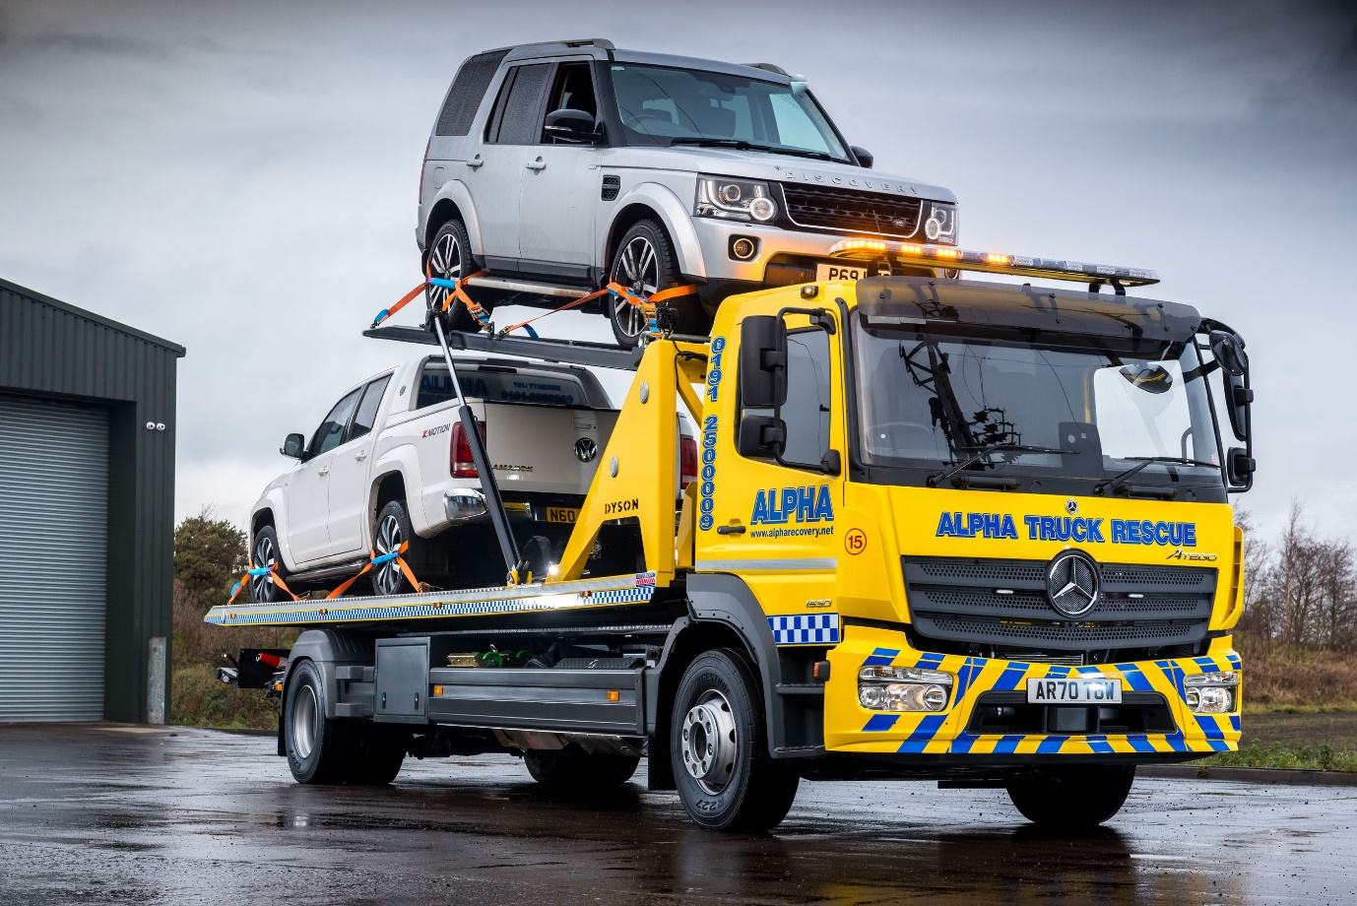

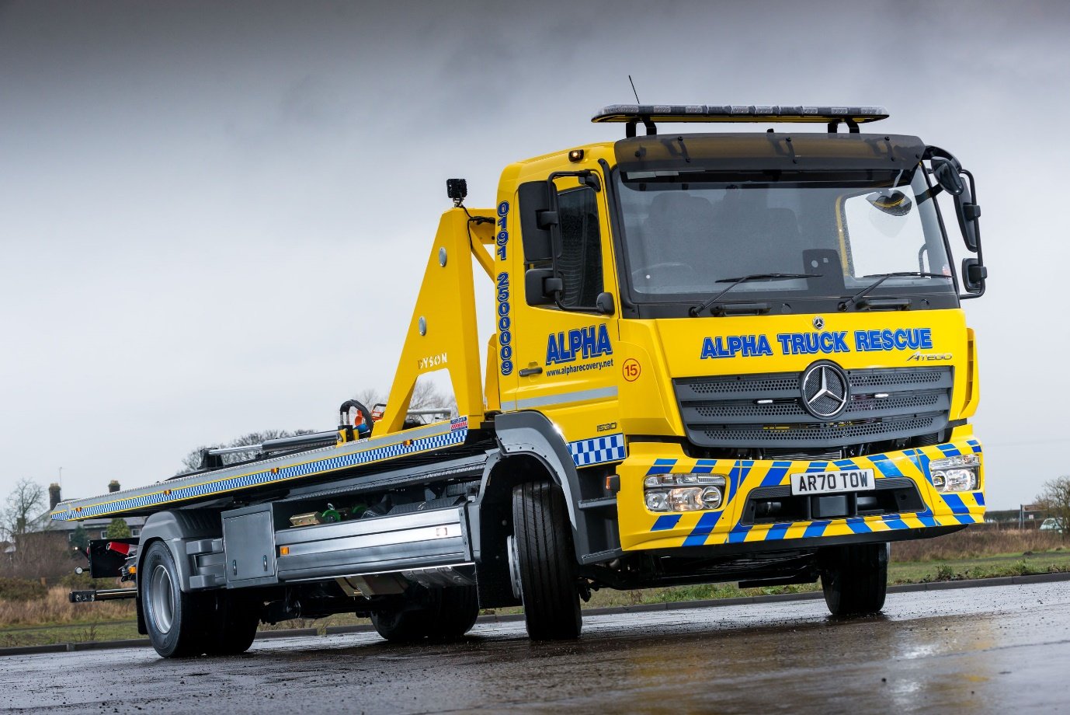

ends

For more information, or to request bigger versions of image files, please contact:
John Ripley or Steve Warren
Impact Communications, 01926 842126
John: 07771 484595, john@impactcom.co.uk
Steve: 07770 470251, steve@impactcom.co.uk

