

Date: 30 June 2021

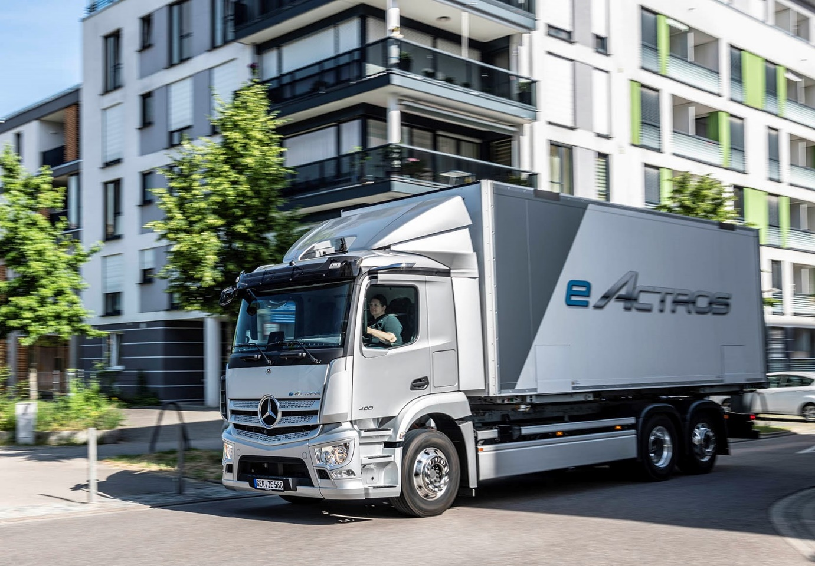

World première of the new Mercedes-Benz eActros

Short version:

The new eActros

A brief overview of the highlights

Range of up to 400 kilometres, battery capacity of around 420 kWh²

Electric axle with two powerful electric motors delivering a top output of 400 kW

Impressive driving dynamics and high driving comfort thanks to a truly responsive two-speed transmission

Tailor-made turnkey charging solutions thanks to comprehensive advice and service offering.

Intelligent digital solutions and apps for even greater efficiency and customer benefit

Equipped as standard with proven, innovative core products such as MirrorCam and Multimedia Cockpit Interactive

Safety with high added value thanks to standard features such as the Acoustic Vehicle Alerting System, Sideguard Assist S1R and fifth-generation Active Brake Assist emergency braking system

Stuttgart – On 30 June 2021, Mercedes-Benz Trucks celebrates the world première of its battery-electric eActros for heavy-duty short-radius distribution. With the first series-produced electric truck to bear a three-pointed star, Mercedes-Benz Trucks is ringing in a new era and simultaneously highlighting its clear desire to achieve CO2-neutral road-based goods transport. The standard model of the eActros is planned to roll off the production line in Wörth am Rhein (Germany) from autumn 2021. The findings from the “eActros innovation fleet” which started in 2018 and the close exchanges with customers have been incorporated into the development of the series-production model. Alongside this, proven features such as MirrorCam and the Multimedia Cockpit Interactive have been adopted in the standard specification. The eActros is now ready to assist customers of Mercedes-Benz Trucks on the road to CO2-neutral transport services.

Practical range

The battery of the eActros series-production model is equipped with either three or four battery packs, each with an energy capacity of around 105 kWh³. The maximum battery capacity of 420 kWh² enables ranges of up to 400 kilometres to be achieved. The technological centrepiece of the electric truck is the drive unit – a rigid electric axle with two integrated electric motors and a two-speed transmission. Both liquid-cooled motors generate a continuous output of 330 kW as well as a top performance of 400 kW. Plus, if the vehicle is driven particularly foresightedly, recuperation enables the vehicle to recover electrical energy. The energy obtained in this way during braking is fed back into the batteries of the eActros and is again made available for use by the drive system.

Impressive performance

The two integrated electric motors offer great efficiency and a constant delivery of power with high starting torque. The provision of immediate torque by the electric motors which are coupled with a two-speed transmission ensures powerful acceleration, impressive driving comfort and driving dynamics which enable more relaxed, low-stress driving than a conventional diesel-powered truck. Plus, the low centre of gravity is also favourable when it comes to cornering. In full-load operations, drivers enjoy a pleasant noise reduction of 10 dB inside the cab, which roughly corresponds to a halving of perceptible noise volume. Thanks to the low noise level, night-time deliveries are also possible. Contrary to a diesel truck, there are also noticeably fewer vibrations. The eActros can be charged with up to 160 kW: When connected to a regular 400A DC charging station, the battery packs need little more than one hour to charge from 20 to 80%⁴.

Integral component of a business eco-system

In order to assist transport companies along every step of their way into eMobility, Mercedes-Benz Trucks has embedded the eActros in an eco-system which also provides advice and services, as well as a range of digital solutions to increase capacity utilisation of the vehicle and to optimise the total cost of ownership. For example, using a customer’s existing route plans, it is possible to establish a highly realistic and meaningful usage profile for electric trucks. This so-called eConsulting doesn’t just include electrification of the depot, but – if the customer desires – also covers questions concerning planning, applying for and implementing everything to do with the charging infrastructure and connection to the electricity network. To this end, Mercedes-Benz Trucks has also established a strategic partnership with ENGIE and EVBox Group. Plus, if required, Mercedes-Benz Trucks can additionally provide help with identifying any available public grants for infrastructure and vehicles.

Intelligent digital solutions

Using the Multimedia Cockpit Interactive which comes as standard in the eActros, the driver remains constantly up-to-date with the charge level of the batteries and the remaining range, as well as the current and average energy consumption. What's more, fleet managers can use the Fleetboard portal's digital solutions to efficiently control their fleet. This includes such things as an individually developed Charge Management System for creating charging profiles, and a logbook containing detailed information on driving times, downtimes and charging breaks. There is also a mapping tool which shows the vehicle's current location in real-time, as well as whether it is in motion, parked or being charged, not to mention how high the battery charge is. Furthermore, the eActros is also available with Mercedes-Benz Complete – a service contract including the All-round Carefree Package. Equally always included with this is intensive customer support through Mercedes-Benz Uptime. As part of this, fully automatic telediagnosis continuously monitors the status of several vehicle systems in the truck in real time. By bundling repair and maintenance requirements, the number of unplanned workshop visits can thus also be reduced.

High level of safety for the driver and other road users

Numerous features and systems in the eActros ensure a high level of road safety for all concerned. For example, special crash elements with an aluminium profile protect the batteries in the event of a side-on crash, while sensors integrated in these can detect a crash scenario. In such a case, the HV battery would be automatically isolated from the rest of the vehicle. What's more, the driver always has the option of actuating the HV shutoff at any time in the cab. Meanwhile, to ensure the vehicle is easier for road users like pedestrians and cyclists to hear, the eActros comes as standard with an external Acoustic Vehicle Alerting System (AVAS). Also assuring additional safety when turning off to the nearside is the Sideguard Assist which comes as standard on the eActros. Another system which is part of the standard scope of equipment is the fifth-generation Active Brake Assist emergency braking system with pedestrian recognition. This can help to reduce the risk of a collision in the longitudinal direction on urban streets, out-of-town roads or motorways.

With all assistance systems, Mercedes-Benz Trucks aims to support the driver as much as possible within the respective limits of each system. However, as the law prescribes, the driver remains fully responsible for driving the vehicle safely at all times.

Long version:

A new truck for a new era

The eActros sets benchmarks in CO₂-neutral goods transport

Mercedes-Benz Trucks is striving to complete its switch to electrically powered trucks in Europe by 2039.

With the eActros, Mercedes-Benz Trucks is making a major step towards achieving the aims of the Paris Agreement.

The eActros is now “Charged & Ready” and forms an integral part of a business-oriented eco-system.

The findings from the “eActros innovation fleet” and the close exchanges with customers have been incorporated into the development of the series-production model.

The logistics sector is facing a massive set of challenges: on the one hand, environmental regulations are getting even more demanding, while on the other, the global transport volume is increasing. This volume of goods needs to be transported as sustainably and efficiently as possible.

In view of its social responsibility for climate protection, Mercedes-Benz Trucks is thus working hard to achieve its aim of CO2-neutral goods transport using battery-electric and hydrogen-based fuel-cell technologies. The company identifies with the Paris Agreement's aim of decarbonising the sector and wishes to completely switch its European product portfolio over to electrically powered trucks by 2039.

The eActros from Mercedes-Benz Trucks is now the first fully-electric series-production truck bearing the three-pointed star and thus marks an important step in the direction of locally CO2-neutral goods transport. Further steps for long-distance haulage are also in the pipeline: series production of the low-floor Mercedes-Benz eEconic truck is expected to start in 2022. In addition to this, the battery-electric eActros LongHaul is expected to be launched in 2024 and the GenH2 Truck with hydrogen-based fuel cell will come in the second half of this decade.

Innovative answer to the shake-up of the transport sector

Specially developed for heavy-duty short-radius distribution, the eActros stands for sustainability and, thanks to its resource-friendly nature, it simultaneously also serves to improve the image of transport companies, not to mention rendering the job of truck drivers more attractive. Another thing which the eActros enables is the ability to re-think regional and local short-radius distribution. After all, the electric truck offers also a range of other benefits for customers. Among the advantages are, for example, the ability to make night-time deliveries or to enter inner cities where diesel vehicles are no longer permitted to be used.

Mercedes-Benz Trucks offers fleet operators an integrated, complete solution

Naturally, the procurement of an electrified truck must also be financially worthwhile in the daily operations of transport businesses. Plus, transport companies will no doubt have a number of questions: on which routes can an electric vehicle be used? What about charging infrastructure? Which building measures and investments will need to be made at the depot?

And so it becomes even more important that customers don’t just buy an electric truck, but that they are also assisted along the entire path to electrifying their fleet. After all, eMobility is more than just a new drive system. It is precisely for this reason that Mercedes-Benz Trucks has embedded the eActros in a business-oriented eco-system bearing the slogan “Charged & Ready”. It offers advice in the form of eConsulting, as well as digital solutions concerning eMobility and the optimisation of the total cost of ownership (TCO). The integrated eActros is a full-service offering which makes Mercedes-Benz Trucks a reliable partner for its customers when it comes to sustainable future mobility.

Successful practical operations in customer hands as part of the “eActros innovation fleet”

After Mercedes-Benz Trucks presented a concept vehicle for heavy-duty short-radius distribution in urban areas at the 2016 IAA for commercial vehicles in Hanover, the first prototypes of the eActros were handed over in 2018 to various customers around Germany and other European countries for practical testing. The declared aim of the “eActros innovation fleet” was to create a market and series-ready electric truck for heavy-duty short-radius distribution from 2021. In line with this, aspects such as the energy requirements in various operating scenarios and the efficiency of the eActros prototypes were determined. The development and testing of the prototypes from the innovation fleet were funded as part of the “Concept ELV²” project to various degrees by the German Federal Ministry for the Environment, Nature Conservation and Nuclear Safety (BMU) as well as by the German Federal Ministry for Economic Affairs and Energy (BMWi).

After running for more than two years, the main finding from the pilot project was that performance of the prototypes was impressive. Drivers, for example, were particularly pleased with the continuous availability of the torque across the entire speed range. What’s more, they also mentioned in particular the quiet running and the pleasant, smooth driving experience. The findings from the innovation fleet and the close exchanges with customers have been wholly incorporated into the development of the series-production model. In comparison with the prototype, the series-production vehicle was drastically optimised in some important characteristics, including the range, drive power and safety. It was customer co-creation in its purest form. In an initial step, the series-production model of the eActros will be available not just in Germany, but in the UK, as well as Austria, Belgium, Denmark, France, Italy, the Netherlands, Norway, Spain, Sweden and Switzerland. Further markets will follow.

High-tech equipment ensures sustainable performance

The eActros has plenty of power and delivers an impressive driving experience

The electric drive system’s compact electric axle with two electric motors enables top performance of up to 400 kW.

The eActros is available with three or four battery packs, each with around 105 kWh⁵ and thus delivers a total battery capacity of 315 or 420 kWh⁶.

The range is as much as 400 kilometres.

The eActros offers a high degree of driving comfort, among other things thanks to its powerful acceleration and low noise level.

When transport companies opt for an electric truck, decisive criteria include range, power delivery, rapid recharging, suitability for daily use and a versatile range of possible applications, not to mention low noise levels and locally CO2-emission-free driving. The eActros is available as a two or three-axle truck with 19 or 27 tonnes permissible gross weight. Serving as the basis of the new truck is the frame of the Mercedes-Benz Actros. The quiet drivetrain also enables night-time deliveries to take place, thus relieving strain on road networks during peak times.

Permanent power transfer to the electric axle

For the eActros, Mercedes-Benz Trucks is using a global platform architecture: the ePowertrain. The technological centrepiece of this is the drive unit – a rigid electric axle with two integrated electric motors and a two-speed transmission. In comparison to the concepts with a central motor, this variant offers a number of advantages. For example, the more compact construction leaves a greater amount of installation space for a larger battery capacity, which naturally has a positive effect on the range. Compared with a central motor, the direct transmission of power which this concept enables also offers efficiency benefits.

The two motors are positioned centrally on the rear axle where they generate a continuous output of 330 kW and a peak performance of 400 kW. The immediate provision of torque by the electric motors coupled with the two-speed transmission ensures powerful acceleration, impressive driving comfort and driving dynamics which enable more relaxed, low-stress driving than a conventional diesel-powered truck. In full-load operations, drivers enjoy a relaxing noise reduction of 10 dB inside the cab, which roughly corresponds to a halving of perceptible noise volume. Contrary to a diesel truck, there are also noticeably fewer vibrations.

Battery technology from Mercedes-Benz Trucks

Depending on the equipment version, it draws its energy from either three or four battery packs with 105 kWh each⁴. These are installed in compartmental form underneath the frame and they result in a total capacity of either 315 or 420 kWh⁸. The maximum capacity of 420 kWh enables ranges of up to 400 kilometres to be achieved⁹.

In this context, the combination of large battery packs with powerful electric motors has a positive side effect: significant recuperation potential. That’s because, with every application of the brakes, the electric motor can convert kinetic energy into electrical energy. The energy which this recovers is fed into the eActros batteries, where it is stored to increase the range for subsequent use. Depending on the situation, the driver can select from five different braking stages.

A display in the standard Multimedia Cockpit Interactive of the eActros to keep the driver up-to-date on the charge level of the batteries and the remaining range, as well as the current and average energy consumption in kWh per 100 kilometres.

Besides the drivetrain, the batteries also supply the electricity for the entire vehicle. Thus, for example, auxiliary units such as the air compressor for the brakes, the compressor for the cab’s air conditioning and, if fitted, a refrigerated body are also electrically powered. If required, the battery packs can be replaced with ease.

Clever concept for charging and bundling of components

The charging standard used is the Combined Charging System (CCS). The eActros can be charged with up to 160 kW: When connected to a regular 400A DC charging station, the battery packs need little more than 1 hour to charge from 20 to 80%¹⁰. To charge the eActros, a CCS Combo-2 type connector is required and the charging station must support DC charging.

The low-voltage on-board electrical network with two regular 12-volt batteries is charged from the high-voltage batteries using a DC/DC converter. In this way, even if the high-voltage electrical system fails or is switched off, all relevant vehicle functions such as the lights, turn signals, brakes, air suspension and cab functions remain operational.

Numerous high-voltage and low-voltage components of the eActros have been installed in an especially space-saving manner within the front box where the combustion engine previously sat. This includes such components as the heat exchanger, water pumps, cab electrical circuits, DC/DC converter, valves and the two low-voltage batteries. In the case of repairs or maintenance, the components in the front box are easily accessible. What’s more, the compact front box also enables a better distribution of weight across the axles.

Business-oriented eco-system

Mercedes-Benz Trucks offers its customers comprehensive eConsulting and intelligent digital solutions for the eActros

The advice offered by the eConsulting team at Mercedes-Benz Trucks includes route analyses, verification of any available subsidies, assistance in operative fleet integration and the optimisation of the total operating costs.

If required, our partners ENGIE and EVBox Group are also available to help customers with the analysis of their depots and the creation of suitable infrastructure and intelligent charging hardware and software solutions.

Digital solutions and apps help ensure the eActros can be operated even more efficiently within fleets.

All-round protection thanks to the Mercedes-Benz Complete service contract with Mercedes-Benz Uptime.

More than ever before, over the coming years, truck customers will be up against the challenge of selecting the best drive system technology for their specific sector, segment and application. As part of this, eMobility will take on the central role. The defined aim of Mercedes-Benz Trucks is to take on the associated challenges above and beyond the vehicle itself by means of a range of tailor-made offers, as well as to assist transport companies in their switch to eMobility and ensure electric trucks can be used as economically as possible.

To this end, Mercedes-Benz Trucks has developed an eco-system under the name eConsulting which provides customers with advice and infrastructure offers: this is the integrated eActros solution. The full-service offering starts by using a customer’s existing route plans to establish a highly realistic and meaningful usage profile for electric trucks. What’s more, eConsulting from Mercedes-Benz Trucks includes comprehensive advice on how to use the vehicle efficiently and how to optimise the total operating costs, not to mention providing assistance with integrating electric trucks in existing fleets or even checking whether there are any public subsidies available for infrastructure and vehicles.

If desired by customers, Mercedes-Benz Trucks is available to help with all questions concerning planning, application and implementation processes, thereby ensuring customers obtain tailor-made, turnkey charging infrastructure and connection to the electrical network. Specifically for this purpose, Mercedes-Benz Trucks has entered into a strategic partnership with ENGIE and EVBox Group. If the customer opts to make use of their services, the partners will analyse their depots and establish suitable infrastructure or energy supplies on their behalf. They also look after maintenance and servicing of the charging infrastructure. ENGIE and EVBox Group collaborate closely with Mercedes-Benz Trucks in all phases of the process.

One of the first and most important steps for making the switch to eMobility is charging the vehicles at the customer’s depots. Here, the required infrastructure can be tailored specifically to the requirements and processes of the respective logistics business. Depot charging is especially suited to use cases where electric trucks are used in urban areas with planned routes and where the vehicles can be charged either overnight or during regular downtimes. The operating processes in the majority of these cases change only very little or not at all. What’s more, complex billing and authentication of vehicles is not required.

Intelligent digital solutions for even greater efficiency

In order to get the most out of the eActros, Mercedes-Benz Trucks provides its customers with an entire range of digital solutions and apps. Using the Multimedia Cockpit Interactive which comes as standard in the eActros, the driver remains constantly up-to-date with the charge level of the batteries and the remaining range, as well as the current and average energy consumption. What’s more, fleet managers can use the Fleetboard portal’s digital solutions to efficiently control their fleet. This includes such things as an individually developed Charge Management System for creating charging profiles, and a logbook containing detailed information on driving times, downtimes and charging breaks. There is also a mapping tool which shows the vehicle’s current location in real-time, as well as whether it is in motion, parked or being charged, not to mention how high the battery charge is.

Mercedes-Benz Complete and Uptime – digital shields, now also for the eActros

The eActros is also available with Mercedes-Benz Complete – a service contract including the All-round Carefree Package. The extensive service package covers workshop activities for the maintenance and repair of both the entire vehicle and the drivetrain, including wear parts. It starts with the co-ordination of appointments and covers everything as far as accounting. This ensures customers have comprehensive cover and that their vehicle remains operational as planned.

Equally always included in the service contract is intensive customer support through Mercedes-Benz Uptime. This is because fleet operators are keen to have any issues arising during daily operations detected and rectified as quickly as possible. The intelligent system comprises all relevant vehicle data – from tyre pressure to the engine, and now to the battery status too. In this context, Mercedes-Benz Uptime has been extended by more than 100 e-specific rules which constantly monitor, for example, charging processes or voltage history associated with the high-voltage battery. In addition, the information is available via the new cloud-based customer portal. Thanks to the networking between Mercedes-Benz Service and the transport companies, trips to the workshop can be planned and unexpected downtime caused by breakdowns can be avoided.

High level of safety for the driver and all other road users

Numerous assistance systems and items of technical equipment in the eActros ensure a high level of safety

Special crash elements with an aluminium profile can protect the batteries in the event of a side-on crash, while sensors integrated in these can automatically initiate the shutoff of the high-voltage battery.

As the eActros drives mostly noiselessly, the standard Acoustic Vehicle Alerting System with warning noises ensures, for example, that pedestrians and cyclists can hear the electric truck better.

For greater safety when turning off to the nearside, as well as when driving in the longitudinal direction, the eActros is equipped as standard with Sideguard Assist S1R and the fifth-generation Active Brake Assist emergency braking system.

The latest Actros generation equipped with a conventional diesel drivetrain enabled Mercedes-Benz Trucks to impressively demonstrate the level of safety which is possible to bring to our roads today already as well as how the manufacturer is pursuing its vision of accident-free driving. For the eActros, Mercedes-Benz Trucks didn’t just focus on active safety, but also on the challenges which electric vehicles and high-voltage systems bring with them.

Automatic or manual deactivation of the HV system

As a general rule, the eActros batteries, HV lines and other HV components are designed and secured in such a way that, in the event of an accident, not only the high safety requirements of Mercedes-Benz Trucks are fulfilled, but also the legal and regulatory provisions. The Battery Temperature Warning System integrated in the electric truck continually monitors the temperature of the HV batteries. When the temperature is too high, the alarm system in the cab emits a warning tone. The alarm also works when the vehicle is switched off. From a construction point of view, the batteries are protected in a side-on crash by special crash elements fitted to the frame. The aluminium profile of these elements enables as much energy as possible to be absorbed. Integrated in them are also sensors which can detect a crash situation. In such a case, the HV battery would be automatically isolated from the rest of the vehicle. For emergency service crews, there are additional isolation points located under the seats, with which the HV system can be deactivated.

When switched off, the system ensures within just a few seconds that there is no residual voltage in the HV system (outside of the battery), which would otherwise pose a risk of injury. Besides automatic deactivation, if the driver detects a danger, he/she also always has the possibility to manually actuate the HV shutoff installed in the cab. When the HV system is deactivated, the drive system and continuous brake function no longer work. If the low-voltage system (24 V) remains activated, the service brakes, lighting, hazard warning lights and steering continue to work.

Acoustic warning system improves perception of the eActros

As with all electric vehicles, the eActros is also mostly noiseless in operation. In some cases, this may lead to dangerous situations, for example if pedestrians or cyclists only notice the electric truck too late. In order to avoid such dangerous situations, the eActros is equipped as standard with an external Acoustic Vehicle Alerting System (AVAS).

The acoustic warning system in the eActros comprises two speakers – one at the front and one at the rear of the vehicle. They are connected with one another and with the vehicle. Depending on the driving conditions, sounds for driving forwards and reversing are played. The forwards noise simulates a quiet fan noise, while in reverse, an intermittent two-tone sound is emitted.

The AVAS more than fulfils the sound levels stated in UNECE Regulation 138.01 for forwards travel by at least 10 dB and for reversing by at least 15 dB. In this way, good perception of the eActros has been assured. The legally permitted maximum level is, however, not exceeded and subjectively, drivers or passers-by are not disrupted by the sounds. Furthermore, an additional safety feature has been implemented which goes above and beyond the stipulations of UNECE Regulation 138.01: as soon as the driver engages transmission position “D” and releases the parking brake, the noise for forwards travel is played in order to allow better perception of the vehicle’s presence. If the driver shifts to transmission position “R”, the reversing sound is emitted.

Greater safety when turning off to the nearside

The improved perception of an electric truck plays a central role when turning off to the nearside. Accidents in this area are among the worst type of inner-city accident possible, particularly for unprotected road users such as cyclists and pedestrians, but also for the truck drivers themselves. In order to avoid such accidents as far as possible or to at least reduce their consequences, the eActros is equipped as standard with Sideguard Assist S1R. If there is a risk of a truck driver unexpectedly overlooking a cyclist or pedestrian in their blind spot when turning off to the left, the system can assist the driver with a multi-stage warning process. For its visual warning messages, S1R uses the MirrorCam display which is also installed on the eActros in place of regular main and wide-angle mirrors.

The core of the Sideguard Assist is made up of two short-range radar sensors on the frame on the passenger’s side in front of the truck’s rear axle. The system is designed so as to monitor the entire length of the vehicle combination plus two metres to the front, one metre to the rear and up to 3.75 metres to the nearside. Sideguard Assist S1R does not actively intervene in the brake system, however. Assisted by the system’s warnings, the driver is responsible for duly braking the vehicle.

Active Brake Assist 5 with pedestrian detection

For years, a large proportion of accidents involving heavy-duty freight vehicles have occurred when travelling in the longitudinal direction: accidents in which a truck collides with a preceding or stationary vehicle due to driver distraction, too short a distance to the vehicle in front or failure to adjust the vehicle speed, for example. With the fifth-generation Active Brake Assist (ABA) installed as standard in the eActros, accidents like this can generally be avoided. ABA 5 works using a combined radar and camera system. Upon detecting the danger of an accident with a preceding vehicle, a stationary obstacle or a person – be that crossing in front of the vehicle, walking towards the vehicle, in the vehicle’s lane or suddenly coming to a halt when startled – the system first warns the driver visually and acoustically. If the driver fails to react sufficiently, in the second stage, the system initiates a partial application of the brakes with deceleration of up to three metres per second. This corresponds to roughly 50% of the maximum braking performance. If the risk of a collision persists, ABA 5 initiates a full application of the brakes – in the case of moving pedestrians, this applies up to a vehicle speed of 50 km/h. Finally, to come to a stop the vehicle applies the new electronic parking brake.

With all assistance systems, Mercedes-Benz Trucks aims to support the driver as much as possible within the respective limits of each system. However, as the law prescribes, the driver remains fully responsible for driving the vehicle safely at all times.

Sustainable and flexible production

The series-production model of the eActros will be produced in Wörth

The electric truck models are manufactured flexibly in the Wörth plant alongside trucks with a conventional drivetrain.

eActros production is wholly integrated in the drivetrain and vehicle production network of Mercedes-Benz Trucks.

The network also includes the processing and assembly of the main electric drive components in the Gaggenau (components for the electric axle), Kassel (assembly and testing of the electric axle) and Mannheim (assembly of the HV battery packs) plants, as well as vehicle production in the Wörth plant.

At the heart of eActros series production is the production hall in building 75 of the Wörth plant. In recent months intensive preparations have been made for the new production processes there. This includes the construction of a new assembly line. It is mainly used for the installation of high-voltage (HV) components – including the battery packs from the Mannheim plant’s centre of competence for emission-free mobility (KEM for short) – and the commissioning of finished vehicles. The vehicles are then conveyed back to the finishing section and final inspection as part of the regular production process.

In the Wörth plant, Mercedes-Benz Trucks has established a specific HV organisational structure. What’s more, the HV experts have to undertake a special qualification at the location’s own training centre to enable them to work on the eActros. As part of this, they cover a number of modules concerning the special components and working with HV components and electric trucks.

In the assembly hall, the electric truck models are manufactured flexibly alongside trucks with a conventional drive system. In essence, the manufacturing of different vehicle types should take place in as integrated a manner as possible, and the basic structure of the vehicle should be made on a single production line, regardless of whether it is fitted with a conventional combustion engine or an electric drivetrain.

An example of this is the electric axle used on the vehicle which stems from the Mercedes-Benz Kassel plant. There, the electric axles and the entire electric drivetrain – made up of the electric motor and activatable transmission elements – is assembled and the final checks carried out with an emphasis on correct functioning, high-voltage safety and noise behaviour. As the electric axle has principally the same basis as the conventional model series, it can be pre-assembled on the existing production line in parallel to the regular model series.

Mercedes-Benz Trucks therefore uses the available infrastructure in the assembly hall, whilst simultaneously increasing its flexibility of production unit numbers for the individual model series. With this in mind, the transformation from conventional to electric model series can be actively implemented.

Statements from management and selected customers/drivers

Karin Rådström, Member of the Board of Management at Daimler Truck AG and responsible for Mercedes-Benz Trucks: “We have to acknowledge that transport is a part of the problem when it comes to climate change. At the same time, we can and we will be part of the solution. We start with our eActros. We developed this truck together with our customers, and we tested it together – all in all more than half a million kilometres on public roads. The eActros and its dedicated services are a big step for Mercedes-Benz Trucks and for our customers towards CO2-neutral transport.”

Andreas von Wallfeld, Head of Sales & Marketing at Mercedes-Benz Trucks: “With a range of up to 400 kilometres¹¹, a permissible gross vehicle weight with trailer of up to 40 tonnes and two powerful electric motors delivering a top performance of 400 kW, the eActros is perfectly equipped to handle the daily work of our customers. Alongside the truck, our digital services and the new eConsulting teams help our customers to make the switch to e-mobility as simply and seamlessly as possible – for example by answering questions on charging infrastructure, fleet integration or route planning.”

Prof. Uwe Baake, Head of Development at Mercedes-Benz Trucks: “The eActros is equipped as standard with some proven core innovations, such as MirrorCam and Multimedia Cockpit Interactive, not to mention our safety systems like the emergency braking assistant with pedestrian detection and Sideguard Assist. What’s more, our customers don't have to make concessions when it comes to the driving experience. The eActros offers a high degree of driving comfort thanks to its powerful acceleration and low noise level. With the compact dual-motor setup of the electric axle, we're able to reach a top performance of up to 400 kW.”

Rainer Schmitt, Managing Director of Logistik Schmitt GmbH in Bietigheim, Germany: “I feel somewhat like I belong to a transitional generation – I grew up with the smell of diesel in our workshop and now we’re teasing our way into the topic of eMobility. And the fact that we can be a part of that, obviously makes us proud. The vehicle is in use around the clock and has been integrated seamlessly into the fleet.”

Wim Roks, Fleet Manager at Simon Loos bv in Wognum, the Netherlands: “Our first experience with the eActros has been very, very positive. People turn around to look at it and some people give you an unexpected thumbs-up in the middle of town. With this truck, Mercedes-Benz has delivered their know-how and usual service to ensure that the vehicle works with the charging infrastructure.”

Torsten Schuhmann, driver for EDEKA: “Driving the eActros is a delight. The power from the electric motors is great, plus the vehicle is extremely quiet. Mercedes-Benz has definitely created a full-fledged electric truck here.”

Guillaume Fortanier, driver for Simon Loos bv in Zaandam, the Netherlands: “The first thing you think is: the engine’s not on. Other truck and car drivers are really taken aback that it can keep up with the traffic flow so well. What I mean by that is that it pulls away just like a normal car. I’m particularly proud to have been given the chance to drive the vehicle.”

The range was determined internally in optimum conditions, including 4 battery packs after preconditioning in partially loaded distribution traffic without a trailer at 20°C outside temperature.

² This corresponds roughly to the energy content of the installed new battery packs, including safety and performance limits to maintain system operation.

³ This corresponds roughly to the energy content of a new battery pack, including safety and performance limits to maintain system operation.

⁴ Based on internally determined empirical values under optimal conditions, including an ambient temperature of 20°C.
⁵ This corresponds roughly to the energy content of a new battery pack, including safety and performance limits to maintain system operation.
⁶ This corresponds roughly to the energy content of installed new battery packs, including safety and performance limits to maintain system operation.
⁷ The range was determined internally in optimum conditions, including 4 battery packs after preconditioning in partially loaded distribution traffic without a trailer at 20°C outside temperature.
⁸ This corresponds roughly to the energy content of installed new battery packs, including safety and performance limits to maintain system operation.
⁹ The range was determined internally in optimum conditions, including 4 battery packs after preconditioning in partially loaded distribution traffic without a trailer at 20°C outside temperature.
¹⁰ Based on internally determined empirical values under optimal conditions, including an ambient temperature of 20°C.
¹¹ The range was determined internally in optimum conditions, including 4 battery packs after preconditioning in partially loaded distribution traffic without a trailer at 20°C outside temperature.

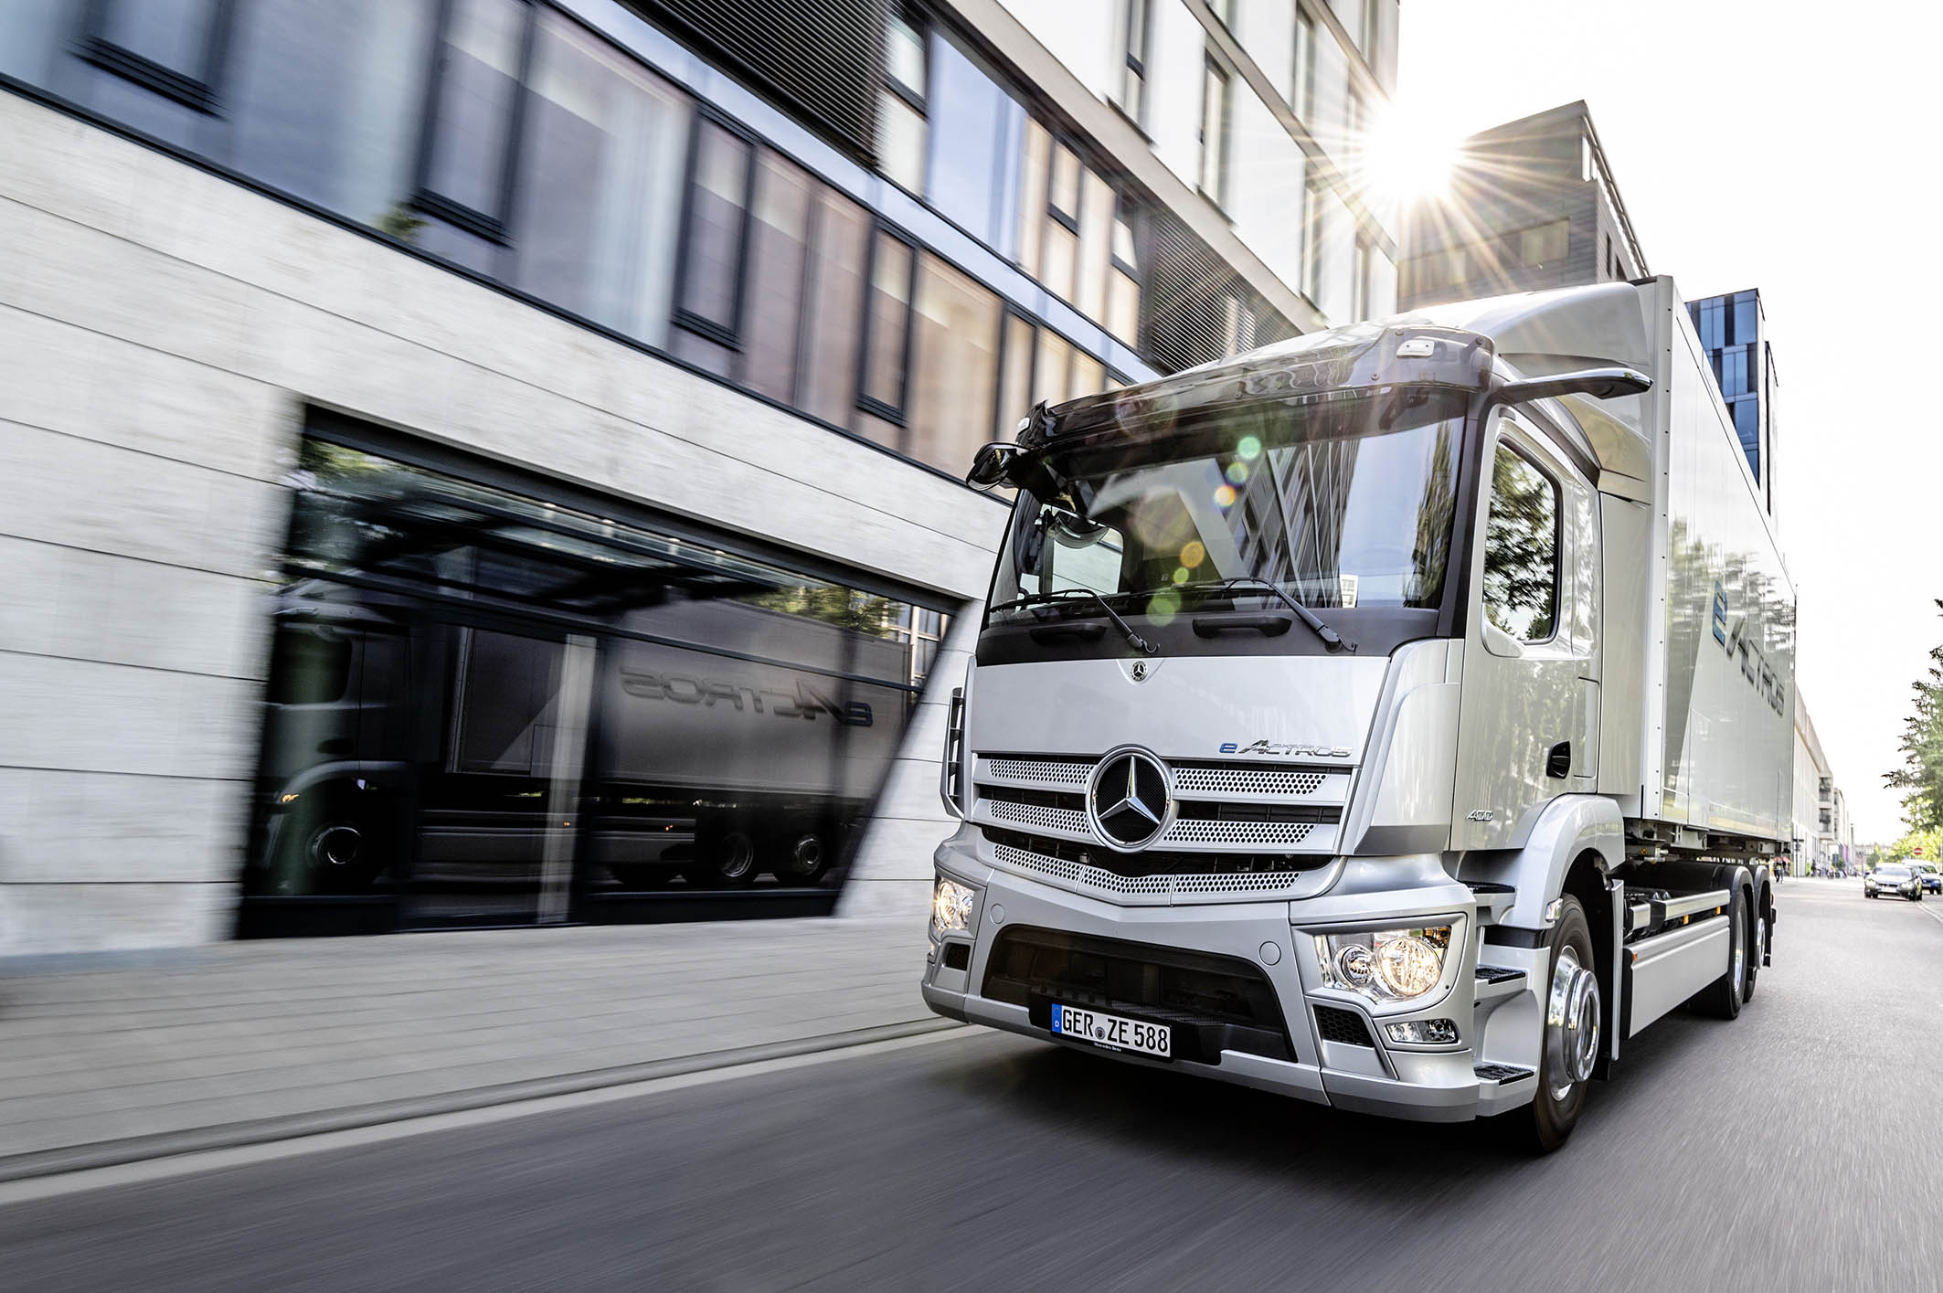

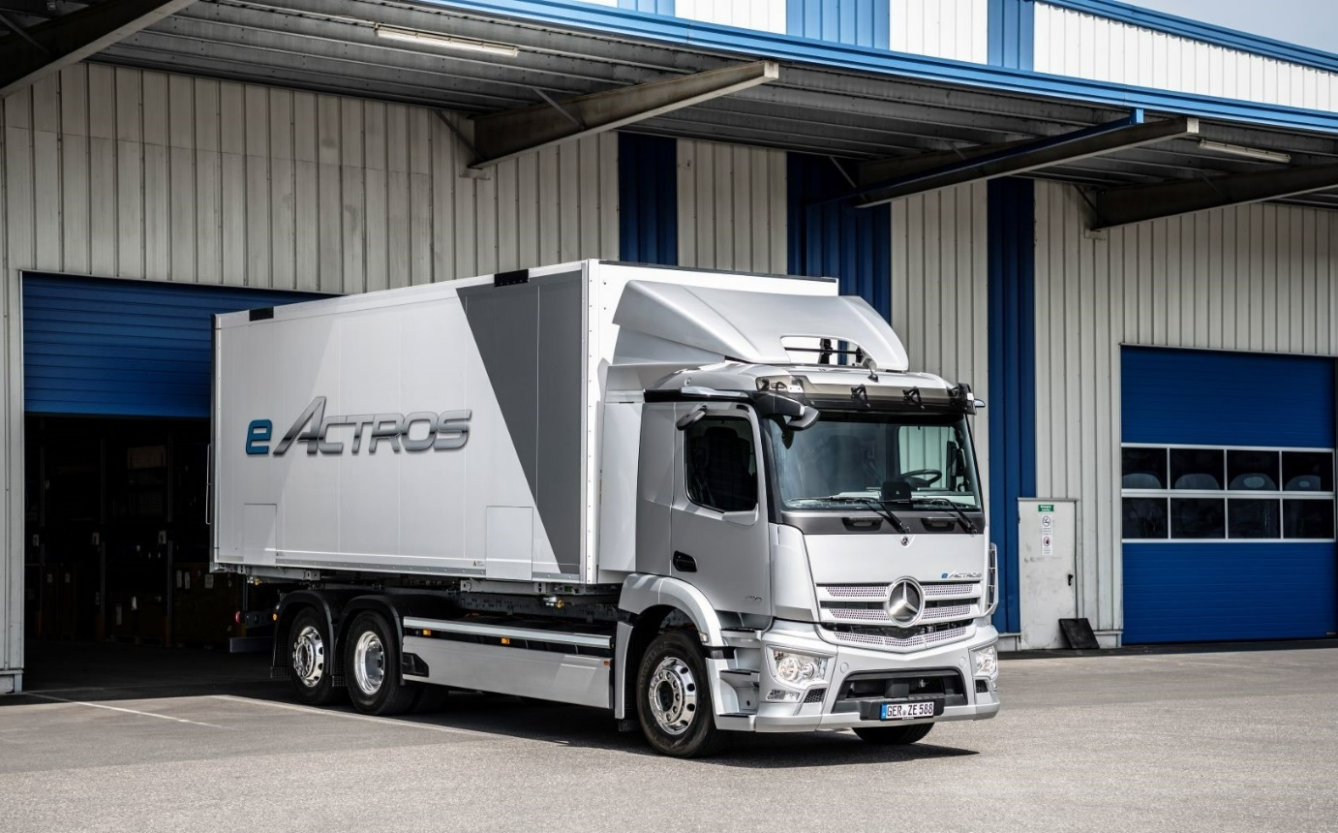

Further information on the world premiere of the eActros is available at:

http://media.daimler.com/go/mercedes-benzeactrosworldpremiere2021
(short link: d.ai/mbeactroswp2021)

https://newtrucknewera.daimler-truck.com/de/before-start

For more information, or to request higher-res image files, please contact:

Jamie Fretwell at Mercedes-Benz Trucks UK Ltd
07712 519230, jamie.fretwell@daimler.com

or

Carola Pfeifle, +49 (0)711 17-53551, carola.pfeifle@daimler.com

Ulrike Burkhart, +49 (0)711 17-58774, ulrike.burkhart@daimler.com

Further information from Mercedes-Benz is available online:
www.media.daimler.com and www.mercedes-benz-trucks.com

Predictive statements:
This document includes predictive statements reflecting our current estimation concerning the course of future events. Words such as »anticipate«, »assume«, »believe«, »estimate«, »expect«, »intend«, »can/could«, »plan«, »project«, »should« and similar terms are indicative of this kind of predictive statement. These statements are subject to a range of risks and unknowns. Some examples of this situation are scenarios such as unfavourable developments in international economic conditions, particularly a decrease in demand within our most important commercial markets, negative developments in the available refinancing options on the credit and financial markets, unavoidable events and forces majeures, such as natural catastrophes, pandemics, acts of terror, political unrest, armed conflicts, industrial accidents, and their causal effects on our sales, purchasing, production or financing activities, changes in exchange rates, customs and foreign trade regulations, a reorientation of consumer preferences toward smaller and less profitable vehicles or a potential loss of acceptance of our products and services culminating in a reduced ability to define prices and reduced utilisation of production capacity, increases in the prices of fuels and raw materials, suspensions in production stemming from bottlenecks in material supply chains, workforce strikes or supplier insolvencies, decreases in the resale values of used vehicles, successful implementation of cost-reduction and efficiency-enhancement measures, the business prospects of the companies in which we retain substantial numbers of shares, successful implementation of strategic cooperation agreements and joint ventures, changes to laws, stipulations and official directives, particularly those affecting vehicle emissions, fuel economy and safety, as well as the conclusion of ongoing official inspections, or of inspections commissioned by official bodies, and the verdicts of pending or potential future legal proceedings as well as other risks and uncertainties, of which some are described in this annual report under the heading "Risks and Chances Report". Should one of these risk factors or these imponderables occur, or should the operative assumptions forming the foundation for predictive statements prove unfounded, then the actual results and events could display substantial deviations from the results and events as directly or implicitly enunciated in these statements. It is not our intention, nor do we undertake any obligation, to update predictive statements on a continuing basis, as these are based solely and exclusively on the conditions prevailing on the day of publication.

An overview of Daimler Trucks
Daimler Truck AG is one of the world's largest commercial vehicle manufacturers, with more than 35 primary locations around the world and approximately 100,000 employees. The company brings together seven vehicle brands under one roof: Mercedes-Benz (light, medium and heavy trucks as well as city, intercity and touring coaches) and Setra (intercity, long-distance and premium coaches) are our traditional European brands; our U.S. brands Freightliner Trucks (trucks in weight classes 5 to 8 for a wide range of commercial vehicle applications), Western Star (heavy trucks for specialized and long-haul transports) and Thomas Built Buses (light to medium-duty buses); and our Asian brands Bharat Benz, based in Chennai, India (trucks in the weight classes 10 to 55 t and medium and heavy-duty buses) and FUSO with its headquarters in Japan (trucks and buses for Asia, the Middle East, Africa, Europe and Latin America). This allows Daimler Truck AG to offer its customers around the globe a broad spectrum of commercial vehicles, ranging from minibuses to heavy-duty trucks for special-purpose transport applications – in short: products and solutions for everyone who keeps the world moving. Gottlieb Daimler and Carl Benz laid the foundation for the modern transport industry 125 years ago. Over the past decades, Daimler AG's truck and bus divisions have consistently set standards for the entire transportation industry – in terms of safety, fuel efficiency and driver and passenger comfort. It is now time for the next evolutionary step: emission-free, automated and connected driving. Daimler Truck AG is working to bring these important technologies to high-volume series production, across brands, divisions and regions. In this way the company intends to take a major step closer to realising its vision of CO2-neutral transport and accident-free driving whilst also contributing to the sustainability of global goods and passenger transport. In 2020, around 378,500 trucks and buses were delivered. In 2020 turnover of Daimler Truck AG was around 35 billion euros. The adjusted EBIT figure for Daimler Truck AG was 678 million euros.

