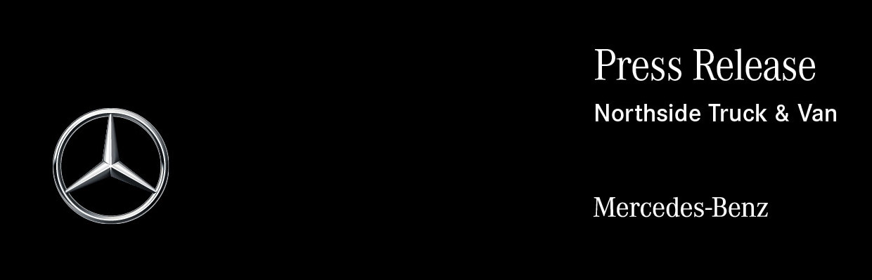

Date: 1 April 2022

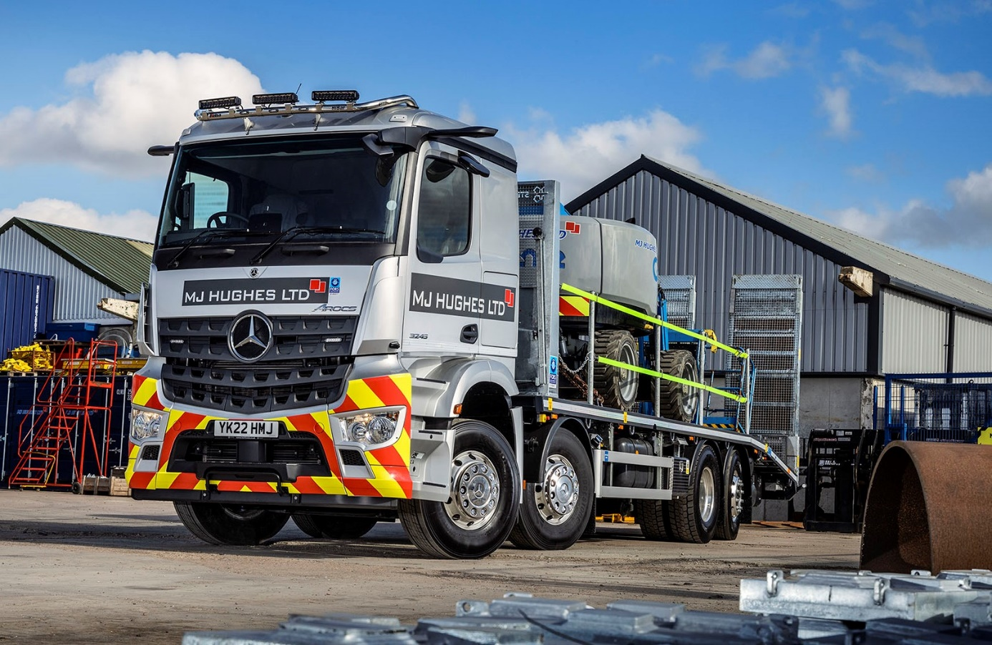

MJ Hughes bridges the visibility gap with MirrorCam-equipped Mercedes-Benz Arocs from Northside Truck & Van

South Yorkshire-based structural steel specialist MJ Hughes has added the first truck with MirrorCam to its all-Mercedes-Benz fleet – the 8x2 Arocs will spend much of its time in London, where the manufacturer’s acclaimed alternative to conventional mirrors is officially recognised for its contribution to safety by Transport for London’s Direct Vision Standard scheme.

Supplied by Northside Truck & Van, the vehicle has a ClassicSpace L-cab sleeper for which Auto Electrics Group, of Bradford, fitted a full complement of cameras that provide 360º visibility.

The Arocs is smartly finished in MJ Hughes’ recently updated silver and grey livery, with Alcoa Dura-Bright alloy wheels and roof-mounted light bar. Its ‘cheese wedge’ beavertail plant body is the work of Sterling, of Stokesley, North Yorkshire.

As a 3245 variant the truck is powered by a 12.8-litre in-line six-cylinder engine that produces 330 kW (450 hp). Thanks to the single drive axle it is significantly more fuel-efficient than an 8x4 32-tonner. The fact that the rear axle can be lifted when the vehicle is running light also allows the operator to save on tyre wear; even when deployed the axle’s turning function reduces scrub as well as enhancing manoeuvrability.

MJ Hughes has been serving the general construction and rail sectors from its headquarters in Maltby, near Rotherham, since it was established in 2002. The company offers a comprehensive assembly and installation service covering bridges and overhead line electrification works, that includes lift plans and Risk Assessment Method Statements (RAMS).

MJ Hughes commissioned its first Mercedes-Benz truck in 2012. The Axor eight-wheeler was also the first new truck to be purchased by the company. Although still reliable and cost-effective to run, its Euro V engine meant the Axor no longer met the required emissions standard for operation in London, so it was sold last year to make way for the new Arocs.

A pre-owned 6x2 Actros 2553 tractor unit purchased in 2016 is still working alongside the four muscular Arocs that MJ Hughes has since acquired: another tractor unit, also a 2553 model with 390 kW (530 hp), 12.8-litre ‘straight-six’, and three plant-bodied 3245 eight-wheelers, one of which is additionally fitted with a crane.

Plant & Transport Manager Chris Hall reported: “Our Mercedes-Benz trucks have always lived up to their premium brand reputation. They don’t let us down, they’re easy to work on, and the drivers like them.

“They look really good too. Image is important and a clean, smart looking truck reflects well on our business in the eyes of every one from the DVSA to ‘Joe Public’.”

He continued: “Our vehicles can spend as much time on rough sites as they do on the road, so the extra ground clearance you get with the Arocs is a big advantage. It offers a good body and payload allowance, and as a purpose-designed construction chassis is ideally suited to our work.”

Mr Hall experienced MirrorCam technology in action during an event at Mercedes-Benz Trucks’ Wentworth Park complex, near Barnsley, which he attended as a guest of Northside Truck & Van. “The safety benefits are obvious, so I’m all for it,” he enthused. “I collected our new truck from the Dealer on a miserable day but the images from the cameras were crystal clear. Fantastic!”

MirrorCam’s roof-mounted cameras are linked to screens mounted inside the cab, on the A-pillars. In Direct Vision terms, the system’s benefits of have nothing to do with the significantly improved rear visibility, and everything to do with what the driver cannot see in front – those huge mirrors that create blind spots which get bigger as distance from the truck increases.

Driver Leejay Neale is equally enthusiastic. “MirrorCam is absolutely brilliant,” he declared. “This is the first time I’ve used it and the all-round visibility is a lot better than I was expecting. I’m on and off tight sites all the time, and being able to see so much more of what’s around you makes the job a lot easier – and safer.”

The 28-year-old, who has been driving for five years, is equally impressed with his truck’s radical Multimedia Cockpit, which features intuitively-operated, tablet-style twin screens – one with touch functionality – instead of traditional switchgear. “It’s a great design, and very easy to use,” he said. “When you’re at the wheel it’s more like being in an upmarket car than a truck. I love it.”
In line with its established policy, MJ Hughes will rely on the workshop team at Northside Truck & Van’s branch in Balby Carr, Doncaster, to inspect and maintain its new Arocs under a Mercedes-Benz Complete Service Contract for the next two years. Thereafter, it will switch to in-house maintenance.

“Everything is pretty sweet in terms of our relationship with the Dealer, and that’s another important reason we remain loyal to Mercedes-Benz,” added Chris Hall. “Its Sales Executive Nigel Hill is always quick to respond to an enquiry and very professional when it comes to specifying the vehicles, and when we do have an issue – as you always will from time to time – it’s always quickly resolved by Northside’s management.”

mjhughesltd.co.uk/

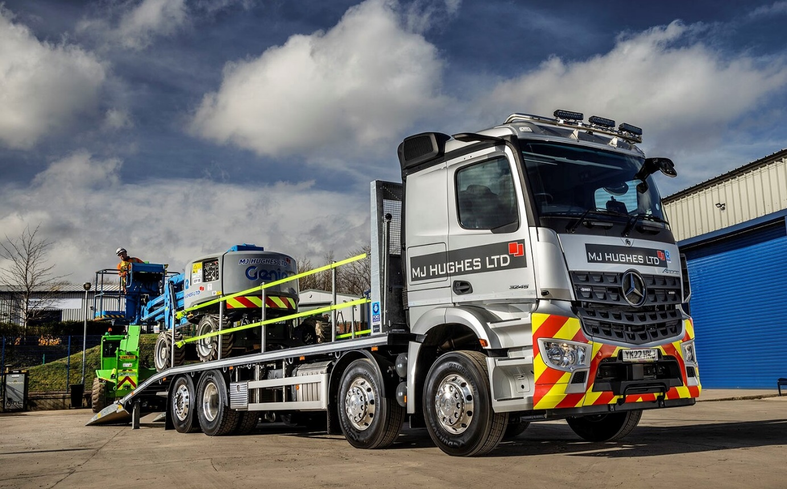

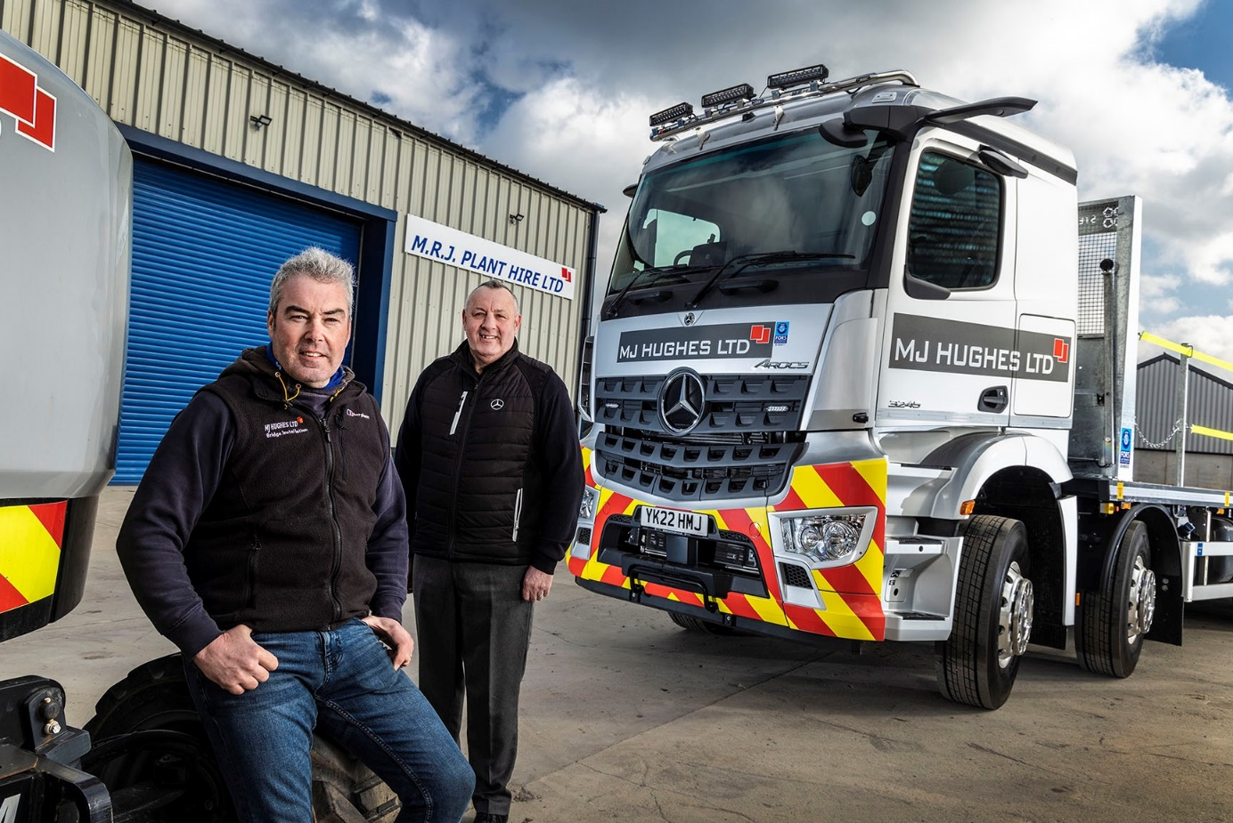

Trusted partner: MJ Hughes Plant & Transport Manager Chris Hall knows from experience that he can rely on Northside Truck & Van Sales Executive Nigel Hill, right, and his aftersales colleagues

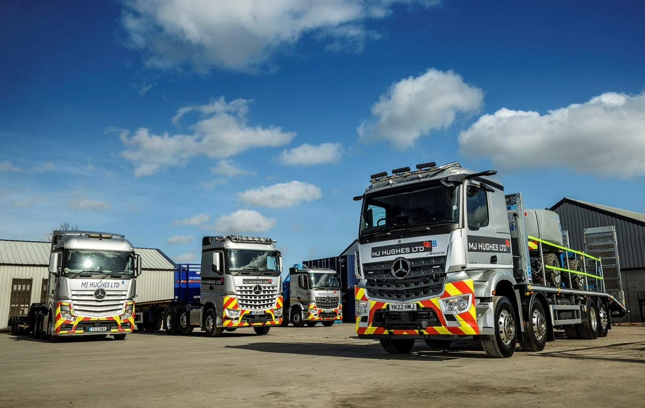

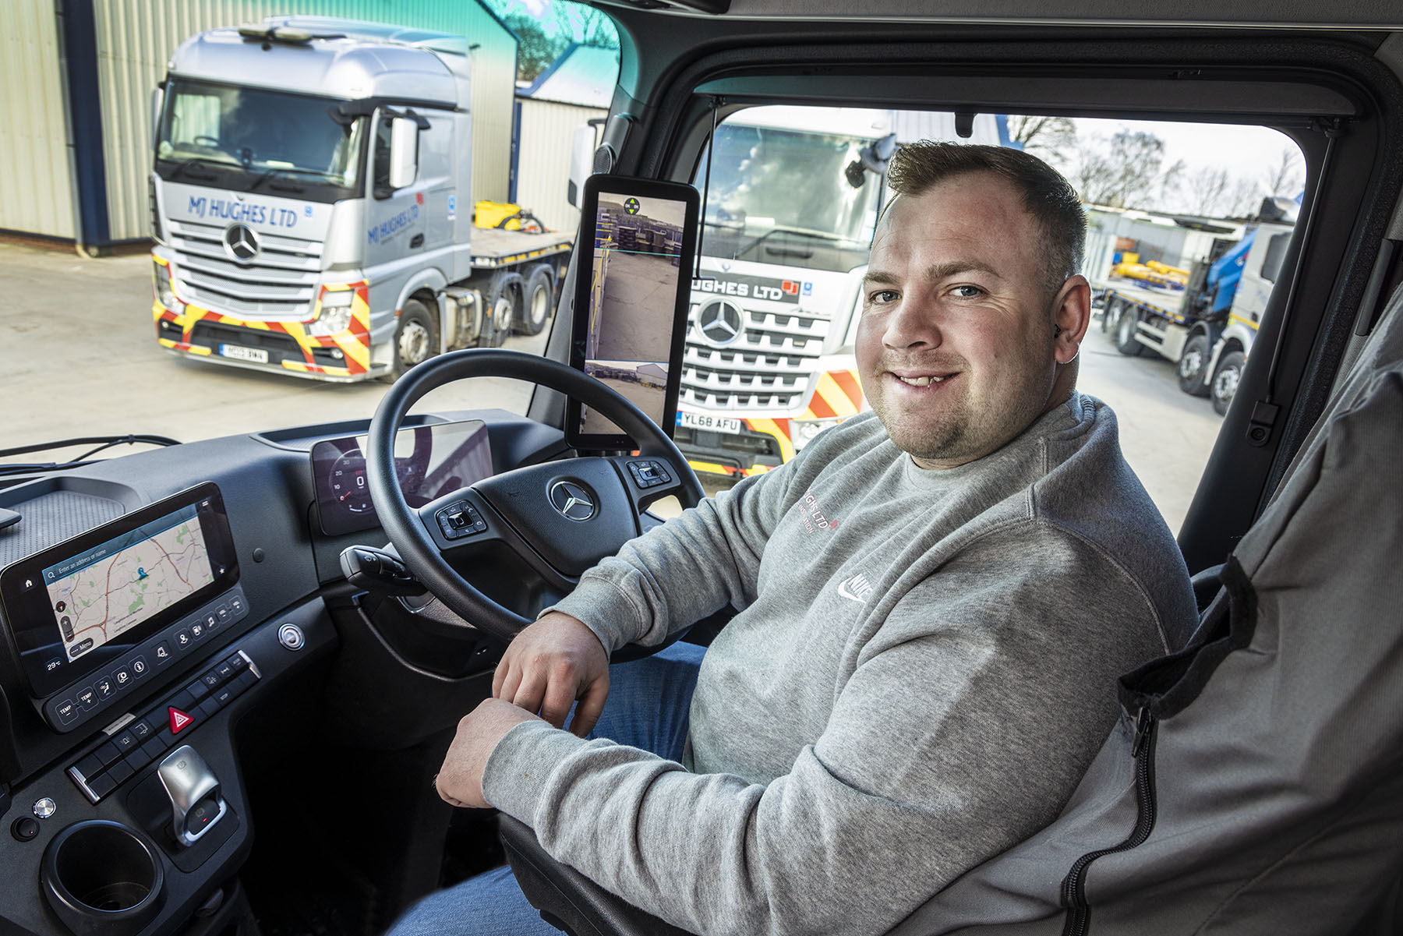

“Absolutely brilliant”: Driver Leejay Neale is a big fan of his new truck’s MirrorCam and Multimedia Cockpit technology

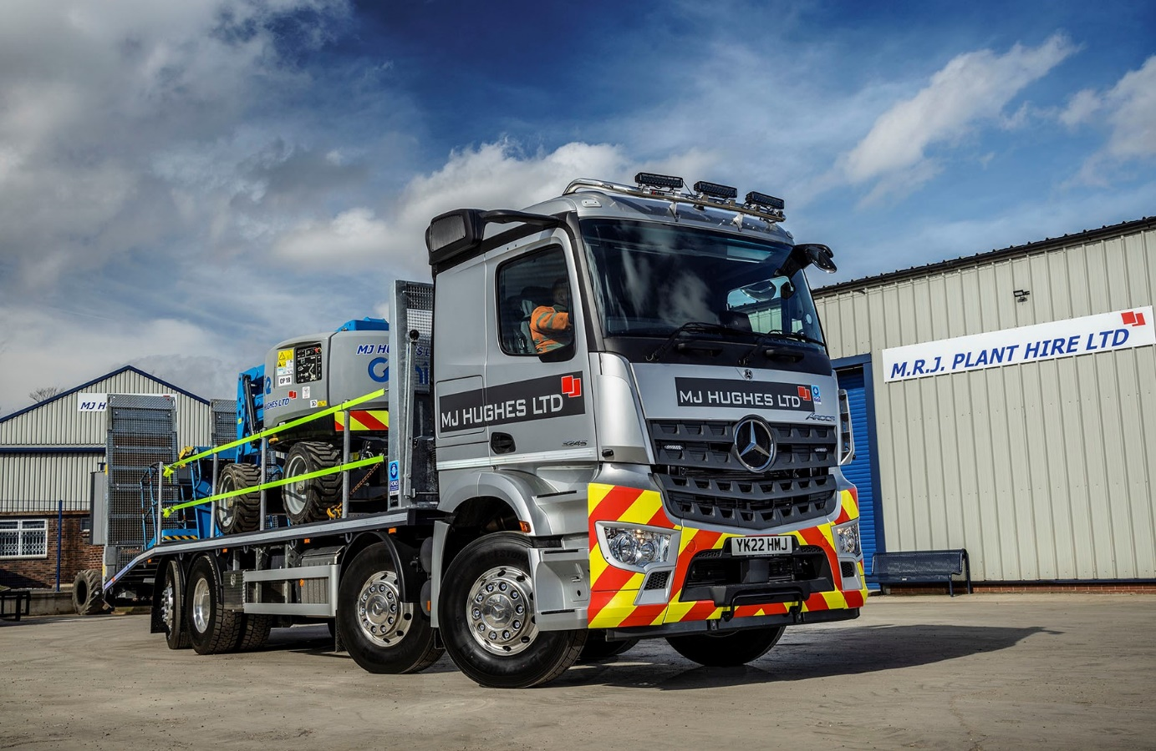

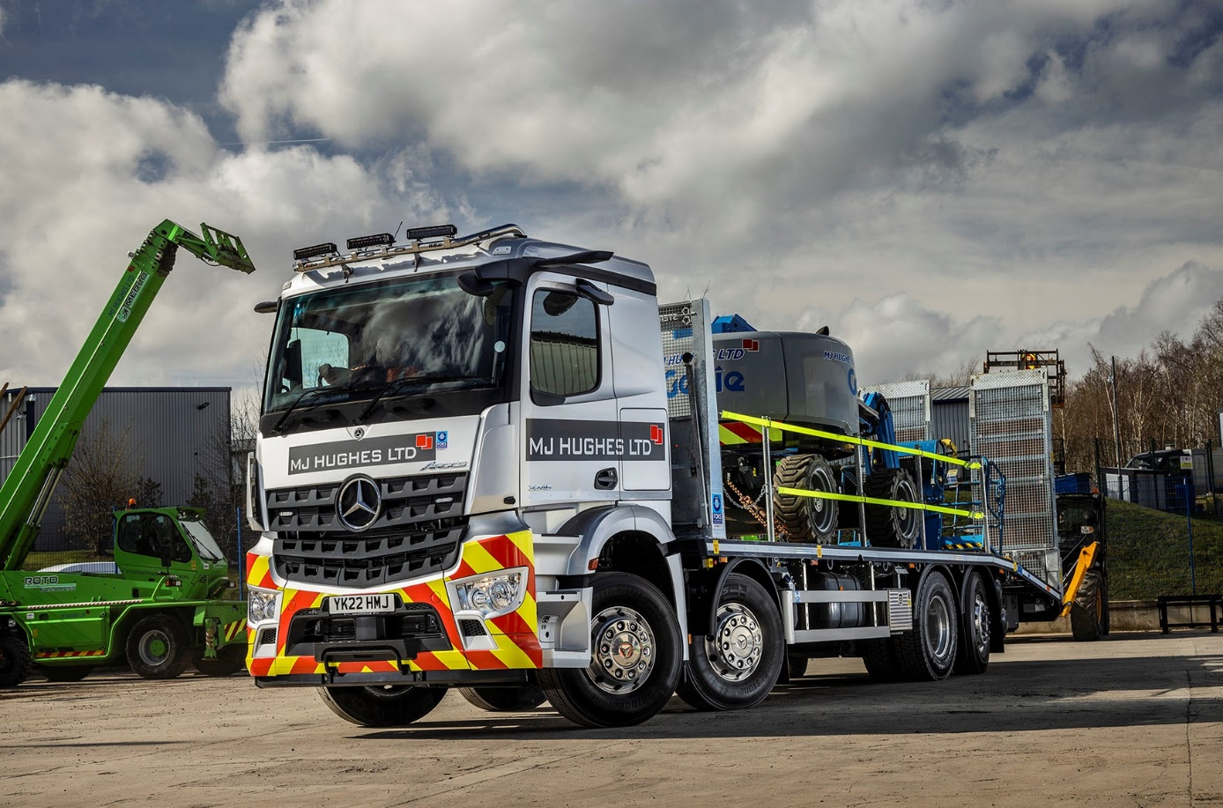

ends

For more information, or to request bigger/higher-res image files, please contact:
Steve Warren or John Ripley
Impact Communications
Steve: 07770 470251, steve@impactcom.co.uk
John: 07771 484595, john@impactcom.co.uk

