

Date: 18 March 2021

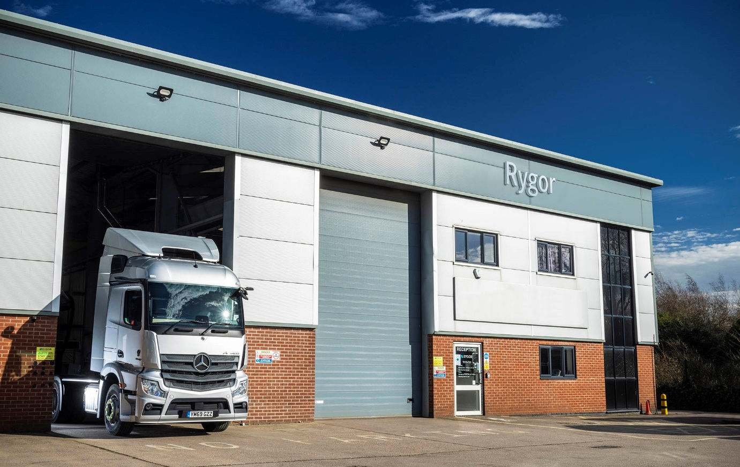

Rygor Commercials raises its Mercedes-Benz Trucks aftersales game at Nuneaton

Mercedes-Benz and FUSO truck customers are reaping the benefits following a major extension and upgrade of its Nuneaton branch by Dealer Rygor Commercials.

The £300,000 development has entailed a comprehensive refurbishment of the workshop – which now features a drive-through lane with 20-metre inspection pit – and the acquisition of a plot of land behind the building, which has been allocated to truck parking.

Rygor’s investment in the most northerly of its 11 Mercedes-Benz commercial vehicle Dealerships means the Tuttle Hill facility now accords with the manufacturer’s latest standards. It also underlines the Dealer’s commitment to locally-based operators, among them fmcg retailers running Mercedes-Benz fleets from distribution centres on the A5.

Completion of the project has allowed Rygor to reintroduce a two-shift system at Nuneaton, which went ‘live’ on 1 March. The workshop, which has six truck bays and another six for vans, is open until 10 o’clock each night, as well as on Saturday mornings, maximising uptime by providing customers with the flexibility to get their vehicles maintained at times convenient to them.

A further four technicians have been recruited, bringing the total team working at Nuneaton to 11. A new set of brake test rollers has been installed, together with headlamp alignment equipment and four new van ramps – a 25-tonne ramp is also available for truck work.

The extra ground at the rear of the premises has been allocated to the required eight truck parking spaces, each long enough to accommodate a tractor unit and semi-trailer combination, offering customers even more convenience and ease of access. Picked out in blue and marked UPTIME, one of these spaces is dedicated to vehicles requiring the most urgent turnarounds.

Rygor has also created a new rear entrance and resurfaced the plot, which also provides more room for visiting truck drivers to manoeuvre than the area at the front of the building they used before. The workshop is accessed via the new back door.

Having previously operated as a vehicle maintenance unit, Rygor Nuneaton was awarded Authorised Repairer status by the manufacturer in 2015. The operation is led by Service Manager Gavin Smith, who is supported by Workshop Controller Nathan Roberts and Parts Supervisor Matthew Bray.

Gavin commented: “We’re committed at Rygor to Setting Standards, and that means we’ll do whatever it takes to keep our customers’ vehicles out there and working. Completion of this project means we’re perfectly placed to provide operators of Mercedes-Benz and FUSO Canter trucks with the timely, high-quality back-up they deserve.

“Naturally, this significant investment has also been a huge morale booster for my colleagues and I – the fact that is now a smarter working environment demonstrates how valued the team is by the business. We’re all very excited and greatly looking forward to the future. Having remained open to serve customers throughout the pandemic, keeping key vehicles and critical workers on the road, we’ll be continuing to provide exemplary service not only to long-standing customers but also to the new ones we look forward to welcoming to our branch.”

Rygor’s latest investment in its branch network has been welcomed by local operators. SARVAL, which manufactures products for use in animal foodstuffs, runs a fleet of 15 four- and six-wheeled Mercedes-Benz tippers from its Nuneaton depot.

Divisional Transport Manager Chris Rushton said: “Communication is of paramount importance for us. It doesn’t happen often but if one of our trucks has gone into the workshop and, for whatever reason, we’re not going to get it back the following day, we need to be told as soon as possible so we can make alternative arrangements.

“We have a brilliant relationship with the Rygor team, who keep us fully updated on progress; rather than having to keep chasing them, we always know where we stand so can run our own operation as efficiently as possible. We were very pleased to learn that the Dealer was upgrading its local branch, and especially with the news that the night shift has been reintroduced, as this allows us to further reduce vehicle downtime.”

Barry Elder, meanwhile, is Contract Manager at FCC Environment, which operates the Judkins Household Waste Recycling Centre on behalf of Warwickshire County Council. The 8x4 Arocs hook-loader it runs from this site is inspected and maintained by Rygor under a Mercedes-Benz Complete Service Contract.

“We only have the one vehicle but if anything crops up – and this applies to work on the body as well as the chassis – we know from experience that we can rely on Rygor to go the extra mile and get into the workshop as quickly as possible,” he reported.

“We normally deal with Service Advisor Urmla, who’s very much on the ball when anything needs attending to on the truck and will liaise directly with our driver to arrange bookings.”

Mr Elder added: “We’re literally next door to the Dealer and have watched the work being done at the rear of the premises. It all looks very impressive and can only benefit customers like ourselves.”

Mercedes-Benz Trucks Managing Director Wolfgang Theissen added: “This is just the latest in a series of investments in its branch network made by Rygor, a fantastic ambassador for our brand and a business that’s steeped in an ethos of customer service.

“While the Truck Centre it opened at Heathrow last autumn is entirely new, at Nuneaton Rygor has greatly enhanced an established facility. Both sites underpin continued investment into the brand, and mean operators of Mercedes-Benz and FUSO trucks can now look forward to an even higher level of back-up from their local Dealer.”
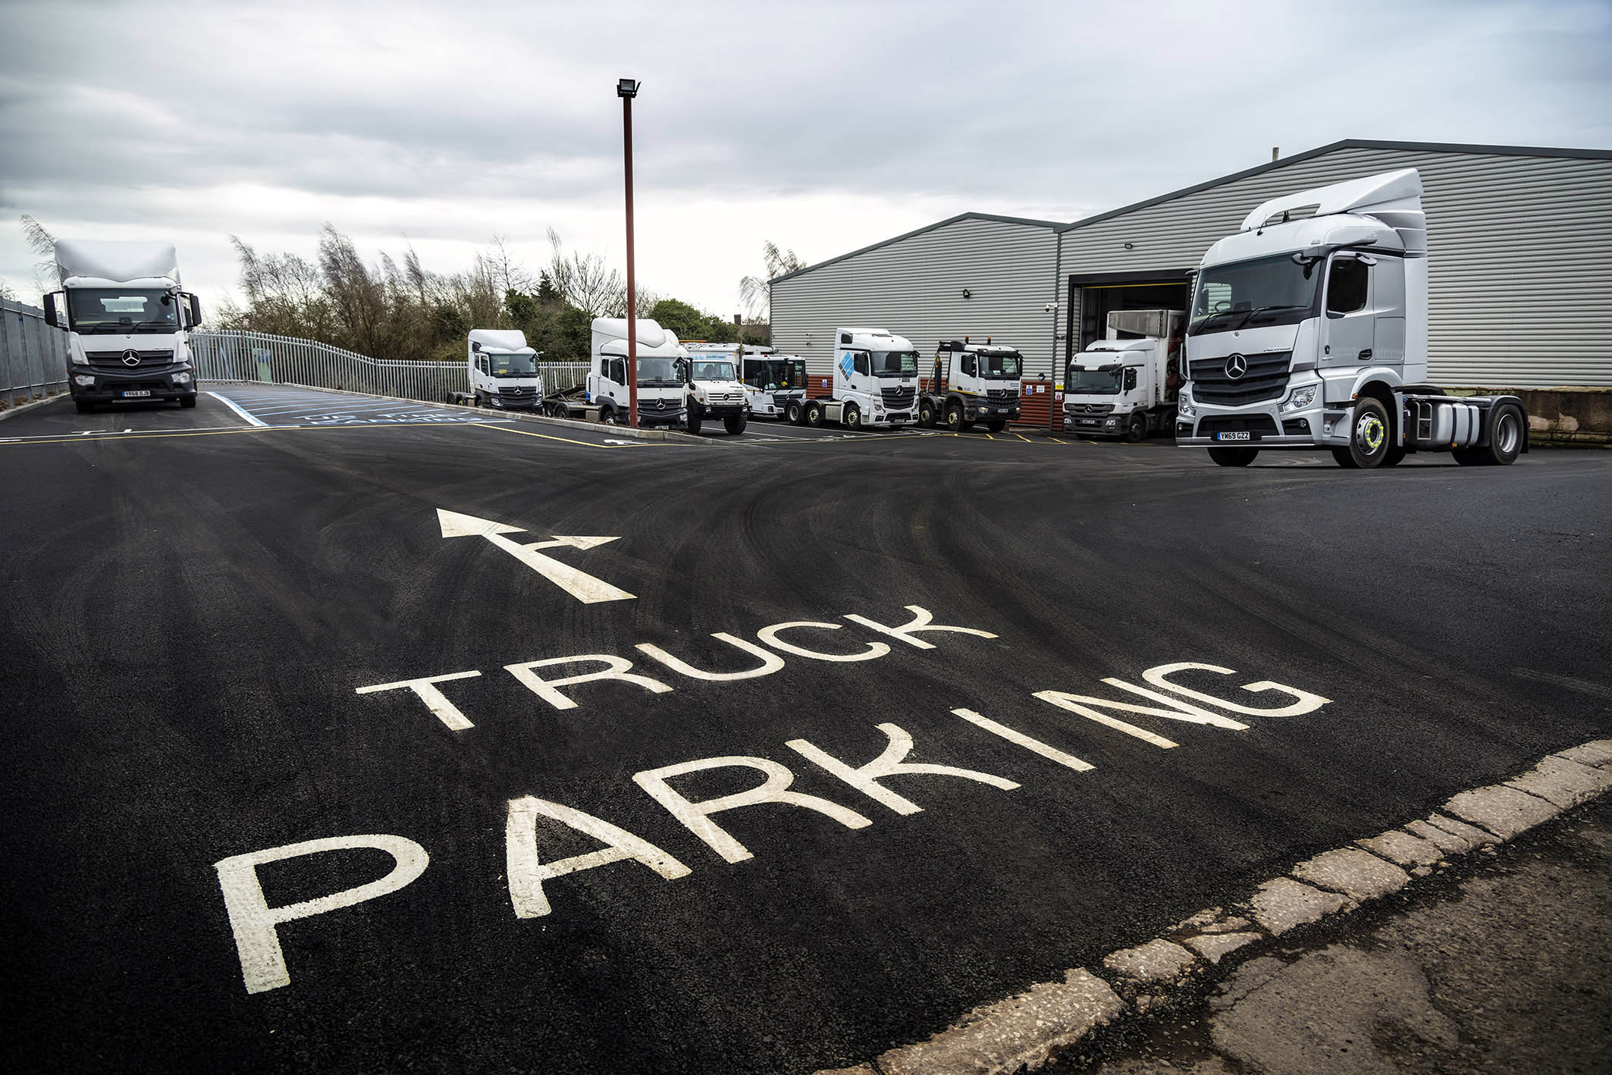

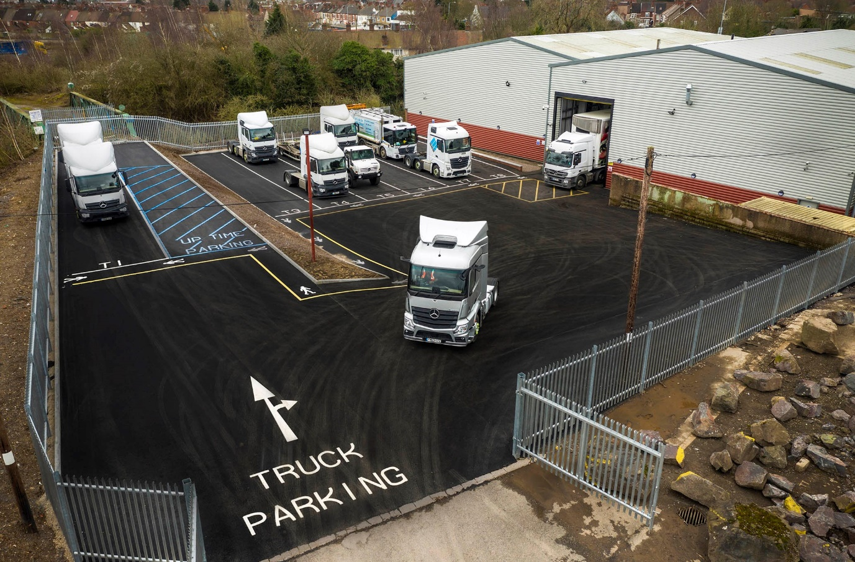

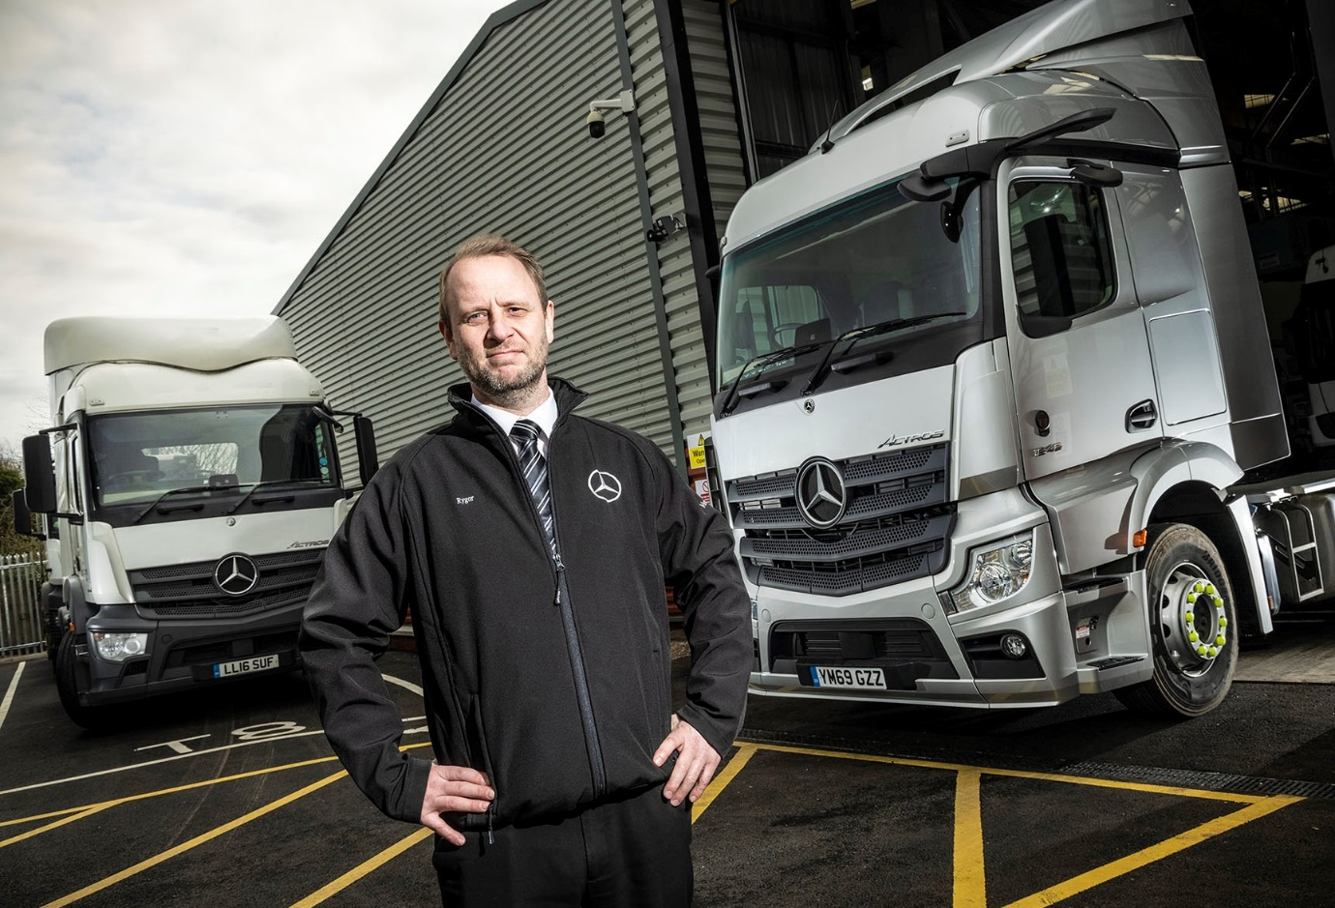

Exciting times: Service Manager Gavin Smith says Rygor’s Nuneaton operation is now ideally placed to serve Mercedes-Benz and FUSO trucks customers

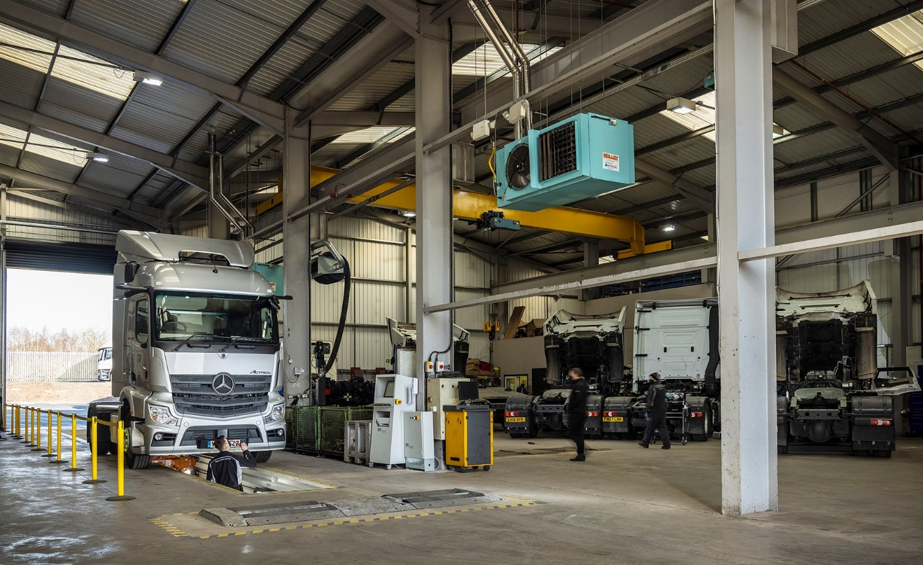

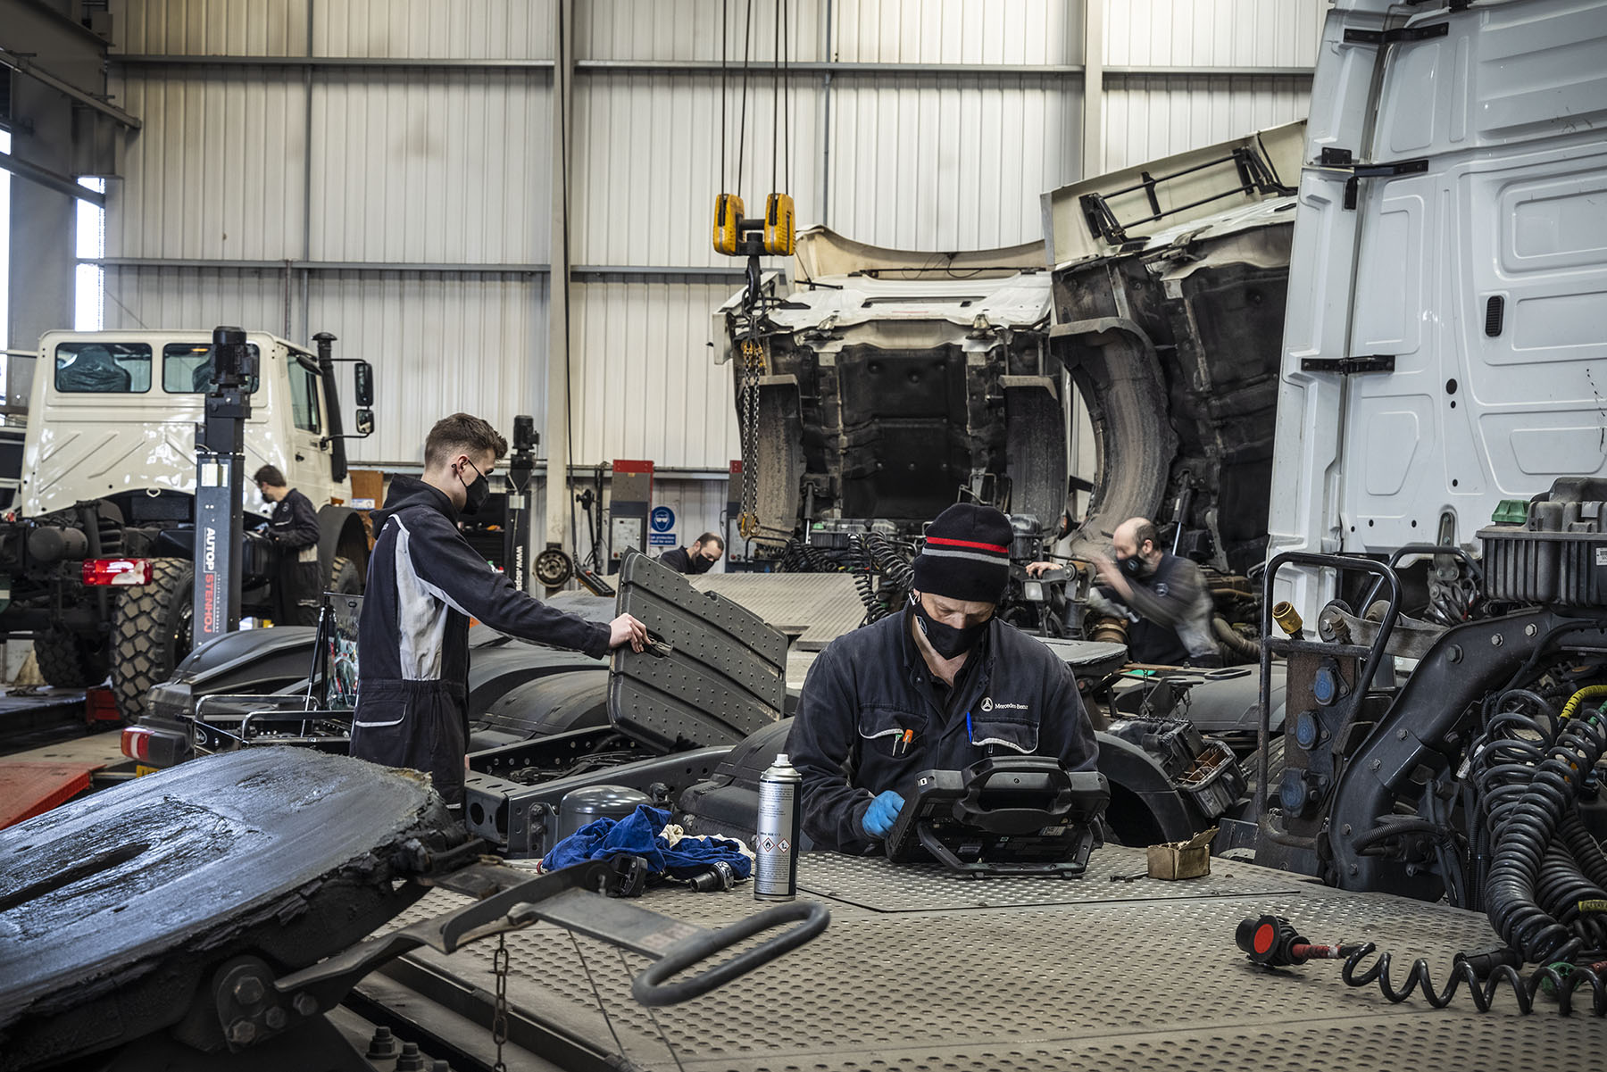

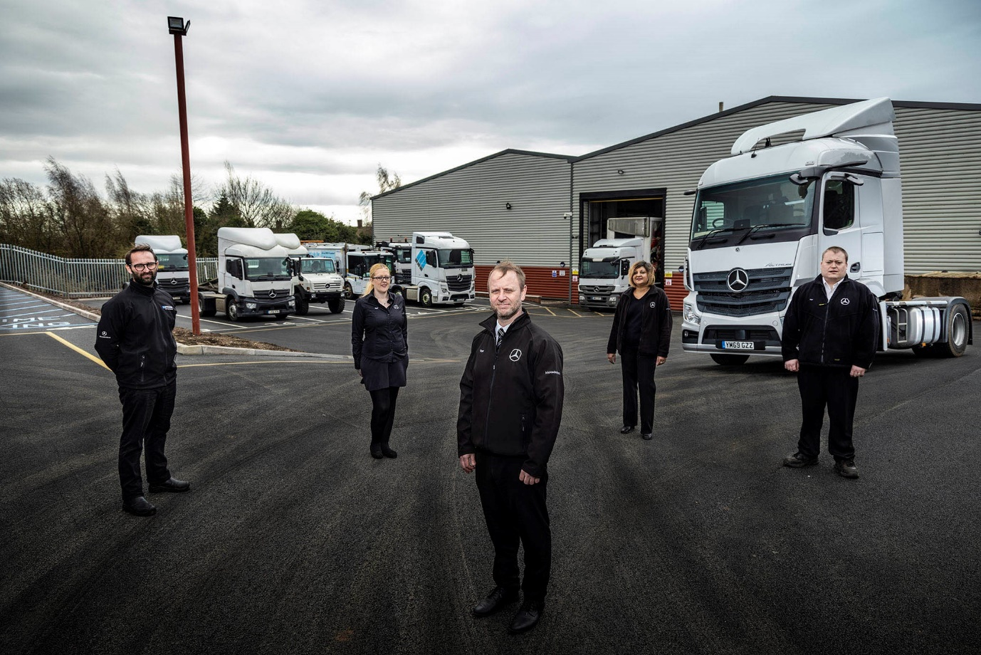

A winning team: Rygor Nuneaton Service Manager Gavin Smith is flanked by, from left, Workshop Controller Nathan Roberts, R&M and Warranty Invoicer Kim Busby, Service Advisor Urmla Purewal and Parts Supervisor Matthew Bray

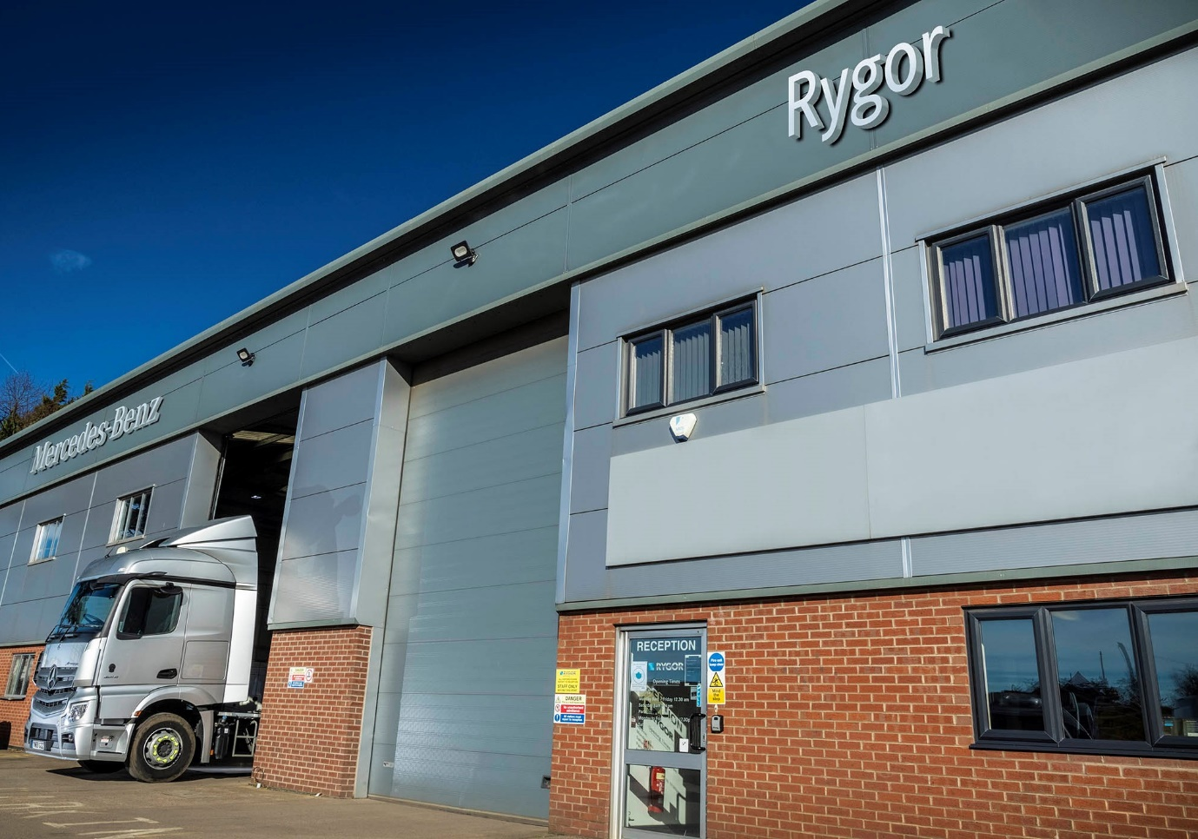

For more information, or to request higher-res image files, please contact:

Jamie Fretwell at Mercedes-Benz Trucks UK Ltd
07712 519230, jamie.fretwell@daimler.com

or

Steve Warren or John Ripley
Impact Communications, 01926 842126
Steve: 07770 470251, steve@impactcom.co.uk
John: 07771 484595, john@impactcom.co.uk

About Mercedes-Benz Trucks UK Ltd
Mercedes-Benz Trucks UK Ltd is the sales and marketing organisation responsible for all Daimler truck products in the UK, including FUSO Canter. In 2019, the company registered 6,963 new trucks. Mercedes-Benz accounted for 6,188 new trucks registered in 2019, making it the third-biggest truck brand in the UK. Meanwhile, FUSO registrations hit 775 – including 580 new trucks over 6.0-tonnes. The flagship new Mercedes-Benz Actros which won the 2020 International Truck of the Year award, features seven core innovations including MirrorCam, Multimedia Cockpit and Active Brake Assist 5. Our premium range of innovative trucks – Actros, Arocs, Atego, Econic and Unimog – draw upon more than 125 years of exceptionally high standards of quality, backed up by our promise of Trucks You Can Trust.
www.mbtrucks.co.uk

