

Date: 25 April 2022

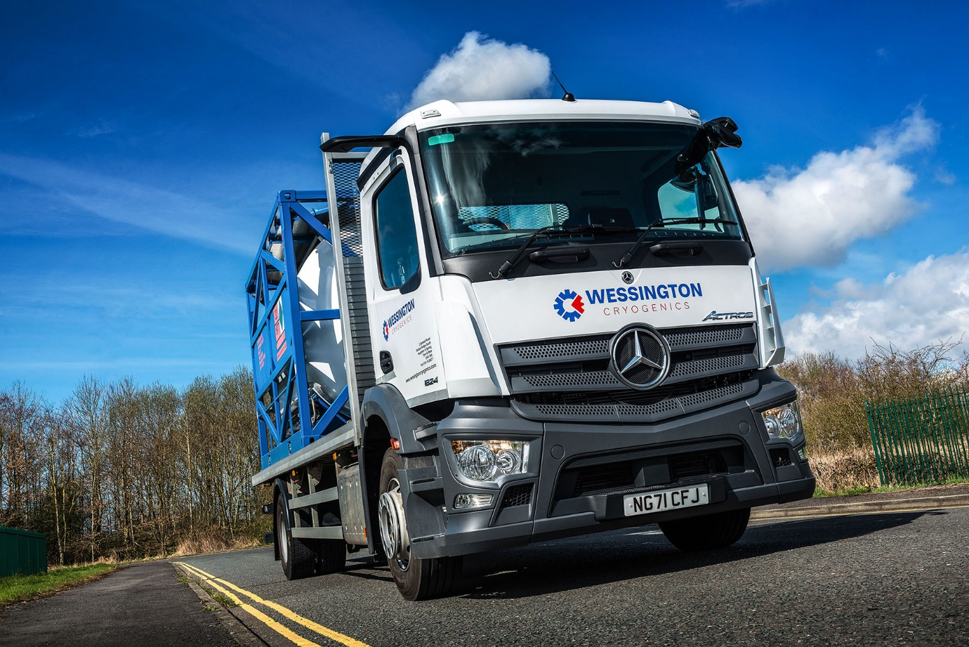

High-tech Mercedes-Benz Actros boosts flexibility and cuts costs for cryogenic vessel specialist

Wessington Cryogenics enjoys a global reputation for the design, quality and reliability of the storage vessels and tanks it manufactures. No surprise, then, that when it came to purchase its first truck, the North East company chose a brand whose name is synonymous with the same attributes – Mercedes-Benz.

The 18-tonne Actros was supplied by local Dealer Bell Truck and Van and boasts a full complement of advanced technology including MirrorCam, the manufacturer’s ground-breaking alternative to conventional mirrors. This boosts safety by providing improved rear vision and eliminating forward-facing blind spots caused by mirror housings.
Other highlights include the stylish and intuitively-operated Multimedia Cockpit, which replaces traditional switchgear with twin, tablet-style screens, one with touch functionality; the latest version of the fuel-saving Predictive Powertrain Control system; and Active Brake Assist 5, with enhanced pedestrian-recognition capability.

Cryogenics is the branch of physics that deals with the production and effects of very low temperatures. Established in 1984, Wessington Cryogenics is based in Houghton le Spring, near Sunderland, and offers a comprehensive range of dewars (specialised vacuum flasks), vessels for storing liquid nitrogen, argon, oxygen and helium, and ISO tank containers, as well as bespoke ‘specials’ for specific applications. These products are used in a host of offshore and industrial applications.

It also provides repair and refurbishment services and can restore to ‘as new’ condition most other makes of cryogenic vessels as well as its own.

The new truck is used solely for very short-range internal transport – it is used primarily to move ISO tanks between Wessington Cryogenics’ three main paintshops and five other subcontract facilities, all of which are located within a 10-mile radius of the company’s headquarters. This task was previously assigned to a third-party haulier.

Acquired with competitive funding support from Mercedes-Benz Finance, the Actros will be inspected and maintained under a five-year Complete Service Contract at Bell Truck and Van’s Longbenton workshop.

The vehicle has a Classic Space S day cab and, as an 1824 variant, employs a 7.7-litre in-line six-cylinder engine that produces 175 kW (238 hp); this is paired with an eight-speed Mercedes PowerShift 3 automated manual transmission.

Its platform body, meanwhile, is by Dependable Bodies, of Gateshead, and fitted with twist-locks for securing the frames in which vessels are carried.

“We’re very busy and have been growing strongly,” explained Sales Engineer Dave Easton. “The company is embarking on a major investment drive so has brought the transport function in-house to provide extra flexibility, as well as cost savings.

“As for our choice of truck, we do have some experience of the transport sector as we also manufacture road tankers. Given what we already knew of the brand, not least through recommendations from customers, it was always going to be a Mercedes-Benz. Our first call, therefore, was to Bell Truck and Van.”

He continued: “The response from its Sales Executive Alex Wordsworth was first class, exactly what we needed. We were starting from scratch and not only did Alex advise on specification of the vehicle and handle all of the liaison with the bodybuilder, but he also arranged driver training for two of our guys and the maintenance contract. He even advised us on how to go about securing our Operator’s Licence. It was a great service from start to finish.”

Mr Easton added: “We’re delighted with our new Actros, as are its drivers. The younger of the two was blown away from the outset by all of the digital technology and while his colleague is a bit more ‘old school’ so missed the mirrors initially, he very quickly came to appreciate the safety and other benefits that MirrorCam offers.”

wessingtoncryogenics.com/

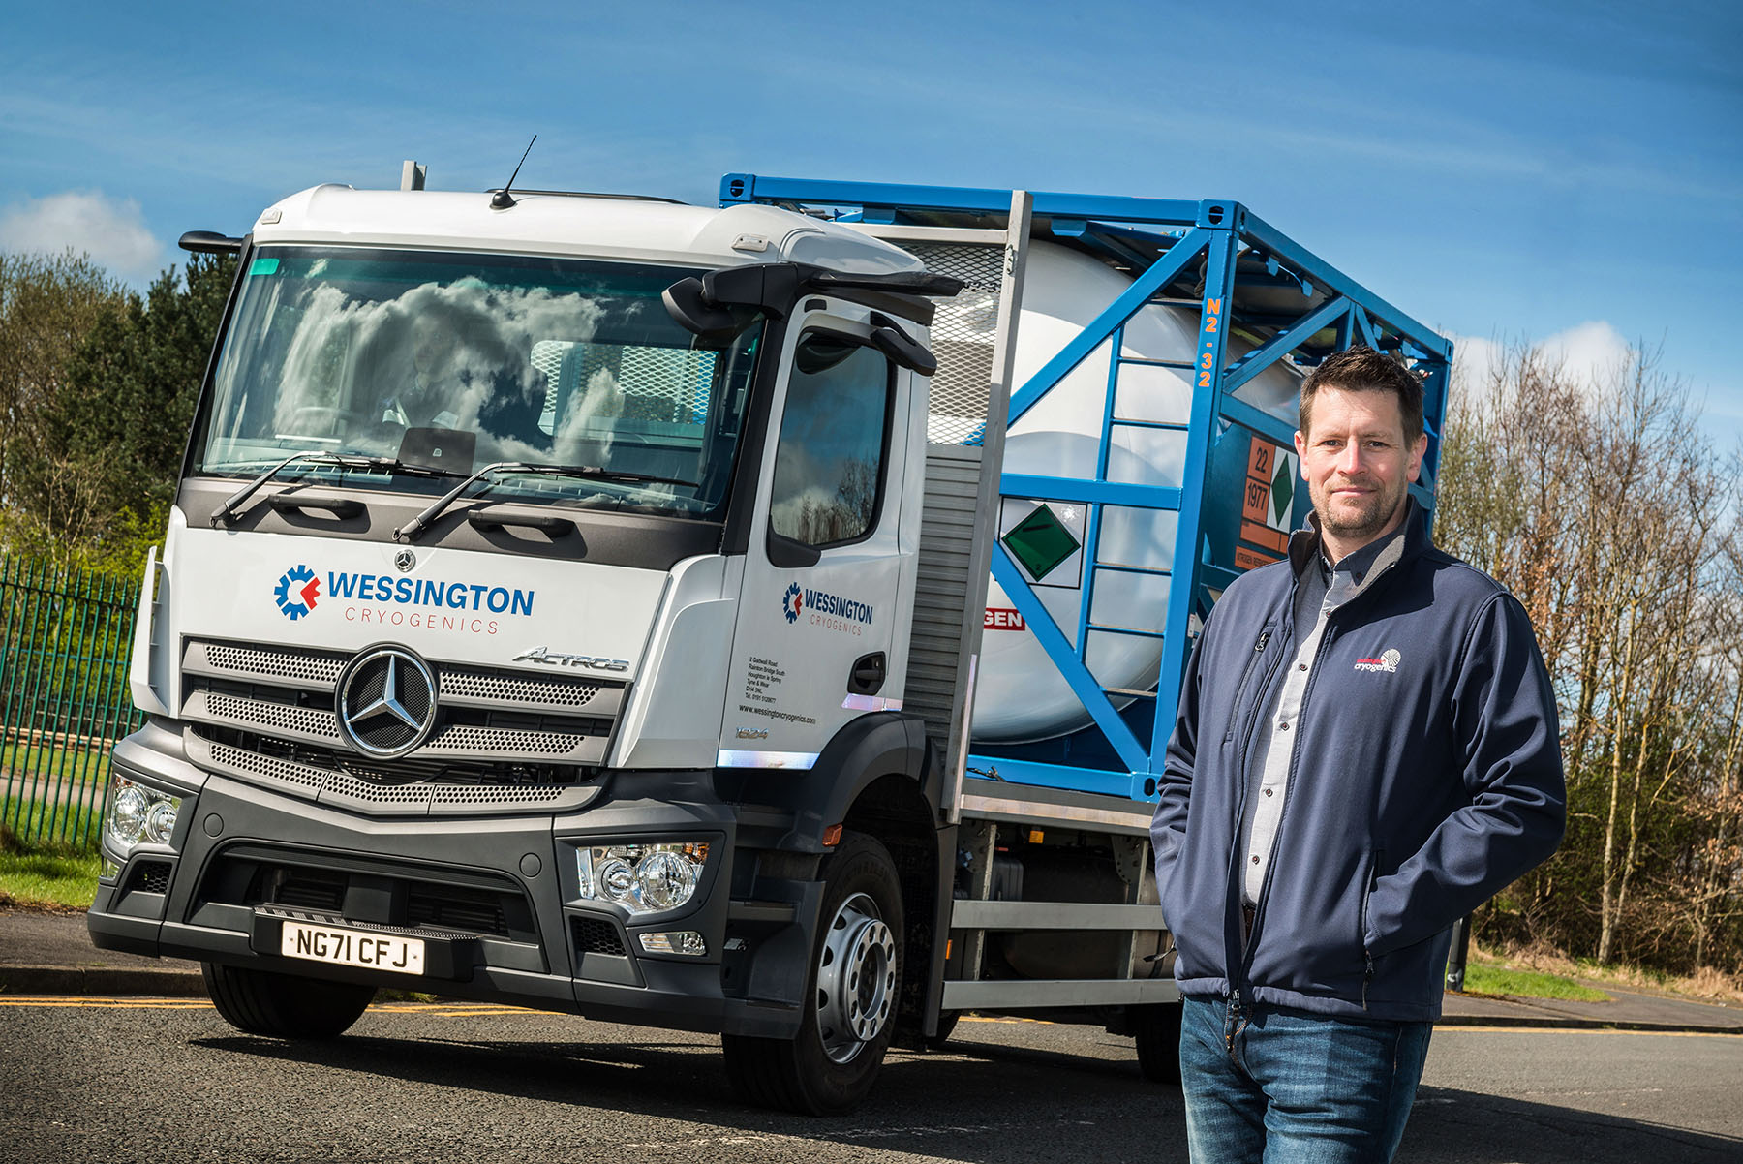

Dave Easton: “Our first truck… was always going to be a Mercedes-Benz”

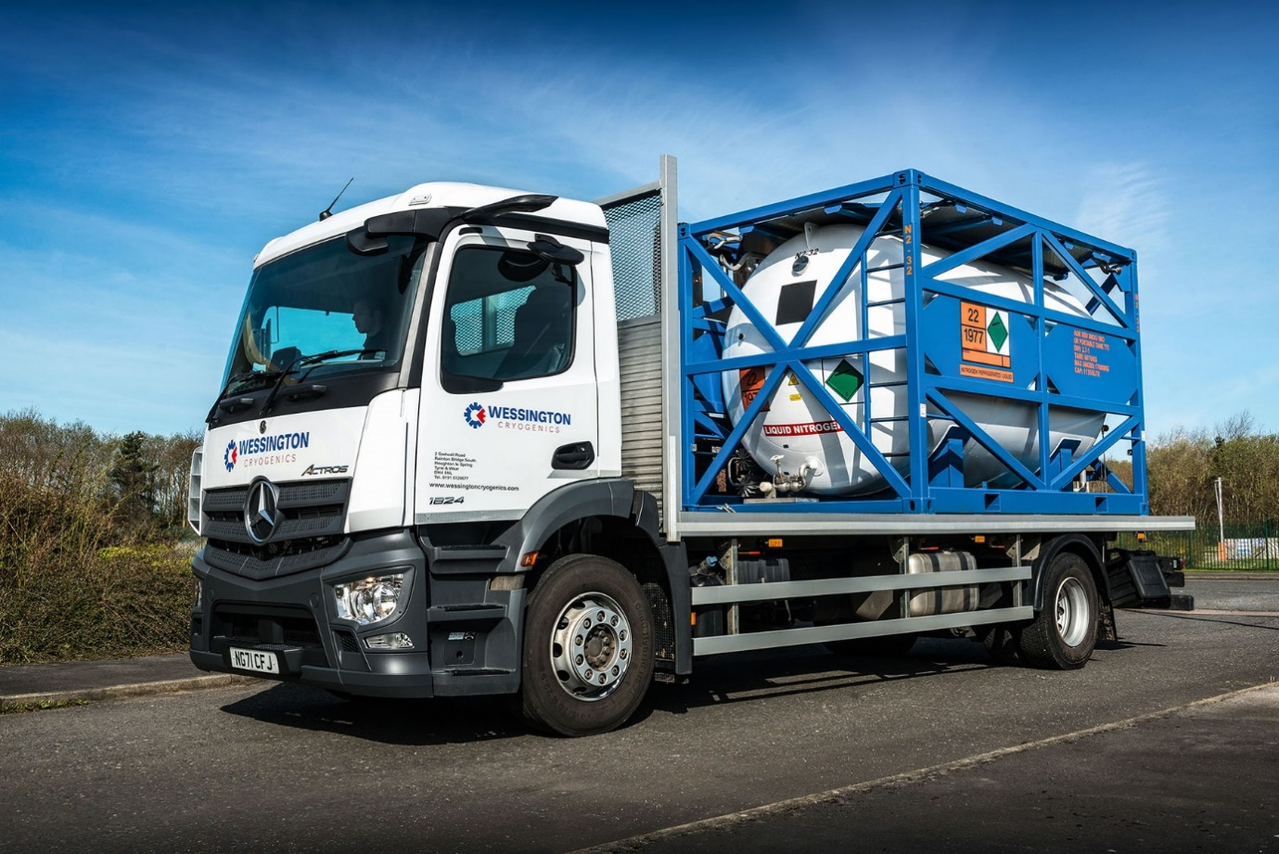

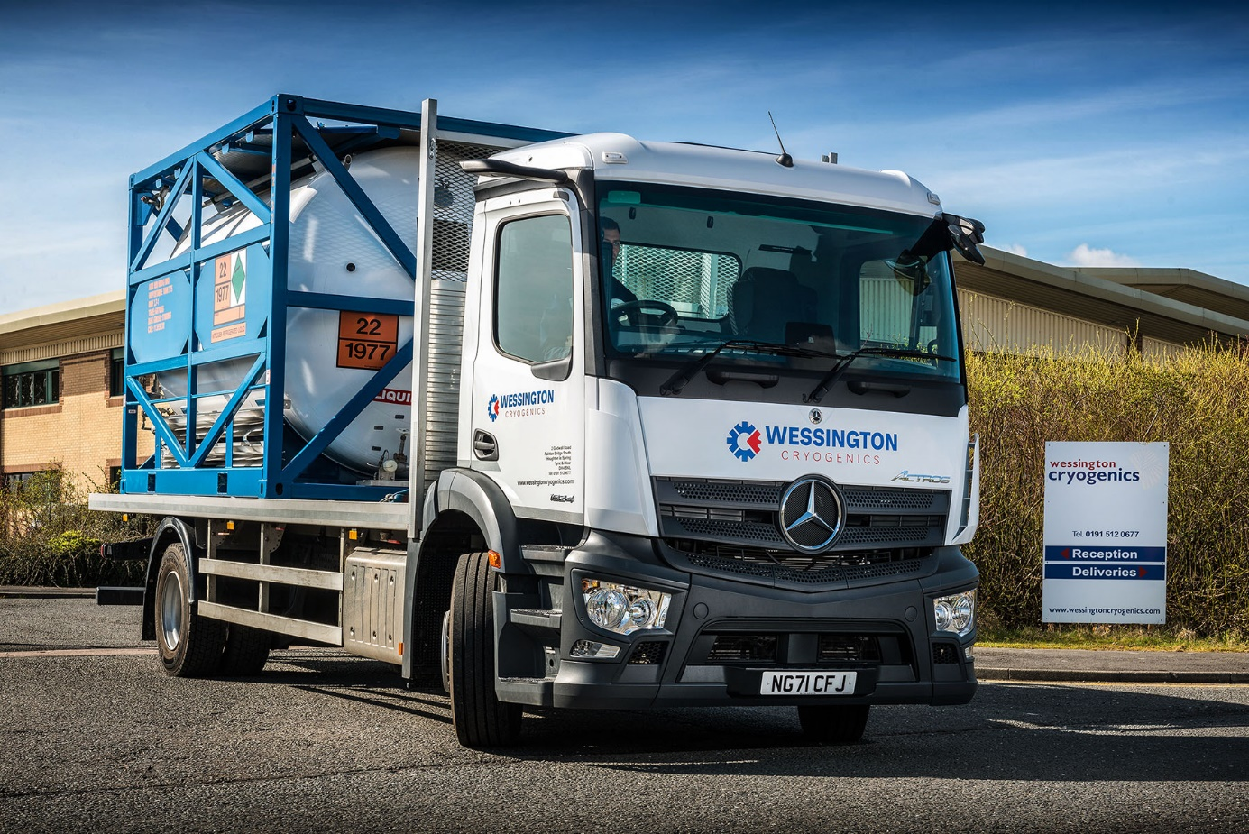

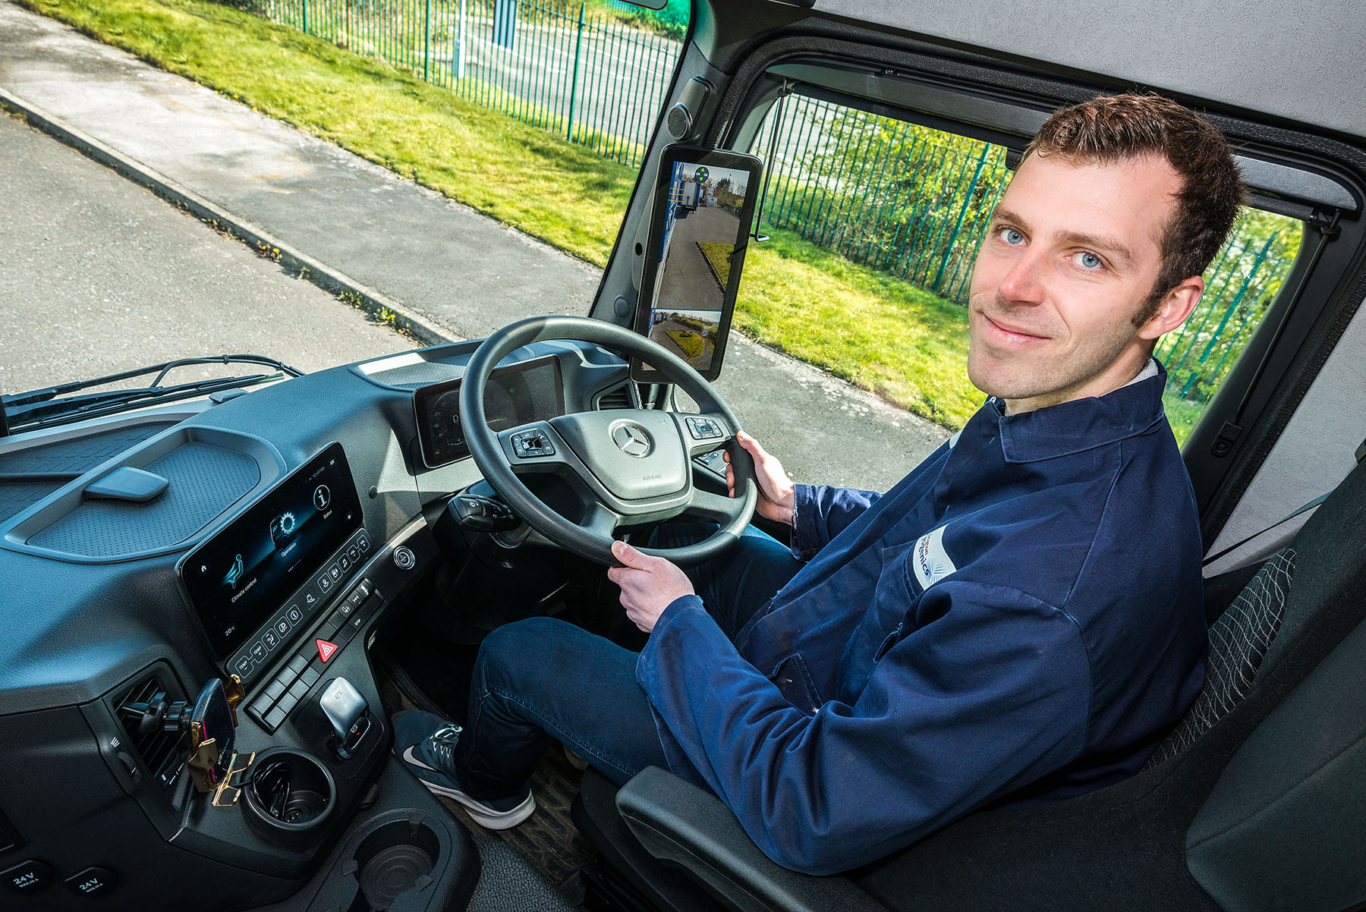

Wheel appeal: Driver Mark Hodgson has been “blown away” by the state-of-the-art technology on the new Mercedes-Benz Actros

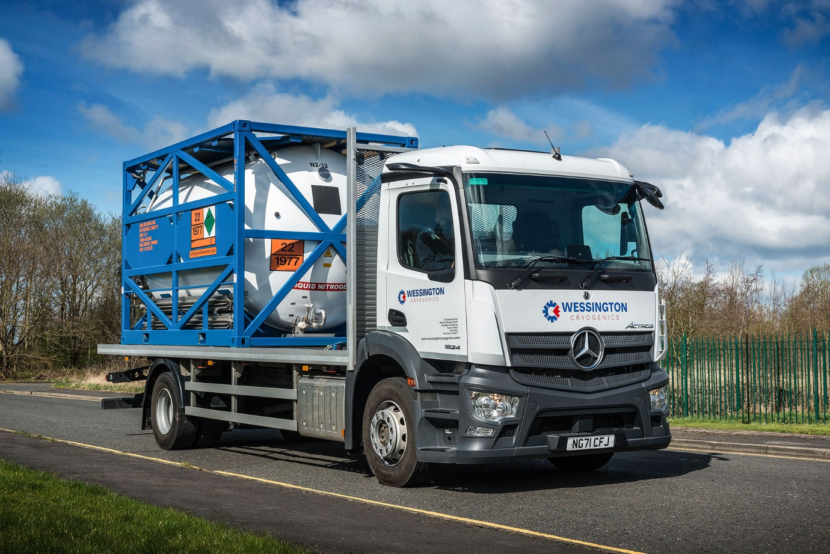

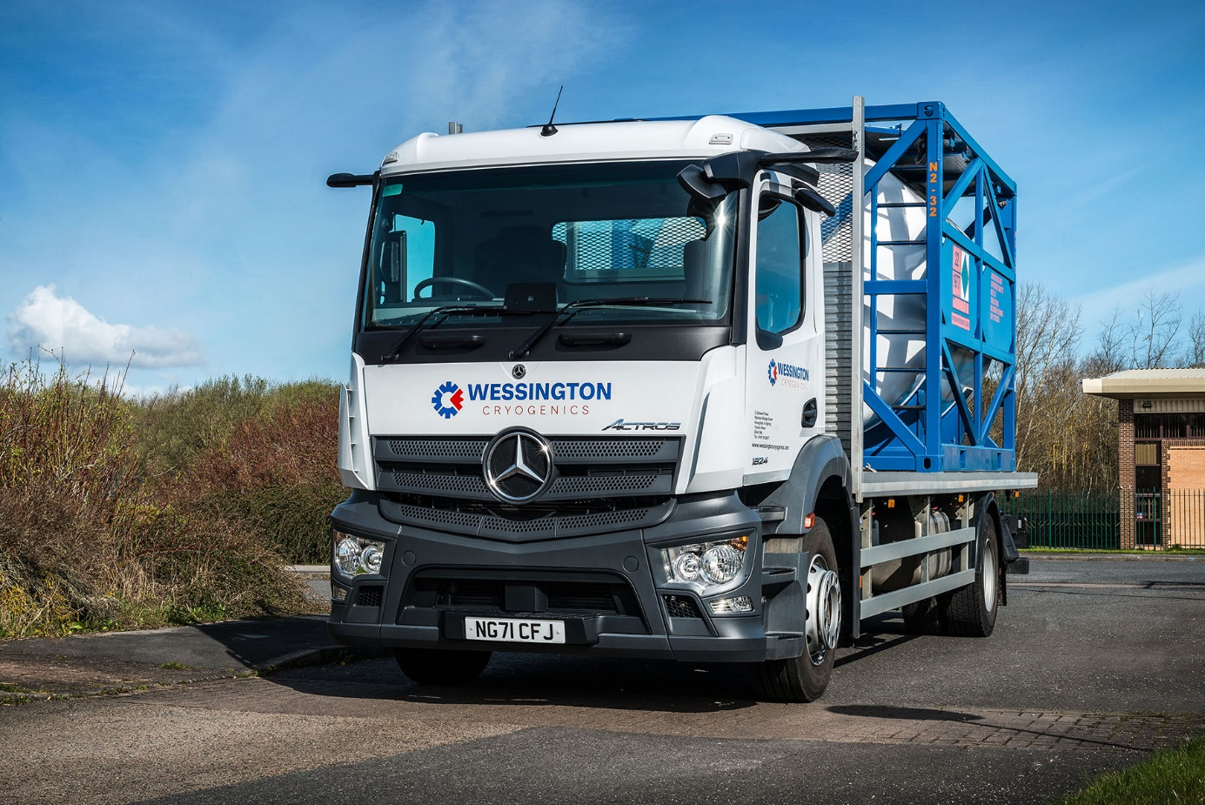

ends

For more information, or to request bigger versions of image files, please contact:
Steve Warren or John Ripley
Impact Communications
Steve: 07770 470251, steve@impactcom.co.uk
John: 07771 484595, john@impactcom.co.uk

