

Date: 8 September 2020

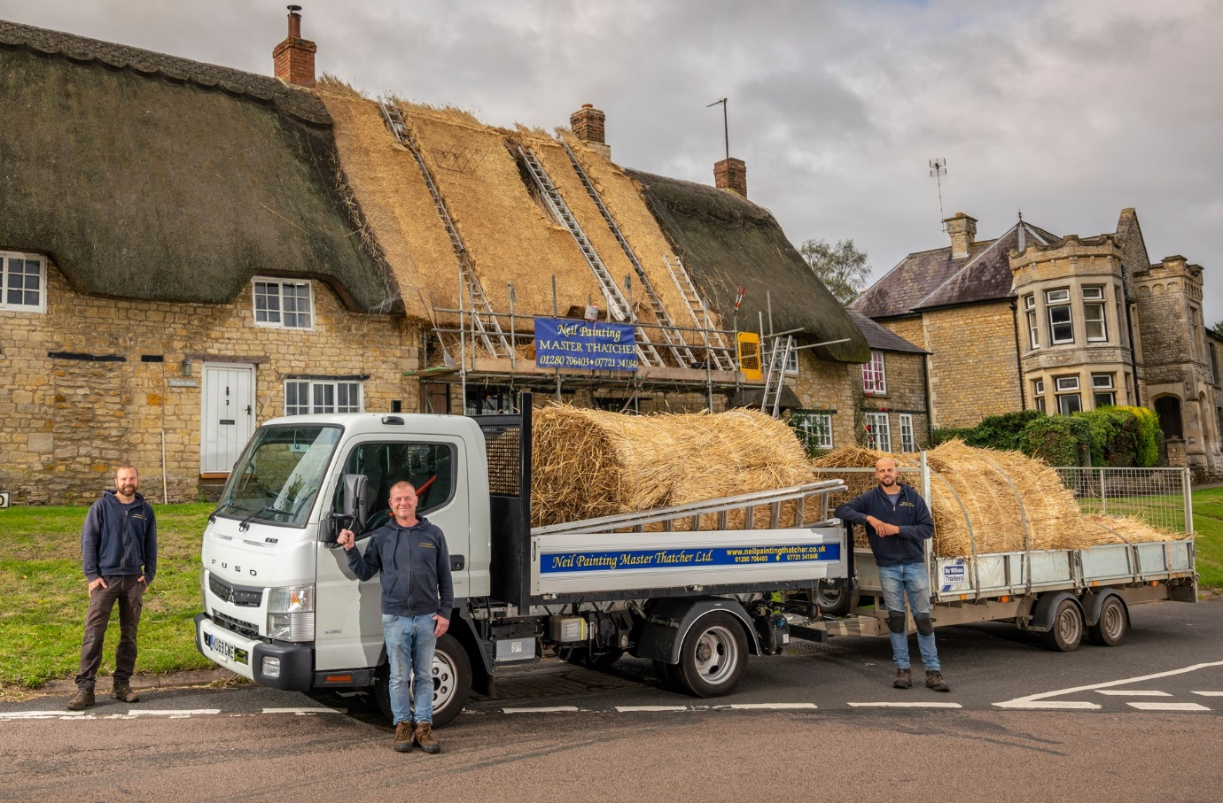

Straw poll: His new FUSO Canter certainly gets the vote of thatcher Neil Painting, centre, and his colleagues David Mansfield, left, and Harrington Melhuish (the fourth member of the team, David Lewis, was on holiday at the time)

Master Thatcher Neil moves up in the world with FUSO Canter from Intercounty Truck & Van

Neil Painting Master Thatcher Ltd is enjoying the benefits of increased efficiency and productivity after switching his bigger deliveries of straw and reed to a 3.5-tonne FUSO Canter.

Not only does the new truck offer the rugged build quality and engine performance he needs, but with its tipping body and 3.5-tonne towing capacity it is also able to carry significantly more thatching material than the pickups he was using previously.

Mr Painting’s company is based in Brackley, Northamptonshire. Its skilled, experienced craftsmen cover and repair the roofs of period properties and listed buildings in the southern half of the county, as well as throughout Oxfordshire and Buckinghamshire.

The FUSO Canter 3C15 arrived via the Milton Keynes branch of Mercedes-Benz Dealer Intercounty Truck & Van – both brands are part of the Daimler family, and sold and supported by the same franchised network in Britain.

Pre-built for demonstration purposes, the Canter has a tipping body by Brit-Tipp, of Warrington, and was already fitted with a tow hook. The truck had covered just shy of 7,000 miles when Intercounty Truck Sales Executive Paul Hind handed over the keys.

“Pickups are limited when it comes to carrying capacity, while lighter, van-based dropsiders don’t provide the toughness and durability we need,” Mr Panting explained. “The Canter, by contrast, has a strong ladder frame chassis, and looks and feels like a proper truck.

“Its higher carrying capacity means we need to make fewer trips to get the same volumes of specially grown, premium quality thatch to site, and take rubbish away. This increased efficiency and flexibility translates into useful time and cost savings.”

All FUSO Canter variants from 3.5-8.55 tonnes GVW are powered by 3.0-litre common-rail turbo-diesel engines that employ variable nozzle turbine technology to deliver high torque from low speeds. The 3C15 model offers 110 kW (150 hp) and 370 Nm of torque, and drives as standard through a smooth-shifting, fuel-efficient DUONIC automated dual-clutch transmission with Eco Mode, Parking and Creep functions. An engine brake is also included.

Mr Painting recalled: “I did also consider a similar vehicle by another Japanese manufacturer, but I didn’t think its 1.9-litre engine would be up to the job. I’m sure I made the right decision, because the Canter pulls and handles really well, even when we’ve a full load on.

“It’s also surprisingly comfortable, and spacious enough to accommodate three members of the team. The very tight turning circle means it’s highly manoeuvrable, too, which is a big advantage when we’re working at locations with restricted access.”

He added: “I contacted Intercounty after seeing the truck advertised, and Paul brought it over to show me. His service has been excellent throughout, and I’ve every confidence the same will be true of the Dealer’s aftersales back-up.”

Mr Painting has always earned his living as a thatcher. “I’d always wanted to do something that would allow me to work outside, in the country, and was just 14 when I took my first, holiday job with a local craftsman,” he said. “That was it, I was hooked.”

Having worked previously for others, Mr Painting established his business in 1999 “so I could put my own stamp on thatching”. In addition to its re-thatching, re-ridging and patching services, Neil Painting Master Thatcher offers thatching surveys, advises on building, conservation and fire protection issues, and undertakes insurance and emergency work.

“I’m now 53 so I don’t get on the roofs anymore – I leave that to the younger lads now. But I still wake up every morning, happy that I made the right decision all those years ago.”

neilpaintingthatcher.co.uk

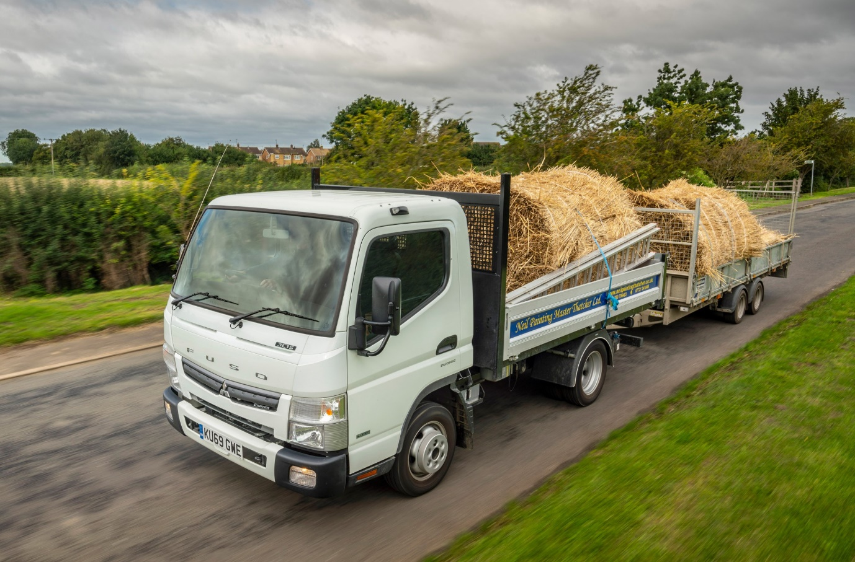

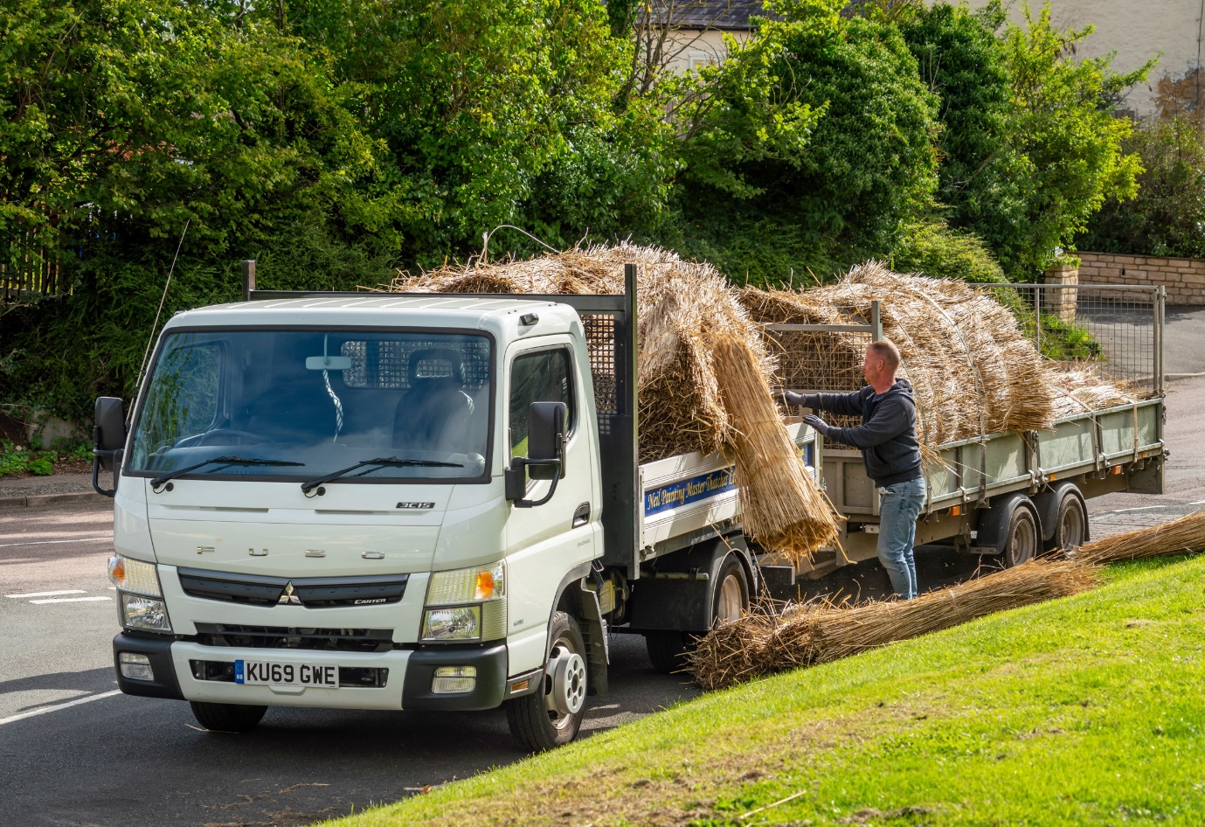

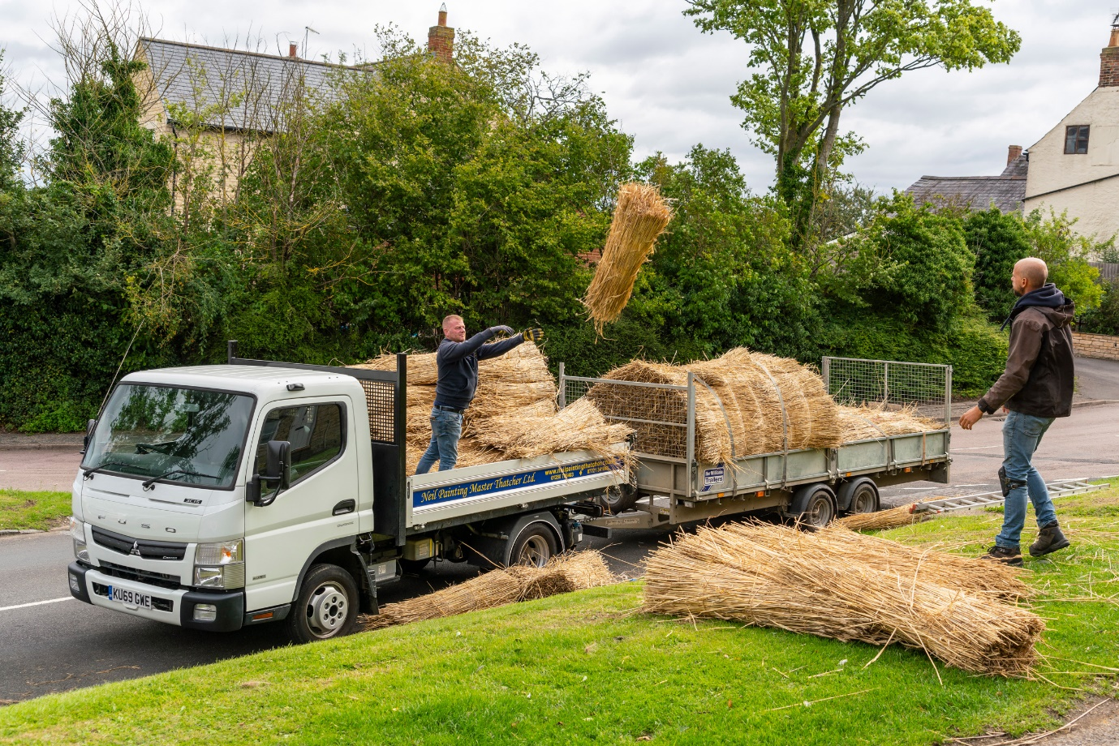

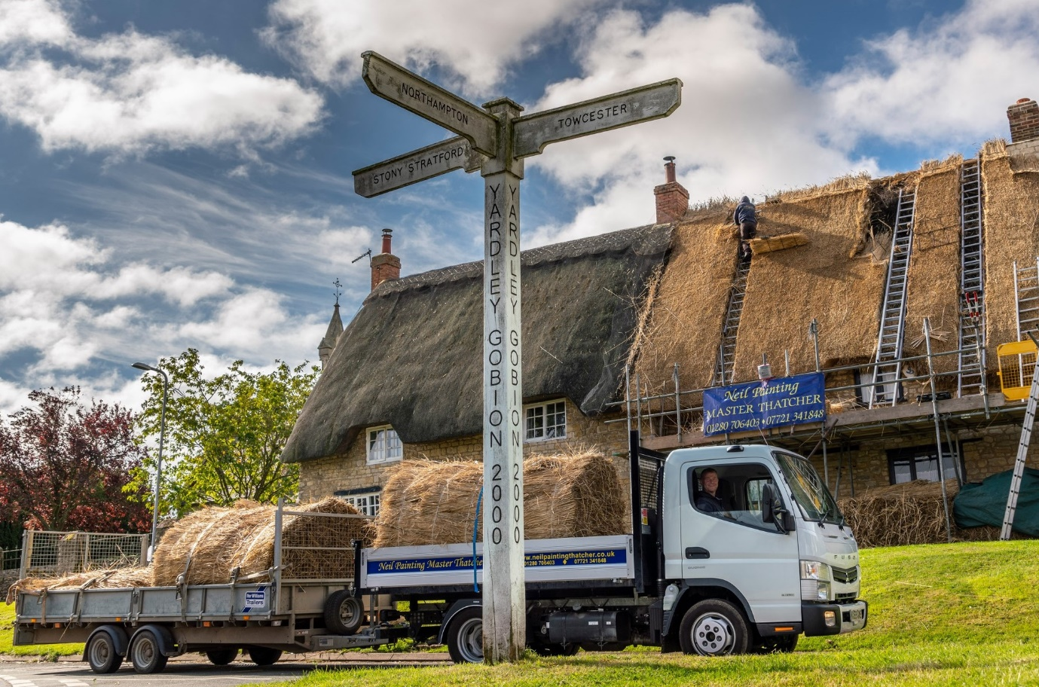

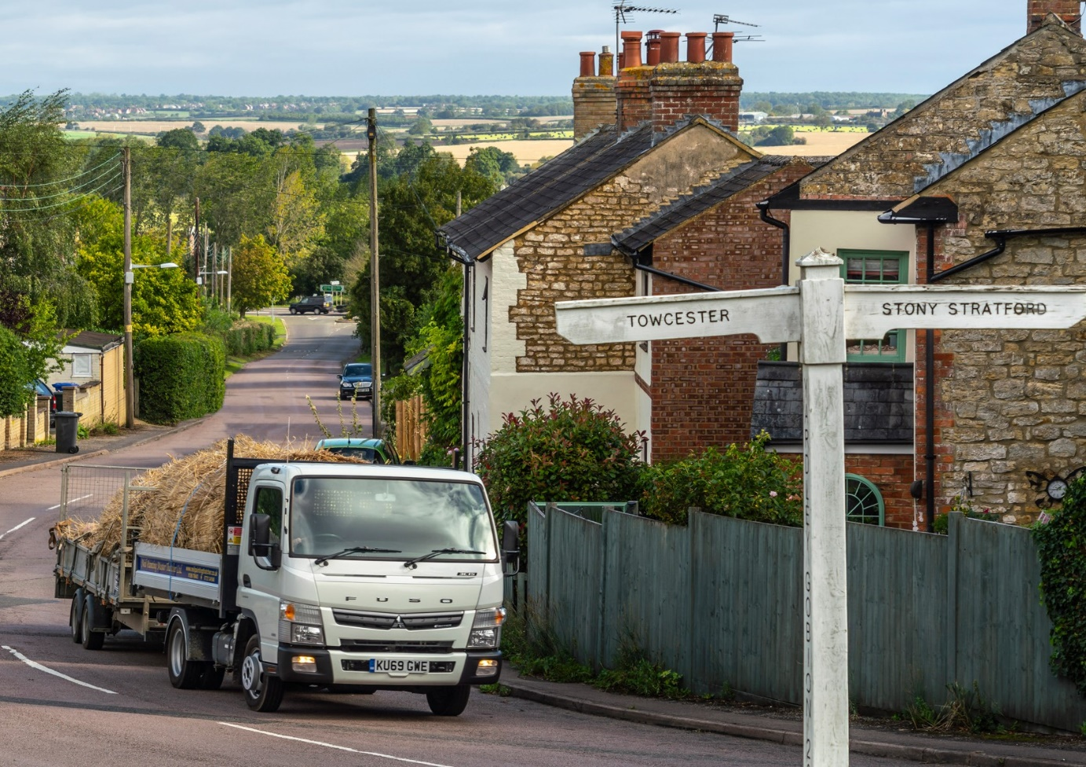

ends

For more information, or to request bigger/higher-res image files, please contact:
Steve Warren or John Ripley
Impact Communications, 01926 842126
Steve: 07770 470251, steve@impactcom.co.uk
John: 07771 484595, john@impactcom.co.uk

