

Date: 25 August 2021

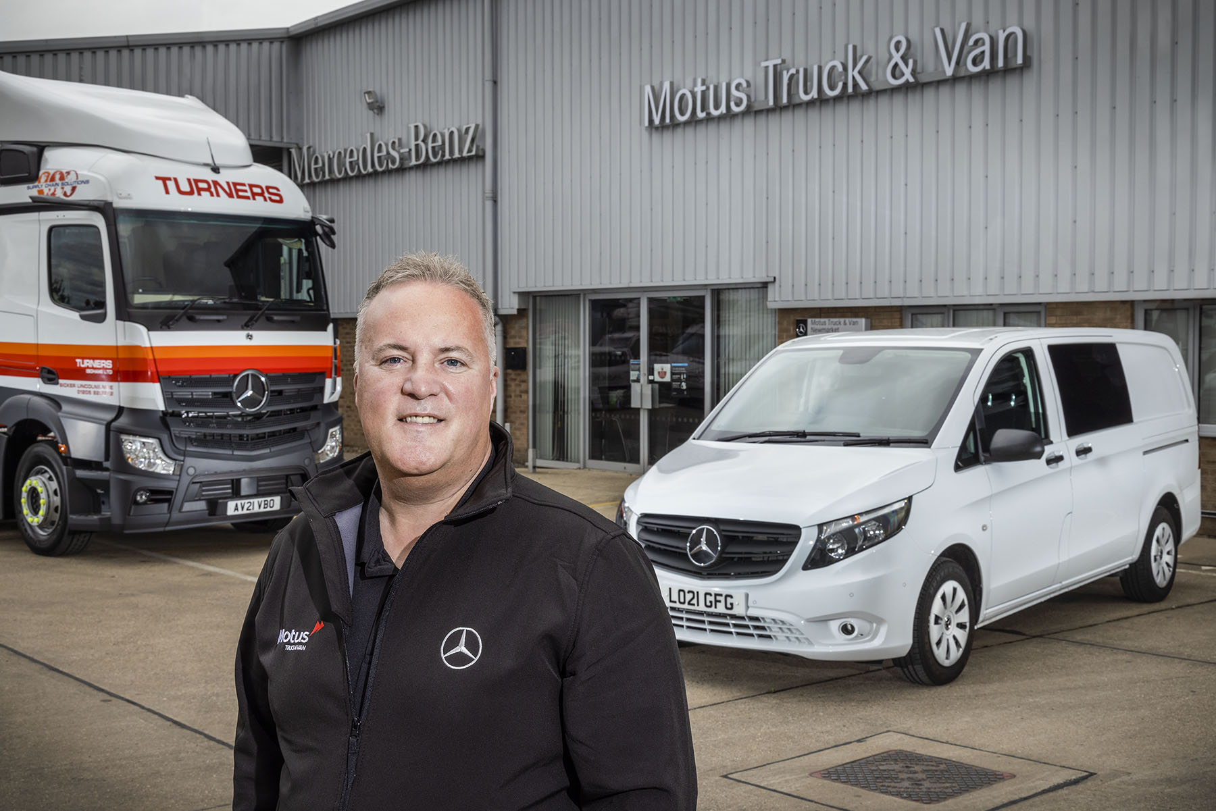

Better together: Managing Director Lee Seward was running two Mercedes-Benz Dealerships before both were combined to form Motus Truck & Van. He is pictured outside the company’s Newmarket branch, whose customers include high-profile fleet operator Turners

Introducing Motus Truck & Van, a new force in Mercedes-Benz and FUSO commercial vehicles

Mercedes-Benz Trucks and Mercedes-Benz Vans have welcomed the latest member of their shared Dealer network – unlike other new franchisees, though, there will be no ‘learning curve’ to negotiate for Motus Truck & Van.

That’s because its team are already steeped in the ethos of the two brands they represent, and experts on the manufacturer’s product ranges, finance offerings and aftersales provision.

The launch of Motus Truck & Van marks the completion of a process begun seven years ago, by formally bringing together as a single, unified business, two long-established and highly successful Mercedes-Benz commercial vehicle Dealers.

Orwell Truck & Van served customers from two facilities in Ipswich, and others in Colchester, Newmarket and Norwich, while S & B Commercials did so from its branches in Hatfield, Stansted, Thurrock and Welham Green.

Following the seamless transition completed on Tuesday (24 August), the newly merged and rebranded company is now trading from all nine of these sites, as well as the vehicle maintenance units it operates at various fleet customer locations.

Reflecting its growth ambitions, Motus Truck & Van is also looking forward to the opening before the end of this year of the state-of-the-art truck and van aftersales centre now under construction on a three-acre site alongside the A12 trunk road, in the Essex town of Witham. This flagship development represents an investment of nearly £4 million.

Motus Truck & Van is part of the South African-owned Motus Group (UK), a multi-franchise automotive business with 78 outlets nationwide. The new Dealer has inherited a combined workforce of more than 400 highly motivated colleagues. They are led by Managing Director Lee Seward, who has held the position with the two former businesses since November 2019.

Motus – the word is Latin for ‘motion’ – was operating under a previous name when it bought into the Mercedes-Benz Dealer network, acquiring Orwell Truck & Van in 2013 and S & B Commercials the following year.

Lee Seward explained: “We have committed a great deal of time and effort to rebuilding the foundations of these two very different businesses over the last couple of years. The rebranding that we’ve announced this week marks the formal completion of this process.

“Having introduced new systems and processes, capitalised on synergies, and developed strategies, we are now on a much stronger footing and working as one, completely unified team. As a result, we are ideally placed to compete with the very best in the Mercedes-Benz network.”

The impressive, three-storey suite of offices at Welham Green, Hatfield, was earmarked at an early stage as the new company’s headquarters, and administrative functions previously undertaken elsewhere are now concentrated here.

Motus Truck & Van sells and supports the multi-award-winning Mercedes-Benz commercial vehicle ranges, which extend from the mighty Actros tractor unit to the Citan small van. Like other members of the manufacturer’s network in Britain, it retails popular FUSO Canter light trucks too.

Together with its fellow Mercedes-Benz Dealers, Motus Truck & Van is leading the charge towards a zero-emission future. It already offers battery-powered eSprinter and eVito van models, as well as the 7.5-tonne FUSO eCanter, the world’s first fully electric truck to enter series production. More ground-breaking electric technology is just around the corner.

“These are tremendously exciting times for our industry,” enthused Lee. “With great products and facilities, a passionate, talented and loyal team of highly professional colleagues, and a commitment to customer service that now runs through every part of this business, we’re perfectly placed to make the most of every growth opportunity.

“Our aim now is to establish Motus Truck & Van as the UK’s number one supplier of Mercedes-Benz and FUSO commercial vehicles.”

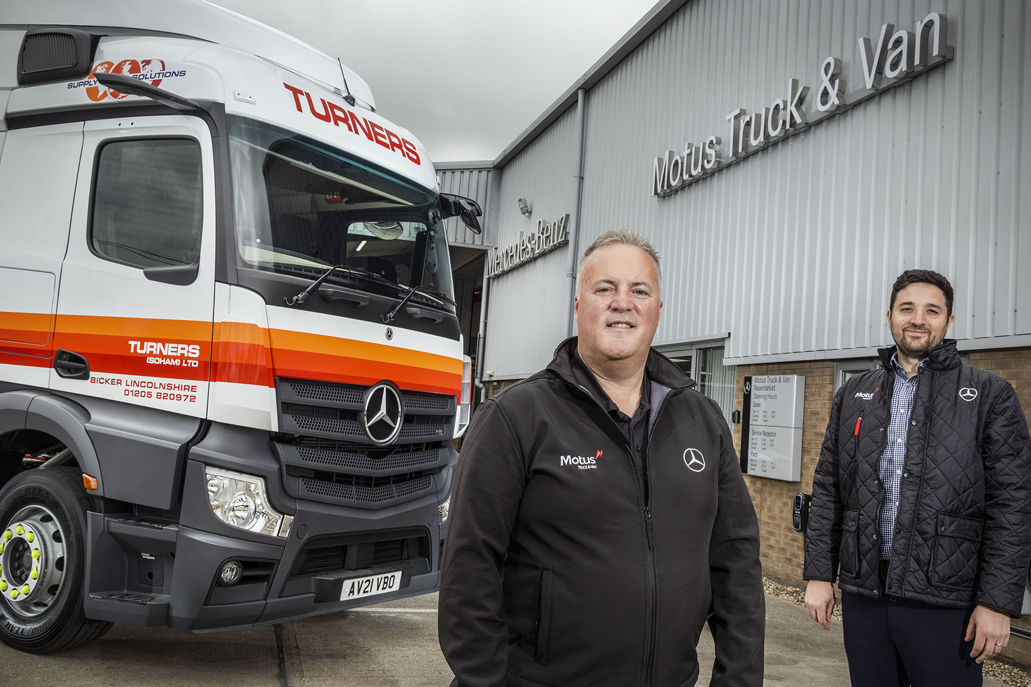

Shining the star: Motus Truck & Van Managing Director Lee Seward, left, is pictured with Head of Marketing & Contact Centre Tom Sunderland, who has played a key role in the re-branding of two former Mercedes-Benz Dealerships

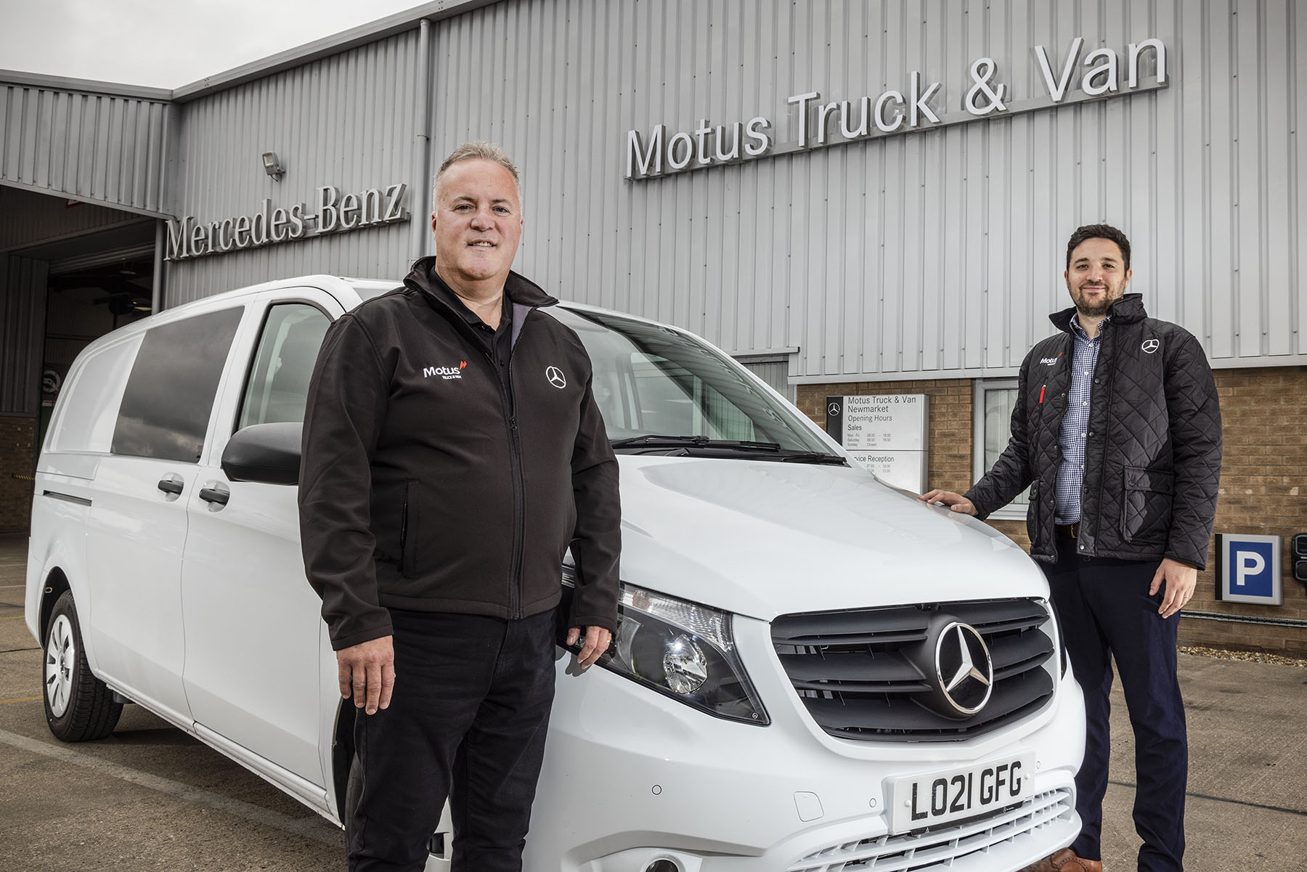

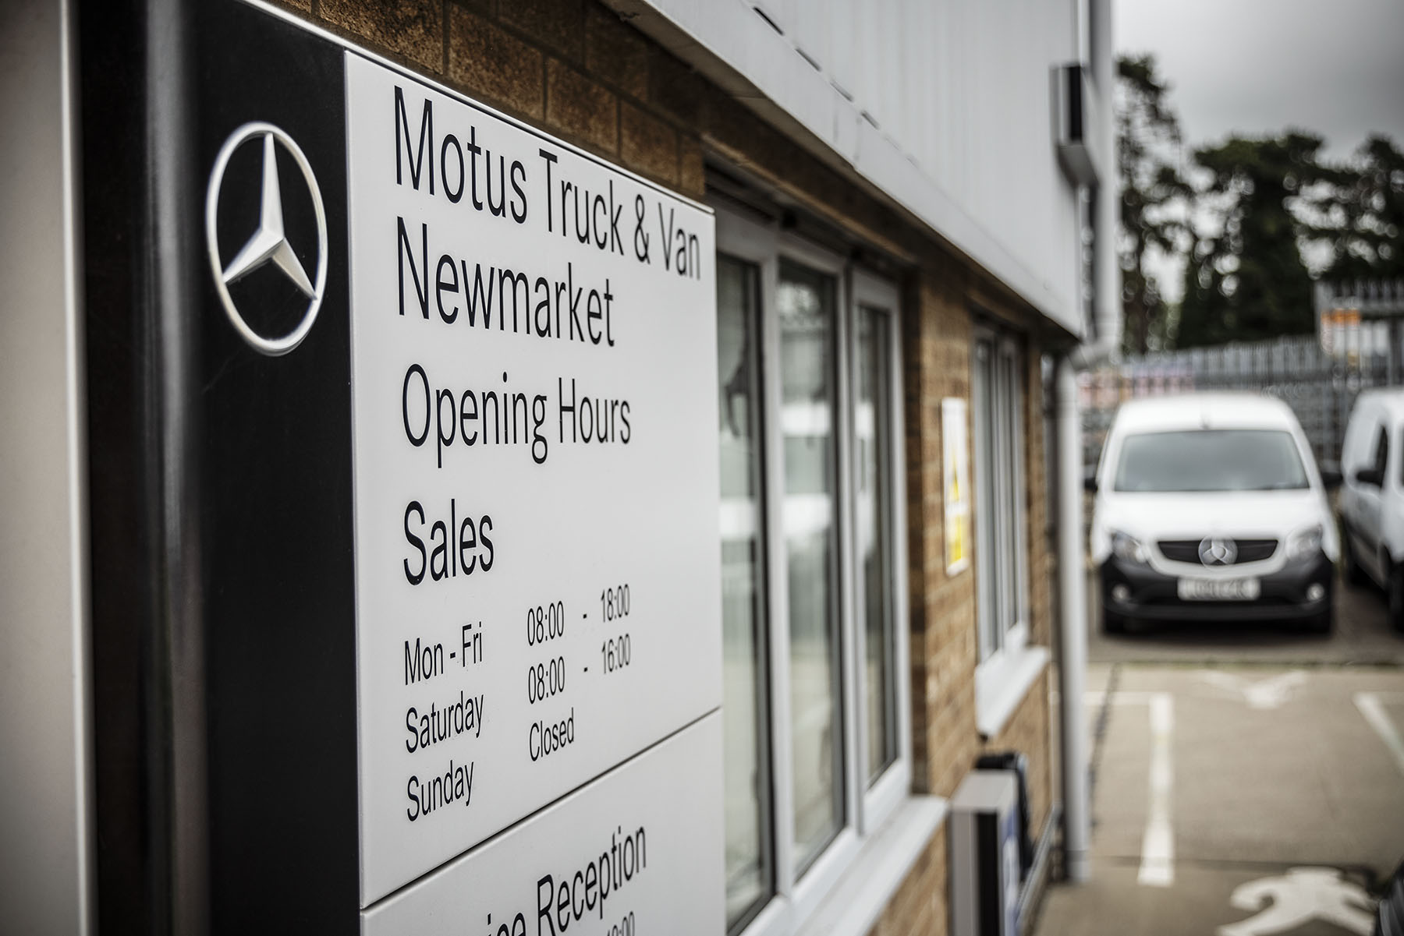

ends

For more information, or to request bigger/higher-res image files, please contact:
Steve Warren or John Ripley
Impact Communications, 01926 842126
John: 07771 484595, john@impactcom.co.uk
Steve: 07770 470251, steve@impactcom.co.uk

