

Date: 2 June 2023

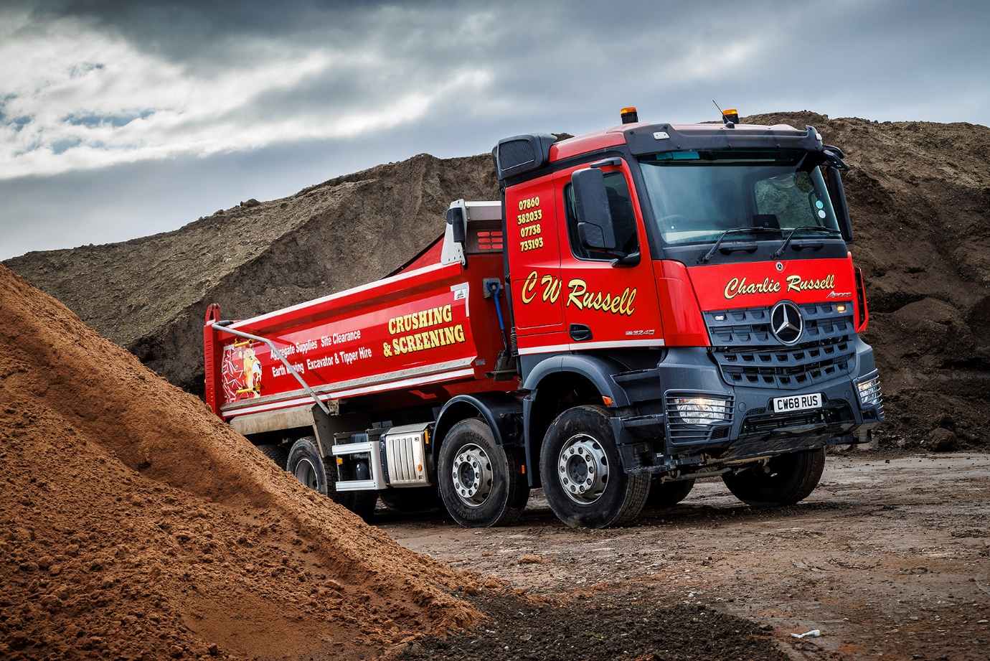

Rugged Mercedes-Benz Arocs from Bell Truck and Van muscles in to CW Russell’s fleet

Two years ago CW Russell wasn’t running any Mercedes-Benz trucks but since then the three-pointed star has risen and will soon account for half of the operator’s 42-strong line-up.

The latest arrivals, three Arocs 8x4 tippers, were delivered to CW Russell’s Middlesbrough headquarters by Dealer Bell Truck and Van. All are 3240K models powered by 355 kW (455 hp) 10.7-litre ‘straight six’ engines, and have ClassicSpace L sleeper cabs.

Previous Arocs tippers supplied to Russell have day cabs with 320 mm engine tunnels, which provide a lower driving position and fewer steps up to the cockpit. The new trucks, though, ride higher and have 170 mm tunnels, to allow space for the under-bunk fridge draws the operator specified. All are covered by Mercedes-Benz ExtendPlus warranties that provide cover for five years.

Fitted with steel Boweld bodies and Edbro front-end rams, the new tippers will be joined later this year by four more Arocs eight-wheelers and a trio of Mercedes-Benz Actros tractor units, also from Bell Truck and Van.

CW Russell specialises in construction and ‘muckaway’ haulage, plant hire – with a range of earth-movers and other machines, which can be delivered on low-loaders – and the supply of aggregates from its own crushing and screening facility. Celebrating its 30th anniversary in business later this year, the company was founded by Managing Director Charlie Russell. He has now been joined by his son and fellow Director, Tom.

“Not so very long ago our fleet was dominated by trucks from another brand,” said Tom Russell. “Over time, though, we became less happy with them and started to look at alternatives. We tried several other options but none gave us a level of toughness and reliability that we were happy with.

“Two years ago, though, we took our first Arocs tipper from Bell Truck and Van and that was a revelation. The Arocs is built a very high standard but, importantly, is also clearly designed with exactly our kind of work in mind – the high ground clearance and suspension make it a very capable off-road performer.”

Since then that first Arocs has been joined by nine more, as well as five Actros tractors which haul bulk tipping trailers.

“Our Mercedes-Benz trucks have been extremely reliable and given us no issues at all,” said Mr Russell. “The service from Bell Truck and Van has been impressive too. Sales Executive Craig Graham has remained in regular contact ever since delivering our first vehicle and looks after us very well, while we’ve also developed a strong relationship with the workshop team at Bells’ Billingham depot. The availability of the five-year extended warranty just adds to our peace of mind.”

Although many of Russell’s eight-wheelers are intended for local day-work, the company is making an increasing number of runs north into Scotland – which is why its latest tippers were specified with sleeper cabs and fridges.

“Our drivers have reacted very well to the Arocs and these new arrivals have certainly been positively received,” Mr Russell continued.

“We’re very pleased with the total package – dependable, driver-friendly trucks with top-quality back-up from an attentive dealer – which explains why Mercedes-Benz is quickly taking over the lion’s share of our fleet.”

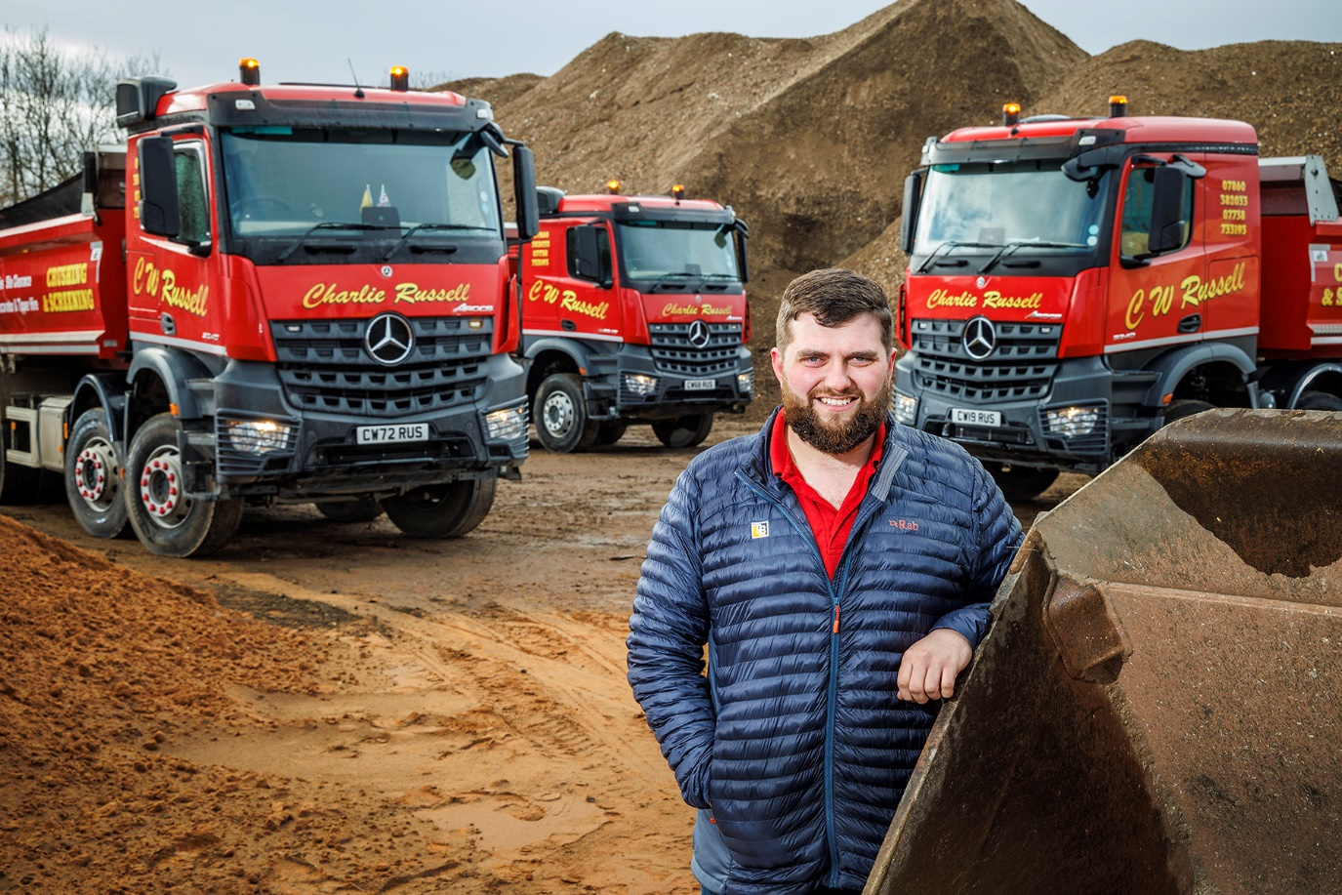

Top tips: Tom Russell with the latest trio of Mercedes-Benz Arocs 32-tonners to join the fleet of his family’s firm

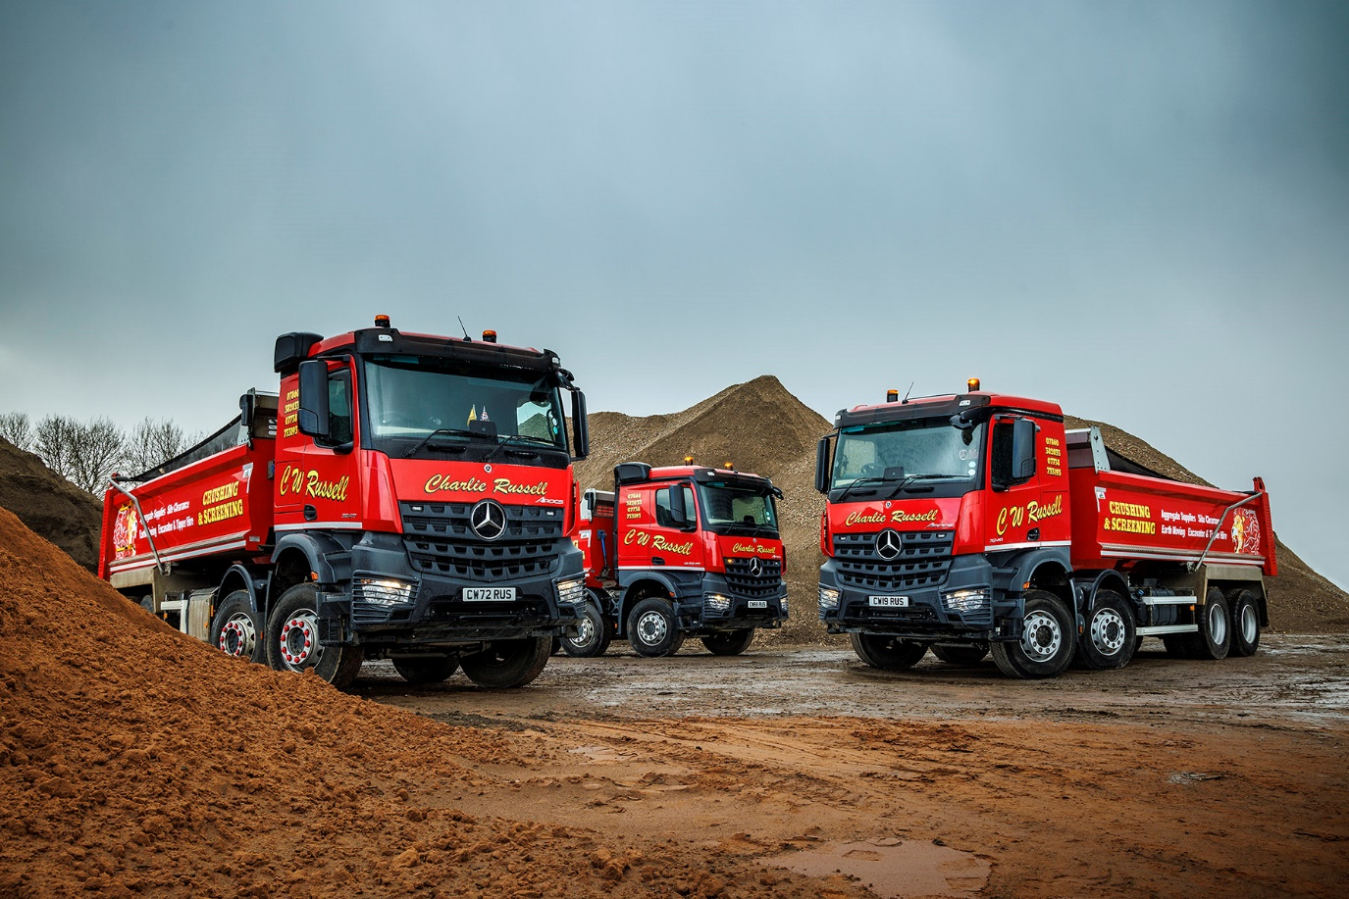

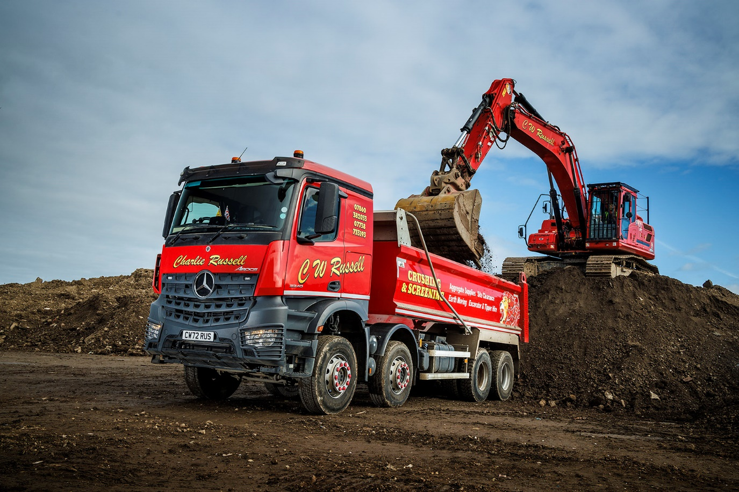

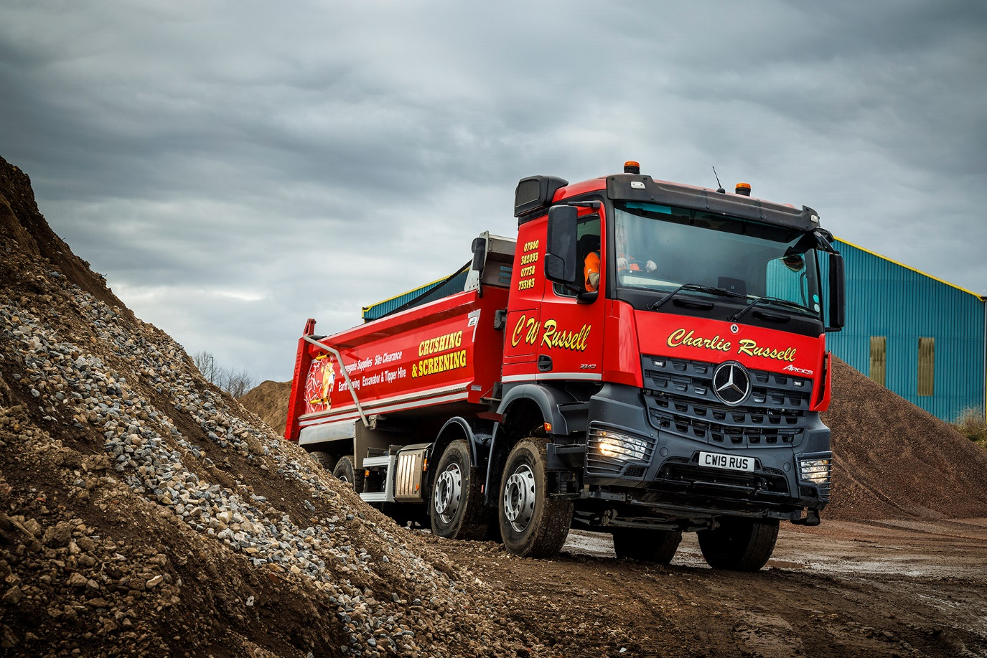

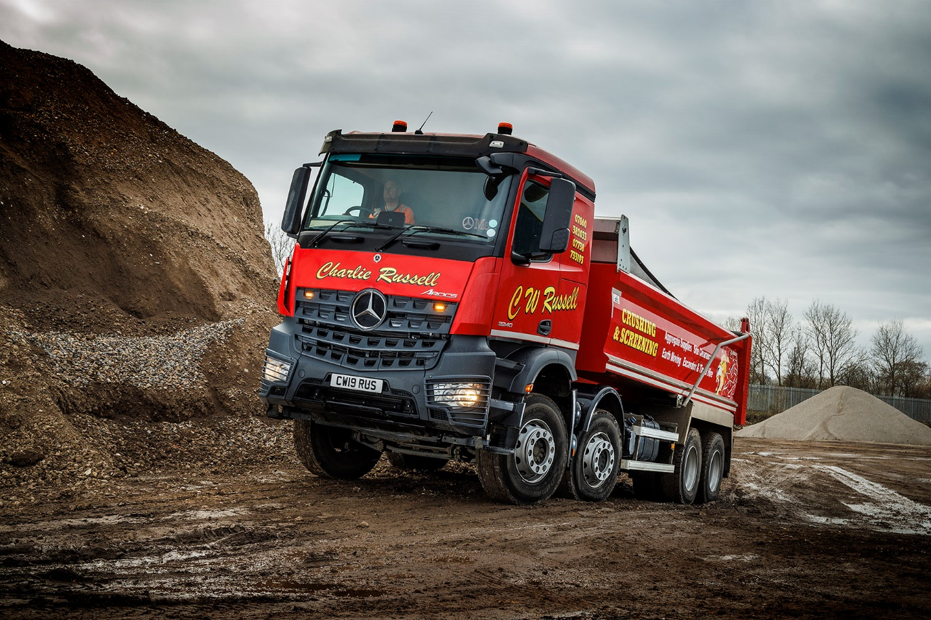

ends

For more information, or to request bigger/higher-res image files, please contact:
John Ripley: 07771 484595, john.ripley@loopagency.co.uk

