

Date: 6 November 2020

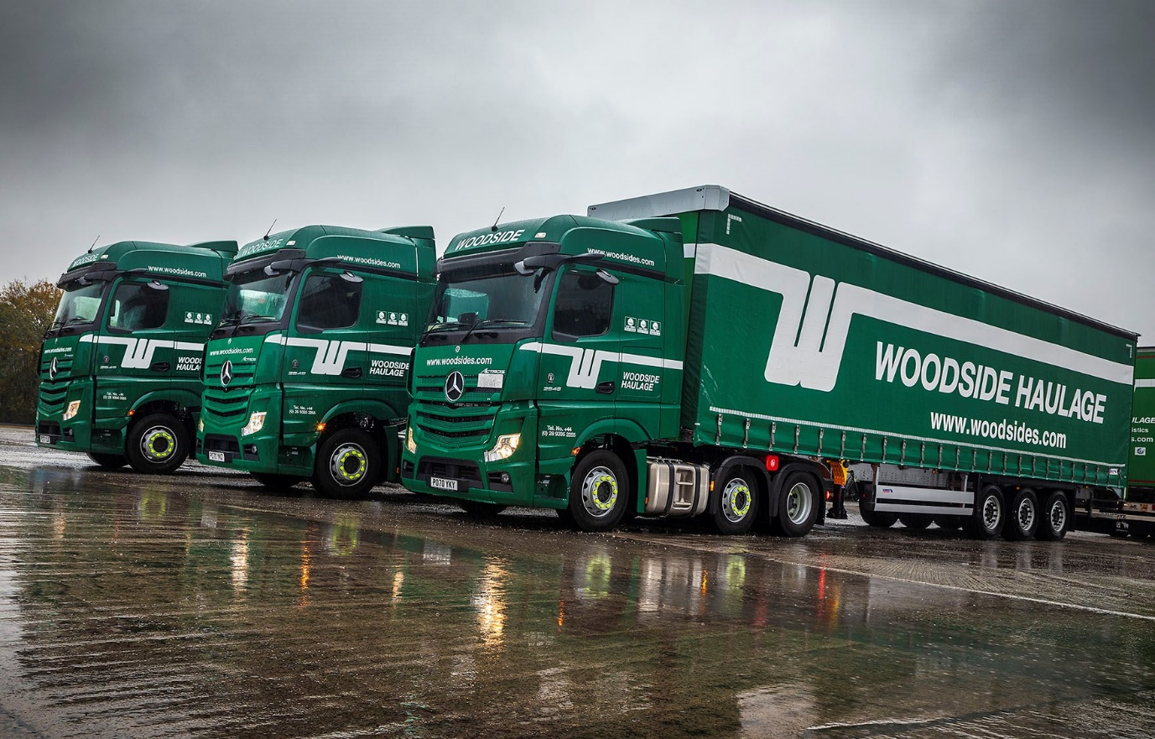

Green for go: Another 12 Actros wear the distinctive colours of Woodside Haulage

Cutting-edge Mercedes-Benz truck technology delivers on efficiency and safety for Woodside Logistics

Enthusiastic feedback from some of the first drivers to experience Mercedes-Benz Trucks’ MirrorCam system was instrumental in persuading Woodside Logistics Group to commission another 12 new-generation Actros equipped with the innovative replacement for conventional mirrors.

The new tractor units were supplied by north west Dealer Ciceley Commercials, and have entered service with the family-owned operator’s Woodside Haulage division. The subject of Mercedes-Benz Finance contract hire agreements, all are 2545 models with BigSpace cabs and 12.8-litre, in-line six-cylinder engines that produce 330 kW (450 hp).

Woodside Haulage runs more than 100 trucks from its base in Preston. The latest have joined 16 other Actros tractors added over the last couple of years, most of which are also new-generation models with MirrorCam.

Maintained by Ciceley Commercials, the Actros work mainly for customers engaged in UK-Ireland trade, transporting loads to and from docks at Liverpool and Heysham, and making collections and deliveries across mainland Britain. Woodside Haulage’s drivers are frequently out on the road all week.

Operations Director Glenn Alderdice said the company knew it could bank on the cutting-edge technology of its new Actros to deliver efficiency gains and enhance safety, and on its chosen Dealer to provide dependable aftersales support.

“When it comes to choosing new vehicles we work through a checklist of attributes,” he explained. “Our trucks must be safe, provide a comfortable working and living environment for our drivers, and offer competitive whole-life running costs. By putting new technology to the most effective use, the Actros ticks all of these boxes.”

Mr Alderdice continued: “MirrorCam is, perhaps, the most high-profile example of new technology on any vehicle at the moment, and has been very well received by our drivers. The feedback from those who’ve been using the system since we introduced our first new-generation Actros last year has been extremely positive. They find it intuitive to use and say it provides an exceptionally clear view, especially when manoeuvring.”

MirrorCam’s rear-facing cameras relay their images to screens mounted inside the cab, on the A-pillars. As well as enhancing safety by providing much-enhanced all-round visibility, not least through the elimination of forward-facing blind spots caused by conventional mirrors, the system cuts diesel costs by an estimated 1.5% because the cameras’ compact, streamlined housings create far less wind resistance.

The latest, enhanced version of Mercedes-Benz Trucks’ well proven Predictive Powertrain Control (PPC) system also contributes to the International Truck of the Year’s impressive economy. PPC employs digital 3D mapping and GPS data to scan the road ahead, then manages gear changes and ensures that full use is made of the Mercedes PowerShift 3 transmission’s Eco Roll function to maximise fuel-efficiency and reduce emissions. The system now makes an even more substantial contribution to economy by covering virtually all A roads, as well as many B roads, and taking account not only of topography but also of corners, roundabouts, junctions and traffic signs.

New Actros also comes with a radical new dashboard, which replaces traditional switchgear with twin screens, one operated by touch. The drivers of Woodside Haulage’s latest trucks benefit from the upgraded Multimedia Cockpit, interactive, which comes with a larger 12in instrument panel and additional functionality.

On safety, meanwhile, standard equipment includes a potential life saver in the form of Active Brake Assist 5. Whereas the previous version of Mercedes-Benz Trucks’ emergency braking system relied solely on radar, its successor employs a combination of radar and cameras. The result, at speeds of up to 50 kph, is a dramatically improved response to moving pedestrians. Active Brake Assist 5 can now employ full braking – as opposed to the 50% achieved previously – when encountering pedestrians crossing its path.

“Like any responsible operator, safety is something we take very seriously both for our own staff and other road users,” confirmed Mr Alderdice. “We feel Active Brake Assist 5 can make a very worthwhile contribution by helping to prevent accidents.

“The final piece in the jigsaw is back-up, and with its strong customer service ethos Ciceley Commercials looks after us very effectively. We’ve been impressed with the professional approach of the team at the Dealer’s Blackburn workshop.”

Established in 1967, Woodside Logistics Group offers professional transport services across Ireland, the UK, Europe and beyond. The Group’s five independent companies provide full and part-load pallet distribution, car transportation and storage, bulk liquid, powder and gas transport, warehousing, and international air and sea freight forwarding.

woodsides.com

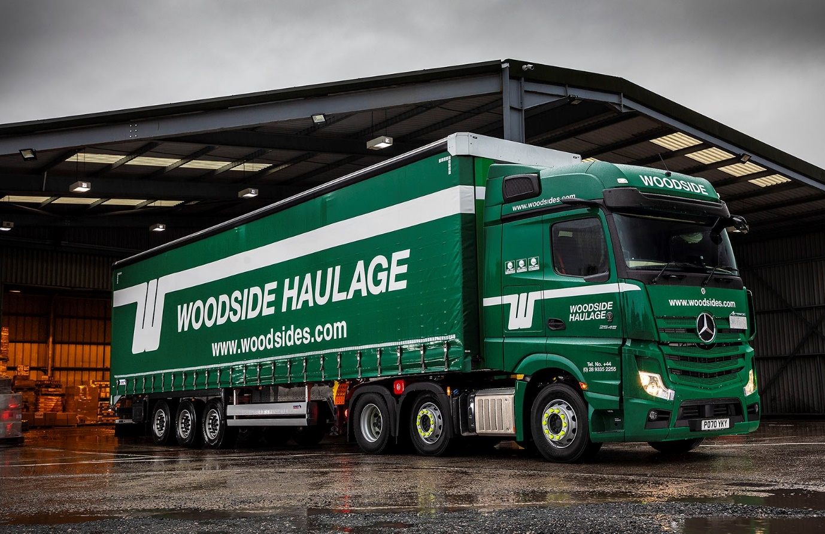

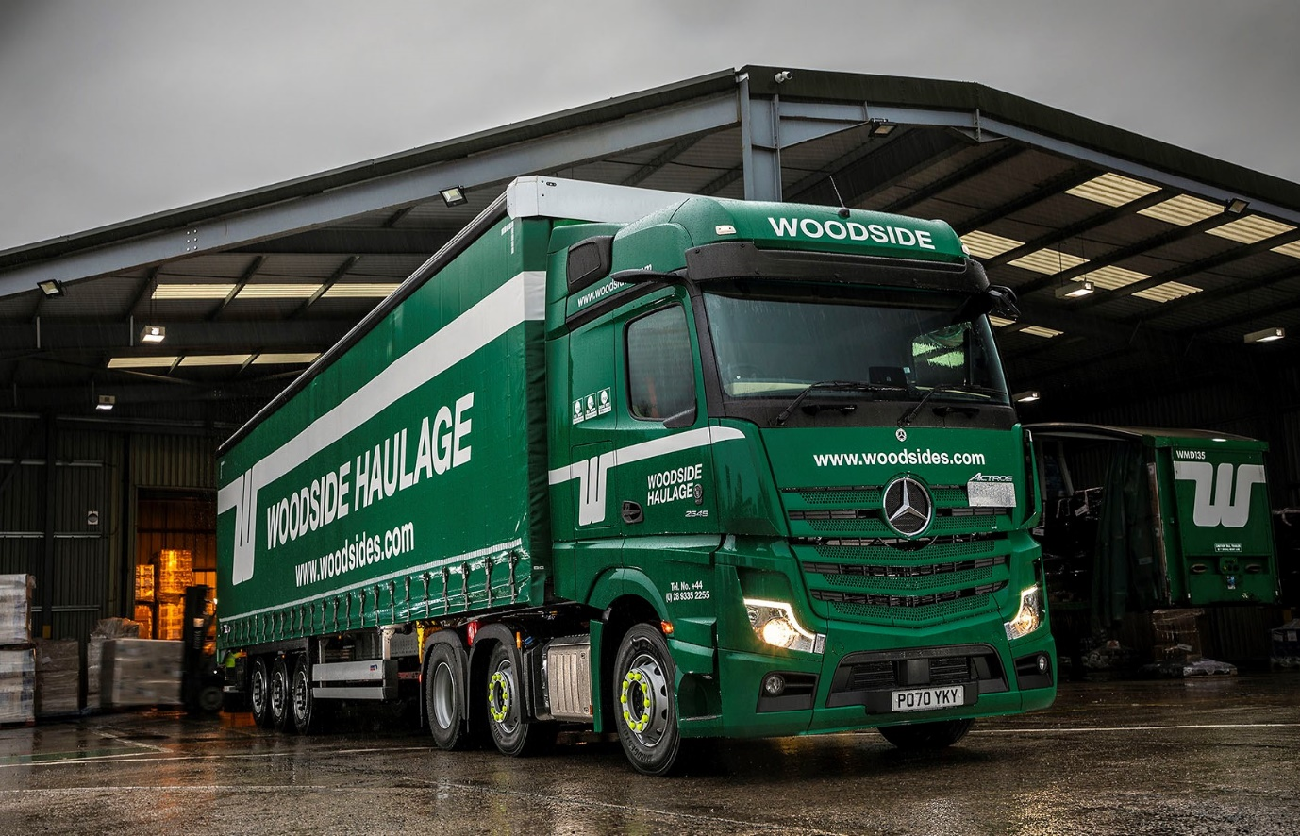

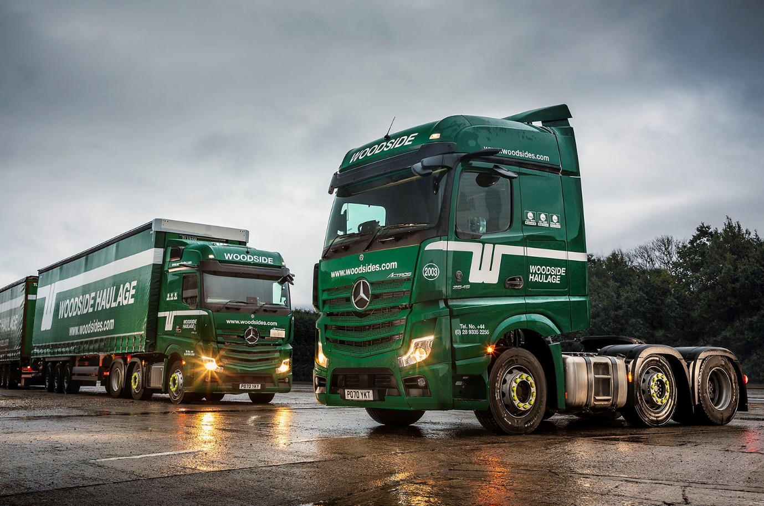

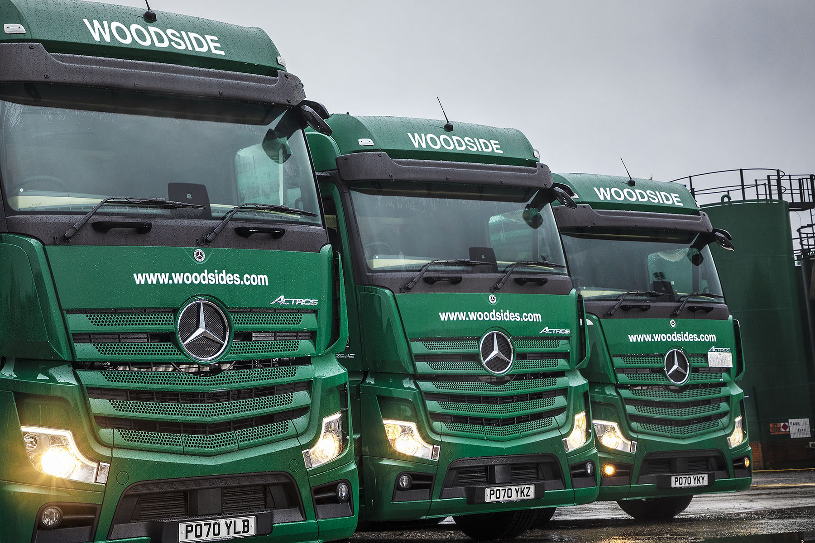

ends

For more information, or to request bigger/higher-res image files, please contact:
John Ripley or Steve Warren
Impact Communications, 01926 842126
John: 07771 484595, john@impactcom.co.uk
Steve: 07770 470251, steve@impactcom.co.uk



