

Date: 28 June 2023

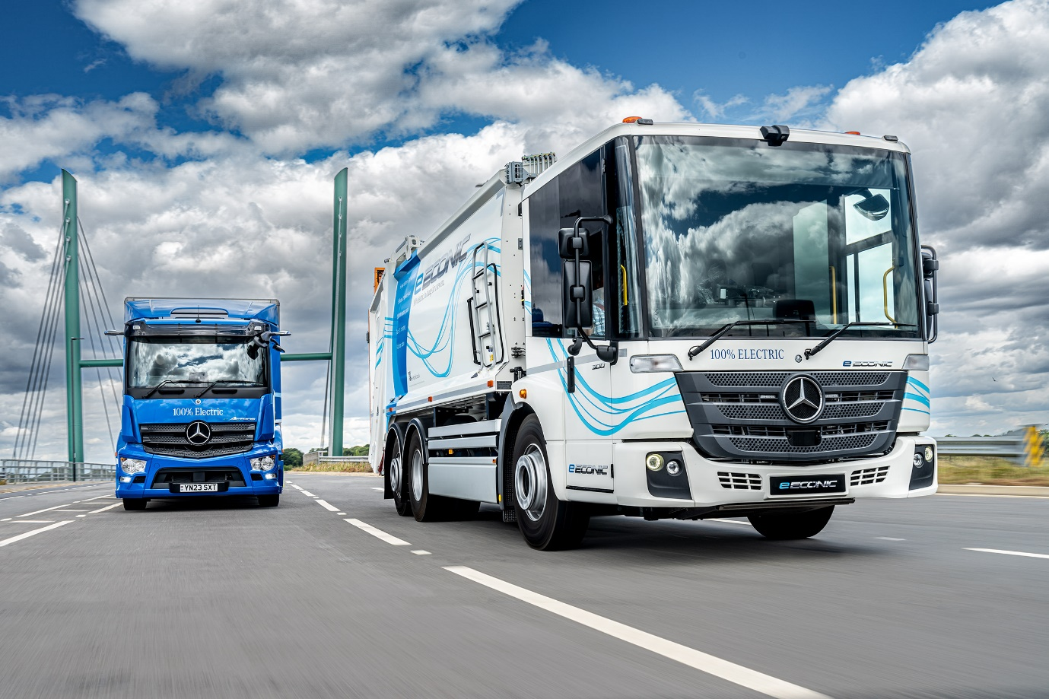

All-electric eEconic leads the Mercedes-Benz charge at Road Transport Expo

One of the most significant additions to Mercedes-Benz Trucks’ electric vehicle line-up, the eEconic, made its first appearance in the UK at this week’s Road Transport Expo event.

Diesel-powered Econic models have become the vehicle of choice for many municipal operators, and increasingly for other urban applications. The arrival of the first battery-powered eEconic was sure to create a buzz – and so it proved, as visitors to the event at Stoneleigh, Warwickshire, flocked to the Mercedes-Benz Trucks stand to take a look.

The Mercedes-Benz eEconic is designed from the ground up as an electric vehicle. Its twin motors are located within the rear eAxle. With no need for a prop shaft energy efficiency is maximised, while chassis space can be freed up for the batteries to be set across the full width of the vehicle. This helps to create a low centre of gravity which, in turn, translates into improved driving dynamics. The motors drive through a special transmission with two forward and two reverse gears, allowing the truck to cruise at up to 89 km/h (55 mph).

Currently available as a single model, the 27-tonne GVW eEconic 300 has a 6x2 configuration with rear-steer axle, and is fitted with three battery packs, for a total installed capacity of 336kWh. The batteries can be recharged from 20 to 80% in 75 minutes, using a 400A 160kW charger.

Equipped with an electrically-powered Dennis Eagle body and Terberg OmniDEL binlift system, the truck will enter trials with a leading UK customer following its appearance at the Road Transport Expo.

Mercedes-Benz Trucks Head of Special Trucks, Ross Paterson, said: “We’re very excited about the arrival of the eEconic – and, judging by the reactions of visitors to our display vehicles, so are our customers.

“This important model shares all the key features that have made the diesel-powered Econic so popular with urban operators – including the flat floor, low driving position, ease of access and excellent visibility, which helps it qualify for a Direct Vision Standard rating of up to five stars, depending on specification.

“To that mix, though, it adds the advantages of a super-efficient electric driveline – with smooth, near-silent performance, ease of use, and zero tailpipe emissions. The large battery pack allows it the flexibility to tackle rural work, with long distances and fewer stops, or intense city-centre operation where more of the battery’s reserve is used to power the compactor. We believe it’s already capable of covering 90% of refuse collection rounds across the UK.”

The Mercedes-Benz eEconic, with a six-year battery warranty, is available to order now. Standard features include the innovative Multimedia Cockpit with twin display screens, electronic parking brake, Keyless Go and LED headlights.

A second eEconic was displayed on the Mercedes-Benz Trucks stand inside the Expo building – this was unbodied, allowing visitors to see the chassis and battery layout. Other Mercedes-Benz trucks exhibited included a pair of electric eActros rigid chassis, while the manufacturer’s eActros demonstrator with refrigerated body by Solomon Commercials was a popular draw at the show’s Ride & Drive area. Combustion-engined Actros, Arocs and Unimog models were also on display.

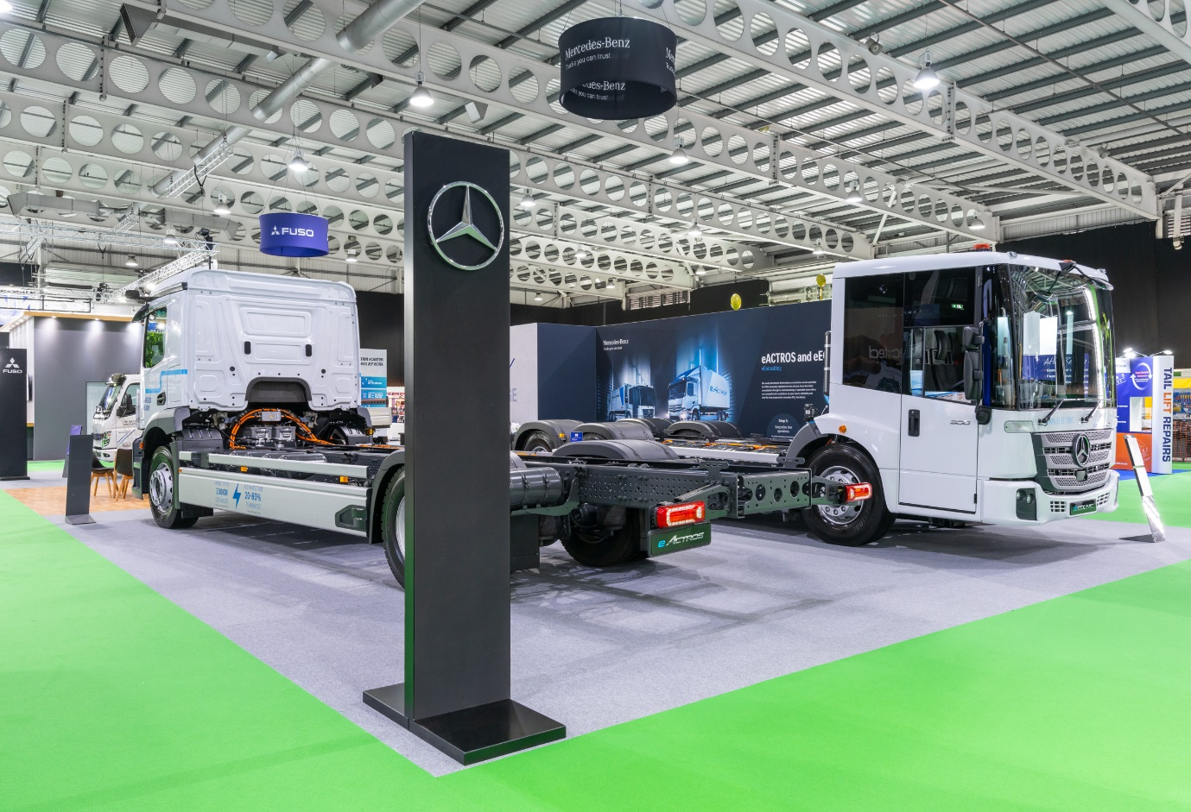

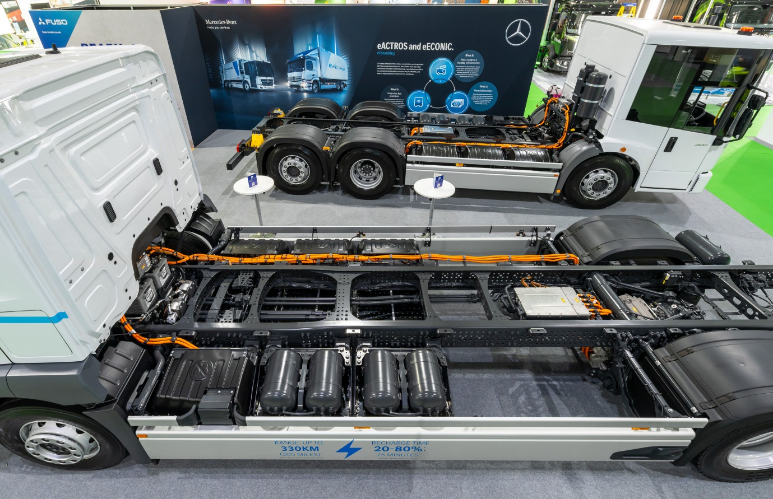

ends

For more information, or to request higher-res image files, please contact:

Jamie Fretwell at Mercedes-Benz Trucks UK Ltd
07712 519230, jamie.fretwell@daimler.com

or

John Ripley: 07771 484595, john.ripley@loopagency.co.uk

