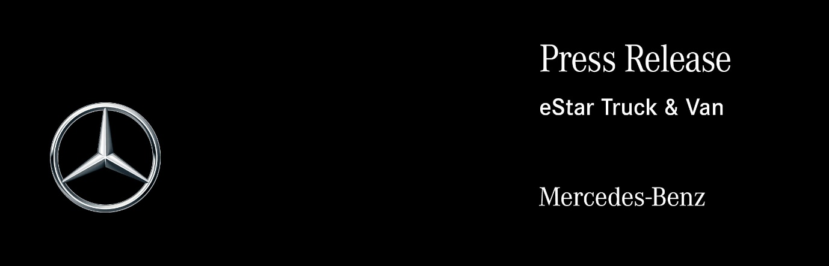

Date: 11 September 2020

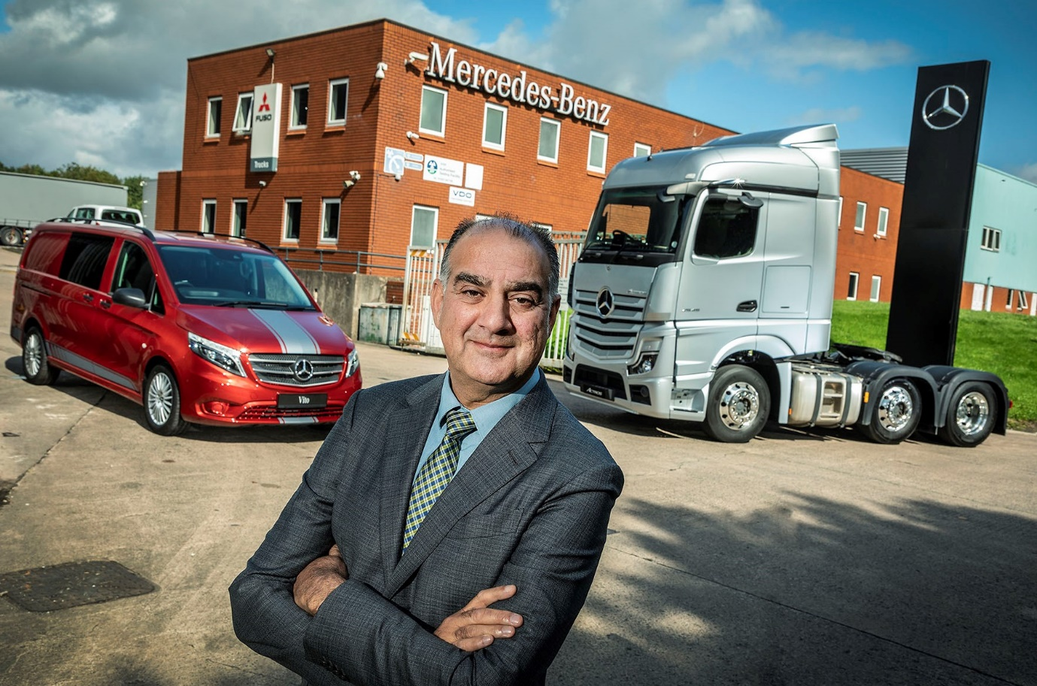

Leading from the front: A customer himself, Sid Sadique understands what operators need from a Dealer, and is relishing the opportunity to develop his new Mercedes-Benz Trucks and Mercedes-Benz Vans business

Sid steps in to launch new Mercedes-Benz Dealer eStar Truck & Van and pledges to lead on EVs

There’s a new name for Mercedes-Benz commercial vehicles in the North West and North Wales – and the dynamic entrepreneur behind the rise of eStar Truck & Van is promising an exciting future for customers and colleagues alike.

Sid Sadique stepped in to buy most of the assets of Roanza Truck & Van, after the former franchisee fell into administration. His intervention has ensured continuity of service for the vast majority of customers, while also saving some 340 jobs.

eStar Truck & Van has been awarded sales franchises for both Mercedes-Benz Trucks and Mercedes-Benz Vans at its predecessor’s facility on Deeside, and for Mercedes-Benz Trucks at Stoke and Trafford Park. It is also providing aftersales support for both brands from all three of these sites, as well as others in Warrington and Liverpool.

Roanza Truck & Van had been struggling long before the arrival of Covid-19, although losses incurred during 2019 were exacerbated by the lockdown. The company went into administration on Tuesday (8th) – the acquisition by eStar Truck & Van was completed the same evening.

Given Sid Sadique’s impressive track record in the industry, Mercedes-Benz Trucks and Mercedes-Benz Vans were delighted to sign-off on the appointment of their latest franchisee in double-quick time. Both now look forward to working with their new partner as he rolls out his plans for the business.

Mr Sadique is a long-established Mercedes-Benz customer, initially as a Director at Biffa Waste Services. He left to found Riverside Truck Rental in 2006, and that business is now part of the NRG Fleet Services Group of companies established in 2013. So, too, is Electra Commercial Vehicles, the zero-emission truck OEM he launched in 2017.

In 2018 Mr Sadique joined the franchised Mercedes-Benz network for the first time, when he teamed-up with brothers Steve and Paul Rooney to purchase Sparshatt Truck & Van. He remains as Chairman and a shareholder of the dedicated Truck Dealer, which operates from four locations in Kent.

Mr Sadique said that although his various businesses buy and operate vehicles by other manufacturers as well, his Mercedes-Benz roots run particularly deep. “I’ve been working with the brand for more than 30 years, and already enjoy strong relationships, not only with its senior management team here in the UK, but also with their colleagues at HQ in Stuttgart.

“As a Mercedes-Benz Dealer we can provide our customers with everything from a small Citan van to a 44-tonne tractor unit, and are just as well placed to serve the sole trader with a single vehicle, as we are the major logistics fleet operator. No other manufacturer can lay claim to the same breadth of product and services.”

Recalling the fast-moving events of recent few weeks, he continued: “We looked at the franchise proposition from a strategic point of view and realised that given the different service points and offerings we already have, the opportunities to ‘cross-sell’ made for a compelling business case.”

Mr Sadique said he would be focusing over the coming weeks on putting together the management team that will lead eStar Truck & Van into a bright future. “You’ll always face challenges with a new venture like this, but there’s nothing fundamentally wrong with this business,” he asserted.

While acknowledging that the acquisition had saved a substantial number of jobs, he added: “That’s important, of course, but it was never about being the man on the white horse… it’s about delivering what essentially is a really good offer from a product and service point of view, and just enhancing it.

“This business needs investment, but in the form of time, not metal, or facilities, or even money. What we’ll be looking to do, therefore, is inject new energy and enthusiasm, as well as some fresh ideas about the way we do things, to reflect the way the world is changing. It’s already apparent that we’ve inherited some excellent people, and it will be nice to give them something to look forward to.”

An early priority will be to establish an eEducation centre, possibly at Trafford Park, where fully electric, zero-emission Mercedes-Benz eVito and eSprinter vans, and FUSO eCanter trucks, could be showcased alongside Electra products based on low-entry Mercedes-Benz Econic chassis. “We’re determined to take a lead and support operators as they make the transition to electric power,” said Sid.

eStar Truck & Van will also be exploiting online channels a lot more heavily than its predecessor, particularly when it comes to retailing vans. “We neither want nor need yards full of product so people can come and kick the tyres,” he said.

Mercedes-Benz Trucks Managing Director Wolfgang Theissen declared: “We are delighted that Sid has chosen to seize this new opportunity to represent our brand. He has a proven track record of success in the commercial vehicle business and his investment has ensured our continued representation in this busy part of the country.”

Steve Bridge, Managing Director at Mercedes-Benz Vans, added: “The van community has shone more brightly than ever this year, and reminded us of the crucial role it plays in keeping our lives moving. eStar Truck & Van will offer the highest levels of service to keep this vital sector running when customers need us the most.”

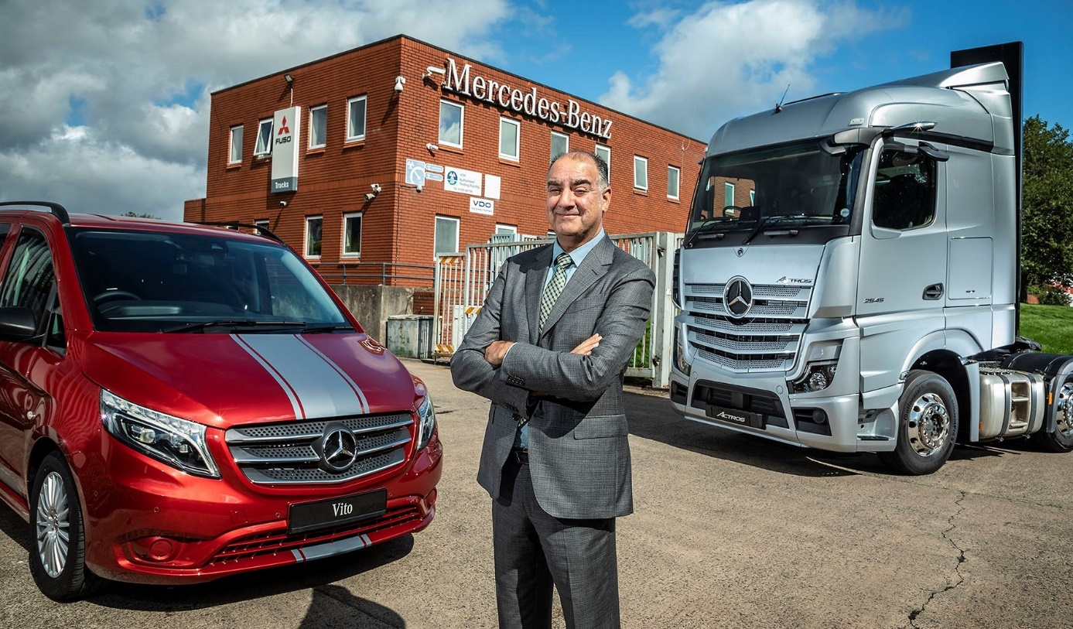

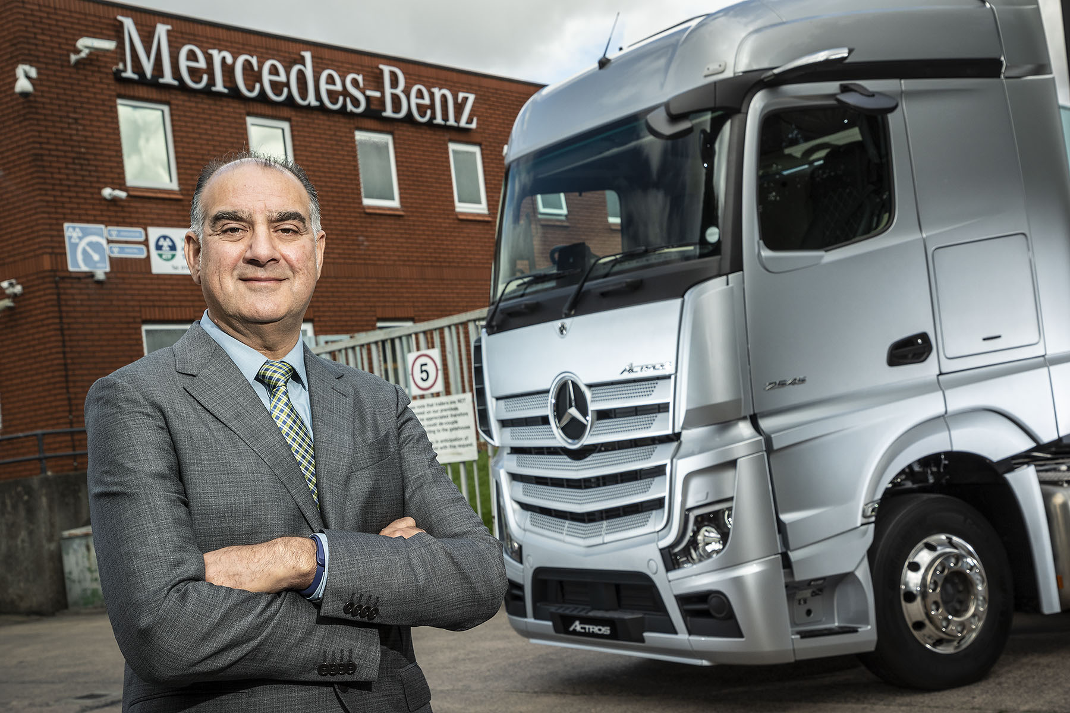

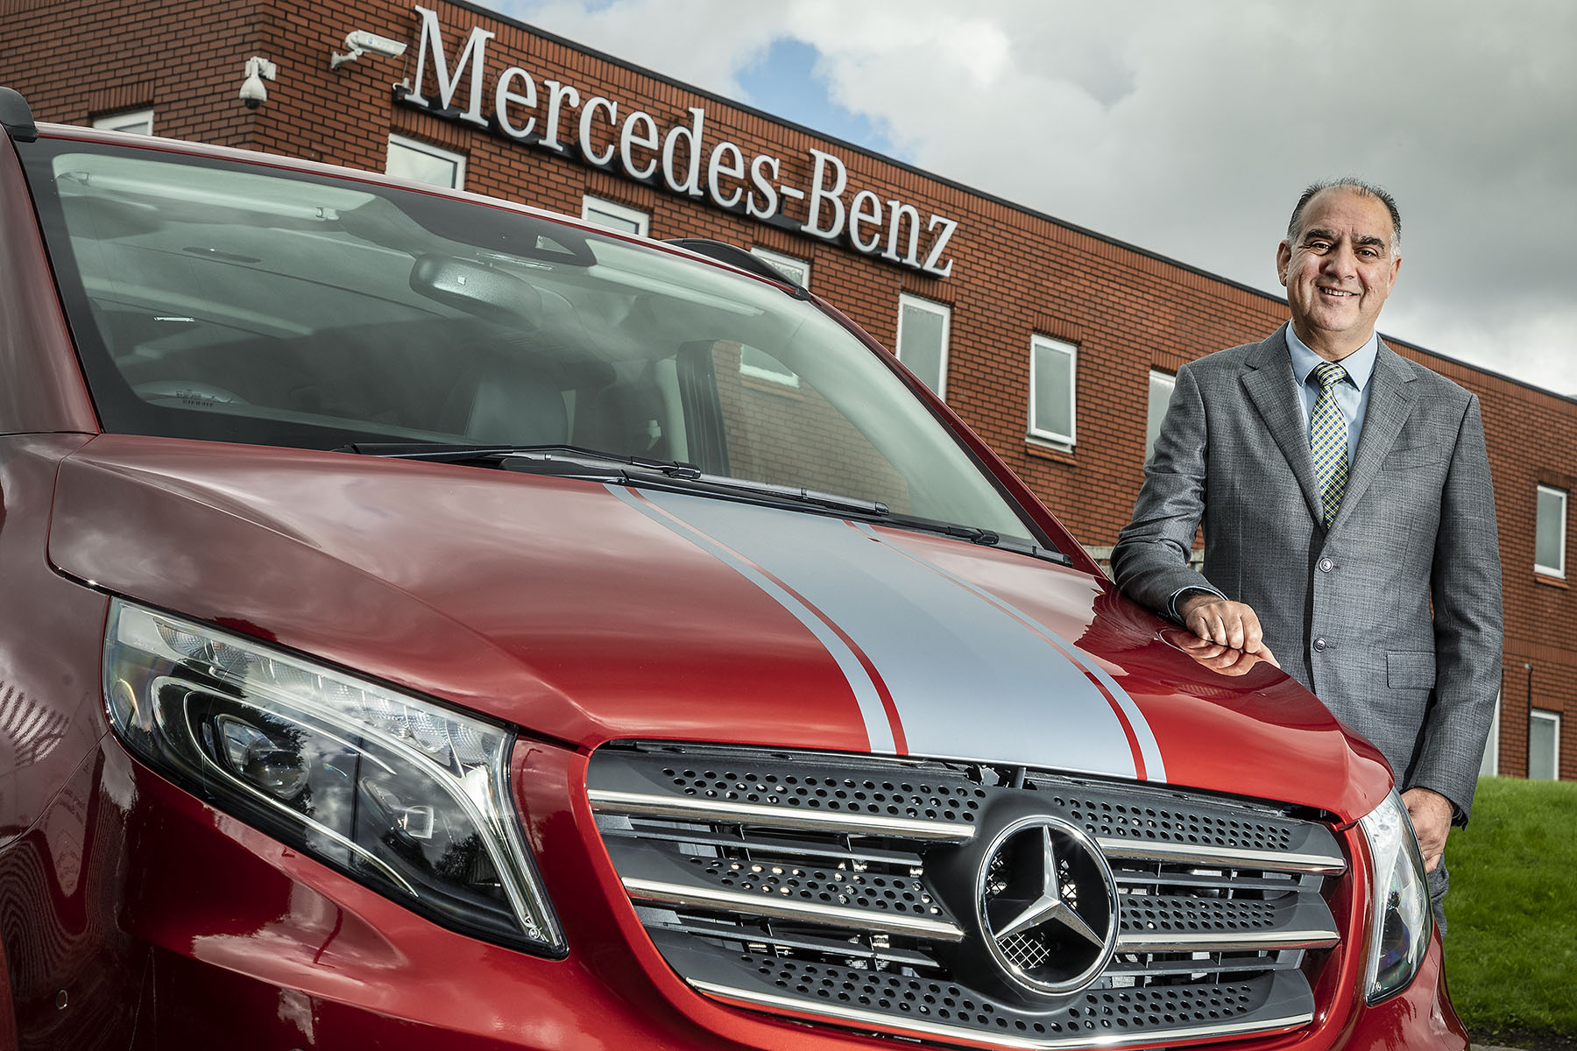

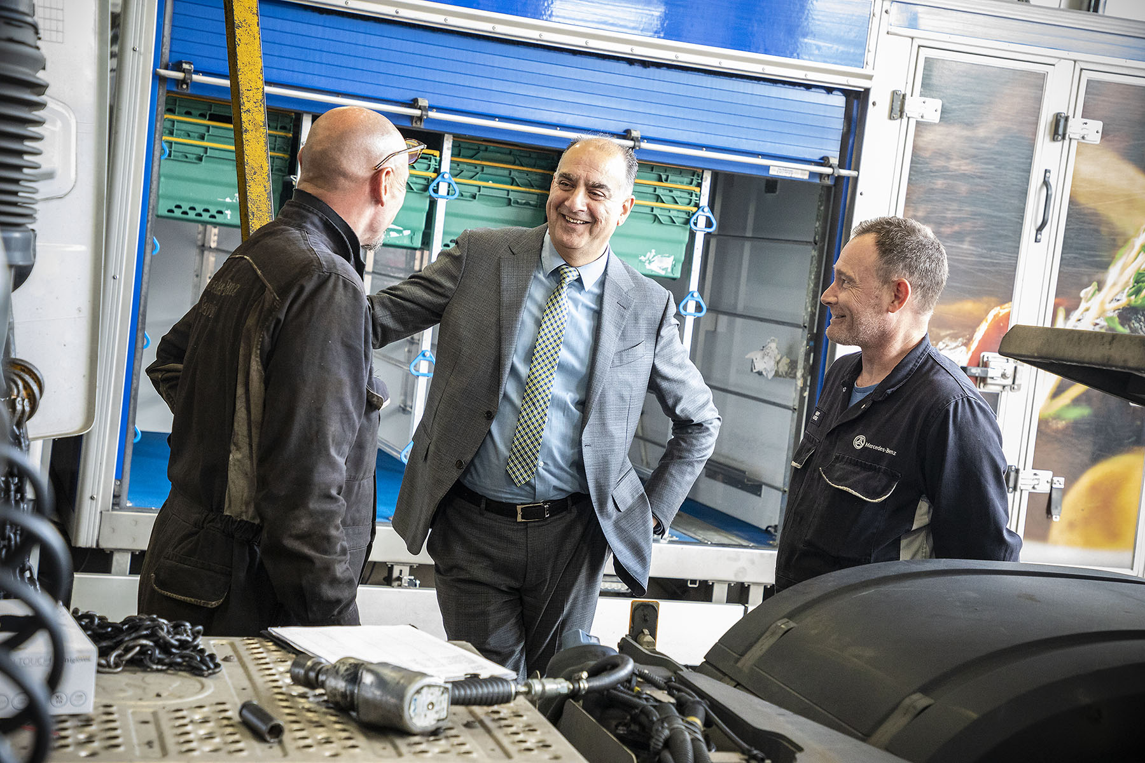

Fact-finding mission: Sid Sadique has already been out on the shopfloor to meet employees of his new business, eStar Truck & Van

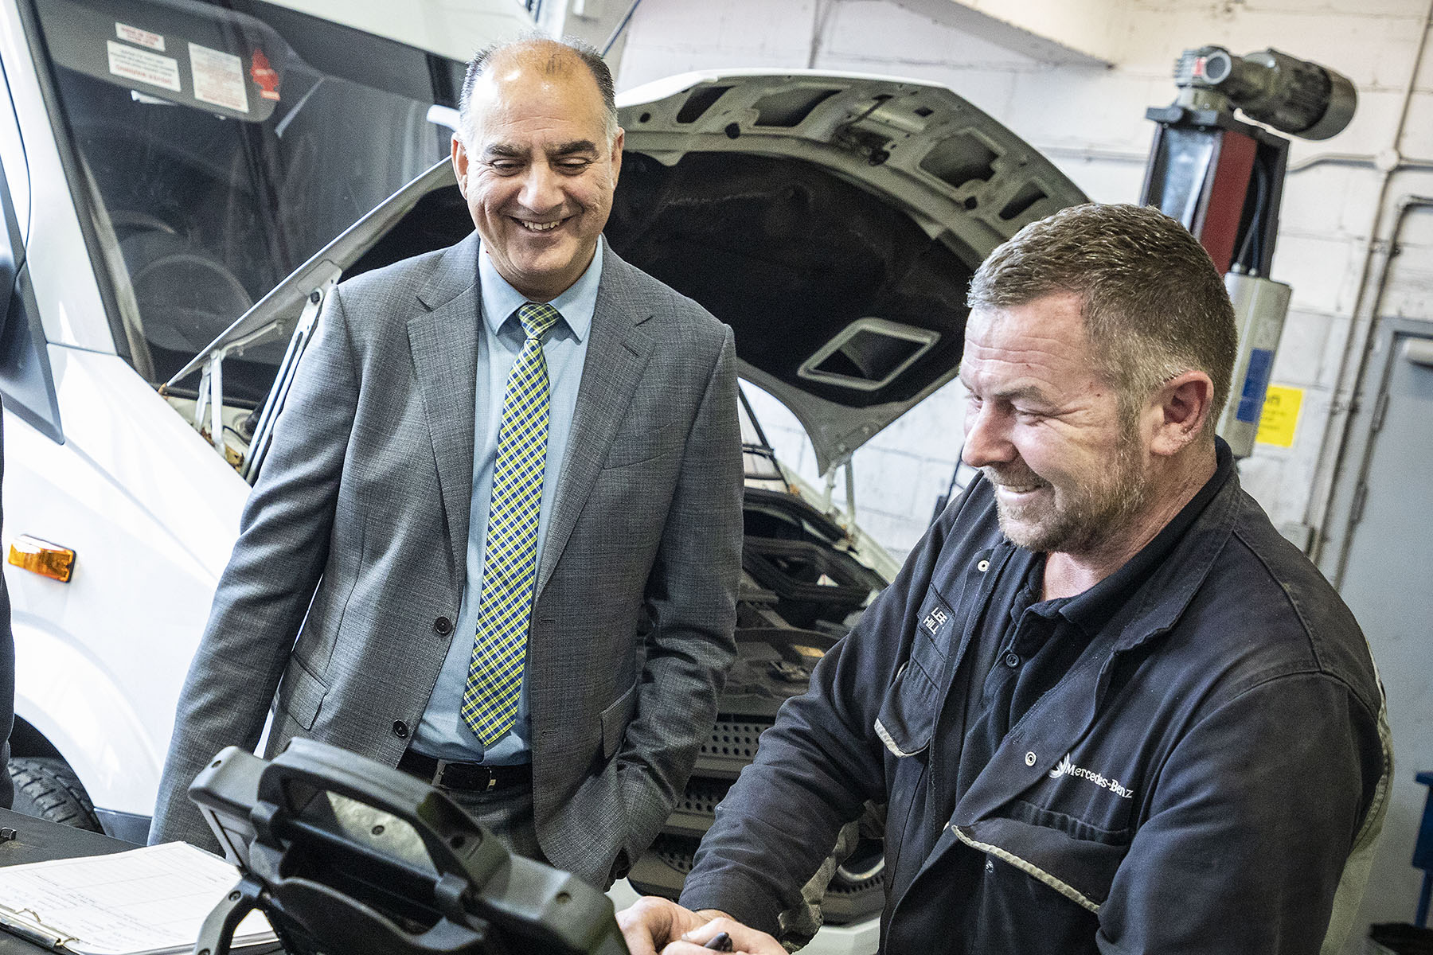

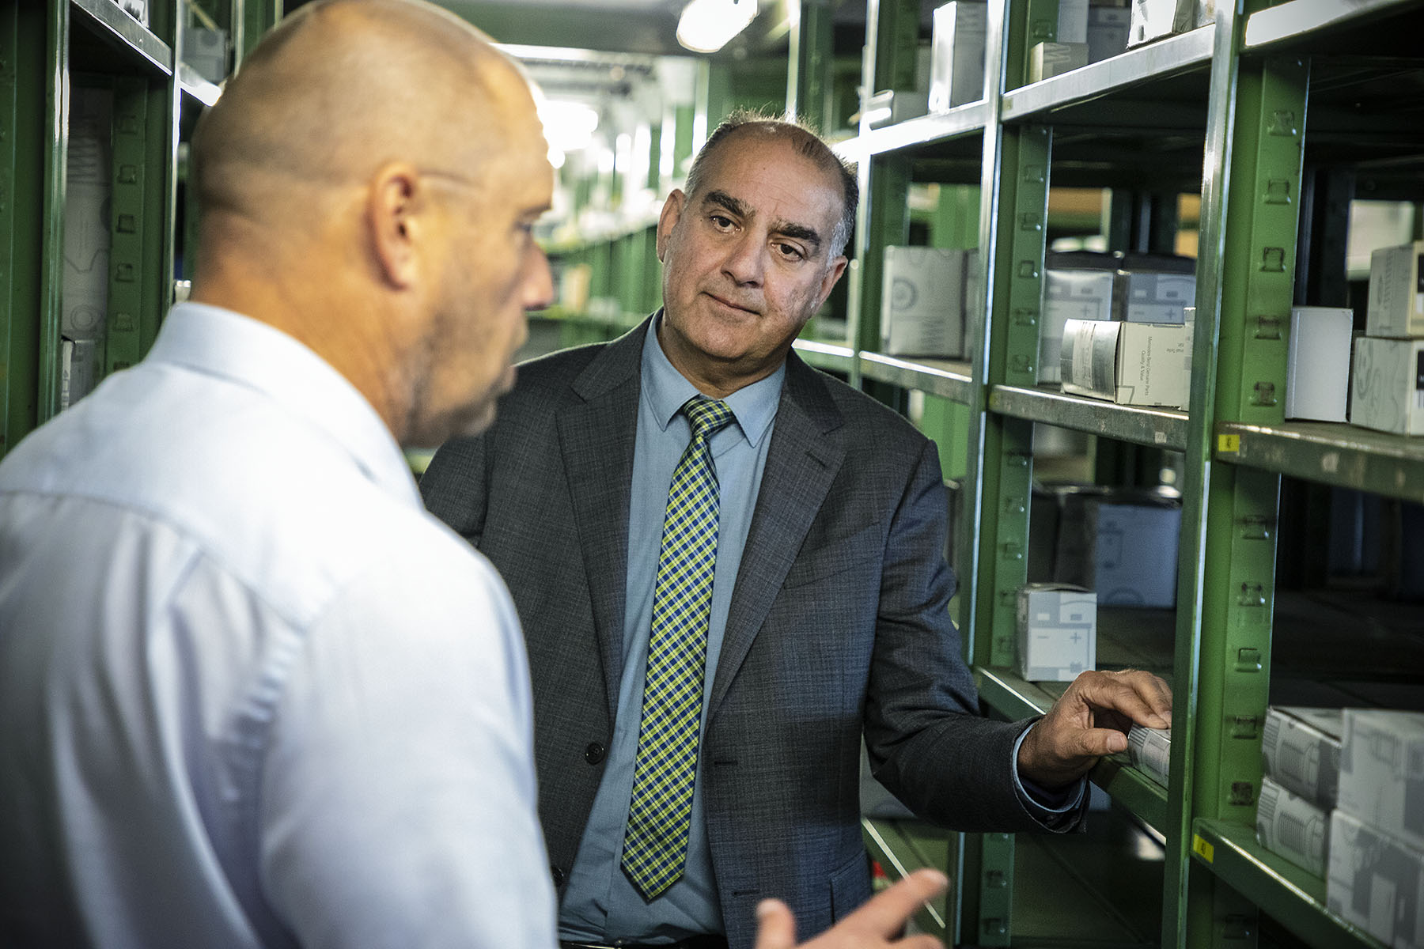

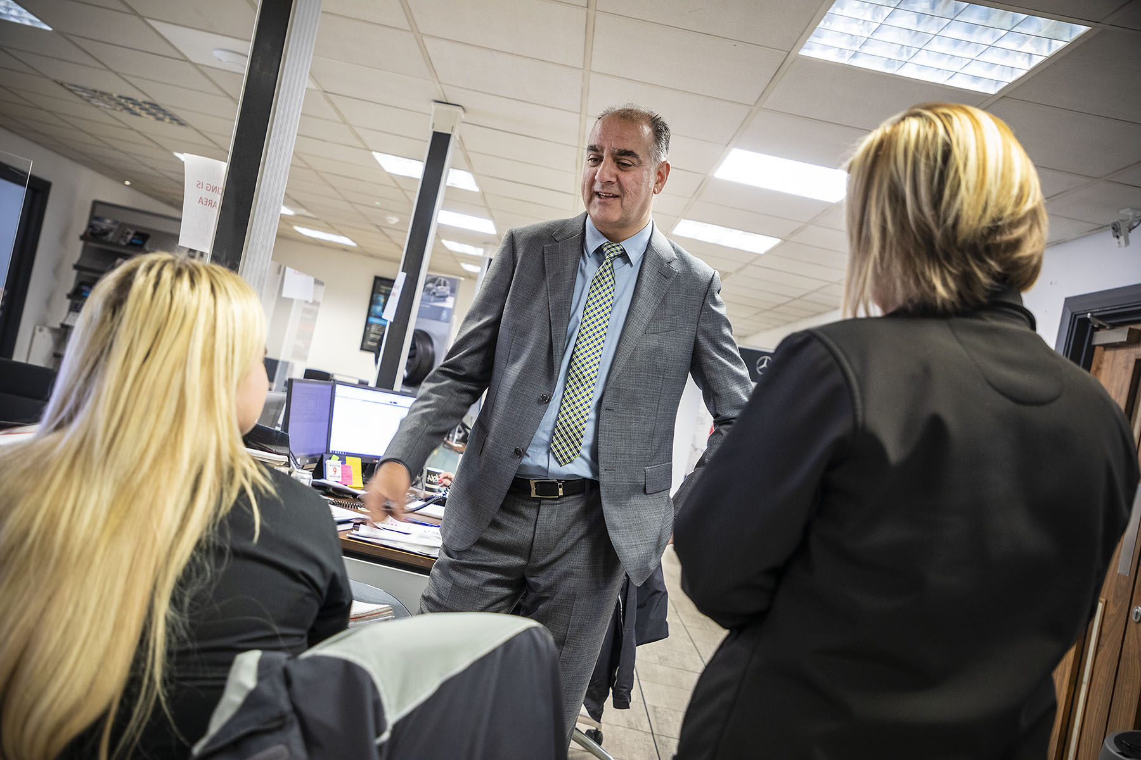

ends

For more information, or to request higher-resolution image files, please contact:
Steve Warren or John Ripley
Impact Communications, 01926 842126
Steve: 07770 470251, steve@impactcom.co.uk
John: 07771 484595, john@impactcom.co.uk

