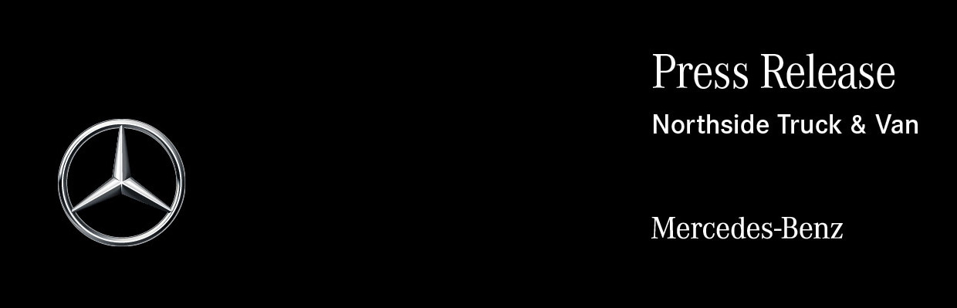

Date: 18 February 2025

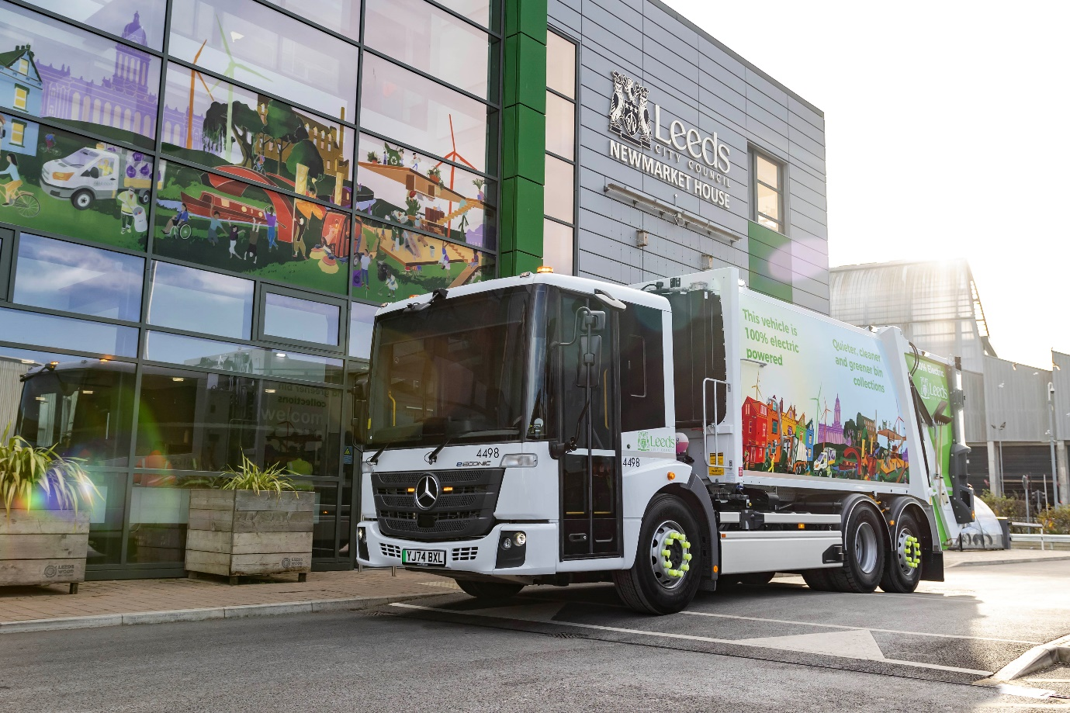

Leeds leads the way with electric Mercedes-Benz eEconic bin trucks

Leeds City Council has taken a major step towards cleaner, greener refuse collection by adding the first three battery-powered Mercedes-Benz eEconic trucks to its fleet.

The council calculates that each vehicle will generate a saving of 15 tonnes of carbon dioxide per year – so 45 tonnes per year in total, compared to diesel-powered trucks – while also bringing improved air quality and lower noise to the communities they serve.

Supplied via refuse collection vehicle specialist FAUN Zoeller UK, the vehicles are equipped with 22 m³ Variopress compactor bodies and Rotary 3 bin lifters. These are built onto Mercedes-Benz eEconic 300 chassis, with 27-tonne gross weights and 6x2 drivelines, supplied by local Dealer Northside Truck & Van, which will also provide ongoing maintenance and technical support.

The trucks have joined a busy operation. Leeds City Council collects over half a million waste and recycling bins per week from households across its area, sending out 75 trucks and crews on six days every week and running the country’s largest free garden waste collection service under a single local authority.

In the last 12 months, less than 0.2% of all domestic waste collected in Leeds has gone to landfill. Black bin waste is incinerated and the energy recovered to generate heat and electricity, some of which goes to public and civic buildings and housing through the award-winning Leeds Pipes heating scheme.

Mixed dry recyclable waste is sorted into constituent parts sent for recycling. Since August this has included glass, and now 82% of glass collected is sent for remelt into new bottles and jars within Yorkshire. The contents of garden waste bins are composted locally by contracted partners.
Chief Environmental Services Officer John Woolmer said: “Leeds has chosen to be one of the pioneers driving forward the use of electric domestic refuse collection vehicles. Our three new fully electric RCV’s will be targeted to areas of the city that have the greatest air quality issues and where operating a cleaner, greener and quieter service will have the most impact.

“Collecting domestic waste and recycling with these new electric trucks will mean that over 45 tonnes of carbon dioxide emissions will be saved per year. This will contribute to the Leeds clean air strategy that aims to reduce air pollution from homes, industry, agriculture, and transport by 2030.

“It is calculated that the council’s household waste management operations across Leeds already contribute an annual carbon saving of 30,000 tonnes and beginning the move of RCVs to electric will not only add to that but also help promote and show leadership for the city on this agenda.”

Leeds Council’s electric trucks will slot into its existing fleet seamlessly. Charging will take place overnight at the Council’s award winning, modern eco-designed depot at Newmarket House, which means that the trucks will be ready to work each morning when the teams arrive at 6am.

“We have a long standing, positive working relationship with FAUN Zoeller, Mercedes-Benz and Northside Truck & Van, having operated Econic waste trucks for over 15 years,” Mr Woolmer continued. “So, when we learned that FAUN Zoeller were working with Mercedes-Benz to develop a fully electric refuse collection truck, we were excited to get some on the streets of Leeds.”

Councillor Mohammed Rafique, Executive Member for Communities, Housing and Environment, added: “We are very excited to see the first all-electric bin wagons working in the streets and neighbourhoods of Leeds. In the same year we introduced glass recycling through our green bins, these brand-new vehicles are part of our journey to provide the cleanest, greenest and most efficient service we can for our residents.”

The Mercedes-Benz eEconic is designed from the ground up as an electric vehicle. Its motors are located within the twin-speed eAxle. With no need for a prop shaft energy efficiency is maximised, while chassis space can be freed up for the batteries to be set across the full width of the vehicle. This helps to create a low centre of gravity which, in turn, translates into improved driving dynamics. The motors drive through a special transmission with two forward and two reverse gears, allowing the truck to cruise at up to 55 mph.

The eEconic 300 has a rear-steer axle and is fitted with three battery packs, for a total installed capacity of 336kWh – these are covered by a six-year warranty. The batteries can be recharged from 20 to 80% in 75 minutes, using a 400A 160kW charger.

Other standard features include the innovative Multimedia Cockpit with twin display screens, electronic parking brake, Keyless Go and LED headlights, and a market-leading suite of safety systems such as Sideguard Assist, Active Brake Assist 5, Lane Keeping Assist and Reversing Assistance. Operators also benefit from a six-year connectivity package, giving free access to a range of digital support services.

www.leeds.gov.uk

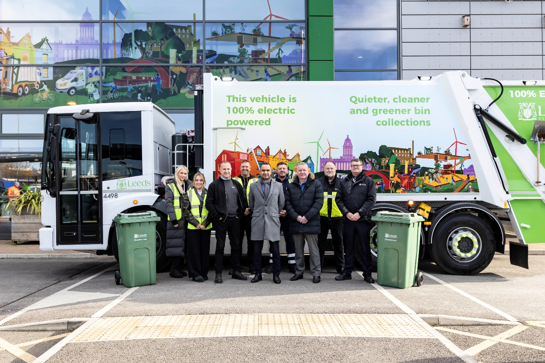

Green team: Leeds City Councillor Mohammed Rafique, centre, flanked by Robert Yates of FAUN Zoeller UK (front left) and James Rogers, Director of Communities Housing and Environment, with one of their new Mercedes-Benz eEconics and colleagues from the Council’s Waste Management Department

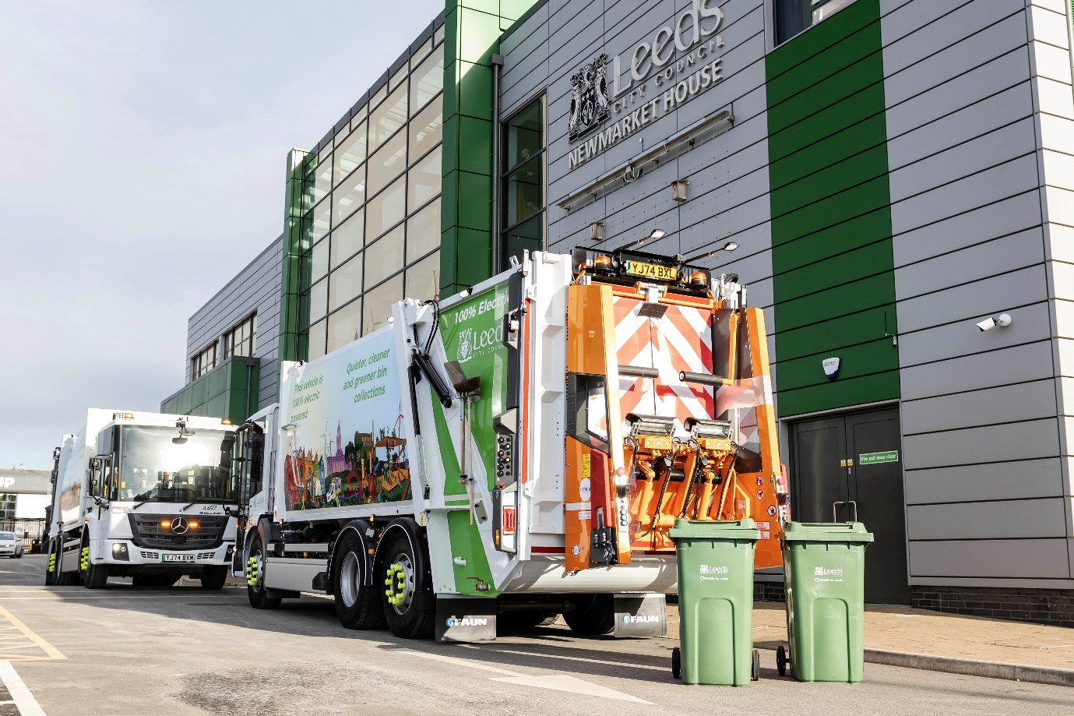

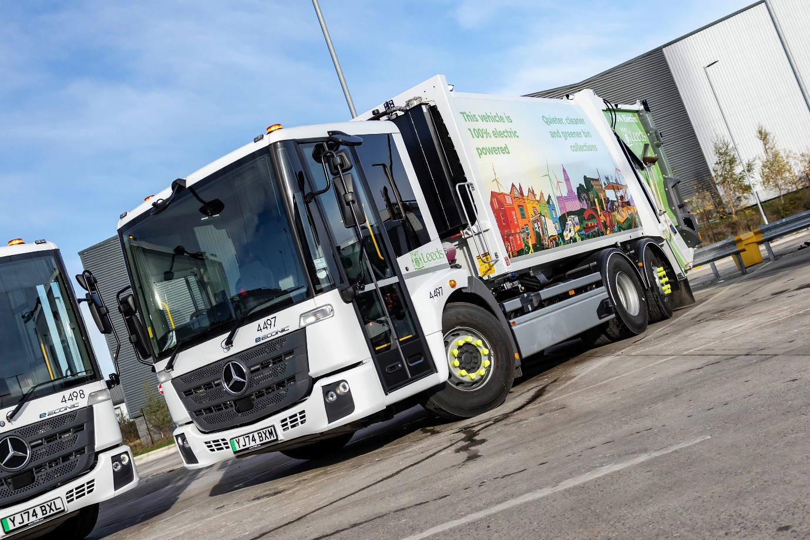

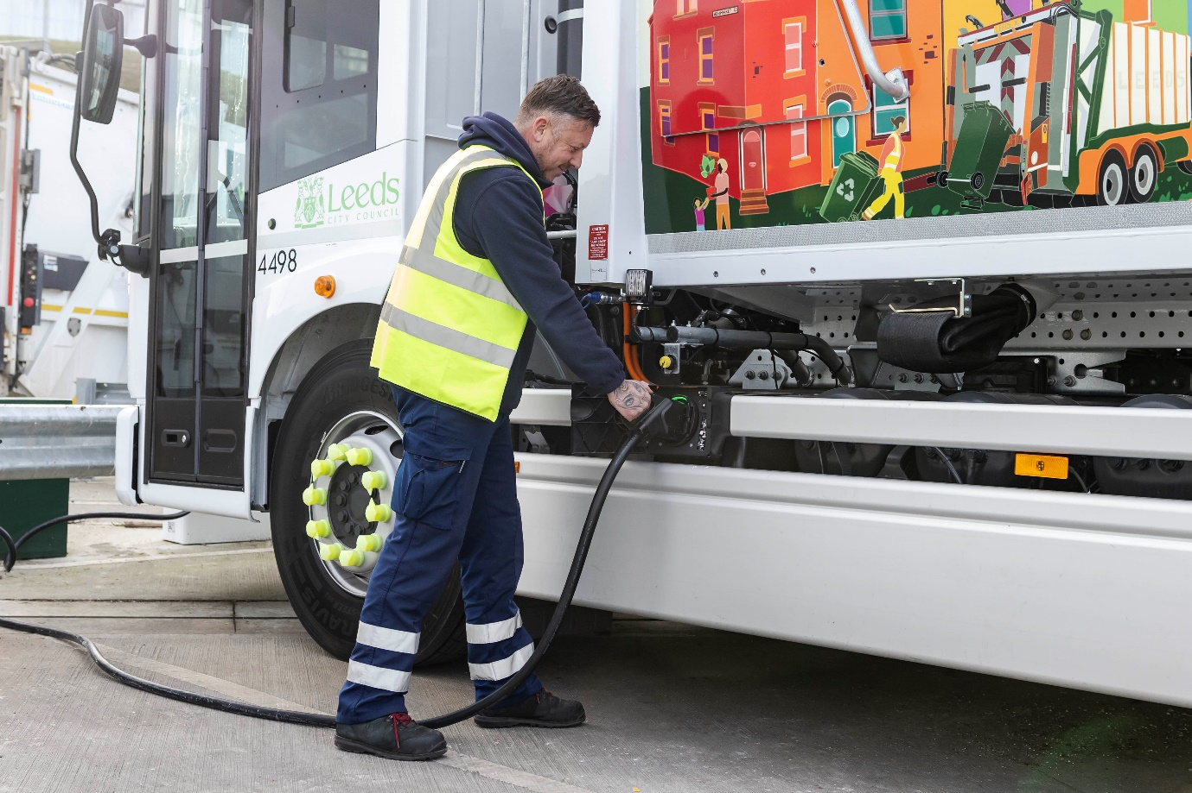

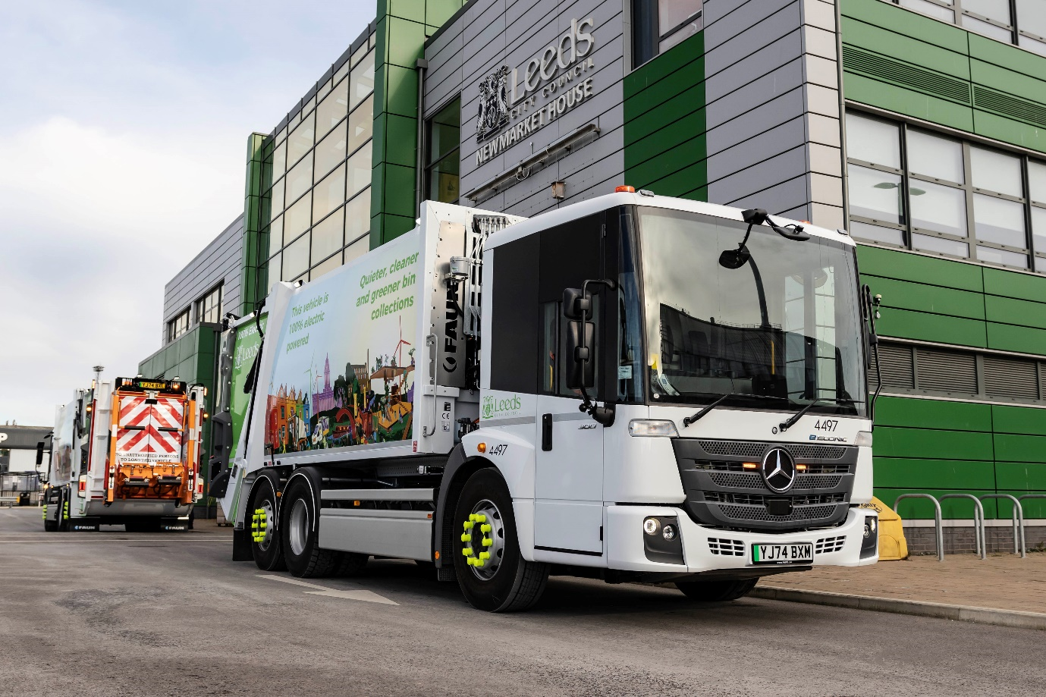

ends

For more information, or to request bigger/higher-res image files, please contact:
John Ripley: 07771 484595, john.ripley@loopagency.co.uk

