

Date: 9 September 2019

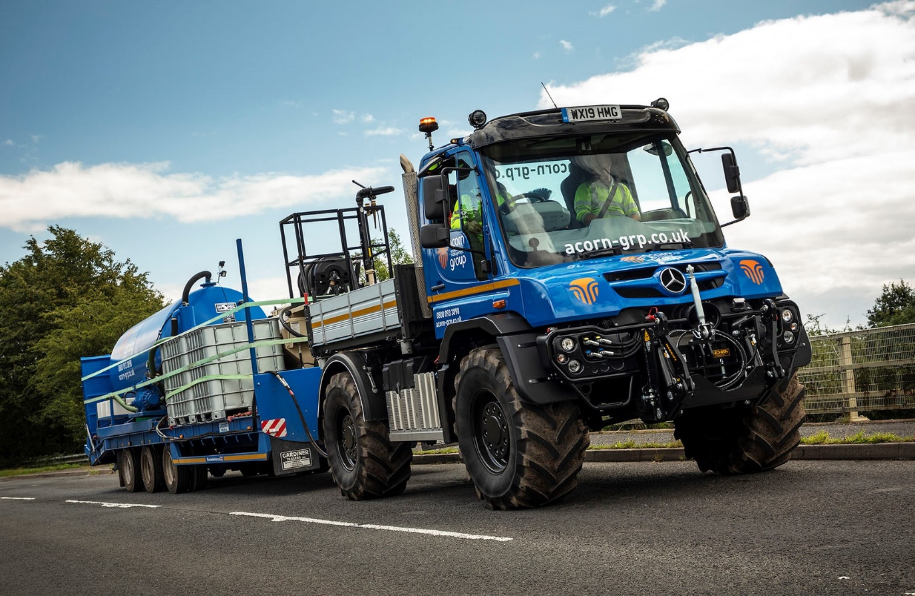

Acorn Environmental sows new seeds of success with versatile Mercedes-Benz Unimog

The Mercedes-Benz Unimog is renowned for its all-terrain capability, but the truck’s on-road performance holds the key to the efficiency savings now being achieved by Acorn Environmental Management Group.

The Redditch-based landscape maintenance and arboriculture specialist purchased its first Unimog from Dealer Rygor Commercials. The range-topping U530 implement carrier tows a US-built FINN T75T HydroSeeder, which is designed to discharge gel-protected seed and fertilizers under high pressure over a distance of up to 90 feet.

Acorn Environmental is heavily engaged in the seeding of banks and verges on Britain’s growing network of smart motorways. It has already completed projects on the M1 and M5, and is currently working on the M6 as a sub-contractor to the Balfour Beatty Vinci joint venture.

The operator has previously relied on agricultural tractors to fulfil this role. However, as Managing Director Kevin O’Rourke revealed, there was a significant drawback to doing so.
“Tractors are not permitted to operate on the motorway, so must always remain within the traffic management area,” he explained. “This meant that when we ran out of water we needed bowser wagons to come in and fill us up, which often entailed frustrating delays as well as the obvious additional costs.

“With the Unimog, that’s all behind us. The truck is superb on rough ground, of course, but unlike a tractor it’s also capable of achieving on-road speeds of 56 mph. As a result, when we need more water for the hydroseeder’s 700-gallon tank we can just exit the traffic management area and travel back to the source at the main depot to refill.”

Acorn Environmental’s short (3,350 mm) wheelbase U530 operates at a gross weight of 13.5 tonnes and will tow a further 18 tonnes. The truck has a factory-fitted tipping body which regularly carries four 1,000-litre ‘cubes’ (intermediate bulk containers) of water, while the hydroseeder travels on a tri-axle trailer by Gardiner, of Arbroath.

The truck’s fuel-efficient 7.7-litre six-cylinder engine produces 220 kW (299 hp) and 1,200 Nm of torque. It drives through a fully synchronised, electro-pneumatic transmission which has eight forward and six reverse gears –the optional working gear range provides another eight forward and eight reverse gears. Permanent all-wheel drive, impressive ground clearance, and uprated portal axles which have differential locks and offer extreme levels of articulation, all contribute to its unrivalled cross-country capability.

To further increase traction Acorn Environmental has specified Michelin 495/70 R24 agricultural tyres, the biggest permissible, as well as optional Central Tyre Inflation (CTI) technology. This unique system allows the driver quickly and easily, and without leaving their cab, to lower tyre pressures, and has the additional benefit of minimising damage to particularly soft ground.

Acorn Environmental purchased its Unimog after trialling a demonstrator supplied by Rygor Commercials’ Special Trucks Sales Manager Matt Cleave. “It’s a fantastic machine,” enthused Kevin O’Rourke. “We’ll be keeping the Unimog busy on our smart motorway contracts for the time being, but its incredible versatility means we can also use it to undertake a wide variety of other tasks.”

Acorn Environmental this year celebrates its 25th anniversary, and enjoys many long-standing customer relationships. Its staff are committed to the protection and enhancement of the natural environment, and experts in everything from ecological mitigation and landscaping, to tree surgery and the control of invasive and noxious weeds.

“We’ve grown in every one of the last 25 years and continue to go from strength to strength,” added Mr O’Rourke. “The Unimog and our new FINN HydroSeeder represent a substantial combined investment, but I’ve every confidence that it will prove to be money well spent.”

The Mercedes-Benz Unimog is widely acknowledged as the world’s leading all-terrain vehicle, with a reputation forged in the harshest operating conditions. The overwhelming majority of those built since 1951 are still in service today.

All Unimogs have 4x4 chassis with single rear wheels, while gross weights vary from 7.5 to 16.5 tonnes. There are two core variants: an implement carrier like Acorn Environmental’s with front, side and rear attachment points, and an ultra-high mobility truck with extreme torsional flexibility, which can accommodate a range of bodies. Both are superbly adaptable to a huge variety of roles.

Matt Cleave commented: “Tough, capable and amazingly versatile, no other vehicle pulls its weight quite like a Unimog. Rygor’s consultative sales approach, coupled with our product-specific expertise, mean that as with Acorn Environmental’s new U530, every Unimog we supply is perfectly tailored to suit the customer’s operational requirements.”

acorn-grp.co.uk

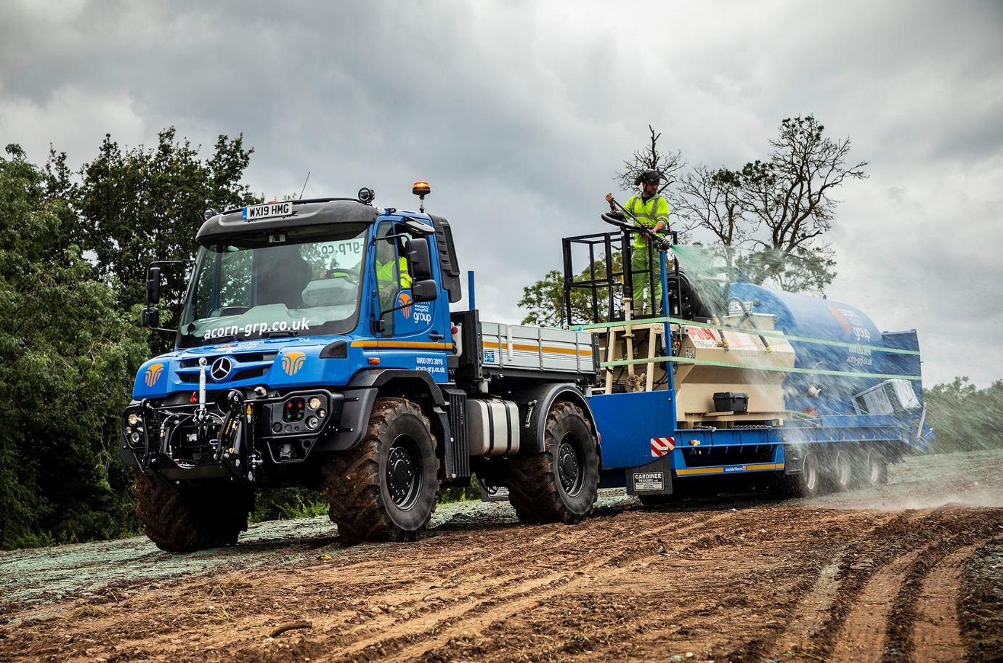

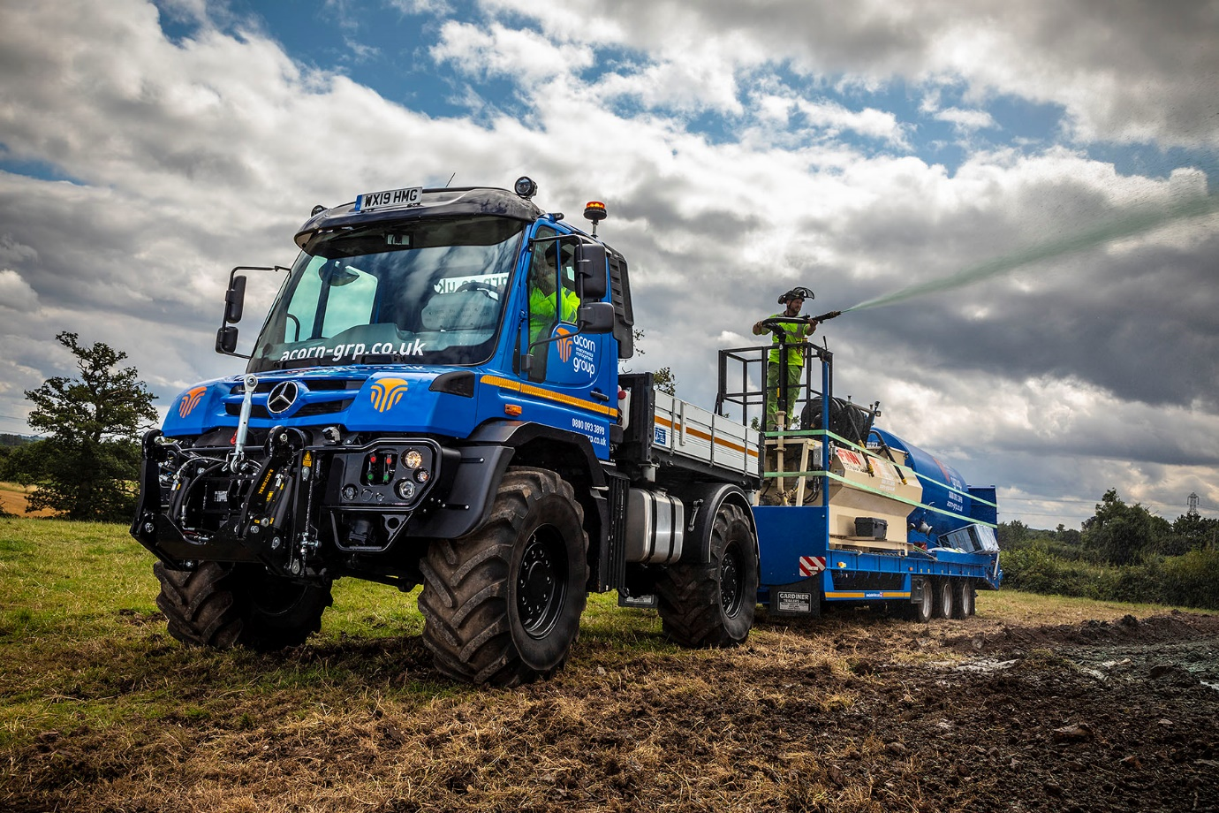

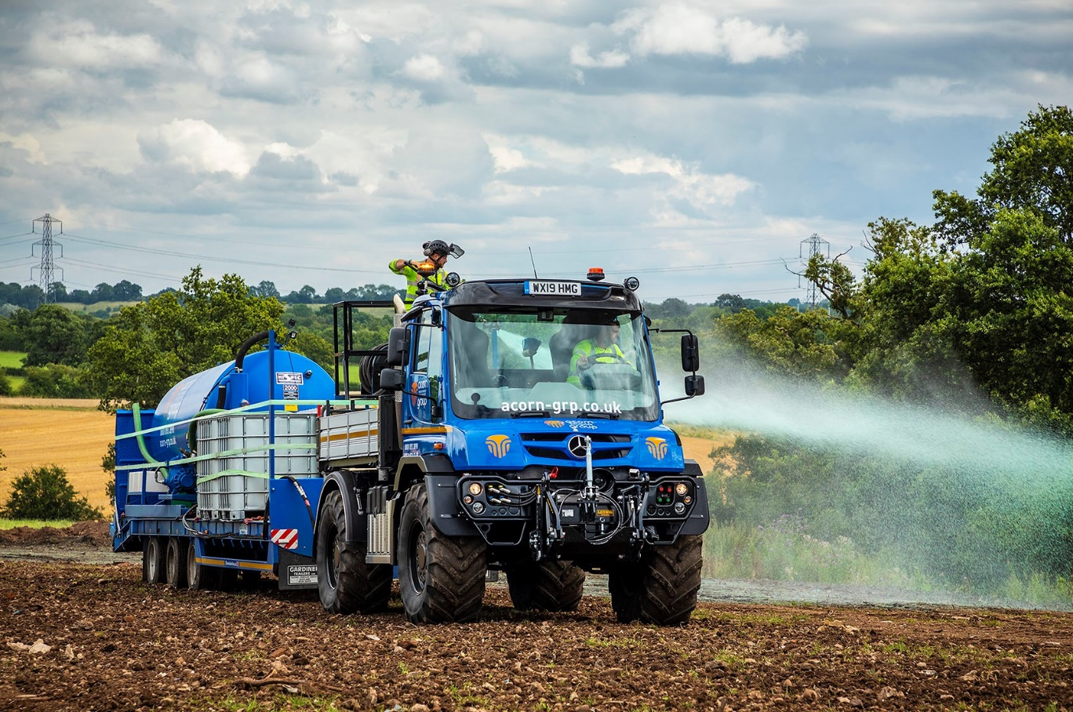

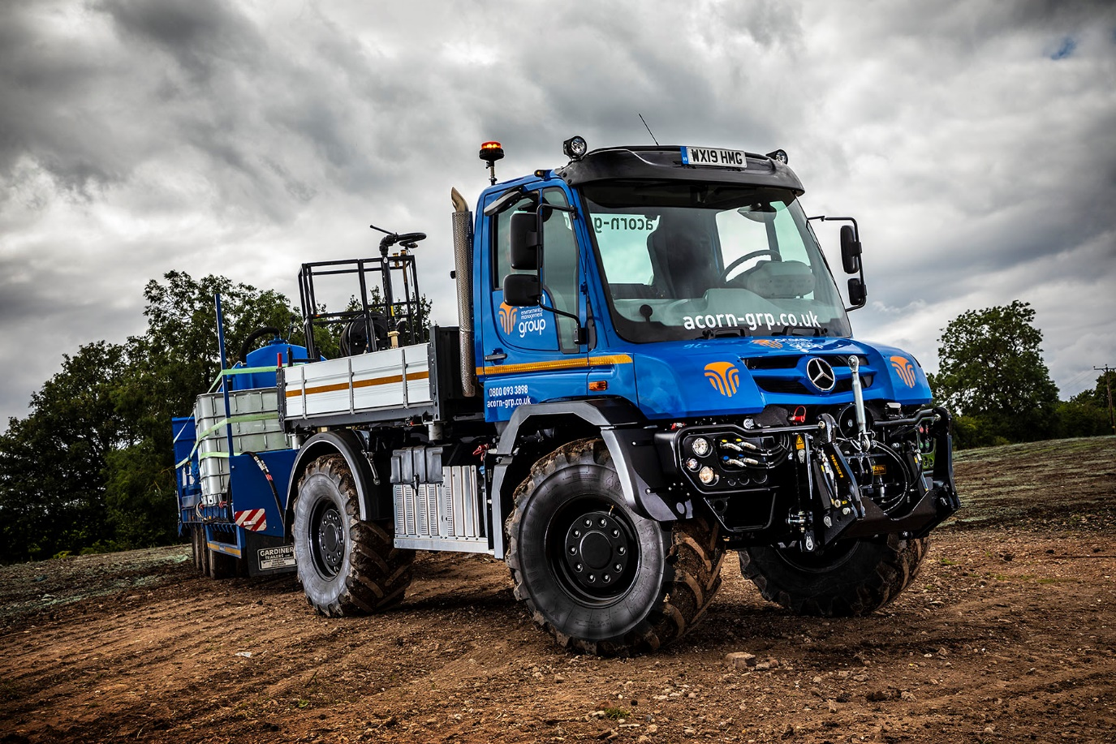

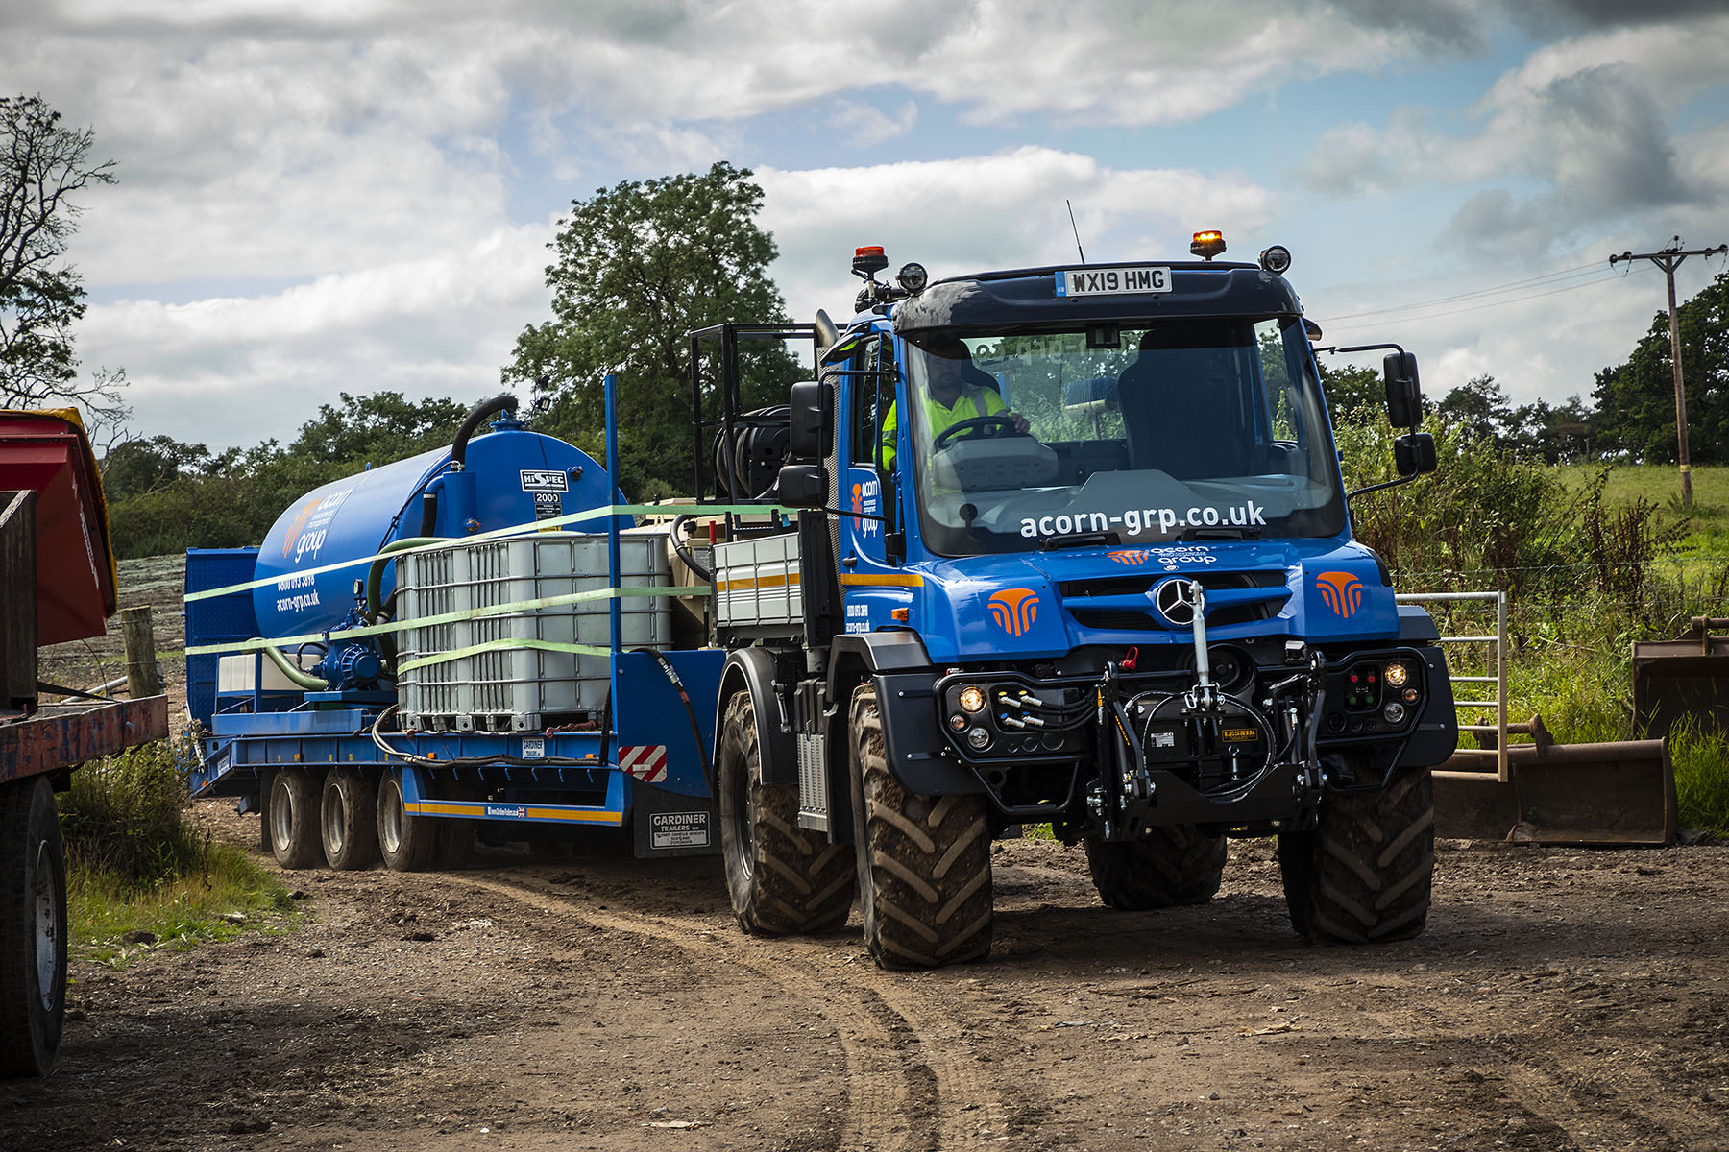

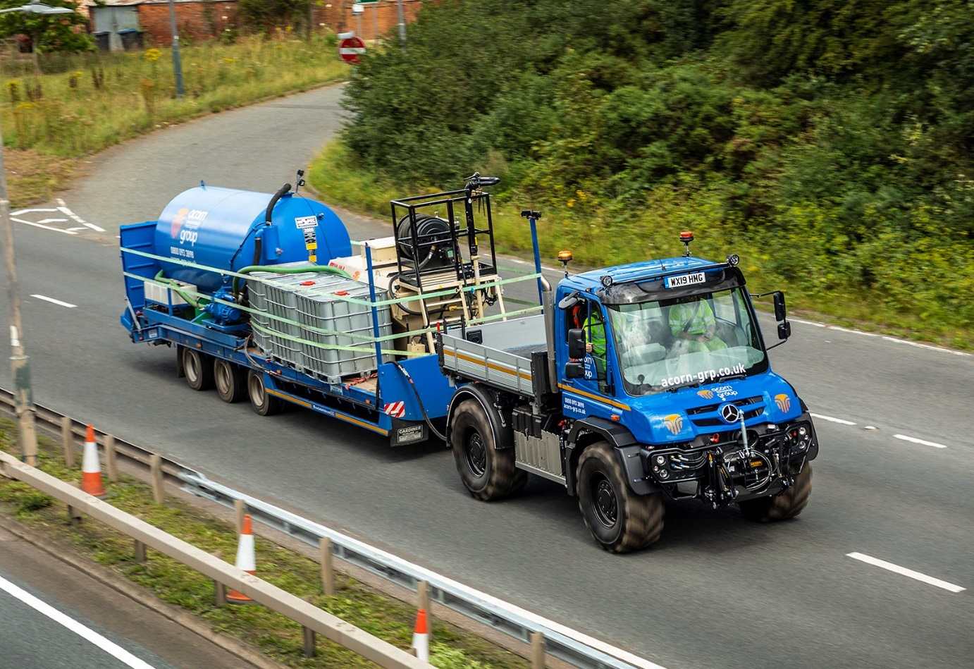

ends

For further information, please contact:
Steve Warren or John Ripley
Impact Communications, 01926 842126
Steve: 07770 470251, steve@impactcom.co.uk
John: 07771 484595, john@impactcom.co.uk

Notes to Editors: Rygor Commercials

Mercedes-Benz Commercial Vehicle Dealer group, Rygor Commercials, has 10 branches throughout Berkshire, Gloucestershire, Oxfordshire, Somerset, West London, Warwickshire, Wiltshire and Worcestershire, offering extensive coverage for customers through the M5, M4 and M42 corridors.

The business has expanded and gone from strength to strength in recent years, launching its flagship Gloucester branch in late 2016 and undergoing a significant refurbishment of its Oxford branch in 2018. With a proven track record, the award-winning Rygor Commercials is proud to be selling and supporting the most prestigious name in commercial vehicles.

For more information, in the first instance please contact Kate Ruberry-Shoemack, Head of People and Communications Manager at Rygor – kateruberry-shoemack@rygor.co.uk

