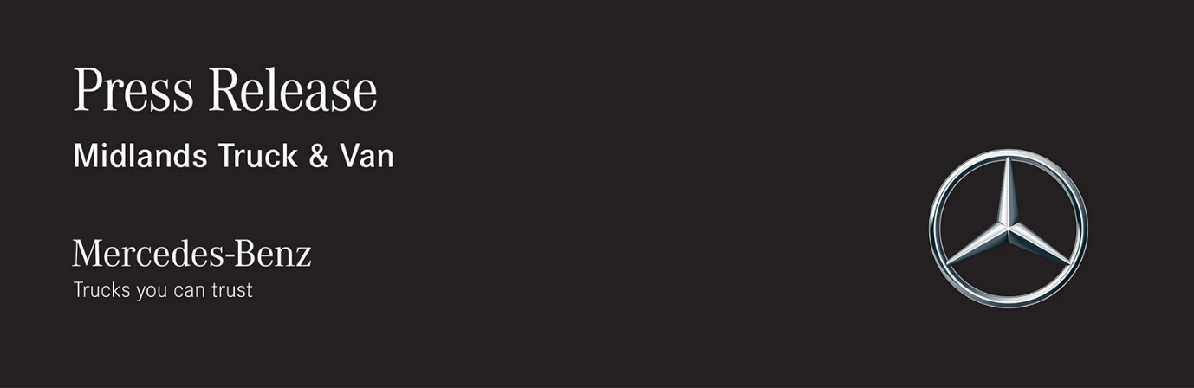

Date: 14 October 2019

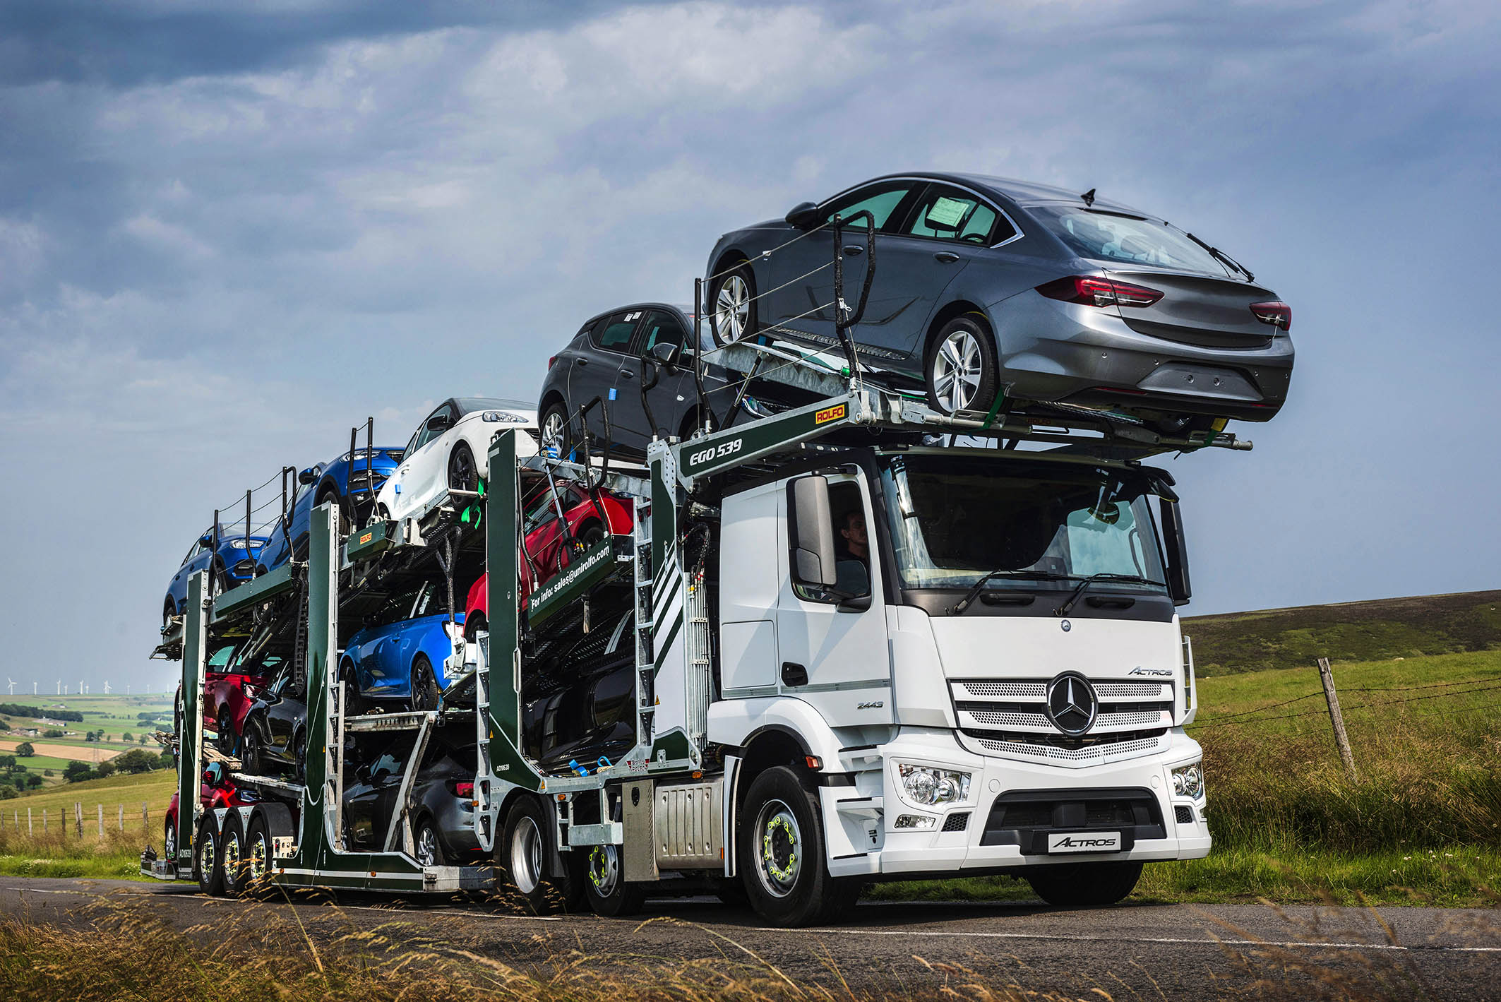

Rolfo Group and Unirolfo team up with Mercedes-Benz Trucks UK to launch innovative car transporter

Leading specialist Rolfo has unveiled a new concept in car transporter bodywork which is based on a Mercedes-Benz Actros tractor unit supplied by Dealer Midlands Truck & Van, and sets new standards for productivity, safety, and build quality.

The Italian manufacturer presented its innovative EGO 539 model to prospective UK customers for the first time, at Mercedes-Benz Trucks’ Wentworth Park customer experience centre, in South Yorkshire. The rig is capable of transporting 12 cars, or mixed loadings with large vehicles.

The truck, which carries four cars, is a 315 kW (428 hp) Actros 2443. It has a low-roofed CompactSpace cab, as well as a space- and weight-saving small-wheeled mid-lift axle, and an uprated, 9.0-tonne front axle.

SB Components, of Wisbech, replaced the standard 390-litre fuel tank with a long-range 525-litre version, while relocating the batteries and air tanks to free up as much room on the chassis as possible for Rolfo’s bodywork. The drive axle tyres were also swapped for low-profile 315/60 rubber, to reduce the vehicle’s height.

Built “without compromise” for a long operating life of more than 14 years, Rolfo’s latest transporter incorporates a variety of features designed to increase operating efficiency, minimise whole-life operating costs, and enhance safety.

For example, each individual platform on the body and trailer is rated to carry cars weighing up to 3.0 tonnes, while the combination is typically two to three inches lower overall than its previous, 11-car EGO model.

Davide Sobrino, Managing Director of Unirolfo, the Rolfo Group’s agent for the UK market, acknowledged that the EGO 539’s market-leading carrying capacity was sure to catch the eye of many potential customers. But he insisted this was only part of the story.

“With its increased loading volume, this vehicle is more productive than anything Rolfo has built before,” he said. “Features like all-round disc brakes mean it sets very high safety standards too.

“Constructed from high yield steel, and fully hot-dip galvanised for ultimate protection, it’s also extremely durable and cost effective. Even the loading skids are galvanised steel, rather than aluminium, which makes them extremely tough and hard-wearing.

“The Rolfo R&D team focused specifically on total life cost when designing the EGO 539. One body and trailer can easily work for seven years with a base vehicle, then – thanks to the modular design – be swapped to a new chassis for a second life of another seven years.”

He continued: “The Mercedes-Benz Actros is the perfect template for this concept. With the small wheels on the mid-lift axle, the chassis is very adaptable and able to accept our bodywork while maintaining a low overall height. The Actros also reflects the same focus on cost-effectiveness, high productivity, safety, and quality engineering as our own equipment.”

Rolfo Group has established a strong partnership with Mercedes-Benz Trucks and Midlands Truck & Van, which explains why it chose Wentworth Park as the venue for the EGO 539’s UK debut.

Mr Sobrino said: “The Wentworth Park facilities were perfect for an event of this type, and allowed us to deliver a comprehensive demonstration of the vehicle’s capabilities, in a safe, controlled environment. The team at Midlands Truck and Van have been excellent partners throughout this project and Rolfo Group looks forward to working closely with them from here on.”

www.rolfo.com
www.unirolfo.com



Working together: Unirolfo Managing Director Davide Sobrino, with his Actros-based EGO 539 car transporter

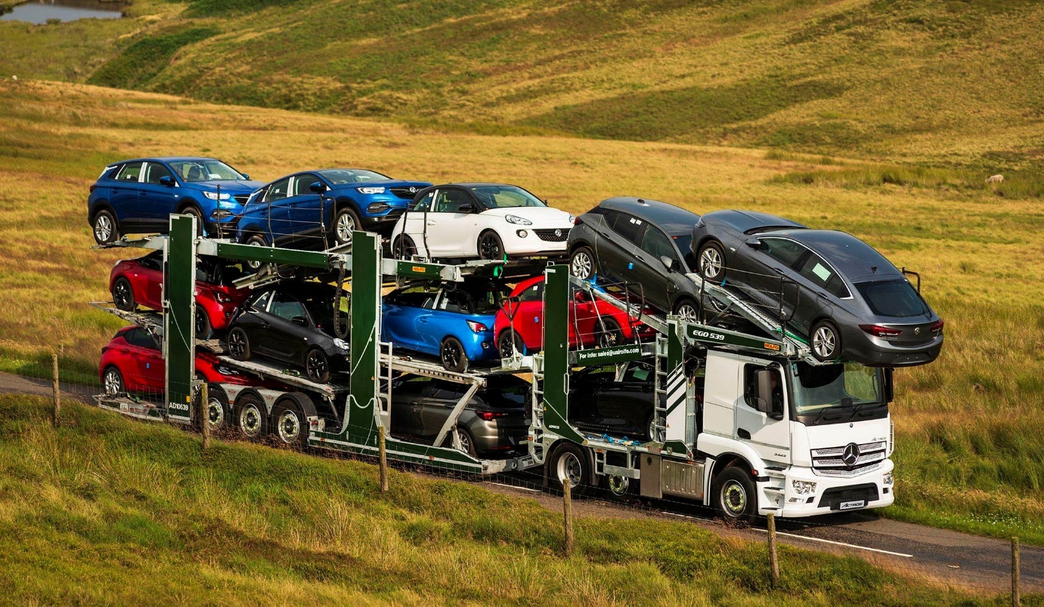

ends

For more information, or to request bigger/higher-res image files, please contact:
John Ripley or Steve Warren
Impact Communications, 01926 842126
John: 07771 484595, john@impactcom.co.uk
Steve: 07770 470251, steve@impactcom.co.uk

