
Date: 12 January 2024

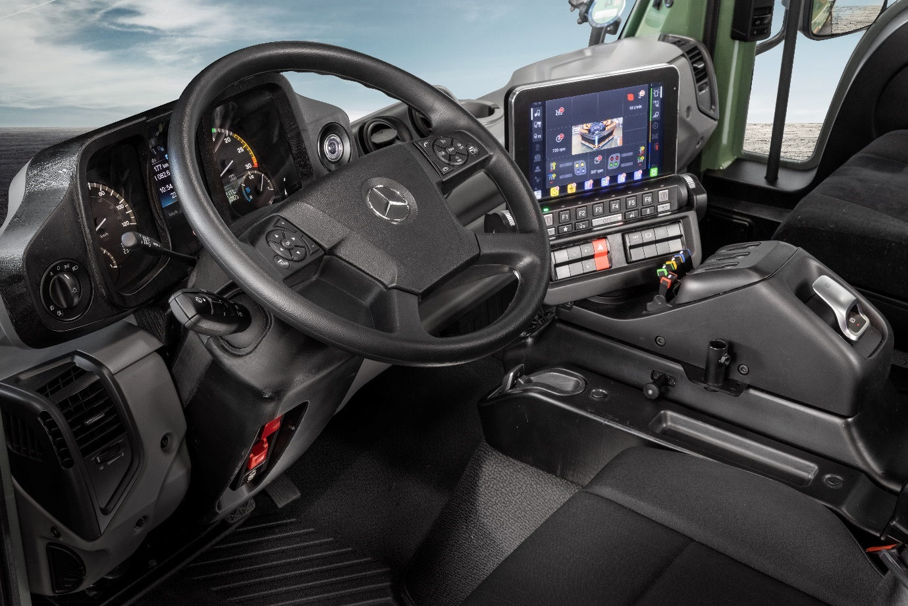

New UNI-TOUCH operating system for the Mercedes-Benz Unimog implement carrier

Mercedes-Benz Trucks UK has announced the all-new UNI-TOUCH operating system for the Unimog implement carrier, which is available to order now ahead of first deliveries in the second half of the year.
The manufacturer is making the announcement at LAMMA 2024 – the UK’s leading agricultural machinery, equipment and technology show – where it is exhibiting its new U535 demonstrator equipped with optional Comfort Steering, Hydropneumatic rear suspension and a rear Power Take-Off (PTO).
The new UNI-TOUCH operating system is leaner, more flexible and fully-customisable. While it is characterised mainly by a new electronic architecture, hidden under the skin, the new operating system results in a comprehensively revised centre console for the driver, which has a leaner design and can be moved sideways, forwards and back.
Also new is a 10.5 inch (26 cm) touchscreen with roller selection as standard - this allows the user to make the right settings for the job at hand. An implement’s Operating procedures can be programmed via the screen so that a specific process, which would otherwise require a number of separate operating steps, can be initiated at the touch of a button. For the best viewing angle, irrespective of the driver’s height or posture, the screen can be rotated and the angle can be adjusted up and down.
An optional multifunction joystick also has freely assignable control elements that can be used for preprogrammed sequences. A feature of the new UNI-TOUCH operating system is that the joystick can be fitted in advance directly on the right-hand folding armrest. This ensures that the main control element is closer to the driver’s seat position, making it easier to use even for extended periods of time.
If required, the joystick can also be fitted on the right armrest of the front passenger seat. If VarioPilot® dual-mode steering is used and the implement is controlled by the front passenger or from the front passenger seat, operation can be carried out as usual with the right hand.
The new UNI-TOUCH operating system is available to order now. It will be installed as standard in every Unimog implement carrier – from U219 to U535 – manufactured from the second quarter of 2024.
Mercedes-Benz Trucks UK also proudly exhibited its new U535 demonstrator at LAMMA. With 260 kW (354 hp), the new U535 is a powerful tool for farming. Mercedes-Benz Trucks’ new demonstrator includes a rear PTO, and newly developed hydropneumatic suspension on the rear axle, which provides stability when driving and when working with heavy loads and is intended to aid the coupling and uncoupling of implements.
In the field, the Unimog can carry out many tasks on the farm when combined with suitable implements. The advantages of the highway-compatible Unimog are particularly relevant for transport over longer distances, not to mention in terms of fuel economy and safety compared to other agricultural vehicles.
The Unimog range encompasses gross weights from 7.5 to 16.5 tonnes and is built around two core variants: the UGE implement carrier U219-U535, and UHE extreme off-roader U4023-U5023 that can be fitted with many different types of body.
https://mercedes-benz-trucks.com/en_GB/brand/unimog-part-of-a-legend/become-part-of-a-legend
ends
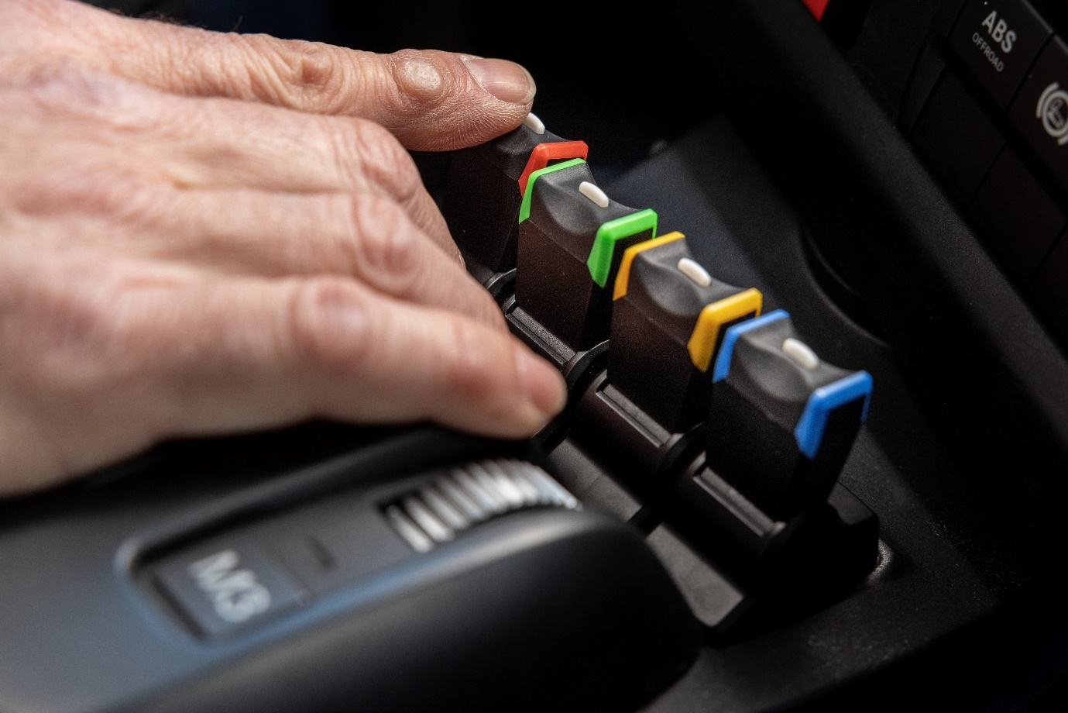
Within arms’ reach: Colour-coded toggle switches to relevant hydraulic circuits
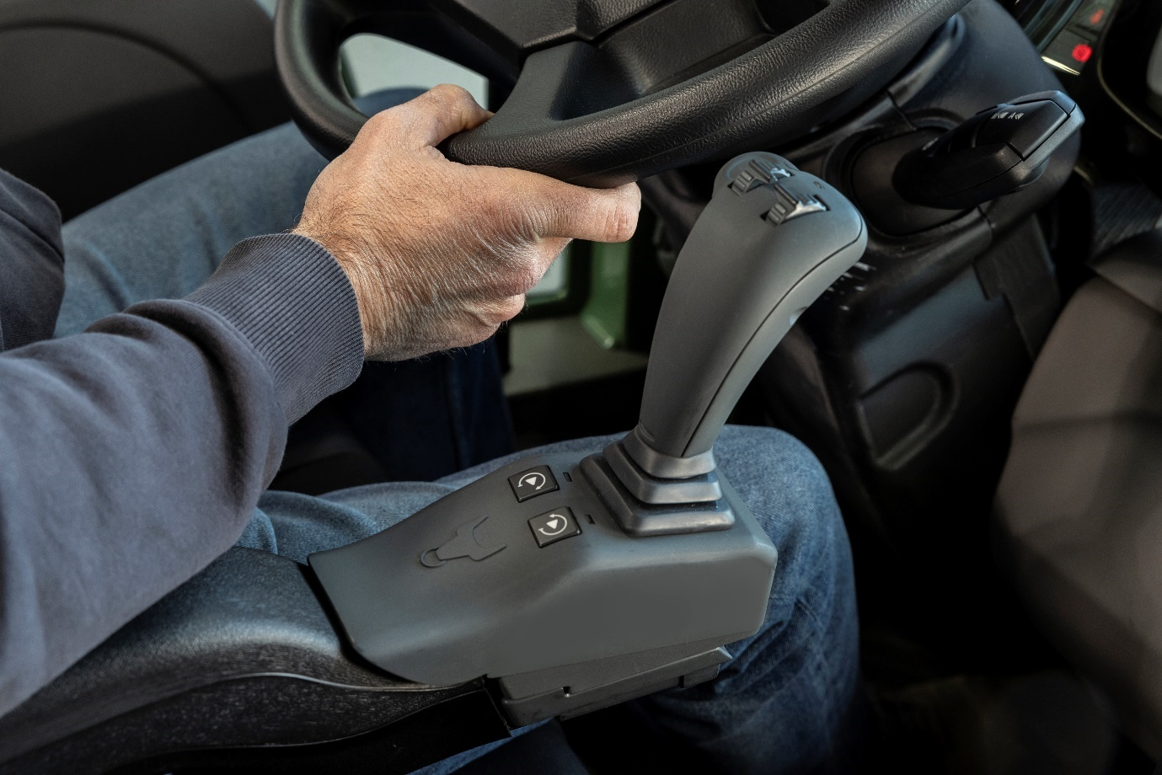
By your side: Easy implement control with the optional joystick

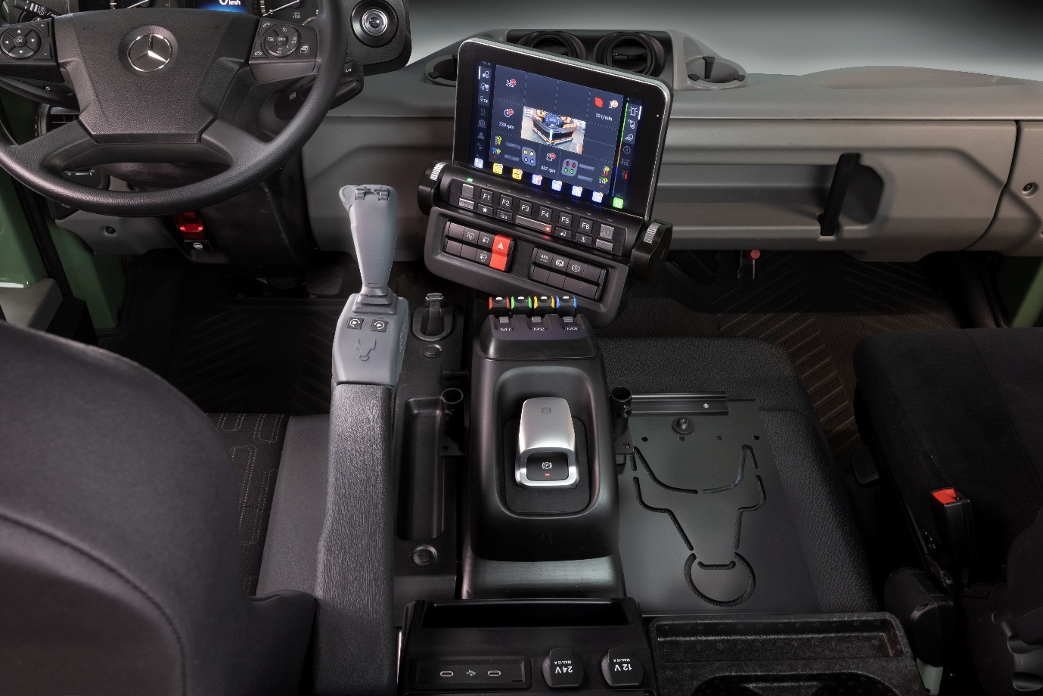
VarioPilot: Controls can be moved from RHD to LHD without interference
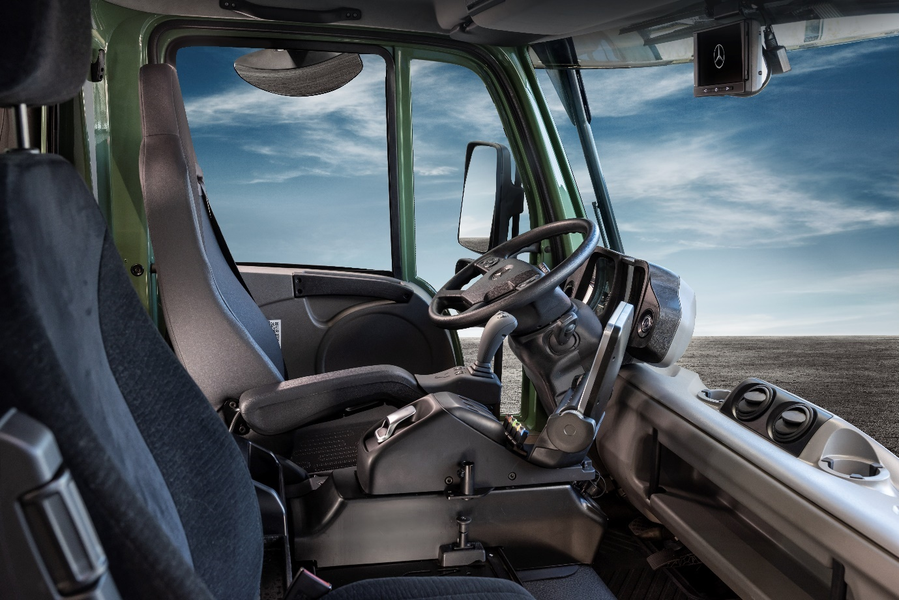

For more information, or to request higher-res image files, please contact:

Jamie Fretwell at Mercedes-Benz Trucks UK Ltd
07712 519230, jamie.fretwell@daimlertruck.com
or
John Ripley: 07771 484595, john.ripley@loopagency.co.uk

