

Date: 2 April 2024

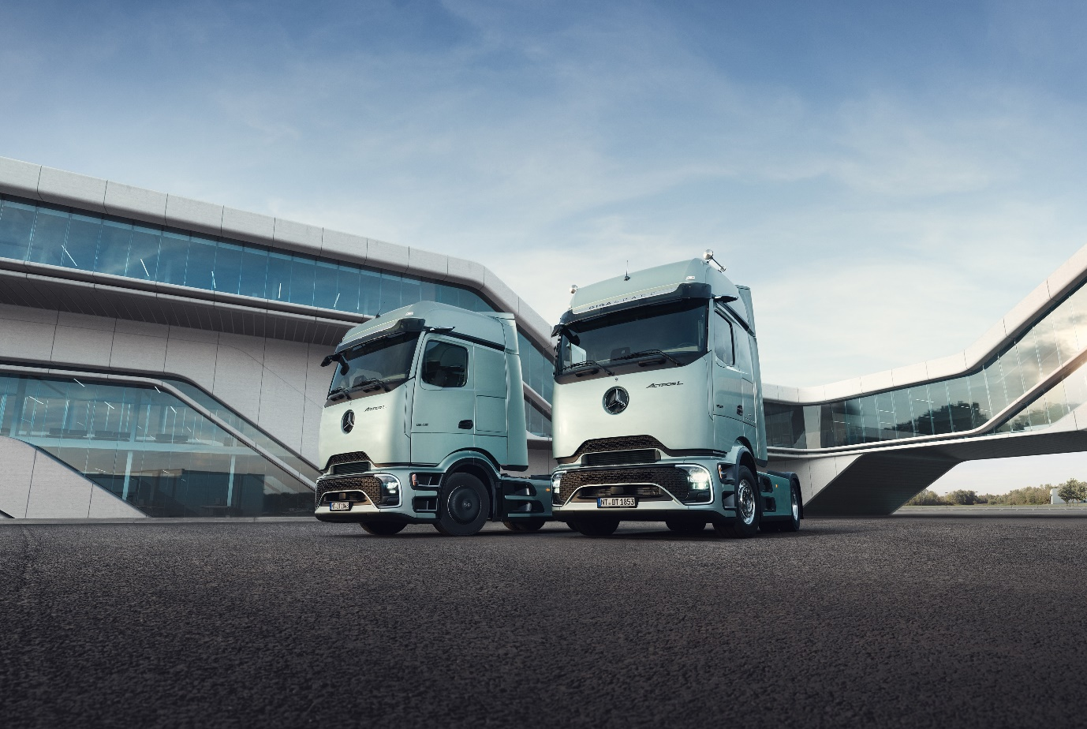

Even more efficiency on the road: The new Actros L from Mercedes-Benz Trucks with its futuristic ProCabin, even better aerodynamics and further optimized assistance systems
- The new Actros L is set to go into production in December 2024.

- The futuristically designed ProCabin heralds a new era for the Actros model series.

- The 80 millimeter longer front end and further aerodynamic measures bring about fuel savings of up to three percent.

- The efficiency of the new Actros L is improved by the aerodynamic driver’s cab, as well as the current generation of the OM 471 commercial vehicle engine.

- Installed safety systems such as Active Brake Assist 6 or Active Sideguard Assist 2 go beyond the requirements of the General Safety Regulation.

- Further innovations such as Multimedia Cockpit Interactive 2 with additional digital services are set to follow in spring 2025.

- Service contracts such as Mercedes-Benz Trucks Complete including Mercedes-Benz Trucks Uptime can also help optimize total operating costs.

- Rainer Müller-Finkeldei, Head of Development at Mercedes-Benz Trucks: “We always aim to provide our customers with the best vehicle solutions for all drive technologies. The traditional diesel-powered truck will also continue to be indispensable in the various regions of the world for some time to come. With the new Actros L, we have further optimized our tried and tested flagship in many aspects. This is already reflected in the revolutionary cab design.”

Leinfelden-Echterdingen - Since its launch in June 2021, the Actros L has defined the premium segment of heavy diesel-powered trucks from Mercedes-Benz Trucks. Now the company is taking its successful flagship to a new level: With futuristic vehicle design, optimized aerodynamics, numerous comfort features, efficient engines, high levels of driving dynamics, and the latest assistance systems, the new Actros L has everything it takes to impress fleet operators and professional drivers alike. The traditional diesel-powered truck thus continues the success story of this model series that began in 1996, reaffirming once again the commitment of Mercedes-Benz Trucks to best meet the needs of its customers and their drivers. The objective: Continuing to be one of the pacesetters in the industry for conventionally powered trucks. The new Actros L with ProCabin can be ordered from April 2024 and will go into production in December 2024.

Rainer Müller-Finkeldei, Head of Development at Mercedes-Benz Trucks, said: “We always aim to provide our customers with the best vehicle solutions for all drive technologies. The traditional diesel-powered truck will also continue to be indispensable in the various regions of the world for some time to come. With the new Actros L, we have further optimized our tried and tested flagship in many aspects. This is already reflected in the revolutionary cab design.”

New aerodynamic design brings about fuel savings of up to three percent

At first glance, the completely new exterior appearance of the Actros L already catches the eye. The entire shaping of the ProCabin, which was first unveiled during the world premiere of the battery-electric eActros 600 in October 2023, has been completely designed for particularly efficient aerodynamics: From the pre-spoiler on the roof in front of the actual roof spoiler, to the A-pillar deflector panels around the side windows and the large, flat front-end flap of the cab to the optimized bumper with minimal air inlet openings for cooling and its new underbody paneling. The airstream thus meets an aerodynamically favorable front extended by 80 millimeters and continues to be guided around the vehicle as optimally as possible. This is ensured by a streamlined entrance, improved wheel-arch trim and optimized side trim. There are virtually no gaps or spaces left in favor of an optimized airflow. Extended side deflectors have been designed like sails to ensure a good transition between the semitrailer truck and the attached semitrailer. The use of various seals to decouple the engine compartment from external airflow rounds off the aerodynamic concept. All in all, this results in fuel savings of up to three percent in the new Actros L.

High level of driver comfort

With the new Actros L and its futuristic cab design, Mercedes-Benz Trucks simultaneously acknowledges the fact that, in addition to efficiency and cost-effectiveness, aspects such as an attractive exterior and comfort in the driver's cab also play an important role in vehicle purchases. Externally, noticeable details in this regard include features such as the full cab paintwork, including the Mercedes-Benz logo and lettering in Dark Chrome as well as the aluminum step plates. All lighting in and around the vehicle also feature LED technology. This applies to the main headlamps and turn signal lights as well as the side and tail lights. Matrix LED headlamps are also available as an option for maximum lighting performance.

In the interior, ProCabin, available in three variants - StreamSpace, BigSpace, or GigaSpace - offers numerous comfort features such as optimized seat heating, new premium flat-woven seat covers, or bunks with full slatted frames and a new, thick premium mattress. The extended range of functions of the switch panels on the bunks as well as the ambient lighting and the additional gooseneck LED reading lamps are also new. In addition, there are other equipment features such as additional USB-C sockets in the side walls, a high-quality curtain in two-tone design, a second refrigerator, a 230-volt socket or the SoloStar Concept, which is now available in two new seat cover variants. Starting in April 2025, Multimedia Cockpit Interactive 2 will also be available with a revamped menu design, voice control, further improved connectivity and new applications such as Connected Traffic Warnings.

Third generation of the OM 471 diesel engine ensures further fuel savings

In addition to the aerodynamic optimization measures, Mercedes-Benz Trucks further increases the efficiency of the new Actros L in combination with the third generation of the 12.8-litre OM 471 diesel engine. The OM 471, available alongside proven OM 470 and OM 473 diesel engines, is consistently designed to reduce Total Cost of Ownership (TCO) without compromising on performance, driving dynamics, or comfort in terms of fuel-efficient driving, reduced CO2 emissions, lower operating costs, and higher returns.

With the third generation of the OM 471, Mercedes-Benz Trucks has introduced two new turbochargers precisely geared towards the diverse needs of customers. In the variant destined for long-haul transportation, the focus is on achieving the lowest possible fuel consumption. In combination with the revised exhaust gas after-treatment system, this exhaust gas turbocharger enables a maximum fuel saving of up to four percent over the previous generation.

Best possible accident prevention to protect all road users

The safety features used in the new Actros L also reinforce the manufacturer’s position as one of the pioneers in the industry. Often these systems significantly exceed the strict standards of the General Safety Regulation (GSR), which will be effective from July 2024 and mandate a wide range of driver assistance systems to further enhance road safety for all road users. The equipment of the vehicles with cameras and sensors is very important for the effectiveness of such systems. In order to make an even better contribution to preventing accidents, Daimler Truck has developed a new electronics platform that enables an even larger view to the front and side with so-called sensor fusion, i.e. merging radar and camera data. The electronics platform offers 20 times faster data processing, and the total of six installed sensors – four lateral short-range radars at the front and rear, both on the right and left, one long-range radar at the front in the center and the multifunction camera in the windshield – can now cover an angle of 270 degrees around the vehicle. Thanks to the significantly enlarged viewing angle, the installed assistance systems can make even better use of their strengths.

Active Brake Assist 6 with multi-lane monitoring

An example of how efficient the 270-degree fusion technology is and what going beyond GSR stipulations means is the already sixth generation of Active Brake Assist (ABA). The latest emergency braking assistant from Daimler Truck can now perform automated maximum full-stop braking to a complete stop at speeds of up to 60 km/h ahead of crossing, oncoming traffic, or other road users in the same lane. GSR calls for the extended response to pedestrians and cyclists for new trucks and buses/touring coaches only as of July 1, 2026. At speeds up to 80 km/h, the system can react ahead of stationary vehicles with maximum full-stop braking, as had previously been the case. A further added value of ABA 6 is multi-lane monitoring at distances of up to 250 metres for even better hazard detection.

Active Sideguard Assist 2 with extended functionality on the driver’s side

The second-generation Active Sideguard Assist (ASGA) also demonstrates the extent to which equipping the vehicles with six sensors and the associated increased viewing angle increases road safety. ASGA 2 monitors traffic on both the driver’s and front passenger sides and with its two-stage warning system it can alert drivers to potential dangers so that timely intervention can mitigate a critical traffic situation. The active warning zone extends up to 30 meters behind and seven meters in front of the vehicle, operating at speeds of up to 30 km/h. Additionally, the system can initiate automated braking to bring the vehicle to a complete stop within the red warning area up to its own turning speed of 20 km/h, should drivers fail to respond to an earlier audible and visual warning. This function also goes beyond the requirements of GSR, which only stipulates that Sideguard Assist must issue a warning if necessary. Furthermore, ASGA 2 features an intelligent lane change warning concept based on the vehicle's own position within the lane.

Front Guard Assist monitors traffic in front of the vehicle

The new Front Guard Assist can be a helpful feature to prevent accidents with pedestrians or cyclists who may be directly in front of the truck when it moves off. The assistance system monitors the traffic in front of the vehicle and supports the driver when the vehicle is at a standstill, when moving off and at intersections. If the system detects stationary or moving objects in front of the vehicle, it supports the driver in driving situations up to 15 km/h by sending warning messages as part of the two-stage warning system. The 270-degree fusion technology covers the blind spot in front of the vehicle from 0.8 meters to approximately four meters across the full width of the vehicle.

With all the assistance systems, Daimler Truck pursues across its entire product portfolio the objective of supporting and relieving drivers as much as possible during their trips within the system limits. However, the systems are unable to shift the boundaries of physics – even as good as they are. The driver therefore remains fully responsible for driving the vehicle safely at all times, as stipulated by law.

Harmonious overall package for relaxed assisted driving

In addition to the traffic safety-focused assistance systems, the well-coordinated interplay of features such as Active Drive Assist 3 (ADA) and the intelligent transmission and cruise control system Predictive Powertrain Control (PPC) is noteworthy in the new Actros L. The ADA has allowed for semi-automated driving (SAE Level 2) in a series production truck since 2018 and is now being launched in its third generation. Beginning in June 2021, the second generation of ADA has been enhanced by the emergency stop function. ADA 3 now further improves support for drivers in both longitudinal and lateral guidance of the truck. Forward-looking PPC, on the other hand, contributes to relaxed driving by automatically taking into account topography, road layout and traffic signs for the most efficient driving style possible. Starting in April 2025, route information from the navigation system will also be integrated to enable better detection of upcoming route events. This allows drivers to avoid unnecessary braking, acceleration and gear changes.

Smart digital solutions for even more efficient use

Mercedes-Benz Trucks offers a comprehensive range of digital solutions and services surrounding the new Actros L to simplify processes and workflows for fleet operators. TruckLive offers a free entry into the digital service solutions of Mercedes-Benz Trucks. This includes various connectivity services that can be used on existing platforms such as MyTruckPoint. For example, Maintenance Management ensures improved vehicle availability, while Live Traffic assists in route planning by providing real-time traffic data through navigation. The new Connected Services, such as Over-the-Air Update or Service24h Connected, can already be used this year. Additional components are currently in the planning stage.

Premium Fleetboard telematics services are also associated with a high added value for a profitable fleet management system. One example includes the Fleetboard Deployment Analysis, which captures and processes technical data from the Actros L. The driving characteristics can be evaluated and optimized on the basis of this data. This contributes to optimizing consumption and reducing wear, as well as to higher vehicle utilization and a better CO2 footprint. Ultimately, this can sustainably increase the overall economic handling of the fleet.

Moreover, with intelligent networking, Mercedes-Benz Trucks Uptime increases the availability of the new Actros L. The system continuously diagnoses the status of the vehicle and provides specific recommendations for action. This approach allows for the early detection of repair needs to reduce breakdowns, and supports customers in promptly organizing the necessary work – all while considering their specific operational planning. The results: Improved predictability of workshop visits, increased vehicle availability, and a higher level of traffic safety. Mercedes-Benz Trucks also offers its customers various service contracts with monthly predictable costs to ensure maximum vehicle availability and minimal downtimes. Presenting Mercedes-Benz Trucks Complete as a premium package: The comprehensive service package covers all workshop work including wear parts.

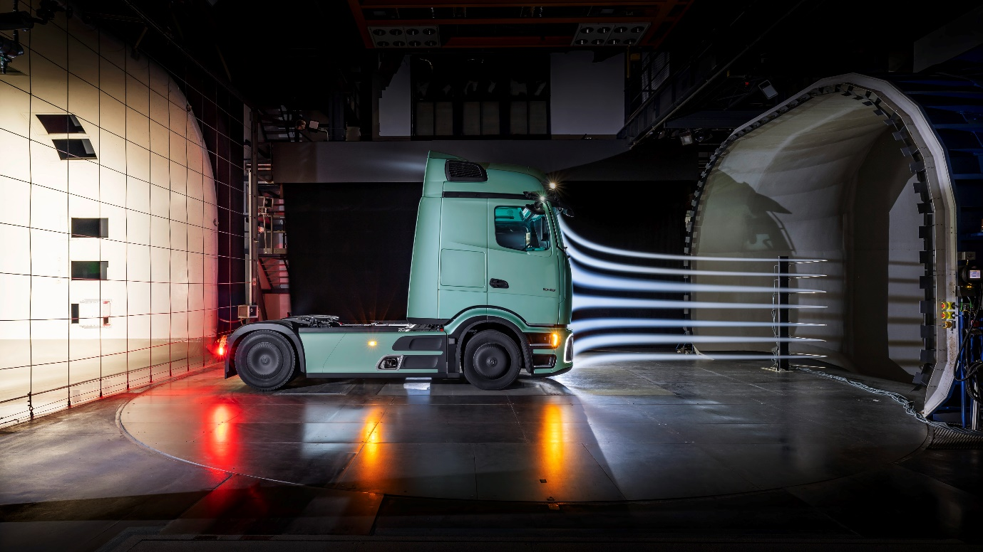

ends

For more information, or to request higher-resolution images, please contact:

Jamie Fretwell at Mercedes-Benz Trucks UK Ltd
07712 519230, jamie.fretwell@daimler.com

or

John Ripley: 07771 484595, john.ripley@loopagency.co.uk

or

Carola Pfeifle, +49 (0) 160 8612423, carola.pfeifle@daimler.com
Peter Smodej, +49 176 30936446, peter.smodej@daimlertruck.com

Further information on Daimler Truck is available at:
newsroom.daimlertruck.com and www.daimlertruck.com

Forward-looking statements:
This document contains forward-looking statements that reflect our current views about future events. The words "aim", "ambition", "anticipate", "assume", "believe", "estimate", "expect", "intend", "may", "can", "could", "plan", "project", "should" and similar expressions are used to identify forward-looking statements. These statements are subject to many risks and uncertainties, including an adverse development of global economic conditions, in particular a decline of demand in our most important markets; a deterioration of our refinancing possibilities on the credit and financial markets; events of force majeure including natural disasters, pandemics, acts of terrorism, political unrest, armed conflicts, industrial accidents and their effects on our sales, purchasing, production or financial services activities; changes in currency exchange rates, customs and foreign trade provisions; a shift in consumer preferences; a possible lack of acceptance of our products or services which limits our ability to achieve prices and adequately utilise our production capacities; price increases for fuel or raw materials; disruption of production due to shortages of materials, labour strikes or supplier insolvencies; a decline in resale prices of used vehicles; the effective implementation of cost-reduction and efficiency-optimisation measures; the business outlook for companies in which we hold a significant equity interest; the successful implementation of strategic cooperations and joint ventures; changes in laws, regulations and government policies, particularly those relating to vehicle emissions, fuel economy and safety; the resolution of pending government investigations or of investigations requested by governments and the conclusion of pending or threatened future legal proceedings; and other risks and uncertainties, some of which are described under the heading "Risk and Opportunity Report" in the current / in this Annual Report or in the current Interim Report. If any of these risks and uncertainties materializes, or if the assumptions underlying any of our forward-looking statements prove to be incorrect, the actual results may be materially different from those we express or imply by such statements. We do not intend or assume any obligation to update these forward-looking statements since they are based solely on the circumstances at the date of publication.

Daimler Truck at a glance
Daimler Truck Holding AG ("Daimler Truck") is one of the world's largest commercial vehicle manufacturers, with over 40 main locations and more than 100,000 employees around the globe. The founders of Daimler Truck have invented the modern transportation industry with their trucks and buses a good 125 years ago. Unchanged to this day, the company's aspirations are dedicated to one purpose: Daimler Truck works for all who keep the world moving. Its customers enable people to be mobile and get goods to their destinations reliably, on time, and safely. Daimler Truck provides the technologies, products, and services for them to do so. This also applies to the transformation to CO2-neutral driving. The company is striving to make sustainable transport a success, with profound technological knowledge and a clear view of its customers' needs. Daimler Truck's business activities are structured in five reporting segments: Trucks North America (TN) with the truck brands Freightliner and Western Star and the school bus brand Thomas Built Buses. Trucks Asia (TA) with the FUSO, BharatBenz and RIZON commercial vehicle brands. Mercedes-Benz (MB) with the truck brand of the same name. Daimler Buses (DB) with the Mercedes-Benz and Setra bus and coach brands. Daimler Truck's new Financial Services business (DTFS) constitutes the fifth segment, the product range in the truck segments includes light, medium and heavy trucks for long-distance, distribution and construction traffic and special-purpose vehicles used mainly in the municipal and vocational sector. The product range of the bus and coach segment includes city buses, school buses and intercity buses, coaches and bus chassis. In addition to the sale of new and used commercial vehicles, the company also offers aftersales services and connectivity solutions.

