

Date: 30 July 2021

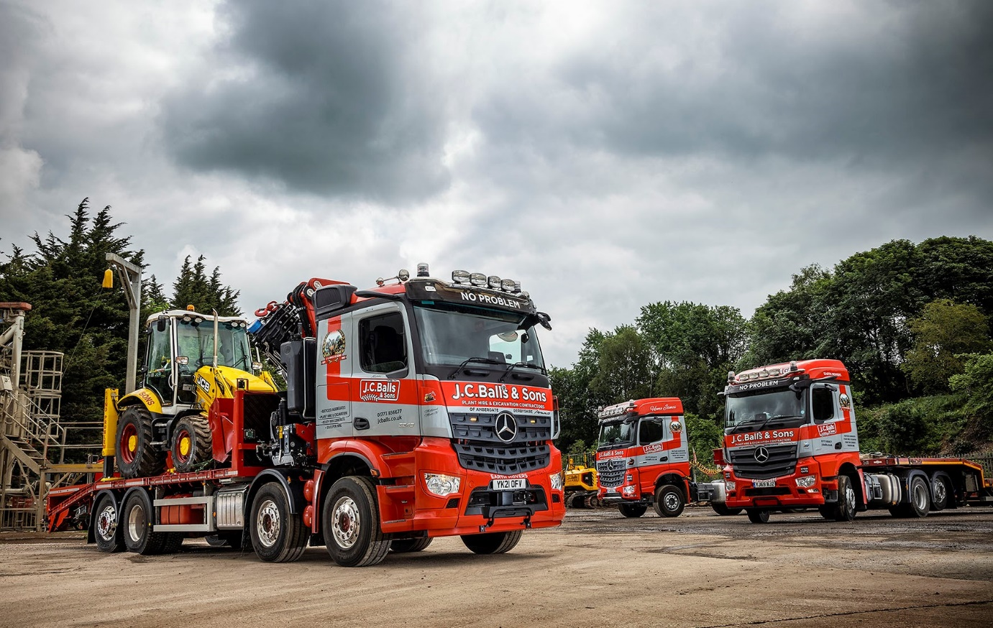

JC Balls & Sons nets a hat-trick of latest-generation
Mercedes-Benz trucks from Northside

Derbyshire’s JC Balls & Sons has added a third MirrorCam-equipped Mercedes-Benz truck to the two it commissioned in 2019, when it became one of the first UK customers for the manufacturer’s ground-breaking alternative to conventional mirrors.

The muscular 8x2 Arocs 3248 was supplied by Northside Truck & Van, which has won praise from the Belper-based operator for its flexible and efficient, round-the-clock back-up.

A third-generation family firm, JC Balls offers excavation, earthmoving, plant hire and recycling services and runs a mixed-marque fleet of 28 trucks that includes tippers, tipper grabs and volumetric mixers.

The latest addition to the line-up has a ClassicSpace L-cab and rear-steer axle. It is powered by a 12.8-litre ‘straight-six’ that produces 350 kW (476 hp) and drives through a 12-speed Mercedes PowerShift automated manual transmission with Manoeuvring, Rocking and EcoRoll modes.

The Arocs has a ‘cheese wedge’ plant body by Truck Hydraulics, of Thorne, Doncaster, and is fitted with a 50 tonne/metre PM 50.5 SP crane. It is used to transport excavators and other construction machinery, as well as portable buildings and a variety of fabricated equipment.

Also delivered by Northside Truck & Van within the last 18 months were JC Balls’ only tractor units, both of which are heavy haulage models that work with low-loader trailers. The 6x4 Arocs 3363 has a BigSpace cab and 460 kW (625 hp) 15.6-litre engine, and is plated for operation at up to 80 tonnes GCW. The 65-tonne Actros 2551 StreamSpace model has a tag axle and employs a 12.8-litre powerplant producing 375 kW (510 hp).

All three vehicles are smartly finished in the operator’s red and silver livery, and fitted with roof-mounted light bars. The fleet also includes three Arocs tippers, all 6x4 variants with lightweight, all-steel Thompsons Stonemaster bodies, which have been in service since 2016.

JC Balls was established in 1963 by Jim Balls, with a single JCB digger. At 93 he continues to take an active interest, though responsibility for its management has long rested with his sons Chris and Kevin – Chris’s children Jamie and Lisa, and Kevin’s Carly-Ann, Hollie and Tom are also now employed in the family business.

The 32-tonne Arocs has replaced a 26-tonne plant vehicle by another manufacturer. “Customer demand meant we needed more lifting capacity,” explained Chris Balls. “The new truck will carry an extra 3.2 tonnes but the rear-steer axle gives it the same degree of manoeuvrability as the six-wheeler. We didn’t need an 8x4 chassis, though, so opted for the single drive axle as this is going to be a lot more fuel efficient.”

Of all the innovations introduced with the fifth-generation Actros range, MirrorCam grabbed the most headlines. The system offers significant benefits when cornering or reversing, especially with an articulated rig. The images relayed to the pair of 15-inch screens mounted on the A-pillars adapt automatically to provide the driver with a clear view – not possible with mirrors – of the full length of the semi-trailer. A guidance line in the display which shows where the end of the trailer is, assists with precision reversing.

As an early adopter of this revolutionary technology, JC Balls is well placed to comment on its ease of use and contribution to safety. “The drivers really like MirrorCam,” reported Chris Balls. “The lads in the artics appreciate the fact that the cameras follow the trailer, so they can always see the corner when reversing.

“Also, of course, drivers no longer have a big slab of mirror housing in front of them. MirrorCam has effectively done away with a major, forward-facing blind spot and they can now see a lot more of what’s going on around them, particularly at the approaches to roundabouts.

“From an operator’s point of view, MirrorCam helps to protect vulnerable road users while also relieving our drivers of stress, and that can only be a good thing.”

JC Balls specified its new Arocs with Multimedia Cockpit, interactive, the optionally upgraded version of Mercedes-Benz Trucks’ radical new dashboard, which replaces traditional switchgear with stylish and intuitively operated twin screens. Features include a larger, 12in instrument panel and extra functionality, including satellite navigation.

“The drivers have taken to the new dashboard as well,” confirmed Chris Balls. “It looks good and I’m told it’s very easy to use.”

Commenting on the Dealer’s aftersales support, he added: “We like the set-up at Northside Truck & Van. Its Sheffield and Doncaster workshops are open round-the-clock, seven days a week. We use both and can always rely on one of them to get us in when it suits us, sometimes at very short notice. It’s a first-class service.”

www.jcballs.co.uk

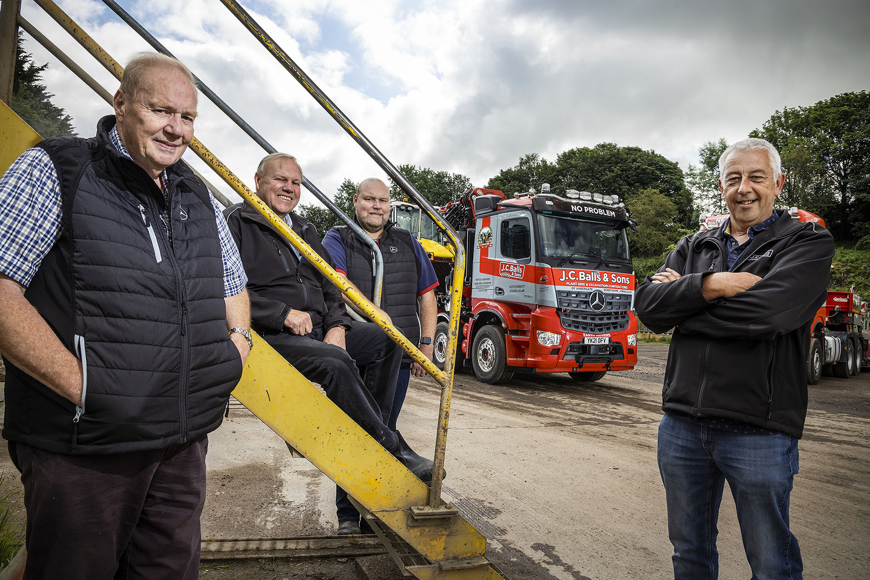

Another step forward: Chris Balls is pictured, left, with his brother Kevin, son Jamie, and Arocs driver Alan Penny

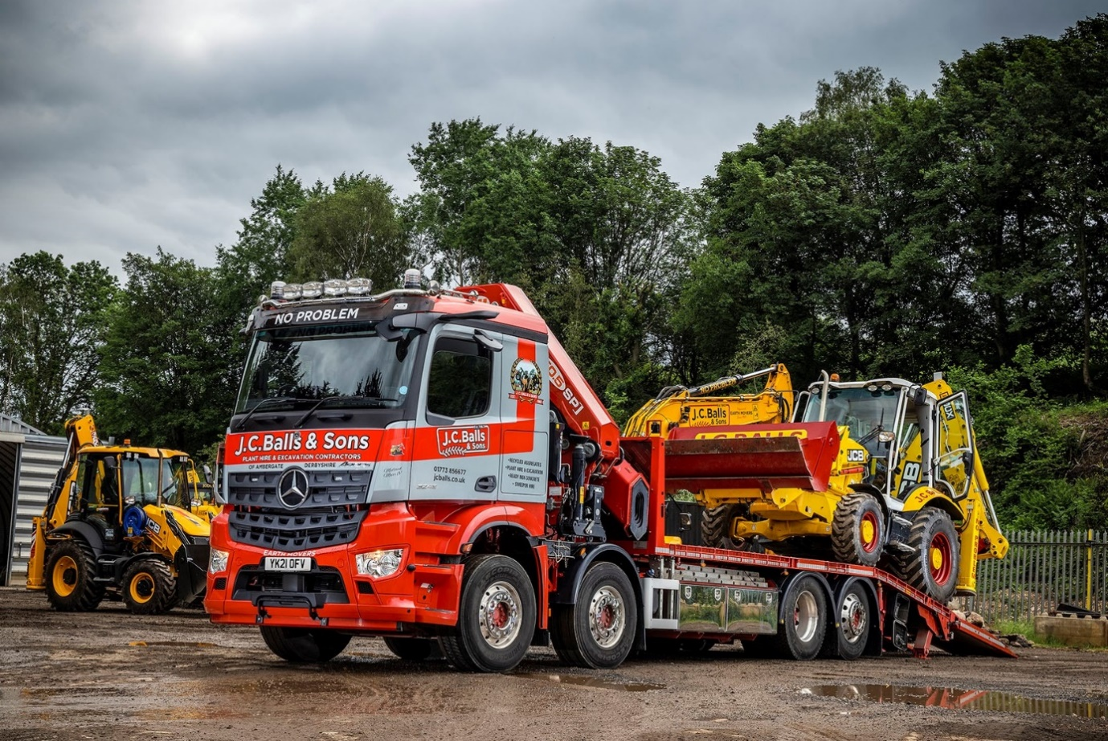

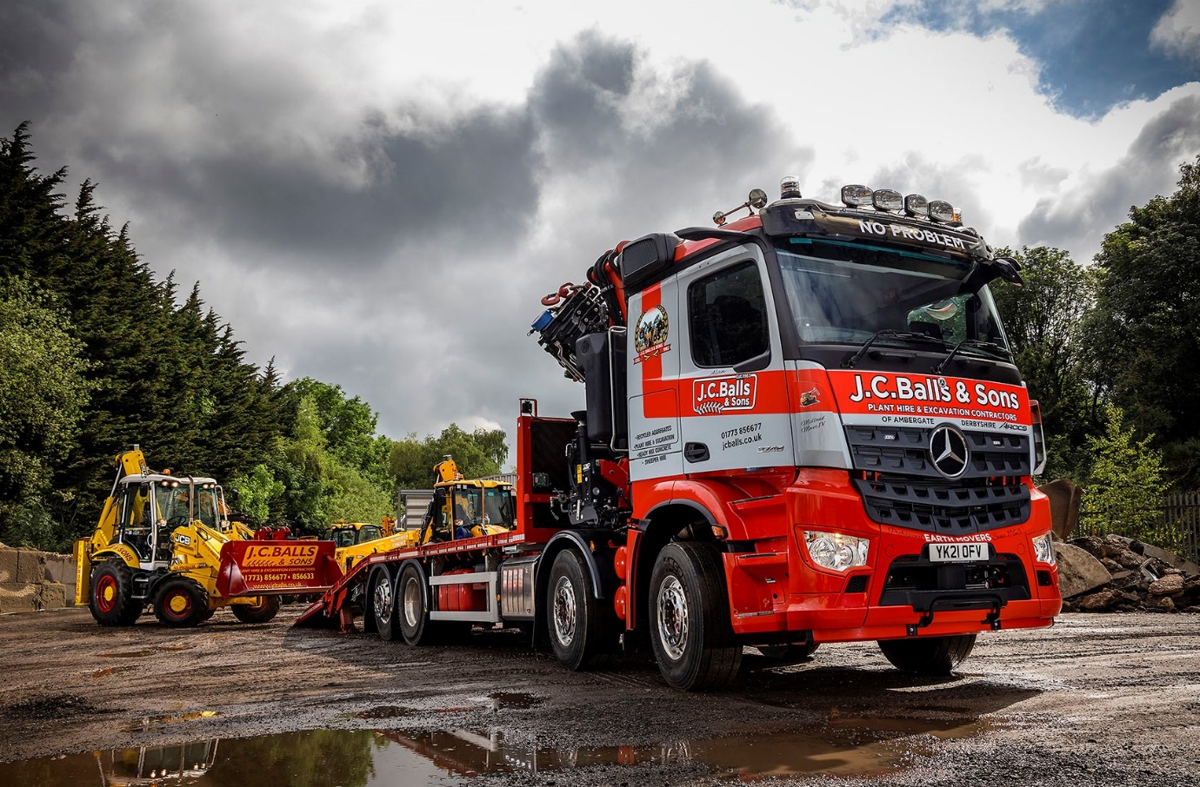

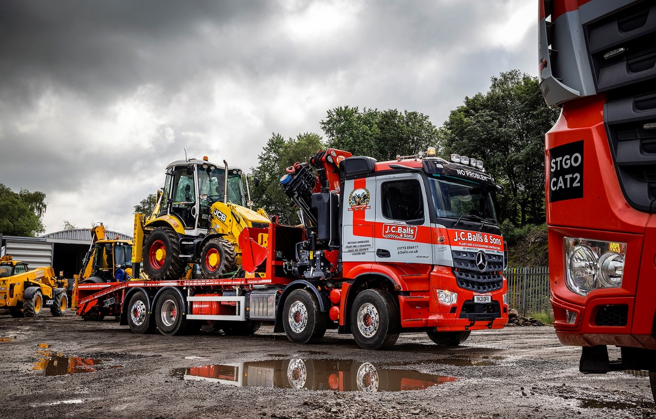

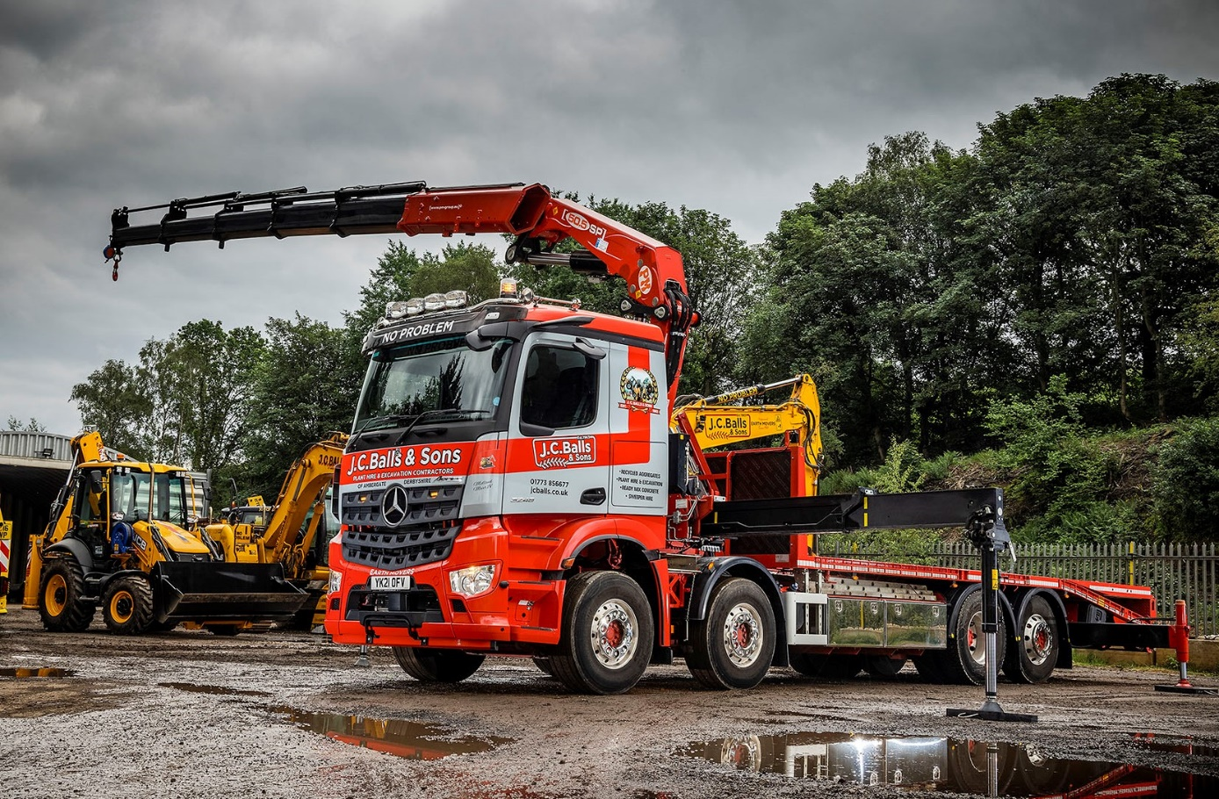

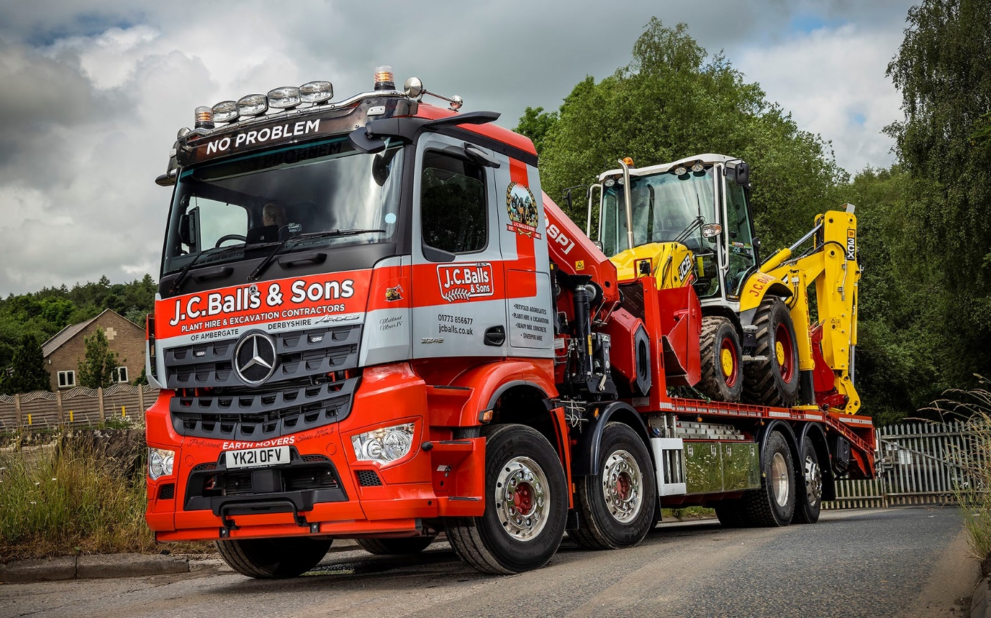

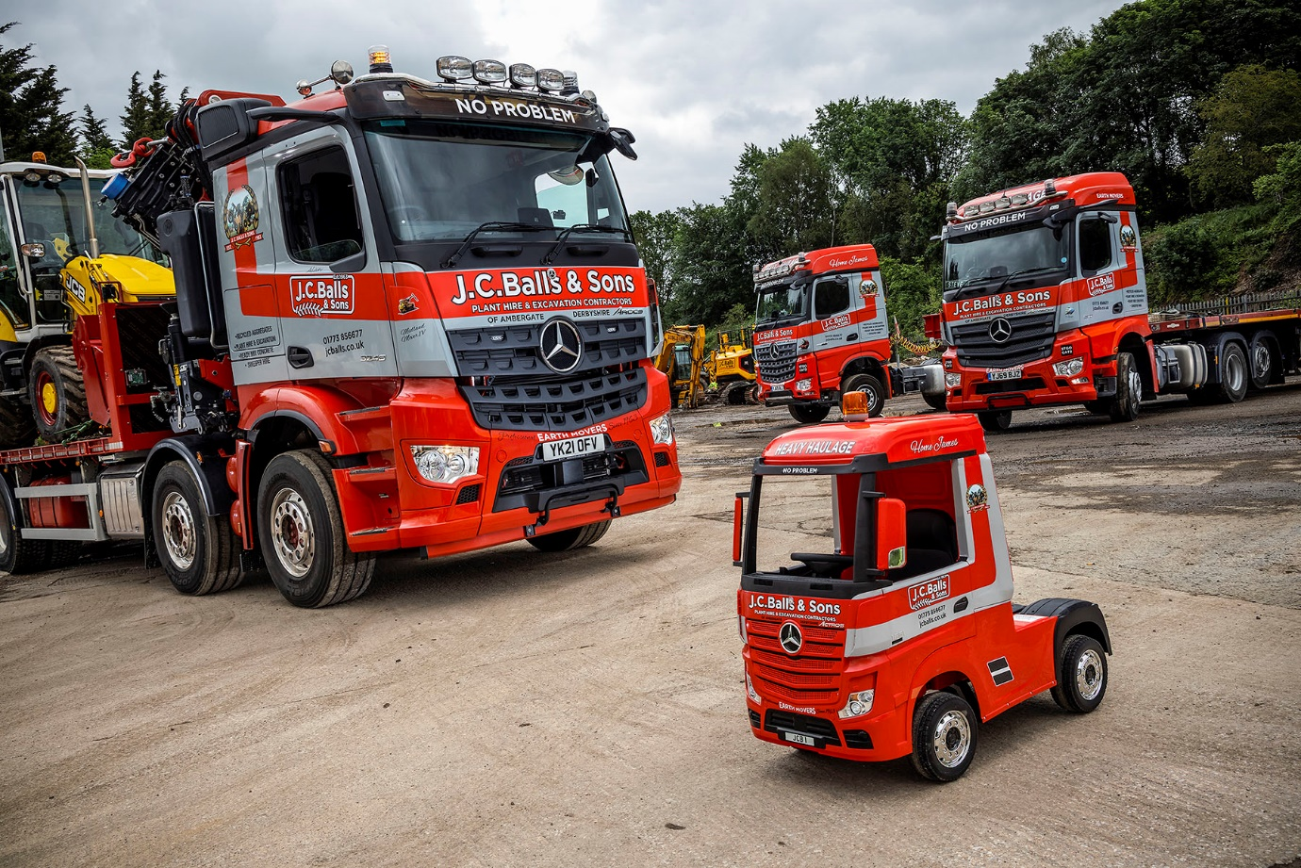

A toy for the boys: Big or small, a Mercedes-Benz truck is always up to the job

ends

For more information, or to request bigger/higher-res image files, please contact:
Steve Warren or John Ripley
Impact Communications, 01926 842126
Steve: 07770 470251, steve@impactcom.co.uk
John: 07771 484595, john@impactcom.co.uk

