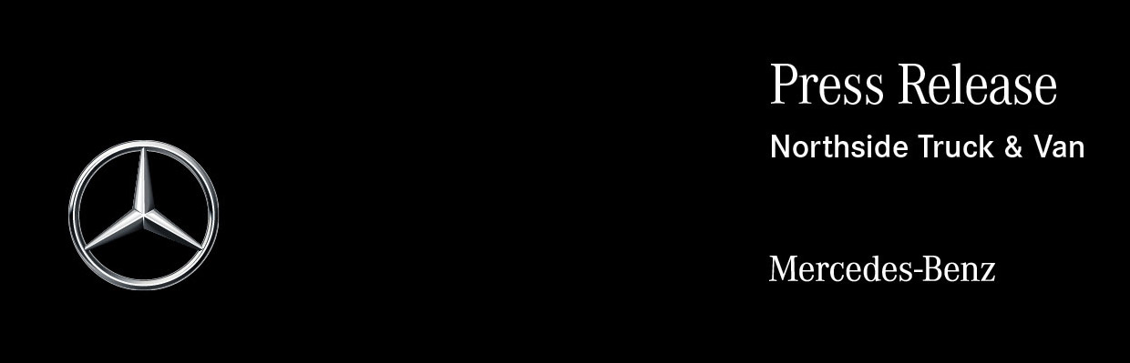

Date: 2 July 2020

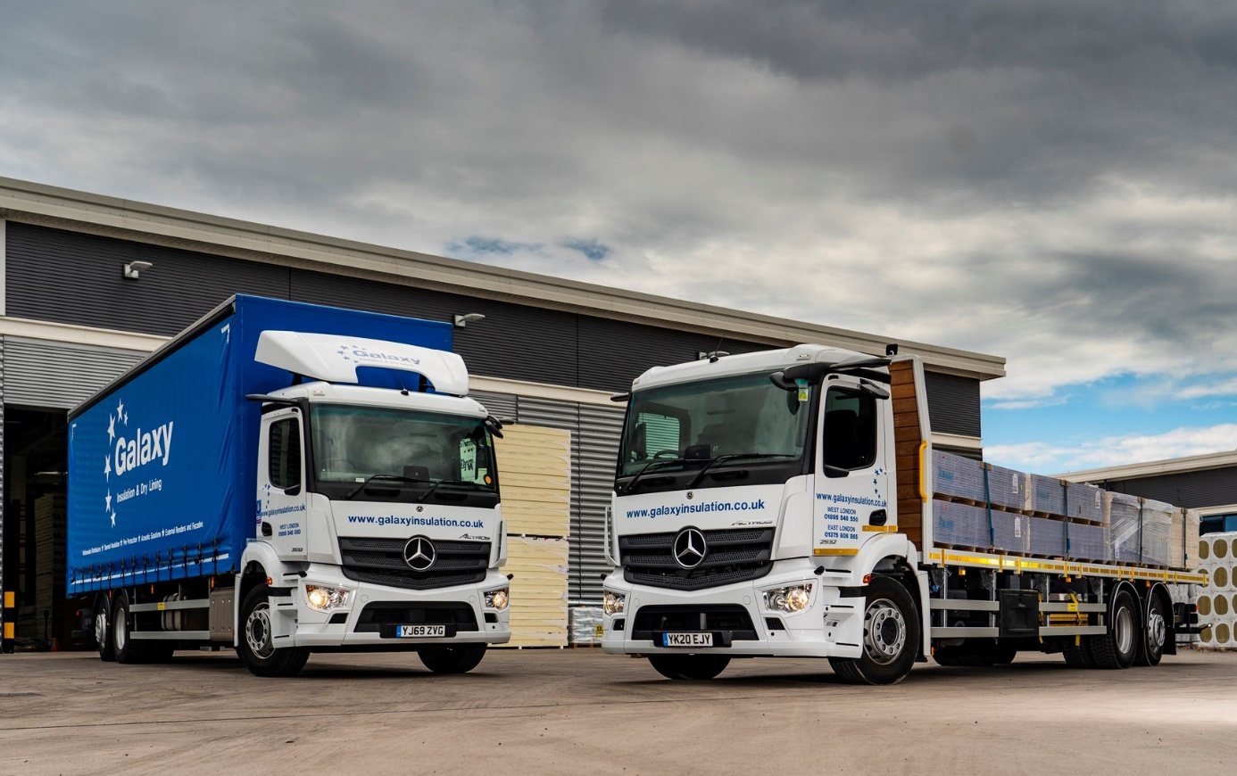

Galaxy shoots for the stars with ‘clear-sighted’ Mercedes-Benz Actros from Northside

Sheffield-based Galaxy Insulation & Dry Lining can see a clear road ahead as it emerges from the Covid-19 pandemic, thanks to the four-star Direct Vision Standard rating of its latest eight Mercedes-Benz Actros rigids.

The 26-tonners were chosen specifically to work in London. They have ClassicSpace S-cabs with 320mm engine tunnels, a combination that offers a relatively low floor and driving position. Coupled with the MirrorCam system which is standard on all new-generation Actros and Arocs models, the specification of these vehicles allows them to achieve their four stars.

MirrorCam’s cameras relay a clear and broad field of vision to a pair of 15-inch screens on the cab’s A-pillars. Crucially, the streamlined camera housings are compact and mounted at roof height, so they also eliminate the forward-facing blind spots caused by conventional mirrors that drivers of other trucks must contend with.

Transport for London’s Direct Vision Standard employs a star ratings system – from zero to five – which is based on how much drivers of goods vehicles over 12 tonnes GVW can see through their windows, particularly in relation to cyclists and pedestrians. Regulations, which would have left trucks in the lowest category requiring additional safety systems in order to work legally in London, were due to be introduced in October. Due to the intense demands placed on operators by the pandemic, however, implementation has been put back to March 2021 at the earliest. By 2024, the minimum requirement increases to three stars.

Star ratings are calculated according to how the vehicle left the production line, and do not take account of aftermarket camera systems and sensors. With its panoramic windscreen the low-entry Mercedes-Benz Econic has secured a five-star rating, but other models bearing the three-pointed star also score relatively highly thanks to their cab design. This advantage over competitors is extended by MirrorCam.

By opting for Actros vehicles which already meet the second-highest level of vision, Galaxy has effectively ‘future-proofed’ itself against any further tightening of the regulations in years to come. It has also underscored its commitments to safety and compliance.

The trucks were supplied by Yorkshire and North Lincolnshire Dealer Northside Truck & Van shortly before the lockdown was introduced, and assigned to two recently-opened depots on the outskirts of London – four are now working from Uxbridge, the other four from West Thurrock.

The subject of a Mercedes-Benz Finance contract hire agreement, all are Actros 2532 models with 7.7-litre in-line six-cylinder engines that produce 235 kW (320 hp) and are paired with eight-speed Mercedes PowerShift 3 automated manual transmissions.

Six are curtainsiders built by Alloy Bodies, of Manchester, while the remaining two – one for each depot – are fitted with platforms which are the work of Wakefield-based Micra Truck Bodies. All eight Actros carry Moffett rear-mounted forklifts.

Independently owned Galaxy Insulation & Dry Lining provides a wide range of insulating and lining board products to construction industry operators and independent builders’ merchants, across most of the UK. It operates more than 30 other Actros six-wheelers from depots in the North and Midlands.

“These, however, are our first with MirrorCam,” said Operations Director Richard Walker. “Given that we were acquiring them for operation in London we worked with Northside’s Truck Sales Executive Steve Cusworth to secure a cab specification that would allow us to achieve the Direct Vision Standard four-star rating.

“Protecting our investment against stricter requirements in the future was certainly a consideration. More importantly, though, we wanted the trucks to be as safe as possible, both for our own staff and other road users. That’s why we’ve added 360-degree camera systems, and scanners to warn drivers of the presence of vulnerable road users on their nearsides.”

Another ‘first’ for Galaxy Insulation & Dry Lining are the trucks’ rear-steer axles. “Steve suggested we consider this option, because the increased manoeuvrability would be a big asset when working in the capital,” explained Mr Walker.

“Thanks to his input these new Actros meet all our safety and vision requirements, while the drivers report that the significantly reduced turning circle makes it a lot easier for them to get in and out of locations where access is particularly restricted.”

He continued: “We’ve built an excellent working relationship with Northside, and with Steve in particular, so were very happy to take his advice on this occasion. He and his colleagues understand our business and provide a consistently high level of customer service.

“This support, together with the reliable, cost-effective performance of the trucks themselves, and the competitive Mercedes-Benz finance that Northside offers, explains why our fleet is dominated by the Mercedes-Benz brand.”

Launched last year, the fifth-generation Actros range is a technological tour-de-force, and has set new standards in terms of safety, efficiency and driver comfort. MirrorCam, in particular, has been an instant hit with the company’s drivers.

Cuthbert Esprit works from its Uxbridge depot, which enjoys FORS (Fleet Operator Recognition Scheme) Silver accreditation. He enthused: “The visibility is great. There don’t seem to be any blind spots, and I can still see even when the sun’s shining directly into the cameras.

“The cab interior is very well designed too. I love the new Multimedia Cockpit with its twin screens, while the steered back axle makes life a lot easier when I’m negotiating tight city streets or on cramped building sites.

“I was told I’d be getting a real high-quality truck and it’s certainly lived up to its billing. My new Actros is a fantastic vehicle, and real pleasure to drive.”

Galaxy Insulation & Dry Lining was established in 2009 and operated initially from Leeds and Sheffield. In 2016 it opened depots in Haydock and Birmingham. This year, as well as expanding into London, it has added a second West Midlands branch, in West Bromwich.

Like so many other businesses Galaxy faced an uncertain future when the coronavirus struck. “We braced ourselves for a shock and furloughed some 20% of our staff, as well as introducing strict hygiene and distancing measures for those still working,” explained Mr Walker.

However, the pandemic’s effect on earnings has been less severe than first feared. “The construction industry suffered less of a slowdown than other sectors, so we never dropped much below about 85% of our normal trading volume.

“Now, with each week that goes by, we’re seeing increasing demand for our services and getting closer to the levels we were seeing before the crisis began. With all of our Actros hard at work it’s onwards and upwards for Galaxy.”

www.galaxyinsulation.co.uk

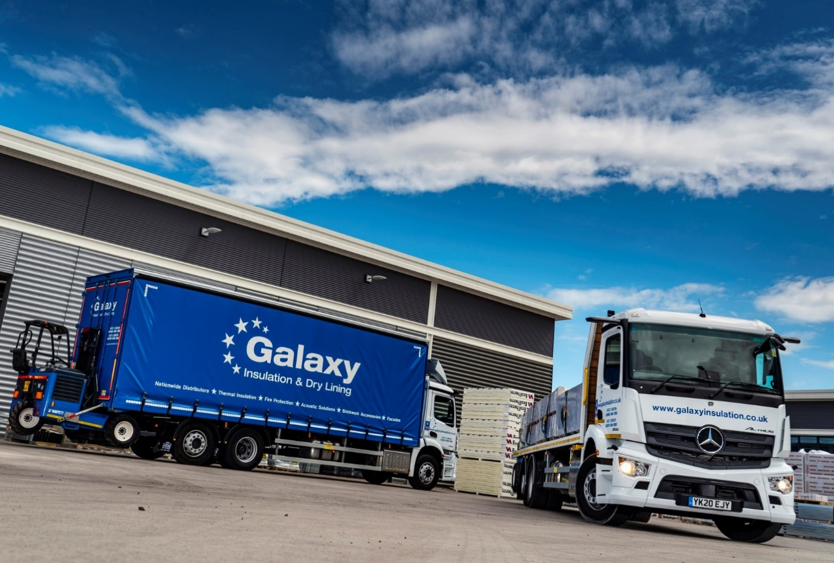

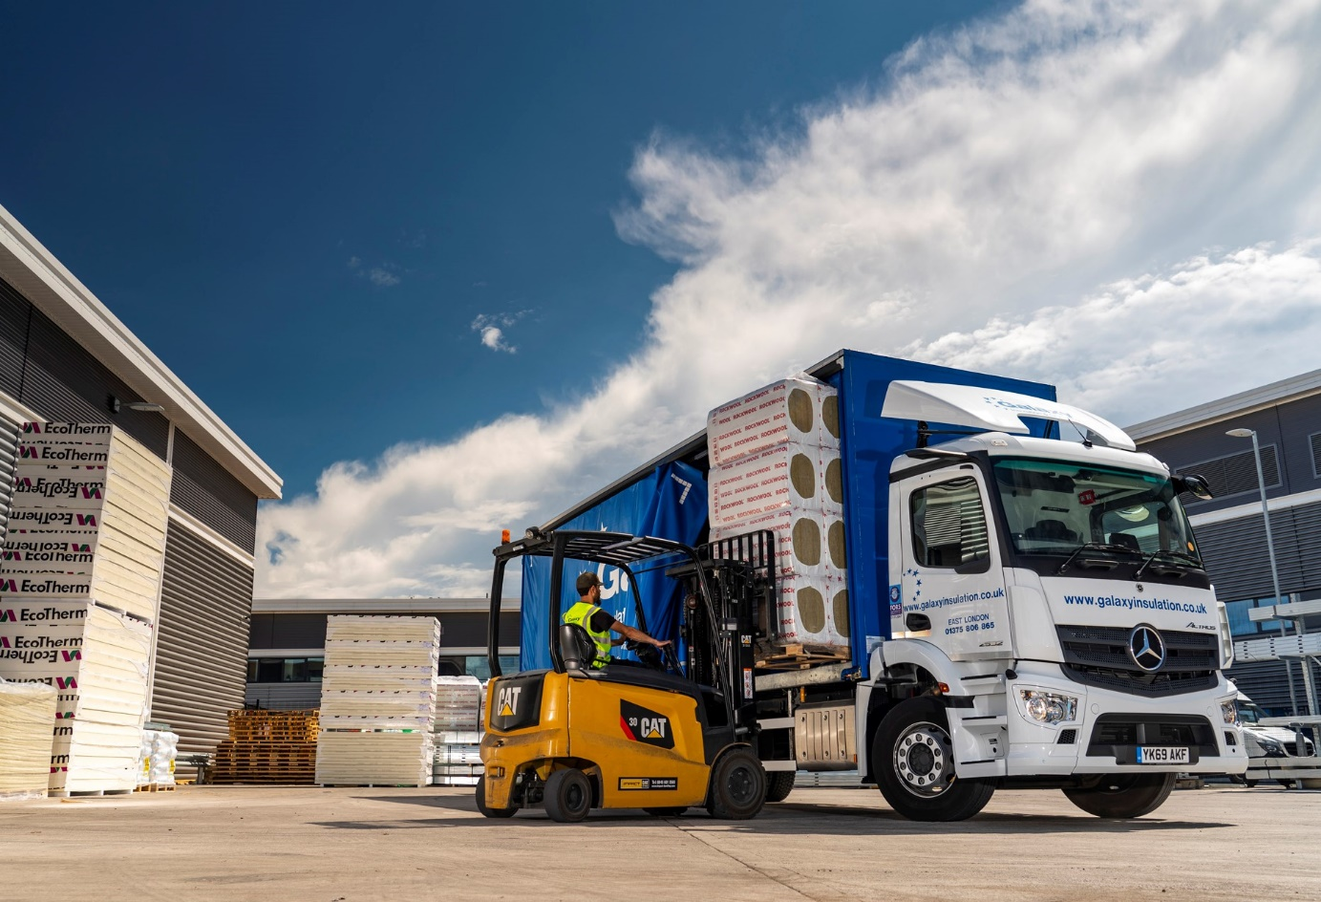
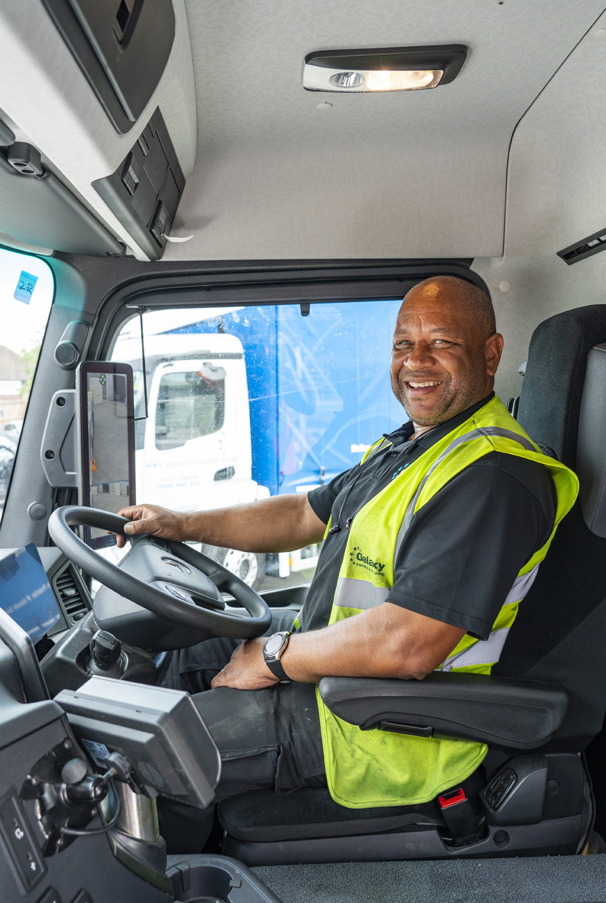

Screen time: Driver Cuthbert Esprit was quickly won over by his Multimedia Cockpit, interactive, an optional upgrade on the standard-fit version of Mercedes-Benz Trucks’ stylish and intuitive dashboard
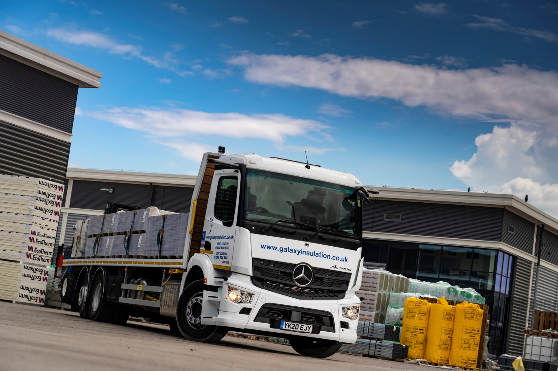

ends

For more information, or to request bigger/higher-res image files, please contact:
John Ripley or Steve Warren
Impact Communications, 01926 842126
John: 07771 484595, john@impactcom.co.uk
Steve: 07770 470251, steve@impactcom.co.uk

