

Date: 11 February 2022

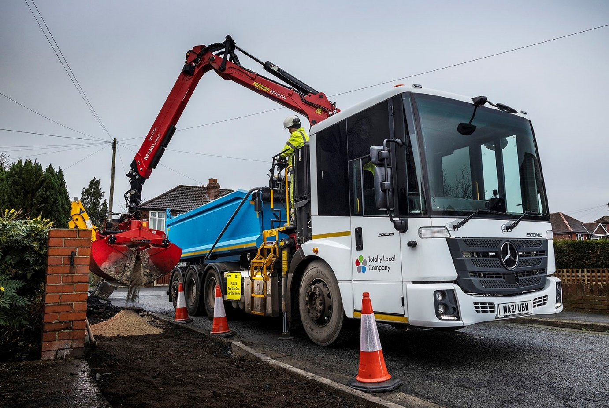

Five star-rated Mercedes-Benz Econic tipper-grabs tick all the boxes for TLC

Totally Local Company Limited (TLC) had an exacting set of requirements for its latest trucks, and a pair of Mercedes-Benz Econics met or exceeded every one of them.

The Stockport-based operator’s 32-tonne tipper-grabs were supplied by North West Dealer eStar Truck & Van and are now hard at work on a range of construction projects for public and private sector clients.

TLC runs a range of heavy trucks. Although these are its first Econic tippers, many of the company’s refuse collection vehicles are based on the same chassis and have proved both reliable and cost-effective to operate.

Head of Fleet Services Alastair Burns recalled: “We needed eight-wheeled tipper-grabs for on-highway work that often entails muckaway duties. But we also wanted low-entry cabs that would provide drivers with optimum visibility, and rear-steer axles to ensure the trucks were as manoeuvrable as possible, given that they would be working in an urban environment.

“Few vehicles are capable of meeting such a brief, and of the tenders we received the Econic was the clear winner. The field of view from the driver’s seat is excellent and the cab is easily accessed, while for such a large truck the tight turning circle is hugely impressive. Taken together, these and other attributes of the vehicle, coupled with the promise of eStar Truck & Van’s customer-focused back-up, added up to an unbeatable proposition.”

The Mercedes-Benz Econic has a deep, panoramic windscreen and low seating position that affords drivers an unrivalled view. The bus-style folding nearside door specified by TLC is glazed to its full height and allows them to make direct eye contact with cyclists or pedestrians at junctions and in traffic, a key advantage in helping each to understand the other’s intentions.

These industry-leading safety features have earned the Econic Transport for London’s highest, five-star Direct Vision Standard rating. “We undertake the vast majority of our work in the North West but the benefits encouraged by the Direct Vision Standard apply here every bit as much as they do in the capital,” continued Mr Burns.

“The quality of visibility from the cab is crucial to the safety not only of our own crews, but also of the public, and particularly vulnerable road users. Econic drivers can see so much more than is possible from a traditional, high-riding construction truck.”

Both 3235L ENA variants, TLC’s new trucks have single front steer axle, double-drive bogie and rear-steer axle configurations. The resulting, enhanced manoeuvrability compared to a standard 8x4 vehicle is a major advantage for operation on busy urban streets and at other locations where access is tight.

Their 7.7-litre six-cylinder engines produce 260 kW (354 hp) and drive through 12-speed Mercedes PowerShift 3 automated manual transmissions, while the steel tipping bodies are by Massey Truck Engineering, of Sheffield. Fitted immediately behind each cab is a Palfinger Epsilon M135L crane with a maximum capacity of 1,500 kg and reach of up to 8.2 metres.

Standard safety equipment includes Active Brake Assist 4 emergency braking technology. This can detect vehicles ahead and stationary objects in its own lane, at speeds of up to 56 mph (90 km/h). It can initiate maximum braking to bring the truck to a complete stop, and at speeds of up to 31mph (50km/h) can also detect moving pedestrians.

Central locking allows the cabs to be secured if the driver is outside the vehicle, and cab heaters keep crews warm during breaks without needing to run the engine, while also allowing timed defrosting of the cab on cold mornings.

As with all new Econics supplied through the manufacturer’s UK Dealer network, the trucks are covered by three-year/160,000 km warranties. Like its Econic refuse collection vehicles, TLC is maintaining the latest additions to the fleet in its own workshop but will be able to call upon eStar Truck & Van for expert technical advice if needed.

www.totallylocalcompany.co.uk

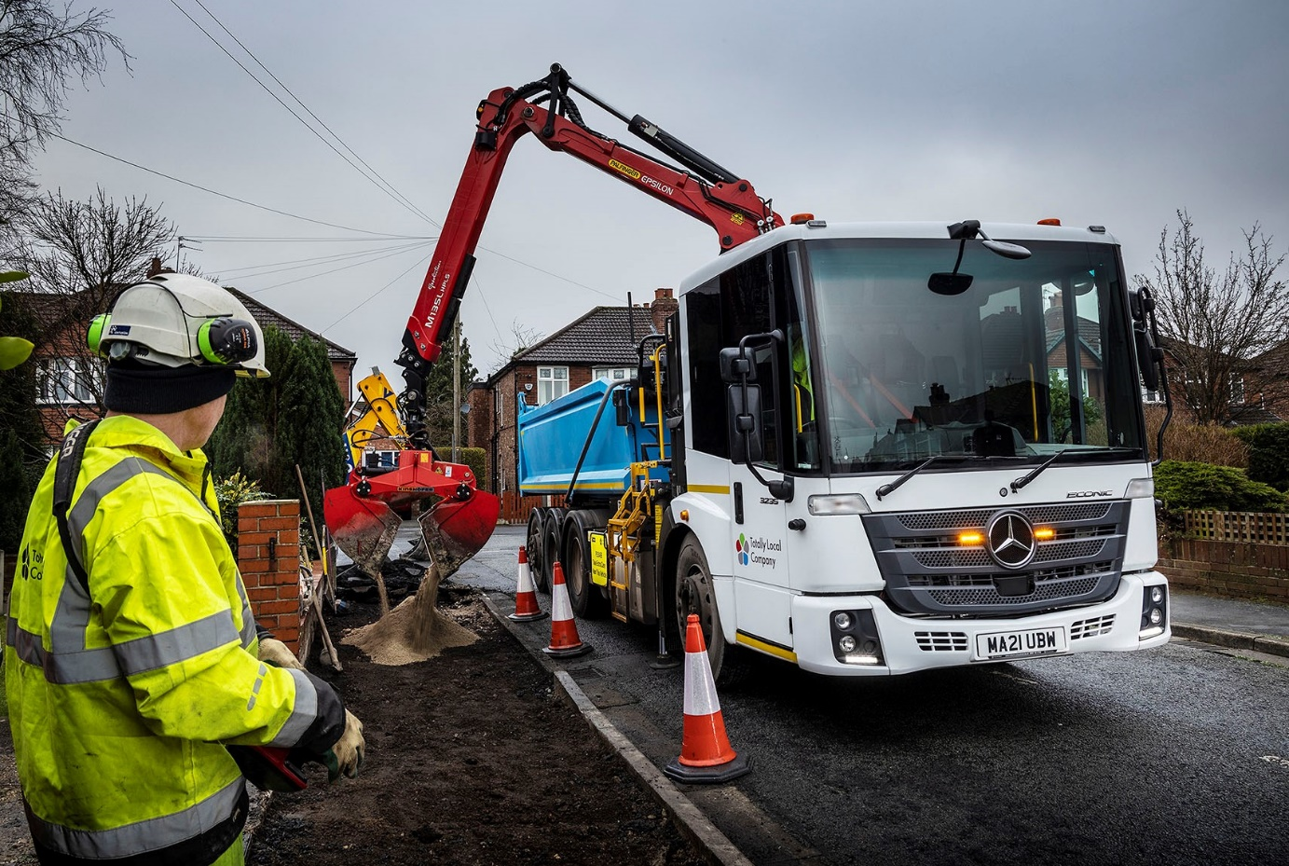

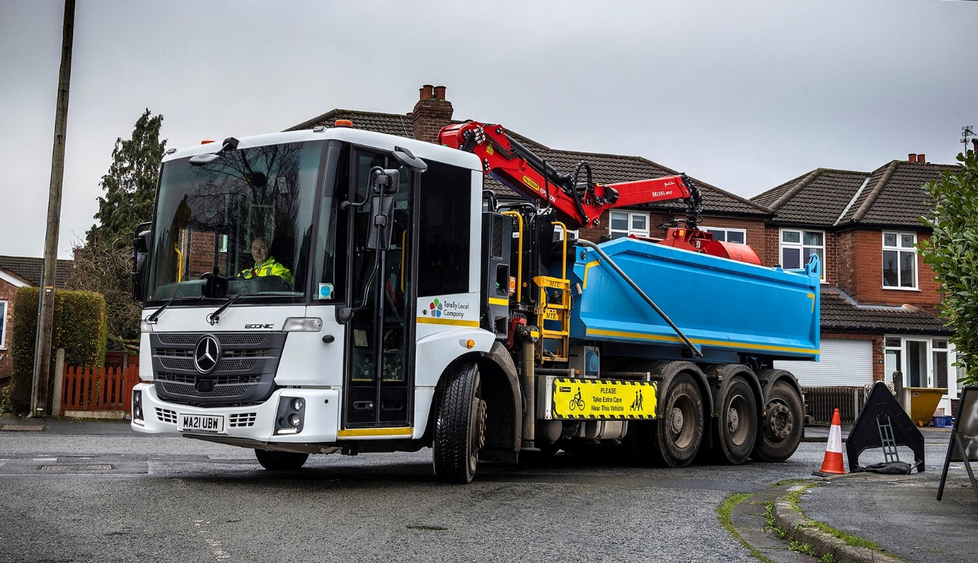

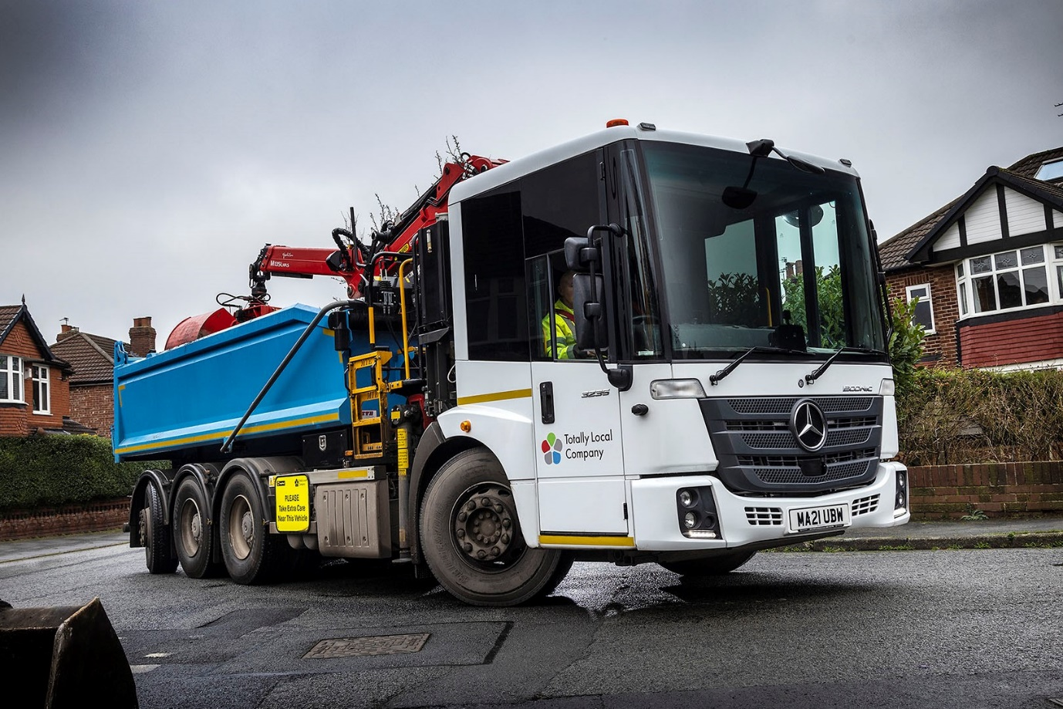

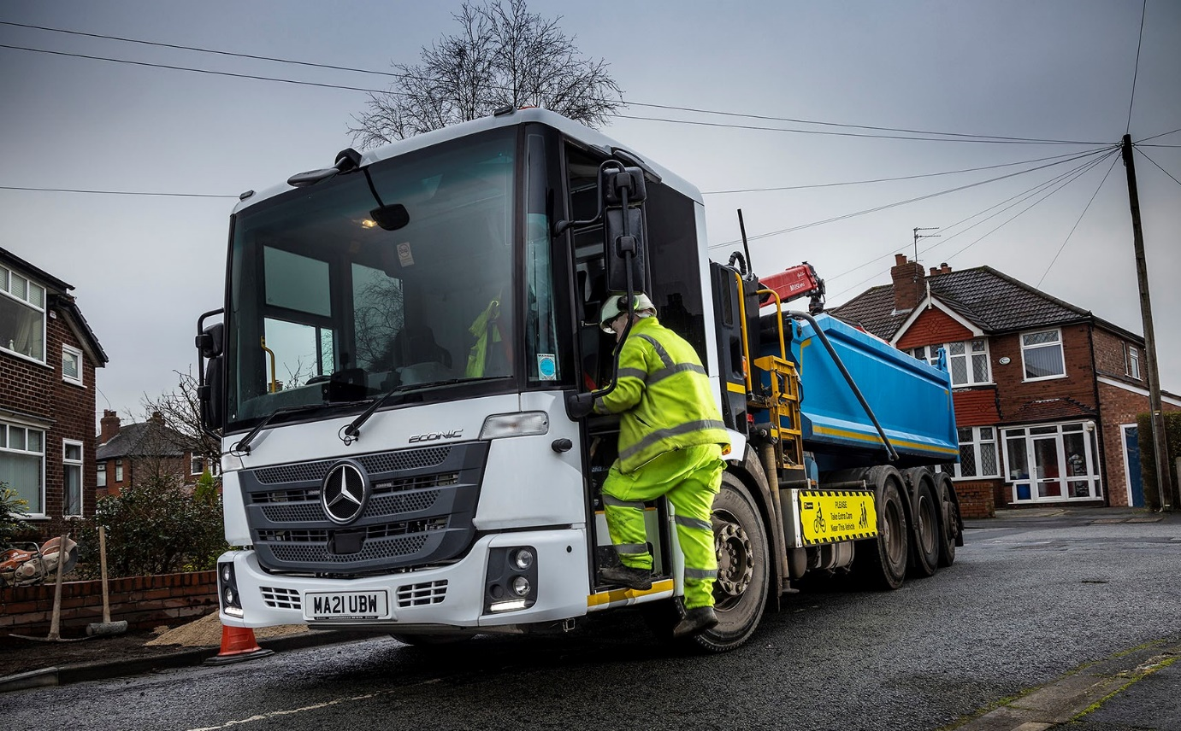

ends

For more information, or to request higher-resolution image files, please contact:
John Ripley or Steve Warren
Impact Communications
John: 07771 484595, john@impactcom.co.uk
Steve: 07770 470251, steve@impactcom.co.uk

