

Date: 21 June 2021
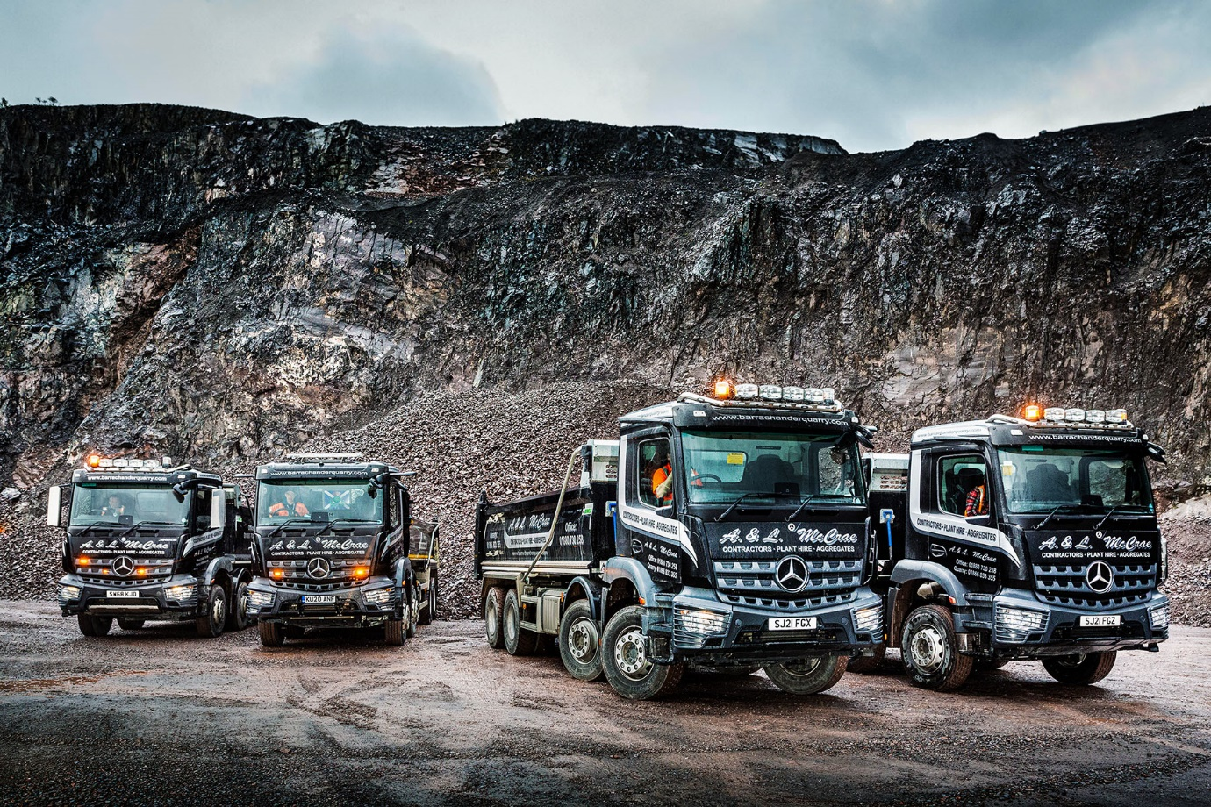

Robust, fuel-efficient Mercedes-Benz Arocs tippers dig in with Barrachander Quarry

Barrachander Quarry boss Calum McCrae has been so impressed with the rugged reliability of the 8x4 Mercedes-Benz Arocs he set to work three years ago that he has just commissioned another two from Western Commercial.

The Dealer’s customer-focused back-up was also crucial in convincing the Argyll-based operator to add more Mercedes-Benz tippers to a fleet in which a Swedish brand previously held sway.

The new arrivals are both 3240K variants with ClassicSpace M-cabs and 10.7-litre ‘straight-six’ engines that produce 290 kW (394 hp) and drive through smooth and efficient 12-speed Mercedes PowerShift 3 automated manual transmissions.

Pre-built with steel Boweld bodies for the manufacturer’s WorkReady programme, they were wrapped and sign-written by DS Graphics, of Bonnybridge, fitted with Kelsa light bars and delivered within a month of the order being placed.

Like the ex-demonstrator Barrachander Quarry purchased from another Mercedes-Benz Dealer earlier this year, its latest trucks boast innovative MirrorCam technology rather than conventional mirrors, as well as the new Multimedia Cockpit with its stylish and intuitive twin screens.

They are exceptionally fuel-efficient. “It’s difficult to be precise, given the nature of the work, but I reckon we’re saving 20% on our diesel bills,” reported Mr McCrae. “That will make a very welcome contribution to our ‘bottom line’.”

A&L McCrae, whose name also appears on the fronts of the tippers, was established by Calum McCrae’s parents Alistair and Linda in the mid-1970s. It operates from Whitehouse, on the Argyll Peninsula, and provides a range of services including plant hire and sales, heavy haulage, aggregates supply and contracting.

Barrachander Quarry is located 50 miles north, at Taynuilt, near Loch Awe. When it was acquired by the McCrae family a decade ago it had a single customer. Today, its diverse customer base includes wind farm developers, local authorities, civil engineering companies, housing and commercial developers, and marine and utilities contractors.

The basalt carried by its seven trucks – two of them tractor units that work with bulk tipping trailers – is used for a variety of civil engineering purposes, particularly road building and repairs, and to maintain the railway infrastructure.

The operator inspects and maintains its Arocs tippers in-house, but benefits from Western Commercial’s technical assistance and an imprest stock of Mercedes-Benz GenuineParts. Mr McCrae and his wife Susan, the company’s Transport Manager, also took out ExtendPlus warranties under which the first 12 months’ comprehensive cover remains in place for a further three years.

“We’ve enjoyed close support from the manufacturer as well as our local Dealer,” said Mr McCrae. “This has given us the confidence that has underpinned our recent decision to purchase the new trucks.

“As far as parts are concerned we have four of everything we’re likely to need to keep us on the road, and Western Commercial replenish the stock as necessary. Meanwhile, on the odd occasions we’ve had to call for Mercedes-Benz assistance – for example, when a warning light has come up on the dash – its Service 24h technician has responded quickly and efficiently.”

“Both the drivers are raving about their new Arocs, and the same is true of their colleague, who’s in the ex-demonstrator,” reported Mr McCrae. “They all love the fact that MirrorCam eliminates a big blind spot and allows them to see so much more, while the trucks are so comfortable, and the Multimedia Cockpit so easy to us, that none of them want to go back.”

He added: “We’ve had very few issues with the Arocs we’ve been running for the last three years – tyres and diesel apart, we’ve spent virtually nothing to keep it on the road. Other brands of truck have definitely cost us more money.”

Purpose-designed for construction applications, the robust, high-riding Arocs is ideally suited to operation in rough terrain. “It looks great, too,” enthused Mr McCrae. “Truck Sales Executive Calum Aitken sourced our new tippers then had the cabs wrapped and the light bars fitted exceptionally quickly. It was a great service all round.”

barrachanderquarry.com

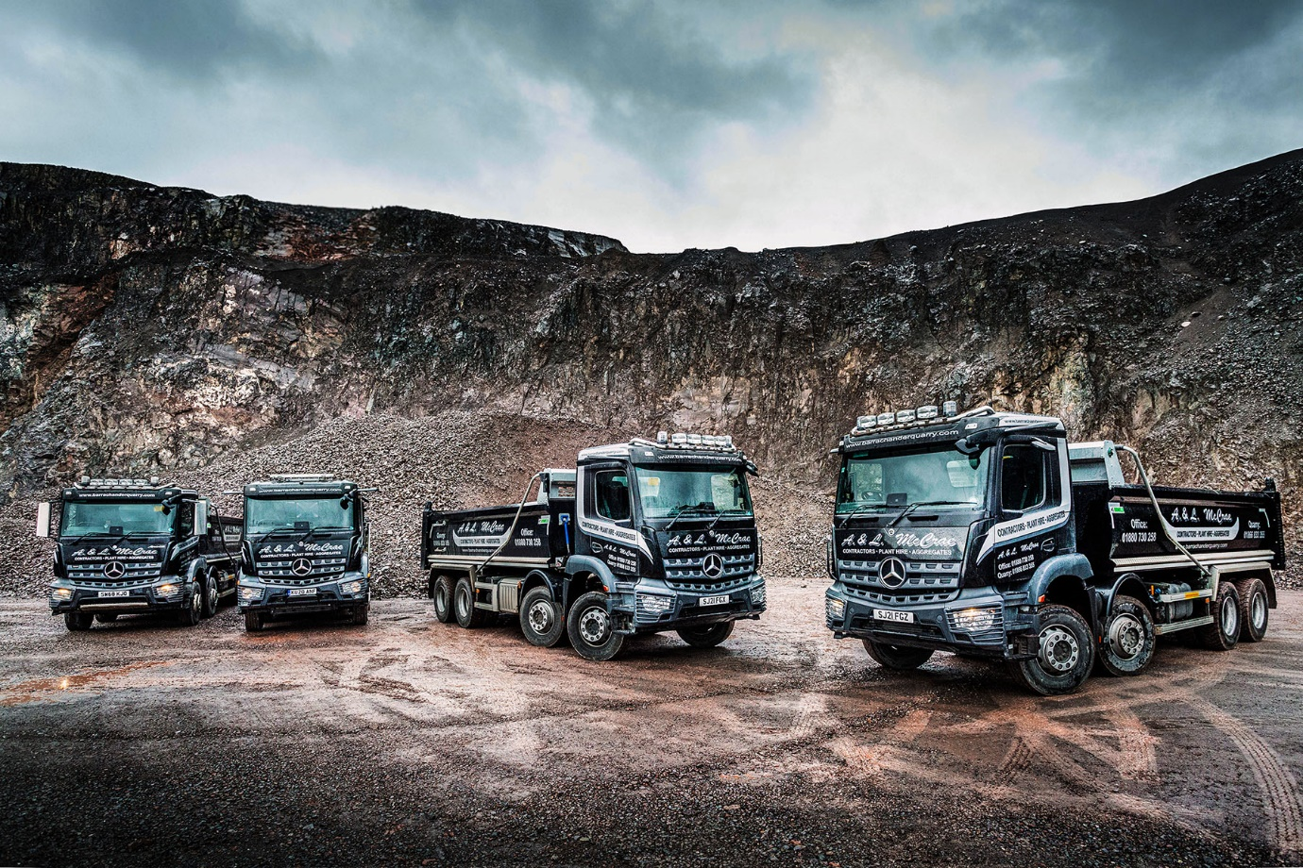

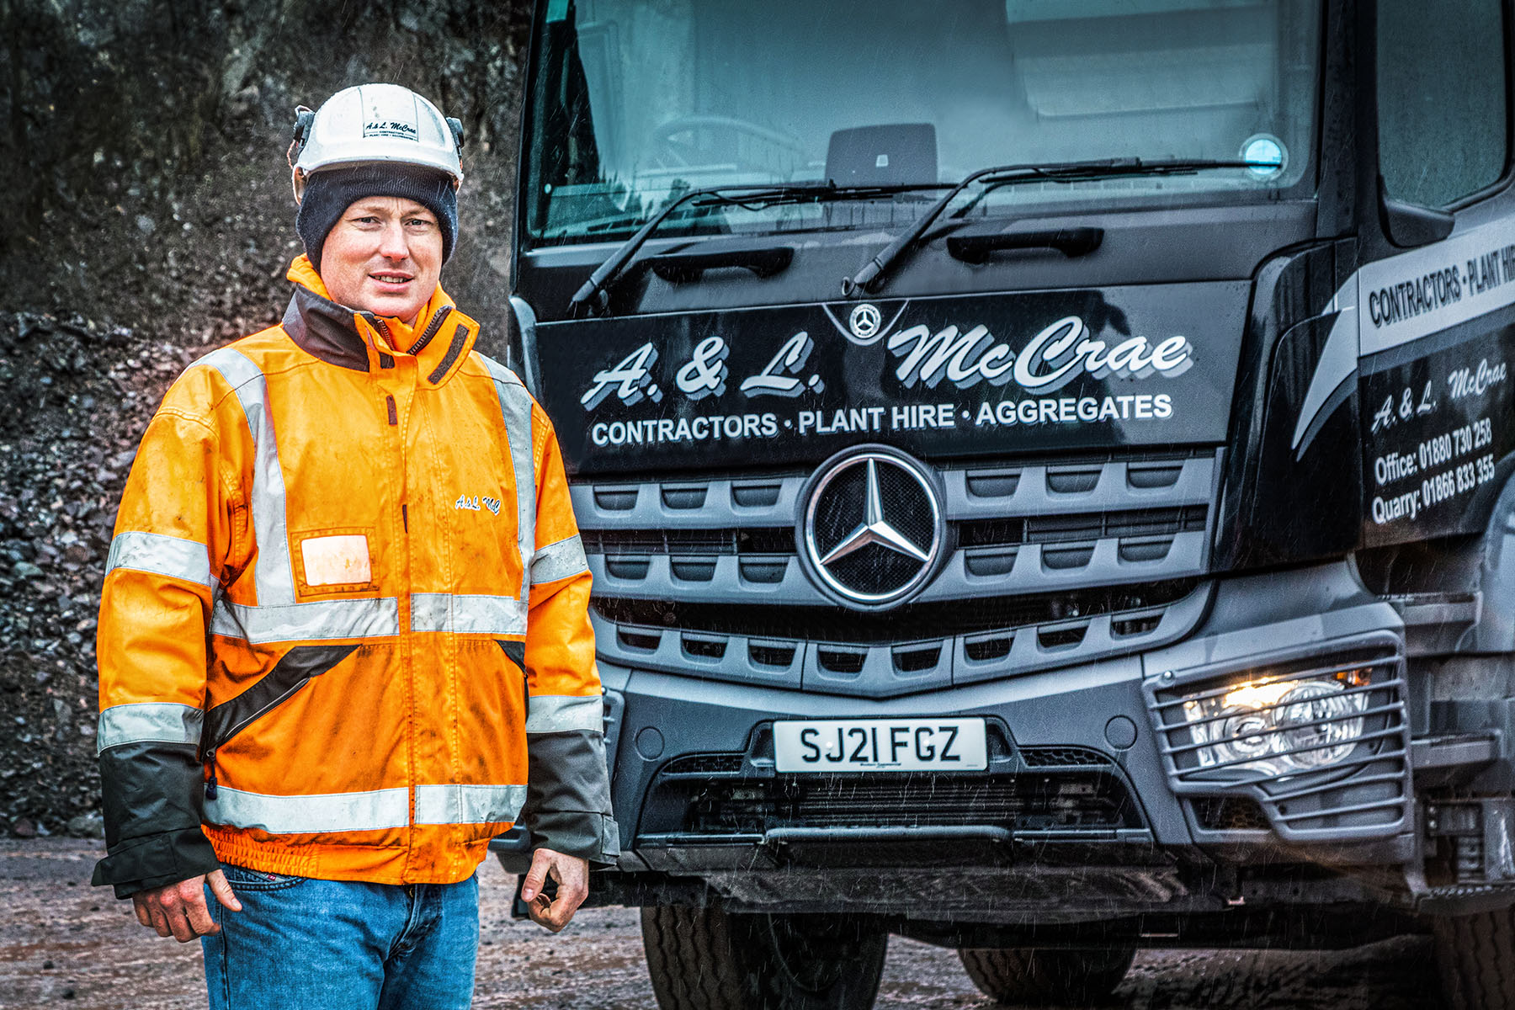

Fuel for thought: Calum McCrae said Barrachander Quarry’s new Mercedes-Benz Arocs were delivering a 20% saving in diesel costs compared to its previous, Swedish-built trucks

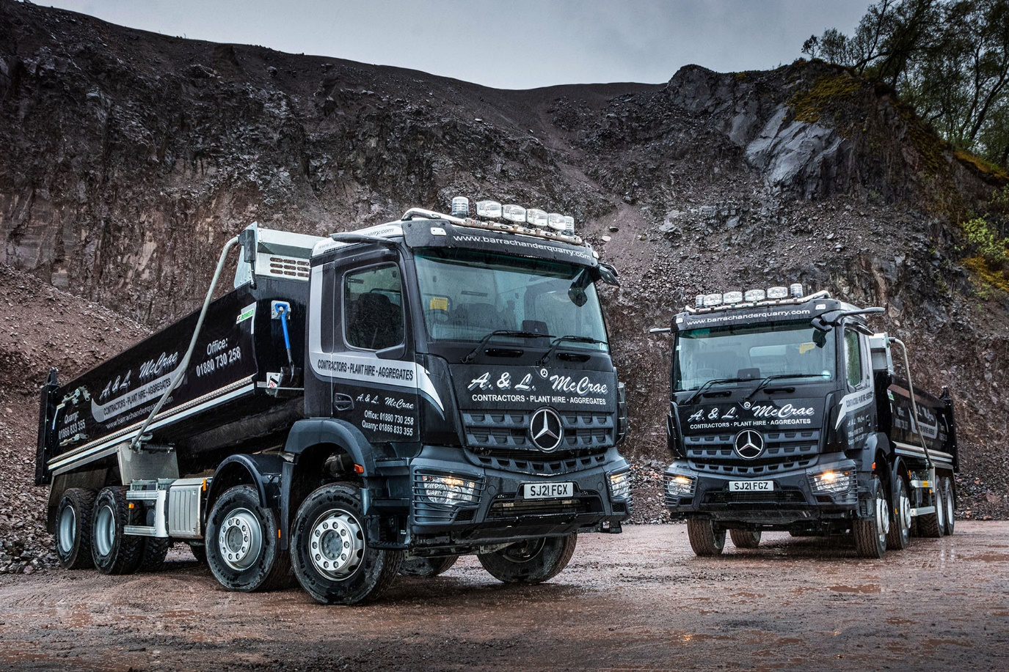

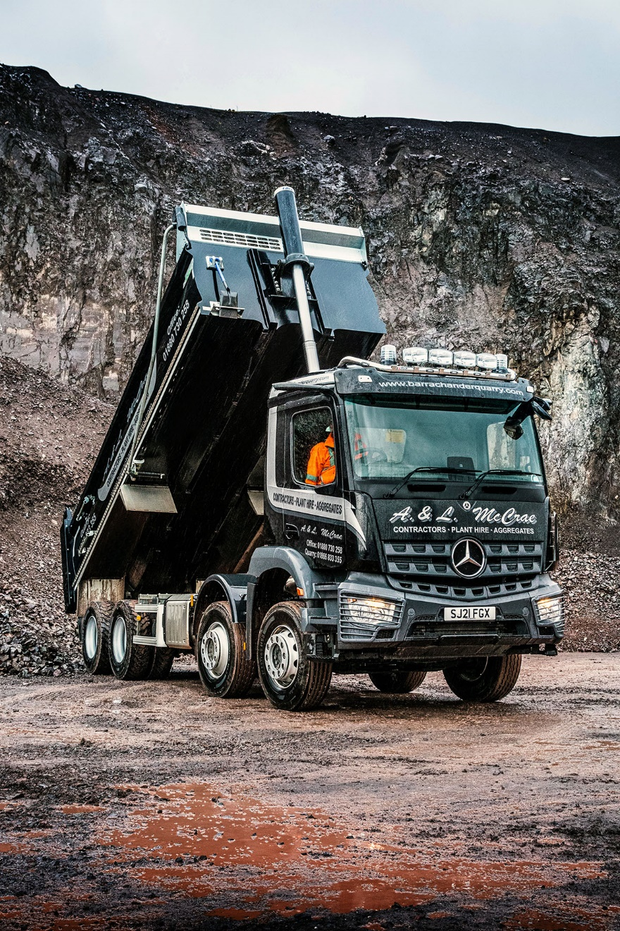

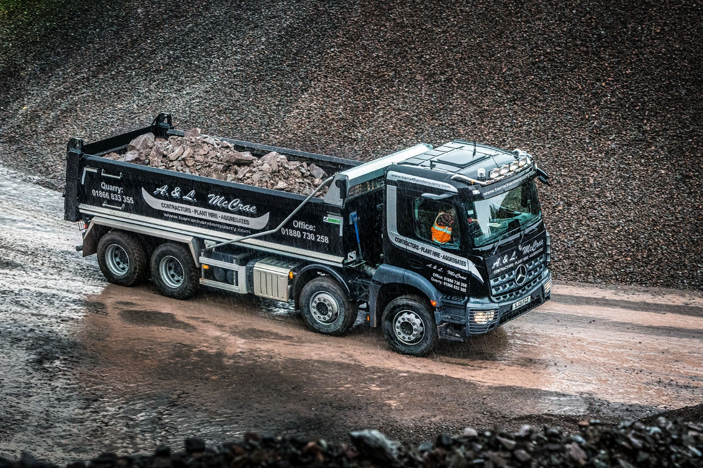

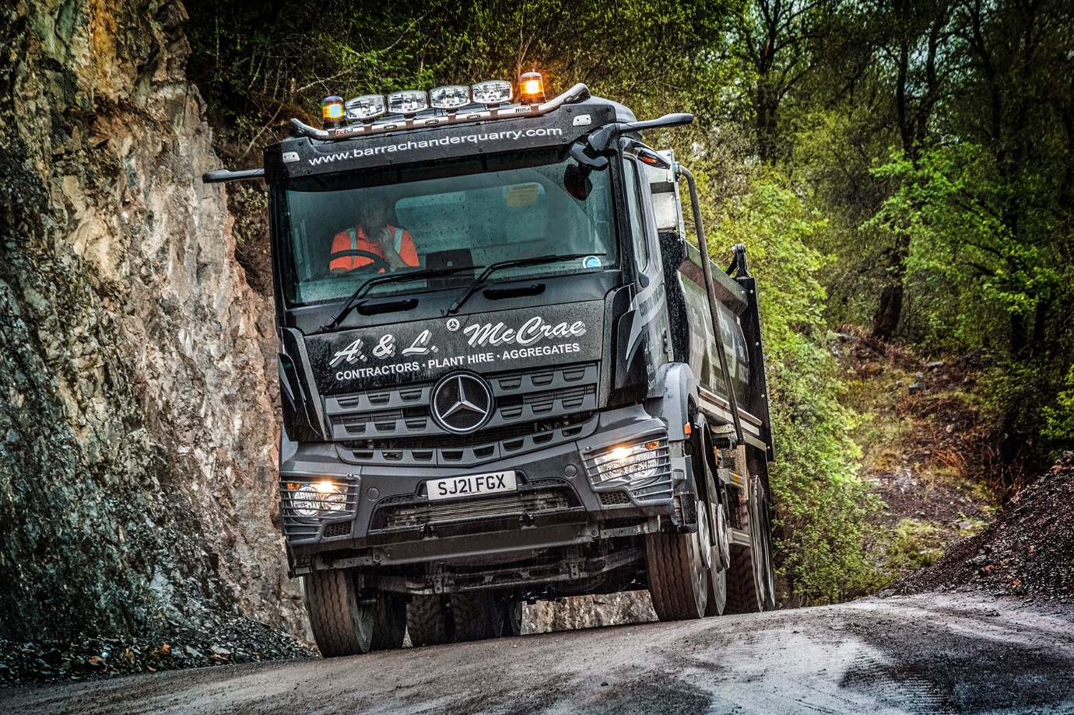

ends

For more information, or to request higher-res image files, please contact:
Jamie Fretwell at Mercedes-Benz Trucks UK Ltd
07712 519230, jamie.fretwell@daimler.com

About Mercedes-Benz Trucks UK Ltd
Mercedes-Benz Trucks UK Ltd is the sales and marketing organisation responsible for all Daimler truck products in the UK, including FUSO Canter.

In 2019, the company registered 6,963 new trucks. Mercedes-Benz accounted for 6,188 new trucks registered in 2019, making it the third-biggest truck brand in the UK. Meanwhile, FUSO registrations hit 775 – including 580 new trucks over 6.0-tonnes.

The flagship new Mercedes-Benz Actros which won the 2020 International Truck of the Year award, features seven core innovations including MirrorCam, Multimedia Cockpit and Active Brake Assist 5. Our premium range of innovative trucks – Actros, Arocs, Atego, Econic and Unimog – draw upon more than 125 years of exceptionally high standards of quality, backed up by our promise of Trucks You Can Trust.

www.mbtrucks.co.uk

