

Date: 25 January 2019

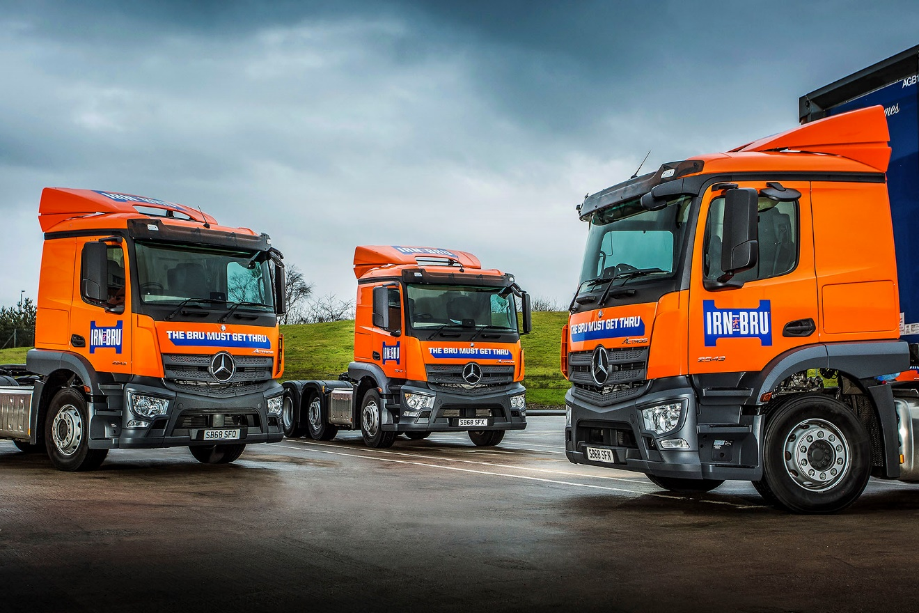

Nine new Mercedes-Benz Actros sparkle for AG Barr

World famous soft drinks leader AG Barr has made a major investment in “future-proofed” transport technology by commissioning nine new tractor units from Mercedes-Benz Dealer Western Commercial.

The Cumbernauld-based company’s latest order reflects its commitment to safety, and desire to minimise maintenance costs, while also ensuring it is well placed given the proposed introduction of low-emission zones in Edinburgh and Glasgow.

The new trucks are all Actros 2543 models with ClassicSpace cabs and 10.7-litre straight-six engines producing 315 kW (428 hp). Each is equipped with a Mercedes-Benz Safety Pack incorporating the ground-breaking Active Brake Assist 4 system, which features a ‘first’ in the shape of pedestrian recognition, as well as Proximity Control Assist and a driver’s airbag.

They wear the livery of AG Barr’s best-known brand IRN-BRU, the carbonated icon which is often described as “Scotland’s other national drink”.

AG Barr runs 47 trucks, 94% of which are by Mercedes-Benz. Rigid 26-tonners form the backbone of the fleet, the new Actros being its only tractors.

Transport Manager Gary Campbell confirmed: “We choose Mercedes-Benz trucks for their premium quality and reliability, and for the excellent back-up provided by the manufacturer’s strong, 24-hour UK Dealer network. The support we’ve received from the Western Commercial Sales team, and particularly from its Truck Sales Executive Paul Mundie, has also been second-to-none.”

He continued: “Our policy previously has been to acquire pre-owned vehicles. But we have chosen new trucks on this occasion to ensure that we benefit from their state-of-the-art safety specification. The hugely impressive Active Brake Assist technology in particular, will make a major contribution to the protection not only of our drivers, but also of other road users.

“To use a word around which AG Barr built a highly successful advertising campaign a few years ago, it’s a ‘phenomenal’ all-round package.”

Established more than 140 years ago, AG Barr is a FTSE 250 company and operates across the UK and internationally. Eight of the Actros work from its headquarters and main production and distribution centre in Cumbernauld, the other from the facility in Forfar which is home to another of its high-profile brands, Strathmore spring water.

The Forfar-based vehicle is double-shifted and transports product to Cumbernauld, while another trunks to the company’s biggest regional distribution centre in Milton Keynes. The remaining seven vehicles are assigned to secondary distribution duties, and deliver product to leading supermarket RDCs, wholesalers and independents, the majority of which are located across Scotland’s Central Belt.

Mr Campbell added: “With low-emission zones on the horizon for Scotland we were keen to future proof the business by moving to Euro VI engines, and to de-risk our maintenance cost exposure by purchasing new, rather than pre-owned vehicles.”.

The Actros are also equipped with the optional Predictive Powertrain Control system, which employs digital 3D mapping and GPS data to scan the topography of the road ahead, then manages gear changes and ensures that full use is made of the truck’s Eco Roll function. As well as increasing fuel-efficiency and reducing emissions, PPC complements safety by promoting a relaxed driving style.

www.agbarr.co.uk

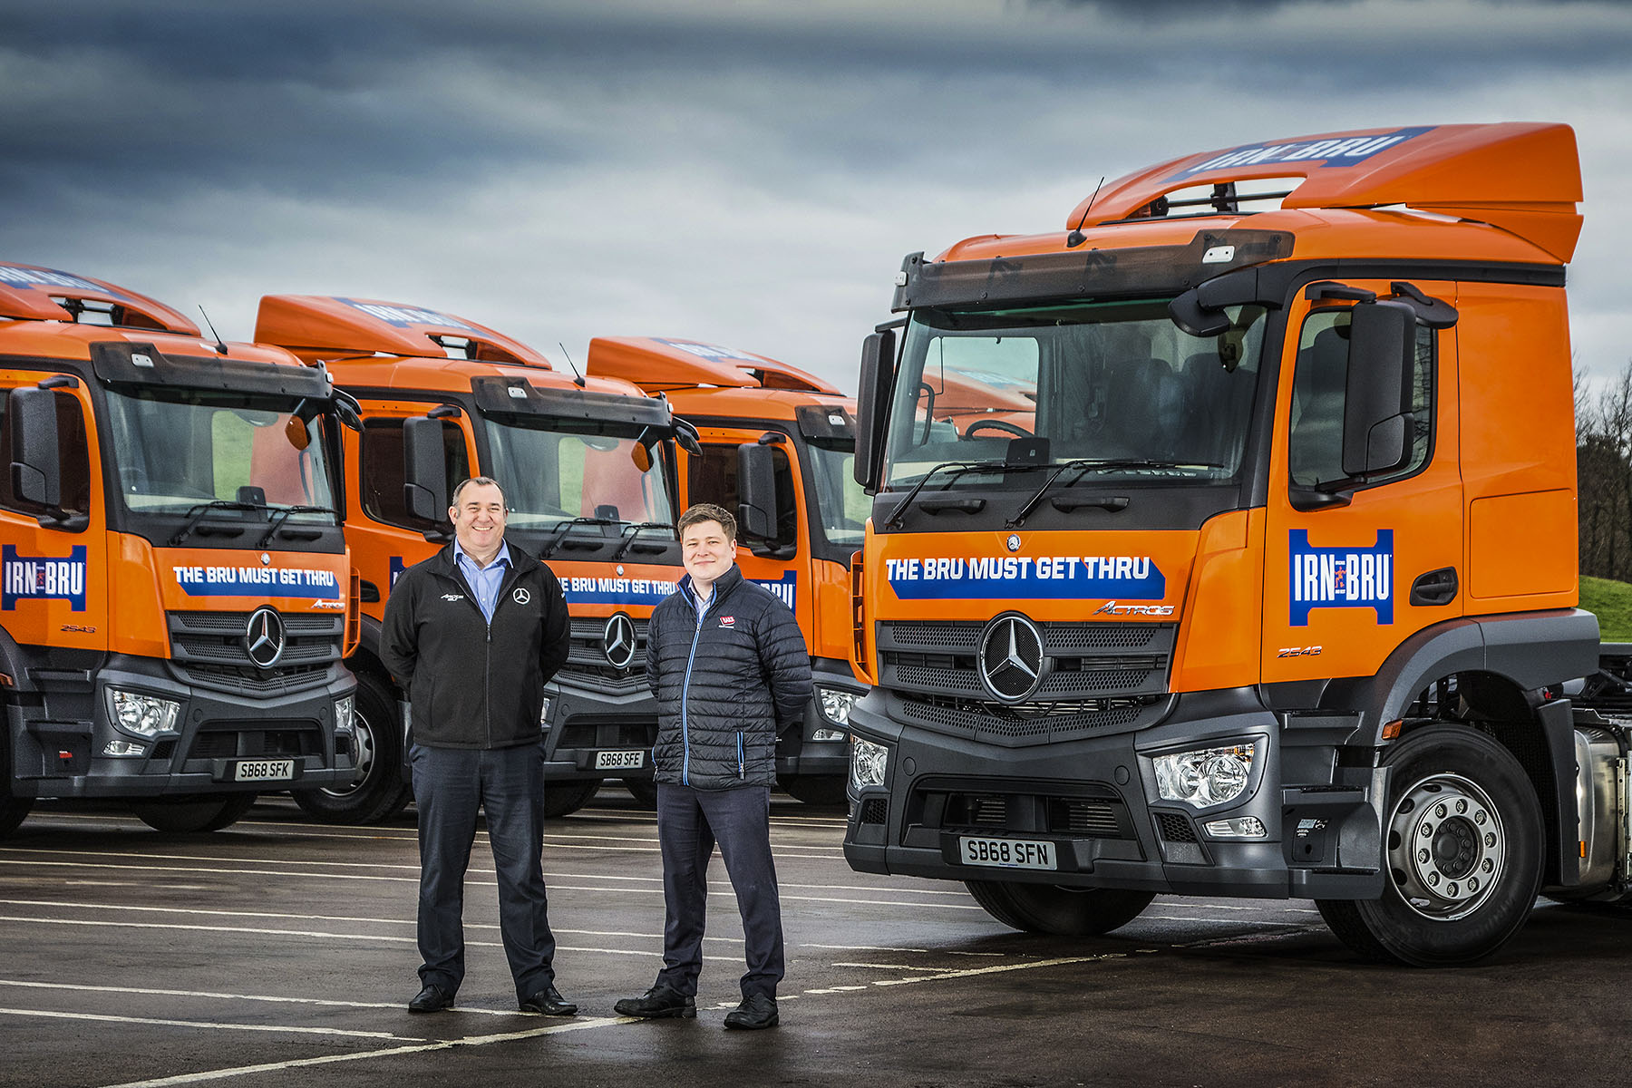

The BRU must get through: And it will do, thanks to AG Barr Transport Manager Gary Campbell, right, and Western Commercial Truck Sales Executive Paul Mundie

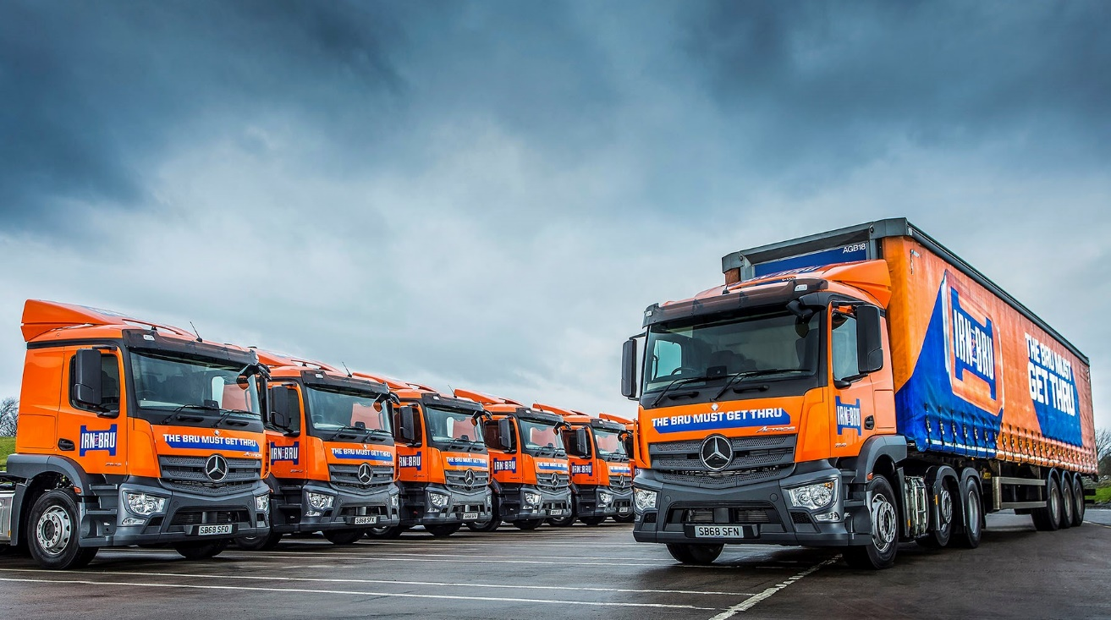
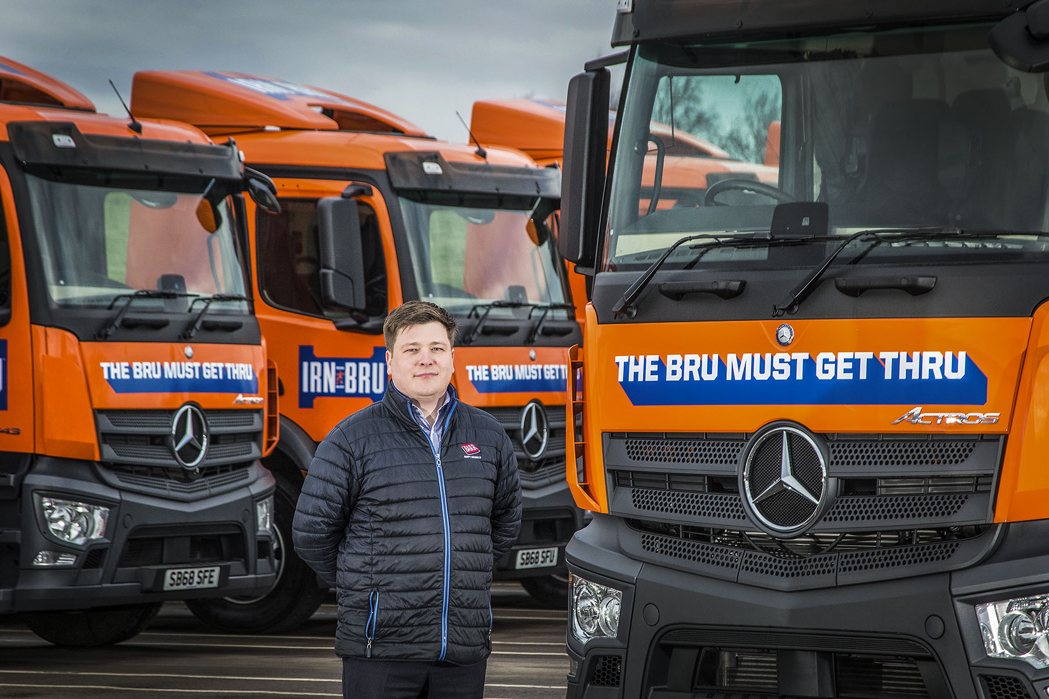

Looking to the future: That’s Transport Manager Gary Campbell, with AG Barr’s new Mercedes-Benz Actros

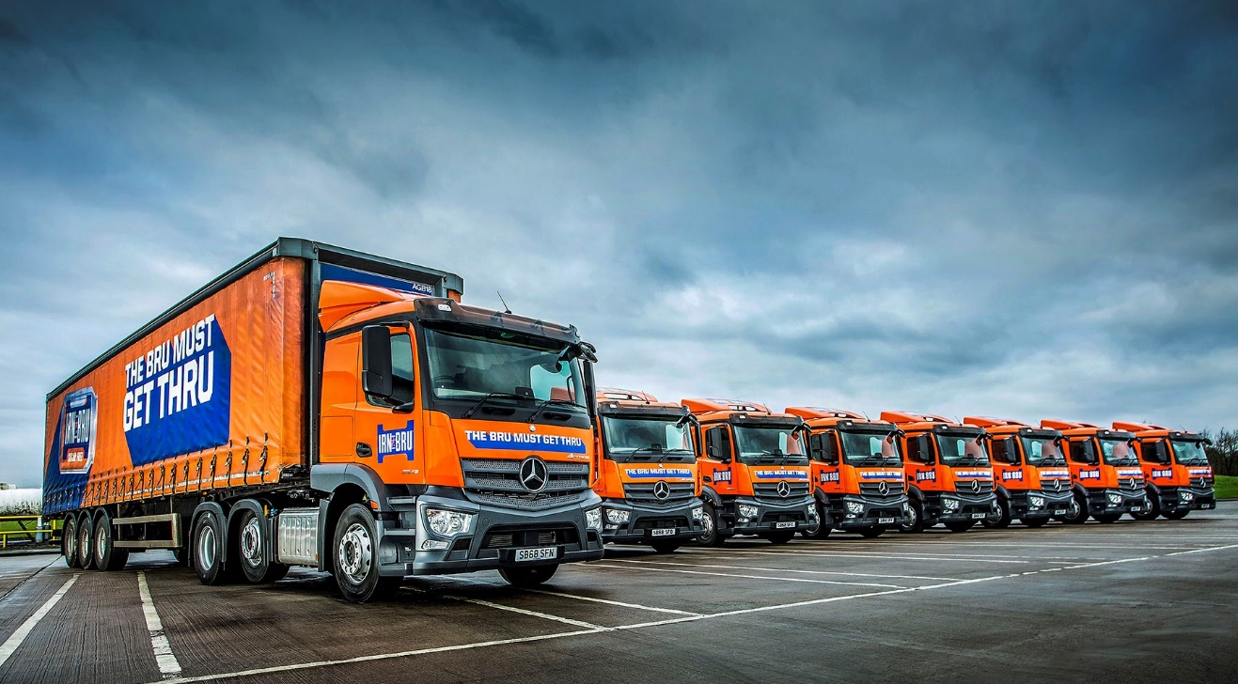

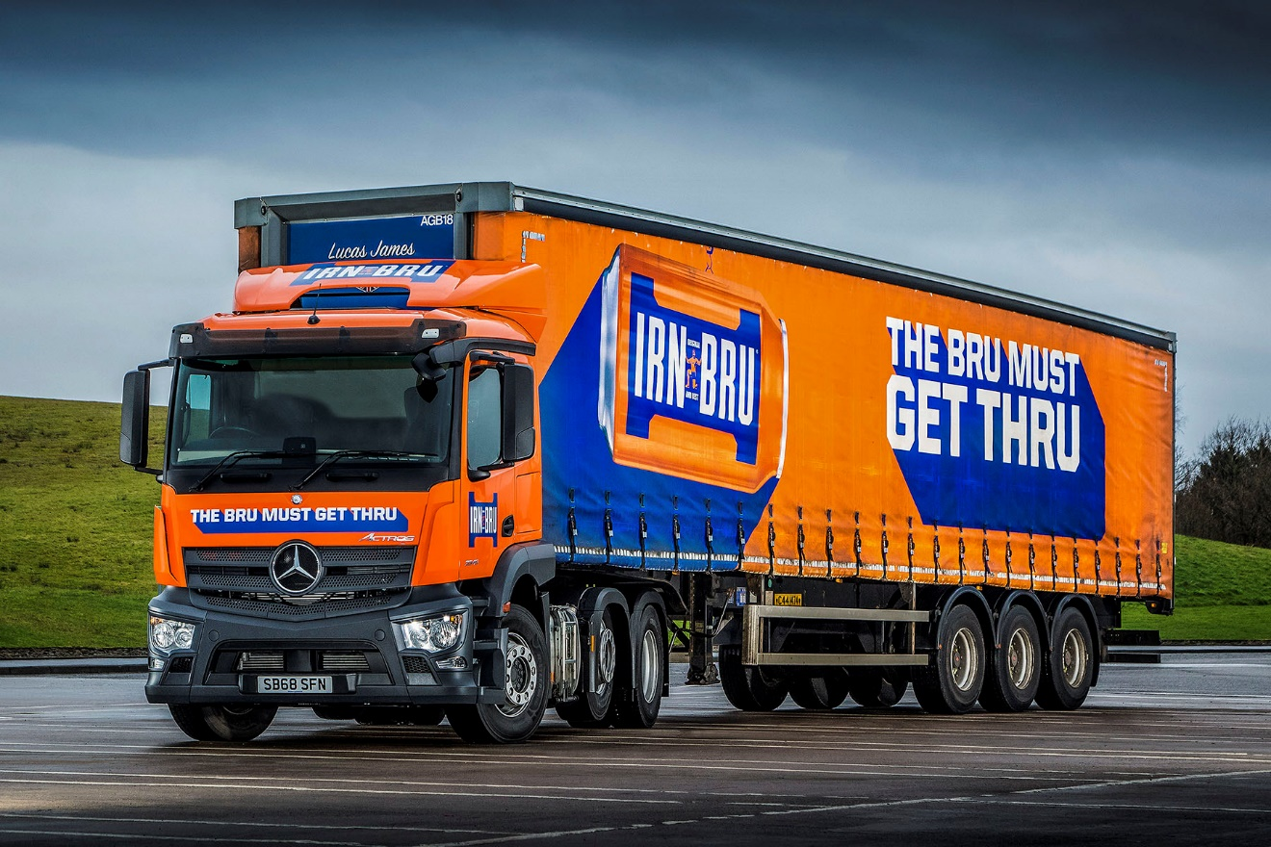

ends

For more information, or to request bigger/higher-res image files, please contact:
Steve Warren or John Ripley
Impact Communications, 01926 842126
John: 07771 484595, john@impactcom.co.uk
Steve: 07770 470251, steve@impactcom.co.uk

