

Date: 26 April 2021

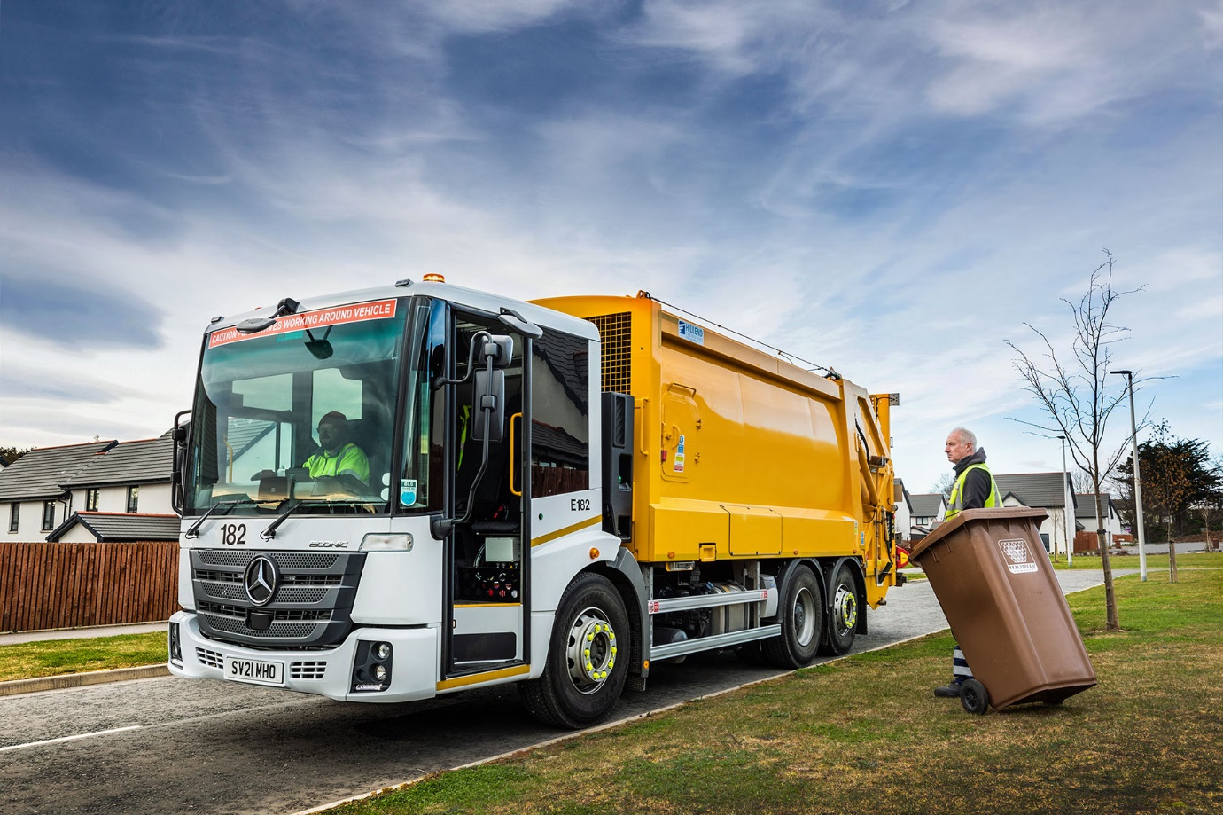

Evolved Econic sets a new safety standard for
Mercedes-Benz Trucks customer Moray Council

Moray Council played it safe in more ways than one when ordering its latest four refuse collection vehicles from Aberdeen-based Mercedes-Benz Dealer BLS Truck & Van.

Not only do the low-entry Econics incorporate the latest accident prevention technology, but they also represent a secure investment thanks to the proven reliability and low running costs from which the north-east Scotland authority has benefited for more than a decade.

All but three of Moray Council’s 29 refuse collection trucks wear Mercedes-Benz three-pointed stars. Vehicle Services & Compliance Manager John Pearson said: “We know from experience that the Econic is highly dependable over a 10-year working life, during which it provides excellent value for money thanks to low running costs and minimal downtime.

“It also helps that our in-house technicians are very experienced when it comes to maintaining the fleet, and can call upon BLS Truck & Van for expert technical support on the rare occasions they need to do so.”

He continued: “The Econic is very popular with our operatives too. Drivers particularly appreciate its excellent all-round vision, while the vehicle also scores highly with crews for its air-conditioned comfort, ease of access, and all-round quality.”

The Mercedes-Benz Econic has long been the market leader in terms of safety, but the latest model has raised the bar still further. Standard features now include Active Brake Assist 5, the cutting-edge emergency braking system which adds a camera to the radar employed by previous versions to spot potential hazards.

Active Brake Assist 5 can detect vehicles ahead and stationary objects in its own lane, at speeds of up to 56 mph (90 km/h). Detection of a dangerous situation triggers a three-stage reaction: first, the system warns the driver with visual and audible alerts; then, if the driver fails to react, it applies partial (approximately 50%) braking; finally, if the driver has still not intervened, it initiates maximum braking to bring the truck to a halt, activating the hazard warning lights to alert drivers behind.

The new sensor fusion has dramatically improved response to moving pedestrians at speeds of up to 31 mph (50 km/h). Active Brake Assist 5 is now capable of applying full braking when encountering pedestrians crossing its path, approaching from the front or walking ahead. Not only does this remarkable technology increase safety for vulnerable road users and vehicle crews, but it also helps to relieve stress for drivers.

The electronic architecture required for operation of Active Brake Assist 5 means Moray Council’s Econics also benefit from Electronic Parking Brakes, which are applied automatically when the engine is switched off. Also, when the truck is at a standstill, after emergency braking for example, the automatic HOLD function prevents unintended rolling away.

The optional Rearguard Assist system specified by Moray Council supports the driver when reversing at manoeuvring speed, by displaying on the instrument cluster the distance from objects being approached. Like Active Brake Assist 5, it provides visual and audible warnings, and can brake the vehicle to a controlled stop when the distance to an object becomes critical.

“We’re extremely conscious of our Duty of Care not only to our own staff, but also to other road used and local residents,” said Mr Pearson. “With its low floor and deep, panoramic windscreen, the Econic has always made a major contribution to safety by affording drivers an excellent field of vision, and allowing them to make contact with vulnerable road users, particularly cyclists and pedestrians.

“The latest enhancements to the truck’s standard specification and additions to the options list build on these excellent safety foundations.”

Moray Council’s new Econic 2630 Ls have rear-steer axles that enhance manoeuvrability by significantly reducing turning circles. Their 7.7-litre in-line six-cylinder engines produce 220 kW (299 hp) and are paired with six-speed automatic Allison gearboxes, purpose-designed for stop-start applications.

Fitted with Farid Hillend Engineering Powerlink bodies and Terberg Matec bin lifts, three are working on general domestic waste collections from more than 45,000 households across Moray. The fourth has a split TwinTrak body and is dedicated to mixed recyclables.

BLS Truck & Van’s Truck Sales Executive Craig Graham liaised closely with the bodybuilders and bin lift supplier to help refine the vehicle specifications and ensure smooth deliveries .

The Moray Council fleet also includes 4x4 and 6x6 Mercedes-Benz Arocs and Actros gritters and tippers supplied by BLS Truck & Van. “Once again the Dealer’s team have been very helpful,” added Mr Pearson. “They’re always willing to assist and invariably do so in a professional, yet at the same time friendly and approachable, manner.”

www.moray.gov.uk

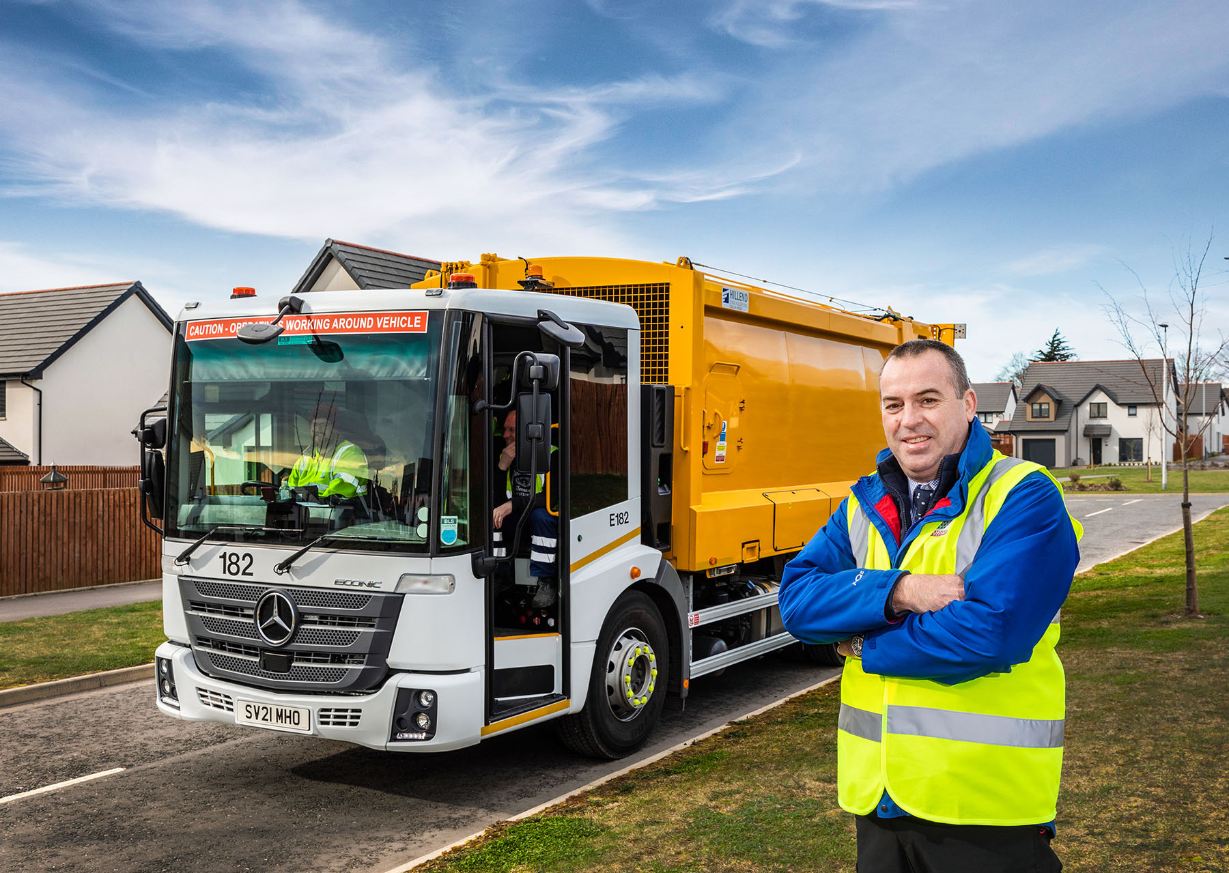

Safe as houses: The Mercedes-Benz Econic is a well-proven winner for Moray Council’s John Pearson

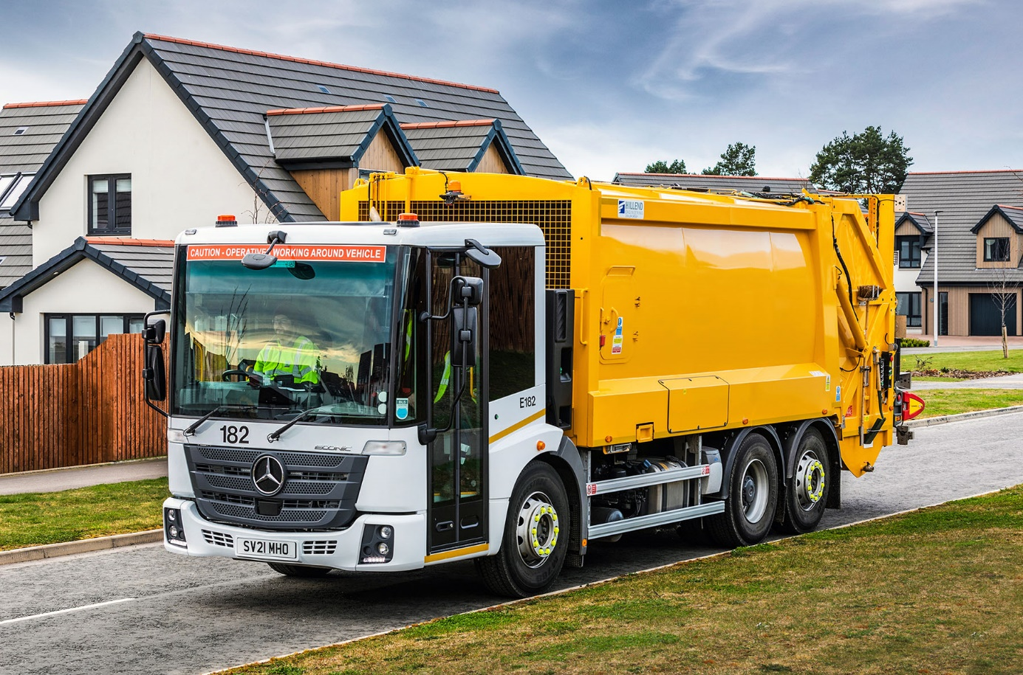

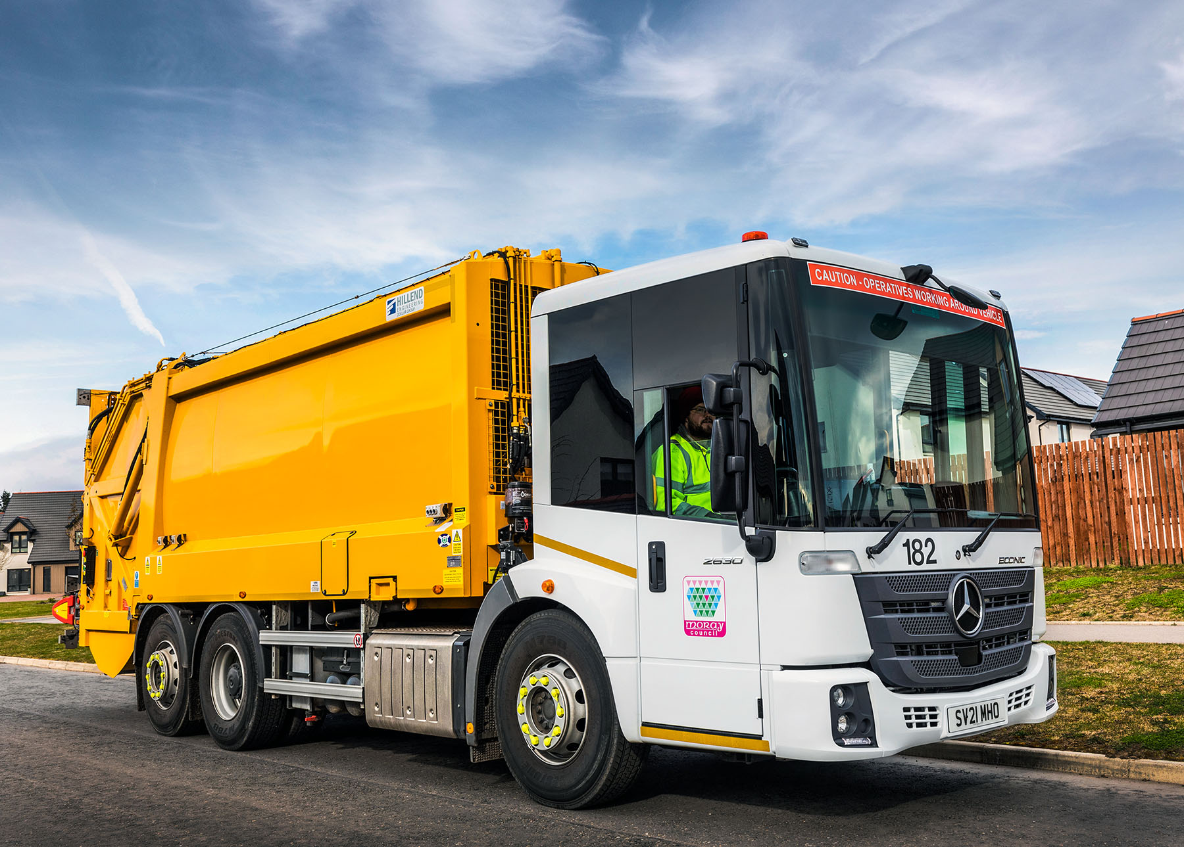

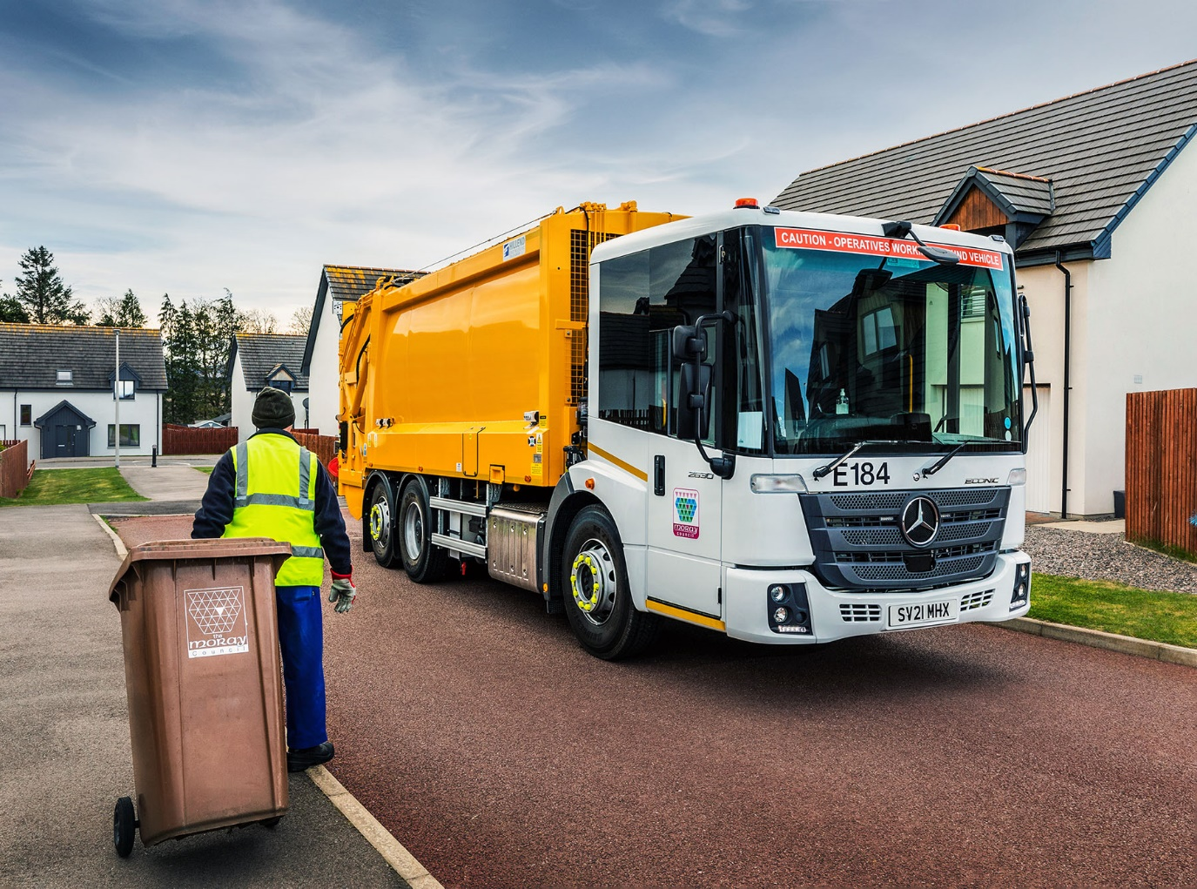

ends

For more information, or to request bigger versions of image files, please contact:
John Ripley or Steve Warren
Impact Communications, 01926 842126
John: 07771 484595, john@impactcom.co.uk
Steve: 07770 470251, steve@impactcom.co.uk



