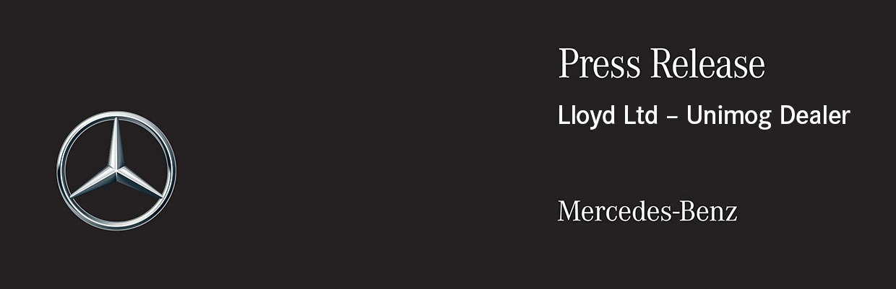

Date: 3 November 2020

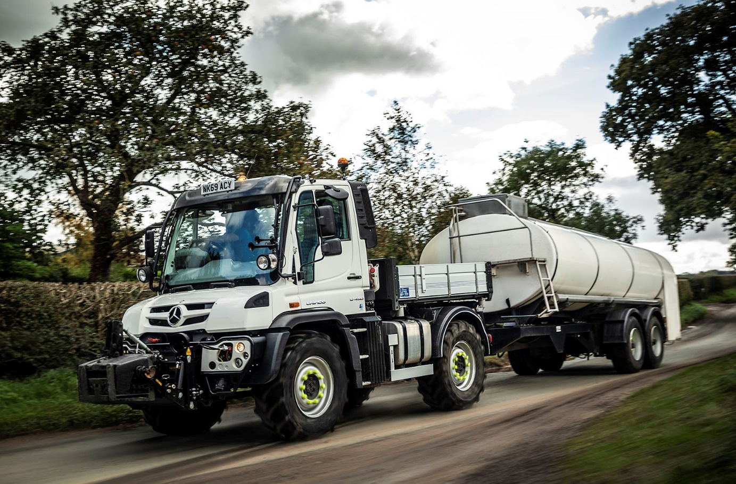

Milking the Mercedes-Benz advantage: Quick, comfortable and highly cost-effective, the Unimog leaves its agricultural competitors standing when it comes to on-road performance

Mercedes-Benz Unimog delivers tasty time and cost savings for award-winning cheesemaker

Hayfields Dairy’s new Mercedes-Benz Unimog is significantly faster on road and a lot more economical than the ‘high-speed’ agricultural tractor it used previously to collect milk from suppliers – yet the 4x4 implement carrier is also every bit as capable as its predecessor when venturing onto rough ground.

Proprietor Rob Huntbach revealed: “The Unimog has cut journey times by as much as three hours, and is also saving us more than 75 litres of fuel on some working days. In financial terms, it’s a ‘no brainer’!”

The U430 was supplied by Dealer Lloyd Ltd. It is powered by a 7.7-litre six-cylinder engine which produces 220 kW (299 hp) and is paired with a fully synchronised electro pneumatic transmission that allows drivers to switch between manual gear shifting and automatic mode at the press of a button, even while on the move.

Hayfields Dairy’s 12.7-tonne GVW Unimog is a Short model – a Long variant of the U430 is also available. It has a factory-fitted tipping body, while the front-mounted linkage and DIN plate, and an engine PTO (power take-off), allow it to operate with a variety of attachments.

The Huntbach family has been farming in Audlem, Cheshire, since 1949. For most of that time Hayfields was home to a dairy herd, although the first cheese was produced here as long ago as 1957. Since 2018, when the last dairy cow left, the business has been fully focused on its passion for making and selling award-winning cheeses and butter, which are hugely popular with customers of pubs, restaurants and shops throughout the area. Launched in June, its online outlet has also made an important contribution to revenues in the face of the Covid-19 pandemic.

Hayfields Dairy collects the high-quality milk it uses as a raw material from selected farms located throughout Cheshire, Shropshire and Staffordshire. This task is now undertaken by the Unimog, which can cover anything up to 250 miles in a day – its hydraulic system is also used to drive the pumps on the 16,000-litre milk tank trailer it tows.

Managing Director Rob Huntbach, a grandson of the founders, explained: “If this was its only role we’d run a conventional truck, but I need a multi-talented vehicle that can also be used to undertake a wide variety of other tasks on the farm.”

He recalled: “We tried Lloyd Ltd’s demonstrator before we committed to buy the Unimog, and if I’m honest I wasn’t sure it was going to be up to the job. I couldn’t have been more wrong.

“Our new Mercedes-Benz is incredibly versatile. When it comes to road work the Unimog has a 56 mph cruising speed which makes it significantly quicker than the tractor we’d been using to pull the tanker. It’s also more nimble, more comfortable, and much more fuel-efficient.”

Mr Huntbach continued: “We have about 250 acres at Hayfields. I rent all my ground out now, but there are still plenty of jobs to do around the farm, and here, too, the Unimog excels. We’ve also used it with hedge cutting attachments, and for pulling a silage trailer over the fields – we couldn’t do any of that with a standard truck. It really does offer the best of both worlds.”
Hayfields Dairy’s Unimog also benefits from the optional VarioPilot system. This allows the driver to swap between left- and right-hand drive, moving the steering wheel, instrument panel and pedals from one side to the other in less than a minute. It is ideal for tasks such as mowing and hedge-cutting, which are more easily and safely completed from the verge-side of the vehicle.

Lloyd Ltd’s Unimog Sales Specialist Simon Holmes arranged a two-year extension to the Unimog’s standard three-year warranty. The vehicle will be maintained at the customer’s base by the one of the Dealer’s dedicated mobile technicians. “I’m chuffed to bits with the Unimog, while the service has been first class throughout,” confirmed Mr Huntbach.

The Mercedes-Benz Unimog is an off-road icon, with a heritage that stretches back more than 70 years and a reputation forged in the harshest operating conditions. There are two core variants: an implement carrier, like the Hayfields Dairy vehicle, with front, side and rear attachment points, and a base truck for a range of other bodies. All Unimogs have 4x4 chassis with single rear wheels, which follow the track created by the front wheels. Gross weights vary from 7.5 to 16 tonnes and engine outputs from 156 hp to 300 hp.

- Lloyd Ltd Unimog Sales Specialist Simon Holmes can be contacted on
07814 860985, simon.holmes@lloyd.ltd.uk

www.hayfieldsdairy.co.uk

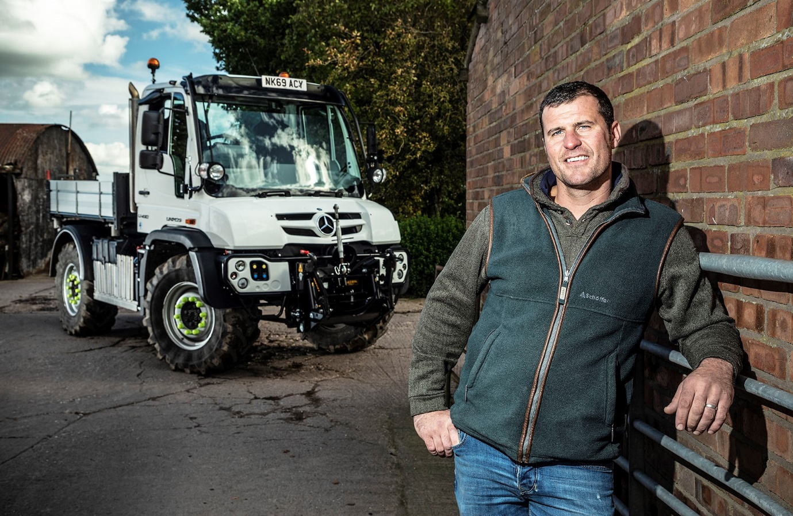

Best of both worlds: Rob Huntbach, of Hayfields Dairy, is delighted with his “incredibly versatile” Mercedes-Benz Unimog

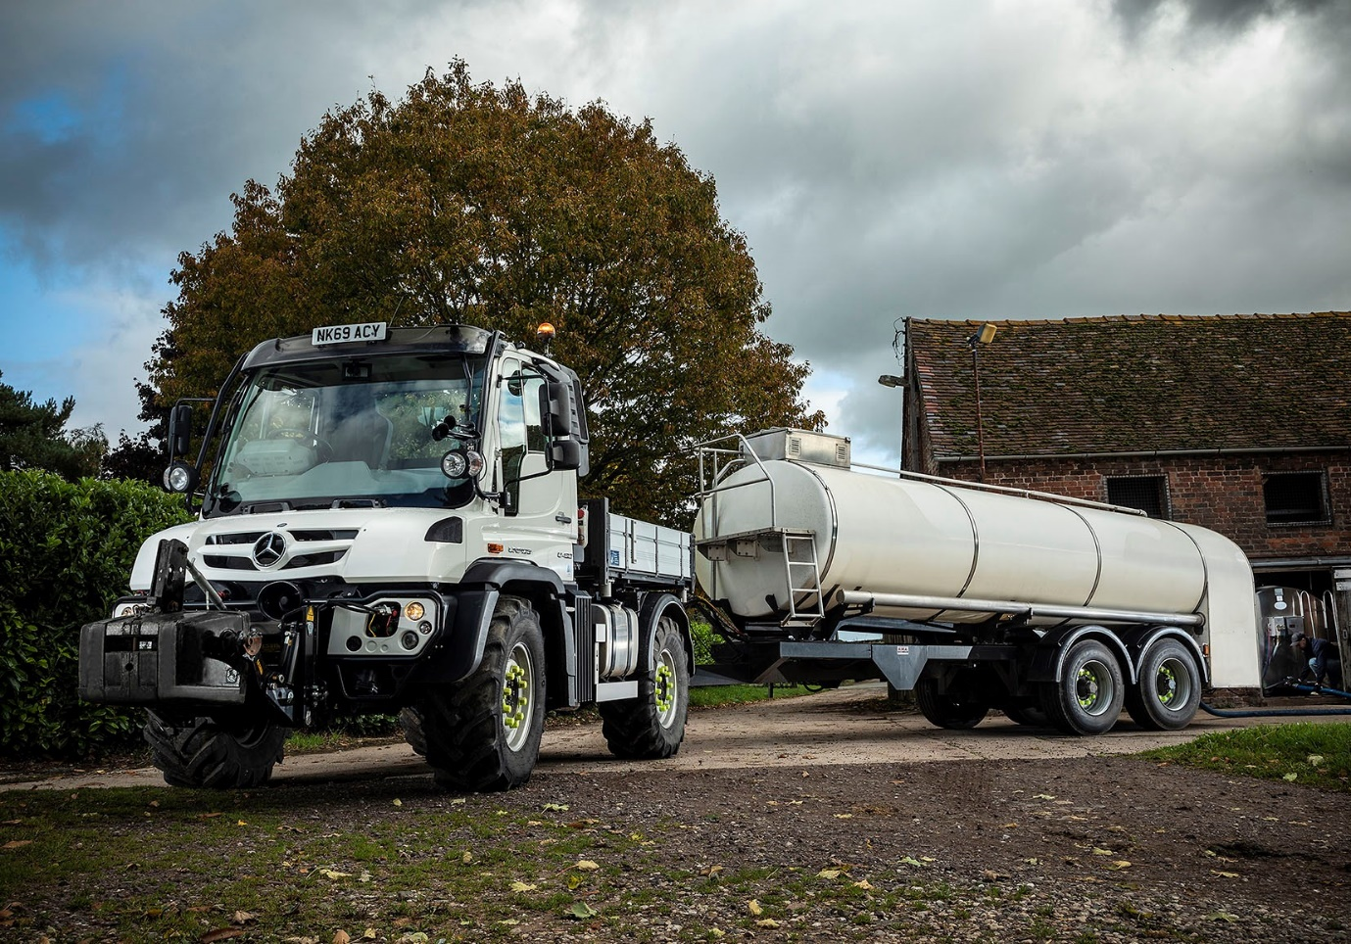

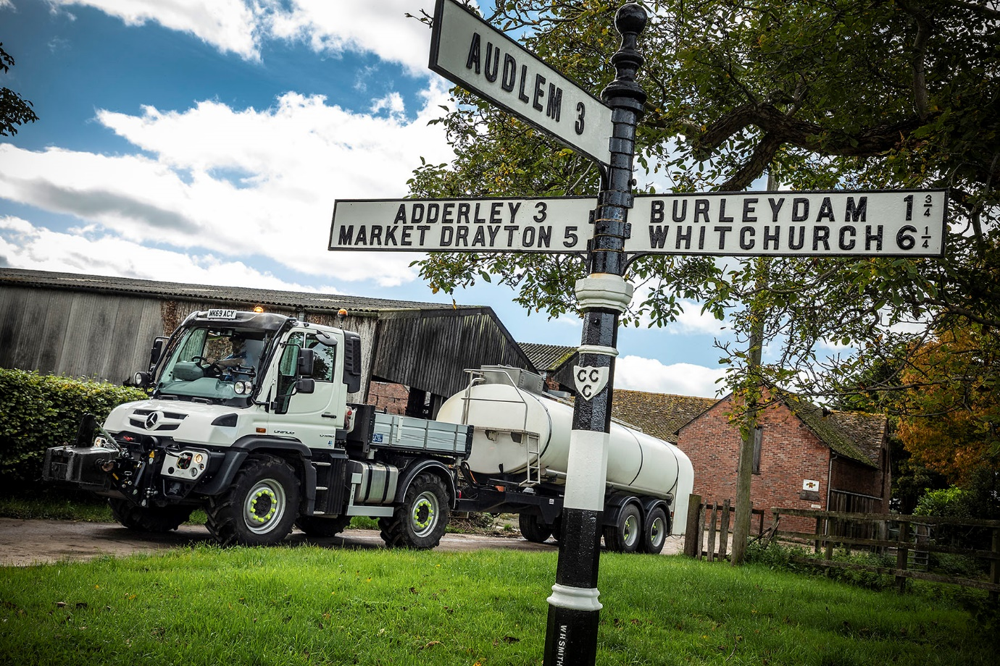

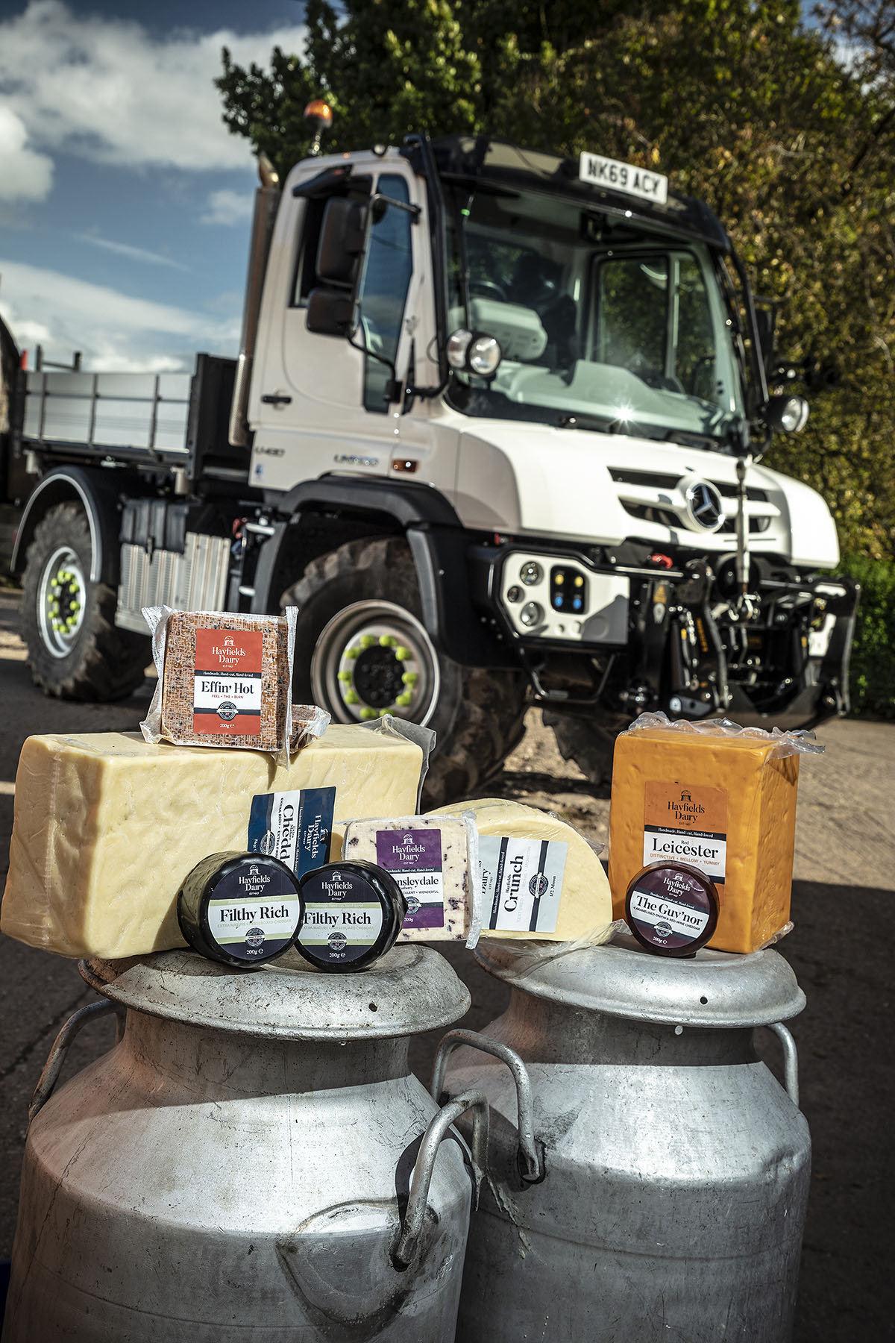

Hand-made, hand-cut: The Hayfields Dairy team are passionate about their award-winning cheeses
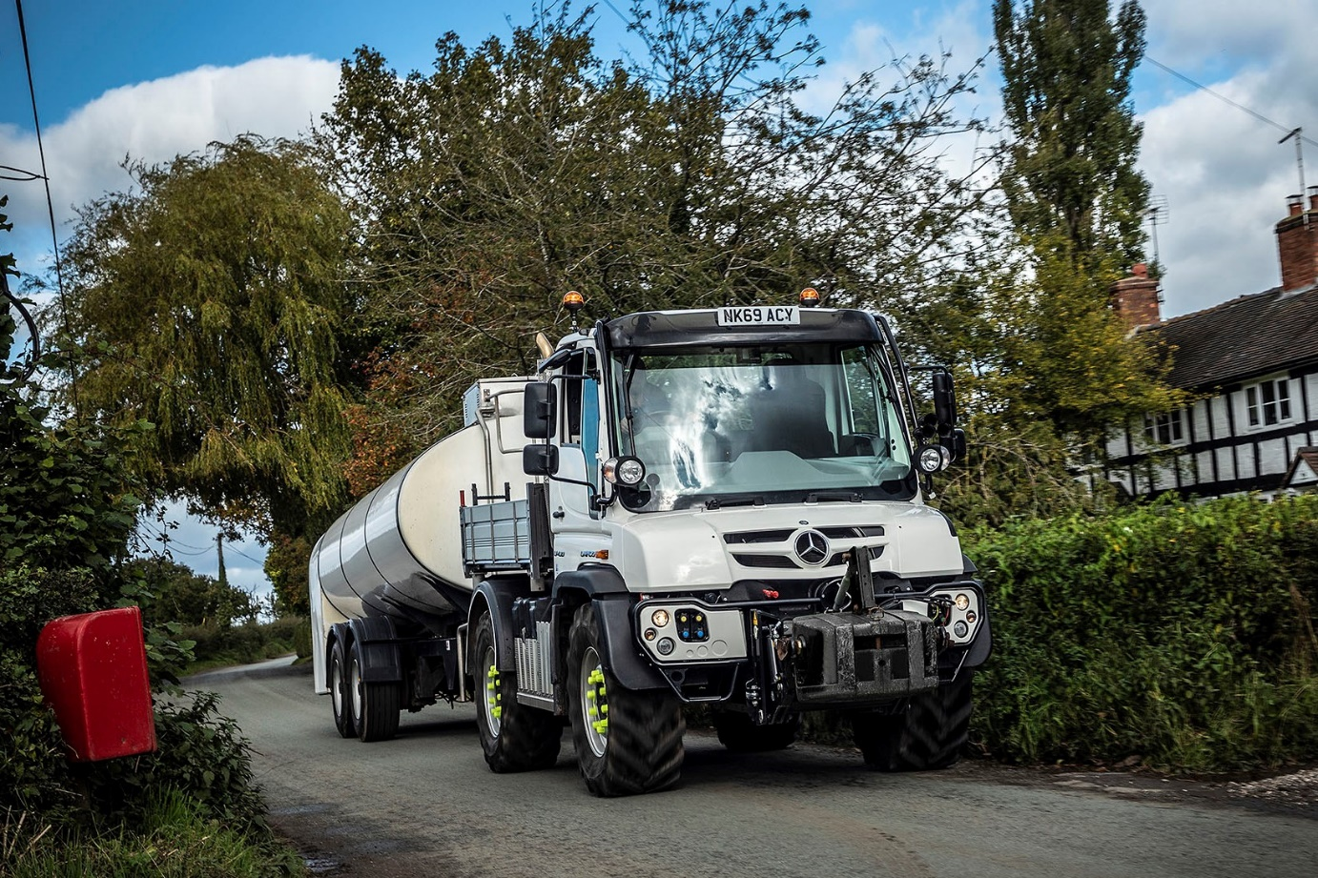

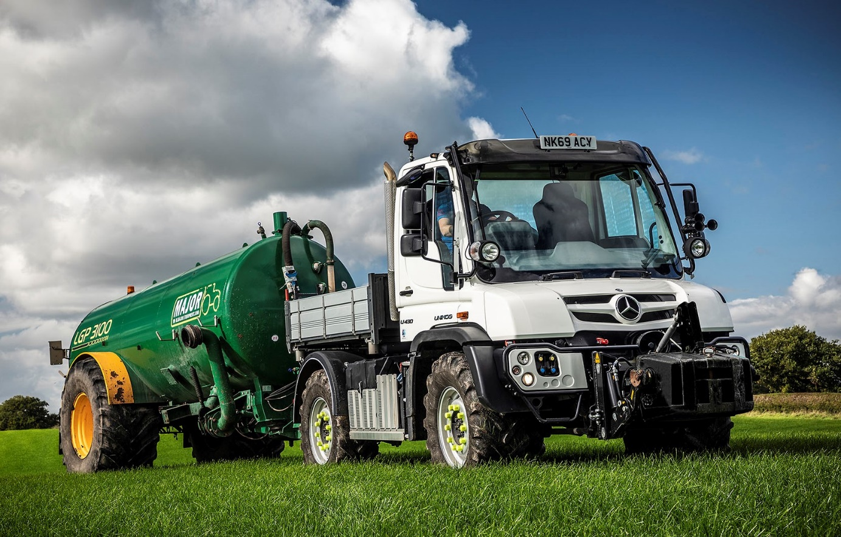

Farm worker: The Unimog also excels when undertaking off-road tasks, such as pulling a slurry trailer over fields

ends

For more information, or to request bigger/higher-res image files, please contact:
Steve Warren or John Ripley
Impact Communications, 01926 842126
Steve: 07770 470251, steve@impactcom.co.uk
John: 07771 484595, john@impactcom.co.uk



