

Date: 7 December 2021

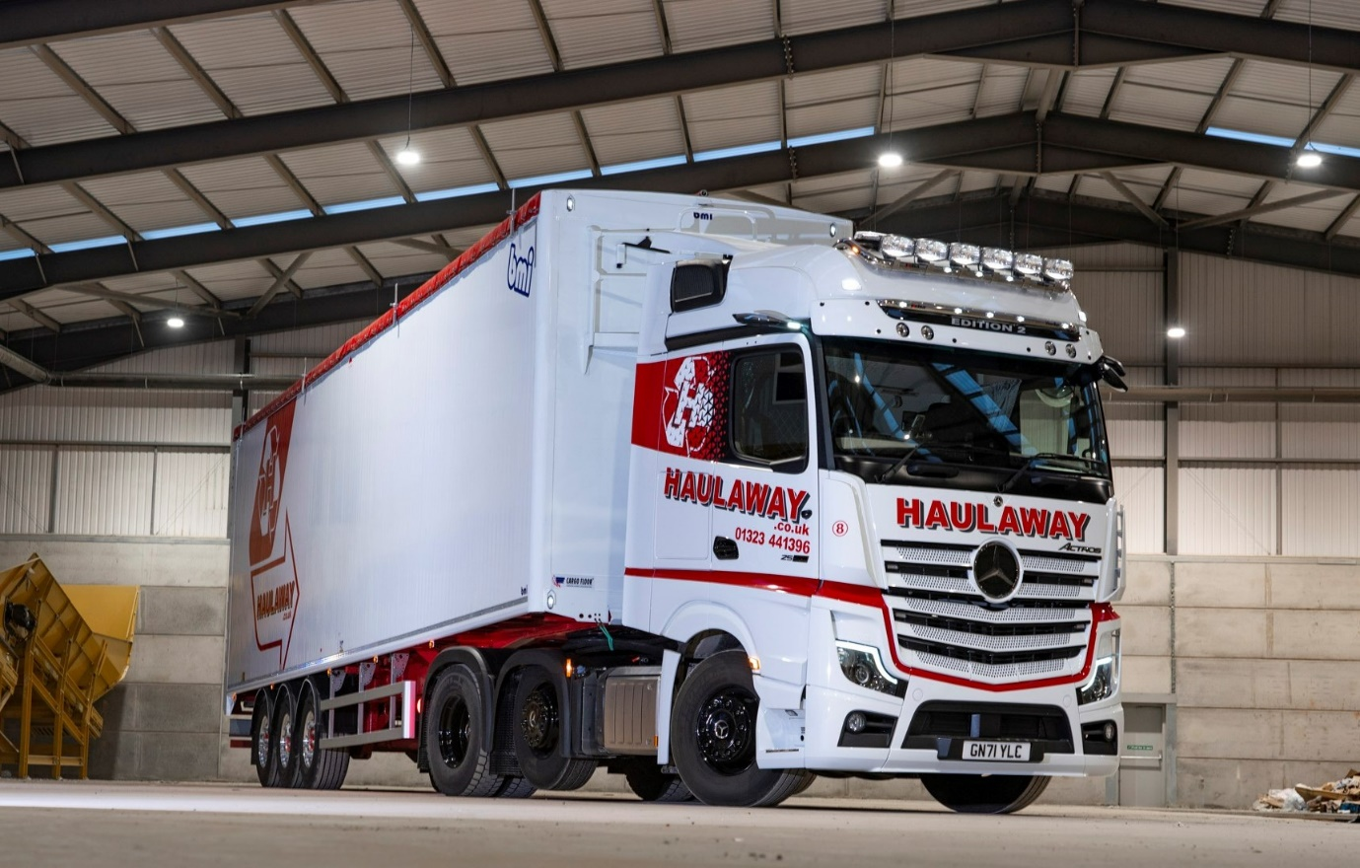

Haulaway saves the best till last, as Mercedes-Benz Actros Edition 2 flagship caps a year to remember

Long-standing Mercedes-Benz operator Haulaway has brought down the curtain on its 30th anniversary celebrations by commissioning a stunning Actros Edition 2 tractor unit.

The East Sussex-based operator provides a comprehensive portfolio of waste management services to trade and domestic customers. Its fleet of 22 skip-loaders, tippers, tipper-grabs and tractors is dominated by the three-pointed star.

The latest addition to that line-up arrived via Dealer Sparshatt Truck & Van. The Edition 2 is a dazzling showcase for the fifth-generation Actros. Just 400 have been built for customers worldwide, and of these only a small handful have reached the UK.

Haulaway’s new flagship has a flat-floored BigSpace cab and, as a 2563 variant, is powered by a range-topping 460 kW (625 hp), 15.6-litre in-line six-cylinder engine. It is
strikingly finished in Arctic White paint with colour-coded bumpers and red decals, while the black gloss wheels have silver Mercedes-Benz stars on their hubs.

External features that mark this out as a truck like no other include a sun visor incorporating four LED headlights, above which is a deep black panel with EDITION 2 lettering, an illuminated three-pointed star in dark chrome with a black closed cover, and self-cleaning Bi-xenon headlamps. Three more LED headlights behind the cab, a chassis frame cover and LED tail lights confirm that the vehicle is more than just ‘a pretty face’.

Accessed via stainless steel steps, the Edition 2’s cab interior is every bit as eye-catching inside as its exterior. An abundance of stitched black Nappa leather contrasts with dashboard components in carbon. There is a sliding and tilting sunroof, eight colours of ambient lighting, and a driver’s suspension seat that incorporates climate and massage functions, while at 900 mm-wide and with its own, cosy topper, the comfort mattress is a dream for any driver. A brushed and polished aluminium badge on the co-driver’s side hails the Edition 2 as “One of 400”.

The truck also comes with a full complement of high-tech aids for increased safety, efficiency and comfort. MirrorCam, Mercedes-Benz Trucks’ pioneering alternative to conventional mirrors, is fitted as standard on all Actros. So, too, is the latest version of Predictive Powertrain Control, which manages gear changes to optimise fuel economy, and Active Brake Assist 5, the emergency braking system that outperforms its rivals, particularly in its responses to pedestrians stepping into the vehicle’s path.

Edition 2 drivers also benefit from Proximity Control Assist and the upgraded interactive version of the radical, twin-screen Multimedia Cockpit, which boasts a larger, 12in instrument panel and comes with extra functionality, including satellite navigation.

All of this equipment, and much else besides, is bundled into the Edition 2’s Driving, Comfort, Media, Stowage, Safety and Sight Packages, and ExtraLine design, to create a vehicle with an unmistakable “Wow!” factor.

Colin Holloway bought his first Mercedes-Benz truck – a 24-tonne tipper – in 1985, six years before he established Haulaway. He remains at the helm as Managing Director of the family concern, for which wife Julie is Financial Director, their son Sam serves as Logistics Manager, and daughters Lisa and Cara are employed, respectively, as Office Manager and Human Resources Manager.

Haulaway is heavily focused on sustainability and operates a materials recycling facility at its headquarters in Hailsham. It also crushes and screens aggregates to produce sub-base for resale, and supplies skips and roll-on, roll-off containers with capacities of up to 50 cubic yards.

Colin Holloway commented: “The new generation of Mercedes-Benz trucks are very modern and refreshing in their appearance, and popular with our drivers too. They appreciate the comfort and cab layouts – the twin screens of the Multimedia Cockpit provide clear visibility on all of the vehicle’s parameters, while MirrorCam makes a real contribution to enhanced safety, not least by eliminating some big blind spots.

“The Edition 2 really stands out from the rest, though. We’ve bought in excess of 200 vehicles from Mercedes-Benz over the last three decades. I’m immensely proud, therefore, that we’ve been able to mark our anniversary by investing in one that not only looks fantastic, but also represents the cutting-edge in terms of truck technology.”

The new unit operates from a distribution centre in Polegate, where Haulaway also has a second recycling facility, and pulls a BMI walking floor trailer. Most of its work entails transporting waste, particularly hard plastics and wood, to and from recycling centres located in and around London.

Driver Jason Hedges has long favoured a Swedish brand but was quickly won over to his Mercedes-Benz. “Inside and out, the styling and build quality are second-to-none,” he enthused. “The engine is so powerful and smooth that progress is effortless, while the seat is so good you could spend an entire week at the wheel and not feel tired, it’s that comfortable. I love the interior lighting too; it’s amazing to have so many colour options.”

A driver for more than 30 years, Jason also surprised himself by adapting quickly to his new truck’s MirrorCam system and radical dashboard. “If I’m honest I had big reservations about losing the mirrors but the cameras work amazingly well and the visibility is much better,” he acknowledged. “As for the Multimedia Cockpit, interactive, I’m the least ‘techy’ person you can imagine, but it’s so easy to use that a five-year-old could do it.”

He added: “I really can’t fault the Edition 2. It’s a very special truck indeed, and one that I feel privileged to be driving.”
The Edition 2 was delivered by Sparshatt Truck & Van Sales Executive Shaun O’Hara, from whom Haulaway has purchased 10 new trucks over the last couple of years alone. Most were 18-tonne Arocs skip-loaders, although the operator has also taken two other Actros tractor units, an eight-wheeled Arocs tipper and a 13-tonne Atego skip-loader.

The Haulaway fleet is inspected and maintained under Mercedes-Benz Complete Service Contracts at the Eastbourne branch of Mercedes-Benz Trucks Approved Repairer Rossetts Commercials. “The agreements are competitively priced and we have a very good relationship with the workshop team,” confirmed Mr Holloway. “Their first-class, 24-hour back-up helps to explain why we continue to favour Mercedes-Benz trucks.”

www.haulaway.co.uk

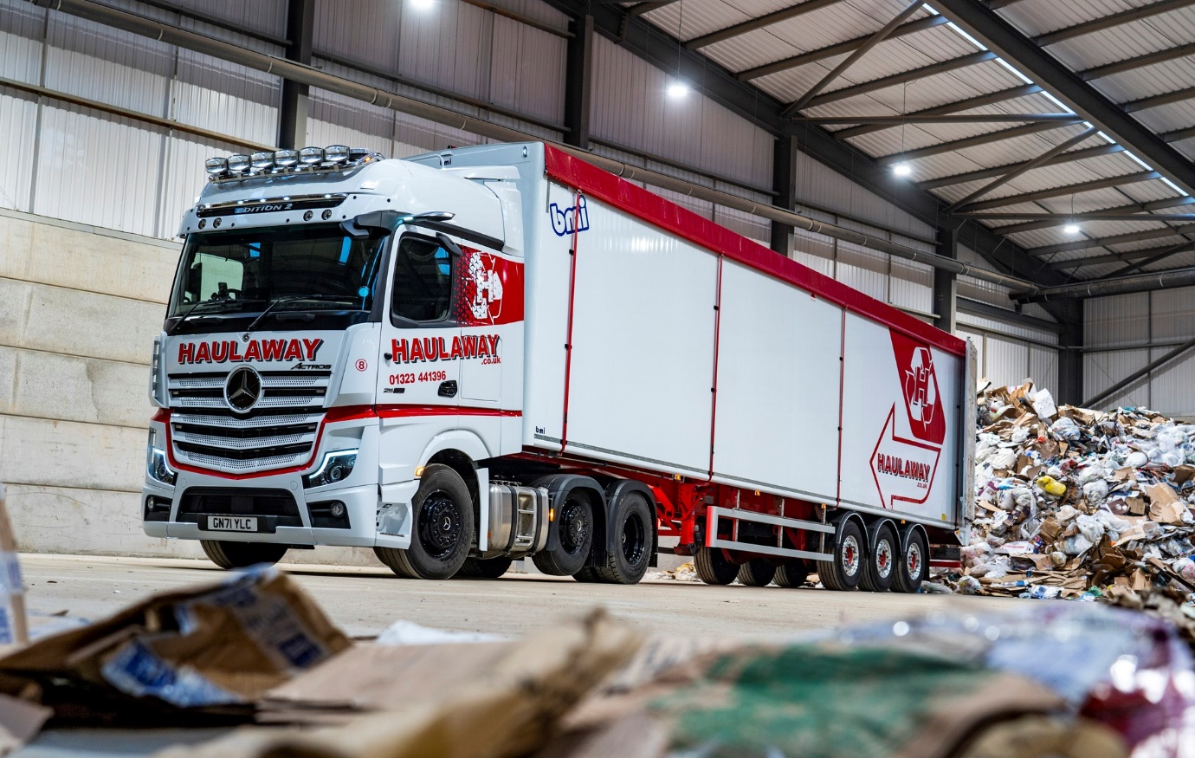

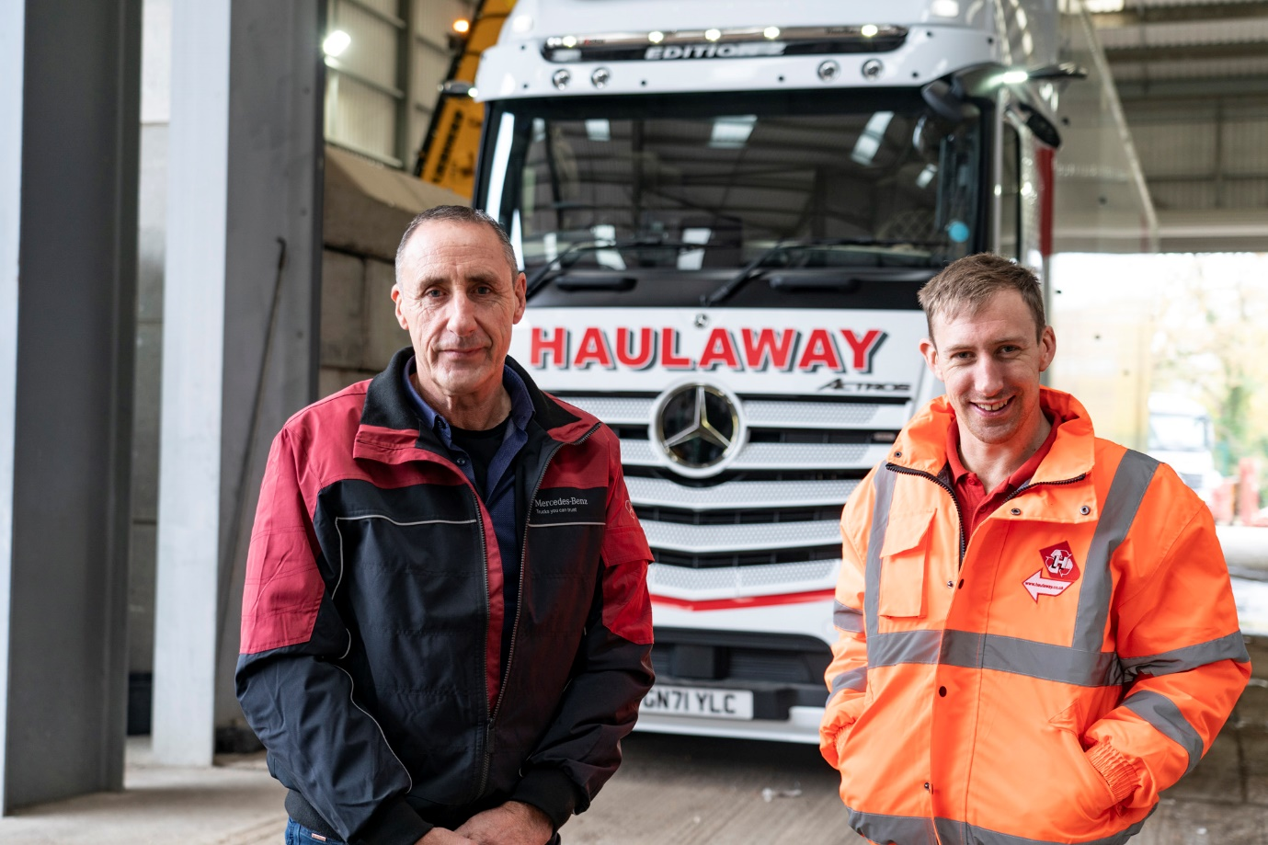

Moving forward with Mercedes-Benz: Colin Holloway and his son Sam are pictured with the Actros Edition 2 flagship that underscores, once again, their commitment to the three-pointed star

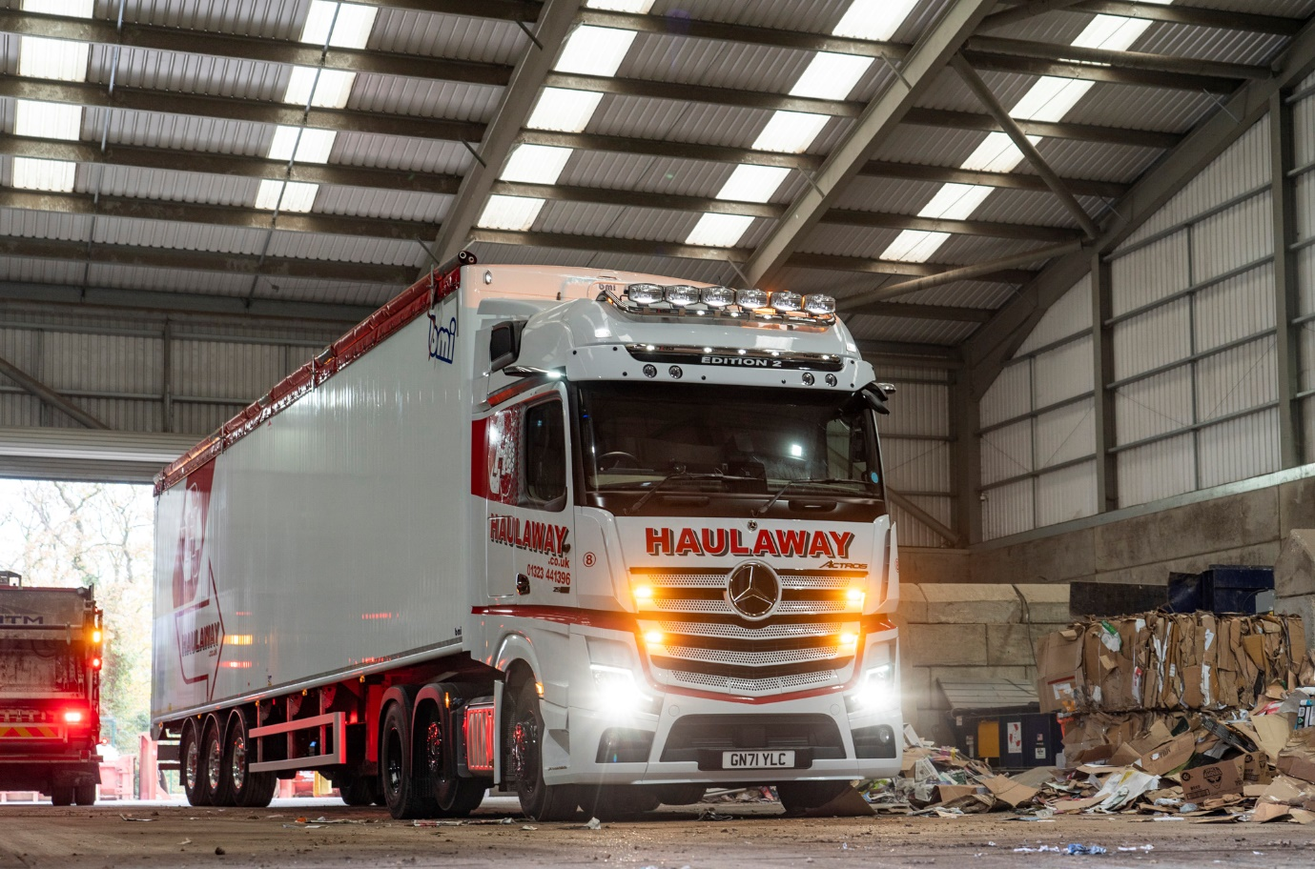

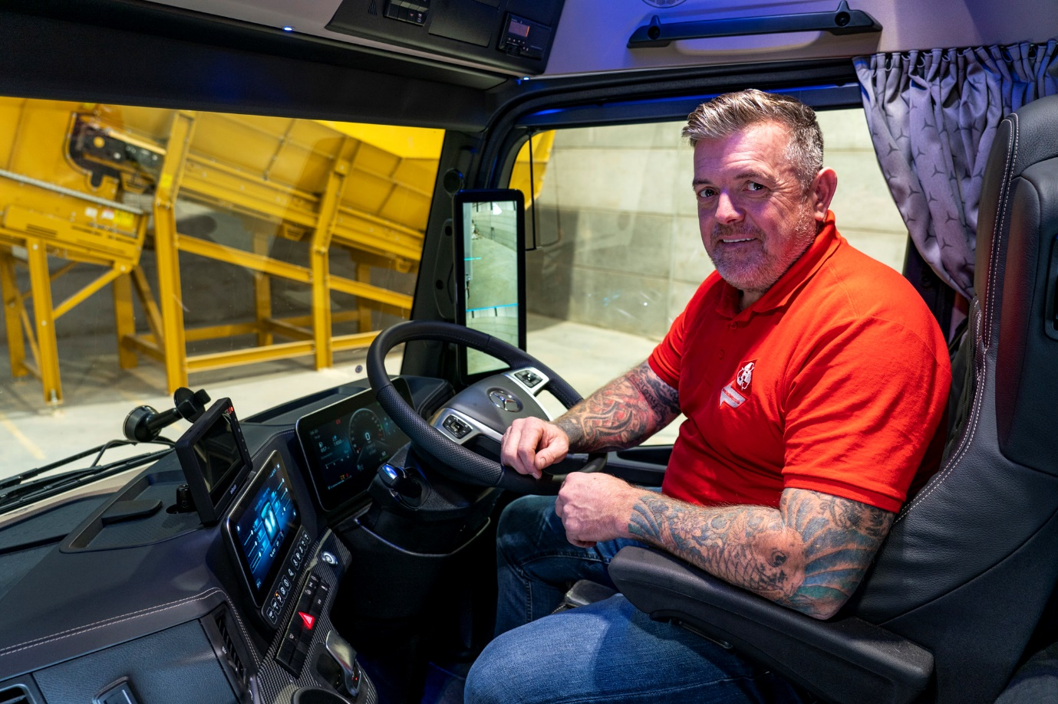

Hedges’ bet: Driver Jason has always favoured a Swedish truck brand, but is hugely impressed with his new Mercedes-Benz Actros Edition 2

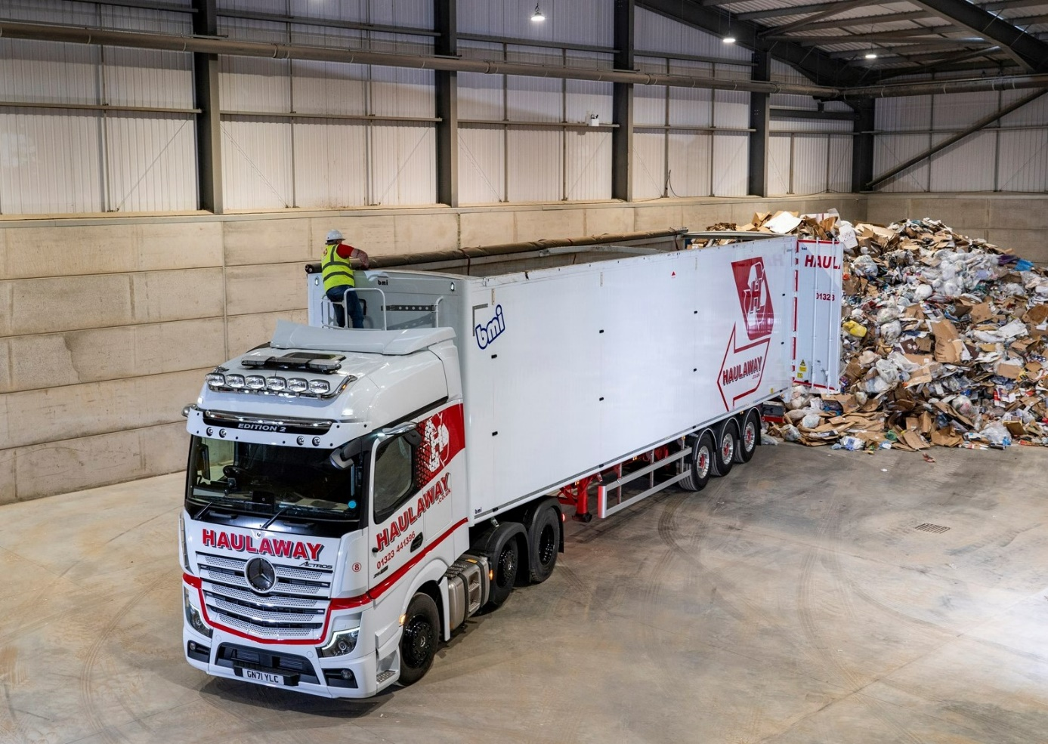

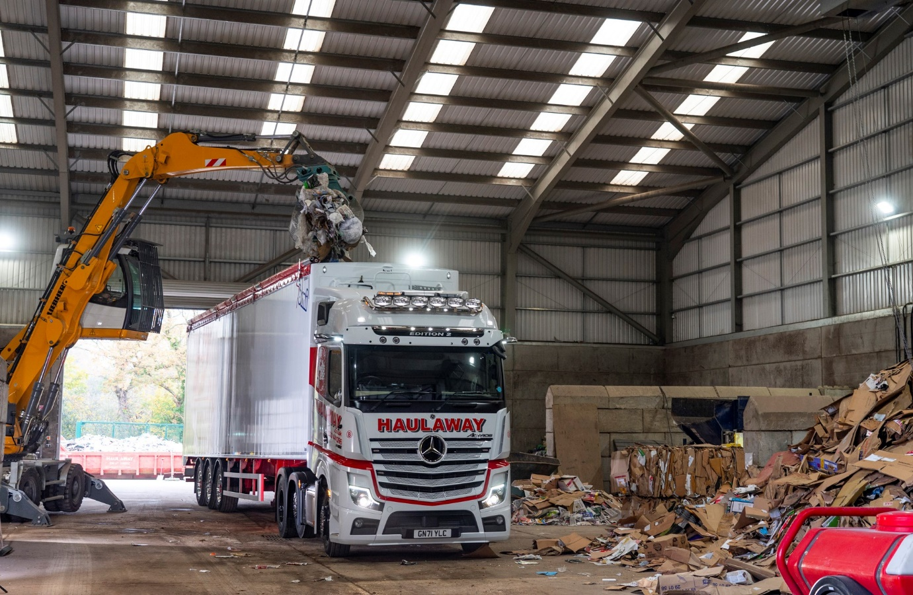

ends

For more information, or to request higher-res image files, please contact:

Jamie Fretwell at Mercedes-Benz Trucks UK Ltd
07712 519230, jamie.fretwell@daimler.com

or

Steve Warren or John Ripley
Impact Communications
Steve: 07770 470251, steve@impactcom.co.uk
John: 07771 484595, john@impactcom.co.uk

