

Date: 9 April 2021

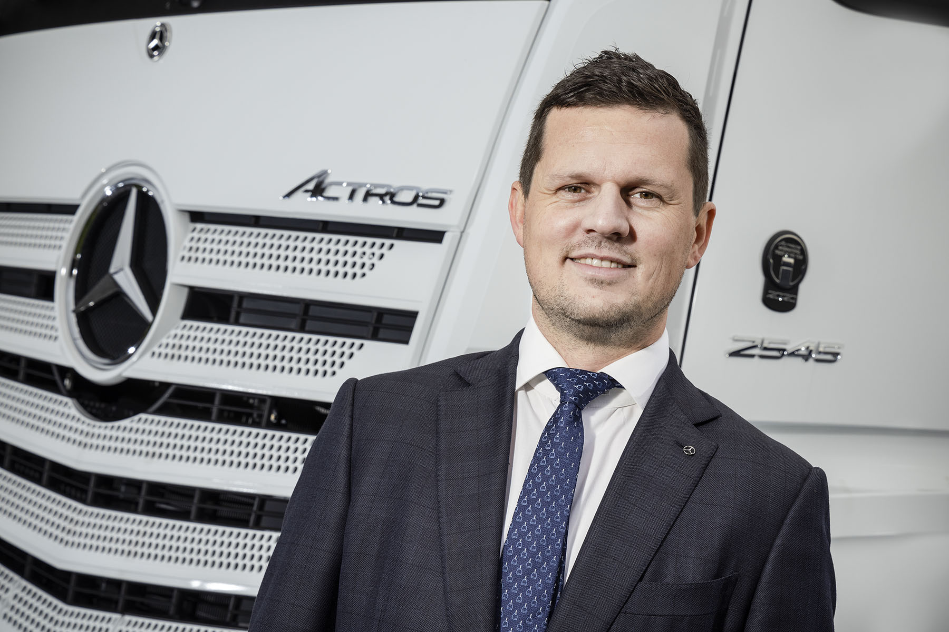

Back to the future: Ross Davies had served Mercedes-Benz truck customers in the Middle East and North Africa for a decade before he accepted an exciting new challenge in the UK

New recruit Ross relishes the opportunity to drive Dealer sales for Mercedes-Benz Trucks UK

Having begun his commercial vehicle career with telematics specialist Daimler Fleetboard in the Middle East ten years ago, Ross Davies is back on ‘home turf’ and leading
Mercedes-Benz Trucks UK’s District Management & Connectivity Sales Teams.

In his last role, Ross was based at Daimler Truck AG’s regional centre in Dubai. As Head of Sales, Key Accounts and Used Truck for Mercedes-Benz Trucks in the Middle East and North Africa region, he was responsible for steering manufacturer and distributor Sales operations in 19 markets.

Explaining the decision to return with his young family to the country in which he was born and brought up, Ross said: “It was time for my next big challenge. I was attracted by the maturity of the market here in the UK, and by the opportunities that are presenting themselves at the moment under the new leadership of Managing Director Wolfgang Theissen, whose vision is to cement Mercedes-Benz Trucks’ position on the podium.”

He continued: “Obviously, the industry is in a state of flux, not only because of factors like Brexit and the pandemic, and the impact these have had on economic stability as a whole, but also the emergence of new technologies.

“These include benchmark systems such as MirrorCam, the Multimedia Cockpit and Active Brake Assist 5, which are available only to Mercedes-Benz truck customers, as well as the alternative fuels in which we’ve been investing, and which we’ll start to see being rolled out in the very near future.

“Our aim is to reinforce the trust that operators of new and used Mercedes-Benz and FUSO vehicles place in our Dealer Network. Across Sales, Customer Service and Parts, we must build an aura of quality and professionalism, that reassures our customers we are there to support them through thick and thin.”

Reporting to Ross are four District Managers: James Collins, Scott Miller, Gary North and Stephen Richardson; a fifth member of the team will be appointed soon. They are, he said, the “key gateway” between the manufacturer and its franchised Dealer partners.

“It’s certainly our job to help Dealers maintain and develop their relationships with established Mercedes-Benz customers,” Ross confirmed. “However, an equally important aspect of the District Manager’s role is to spark ideas and new initiatives that can help us win new converts to our brand.

“We’re here to help our Dealers drive their businesses forward by providing support in terms of development, marketing, training requirements, and numerous other activities. My team also funnels market intelligence from the ‘front line’ back into our own business, so new solutions that meet customer requirements and expectations can be developed.”

It is the first time that Mercedes-Benz Trucks UK’s Head of District Management has been responsible for Connectivity as well. The strategic decision to include this function within Ross Davies’ remit reflects the fact that Daimler Fleetboard’s telematics technology is now a mainstream and popular element of the Mercedes-Benz Trucks ‘offer’. It also underscores the manufacturer’s confidence in the appeal to operators of its Truck app Portal – a feature of the radical Multimedia Cockpit, interactive, this allows vehicles to be equipped individually with apps that can increase efficiency and comfort.

Again, Ross’s three, highly experienced Connectivity Specialists – John Armes, Chris Gutowski and Mark Sach – work with franchised partners as well as directly with operators. “Our value proposition is focused on supporting customers by reducing their vehicle running costs,” said Ross. “We do that by delivering fleet management excellence through the provision of access to data and integrated apps. The resulting transparency and holistic support can improve driver engagement and drive increased profitability.”

He added: “We are fortunate in having a well-established Dealer network that continues to support the Mercedes-Benz Trucks brand through substantial investments in facilities, people and processes. The task now is to ensure that this commitment is rewarded through consolidation of our podium position in the UK market.”

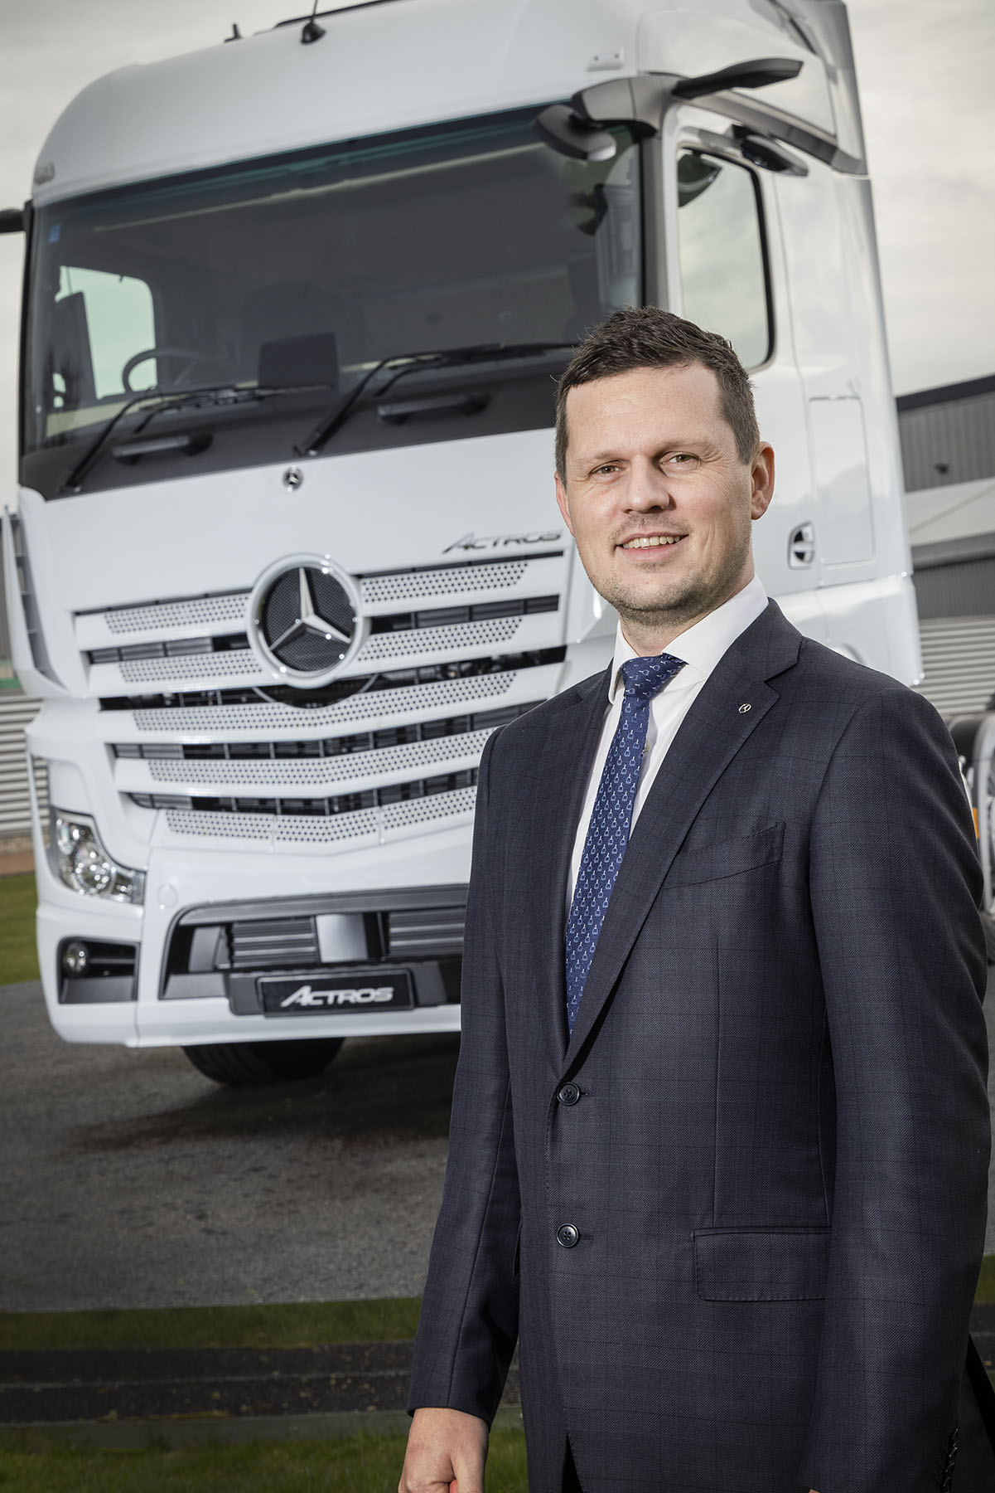

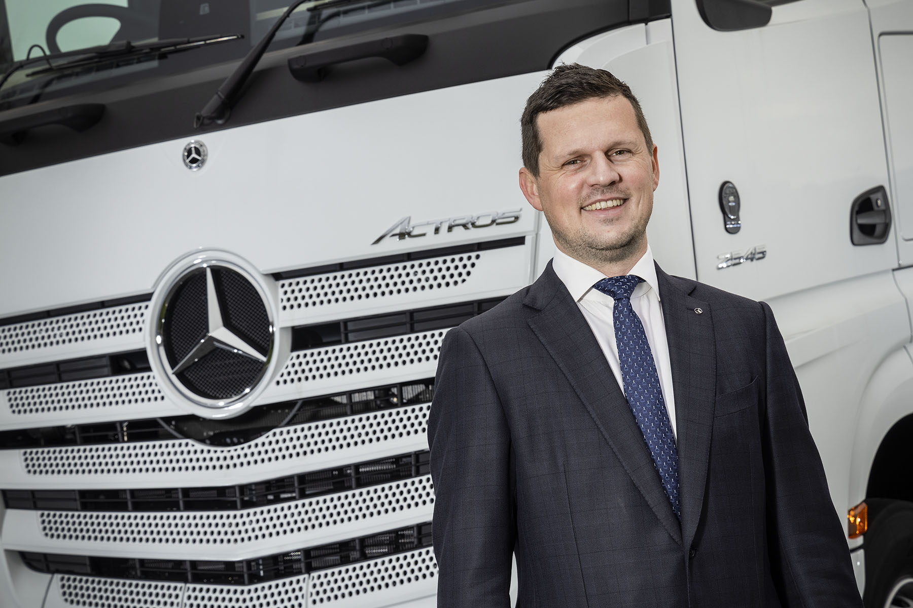

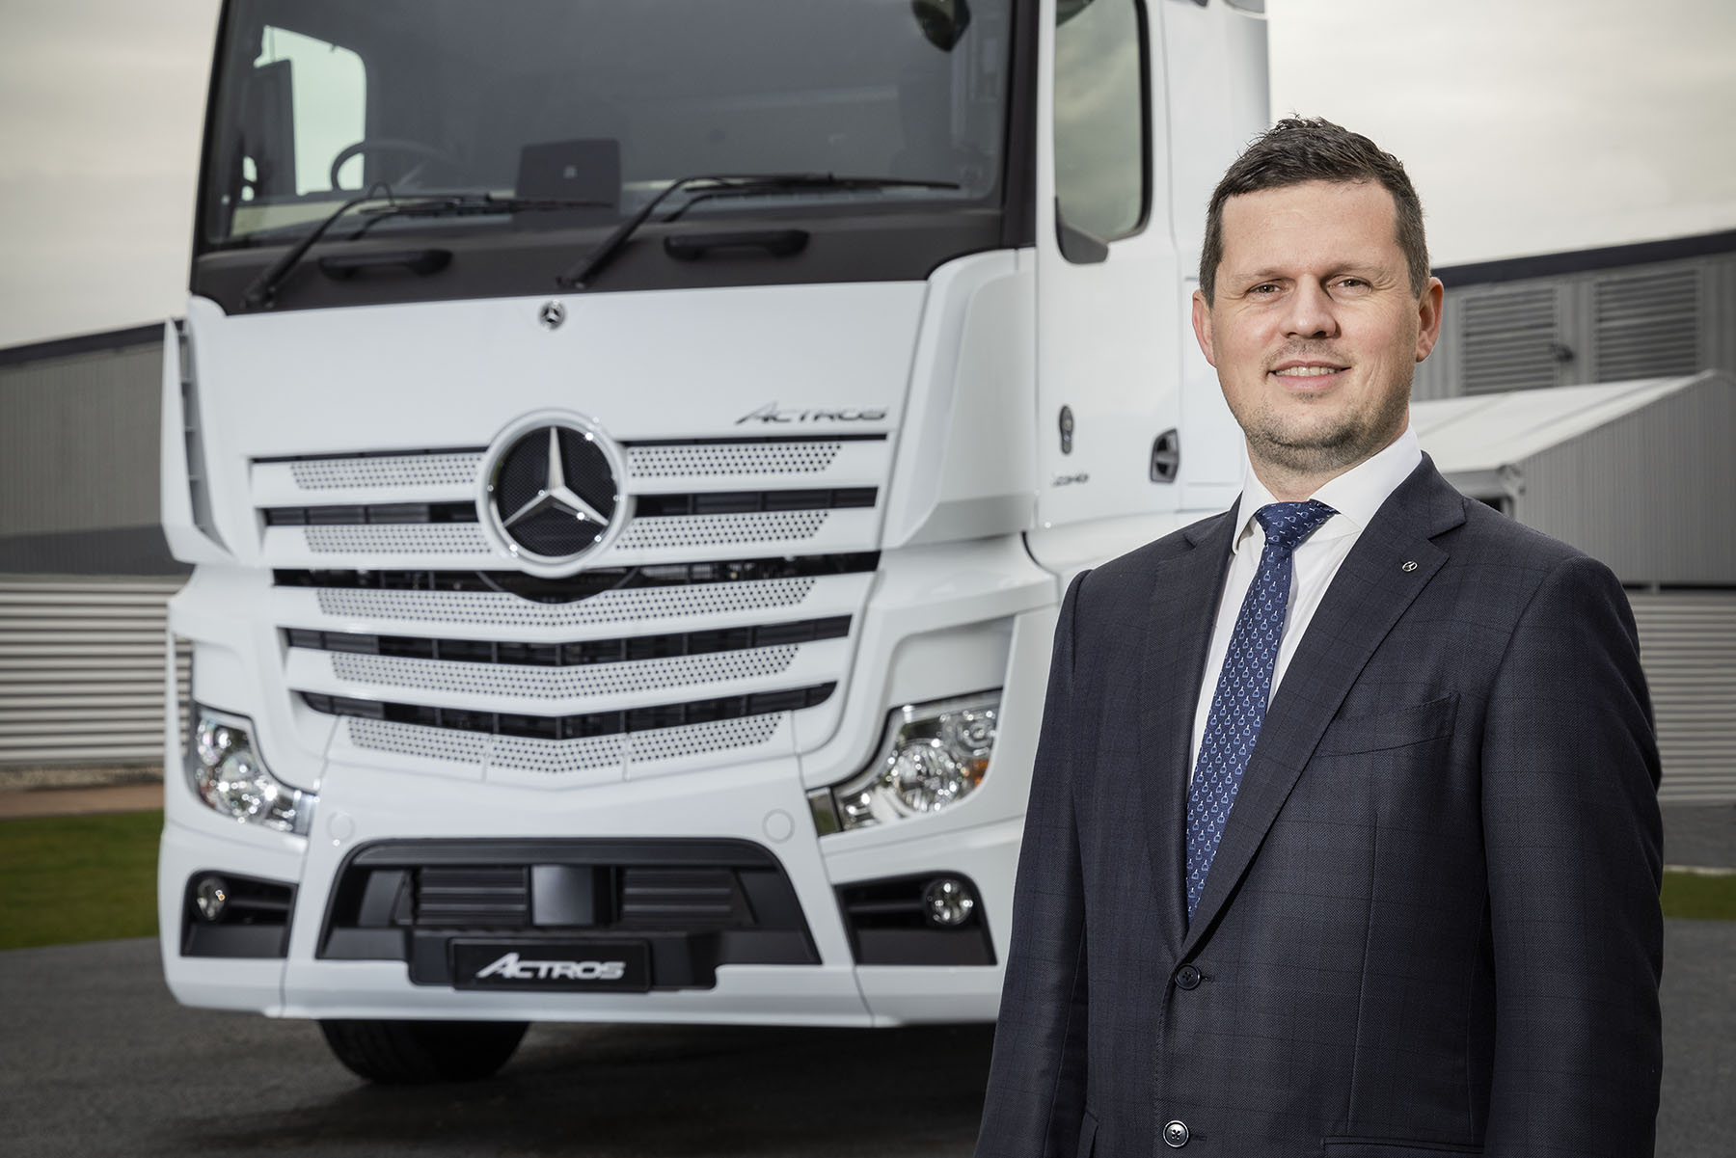

ends

For more information, or to request higher-res image files, please contact:

Jamie Fretwell at Mercedes-Benz Trucks UK Ltd
07712 519230, jamie.fretwell@daimler.com

or

Steve Warren or John Ripley
Impact Communications, 01926 842126
Steve: 07770 470251, steve@impactcom.co.uk
John: 07771 484595, john@impactcom.co.uk

About Mercedes-Benz Trucks UK Ltd
Mercedes-Benz Trucks UK Ltd is the sales and marketing organisation responsible for all Daimler truck products in the UK, including FUSO Canter. In 2019, the company registered 6,963 new trucks. Mercedes-Benz accounted for 6,188 new trucks registered in 2019, making it the third-biggest truck brand in the UK. Meanwhile, FUSO registrations hit 775 – including 580 new trucks over 6.0-tonnes. The flagship new Mercedes-Benz Actros which won the 2020 International Truck of the Year award, features seven core innovations including MirrorCam, Multimedia Cockpit and Active Brake Assist 5. Our premium range of innovative trucks – Actros, Arocs, Atego, Econic and Unimog – draw upon more than 125 years of exceptionally high standards of quality, backed up by our promise of Trucks You Can Trust.
www.mbtrucks.co.uk

