

Date: 10 May 2023

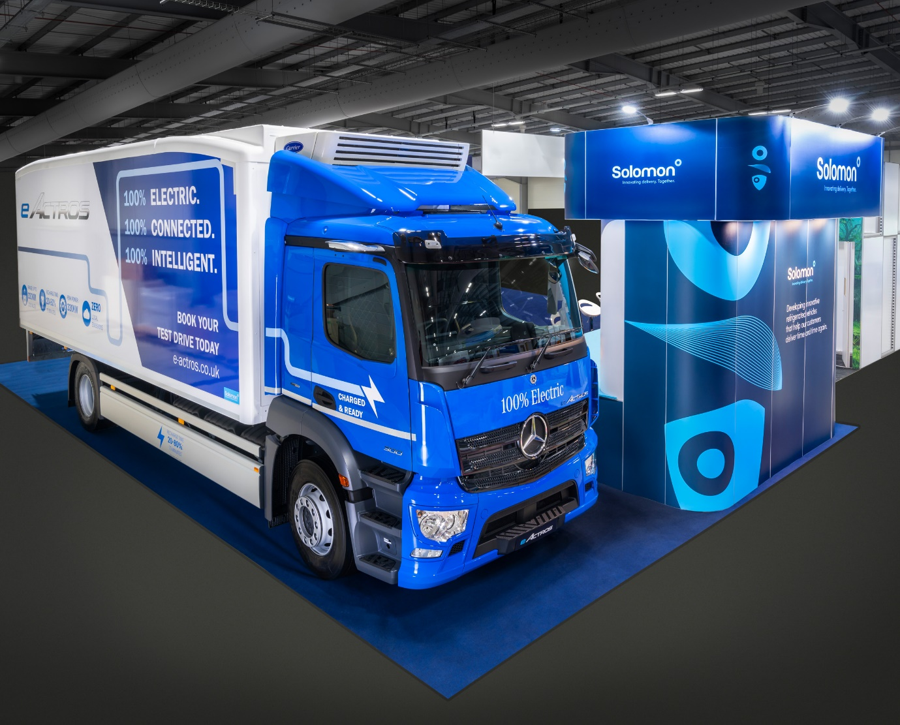

Standing proud: the Mercedes-Benz eActros 300, with Solomon Commercials refrigerated body, on display at ITT Hub 2023

Mercedes-Benz Trucks unveils refrigerated eActros electric demonstrator

Mercedes-Benz Trucks UK has teamed up with leading bodybuilder Solomon Commercials to launch Britain’s first fridge-bodied eActros electric truck.

The 19-tonne GVW eActros made its debut at the ITT Hub event in Farnborough on 9 May. A fully operational vehicle, it will now be offered for live demonstrations to operators across the country.

The truck is based on a 4x2 eActros 300. Fitted with three nickel manganese cobalt battery packs, for a total installed capacity of 336kWh, it boasts a range of up to 330km (205 miles). The batteries can be recharged from 20 to 80% in 75 minutes, using a 400A 160kW charger.

The eActros is designed from the ground up as an electric truck. Its twin electric motors are located within the rear eAxle. With no need for a prop shaft, chassis space is freed up for the batteries to be set across the full width of the vehicle. This helps to create a low centre of gravity which, in turn, translates into improved driving dynamics. The motors drive through a special transmission with two forward and two reverse gears, allowing the truck to cruise at up to 89 km/h (55 mph). The absence of a combustion engine under the ClassicSpace cab means there’s much less noise and vibration than in a traditional diesel-powered truck.

The body, meanwhile, is designed for optimum aerodynamic efficiency to reduce drag and thereby help to maximise range. It features a full Solomon Slipstream system incorporating tapered bulkhead, 3D roof deflector and sloping Kamm tail. Refrigeration is controlled by a Carrier TRS Syberia overcab chiller unit and Carrier Datacold temperature monitoring system.

At the rear there’s a 1,500 kg Dhollandia column tail lift, as well as a reversing camera which is integrated with the truck’s Multimedia Cockpit display screens, so no extra in-cab hardware is required. Other standard equipment includes MirrorCam, Active Brake Assist 5, and an Acoustic Vehicle Alerting System.

Launched last year, the eActros is also available as a 6x2 chassis, with 27-tonne GVW and a body-and-payload allowance of 16.6 tonnes, and as an eActros 400 with four batteries allowing up to 400 km (249 miles) of range. Deliveries of the first vehicles to UK customers are now underway.

Mercedes-Benz Trucks Head of Future Sustainability, James Venables, said: “The eActros is a truck for a new era, and by launching this refrigerated demonstrator we’re showing that it’s ready to work in real-life applications – anyone interested in trialling this exciting vehicle should contact their Mercedes-Benz Dealer as soon as possible.

“We’re here to support operators on the journey towards CO2-neutral transport too, though. All our Dealers are fully qualified and eTruck-ready, while our team of eConsultants can provide valuable advice and assistance on all aspects of electric truck operation, from charging infrastructure, to a range of digital services to increase utilisation and optimise the total cost of ownership.”

Solomon Commercials Managing Director Anthony Clegg added: “The road to net zero is no longer an optional extra; it’s a certainty, and more and more customers are actively looking to introduce carbon-neutral policies and to minimise the impact of their vehicles on the environment.

“We’re proud to work with manufacturers such as Mercedes-Benz, helping customers transition to zero-emissions transport. Adopting these vehicles is certainly picking up pace, particularly with the Government wanting to reach stringent emissions targets and create clean-air cities. Electric vehicles will play an important role in ensuring this is achieved.”

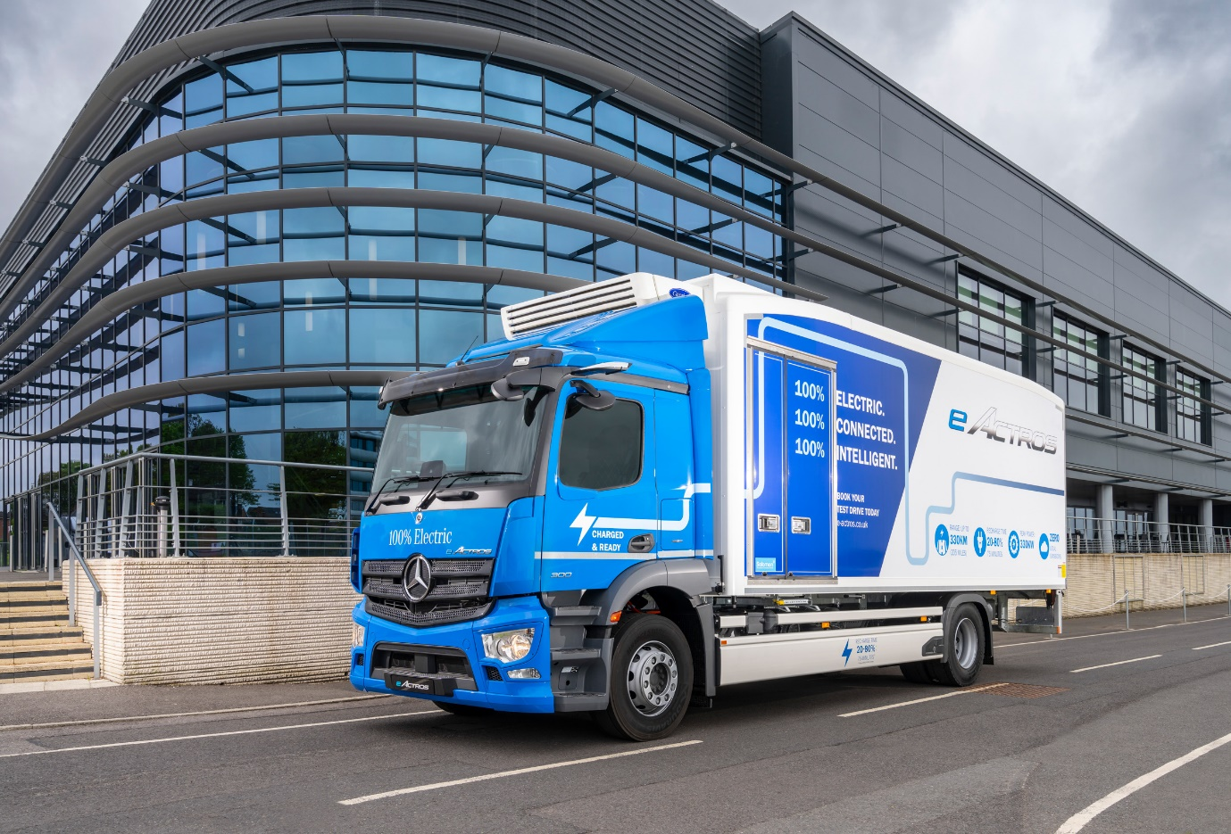

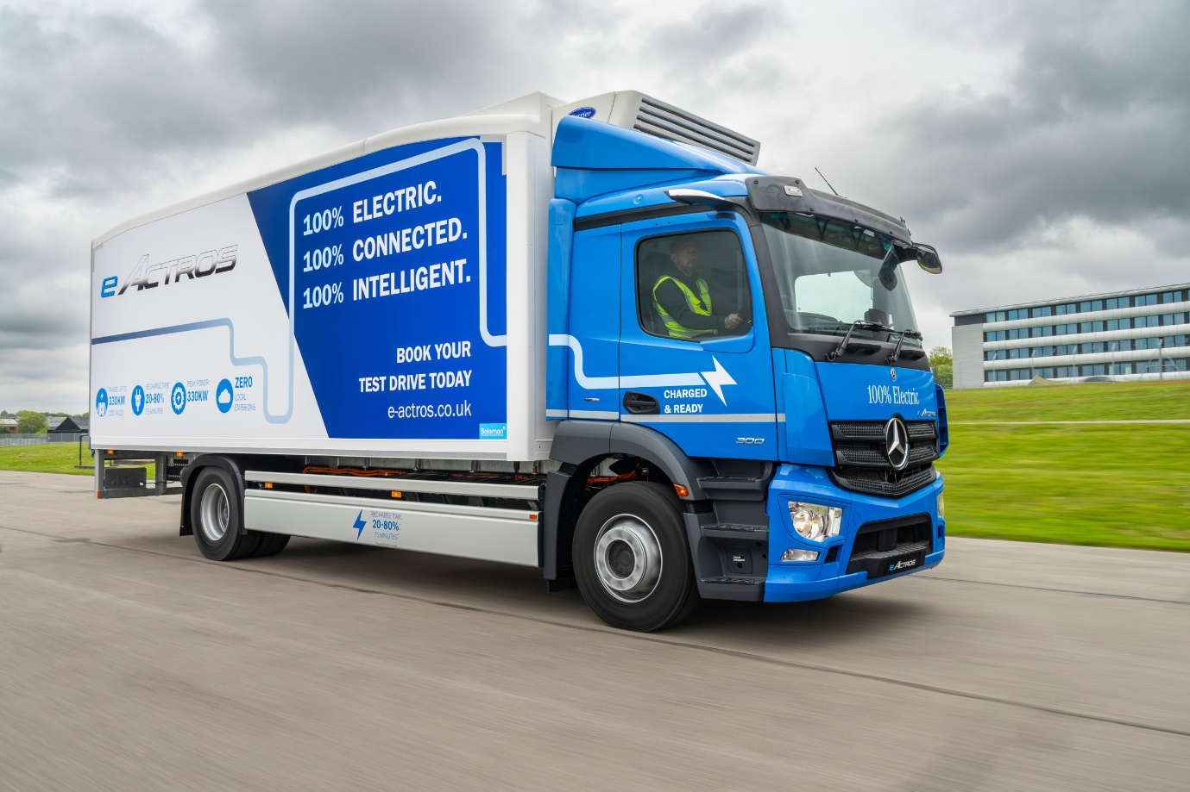

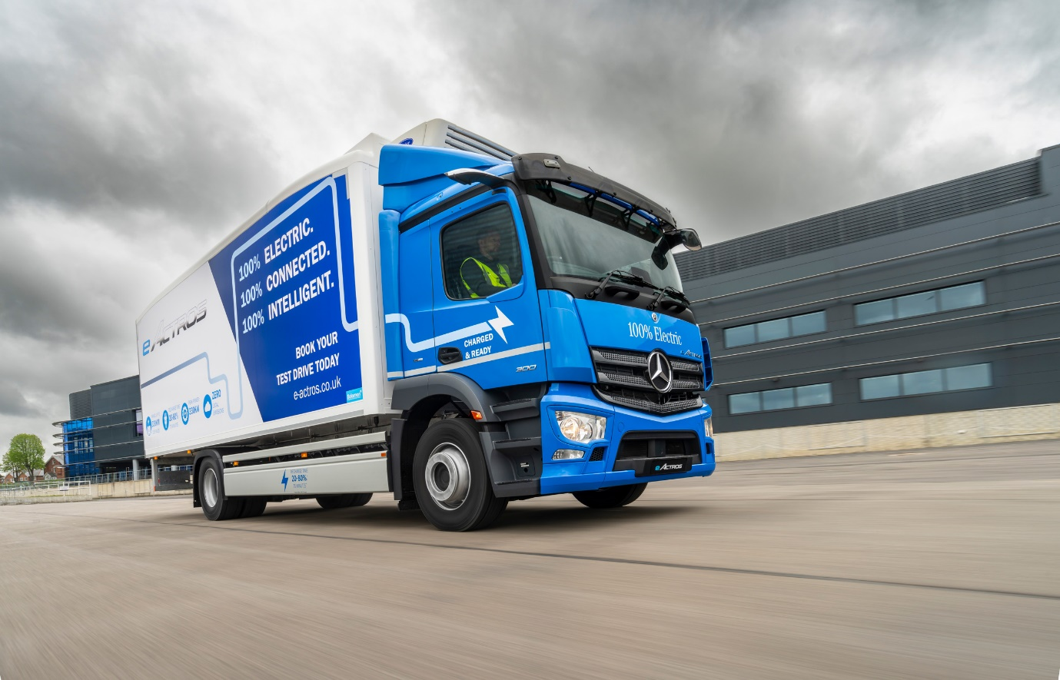

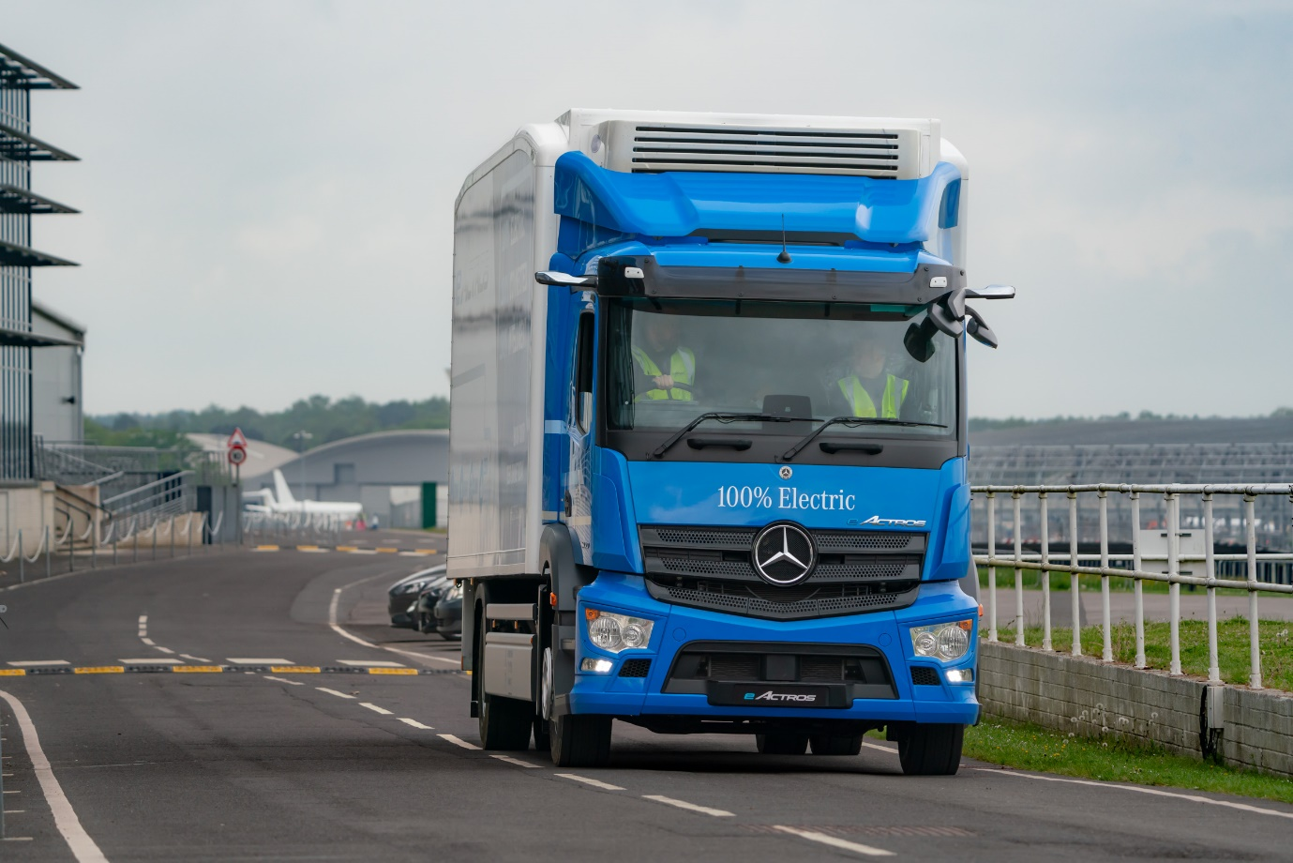

ends

For more information, or to request higher-res image files, please contact:

Jamie Fretwell at Mercedes-Benz Trucks UK Ltd
07712 519230, jamie.fretwell@daimler.com

or

John Ripley: 07771 484595, john.ripley@loopagency.co.uk

