

Date: 14 July 2023

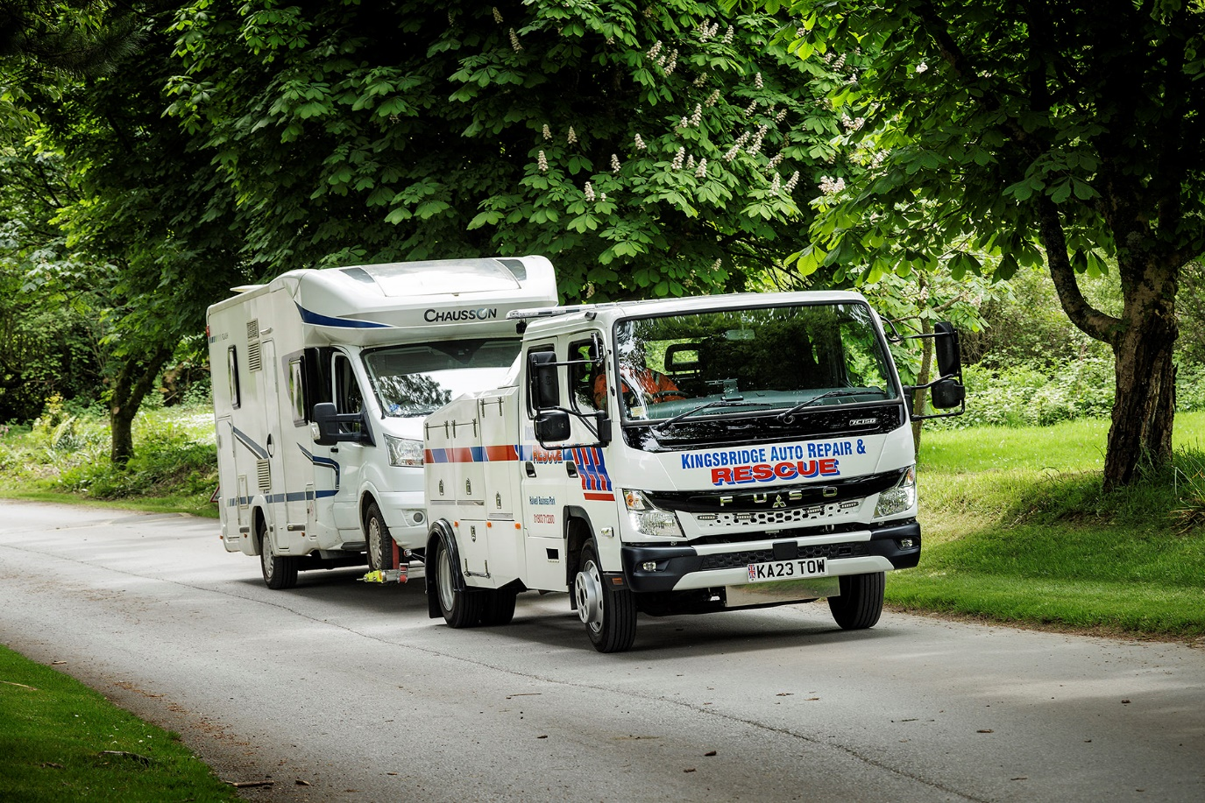

Third FUSO Canter gives Kingsbridge Auto Repair & Rescue fleet a lift

A surge in the number of camper vans and mobile homes on the roads of Devon meant contractor Kingsbridge Auto Repair & Rescue needed a new breakdown truck to keep holiday traffic moving – and a 7.5-tonne FUSO Canter was the natural choice.

The truck was supplied to the operator, which works from Halwell, near Kingsbridge, by Dealer Intercounty Truck & Van. As a 7C15D variant, it employs a 3.0-litre common-rail powerplant that generates a range-topping 110 kW (150 hp) and up to 370 Nm of torque. A newly developed, compact exhaust system means the model also meets the EURO VI – STEP E emission standard.

Kingsbridge Auto Repair & Rescue specified a factory-built double cab, with seating for a driver and up to six passengers. Specialist bodybuilder J&J Conversions fitted the chassis with Super Hawk Underlift equipment, including a ‘spectacle’ lift with 2.5-tonne capacity and bodywork with secure lockers for tools and protective clothing.

“We cover a busy area of South Devon, including Torquay, the South Hams and Dartmoor,” said proprietor Michael Saunders. “In summer, especially, the local roads can be extremely busy with holiday traffic – and these days, an increasing number of those vehicles are vans.

“The 7.5-tonne Canter has the capacity to lift a camper, a large SUV or a heavy electric or hybrid vehicle, with ease, and there’s room in the cab for all passengers to be seated safely. We have a sub-frame which means we can recover motorbikes, and ‘dolly’ wheels to enable a full lift of a 4x4, too. It’s a bit of a ‘Swiss Army Knife’, and very well suited to our requirements – big and powerful enough to do the job but with relatively compact exterior dimensions, for a 7.5-tonner, so it’s easier to manoeuvre down narrow lanes.”

He continued: “The first requirement of a breakdown truck is that it should be reliable – you don’t want to break down yourself, when you’re supposed to be rescuing a stranded motorist. This is our third Canter so we know from experience that they are very robust and well-built.

“Intercounty Truck & Van have looked after us well too. Like our last new vehicle this Canter was supplied by Sales Executive Matteo Mirabile, and once again he handled our order very professionally. The truck was delivered on time and in perfect condition, and we’re delighted with our choice.”

Established in 2003, Kingsbridge Auto Repair & Rescue provides a range of garage services to local motorists, alongside its breakdown business – these include servicing, MoT testing, engine diagnostics, wheel alignment and gearbox repairs. As well as its new truck the company runs two other FUSO Canters and a larger recovery truck with platform body capable of carrying two cars.

“Like any small local business we rely on repeat business and word-of-mouth to stay successful,” said Mr Saunders. “We’ve worked hard to build a reputation based on honesty and customer care, and our dependable breakdown service shares those same values.”

www.kingsbridgeautorepair.co.uk

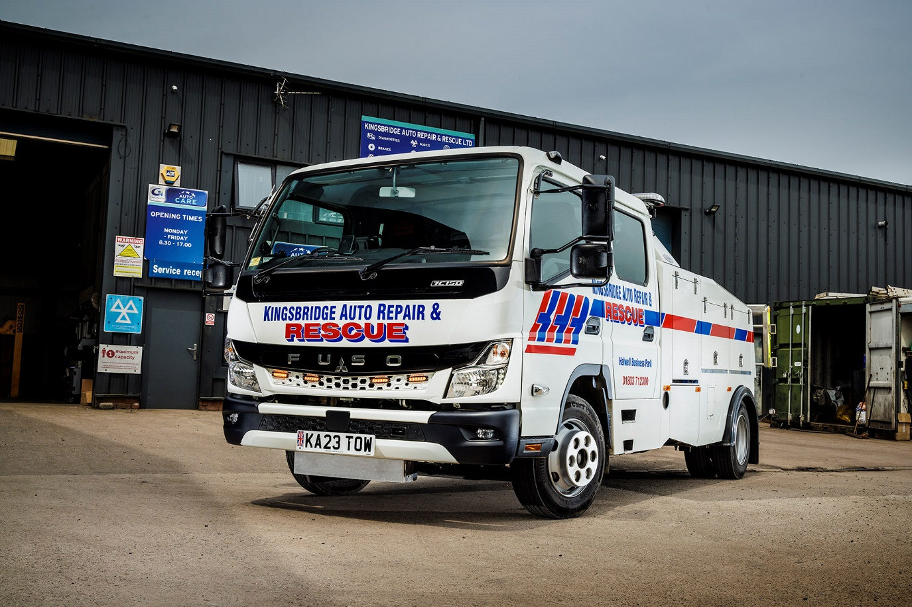

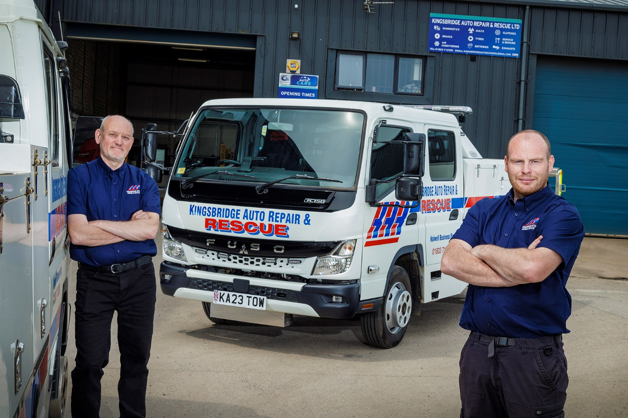

Double top: Michael Saunders, left, and driver Nick Smith with their new seven-seater FUSO Canter breakdown truck

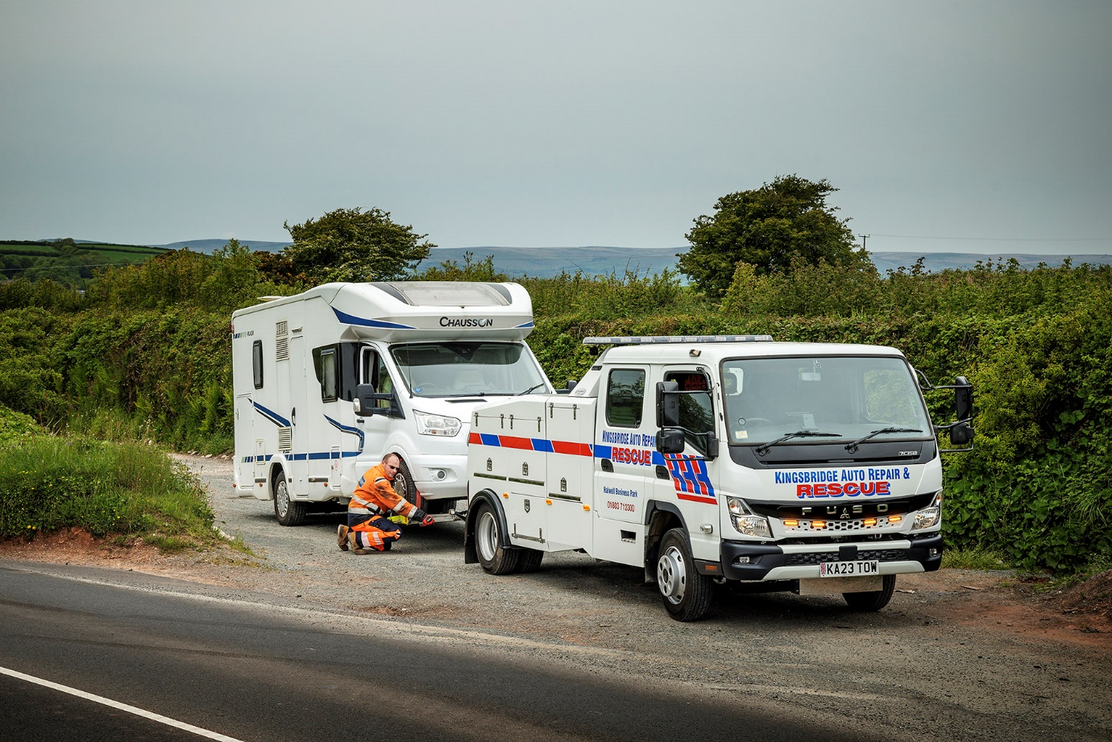

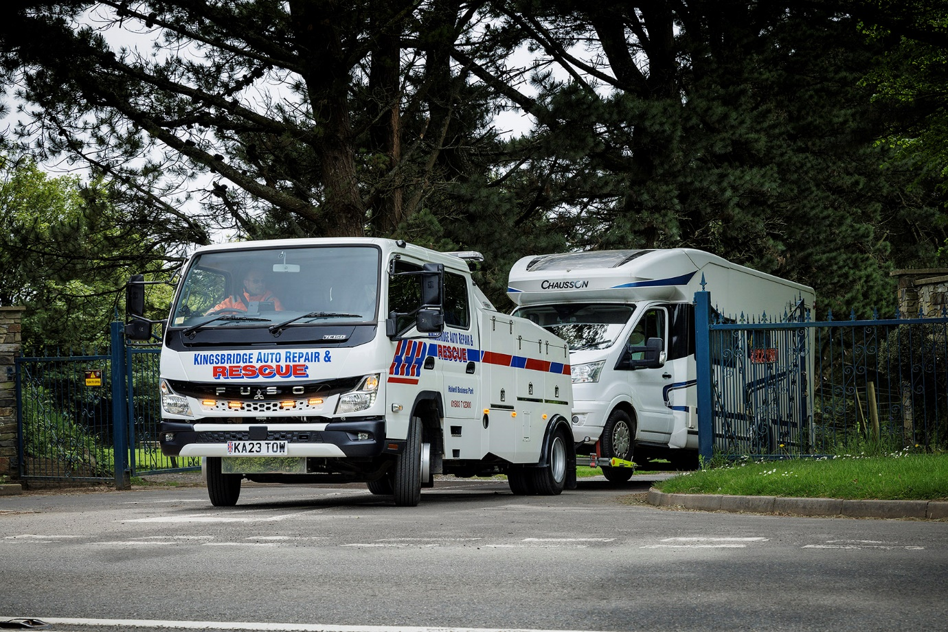

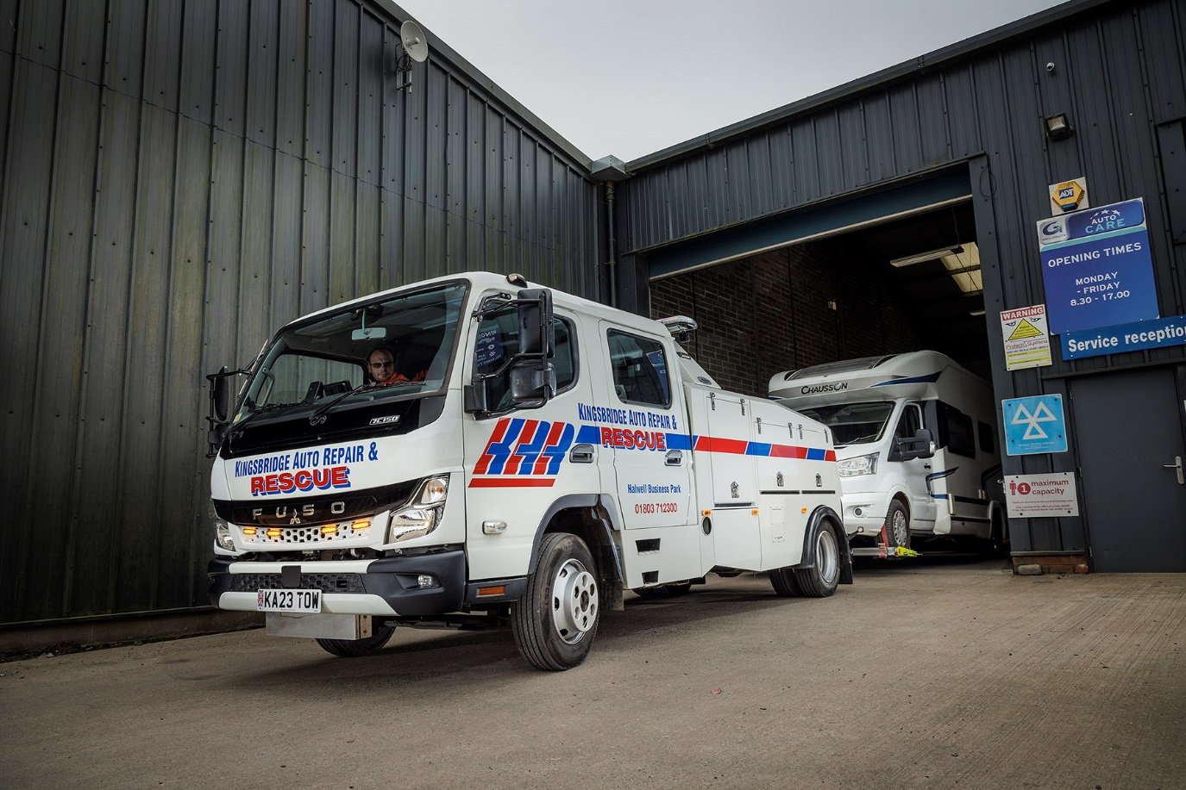

ends

For more information, or to request bigger/higher-res image files, please contact:
John Ripley: 07771 484595, john.ripley@loopagency.co.uk

