

Date: 4 March 2020

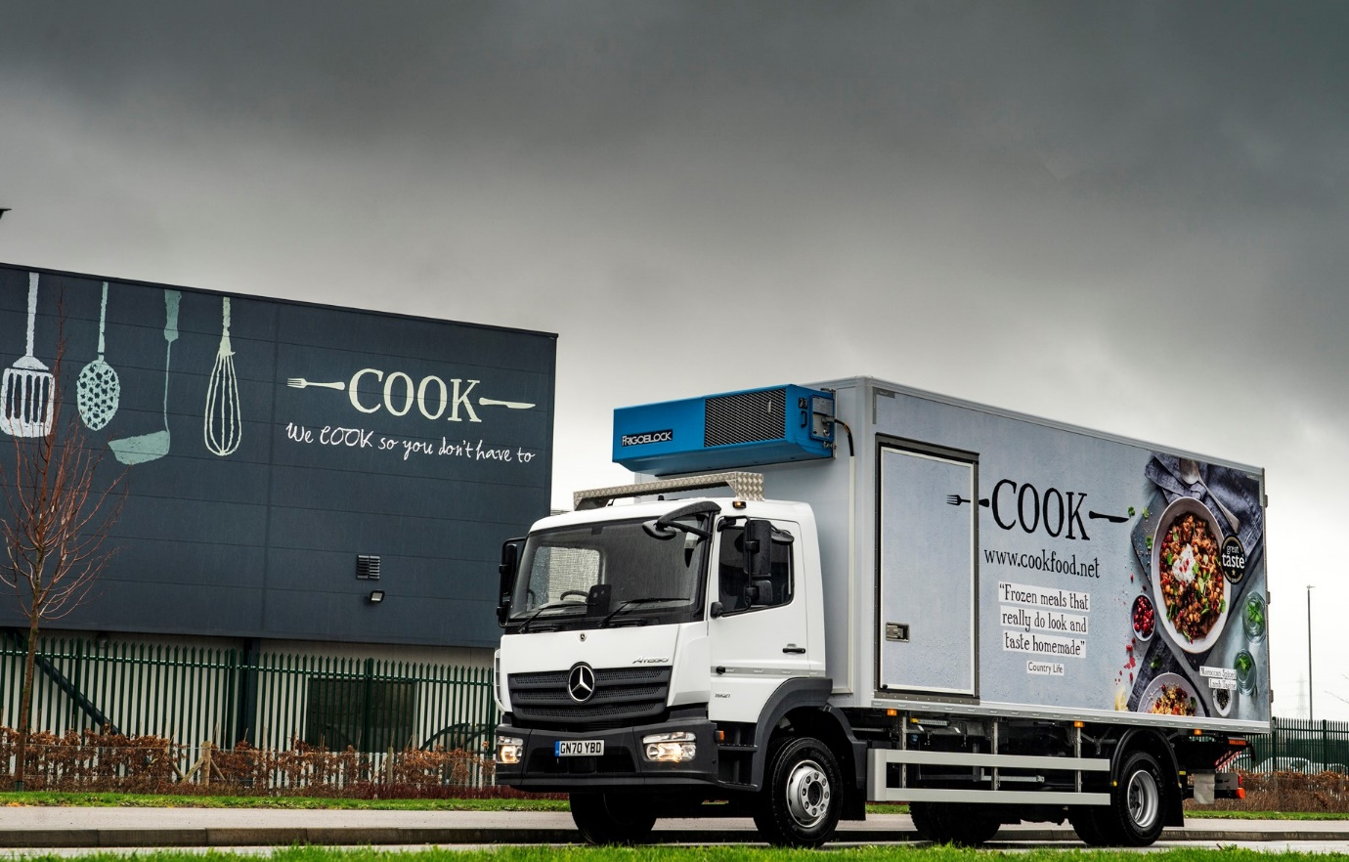

Mercedes-Benz trucks and Sparshatt’s back-up are key ingredients in Cook’s recipe for success

Award-winning manufacturer and retailer Cook has responded to surging demand for its premium quality frozen ready meals by adding another Mercedes-Benz truck to its logistics fleet.

Following a £16-million investment the fast-growing company is also preparing to open a second kitchen on the Eurolink Industrial Estate in Sittingbourne, Kent. The Cook Classics facility boasts new, more efficient freezing technology, and will increase its capacity to create hand-prepared meals by more than 60%.

Mercedes-Benz Dealer Sparshatt Truck & Van, whose own headquarters are on the same development, has just supplied its fast-growing customer with a new 15-tonne Atego 1521 L. The subject of a Mercedes-Benz Finance contract hire agreement, the truck has a ClassicSpace S-cab and rear air suspension, and is powered by a 5.1-litre four-cylinder engine that produces 155 kW (211 hp).

Its insulated body is by Solomon Commercials, of Rossendale, Lancashire and has a side door in addition to the two at the rear, plus a moving internal bulkhead – this ensures the load can be kept compact during transportation at a temperature of minus 20ºC. Frigoblock’s FK Series refrigeration unit is designed for high-end distribution applications; it features an integrated evaporator freeing up space in the cargo area and is highly fuel-efficient.

Cook was established in 1997 by Dale Penfold and Edward Perry, who set out to create meals “using the same ingredients and techniques you would at home, so everything looks and tastes homemade”. It is now an £80-million turnover business with approximately 100 of its own retail stores, the majority of them in the South-East, and many more concessions in farm shops, garden centres, fuel stations and the like.

Purpose-designed for light- and medium-duty distribution work, as well as construction applications, the Mercedes-Benz Atego range from 7.5-16 tonnes GVW offers outstanding dynamics, comfort and manoeuvrability, and is renowned for its strength and durability.

Cook’s new Atego has replaced a rented 16-tonner and been commissioned to service some of the more difficult-to-access outlets, many of them in market towns. It has lined up alongside eight other Mercedes-Benz trucks, most of them 18-tonners, and nine Sprinter vans on the company’s logistics fleet.

Cook has a distribution centre and cold store in Gillingham, from which its vehicles supply shops and concessions across southern and central England. One of the trucks, an 18-tonne Antos with sleeper cab, also makes twice-weekly collections from the company’s puddings kitchen in Ilminster, Somerset. Deliveries to stores as far afield as Edinburgh, Glasgow, Harrogate and Leeds are made by a transport partner.

Meanwhile, in response to the increased demand prompted by the pandemic, Cook’s store-based home delivery fleet has shot up from nine small, refrigerated vans a year ago, to 50 today.

Logistics Manager Richard Lee joined Cook a decade ago, after its owners resolved to bring the greater part of the distribution function in-house. He recalled: “We took on some short-term rentals initially. As soon as we were in a position to do the job properly, though, we contract-hired an 18-tonne Axor from Sparshatt. It has supplied all of our trucks ever since.”

He continued: “Reliability is the single most important factor we look for in a vehicle. Mercedes-Benz builds a top-tier product, one that combines engineering quality with competitive running costs and market-leading safety features.

“Sparshatt, meanwhile, provides the customer-focused back-up that ensures downtime is kept to an absolute minimum. We know from experience that its workshop team will work with us on the maintenance schedules, inspecting and servicing the vehicles overnight so they’re always available for work when we need them, and ensuring they pass their MoT tests at the first attempt.

“It’s a great relationship – Sparshatt’s Truck Sales Executive Martin Kemsley was very professional in his management of our latest order, while we trust his aftersales colleagues implicitly to ensure that our fleet is fully compliant and operating at peak efficiency.”

Commenting on the imminent opening of the Cook Classics kitchen, co-Chief Executive Officer Edward Perry said: “Our existing kitchen facility is at full capacity, so we needed additional space to be able to achieve our plan of doubling our sales in five years.

“The new site gives us total confidence that we will achieve our goal and, at the same time, allows us to continue to improve our manufacturing process and products. We are also recruiting 80 members of staff initially, with a view to growing to a total headcount of 200 new colleagues over the next three to four years.”
www.cookfood.net

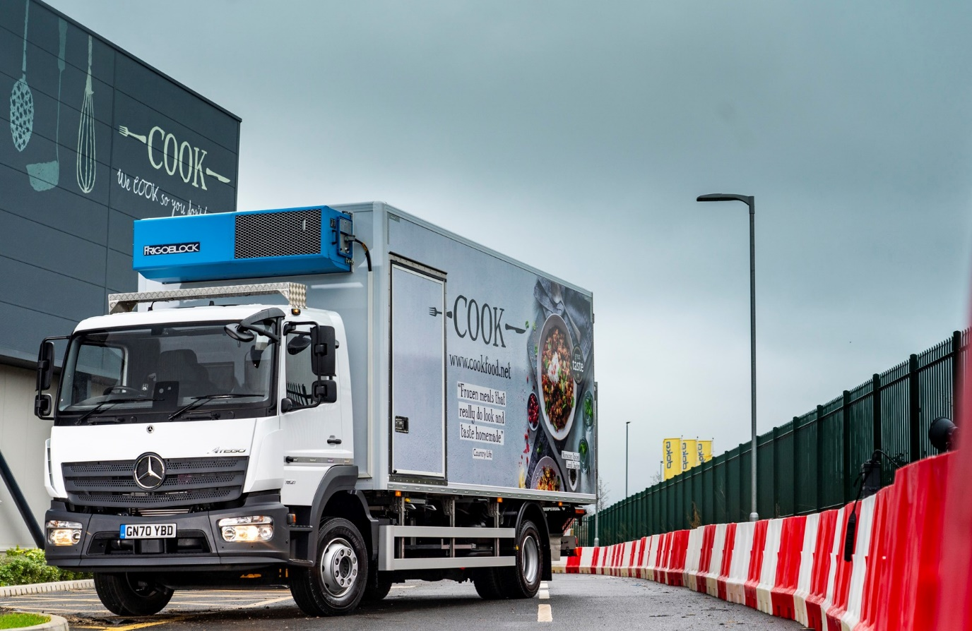

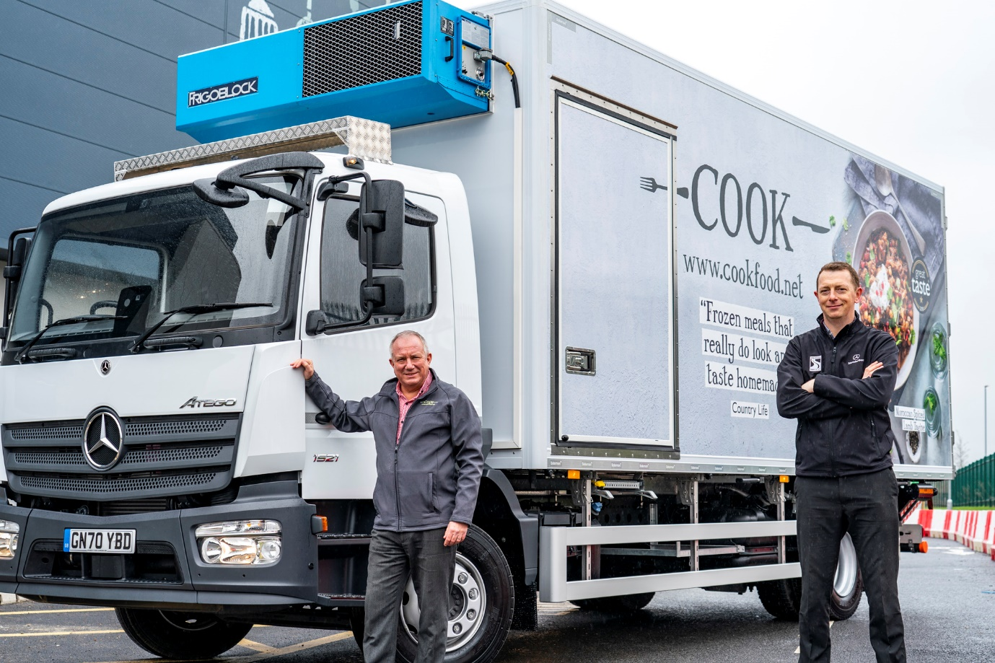

Serving up another winner: Logistics Manager Richard Lee, left, took delivery of Cook’s new Mercedes-Benz Atego from Martin Kemsley, of Sparshatt Truck & Van

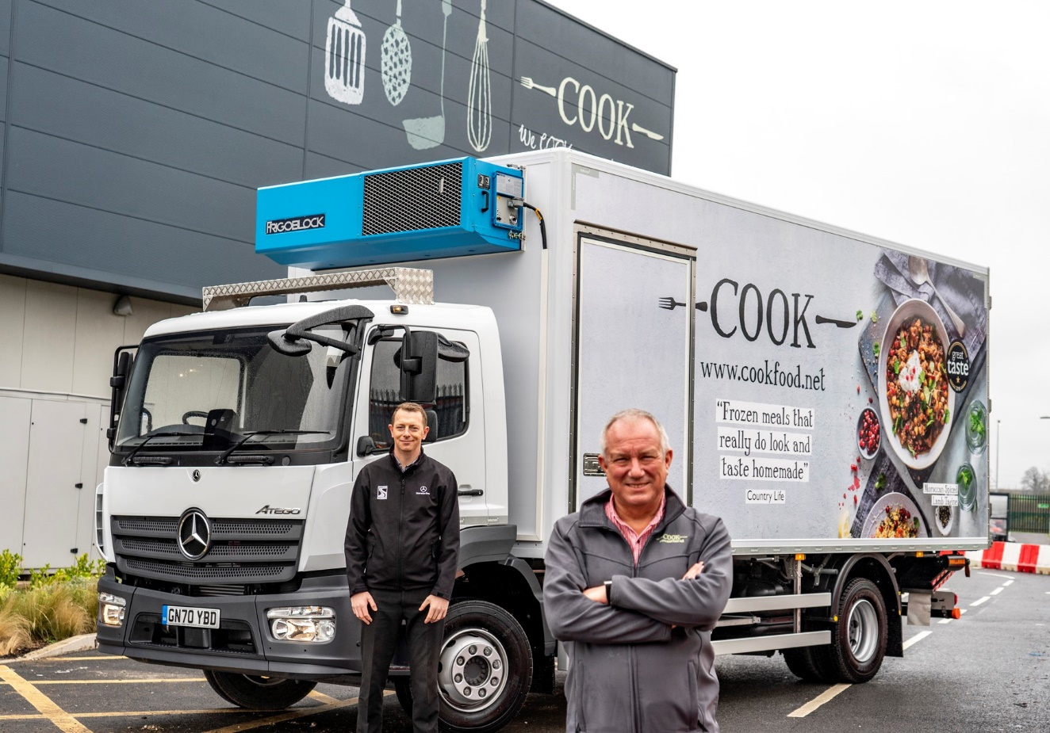

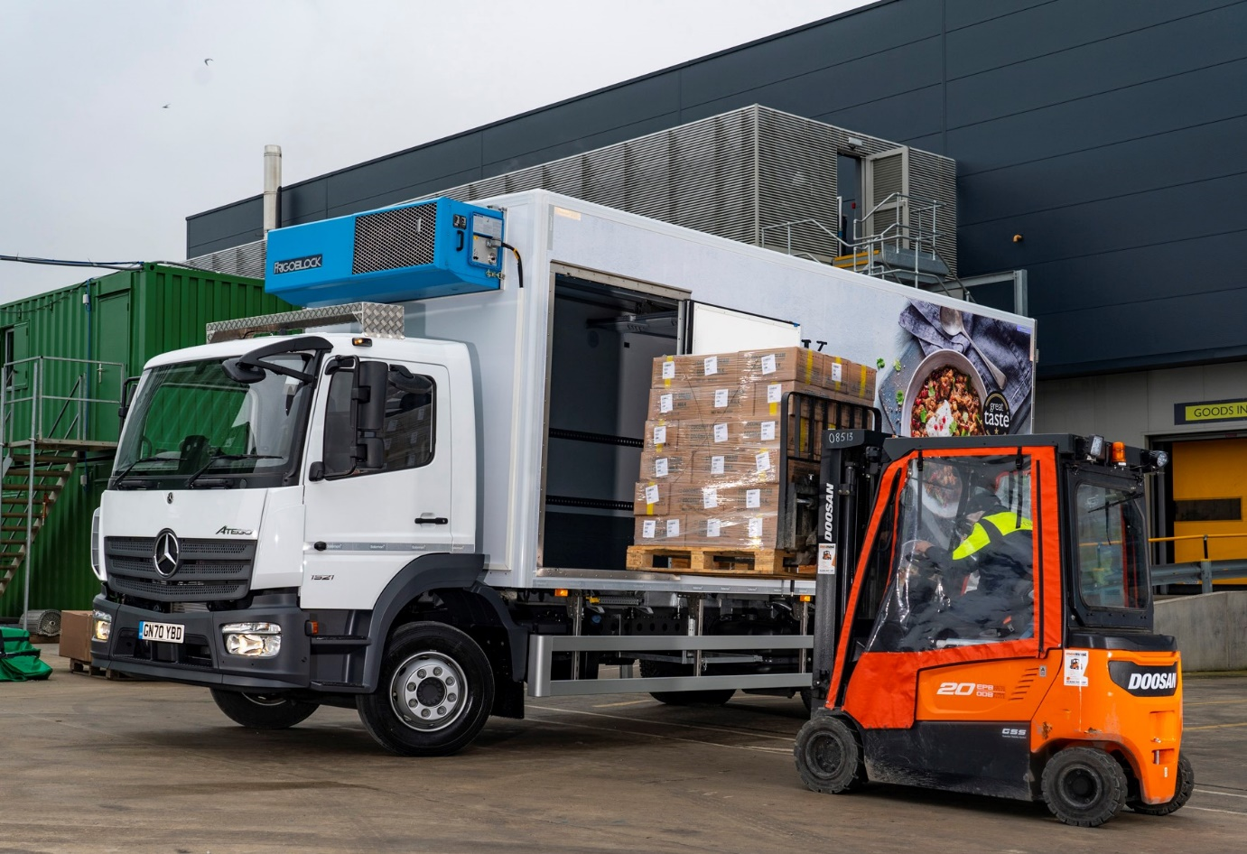

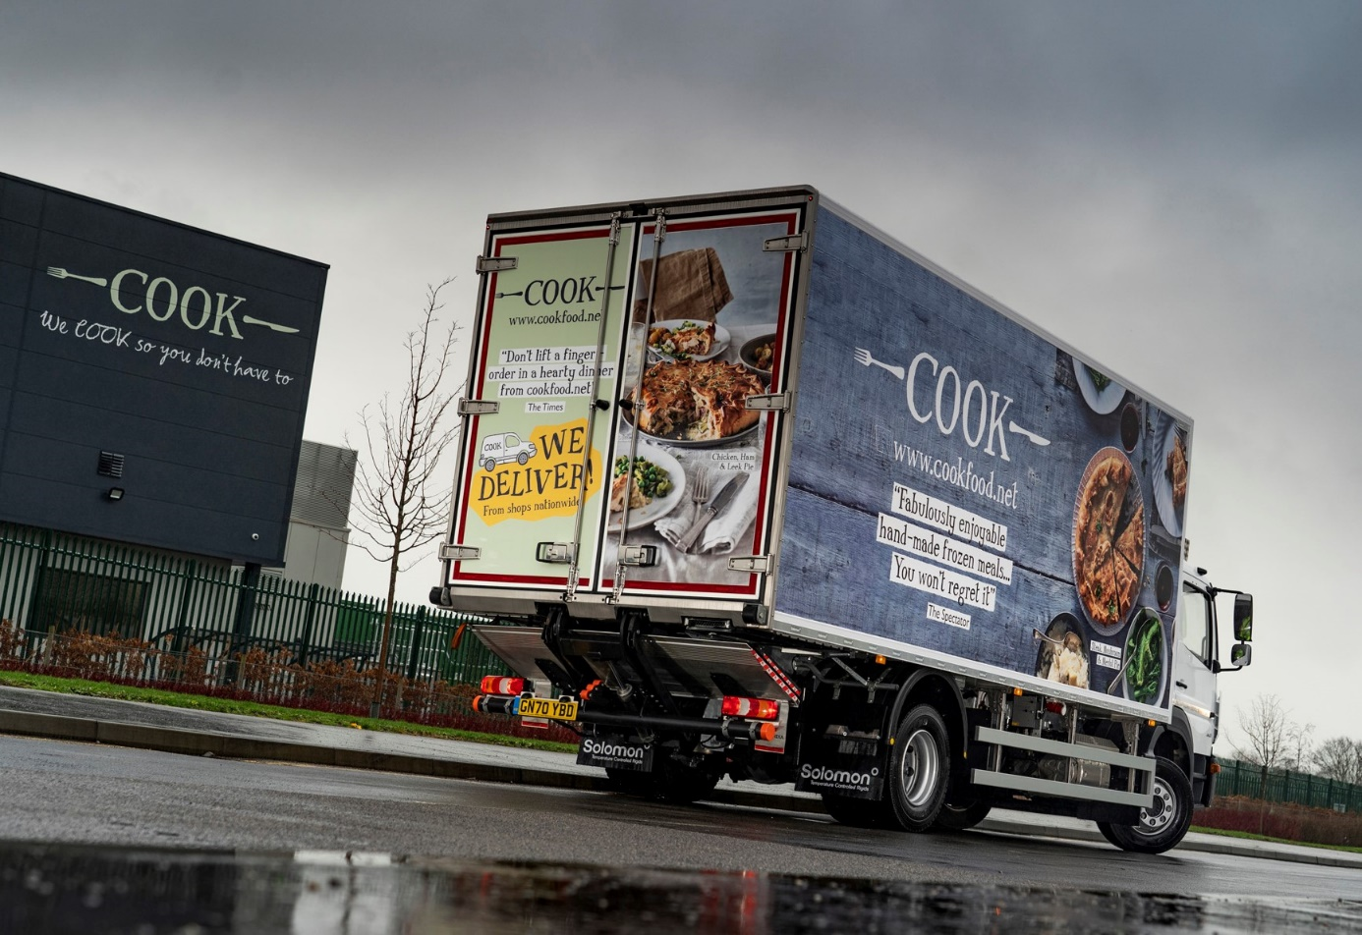

ends

For more information, or to request bigger/higher-res image files, please contact:
Steve Warren or John Ripley
Impact Communications, 01926 842126
Steve: 07770 470251, steve@impactcom.co.uk
John: 07771 484595, john@impactcom.co.uk

