

Date: 10 October 2019

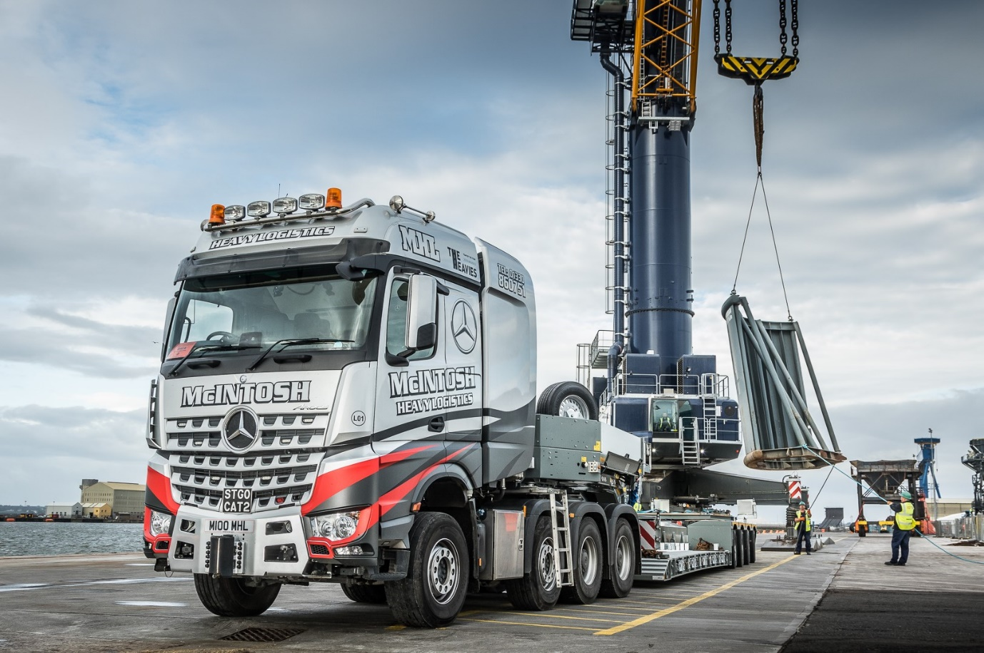

Big-hitting Arocs SLT lays down a Mercedes-Benz marker for McIntosh Heavy Logistics

The first Mercedes-Benz truck to wear the colours of north-east of Scotland’s foremost heavy haulage operator has won enthusiastic praise for its fuel-efficiency and driver appeal.

McIntosh Heavy Logistics, a high-profile supplier to the oil and gas sector, purchased the 8x4 Arocs 4163 SLT tractor unit from the truck-dedicated Bellshill branch of Dealer Western Commercial.

Plated at 180 tonnes GCW, the truck employs a 15.6-litre in-line six-cylinder engine producing a top-rated 460 kW (625 hp), and a Turbo Retarder Clutch which works in conjunction with the 16-speed Mercedes PowerShift automated manual transmission.

McIntosh Heavy Logistics is a division of family-owned McIntosh Plant Hire (Aberdeen), which operates from the purpose-built, 62-acre Birchmoss Plant & Storage depot, near the village of Echt, 12 miles inland from the ‘Granite City’ of Aberdeen. MPH also offers plant and transport hire, civil engineering, and storage services, while its fleet of 40 trucks includes nine Special Types units that work with a variety of trailers.

The company traces its roots back to 1951 but was established in its current form in 1976 by Bert McIntosh and his wife Moira, and expanded strongly through the years of the North Sea oil and gas boom. Their son Gary is the Director responsible for the day-to-day management of the heavy haulage and storage services businesses; his sister Jacqueline is Office Manager, while nephew Darren is a transport controller, and mentored by experienced colleague John Gray.

The Arocs operates on a daily basis with a four-axled Faymonville low-loader, but also works with the operator’s fleet of Nooteboom trailers. McIntosh plans to fit Rockinger couplings to its chassis extensions front and back, so it can also be used for push-pull work with an eight-axled Goldhofer modular trailer.

Western Commercial is a specialist supplier of heavy haulage vehicles and sold the Arocs from stock in January. “We went down to view the truck at the Dealership and having looked it over were very happy to buy it ‘off the shelf’,” recalled Gary McIntosh.

“We’ve been doing this job for many years now, so we know what we’re looking for. The Arocs SLT was very well specified and kitted out, and had a really smart paint job too. We came up with a livery design that complements this and have given it the personalised registration M100 MHL, so it looks fantastic.”

He continued: “Reliability is the most important attribute that we look for in a truck, and I’m delighted to report that with nearly 37,000 km now under its belt, our first Mercedes-Benz hasn’t missed a beat. The Arocs is also impressively economical – average returns of 6.6 mpg stack up very well against the competition.

“We adhere to a ‘one driver, one vehicle’ policy, because this means they treat them as their own, enhancing the performance and longevity of the asset. The Arocs is assigned to one of our best drivers, David Ewan, and he couldn’t be happier with it. He likes the roomy, flat-floored BigSpace cab, and reports that the automated transmission and turbo clutch, which replace the traditional manual ’box and torque converter, make it very easy to drive.”
Designed to be wear-free and fuel-efficient, the Turbo Retarder Clutch is capable of handling and delivering some 3,000Nm of torque, significantly more than a torque converter. It also incorporates its own, powerful integrated retarder; without this, a separate retarder would be necessary to assist the high-performance engine brake in bringing a fully-loaded heavy haulage rig safely to a halt.

McIntosh Heavy Logistics offers complete packages, incorporating route planning, all necessary authority notifications, and end-of-journey off-loading requirements. While it also undertakes the in-house transport of earthmoving equipment for McIntosh Plant Hire, its core business remains the transportation of equipment for major companies operating within the oil and gas industry.

Plummeting oil prices have led to a downturn in the offshore exploration and extraction sector, but Gary McIntosh is sanguine about the future. “This business has always undergone peaks and troughs,” he said. “We plan as best we can, and are encouraged by early signs of recovery and renewed growth within the oil & gas market sector.”

Mr McIntosh added: “Western Commercial’s SLT & Heavy Haulage specialist Paul Mundie looked after us very well. We talked it through over the phone before I arranged a visit to Bellshill, where he showed me over the truck. He also arranged the Mercedes-Benz Complete Service Contract as part of the package.

“It was very clear from our conversations that Paul understands the specialist demands of the heavy haulage sector and I appreciated his input, which helps to explain why I also sought his opinion of the various livery designs we considered. Would we buy another Arocs? Well, on the basis of our experience to date, I’d say it’s certainly right up there.”

www.mphltd.co.uk

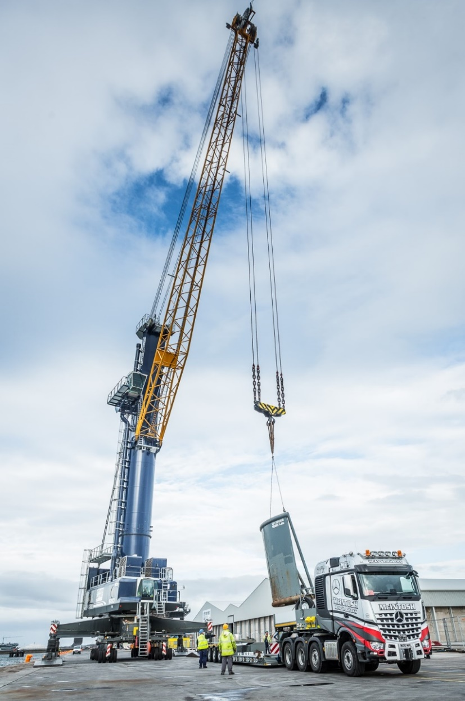
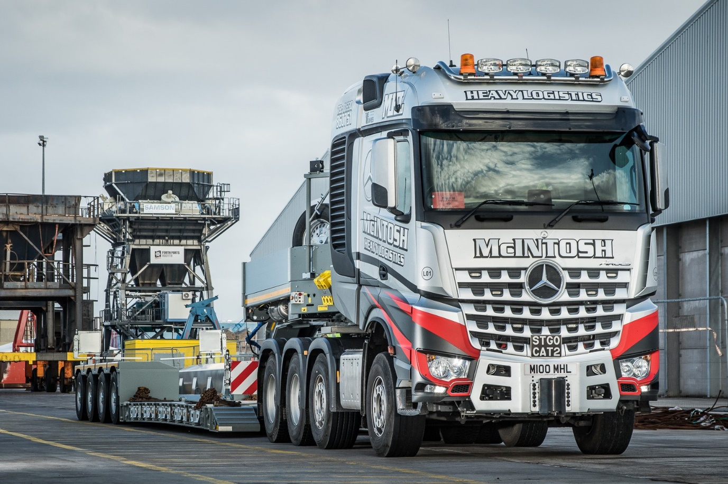

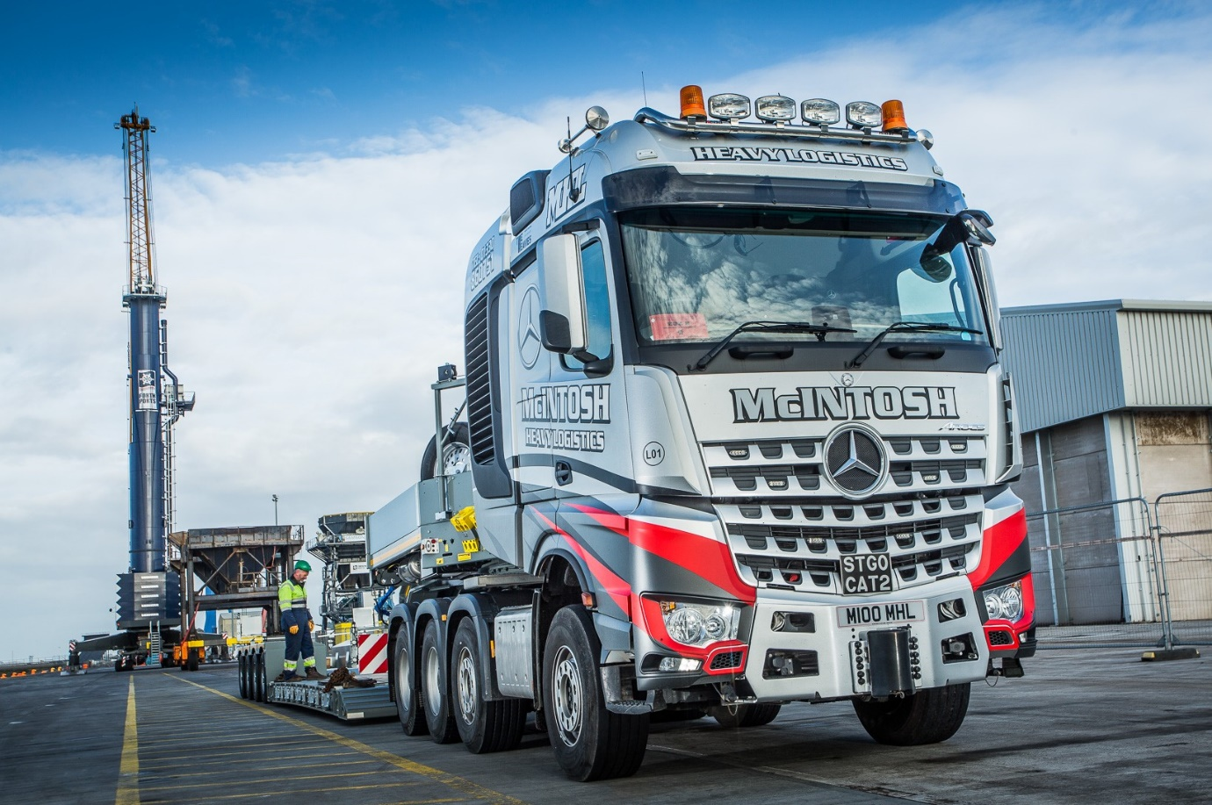

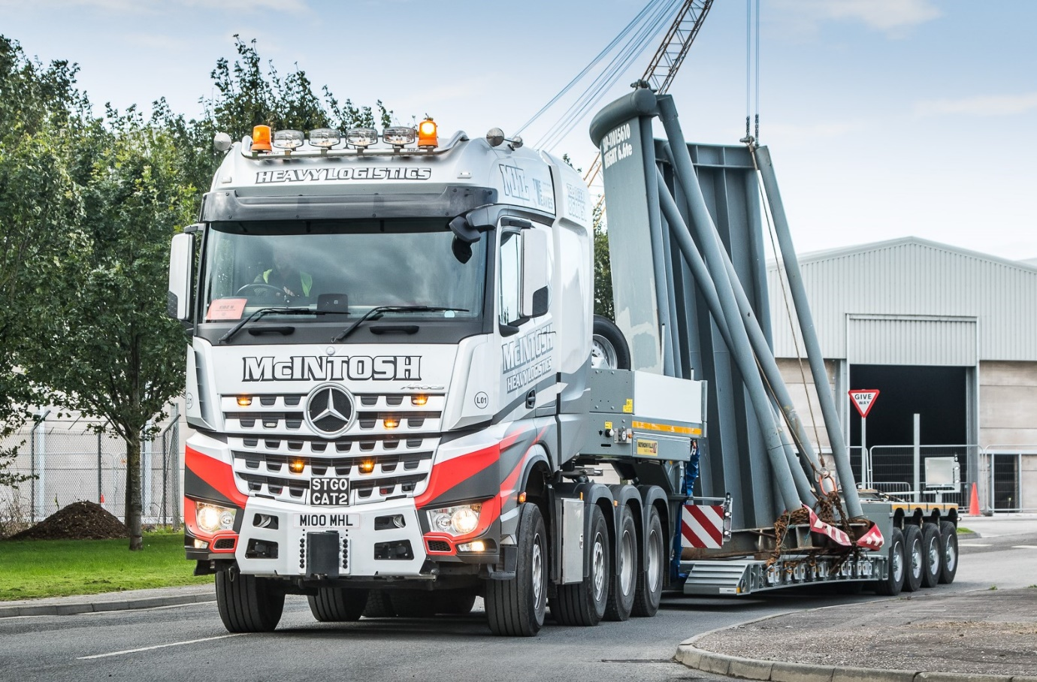

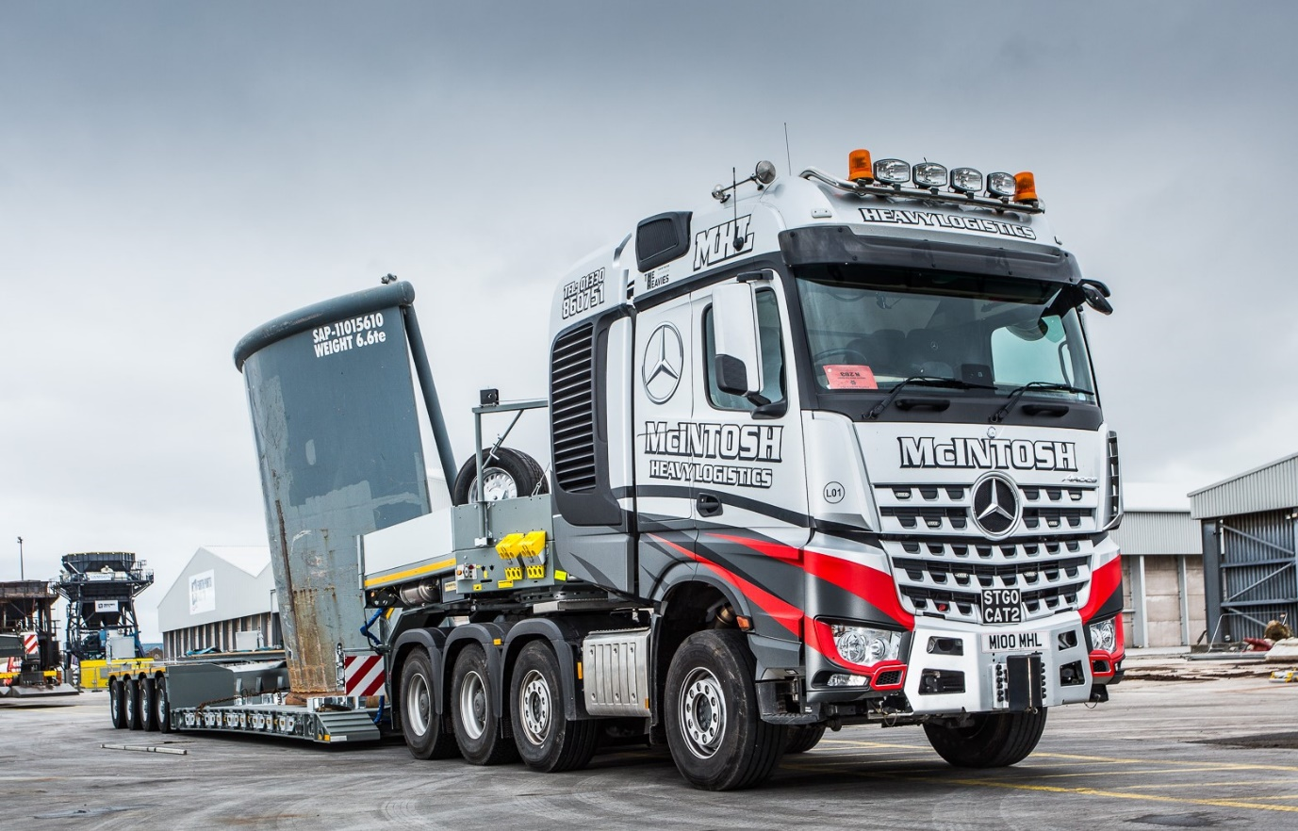

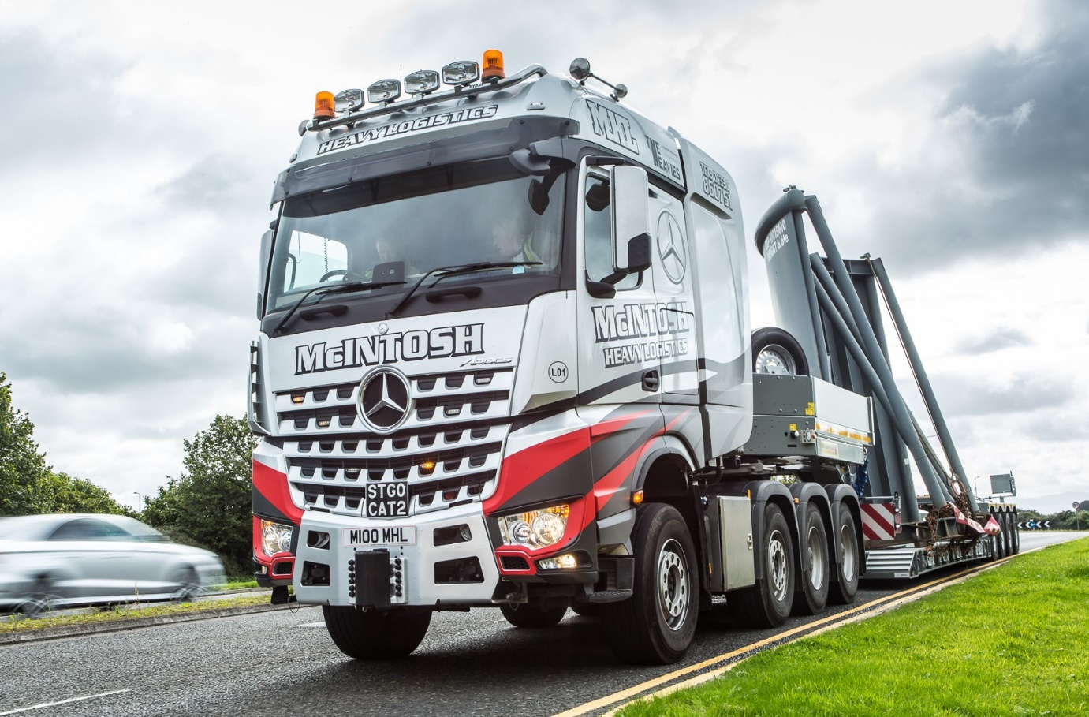

ends

For more information, or to request bigger/higher-res image files, please contact:
Steve Warren or John Ripley
Impact Communications, 01926 842126
John: 07771 484595, john@impactcom.co.uk
Steve: 07770 470251, steve@impactcom.co.uk

