

Date: 27 November 2020

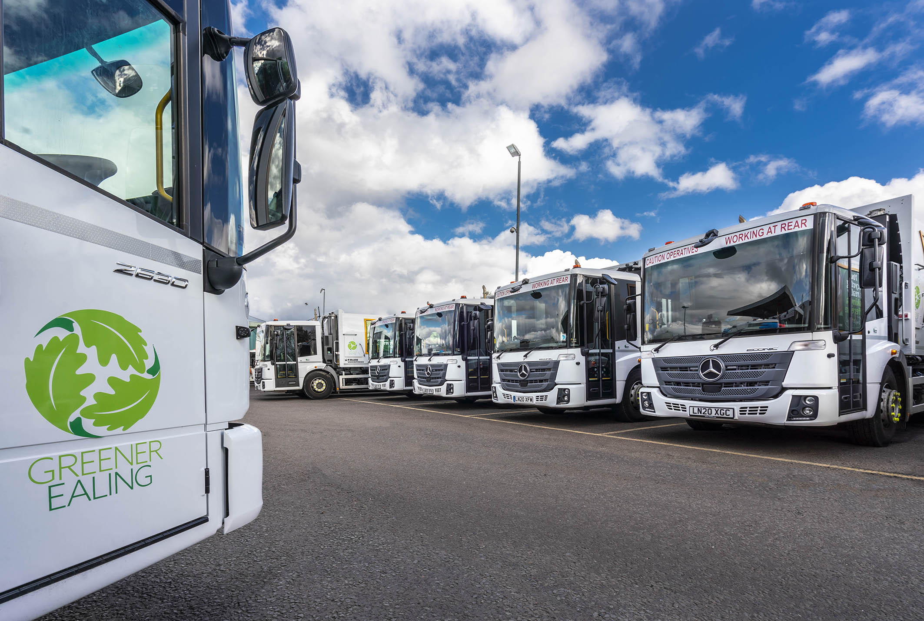

New-start Greener Ealing achieves a seamless transition with 32 well-proven Mercedes-Benz Econics

A recently launched trading company owned by Ealing Council is now relying on a new fleet of Mercedes-Benz trucks to collect waste and recyclables in the West London borough.

Greener Ealing, which took over from the authority’s previous contractor in July, has commissioned 32 Econic refuse collection vehicles as part of a major investment in new equipment.

Supplied by Dealer S & B Commercials, the 26-tonne 6x2 chassis have rear-steer axles that enhance manoeuvrability and are fitted with FAUN Zoeller Variopress compaction bodies and bin lifts. A further three, which will have dual compartment Selectapress bodies with a 70:30 split by the same manufacturer, are still to be delivered.

As specified by Greener Ealing the Econic attracts the maximum five stars from Transport for London’s Direct Vision scheme, thanks to its deep, panoramic windscreen, and full-height, glazed folding side door. This, coupled with the low seating position, allows the driver to make direct eye contact with cyclists and pedestrians at junctions or in traffic queues.

Safety is further enhanced for vulnerable road users by a 360-degree camera system and by Mercedes-Benz Trucks’ Active Brake Assist 4 emergency braking technology. Programmed to recognise other vehicles at higher speeds, as well as pedestrians when moving more slowly, the system is capable of bringing the truck to a complete stop.

As 2630 L models the new trucks are powered by 7.7-litre in-line six-cylinder engines that produce 220 kW (299 hp). Their six-speed Allison automatic transmissions, meanwhile, are purpose-designed for stop-start applications.

Collections of domestic, trade and green waste were previously undertaken by a third-party contractor, but following a strategic review the council resolved to bring the service back under direct control. Rather than moving to a conventional in-house operation, however, it established Greener Ealing, a local authority trading company that can supplement its income by winning commercial contracts.

Initially, though, and especially against the backdrop of the pandemic, Greener Ealing’s focus has been on ensuring that service levels to residents are maintained. In addition to waste collections – it aims to improve on the relatively high recycling rate of 50.24% achieved in 2019 – the new business undertakes functions such as street cleansing, grass cutting and grounds maintenance.

Managing Director Kevin O’Leary confirmed: “Covid-19 brought a number of challenges but we had a very successful launch and achieved a smooth transition from the contractor to the new company. The entire workforce of around 350 staff moved across and benefit from better conditions, with all immediately receiving at least the London Living Wage.”

Key to the seamless transfer of responsibilities for Greener Ealing’s waste and recycling team was their familiarity with the Econic, from both operational and maintenance perspectives. The outgoing contractor also operated an RCV fleet that was dominated by the low-entry Mercedes-Benz; indeed, as well as the 35 new vehicles it ordered from S & B Commercials, Greener Ealing has taken on four of the older Econics, which were registered in 2016. All are inspected and serviced in the council’s own workshop, which is managed by a third-party provider.

Greener Ealing conducted a rigorous tender process for its new RCV fleet. Project Manager John Arnold recalled: “Most respondents based their bids to a greater or lesser extent on the Econic chassis, which offers excellent safety credentials and is ideally suited to the busy, urban environment we have here in Ealing.”

Mr Arnold praised the service that Greener Ealing has received from S & B Commercials, and particularly its Truck Sales Key Account Manager Vick Croker. “There were inevitable delays when Covid hit for the first time but Vick was very ‘up front’ about what was happening and kept us fully advised. He managed to get nine of the new trucks to us before our ‘go live’ date, which was a really great effort and much appreciated.”
S & B Commercials was the prime contractor for the 32 vehicles that are now in service, and Vick Croker worked closely with Mercedes-Benz Trucks’ Municipal Sales & Special Applications Manager Phil Oakey, as well as Commercial Director Stewart Gregory and Business Development Manager Pat Brown at FAUN Zoeller UK, to achieve delivery within the quickest possible timeframe.

Senior Fleet & Compliance Manager Mick Aherne added: “The Econic is very popular with our crews, thanks not least to its roomy, air-conditioned cab, and the full air suspension that contributes to ride comfort. It’s also a product that our technicians already know well, and this can only further enhance its proven reliability.

“Given the urgency with which we wanted to get the vehicles into service, I have been particularly impressed by the quality of the chassis and the bodies as they’ve been delivered. You’ll often have to iron out a few niggles with new trucks but that’s not been the case this time; instead, we’ve been able to deploy them straight away, which has been another big plus.”

Greener Ealing plans to replace its new Econics after five years, a relatively quick turnaround for complex refuse collection vehicles that represent a high capital investment. “We’re very keen to do our bit for air quality in the borough, and to move early to an alternatively fuelled fleet,” explained Mr Aherne. “By 2025 the fully-electric Mercedes-Benz eEconic should be available, and that’s a truck we’ll certainly be looking at.”

ealing.gov.uk

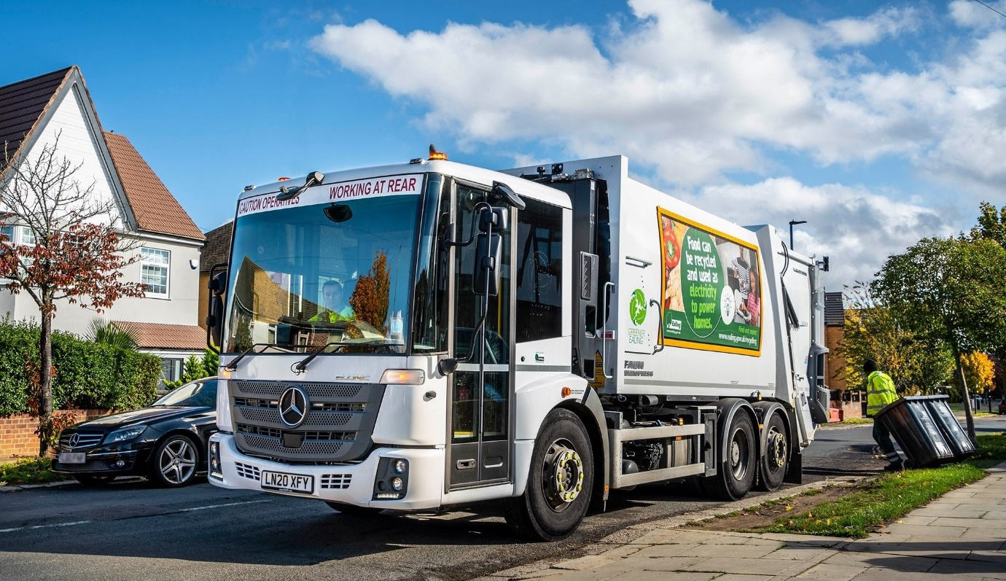

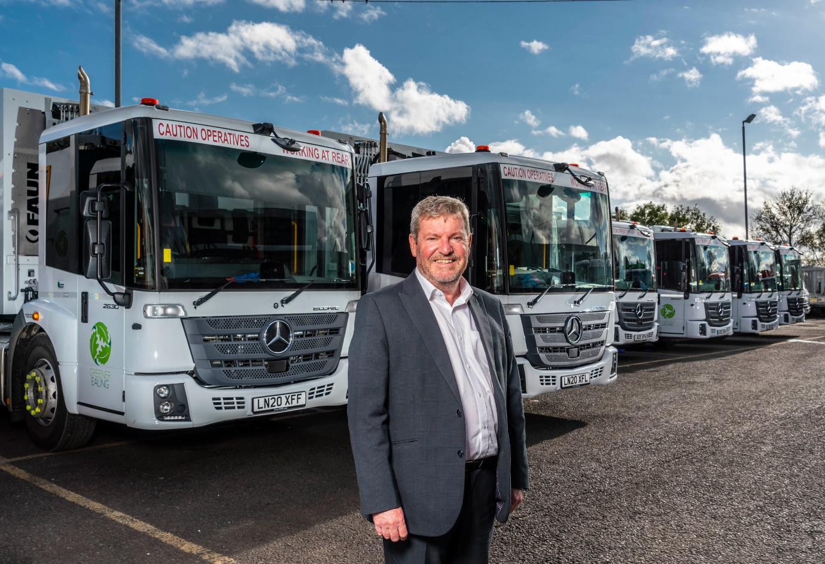

Leading from the front: That’s Greener Ealing Managing Director Kevin O’Leary

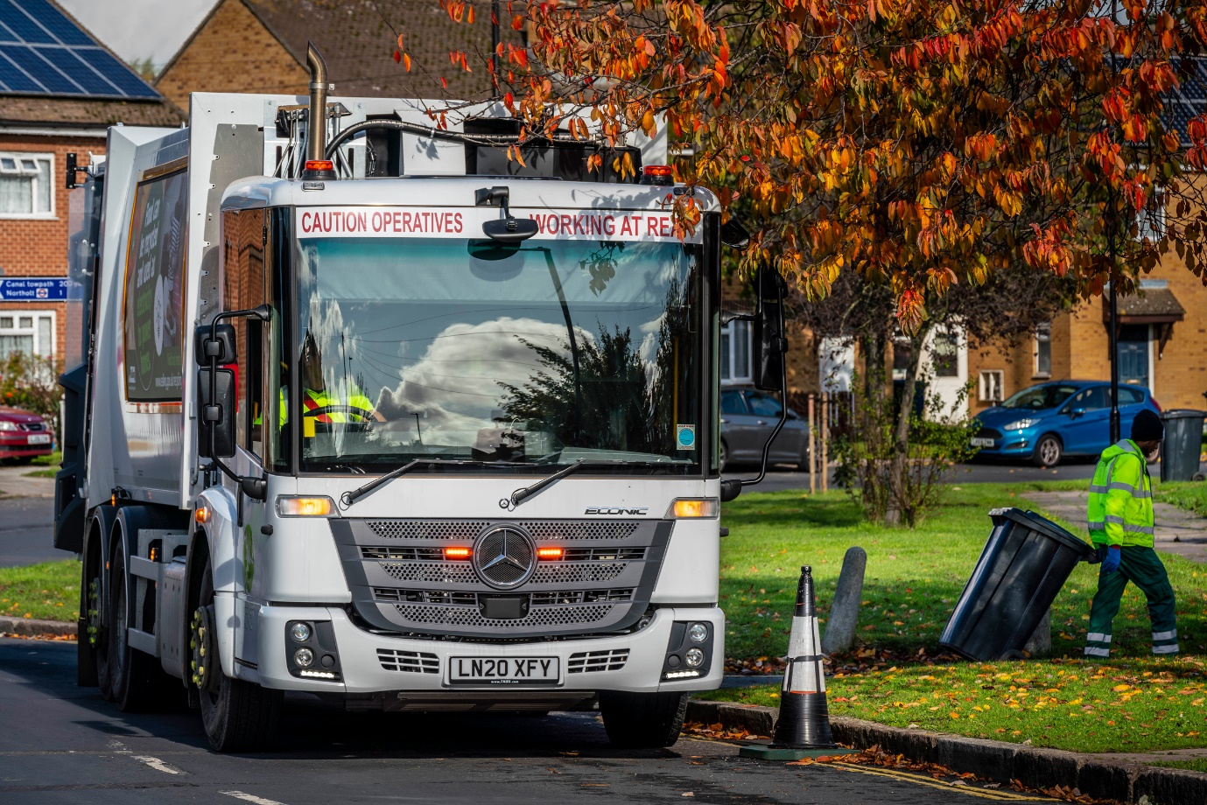

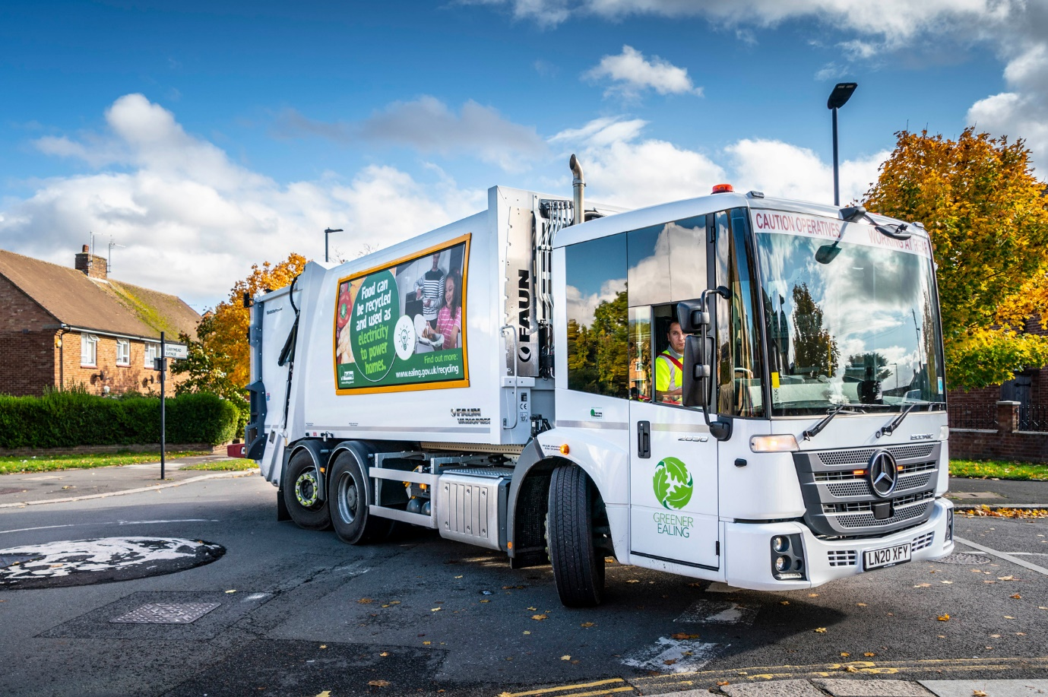

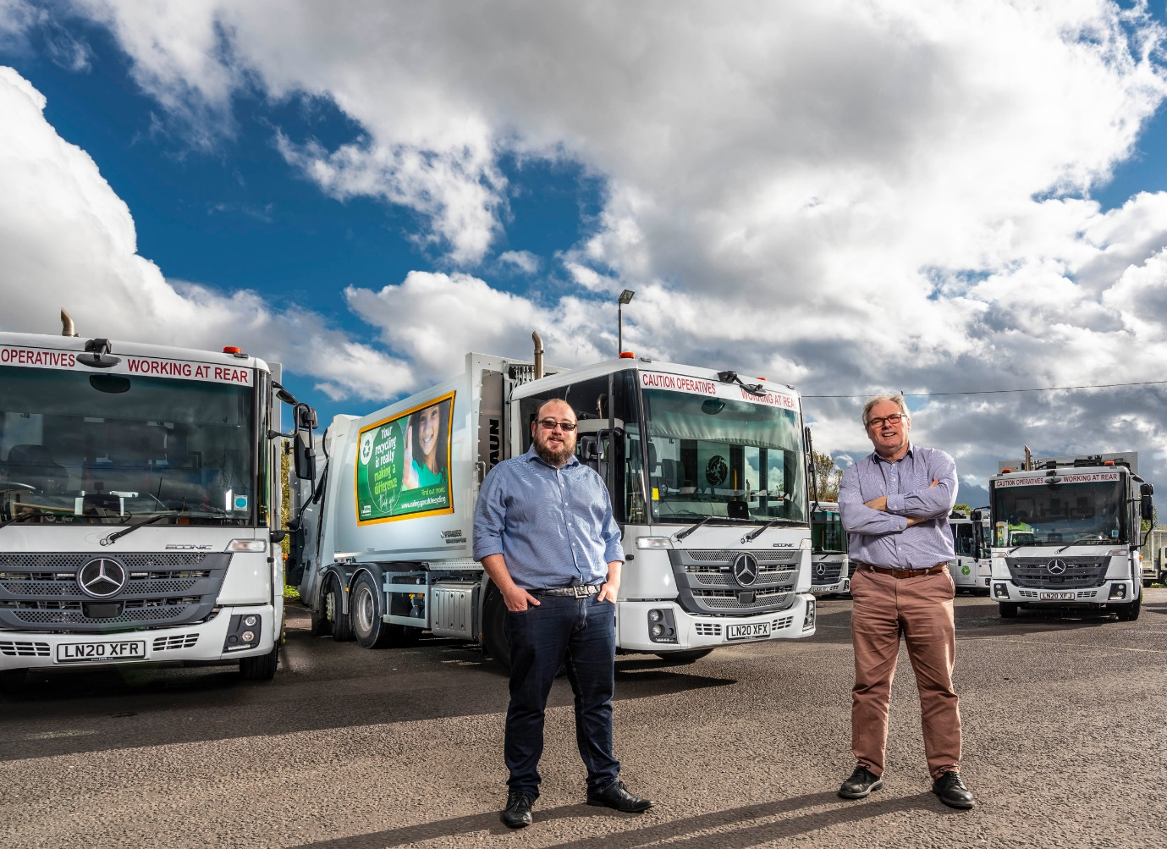

Moving forward with Mercedes-Benz: Greener Ealing Project Manager John Arnold, left, and Senior Fleet & Compliance Manager Mick Aherne

ends

For more information, or to request higher-res image files, please contact:

Jamie Fretwell at Mercedes-Benz Trucks UK Ltd
07712 519230, jamie.fretwell@daimler.com

or

Steve Warren or John Ripley
Impact Communications, 01926 842126
Steve: 07770 470251, steve@impactcom.co.uk
John: 07771 484595, john@impactcom.co.uk

About Mercedes-Benz Trucks UK Ltd
Mercedes-Benz Trucks UK Ltd is the sales and marketing organisation responsible for all Daimler truck products in the UK, including FUSO Canter. In 2019, the company registered 6,963 new trucks. Mercedes-Benz accounted for 6,188 new trucks registered in 2019, making it the third-biggest truck brand in the UK. Meanwhile, FUSO registrations hit 775 – including 580 new trucks over 6.0-tonnes. The flagship new Mercedes-Benz Actros which won the 2020 International Truck of the Year award, features seven core innovations including MirrorCam, Multimedia Cockpit and Active Brake Assist 5. Our premium range of innovative trucks – Actros, Arocs, Atego, Econic and Unimog – draw upon more than 125 years of exceptionally high standards of quality, backed up by our promise of Trucks You Can Trust.
www.mbtrucks.co.uk

