

Date: 28 January 2020

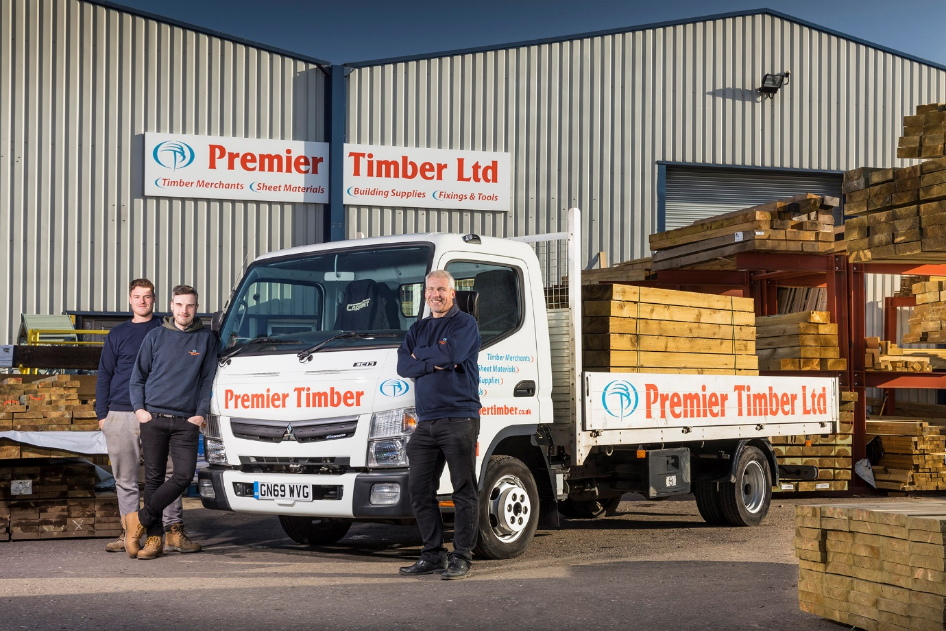

Part of the family: Proprietor Andy Hayward and sons Jamie and Ashley, left, are pictured with their latest FUSO Canter dropsider

Rugged, reliable FUSO Canters are ‘a cut above’ for Premier Timber

Premier Timber bought its first FUSO Canter shortly after it opened for business 20 years ago – to suggest it run any other type of truck now would go very much against the grain.

The family-owned merchant operates from a yard and saw mill in Queenborough, Kent, and has just taken delivery of its latest 3.5-tonne Canter. The subject of an attractively priced Mercedes-Benz Finance lease, the 3C13 model arrived via local Dealer Sparshatt Truck & Van, which also sells and supports vehicles bearing the three-pointed star.

The new truck’s 3.0-litre common-rail turbo-diesel engine produces 96 kW (130 hp) and combines high levels of torque with impressive fuel economy. Its 14ft dropside body is by C&D Fabrications, of Faversham.

Premier Timber was established in 1999 by proprietor Andy Hayward. It supplies high-quality timber, building materials and DIY tools to the trade, including landscaping companies, general builders and contractors, and joiners and carpenters, as well as to the general public. Mr Hayward’s wife Dawn manages the company’s finances, while their elder son Jamie is a Director, and his younger brother Ashley runs the saw mill.

The company serves the South East, including London, although the majority of its customers are located in Kent. While the new truck works within a relatively short radius of base – Premier Timber makes no charge for local deliveries – longer runs are assigned to its second vehicle, a 7.5-tonne Canter which was also supplied by Sparshatt Truck & Van and has been in service for a couple of years.

Andy Hayward recalled: “We bought our first 3.5-tonne Canter in 2000, not long after we started trading. In due course we replaced it with a 7.5-tonner, but then realised we needed a second truck so went back for another small one.

“We’ve been running two vehicles, one of each size, ever since, and update one every couple of years. It’s a policy that’s worked very well for us. Our Canters do exactly what we need them to do. They’re cost-effective to acquire and run, exceptionally reliable, and easily loaded and unloaded.”

The 7.5-tonne FUSO Canter is renowned for its market-leading payload, as well as the compact dimensions and manoeuvrability which make it ideally suited to delivery work in areas with restricted access. Like its larger sibling, the 3.5-tonne Canter employs a ladder frame chassis which contributes to its rugged strength and durability, a major advantage in a segment dominated by van-based vehicles.

Mr Hayward continued: “We tend to use the 7.5-tonner for deliveries to sites, though it’s very nimble and can get up and down narrow tracks too. We don’t go over the top, but it will carry a couple of packs of timber with a combined weight of approximately three tonnes and still leave us with a comfortable margin to spare.

“The 3.5-tonner serves more private customers, so is on and off housing estates and driveways all day. There’s nothing flimsy about it, though; the FUSO is a proper truck, very robust and well built.”

Both Canters are maintained by Sparshatt Truck & Van, the 7.5-tonner under contract as it requires an inspection every six weeks. “The Dealer provides excellent support, which is another reason we’ve remained loyal to FUSO,” added Mr Hayward.

“We’re very busy and our trucks are on the road all day, so the fact that we can get them through Sparshatt’s Sittingbourne workshop overnight is a big help – we drop them off at around 5pm, then pick them up at 7am next day ready to go to work. You can’t get that level of service from other suppliers.”

The latest Canter was supplied by Sparshatt’s dedicated Group Canter Specialist Dan Brunning. Mr Hayward confirmed: “Dan’s very good, and his communication levels are first class. On the odd occasion we need to ask a question about the truck, Dan or one of his colleagues will always come back quickly with an answer. All in all, it’s a thoroughly decent company to work with.”

www.premiertimber.co.uk

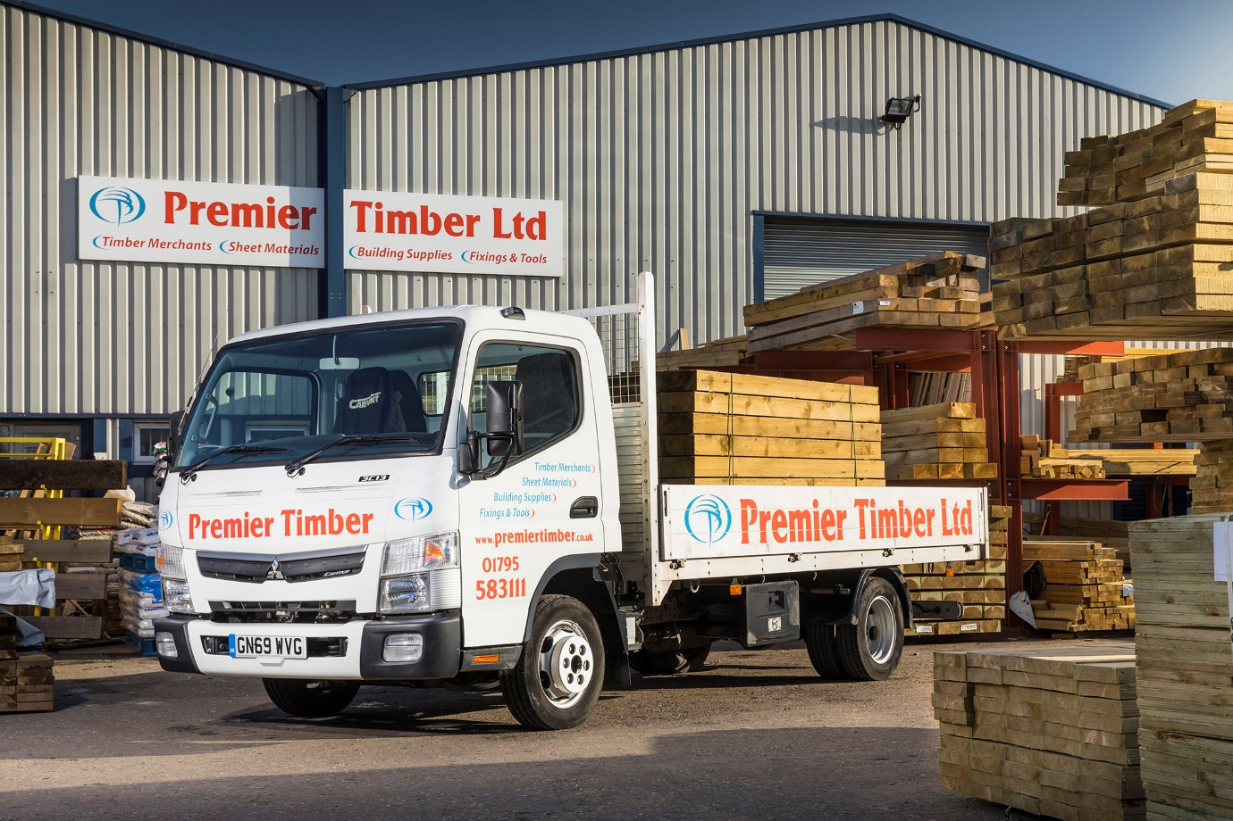

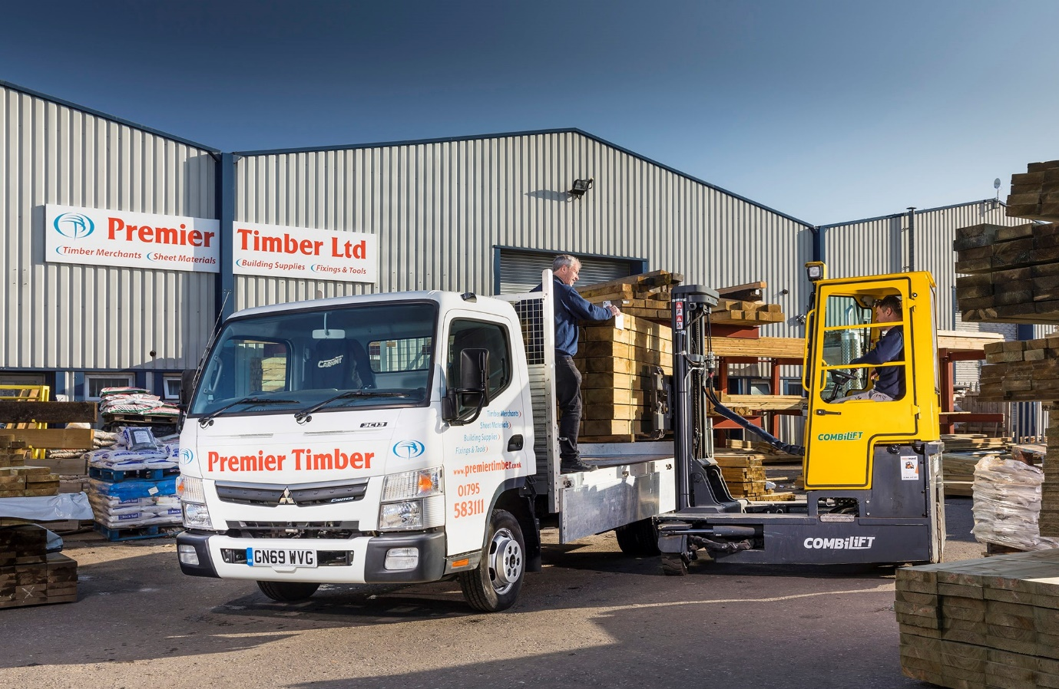

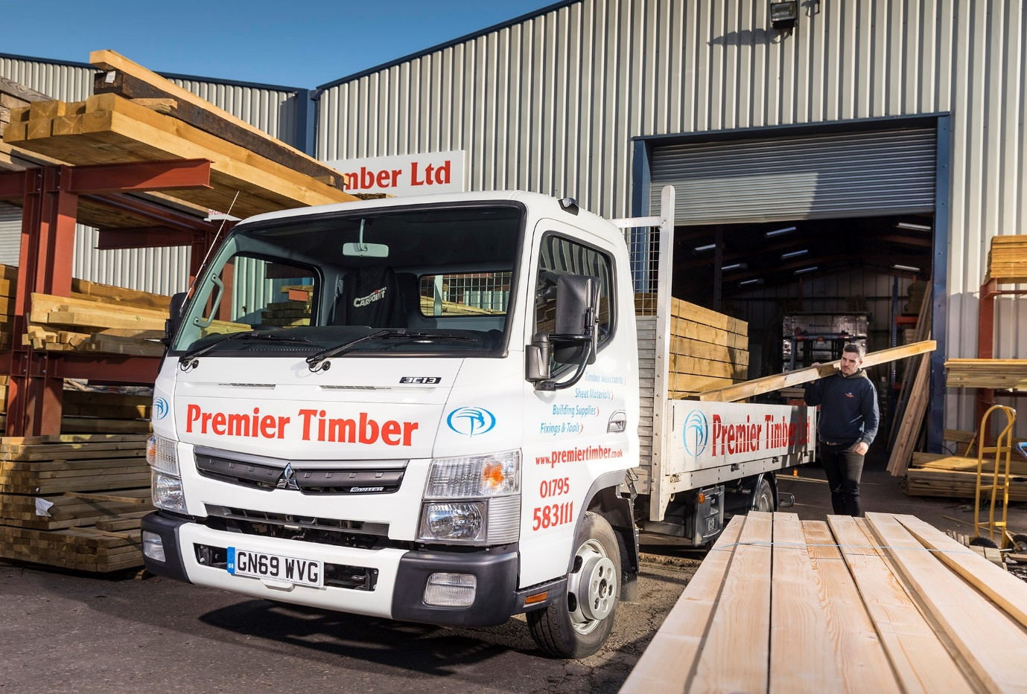

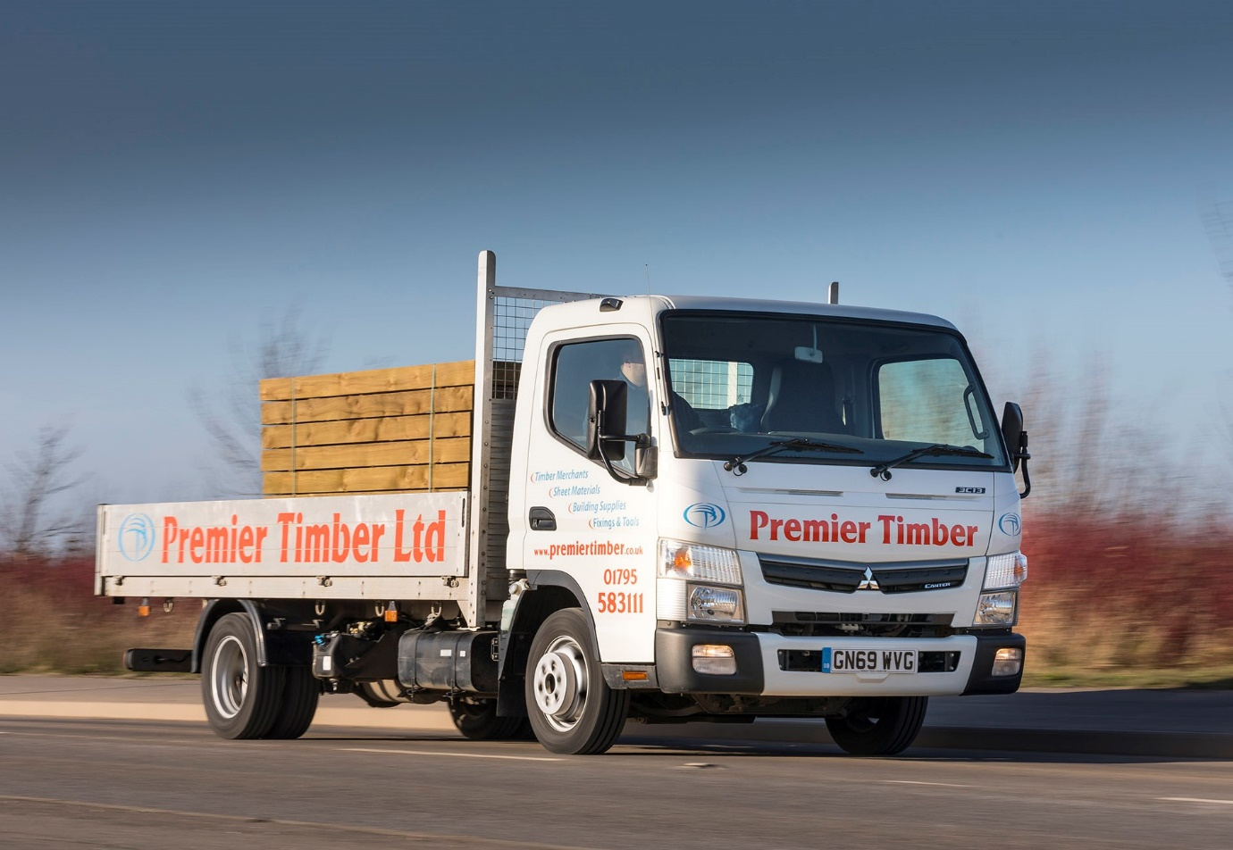

ends

For more information, or to request bigger/higher-res image files, please contact:
Steve Warren or John Ripley
Impact Communications, 01926 842126
Steve: 07770 470251, steve@impactcom.co.uk
John: 07771 484595, john@impactcom.co.uk

