

Date: 22 May 2023

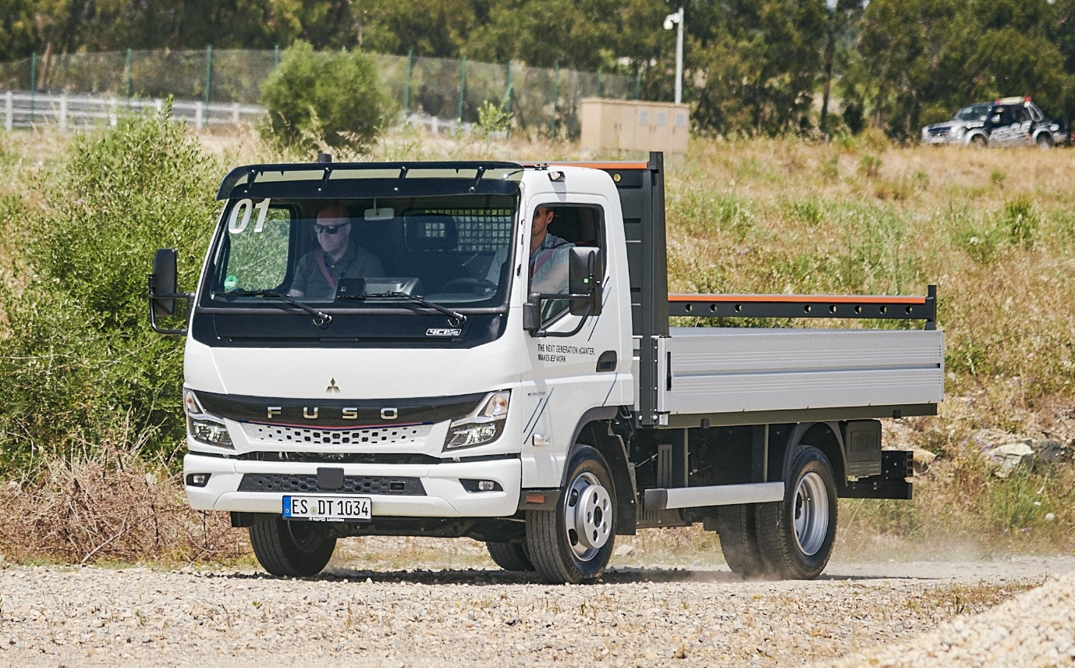

Sustainably Made in Europe: Daimler Truck Subsidiary FUSO celebrates start of production of the Next Generation eCanter

- Ceremonial production start of the Next Generation FUSO eCanter at the FUSO plant in Tramagal, Portugal.

- The Next Generation eCanter is now available in a total of 38 variants with six wheelbases and a gross vehicle weight of 4.25 to 8.55 tonnes.

- 250,000th FUSO Canter from Tramagal since 1980

- Tramagal plant produces CO₂-neutral on the balance sheet and relies on renewable energy sources

Leinfelden-Echterdingen / Tramagal – More powerful, more efficient, longer range – plus a wide variety of applications and CO₂-neutral in driving operation: this is the essence of the Next Generation eCanter from FUSO.

Following its European premiere at the IAA Transportation in Hanover in September 2022, Daimler Truck subsidiary FUSO is celebrating the start of production of the all-electric light truck in Europe. The event at the FUSO Europe production plant in Tramagal, Portugal, brought together company representatives and guests from politics and business to celebrate the first Next Generation eCanter from European production running off the assembly line.

At the event, Karl Deppen, CEO Daimler Truck Asia, and Arne Barden, CEO FUSO Europe, proudly announced another impressive milestone for the Tramagal plant with the 250,000th FUSO Canter produced on-site.

Arne Barden said: “The team is proud to build the iconic FUSO Canter here at Tramagal, now in its fifth generation. Thank you to the highly dedicated team who managed the ramp-up of the Next Generation eCanter with flying colours.” The Tramagal plant has produced the FUSO Canter since 1980.

In the run-up to the event, media representatives had the opportunity to experience the new vehicles at first hand during a factory tour and an exclusive driving event on the Autódromo do Estoril - and the surrounding public roads - to experience the performance of the Next Generation eCanter for themselves. During the driving event, experts from FUSO Europe provided detailed insights into the application versatility of the new vehicle and informed about customised e-mobility solutions.

The Next Generation eCanter: pioneer on the way to sustainable transport

Since the launch of the eCanter in 2017, FUSO, the Japanese subsidiary of Daimler Truck, has been considered a pioneer and frontrunner in electric trucks and has been working consistently to implement sustainable transport solutions. There are now more than 550 FUSO eCanters in customer operation in Europe, Japan and the United States, as well as in Australia and New Zealand.

The total distance covered by the global eCanter fleet in all-electric and thus locally emission-free mode is now around eight million miles – equivalent to about 200 circumnavigations of the globe. The Next Generation eCanter is now taking this success story to a new level.

Production of the all-electric light truck already started in the first quarter at the sister plant in Kawasaki, Japan. Kawasaki delivers the FUSO Next Generation eCanter in Japan as well as in all other non-European markets worldwide. In Europe, sales of the FUSO Next Generation eCanter will initially start in 17 markets (France, Spain, Portugal, Italy, the UK, Ireland, Germany, Austria, Switzerland, Belgium, the Czech Republic, Denmark, Sweden, Finland, Slovakia, Greece and Poland).

More variants for greater flexibility

In order to meet customer requirements even better, FUSO has made several adjustments to the Next Generation eCanter. While the previous electric truck was exclusively available as a 7.49-tonner with a wheelbase of 3,400 millimetres, customers now have the choice of six wheelbases between 2,500 and 4,750 millimetres and a permissible gross vehicle weight of 4.25 to 8.55 tonnes. The load capacity of the chassis is up to 5 tonnes. The Next Generation eCanter is powered either by a 110 kW (variants with a gross vehicle weight of 4.25 tonnes) or 129 kW (variants with a gross vehicle weight of 7.49 and 8.55 tonnes) electric motor with an optimised driveline and 430 Nm of torque; the maximum speed is 89 km/h (electronically limited).

Depending on the wheelbase, three different battery packs are available: S, M and L. The batteries use lithium iron phosphate (LFP) cell technology. These are characterised above all by a long service life and more usable energy. The battery pack in the S variant has a nominal capacity of 41 kWh and enables a range of up to 70 kilometres. In the M variant, the nominal capacity is 83 kWh and the range is up to 140 kilometres. The L variant, as the most powerful package, offers a nominal capacity of 124 kWh and a range of up to 200 kilometres. This is far more than the distance usually covered per day in light distribution traffic. Recuperation can increase the range even further, while at the same time minimising charging breaks. In comparison, until now the eCanter has only had a battery option with a nominal capacity of 81 kWh and a range of up to 100 kilometres.

As far as battery charging is concerned, the Next Generation eCanter is compatible with all main voltages in the major markets. The charging unit supports charging with both alternating current (AC) and direct current (DC). The Combined Charging System CCS is the charging standard, and charging is possible at up to 104 kW. DC fast charging from 20 to 80 percent of capacity is possible in approximately 24 (S), 26 (M) and 39 minutes (L), depending on the battery pack. AC charging (11 and 22 kW) takes between around four and six hours, depending on the battery pack.

FUSO Europe’s Tramagal plant: A pioneer in sustainability

As part of its overall ecological strategy, the FUSO Europe plant in Tramagal has already successfully reduced its CO₂ emissions on a step-by-step basis over the past few years, and by the end of 2022, balance sheet CO₂-neutrality in production has been implemented. In order to reach this milestone, FUSO Europe has among others continuously expanded the use of renewable energy sources and completed the conversion to green power sources.1,200 solar panels on the hall roofs produce up to 350 megawatts of electricity per year. Future targets are to produce up to 600 megawatts of electricity. In addition to expanding photovoltaic systems, the plant is also testing technologies for the local production of green hydrogen.

Reducing water consumption is another measure in the field of sustainability the site is focusing on: its own new water treatment plant already treats more than 60 percent of process water and returns it to the production cycle. At the same time, an optimised rainwater collection system is in the works for more sustainable irrigation of the green areas. FUSO Europe employs around 500 people in Tramagal. The company is the largest employer in the region. From Portugal, the vehicles go to 32 European countries as well as Morocco. FUSO Europe is a major exporter and Portugal’s third-largest vehicle manufacturer.

“Made in Europe” for the FUSO Next Generation eCanter does not only refer to the vehicle assembly in Tramagal: more than 50 percent of the electric truck’s components come from over 90 different European suppliers. In line with the production of the all-electric FUSO eCanter, FUSO Europe has also been successively converting its entire internal logistics and warehouse fleet to locally emission-free, electric vehicles since last year.

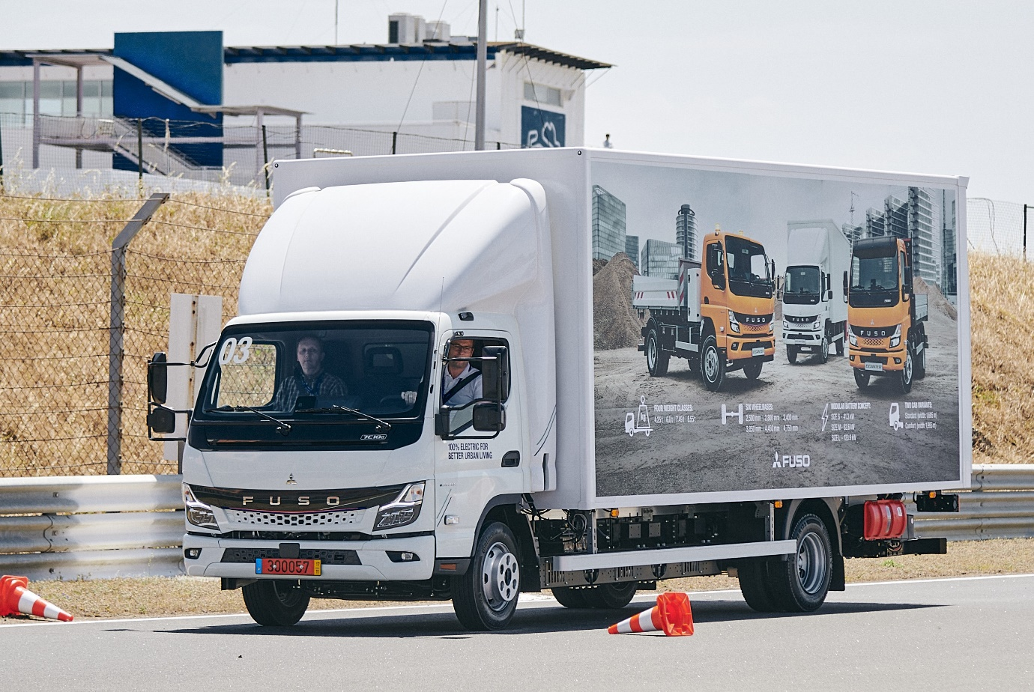

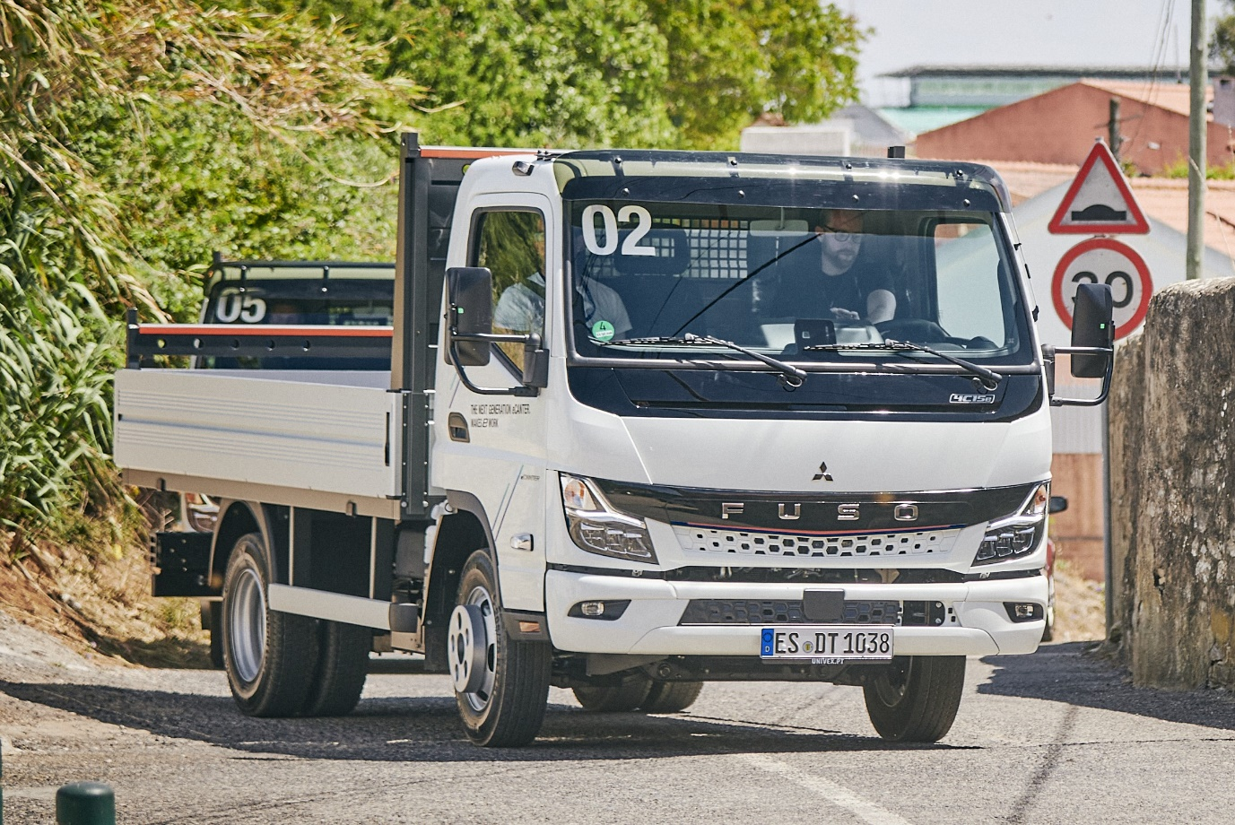

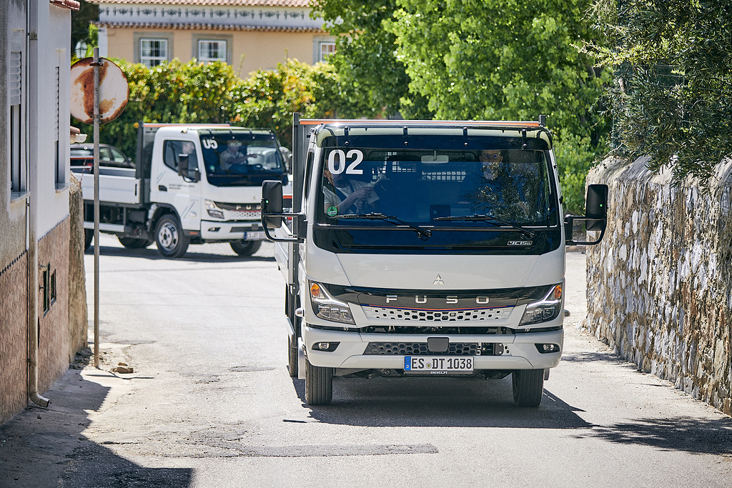

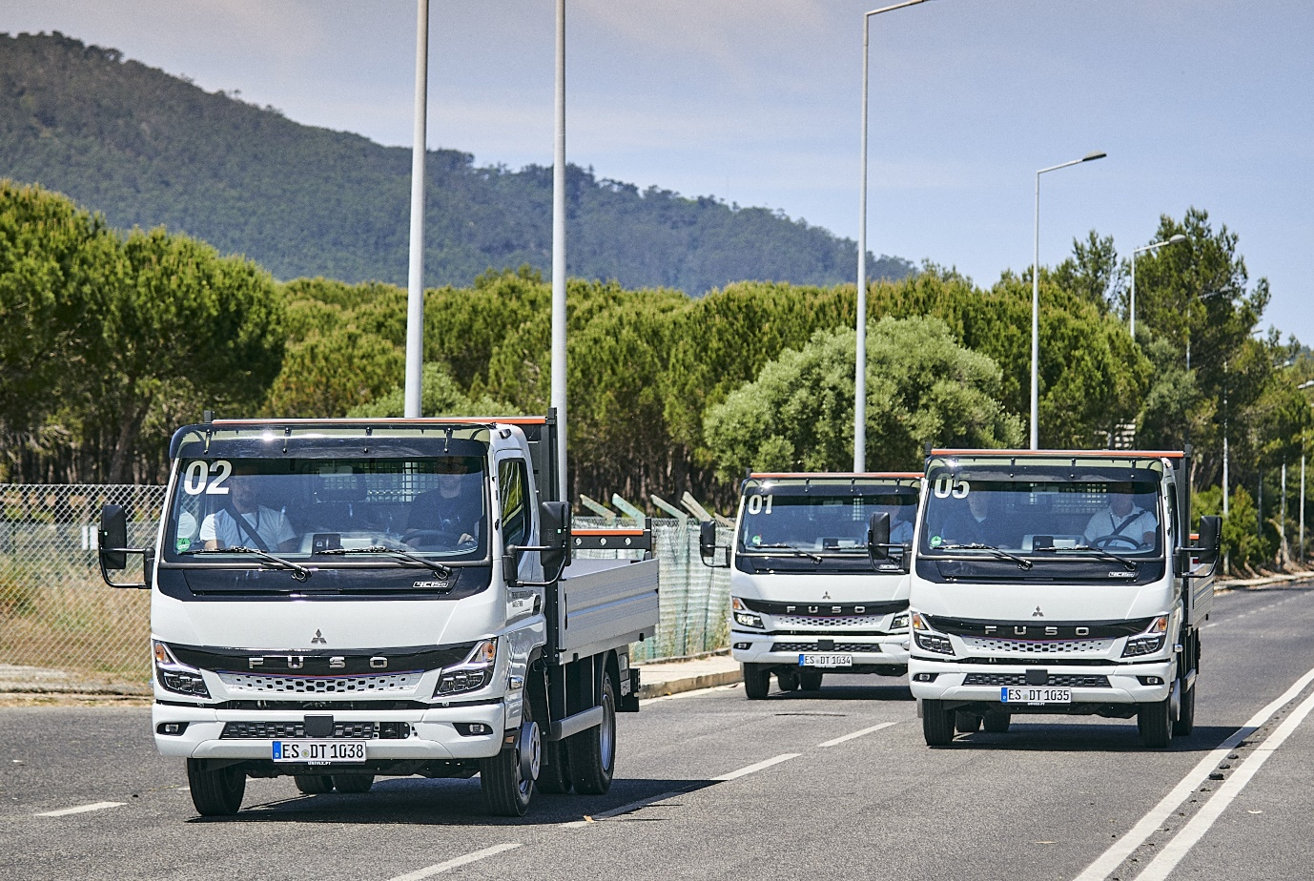

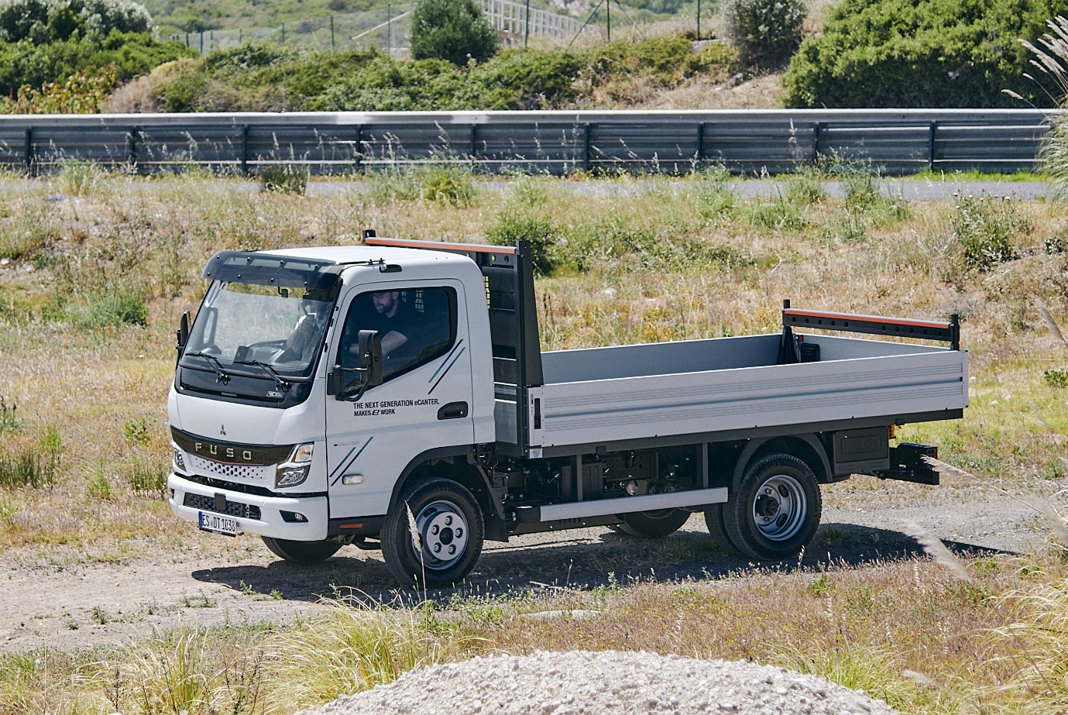

ends

For more information, or to request higher-resolution images, please contact:

Jamie Fretwell: 07712 519230, jamie.fretwell@daimlertruck.com

or

John Ripley: 07771 484595, john.ripley@loopagency.co.uk

or

Maximilian Splittgerber: +49 (0) 160 860 71 24, maximilian.splittgerber@daimlertruckcom
Carolin C. Fritze: +49 (0) 160 864 13 54, carolin.c.fritze@daimlertruck.com

Further information on Daimler Truck and FUSO is available at:
www.media.daimlertruck.com, www.daimlertruck.com and www.fuso-trucks.com

Forward-looking statements:
This document contains forward-looking statements that reflect our current views about future events. The words “aim”, “ambition”, “anticipate,” “assume,” “believe,” “estimate,” “expect,” “intend,” “may,” ”can,” “could,” “plan,” “project,” “should” and similar expressions are used to identify forward-looking statements. These statements are subject to many risks and uncertainties, including an adverse development of global economic conditions, in particular a decline of demand in our most important markets; a deterioration of our refinancing possibilities on the credit and financial markets; events of force majeure including natural disasters, pandemics, acts of terrorism, political unrest, armed conflicts, industrial accidents and their effects on our sales, purchasing, production or financial services activities; changes in currency exchange rates, customs and foreign trade provisions; a shift in consumer preferences; a possible lack of acceptance of our products or services which limits our ability to achieve prices and adequately utilise our production capacities; price increases for fuel or raw materials; disruption of production due to shortages of materials, labour strikes or supplier insolvencies; a decline in resale prices of used vehicles; the effective implementation of cost-reduction and efficiency-optimization measures; the business outlook for companies in which we hold a significant equity interest; the successful implementation of strategic cooperations and joint ventures; changes in laws, regulations and government policies, particularly those relating to vehicle emissions, fuel economy and safety; the resolution of pending government investigations or of investigations requested by governments and the conclusion of pending or threatened future legal proceedings; and other risks and uncertainties, some of which are described under the heading “Risk and Opportunity Report” in the current Annual Report. If any of these risks and uncertainties materializes, or if the assumptions underlying any of our forward-looking statements prove to be incorrect, the actual results may be materially different from those we express or imply by such statements. We do not intend or assume any obligation to update these forward-looking statements since they are based solely on the circumstances at the date of publication.

Daimler Truck at a glance
Daimler Truck Holding AG ("Daimler Truck") is one of the world's largest commercial vehicle manufacturers, with over 40 main locations and more than 100,000 employees around the globe. The founders of Daimler Truck have invented the modern transportation industry with their trucks and buses a good 125 years ago. Unchanged to this day, the company's aspirations are dedicated to one purpose: Daimler Truck works for all who keep the world moving. Its customers enable people to be mobile and get goods to their destinations reliably, on time, and safely. Daimler Truck provides the technologies, products, and services for them to do so. This also applies to the transformation to CO2-neutral driving. The company is striving to make sustainable transport a success, with profound technological knowledge and a clear view of its customers' needs. Daimler Truck's business activities are structured in five reporting segments: Trucks North America (TN) with the truck brands Freightliner and Western Star and the school bus brand Thomas Built Buses. Trucks Asia (TA) with the FUSO and BharatBenz commercial vehicle brands. Mercedes-Benz (MB) with the truck brand of the same name. Daimler Buses (DB) with the Mercedes-Benz and Setra bus brands. Daimler Truck's new Financial Services business (DTFS) constitutes the fifth segment, the product range in the truck segments includes light, medium and heavy trucks for long-distance, distribution and construction traffic and special-purpose vehicles used mainly in the municipal and vocational sector. The product range of the bus segment includes city buses, school buses and intercity buses, coaches and bus chassis. In addition to the sale of new and used commercial vehicles, the company also offers aftersales services and connectivity solutions.

