

Date: 2 November 2022

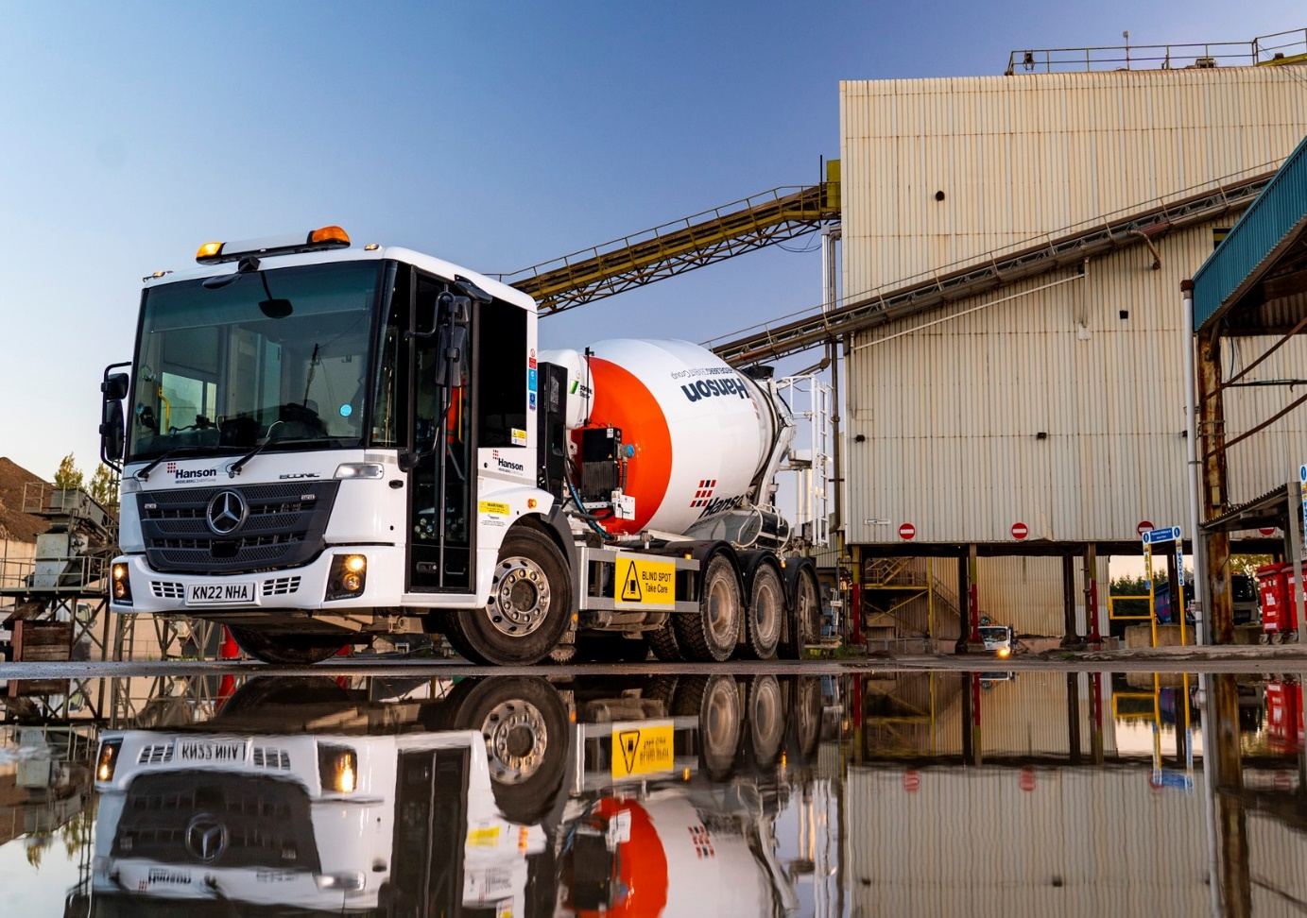

Best UK chooses the UK’s best low-entry mixer, a Mercedes-Benz Econic from Intercounty Truck & Van

When Best UK Transport needed another concrete mixer truck for work in and around London, owner-driver Andrei Balean returned without hesitation for a second eight-wheeled Mercedes-Benz Econic.

“For this application there’s nothing to touch the Econic,” he said. “It combines the reliable, cost-effective performance for which Mercedes-Benz is renowned, with fantastic visibility from the low-entry cab.”

Ilford-based Andrei acquired his latest vehicle from the Peterborough branch of Dealer Intercounty Truck & Van. It wears the colours of leading customer Hanson UK, and works from the concrete giant’s depot in Dagenham, Essex, delivering to construction sites throughout London.

Best UK Transport’s new truck is fitted with an 8m³ Schwing Stetter drum. As a 3235 L variant it employs a 7.7-litre six-cylinder engine that produces 260 kW (354 hp) and drives through a fuel-efficient 12-speed Mercedes PowerShift 3 automated manual transmission.

The truck’s ENA configuration – single front steer axle, double-drive bogie and rear-steer axle – gives it an impressively tight turning circle. The resulting, enhanced manoeuvrability compared to a standard 32-tonne construction eight-wheeler is a major advantage for operation in the capital.

A driver for 20 years, Andrei established Best UK Transport in 2011. His company, which holds Silver accreditation from FORS (the Fleet Operator Recognition Scheme), also runs a second Econic – a 68-plate model with McPhee mixer – and an 8x4 Mercedes-Benz Arocs tipper, purchased as a used truck in 2020.

The Econic’s deep, panoramic windscreen and the full-height, glazed folding side door chosen by Best UK afford unrivalled visibility. Coupled with a seating position which is much lower than that of a conventional construction vehicle, this allows drivers to make direct eye contact with vulnerable road users, particularly cyclists and pedestrians, a major advantage in enabling each to understand the other’s intentions.

Thus specified, the Econic achieves the highest five-star Direct Vision Standard rating from Transport for London. Safety-focused Hanson UK, which is part of the Heidelberg Cement Group, runs a substantial fleet of its own Econics, and encourages its franchisees – particularly those operating in urban areas – to do likewise.

Best UK Transport’s Econic is also equipped with Active Brake Assist 5 emergency braking technology, which boasts an industry-leading pedestrian recognition capability, and an Electronic Parking Brake that is applied automatically when the engine is switched off.

Active Brake Assist 5 combines camera and radar technology to detect vehicles ahead and stationary objects in its own lane, at speeds of up to 56 mph (90 km/h). Detection of a dangerous situation triggers a three-stage reaction: first, the system warns the driver with visual and audible alerts; then, if the driver fails to react, it applies partial (approximately 50%) braking; finally, if the driver has still not intervened, it initiates maximum braking to bring the truck to a halt, applying the Electronic Parking Brake and activating the hazard warning lights to alert drivers behind.

At speeds of up to 31 mph (50 km/h) Active Brake Assist 5 is capable of applying full braking when encountering pedestrians crossing its path, approaching from the front or walking ahead. Not only does this remarkable system increase safety for vulnerable road users and vehicle crews, but it also helps to relieve stress for drivers.

Andrei Balean said: “With the addition of a 360-degree camera system this Econic is the safest, most compliant vehicle available, and effectively future-proofs my business against any tightening of regulations that might be coming down the line.

“It’s also great to drive, the low seating position and wide field of vision making the job of negotiating busy city streets much less stressful. As an all-round package the Econic is unbeatable for this role.”

As with all new Econics supplied through the manufacturer’s UK Dealer network, Best UK Transport’s latest truck is covered by a three-year/160,000 km warranty.

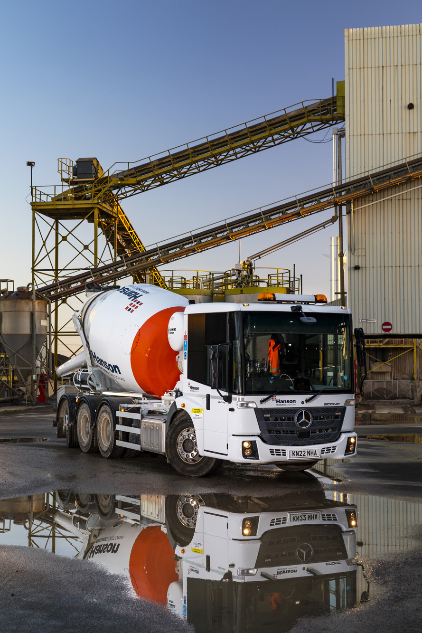

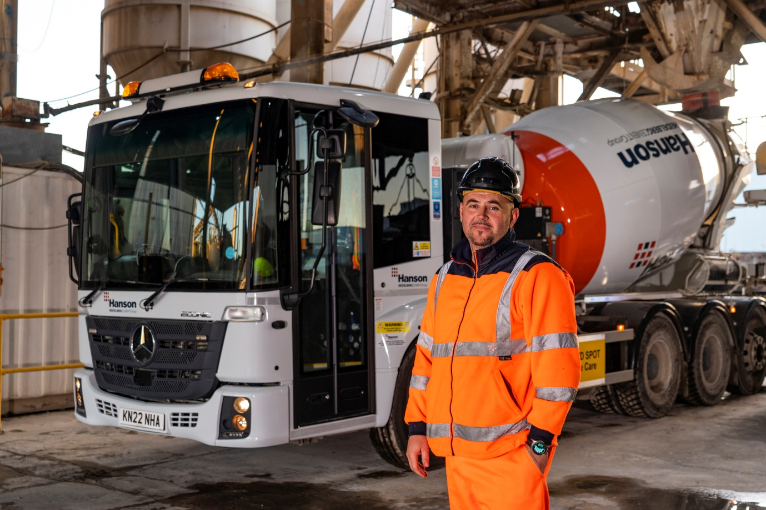

Vision on: Best UK Transport’s Andrei Balean benefits from the Econic’s clear field of view

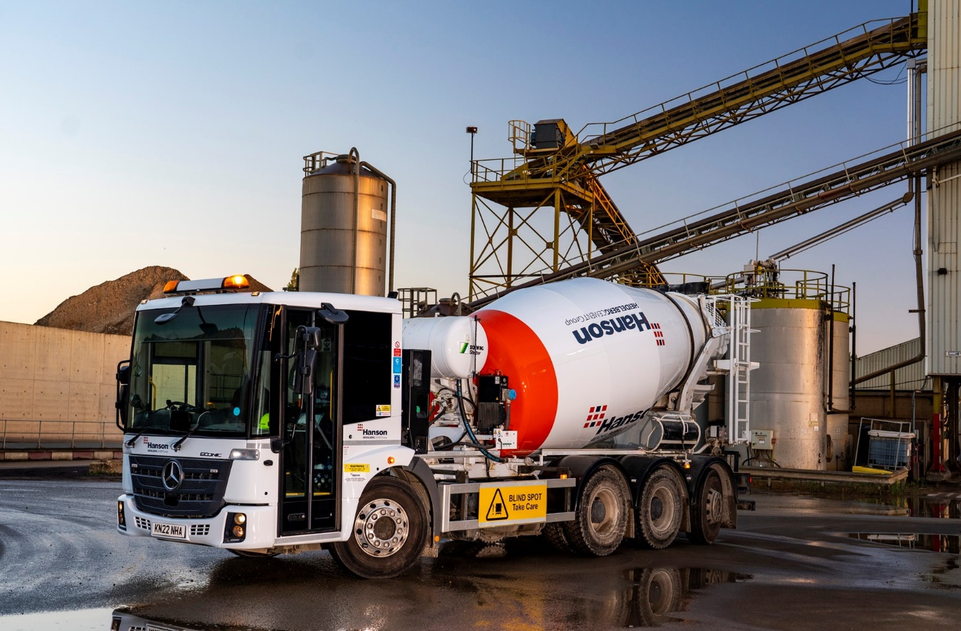

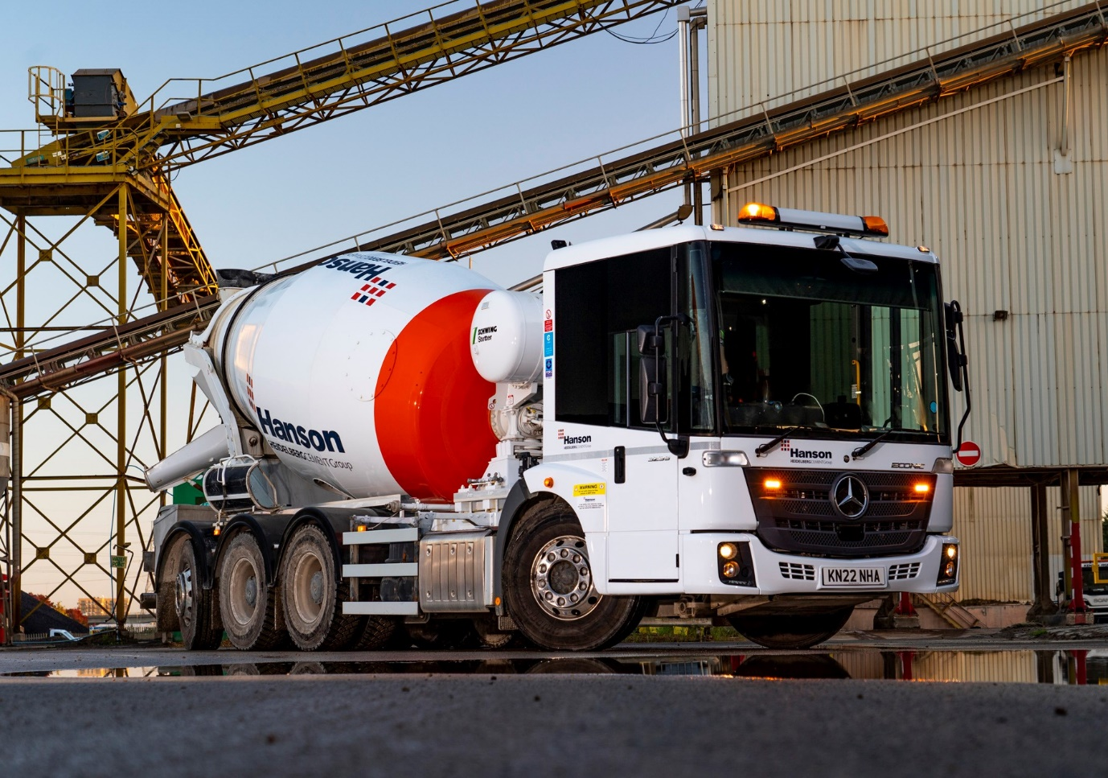

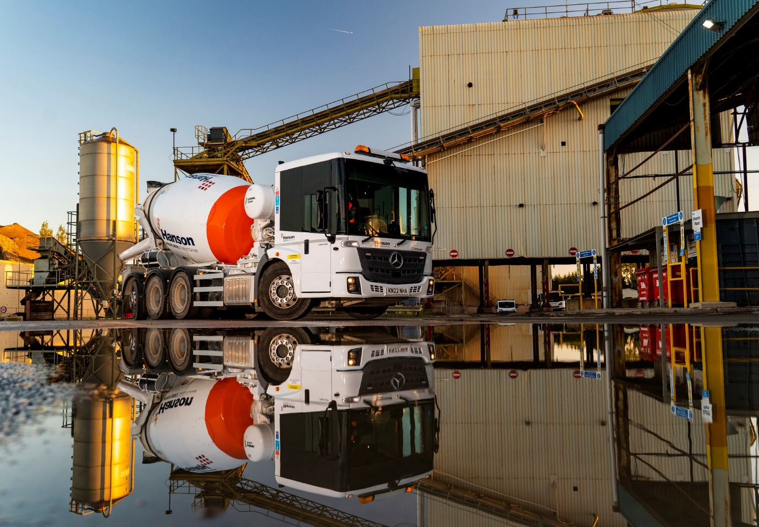

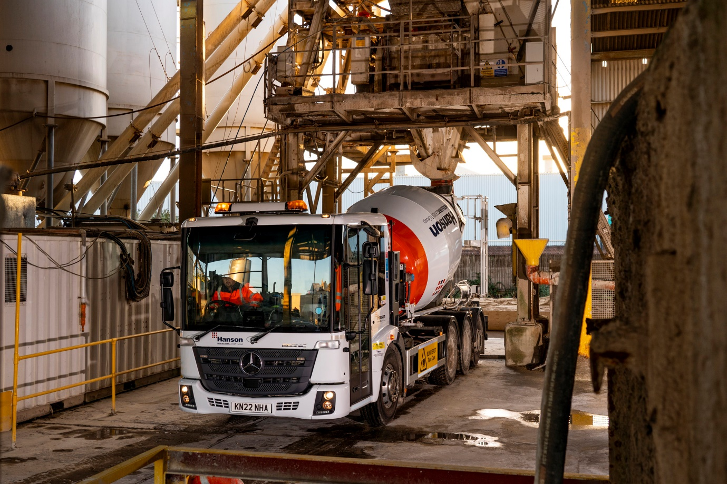

ends

For more information, or to request bigger/higher-res image files, please contact:
John Ripley or Steve Warren
Impact Communications
John: 07771 484595, john@impactcom.co.uk
Steve: 07770 470251, steve@impactcom.co.uk

