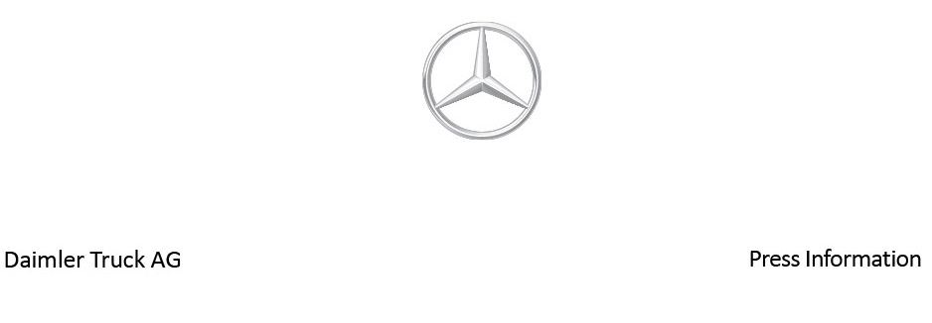

Date: 25 May 2022

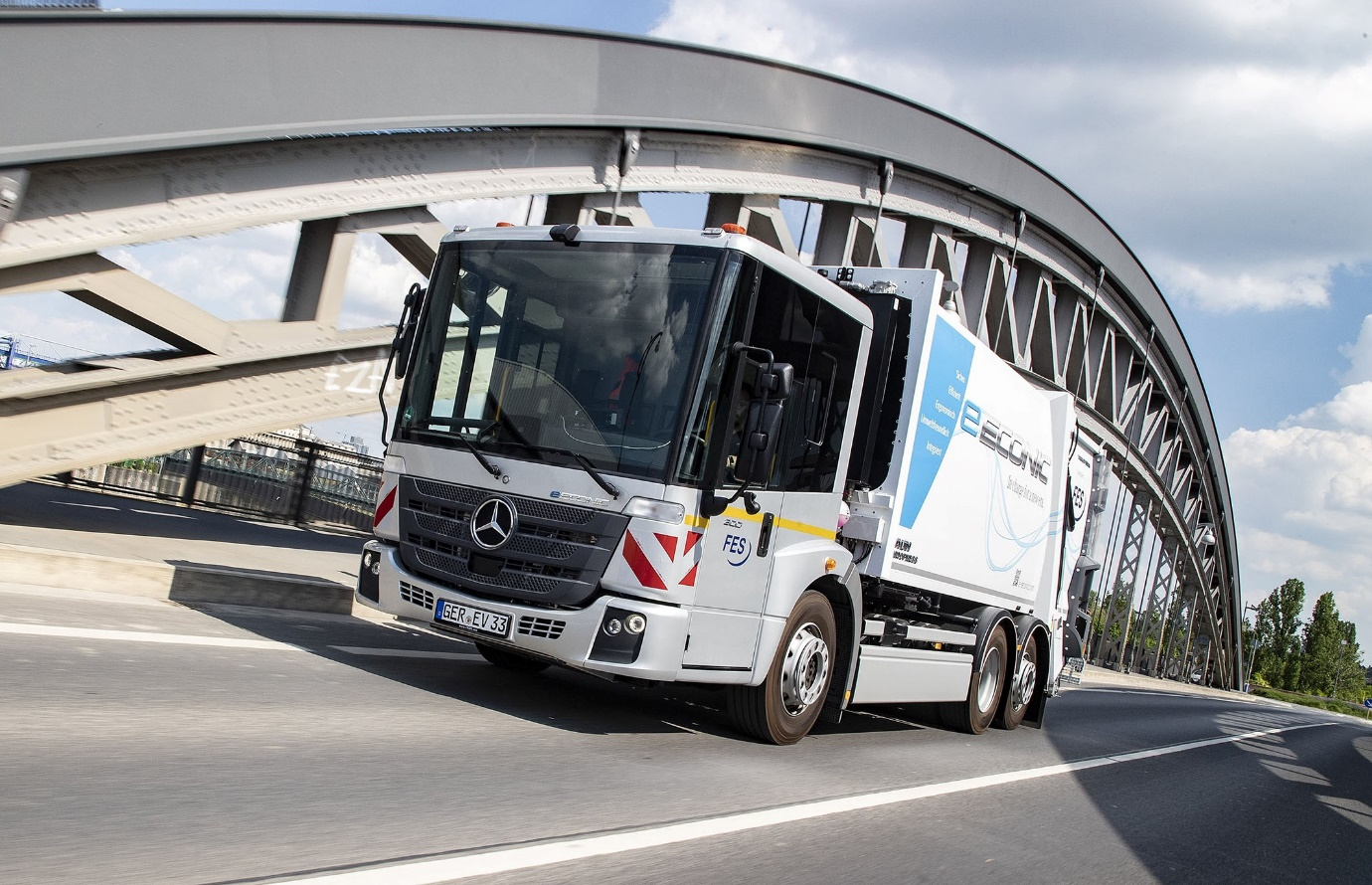

Zero local emissions: The battery-powered eEconic will cover the vast majority of waste collection routes in single-shift operation without intermediate charging

Mercedes-Benz Trucks showcases sustainable municipal mobility solutions at IFAT 2022 in Munich

- The all-electric eEconic celebrates its trade fair premiere at IFAT

- Operating as a waste collection vehicle, the eEconic can cover almost all inner-city waste collection routes on just a single battery charge

- For the first time Mercedes-Benz Trucks is showcasing the eActros with electrified tipper solutions

- eActros and eEconic are each part of an integrated overall offering which also includes comprehensive eConsulting and intelligent digital solutions

- Mercedes-Benz also presents the Unimog as a reliable powerhouse with a wide range of attachment and body options for a wide variety of applications

- Dr Ralf Forcher, Head of Mercedes-Benz Special Trucks, says: “We are facing the challenge of reconciling safe mobility, the environment and quality of life in urban environments. Our all-electric commercial vehicles are locally CO2-neutral, emit low levels of noise and are therefore the ideal solution, especially for municipal use.”

Stuttgart/Munich – Whether for waste disposal, snow clearing, street cleaning, grass cutting or just on the building site, municipal vehicles are used in a wide variety of ways. Cost-effectiveness, performance, safe handling and environmental friendliness are top priorities for companies. Mercedes-Benz Trucks offers a vast portfolio for this purpose, as shown by its attendance at this year’s IFAT Munich, the world’s leading trade fair for water, sewage, waste and raw materials management.

From 30 May to 3 June, 2022, the company will be giving global decision-makers, procurers and users detailed insights into its vehicle range and customer-oriented mobility concepts at Stand 341/343 in Hall C6, as well as outdoors. Highlights include the battery-powered eEconic and eActros trucks as well as various Unimog vehicles.

As Dr Ralf Forcher, Head of Mercedes-Benz Special Trucks, says: “We are facing the challenge of reconciling safe mobility, the environment and quality of life in an urban context. Our all-electric commercial vehicles are locally CO2-neutral, emit low levels of noise and are therefore the ideal solution, especially for municipal use.”

All-electric municipal use: First time at a trade fair for eEconic

Early-morning commuter traffic, turning into narrow, double-parked residential streets, quickly emptying bins and containers: waste disposal is an important part of the modern circular economy. Refuse collection is hard work that requires great care, attention and strength, and the Econic from Mercedes-Benz Trucks has proved itself the chassis of choice among many waste collection companies over the years, as can be seen in various municipalities across the world.

Mercedes-Benz Trucks is heralding a new era in this series in the form of the eEconic, which is being showcased for the first time at a trade fair at this year’s IFAT and is due to enter series production in the second half of 2022. Since May, FES Frankfurter Entsorgungs- und Service GmbH has been testing how the waste disposal expert measures up in practice with a battery-powered electric drive in a customer trial. This low-floor truck with a permissible gross weight of 27 tonnes and an e-axle with integrated drive unit, as well as the two electric motors, is based on the eActros for heavy-duty distribution haulage, which celebrated its world premiere at the end of June 2021 and has already joined the fleets of numerous transport companies.

The series-production eEconic model employs three battery packs, each with an installed capacity of 112 kWh¹ and a usable capacity of around 97 kWh². The e-truck can cover the vast majority of typical Econic waste collection routes in single-shift operation without intermediate charging. Disengaging the gears when driving downhill or rolling to a traffic light can even recover some electrical energy through recuperation. This is a great advantage, especially as part of stop-and-go operation in waste collection. The Interactive Multimedia Cockpit installed as standard in the eEconic provides a continuous stream of information on the state of charge, the remaining range, and the current and average energy consumption in kWh per 100 kilometres.

The truck can be charged with up to 160 kW: three battery packs require just over an hour to charge from 20% to 80% at a standard DC fast charging station with 400 A charging current³. The eEconic is also ready for use in harsh winter conditions, having been extensively tested by Mercedes-Benz Trucks in the Arctic Circle, where a near-production vehicle worked reliably even at ambient temperatures as low as -25 °C. Engineers evaluated the thermal management, pre-conditioning and energy-efficient pre-entry climate control of the eEconic, using various charging stations and also simulating a waste collection route.

Features for high driving comfort and safety

Features of the conventional Econic that have proved particularly popular with customers have also been transferred to the eEconic. For example, the deep, panoramic windscreen, combined with a low seating position provides the driver with excellent direct vision of vulnerable road users, not to mention urban traffic. The coated and heated Thermocontrol windscreen prevents the cab from weather-related fogging, increasing the clear view of the traffic area. The windscreen coating also reduces the extent to which the vehicle interior heats up due to sunlight.

The eEconic’s low position allows for joint-friendly, one-step access to the spacious cab, which offers space for a crew of up to four people. The electric drivetrain also makes it possible to have a flat cab floor, making it easier to climb through the cab – a particular advantage if the driver wants to get out through the folding door on the front passenger side facing away from traffic. As far as safety equipment is concerned, the eEconic is equipped as standard with S1R Sideguard Assist for greater safety when turning, as well as the fifth-generation Active Brake Assist emergency brake assistant with pedestrian detection. An external Acoustic Vehicle Alerting System is also fitted to make it easier for pedestrians or cyclists to hear the truck, in accordance with legal requirements.

At IFAT, Mercedes-Benz Trucks will be showcasing the eEconic with a waste collection body from Zöller: the Medium X4 22.5 Clean Drive. The Clean Drive body, specially designed for all-electric chassis with high-voltage interface, consists of an electrified collection box (22.3 cubic meters capacity) with two internal electric motors including directly-mounted hydraulic pumps, converter and a rectifier.

eActros with an all-electric PTO solution

Like the Econic, the Actros from Mercedes-Benz Trucks has also been one of the most popular commercial vehicles in the municipal sector for many years thanks to its flexible body options. Since the start of eActros series production, the premium truck has been hitting the streets with a battery-electric drive. So far, it has been used specifically in heavy-duty distribution haulage, but the eActros can also benefit operators in other applications with its CO2-neutral and low-noise transportation of goods.

For this purpose, and as part of a pilot project, Mercedes-Benz Trucks has set up the eWorX all-in-one solution developed by ZF together with a PALFINGER skiploader in an eActros. The aim is to efficiently electrify PTOs for operating hydraulic equipment such as skiploaders or hookloaders, cranes or lifting platforms. The advantage: Complete locally emission-free operation and greatly reduced noise levels, which in particular makes it easier to use in cities and residential areas.

PALFINGER electric skiploader in conjunction with eActros and eWorX from ZF

This year’s Mercedes-Benz Trucks stand at IFAT will feature this all-in-one solution in the form of an eActros 300 with the PS T 18 skiploader from PALFINGER. Thanks to its user-friendly design and the asymmetrical and individually controllable lifting arms, the tipper with radio remote control is able to load containers quickly, even when awkwardly positioned. A new feature is the integration of ZF’s eWorX system. This establishes the connection between the vehicle’s energy management system and the body. For optimized operational efficiency, eWorX integrates components such as the electric motor, power inverter, electronic control unit and application-specific software modules into a plug-and-work one-box solution.

The traction battery of the eActros provides the ZF eWorX system with electrical energy over a DC interface. The eWorX electric motor in turn uses this to drive the hydraulic pump for the tipper. Thus, there is no need for a mechanical connection to the traction motor. eWorX ensures smooth communication between the eActros and the body via the CAN bus interface.

Together, ZF, PALFINGER and Mercedes-Benz Trucks created various test and demonstration vehicles to gain a holistic understanding of the system across a wide range of different applications and to create a standardised approach to the communication between vehicle and body. As a full-service provider of lifting solutions, PALFINGER contributed its expertise to the requirements of its wide-ranging product and solution portfolio, from different types of loading cranes to hookloaders and skiploaders and access platforms.

An eActros 300 with the RS21.65 hookloader made for transporting containers is also being showcased at the MEILLER stand. It features the eWorX ZF system acting as a link between vehicle and tipper. The advantage of the system is the hydraulic operation on demand. In other words, the pump only runs when the body is moved. This prevents unnecessary energy consumption. There is also none of the noise a combustion engine would generate, which is a huge advantage when the vehicle is used in sensitive areas such as residential streets in the early hours. The tipper itself is equipped with a radio remote control, a load-dependent overdrive system for high working speeds and hydraulic scissor-type under-run protection with front position lamps.

High-tech for sustainable performance

Mercedes-Benz Trucks relies on the ePowertrain for the eActros in the form of an electric rigid axle with two integrated electric motors and a two-speed transmission. Both liquid-cooled engines generate a continuous output of 330 kW as well as a top performance of 400 kW. The batteries of the eActros comprise either three (eActros 300) or four battery packs (eActros 400), each of which offers an installed capacity of 112 kWh⁴ and a usable capacity of around 97 kWh⁵. With four battery packs, the eActros 400 has a range of up to 400 kilometres⁶. The eActros can be charged at up to 160 kW: Three battery packs in the eActros 300 require just over an hour to charge from 20% to 80% at a standard DC fast charging station with 400 A charging current⁷.

The standard safety equipment includes the external Acoustic Vehicle Alerting System in accordance with legal requirements, the fifth generation of Active Brake Assist with pedestrian detection and the S1R Sideguard Assistant. The Sideguard Assist uses the MirrorCam display for visual warning notices, which is installed in the eActros in place of conventional main and wide-angle mirrors. The second generation of the mirror camera system has been in use since April 2022. It provides the driver with even better support in many road-traffic situations thanks to the camera arms being 10 centimetres shorter on each side, plus new imaging parameters.

Smart digital solutions for even more efficient use

In order to maximise the use of the eActros and eEconic, to integrate electric trucks into an operator’s daily routine in the best possible way, save time and effort, and to make the switch to e-mobility as easy as possible, Mercedes-Benz Trucks provides its customers with a whole range of digital solutions from the Fleetboard Portal. This includes, for example, individually devised charging management for creating charging profiles and a logbook with detailed information on driving, idle and charging times. Also available is a mapping tool that shows in real time the current location of a vehicle, whether it is driving, stationary or charging, and the state of charge of the battery.

The Mercedes-Benz Complete service contract is also available for the eActros and eEconic to ensure optimum vehicle deployment. The comprehensive service package covers workshop work for maintenance and repair of the overall vehicle as well as the drivetrain, including wear and tear parts. The service contract always covers intensive customer support provided by Mercedes-Benz Uptime. The intelligent system records all relevant vehicle data, from tyre pressures and the engine status to battery status. In this context, Mercedes-Benz Uptime has already been expanded by more than 100 e-specific regulators that continuously monitor charging processes or voltage curves related to the high-voltage battery. The information is also available via the new cloud-based customer portal. By connecting vehicles to Mercedes-Benz Service and haulage companies, it becomes easier to plan workshop visits and significantly reduce unforeseen breakdowns.

Expert advice for tailored e-mobility

Irrespective of the drive technology, every investment in a commercial vehicle needs to pay off in the everyday activities of transportation companies. In addition, a whole series of questions must be clarified in advance, especially with regard to all-electric trucks: On which routes can I use electric vehicles? How developed is the charging infrastructure? What structural measures and investments are needed for depot charging? This makes it all the more important not only to sell customers an electric truck, but also to accompany them on their journey to fleet electrification. After all, e-mobility is more than just a new kind of drive. This is precisely why Mercedes-Benz Trucks has integrated the eActros and eEconic into a business ecosystem that also includes consultancy services for high vehicle usage and optimisation of the total costs of ownership.

For example, our eConsulting teams use existing driving routes to determine usage profiles for electric trucks that are as realistic and meaningful as possible for a particular customer. Depending on the customer's demands and in addition to the electrification of the depot, eConsulting also includes all questions related to planning, ordering, and implementation concerning the charging infrastructure as well as the grid connection. Mercedes-Benz Trucks has concluded a strategic partnerships specifically for this purpose with Siemens Smart Infrastructure and ENGIE. Mercedes-Benz Trucks can also provide assistance with sourcing possible public funding for infrastructure and vehicles.

Unimog: Utilisation throughout the year thanks to various bodies and detachable equipment

At IFAT, Mercedes-Benz Trucks will be showcasing battery-electric trucks and vehicles with conventional diesel drives, such as the Unimog, a model that is in demand in the municipal sector. Specially developed for use with implements, the great strength of the Unimog lies in the fact that customers can carry out completely different tasks throughout the year with a single vehicle. Working together with many qualified implement partners, individual system solutions are built which increase fleet utilisation rates and productivity. Standardised interfaces make it quick to change implements, while the open-view cab and short front overhang provides a great view of the work area, at same time increasing safety.

Another highlight of the Unimog implement carrier is the EasyDrive system. This combines the advantages of the automated manual transmission for driving at up to 89 km/h with the hydrostatic traction drive for seamless driving and working in the speed range up to 50 km/h. The benefit of this system is that the working speed can be continuously adjusted regardless of the engine speed, and maintained using the cruise control function. At the same time, the Unimog can also be started up and turned without wear on the clutch.

In the Unimog, the fully-synchronised electropneumatic manual transmission converts the power of the low-maintenance, economical, smooth-running and high-torque Euro VI engines to propulsive force. The synchronised Electronic Quick Reverse turning unit makes it easier to change direction quickly, for example when clearing or manoeuvring.

Unimog U 219 and Unimog U 423

Mercedes-Benz Trucks will be showcasing the Unimog U 219, a representative of the compact 200 model series, at this year’s IFAT. The exhibit is equipped with a Bucher Municipal Yeti L brine spreading mechanism and Mulag front mowing equipment with GE watering unit. The vehicle also has a low steel platform from Eggers. This significantly reduces the height of the loading sill, making loading much easier. The short wheelbase of 2,800 mm and the compact dimensions – the vehicle is just 2.15 metres wide – make the U 219 extremely manoeuvrable. As a result, the implement carrier is particularly suitable for use in municipalities with very narrow streets.

The Unimog U 219 also has other special features, such as VarioPilot dual-mode steering – one of the Unimog’s USPs. The driver can move the steering wheel and pedals from one side to the other in just a few minutes. This gives the driver the confidence and safety to be on the same side of the cab when driving on the road, and they can then slide the wheel and pedals across to the passenger side of the vehicle to be afforded a much better view of the working area when operating implements. In addition, the Unimog now has new comfortable suspension seats on both sides, with seat heating and active ventilation ensuring maximum driver comfort for effortless and healthy working.

For the attachments shown: Buchner’s Yeti L series is a spreader that precisely spreads saltwater up to a width of eight metres with a spreading plate. In addition to snow clearing duties, the Yeti L is suitable for summer-time work such as plant-watering, soaking and cleaning. The advantage of the Mulag front mowing equipment with GE watering unit is that the driver can water plants from the comfort of the vehicle and does not have to leave the vehicle every time watering takes place. For the driver, this is not only more economical but also safer. Mulag’s front mowing equipment can also be fitted with a variety of other implements, such as a mowing head or weed brush instead of a watering head.

Another exhibit at IFAT is the Unimog U 423 implement carrier. The vehicle is also distinguished by its manoeuvrability, with a wheelbase of just 3.0 metres and a permissible gross weight of 14.1 tonnes. Complementing the established advantages of this vehicle concept, such as EasyDrive or automated manual transmission, it offers new comfort steering. This electrohydraulic steering reduces steering forces at low speeds as well as when stationary – an advantage when working with heavy-duty front attachments. The U 423 shown also offers the optional Light, Safety and Winter packages. The Light package includes bi-xenon headlights with LED daytime driving lights and LED spotlights on the cab. The Safety package adds front- and rear-view cameras, a reversing warning device and a large instrumentation cluster with a 12.7cm monitor to display videos, ensuring good visibility even in difficult conditions. The Winter package includes, among other things, hot water heating and a heated windscreen – benefiting safety in frosty temperatures.

In terms of bodies and attachments, the Unimog U 423 presented at IFAT is equipped with the Dücker FKM 2200 front sweeper, the Jotha CombiCon 5018 U spreader and the AEBI-Schmidt Syntos S15-18 VESN wet salt spreader. On request, the FKM model series from Dücker can also be equipped with features such as a hydraulic side brush, a water high-pressure facility or a dirt collection tray. The quick-change skiploader body from Jotha is powered by Unimog vehicle hydraulics and offers many other advantages besides snow-clearing. For example, the ability to tip the bulk material at the construction site and to deposit it in wide variety of switchable containers at the construction site and collect it again later. This reduces the vehicle’s construction site downtime. Ergonomic working is also a priority, as containers with equipment such as vibratory plate compactors, lawn mowers and barrier material can also be placed on or even below road level, for example in construction ditches, which means construction workers do not need to wait around a loading sill.

Mercedes-Benz Trucks is also exhibiting two more Unimogs in this year’s IFAT outdoor area: The Unimog U 530 with Dammann brine sprayer and the Unimog U 323 with a Fischbacher ("Kranimog") quick-change loading crane attached to the rear.

Unimog Partner Portal

The “Unimog Partner Portal” shows how well the Unimog can be incorporated by various attachment and implement suppliers. Thanks to the practical search function at www.unimogpartner.com operators can discover ideal Unimog device combinations for a wide range of jobs – from the airport to agricultural applications. The focus of the portal is the detailed description of the attachments and body implements, with photos and contact details of the Unimog device partner. The personal descriptions provide precise information on product advantages and important technical data for operating the selected device solution. In addition, the website is optimised for desktop, tablets and smartphones.

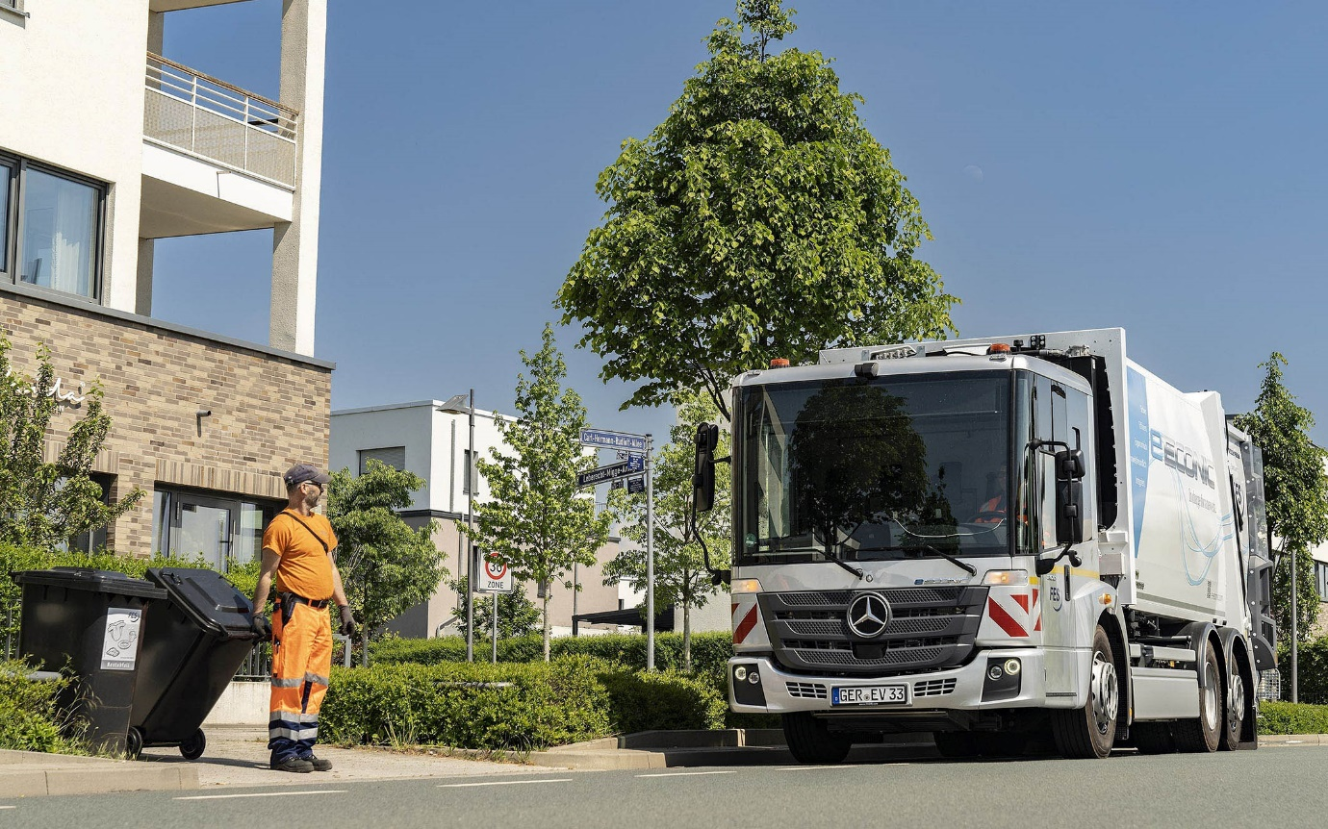

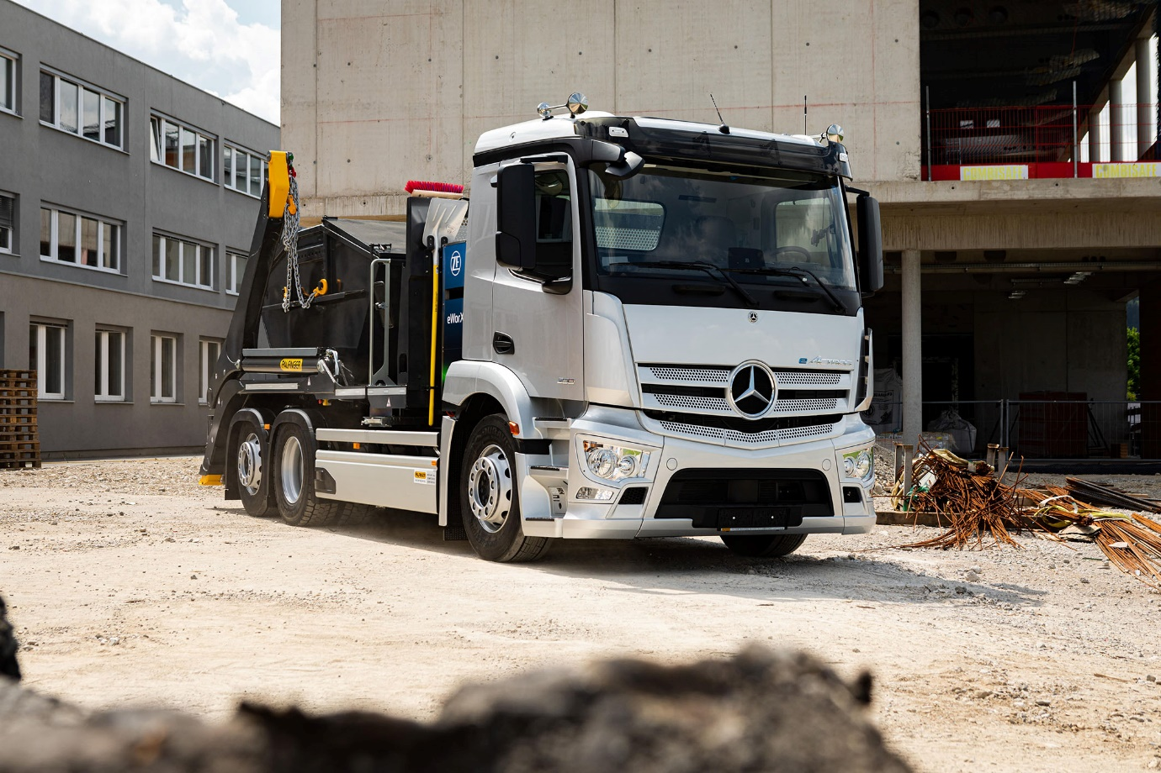

Electric dream: Visitors to IFAT 2022 can see an eActros specified for the first time for a construction application

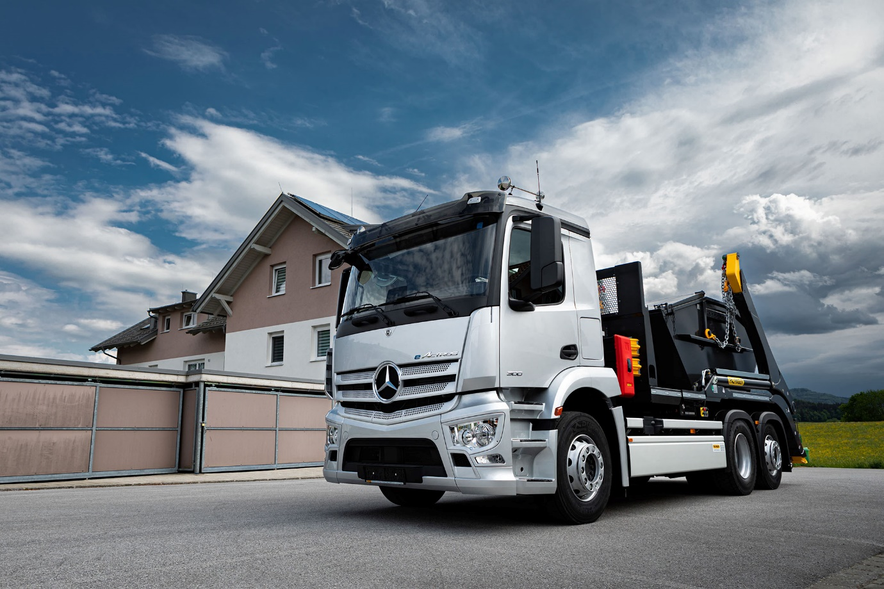
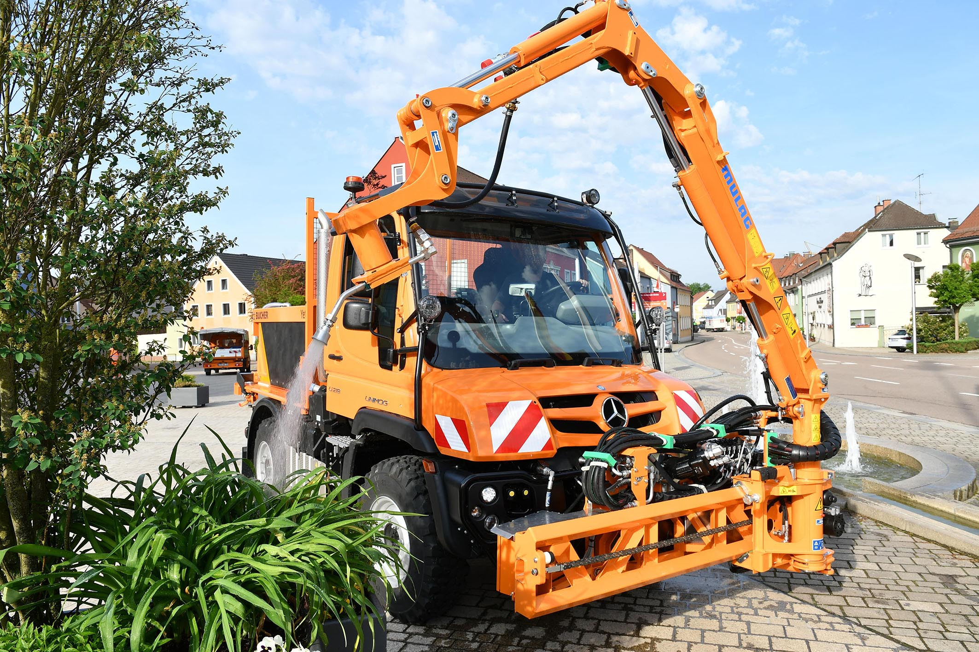

Nominal capacity of new battery, based on internally defined boundary conditions, may vary depending on use case and ambient conditions.

² Energy available for regular truck operation with new batteries. Based on internally defined boundary conditions, may vary depending on use case and ambient conditions.

³ Based on internally determined empirical values under optimal conditions, including an ambient temperature of 20°C.

⁴ Nominal capacity of new battery, based on internally defined boundary conditions, may vary depending on use case and ambient conditions.

⁵ Energy available for regular truck operation with new batteries. Based on internally defined boundary conditions, may vary depending on use case and ambient conditions.

⁶ The range was determined internally in optimum conditions, including 4 battery packs after preconditioning in partially loaded distribution traffic without a trailer at 20 °C outside temperature.

⁷ Based on internally determined empirical values under optimal conditions, including an ambient temperature of 20°C.

ends

For more information, please contact:

Jamie Fretwell at Mercedes-Benz Trucks UK Ltd
07712 519230, jamie.fretwell@daimler.com

or

Steve Warren or John Ripley
Impact Communications
Steve: 07770 470251, steve@impactcom.co.uk
John: 07771 484595, john@impactcom.co.uk

or

Ulrike Burkhart, +49 160 861 3757, ulrike.burkhart@daimlertruck.com
Akim Enomoto, +49 176 309 95099, akim.enomoto@daimlertruck.com

Further information on Daimler Truck is available at:
www.media.daimlertruck.com and www.daimlertruck.com

Forward-looking statements:
This document contains forward-looking statements that reflect our current views about future events. The words “anticipate,” “assume,” “believe,” “estimate,” “expect,” “intend,” “may,” ”can,” “could,” “plan,” “project,” “should” and similar expressions are used to identify forward-looking statements. These statements are subject to many risks and uncertainties, including an adverse development of global economic conditions, in particular a decline of demand in our most important markets; a deterioration of our refinancing possibilities on the credit and financial markets; events of force majeure including natural disasters, pandemics, acts of terrorism, political unrest, armed conflicts, industrial accidents and their effects on our sales, purchasing, production or financial services activities; changes in currency exchange rates, customs and foreign trade provisions; a shift in consumer preferences towards smaller, lower-margin vehicles; a possible lack of acceptance of our products or services which limits our ability to achieve prices and adequately utilize our production capacities; price increases for fuel or raw materials; disruption of production due to shortages of materials, labor strikes or supplier insolvencies; a decline in resale prices of used vehicles; the effective implementation of cost-reduction and efficiency-optimization measures; the business outlook for companies in which we hold a significant equity interest; the successful implementation of strategic cooperations and joint ventures; changes in laws, regulations and government policies, particularly those relating to vehicle emissions, fuel economy and safety; the resolution of pending government investigations or of investigations requested by governments and the conclusion of pending or threatened future legal proceedings; and other risks and uncertainties, some of which are described under the heading “Risk and Opportunity Report” in this Annual Report. If any of these risks and uncertainties materializes or if the assumptions underlying any of our forward-looking statements prove to be incorrect, the actual results may be materially different from those we express or imply by such statements. We do not intend or assume any obligation to update these forward-looking statements since they are based solely on the circumstances at the date of publication.

Daimler Truck at a glance
Daimler Truck Holding AG ("Daimler Truck") is one of the world's largest commercial vehicle manufacturers, with over 40 main locations and more than 100,000 employees around the globe. The founders of Daimler Truck have invented the modern transportation industry with their trucks and buses a good 125 years ago. Unchanged to this day, the company's aspirations are dedicated to one purpose: Daimler Truck works for all who keep the world moving. Its customers enable people to be mobile and get goods to their destinations reliably, on time, and safely. Daimler Truck provides the technologies, products, and services for them to do so. This also applies to the transformation to CO2-neutral driving. The company is striving to make sustainable transport a success, with profound technological knowledge and a clear view of its customers' needs. Daimler Truck's business activities are structured in five reporting segments: Trucks North America (TN) with the truck brands Freightliner and Western Star and the school bus brand Thomas Built Buses. Trucks Asia (TA) with the FUSO and BharatBenz commercial vehicle brands. Mercedes-Benz (MB) with the truck brand of the same name. Daimler Buses (DB) with the Mercedes-Benz and Setra bus brands. Daimler Truck's new Financial Services business (DTFS) constitutes the fifth segment, the product range in the truck segments includes light, medium and heavy trucks for long-distance, distribution and construction traffic and special-purpose vehicles used mainly in the municipal and vocational sector. The product range of the bus segment includes city buses, school buses and intercity buses, coaches and bus chassis. In addition to the sale of new and used commercial vehicles, the company also offers aftersales services and connectivity solutions.

