

Date: 4 August 2021

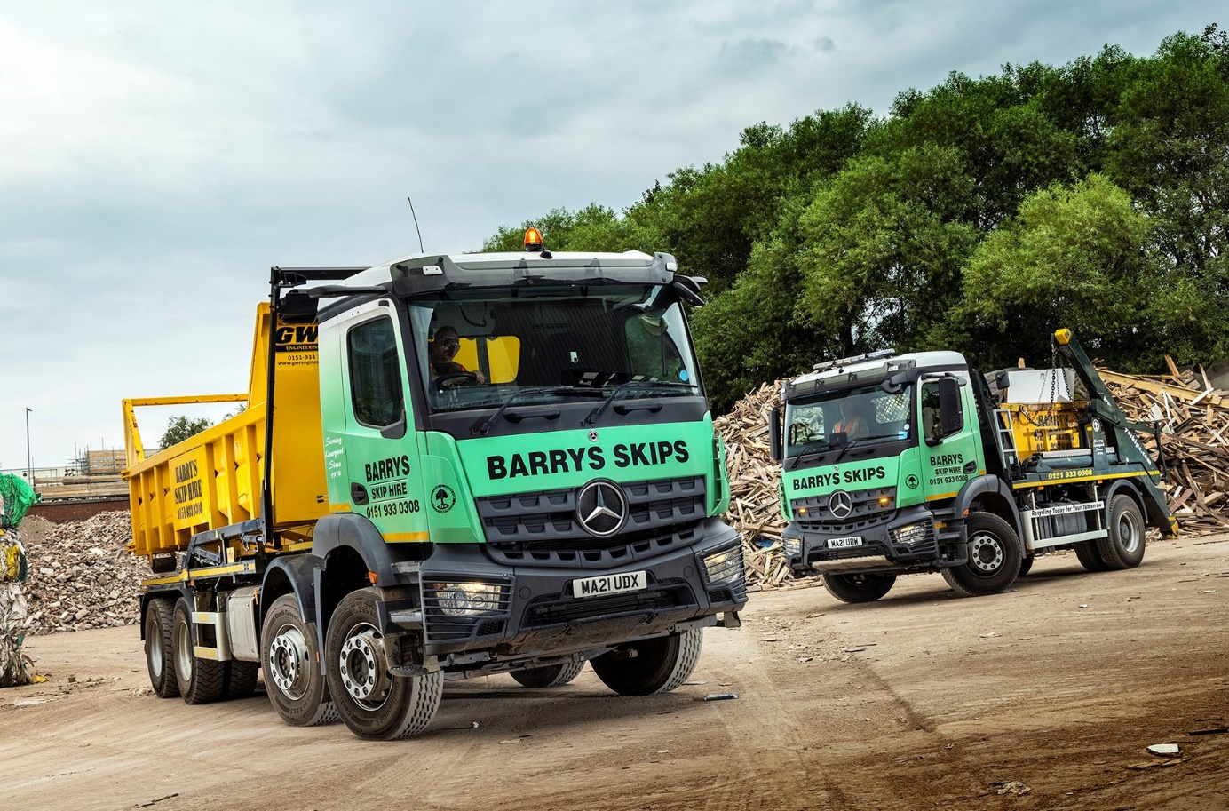

Barry’s Skip Hire chooses another productive and reliable Mercedes-Benz Arocs eight-wheeler from eStar

Three years ago Liverpool-based Barry’s Skip Hire bought a pair of 32-tonners, one of them a Mercedes-Benz Arocs, then pitched both into a long-term evaluation challenge with a vehicle from a third brand it was already running.

The results are now in, and they could not be clearer – the truck with the three-pointed star has trounced its rivals in the reliability stakes, while local Mercedes-Benz Dealer eStar Truck & Van is putting the competition in the shade when it comes to back-up.

No surprise, then, that when the operator needed another 8x4 hook-loader and an 18-tonne 1824 skip-loader, it was to eStar that proprietor Barry Flanagan turned. Like the 32-tonner that entered service in 2018, both are from the muscular Arocs range, which was purpose-designed for construction and related applications.

Pre-built with Hyva lifting gear and supplied from stock at short notice, they are scheduled to be followed over the next 12 months by five more Mercedes-Benz skip trucks, four 18-tonne Arocs and a 13-tonne Atego.

Recalling the three-cornered 32-tonner trial his company conducted, Barry Flanagan said: “The Mercedes-Benz was in a completely different league. It’s been far more reliable over the period than the other two trucks, both of which gave us all sorts of problems.”

He continued: “We’re a waste management and recycling specialist, and trucks are just a tool with which to do our job. We want our guys to go out in the morning, do their rounds all day and then go home, without worrying about whether their vehicle will break down. We get that peace of mind from the Arocs.

“Dealer support is also important, and here, too, we’ve found that Mercedes-Benz is ahead of the rest. We have an excellent working relationship with eStar Sales Executive Richie Rainford. He understands our business and knows what we need from a truck, while his workshop colleagues are always very professional and accommodating.”

Barry’s Skip Hire runs a fleet of 14 trucks in which Mercedes-Benz holds sway. Indeed, the company has favoured vehicles bearing the three-pointed star for most of the 47 years it has been trading.

Prior to the arrival of the Arocs 3240 three years ago, though, it had tended to steer clear of the manufacturer’s eight-wheeled chassis. “We’d always considered the Mercedes-Benz 8x4 to be a bit too heavy for our application, which is very payload-sensitive,” explained Mr Flanagan.

“The introduction of the Arocs range changed all that, though. The big rigids are light enough to allow us to maximise productivity, while also offering the strength and durability that we’ve come to expect from Mercedes-Benz. There’s plenty of ground clearance too, and the view from the driver’s seat is excellent. It’s a great combination of attributes.”

The new eight-wheeler raises the visibility bar still further, as it is the first truck on the Barry’s Skip Hire fleet to be equipped with MirrorCam, Mercedes-Benz Trucks’ ground-breaking replacement for conventional mirrors. Instead, roof-mounted cameras provide enhanced rear vision, relaying their images to twin screens mounted inside the cab, on the A-pillars, while also eliminating the large, forward-facing blind spots caused by mirror housings.

“We’re an ‘old school’ outfit in many ways – I don’t even carry a mobile phone,” said Mr Flanagan. “But the MirrorCam system has some obvious benefits and our drivers have taken to it very quickly.”

The Arocs 3240 is powered by an advanced, 10.7-litre ‘straight-six’ engine that generates 290 kW (394 hp) and drives through a 12-speed Mercedes PowerShift 3 automated manual transmission, with crawl function and manoeuvring mode for easy low-speed operation. Barry’s latest example has a ClassicSpace M-cab with 320mm engine tunnel, which offers the twin benefits of a relatively low driving position and easier access via the cab steps.

The Arocs 1824 also has a ClassicSpace M-cab and is powered by a 175 kW (238 hp) in-line six-cylinder engine with 7.7-litre displacement.

Barry’s Skip Hire offers a range of sizes from 4.0 tonne ‘midi’ skips to 40 cubic yard roll-on/roll-off containers, to domestic and trade waste customers across Liverpool, Sefton, Knowsley, Wirral, St Helens and Halton. Committed for many years to minimising its environmental impact, the company is proud of the fact that it now recycles 100% of the waste it collects.

www.barrysskips.com

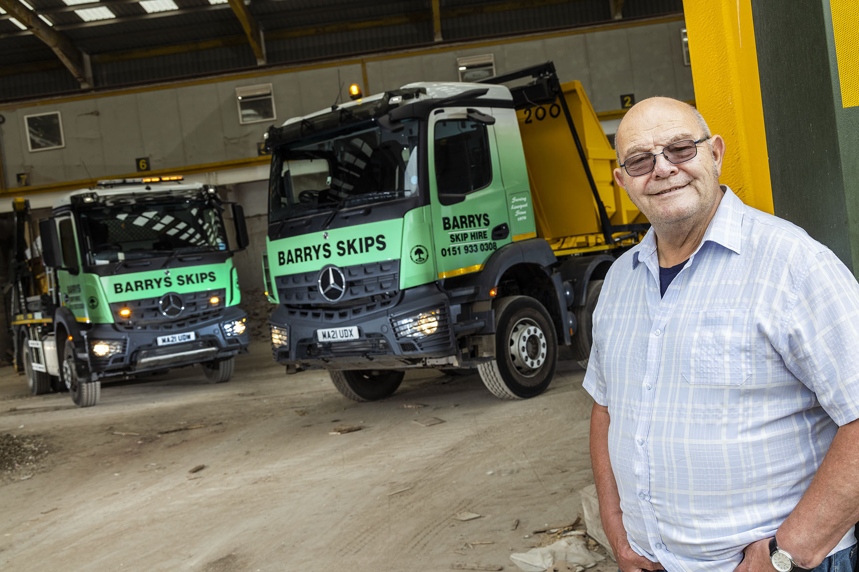

Stars aligned: Barry Flanagan is hooked on Mercedes-Benz reliability and the support of Dealer eStar Truck & Van

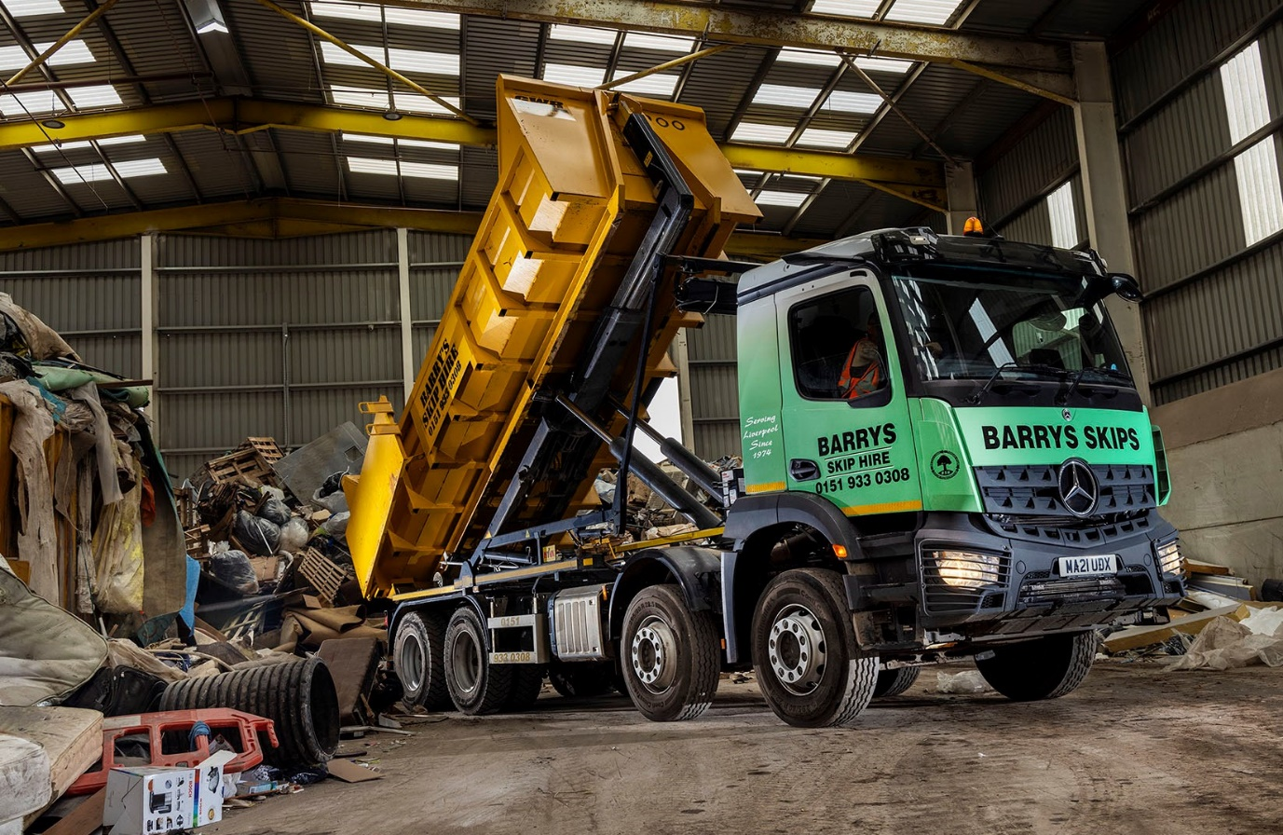

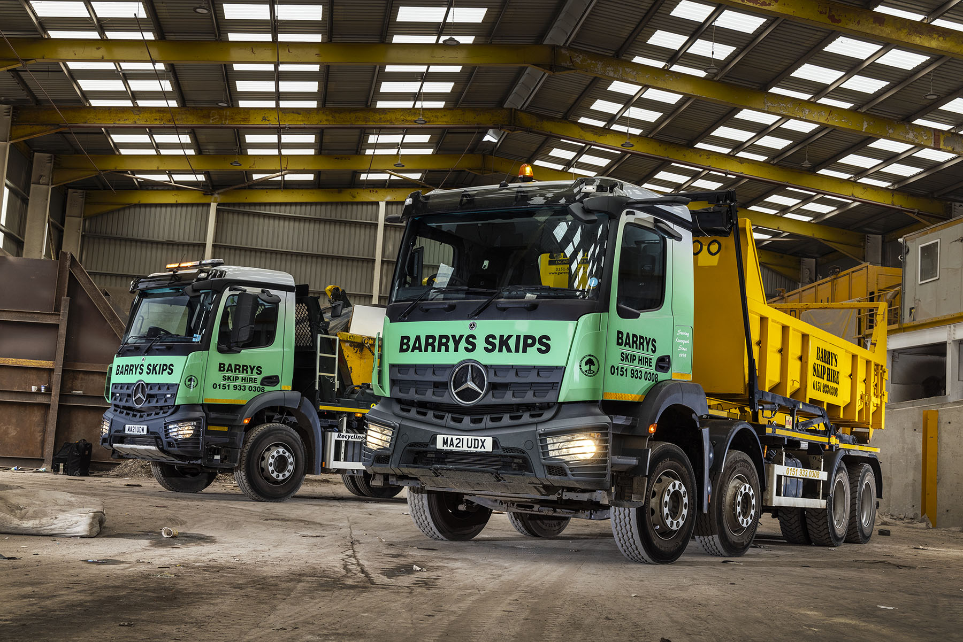

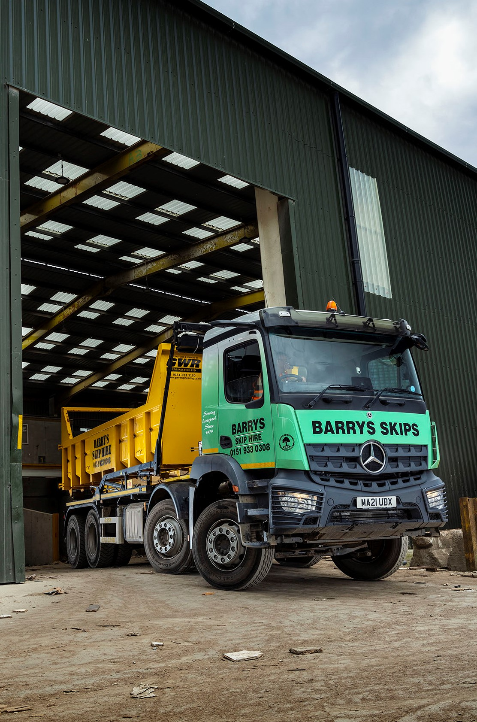

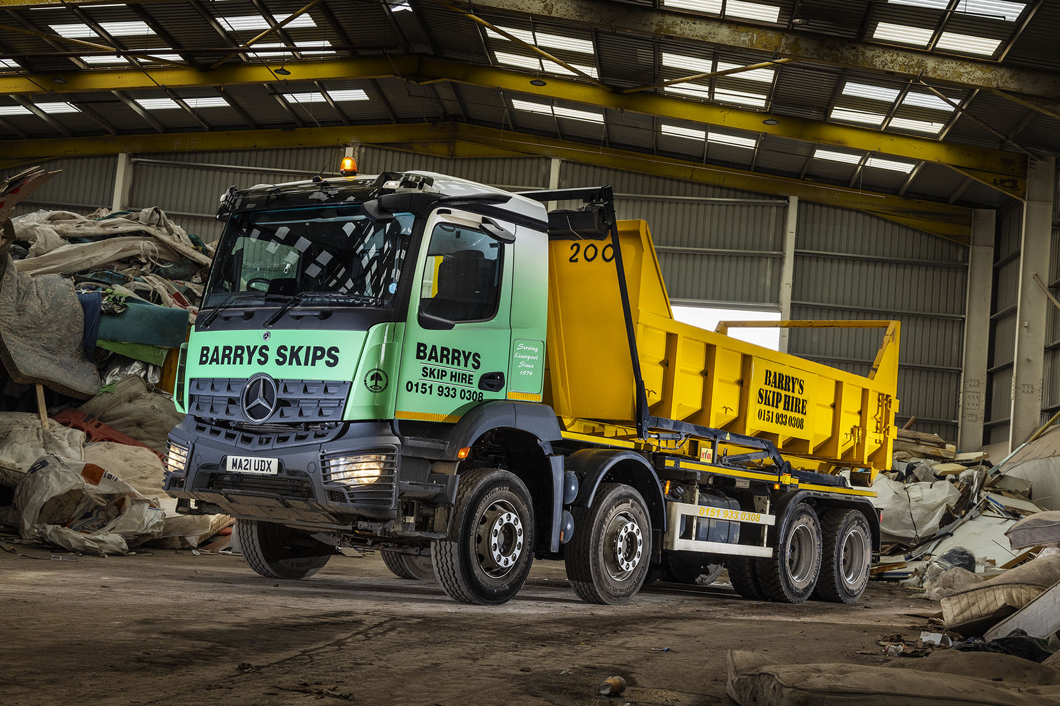

ends

For more information, or to request higher-resolution image files, please contact:
Steve Warren or John Ripley
Impact Communications, 01926 842126
Steve: 07770 470251, steve@impactcom.co.uk
John: 07771 484595, john@impactcom.co.uk

