

Date: 3 April 2019

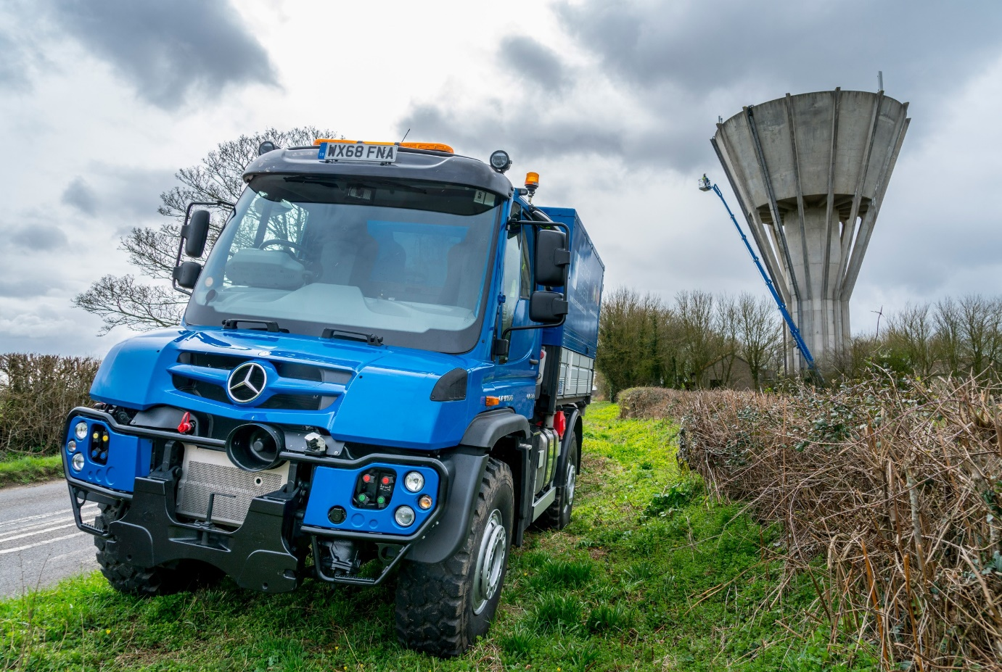

Three into one does go: The Unimog has enabled Fletcher Access to achieve new levels of efficiency, by replacing a 7.5-tonne truck and two vans

Fletcher Access cuts its overheads with flexible
Mercedes-Benz Unimog

Working-at-height specialist Fletcher Access has raised its game by investing in a new, all-terrain Mercedes-Benz Unimog.

The 15.5-tonne GVW U530’s arrival via Dealer Group Rygor Commercials has enabled the Worcester-based company to stand down the three vehicles it relied on previously to perform the same roles.

Fletcher Access was established 20 years ago by brothers Simon and Anthony Fletcher, and operates throughout the Midlands and South West. It undertakes a range of overhead assignments at heights of up to 42 metres, including tree work, roof maintenance, and cleaning, while also offering a range of powered access equipment for hire.

The largest and most powerful of the Mercedes-Benz implement carriers, the U530 pairs a fuel-efficient 7.7-litre six-cylinder engine producing 220 kW (299 hp), with a fully synchronised, electro-pneumatic transmission that has eight forward and six reverse gears –the optional working gear range provides another eight forward and eight reverse gears.

Permanent all-wheel drive, impressive ground clearance, and uprated portal axles which have differential locks and offer extreme levels of articulation, all contribute to the truck’s unrivalled cross-country capability, yet it will also cruise happily at 56 mph on the road.

Options specified by Fletcher Access include unique Central Tyre Inflation (CTI) technology, and the Vario Pilot System. CTI enables the driver quickly and easily, and without leaving their cab, to lower tyre pressures, thereby improving traction and minimising damage to particularly soft ground. Vario Pilot allows them to switch the steering wheel to the other side of the vehicle in around 30 seconds. Other non-standard features include air conditioning, air-suspended driver and passenger seats, and front and rear cameras with monitor.

The Unimog came with a factory-fitted Scattolini tipping body for which Bodycraft, of Worcester, fabricated a high-sided box with lockable rear doors. Using a front-mounted wood chipper driven by the truck’s PTO, Fletcher Access can load chippings through four ‘doors’ in the roof.

The operator also employs the truck to carry up to four baffled, 1,000-litre (one tonne) demountable tanks of rain water, which it harvests and purifies at its base, together with the power washers, ground protection boards, and other equipment it uses for high-reach cleaning services. The fact that the GRP body is insulated helps to prevent the water from freezing when temperatures drop.

A VBG drawbar coupling, meanwhile, allows the Unimog to tow Fletcher Access’s tandem-axle trailer at a gross combination weight of up to 26 tonnes. The trailer transports the company’s tracked access platforms, the biggest of which has a 42-metre reach and tips the scales at seven tonnes.

The Unimog may be new, but the operator was already familiar with Mercedes-Benz vehicles. The U530 has replaced the 7.5-tonne Atego truck with hydraulic boom lift which Fletcher Access relied on previously to tow its trailer, as well as a pair of Sprinter vans, each of which carried a single, 1,000-litre tank of water.

Simon Fletcher recalled: “The Atego was due for replacement so having long favoured Mercedes-Benz vehicles for their reliability and longevity, we considered various options with Rygor Fleet Sales Manager Jeremy Price, from whom we’ve acquired all our vehicles over the years.

“At one point we were inclining towards a flat-bed truck with beavertail, but then Jeremy suggested we look at a Unimog. The more we thought about it, the more sense it made, not least because we often work in rural areas and for tree work, in particular, have to cross fields. We realised the Unimog’s ability to access off-road sites could be a big advantage.”

A visit to a Mercedes-Benz Unimog Live event confirmed the vehicle’s potential, and the brothers decided to go ahead. “With Jeremy’s help and expert advice we were able to specify the Unimog perfectly to meet the needs of our various operations,” continued Simon Fletcher.

“It represents a very substantial investment, but we plan to run the truck for 15 years and are convinced it will prove to be money well spent. It has improved efficiency from the outset by replacing three other vehicles, and offers the multi-role flexibility which ensures that whatever the job, we can use it every day.”

He continued: “The Unimog has also ‘future proofed’ our business. It will provide an ideal platform for growth because not only does it offer hydraulic power for new attachments, but it will also be able to tow the tri-axle trailer to which we’ll have to upgrade when we purchase bigger, heavier access machines.”

Anthony Fletcher is the vehicle’s principal driver. He said: “You sit high up in the Unimog and have an excellent view of what’s around you. In terms of its footprint it’s not a lot bigger than the 5.0-tonne Sprinter van we’ve retained, yet it can carry so much more.

“The truck’s all-terrain capability is an obvious benefit – we regularly deliver our machines down narrow lanes, where its all-wheel drive system means we’ll never get stuck on a verge or the edge of a field.

“What’s really surprised me, though, is its on road performance. With 300 hp on tap, the Unimog simply flies up the hills, no problem. The engine brake also saves wear and tear on the trailer brakes, as well as those of the truck itself, which is another advantage.”

The Unimog is being inspected and maintained under a Mercedes-Benz Complete Service Contract, by the workshop team at Rygor’s Kidderminster branch. Jeremy Price added: “Our consultancy-style sales approach and commitment to Setting Standards means we’ll do whatever it takes to ensure that every vehicle we supply is tailored to meet the precise needs of the customer.

“Few trucks are as complex and highly-specified as the one we’ve just supplied to Fletcher Access, so it’s gratifying to know that their Unimog is living up to Simon’s and Anthony’s high expectations.”

overheadworks.co.uk

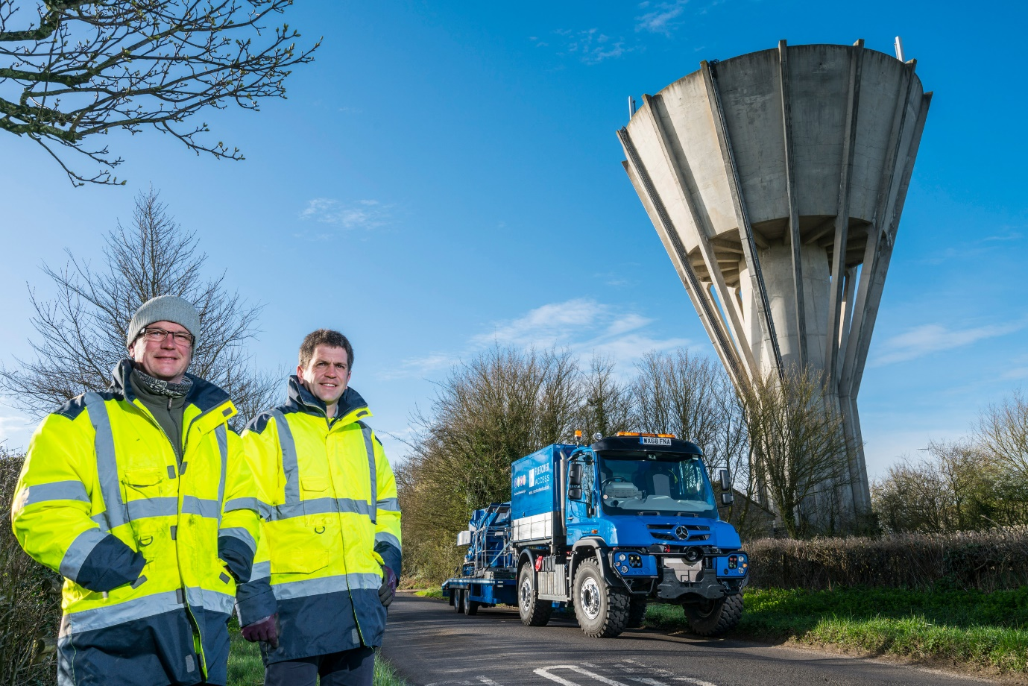

Brand of brothers: Anthony, left, and Simon Fletcher have been loyal customers of Mercedes-Benz for 20 years

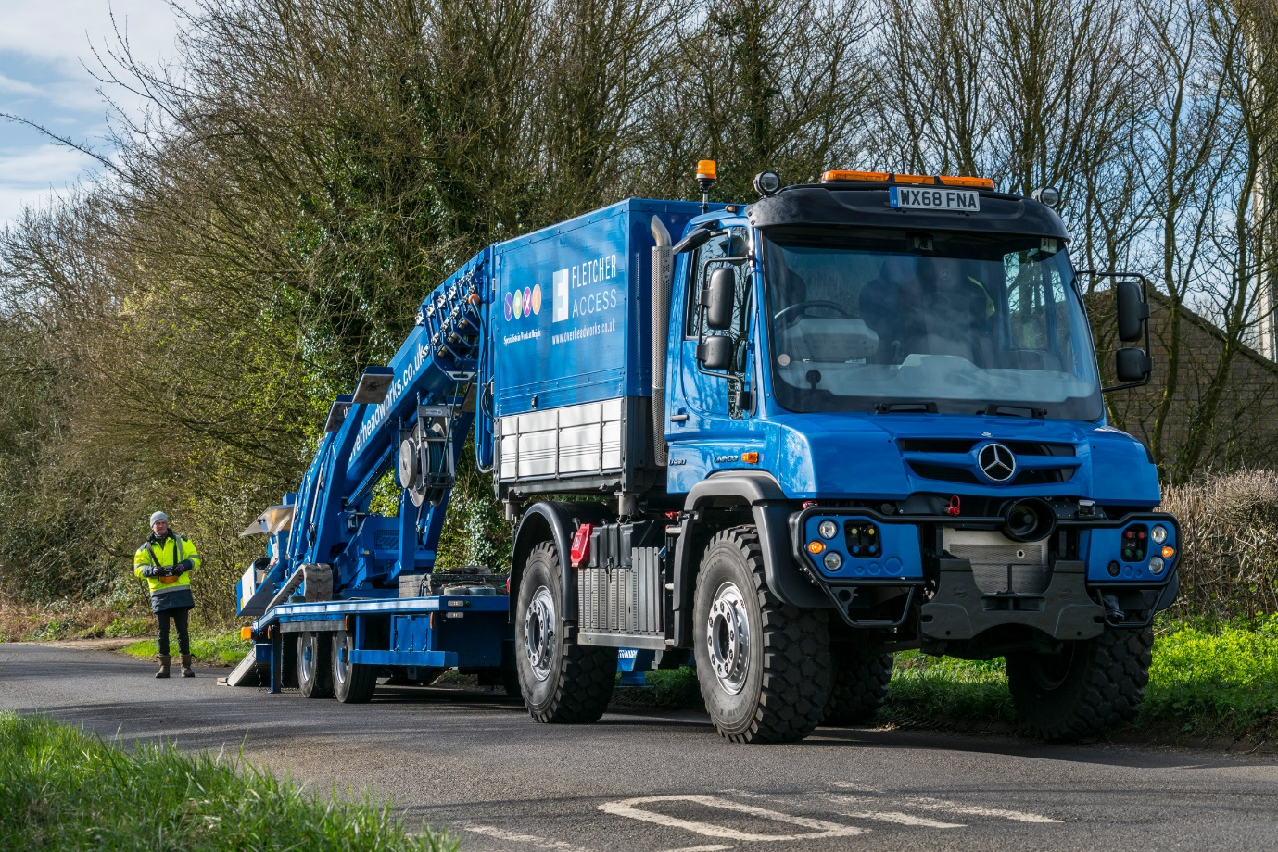

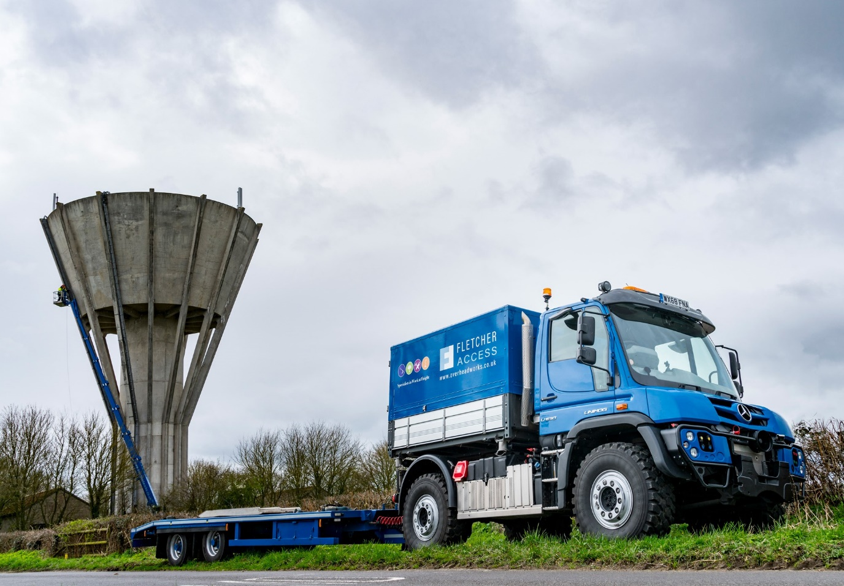

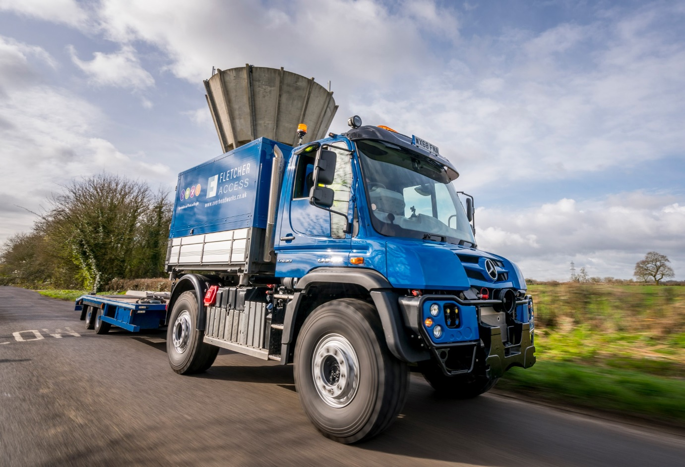

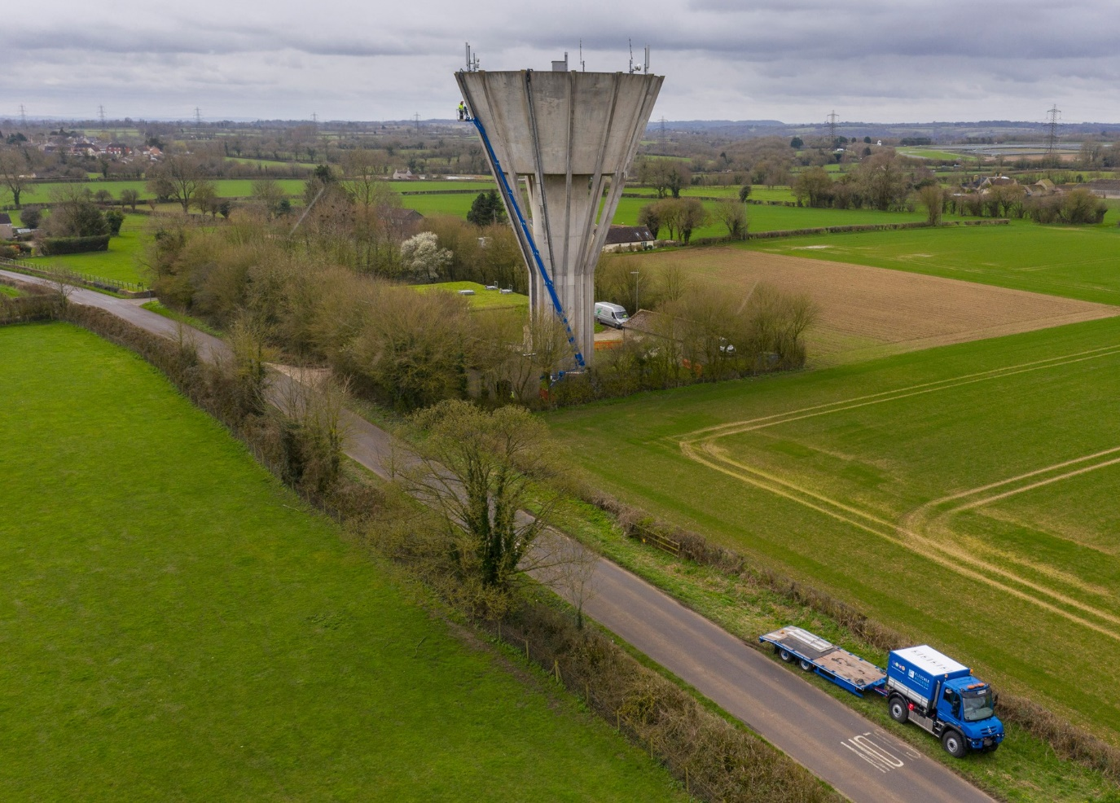

ends

For more information, or to request bigger/higher-res image files, please contact:
Steve Warren or John Ripley
Impact Communications, 01926 842126
Steve: 07770 470251, steve@impactcom.co.uk
John: 07771 484595, john@impactcom.co.uk

Notes to Editors: Rygor Commercials

Mercedes-Benz Commercial Vehicle Dealer group, Rygor Commercials, has 10 branches throughout Berkshire, Gloucestershire, Oxfordshire, Somerset, West London, Warwickshire, Wiltshire and Worcestershire, offering extensive coverage for customers through the M5, M4 and M42 corridors.

The business has expanded and gone from strength to strength in recent years, launching its flagship Gloucester branch in late 2016 and undergoing a significant refurbishment of its Oxford branch in 2018. With a proven track record, the award-winning Rygor Commercials is proud to be selling and supporting the most prestigious name in commercial vehicles.

For more information, in the first instance please contact Kate Ruberry-Shoemack, Communications Manager at Rygor – kateruberry-shoemack@rygor.co.uk

