

Date: 2 October 2021

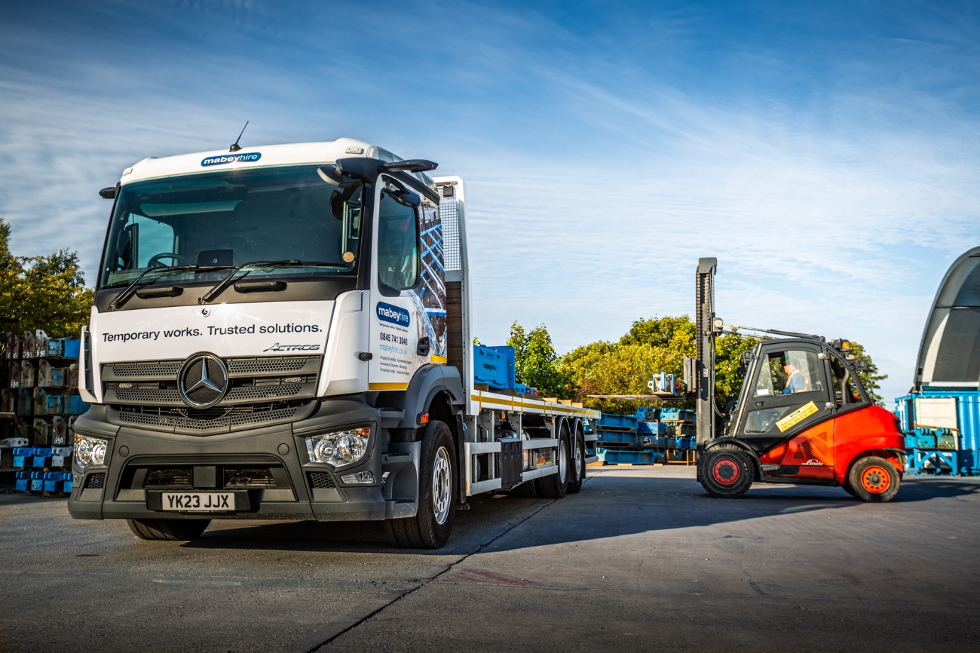

Mercedes-Benz safety makes Actros a definite winner for Mabey Hire

There were no ifs or buts when Mabey Hire chose its latest trucks – an absolute commitment to safety meant the Mercedes-Benz Actros was the only choice.

“We’ve been upgrading our fleet and developing our use of safety systems hand in hand with Mercedes-Benz for the past five years,” said Transport Manager Martin Binns.

“Safety is our number one priority. We want our trucks to be as safe as possible, not just for our drivers but for all other road users too. In my view, with all their various systems, Mercedes-Benz trucks are the best you can get.”

The four Actros 2535 rigids were delivered to Mabey Hire by Dealer Northside Truck & Van. They are powered by 7.7-litre straight-six engines, each generating 260 kW (354 hp). Their 2.3-metre wide ClassicSpace M-cabs feature 320 mm engine tunnels which allow the floor, and therefore the driver’s seat, to be set lower and contribute to the vehicles’ four-star Direct Vision Standard rating. They are now working from Mabey Hire depots in Cardiff, Durham, Glasgow and Wellingborough, delivering the company’s range of scaffolding and temporary works equipment to civil engineering, construction and utilities customers nationwide.

The trucks’ full complement of safety equipment includes Active Brake Assist 5 autonomous braking, Lane Keeping Assist to help drivers stay on the straight and narrow, and Stability Control Assist which mitigates against excessive rolling or pitching. MirrorCam cameras, fitted in place of traditional mirrors, increase forward as well as rearward visibility by removing the large blind spot created by a mirror housing.

Mabey Hire’s attention to the detail of safety extends to the vehicles’ bodies too. Fitted by Micra Truck Bodies, of Wakefield, their platforms feature extendable walkways to the nearside, steps to the rear and an all-round fall prevention system.

“Northside’s Sales Executive Steve Cusworth handled all the liaison with Micra and kept us fully informed at all times,” added Mr Binns.

But although safety is Mabey Hire’s top priority, the new Actros bring other benefits.
“We’re committed to doing all we can to minimise the effect of our operation on the environment too,” he continued. “These vehicles play their part in that – they have replaced the last of our older models so now all our trucks meet the Euro VI emissions standard.

“As a bonus, at 12-13 mpg they’re also proving to be at least a full mile per gallon more economical than the Swedish-built vehicles we stood down, which makes them ‘greener’ as well as more cost-effective to operate.

“Along with the proven reliability of the Actros, and the high standard of back-up we’ve come to expect from Northside Truck & Van, it’s an excellent all-round package.”

The new trucks form part of Mabey Hire’s wider commitment to reducing its carbon footprint. The company plans to reduce its ‘scope one’ direct emissions by moving towards a hybrid and electric car fleet, and is also in the process of reviewing its fleet of forklifts, encompassing electric and biofuels possibilities.

“We believe it’s critical that the construction industry, and society as a whole, looks to minimise pollutant emissions and improve air quality, continued Martin Binns. “As well as delivering a noticeably improved fuel economy and reduced emissions, the new vehicles also offer a range of safety enhancements and technological features, all designed to improve road safety standards for the driver, pedestrians and fellow road users.

“We take our environmental responsibilities as a company very seriously. As well as taking steps to reduce our carbon output at our offices and depots across the UK, it’s just as important that we deliver this same approach to sustainability on the road.

“These new fleet additions mark a significant investment by Mabey Hire into ensuring that we continue to uphold our three ESG principles of Environment, Social and Governance. As well as reducing our environmental impact, this investment also represents our longstanding commitment to the safety of our colleagues and customers but also the general public.”

An award-winning temporary works specialist, Mabey Hire has over 60 years’ experience in the construction industry, offering customers an end-to-end service offering and the widest range of temporary works equipment.

www.mabeyhire.co.uk

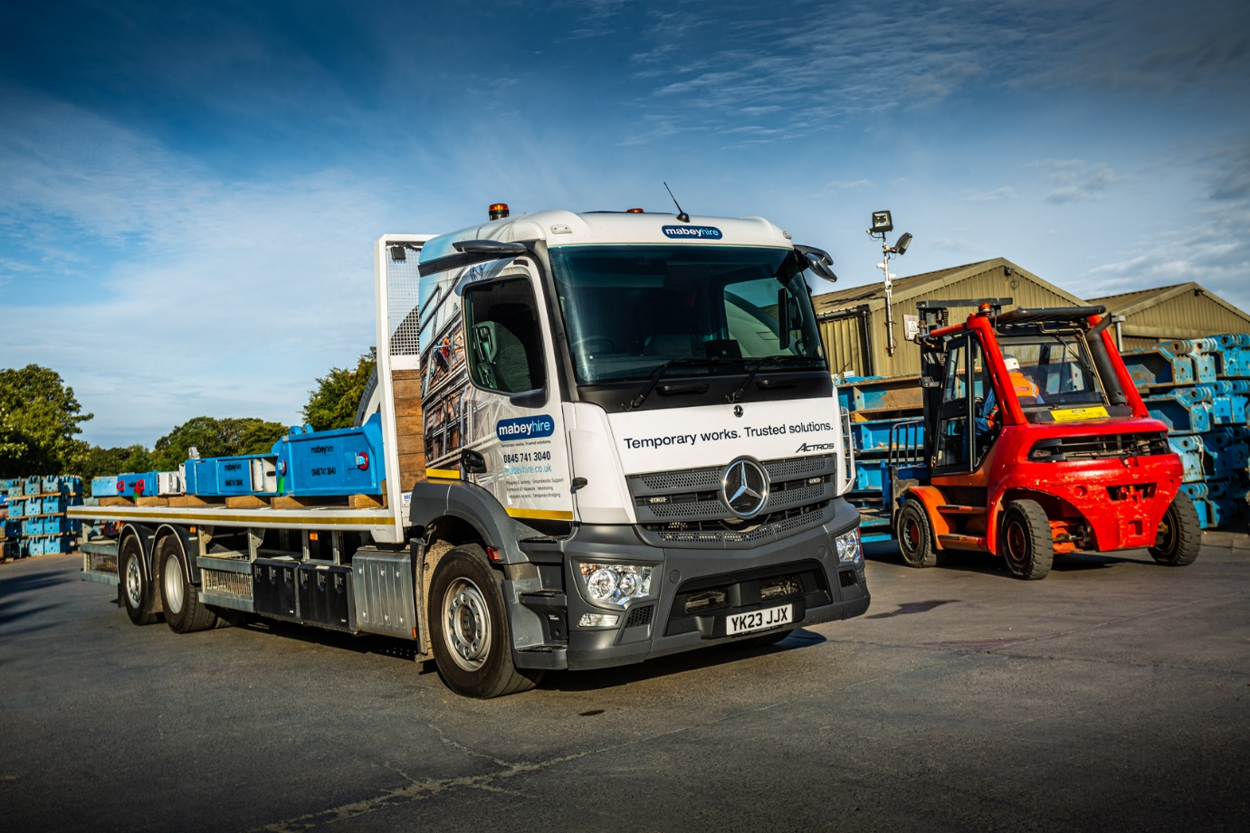

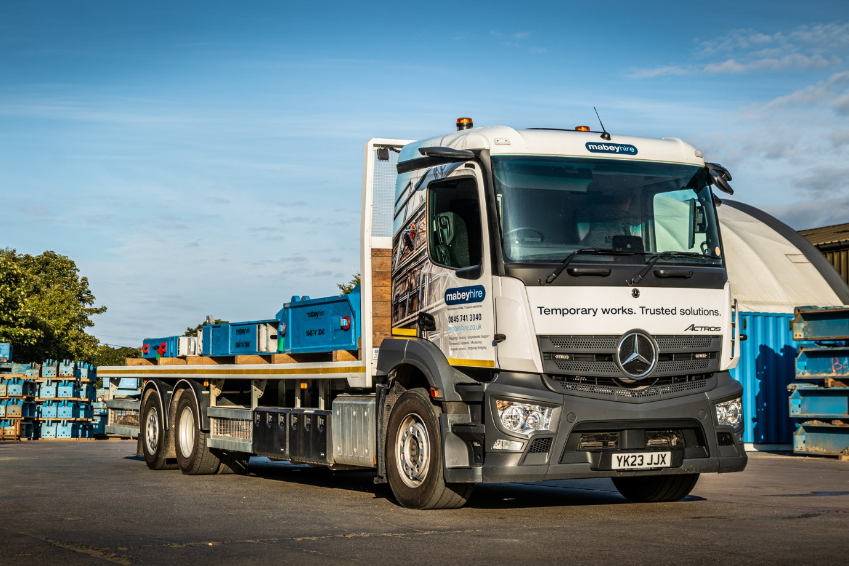

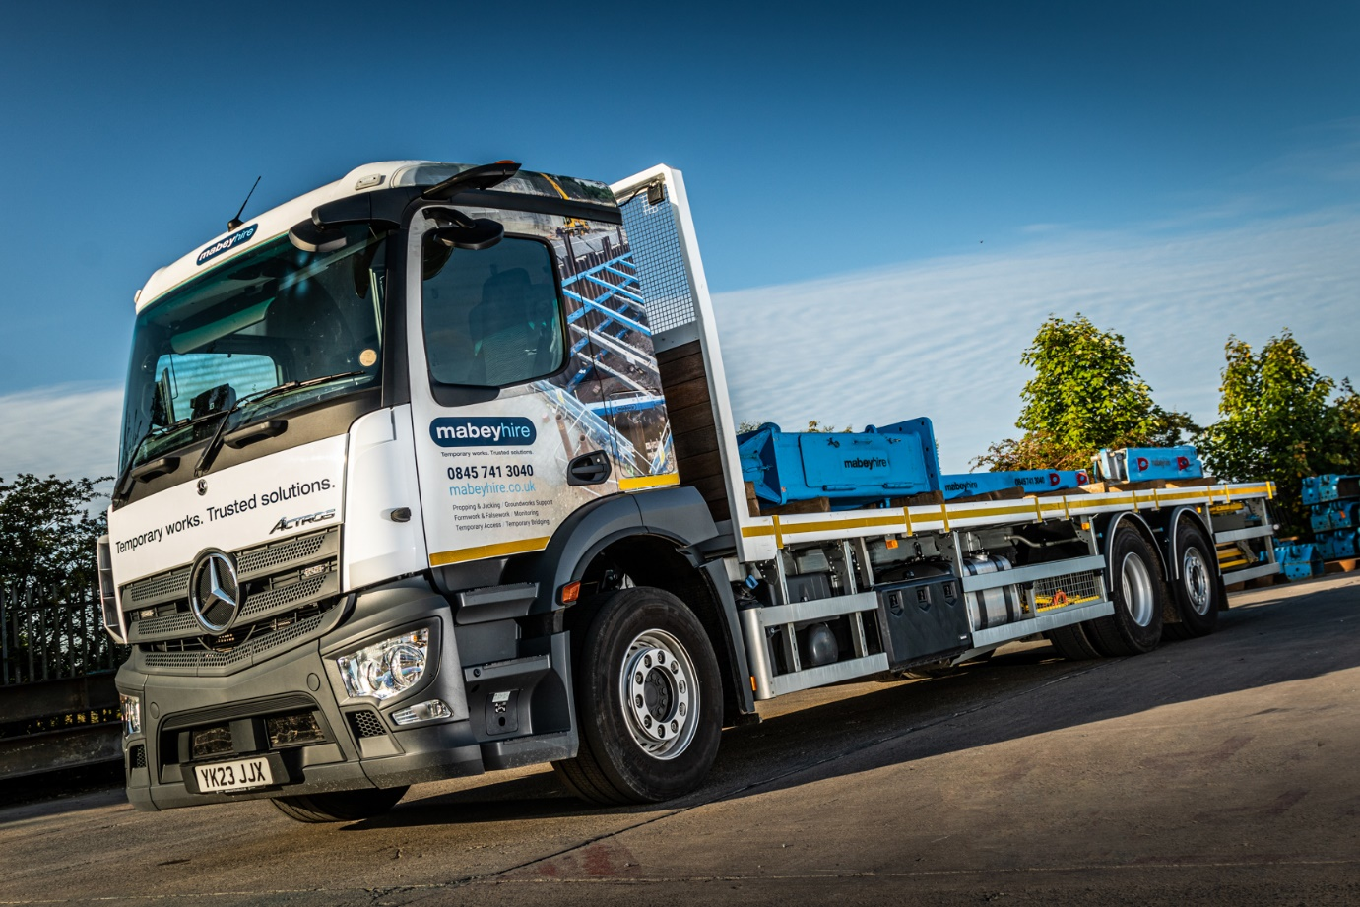

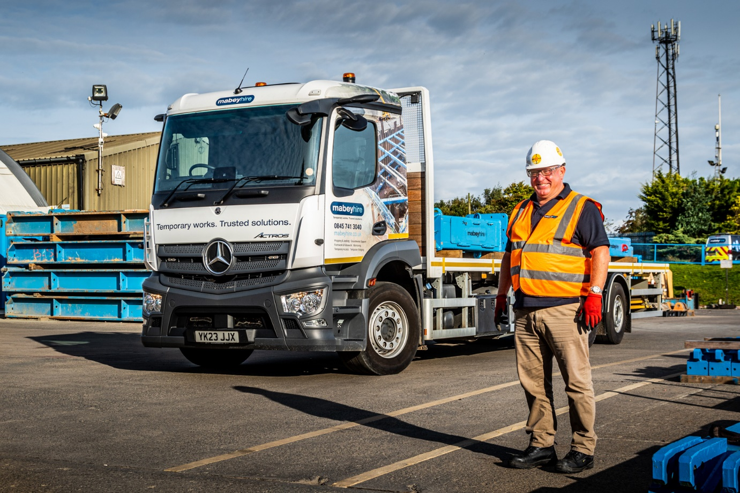

Safe option: Martin Binns of Mabey Hire rates the Mercedes-Benz Actros as “the best you can get”

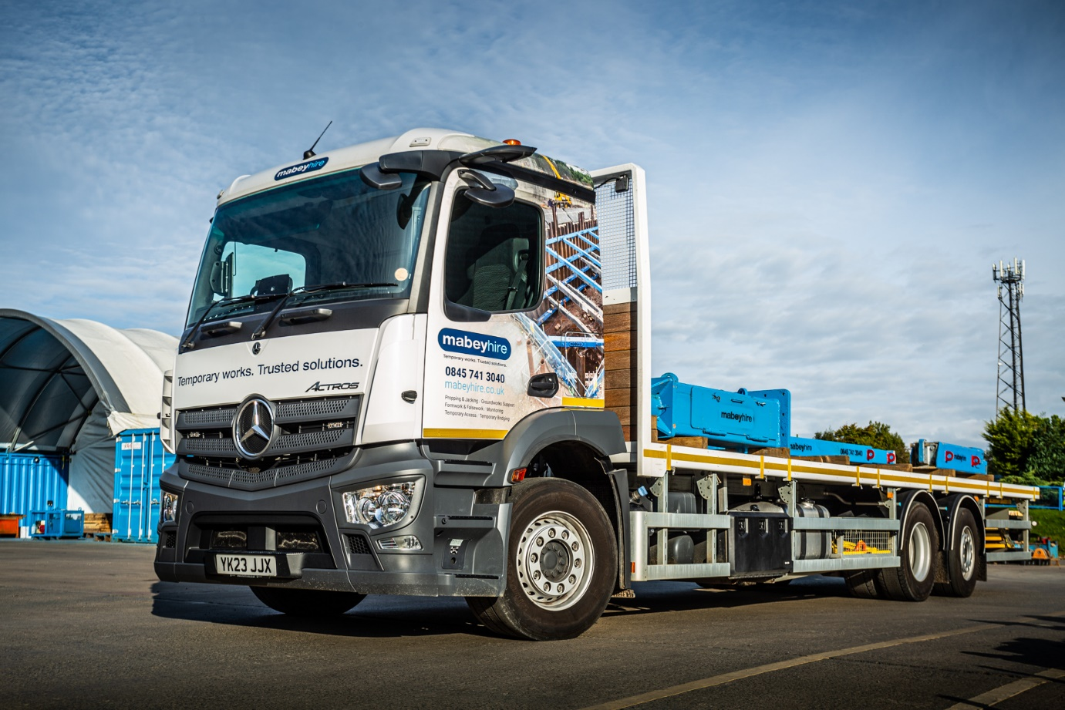

ends

For more information, or to request bigger/higher-res image files, please contact:
John Ripley: 07771 484595, john.ripley@loopagency.co.uk



