

Date: 26 August 2020

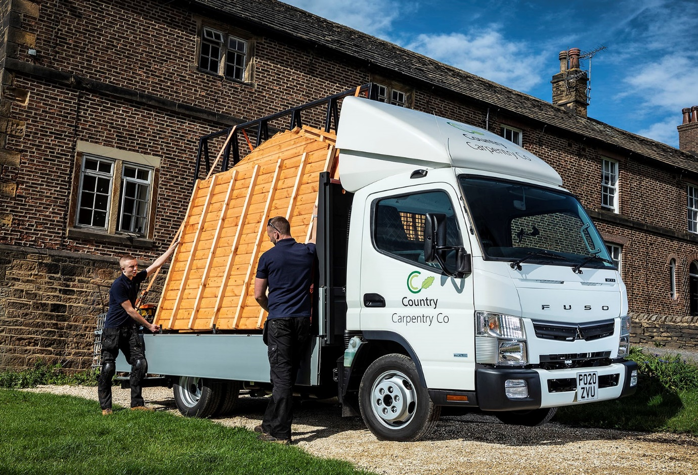

Pre-bodied FUSO Canter hammers the competition for Country Carpentry

Its garden buildings are highly bespoke, but Country Carpentry was only too happy to branch out by purchasing an off-the-shelf, pre-built FUSO Canter dropsider from Ciceley Commercials.

The Leeds-based operator’s new 3.5-tonne Canter 3C13 has replaced its previous dropsider, which was based on a French van chassis. For Director Aidan Jackson, the difference has been a revelation.

“The Canter is a proper truck, with a far more robust design and higher standard of build quality,” he said of Country Carpentry first FUSO. “By contrast, the vehicle we stood down just didn’t have the toughness we need. It wasn’t in the same league.”

In addition to its rugged construction and appetite for hard work, the company’s first Canter has impressed with its fuel efficiency, manoeuvrability and cab comfort. Mr Jackson also praised the Dealer for supplying the vehicle within a very tight timeframe.

“Ciceley’s Sales Executive Peter O’Grady was excellent from the outset,” he recalled. “He understood what we needed in terms of specification, and was able to supply a Canter from stock that met our requirements perfectly. The order was handled very professionally, and the truck arrived on time and in perfect condition. I called Peter the day after we took delivery to let him know how pleased I was, and to confirm we’d definitely made the right decision.”

Ciceley Commercials is a long-standing member of the Mercedes-Benz franchised network. Mercedes-Benz is part of the Daimler family, and so, too, is FUSO. This explains why Mercedes-Benz Trucks Dealers also sell and support the Canter light truck range in Great Britain.

Canter customers can choose ready-to-work 3.5-tonne platform dropsiders and tippers, and 7.5-tonne tippers, pre-bodied at FUSO’s main European production facility in Tramagal, Portugal, by the highly regarded Italian manufacturer Scattolini. This programme allows customers to put their new vehicles to work a lot more quickly than would be the case if chassis were sent to third-party bodybuilders. Finished trucks are also covered by single invoices, simplifying administration and reducing associated costs.

Country Carpentry Canter 3C13 has a day cab and is powered by a high-torque 3.0-litre engine that produces 96 kW (130 hp) and is paired with a five-speed manual gearbox – the 3C13 model is also available with a dual-clutch DUONIC automated transmission. Customers needing a more powerful 3.5-tonner can choose the Canter 3C15, which employs a 150 hp version of the same turbodiesel and the DUONIC system only.

Fuel-efficient and exceptionally manoeuvrable, the smaller Canter shares its 7.5-tonne stablemate’s ladder-frame chassis design, which gives it truck-like strength and durability. Most of its competitors in the 3.5-tonne GVW segment have van-based underpinnings, so these attributes appeal particularly to builders and others whose trades place heavy demands on vehicles.

Unusually for a dropsider, Country Carpentry Canter is fitted with a roof-mounted air deflector, to counter the aerodynamic drag caused by the tall timber panels it frequently carries.

The entire process, from initial order to delivery, was completed within just two weeks. After a month on the road, the truck has lived up to Aidan Jackson’s positive first impression. “I’m delighted with it,” he confirmed. “We’re not a transport firm so we don’t measure fuel consumption obsessively, but the Canter is clearly more economical than the vehicle it replaced.

“The cab-over-engine design means that even with a 12ft body, its overall footprint is no greater than that of our previous 3.5-tonner, which had a 10ft platform. The cab is far more spacious than I’d imagined, too. I’m 6ft 4in tall, and most of our crew members are big guys, but the Canter can seat three of us in comfort. I can’t say a bad word about it.”

Country Carpentry offers a wide range of garden buildings, from compact tool stores to large, fully lined and insulated offices, gyms and summer houses. All are designed and constructed from scratch in the customer’s choice of materials, to fit the plot available.

The company’s teams have worked as far away from home as London and Newcastle, but undertake the bulk of its work within a 50-mile radius of Leeds.

www.countrycarpentryco.com

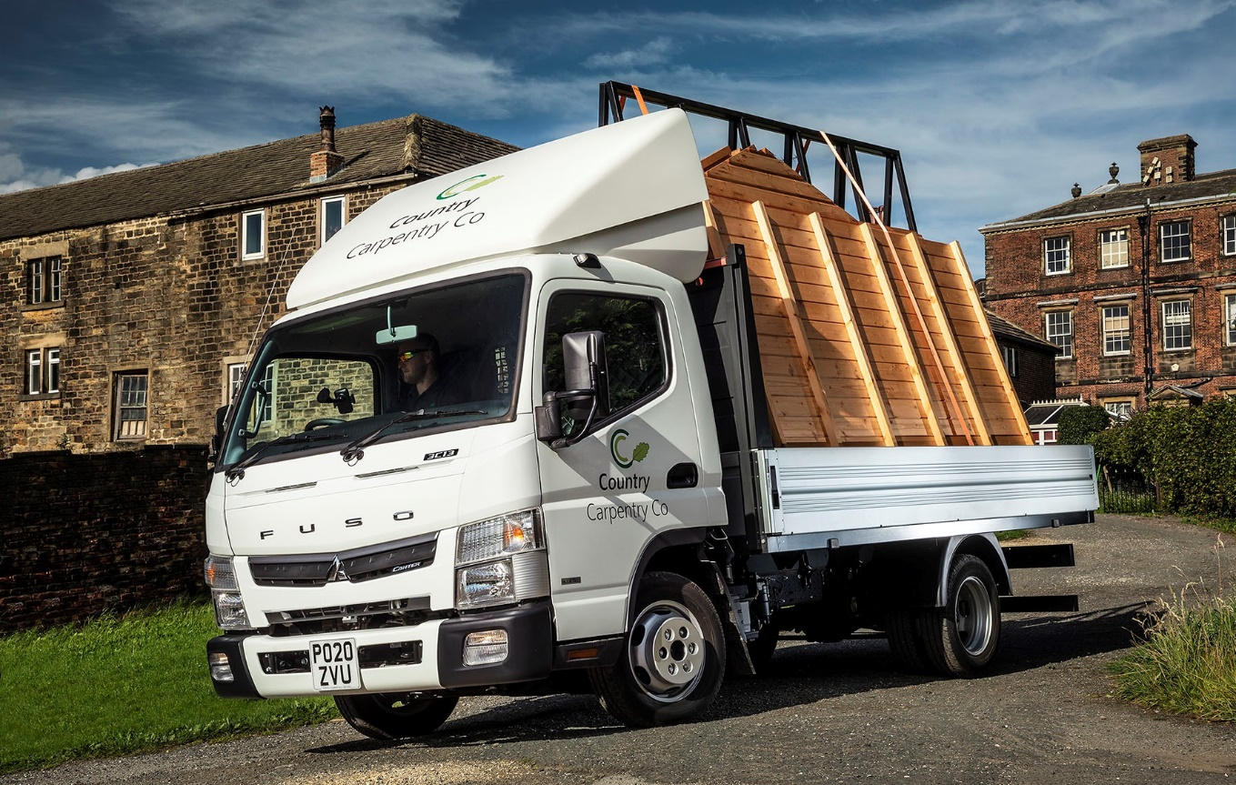

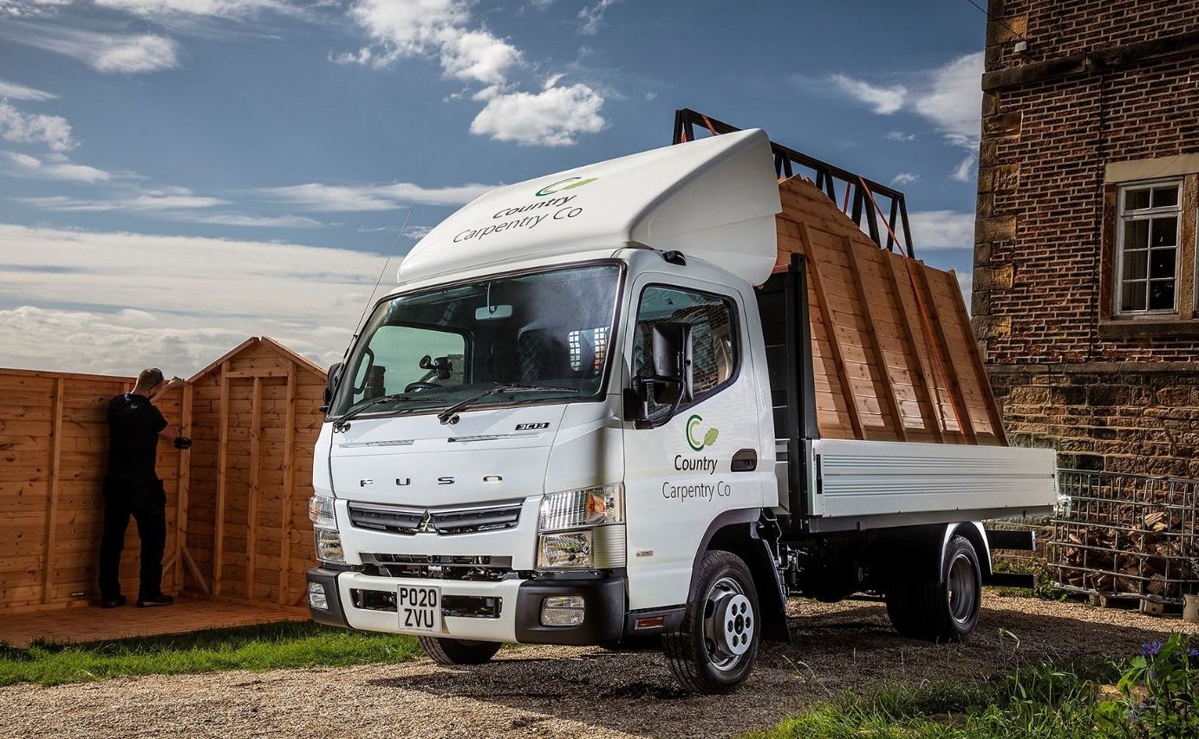

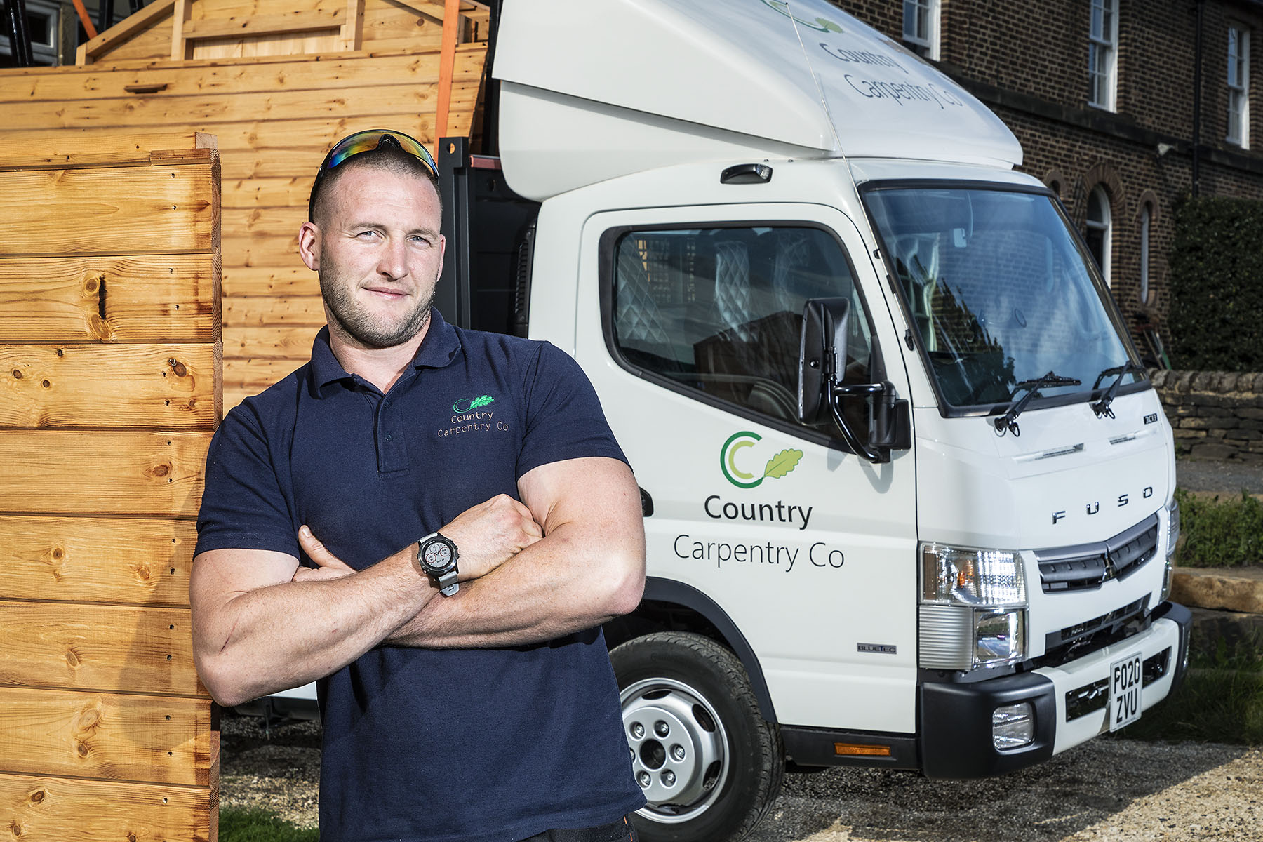

Made to measure: the FUSO Canter is a perfect fit for Country Carpentry’s Aidan Jackson

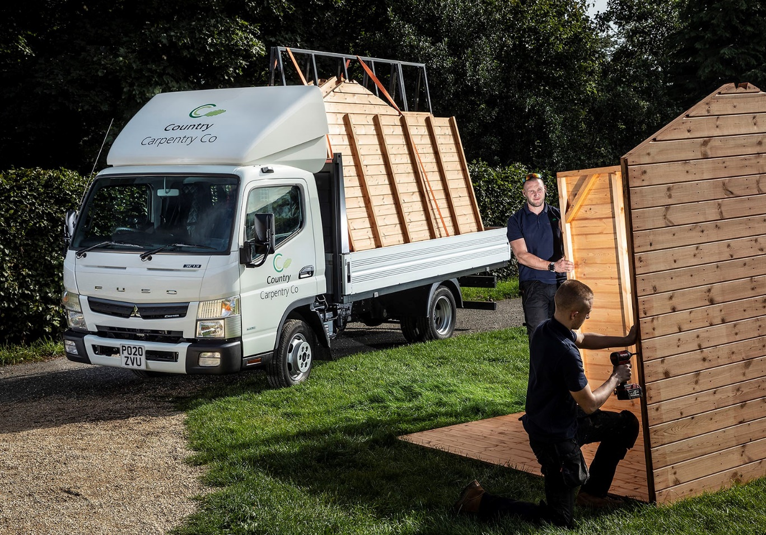

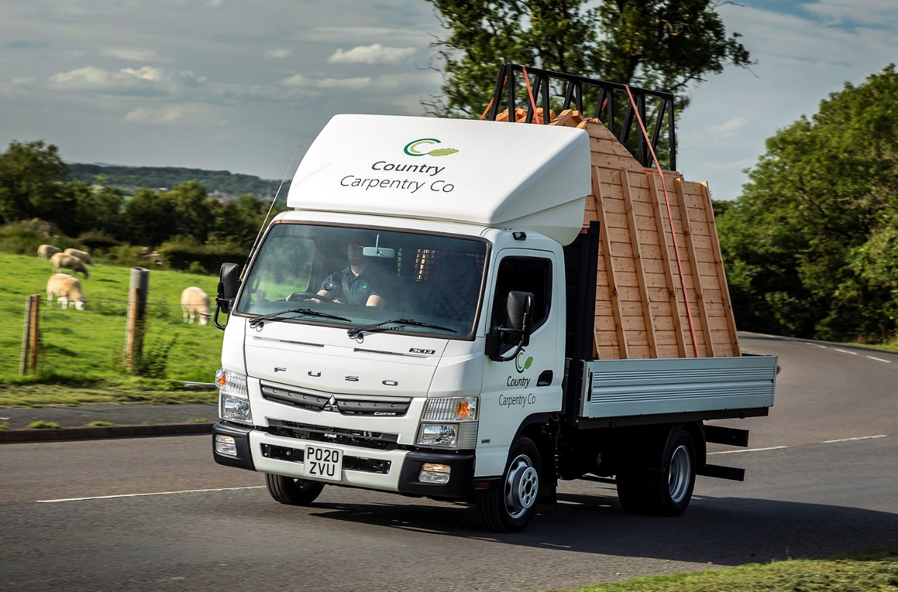

For more information, or to request bigger/higher-res image files, please contact:
John Ripley or Steve Warren
Impact Communications, 01926 842126
John: 07771 484595, john@impactcom.co.uk
Steve: 07770 470251, steve@impactcom.co.uk



